PROJECT TITLE:
LIBRARY MANAGEMENT SYSTEM

Submitted By:
- MADEEHA TALIB ------------------------------------------------ 02-235221-010
- HAMZA NAEEM -------------------------------------------------- 02-235221-034
- SYED HAMZA HUSSAIN SHAH ------------------------------- 02-235221-030

Course instructor: Lab instructor:
Muhammad Marouf Engr.Ambreen Akram

Table of Contents
- INTRODUCTION: ------------------------------------------------- 3
- AIMS AND OBJECTIVE:
- BACKGROUND OF PROJECT:
- PROJECT SOFTWARE USED: --------------------------------------- 3
- CONCLUSION AND FUTURE SCOPE: --------------------------------- 3

INTRODUCTION:
A Library Management System is a project that manages and stores books information electronically according to student’s needs. This system helps both students and library manager to keep a constant track of all the books available in the library.
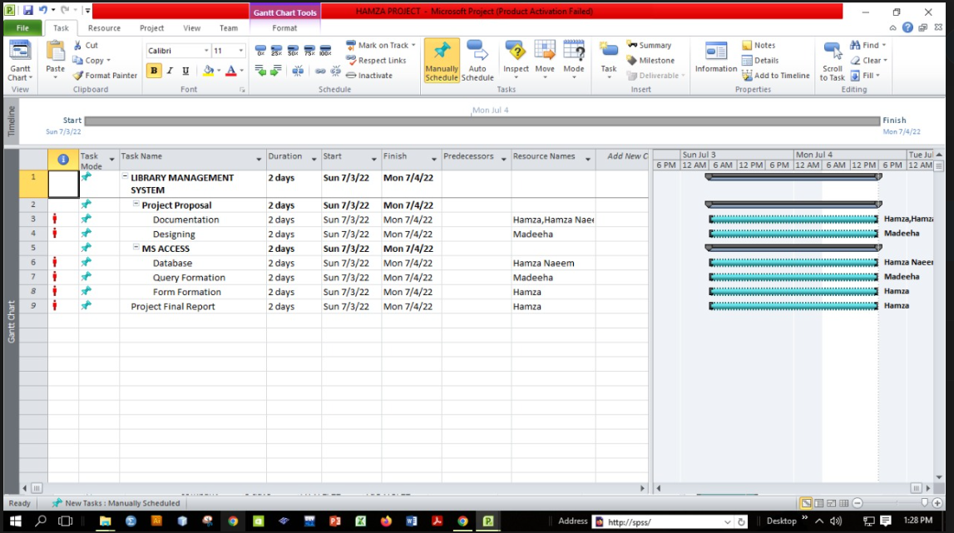
AIM AND OBJECTIVE:
It allowed both for the admin and the student to search for required book. It helps in finding books position where is the located on which shelf. It becomes necessary for library to check a continuous check on the books issued and returned and even calculate fine. This task is carried out manually will be tedious and includes chances of mistake. These errors are avoided by allowing the system to keep track of information such as issue date, last date to return the book and even fine information and thus there is no need to keep manual track of this information which thereby avoids chances of mistakes. Thus this system reduces manual work to a great extend allows smooth flow of library activities by removing chances of error in the details.
BACKGROUND AND FUTURE SCOPE OF PROJECT:
This project is made for school and colleges system based library.
In the past there was a very difficult and time demanding method for library management. They used a lot of registers to keep all the information of books and students. It was difficult to manage all this information of students issuing the books and not returning it on time. The old library system has to hire a large staff to take care of all the problems in library.
But nowadays modern technologies like computer has made it easy to manage a large library. The modern library management system has helped the admin by making their tasks easy and by saving their time by saving all the information in computer. By just one click we can access all the information of students, books he have issued, date of issue, date of return and fine calculated.
PROJECT SOFTWARE USED:
MICROSOFT ACCESS:
Microsoft Access is an information management tool, or relational database, that helps you store information for reference, reporting and analysis. Access can also overcome the limitations found when trying to manage large amounts of information in Excel or other spreadsheet applications.
CONCLUSION:
The Library Database Management System allows the user to store the book details and the person’s details. This software allows storing of all the records related to the library. The implementation of the system will reduce the data entry time and provide easily calculated reports. Library Management System is an application for assisting a librarian in managing a book library in a university. The system would provide basic set of features to add/update members, add/update books, and manage check in specifications for the systems based on the client’s statement of need.

