Getting Started Document

Welcome to Pillbox! We are glad to have you join our team and look forward to getting to know you better. Follow this document to get up to speed on pillbox and our business processes.

**Who is Pillbox?**

Pillbox is a small 3 person software engineering startup working in the health industry.

Team members:

* Carlos Santana
* Cesar Santana
* Madeeha Khan

**Our Mission Statement**

To create efficient, elegant, and impactful solutions to improve the life of people.

**What do we do?**

We are currently in the process of creating a multi-platform application called “Pillbox”. Our team uses the waterfall methodology which means we work on all aspects of the software development lifecycle. Our team gathers requirements, create the designs, implement design into code, test our software, and maintain our software.

**Why do we do what we do?**

The idea behind Pillbox is to build an application which will help patients and pharmacists better keep track of medication dispensary and usage. The application is mainly geared towards patients, and will serve a wide range of users, including the elderly and children. \\

**The Pillbox app**

The product will have features to add, manage, and update medication usage and timings for the user in a personalized way, as well as allow them to communicate with the pharmacist who dispensed their medication to them, and with trusted loved ones (Caregiver).

The target audience of the application are people who use medication regularly. It is directed especially to those who experience chronic illnesses, the elderly and/or anyone who may need assistance taking medication. The goal for the application is to be easily accessible and effortless to use, as well as low in data, storage.

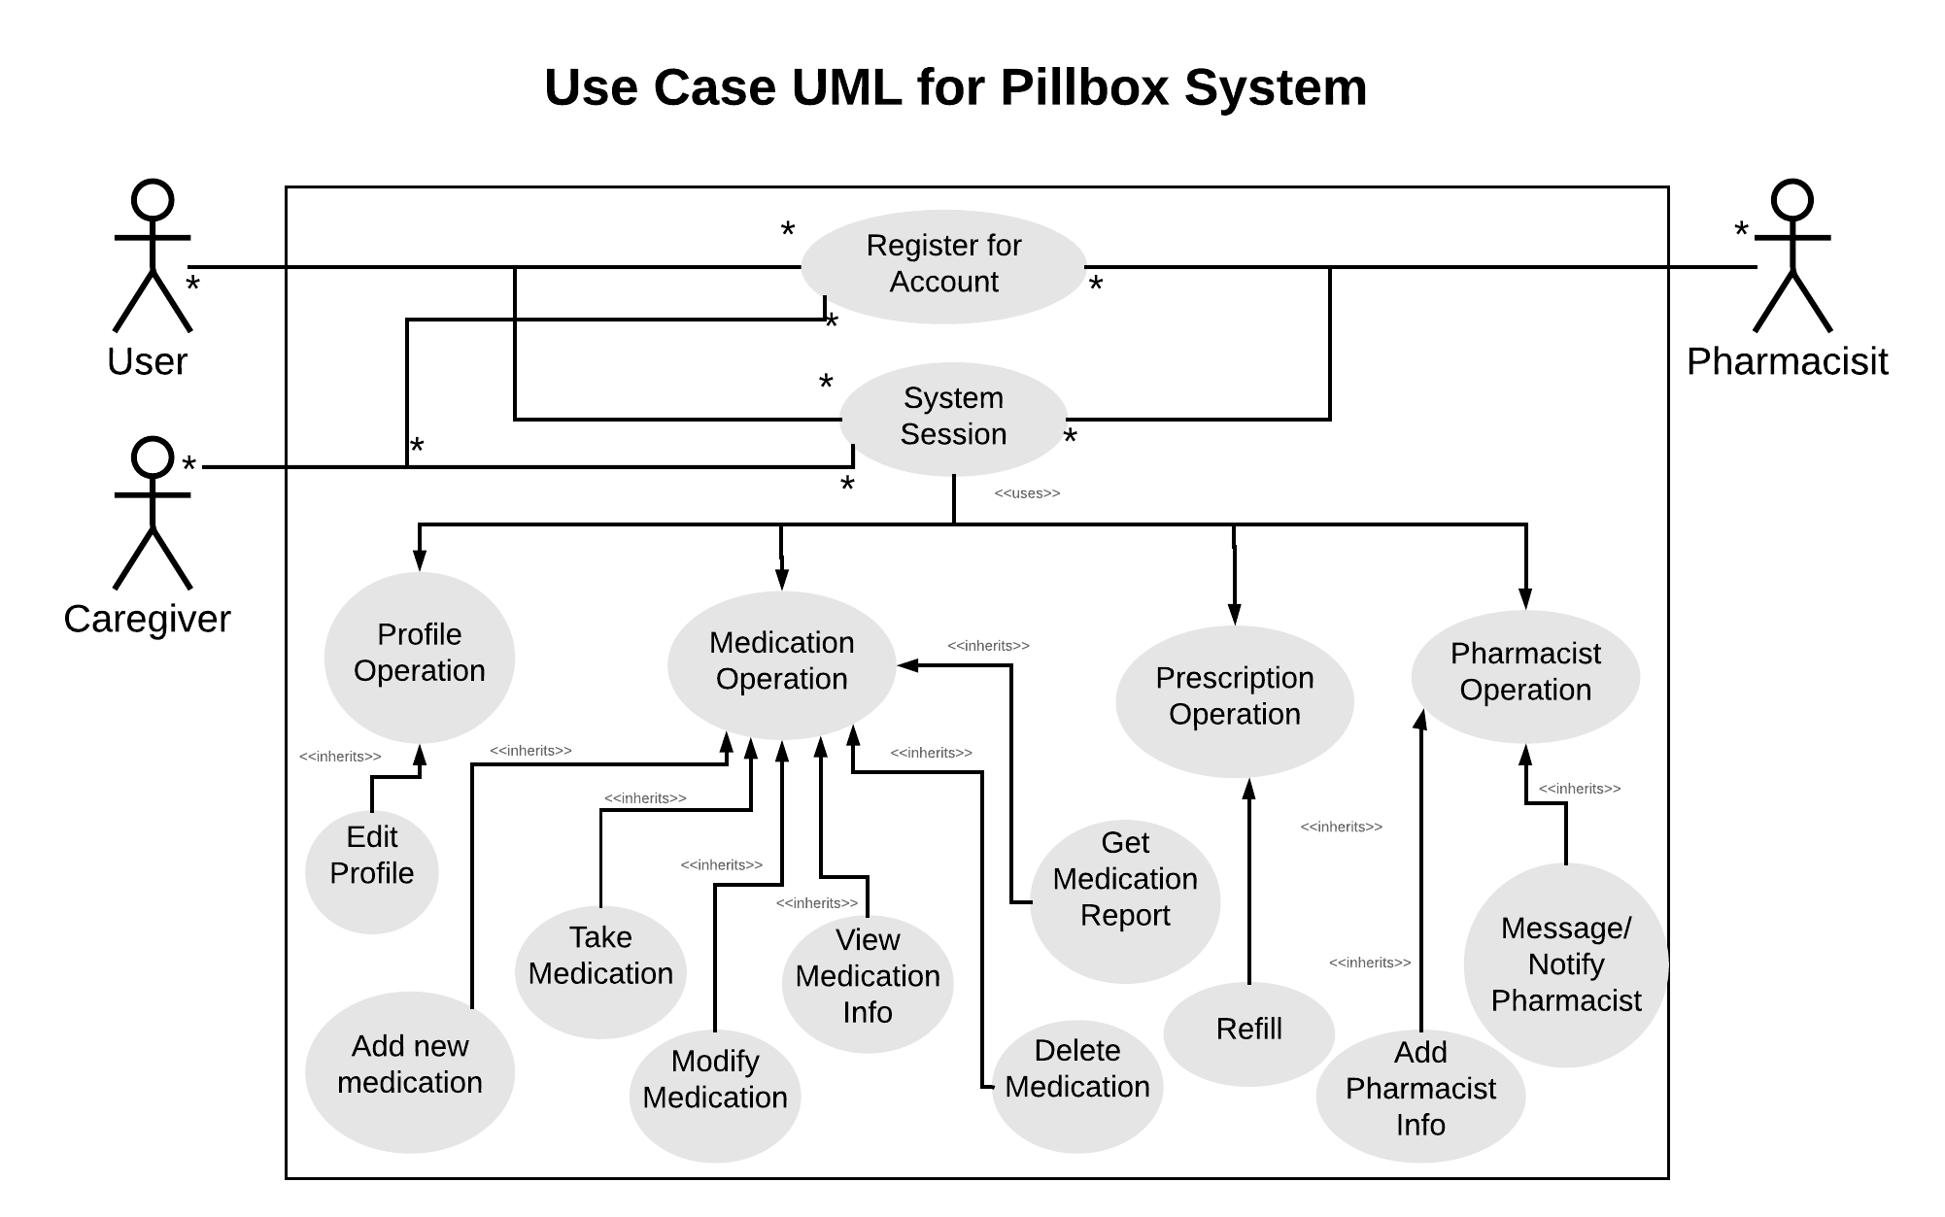

The above diagram illustrates the three actors and their role with interacting with the system. An actor is a role played by one of three users:

* the user, who can view their medication information, adding new prescriptions, receive reminders to take medication and add pharmacy information.
* the caregiver, whose role is to reduce the isolation that patients may feel
* the pharmacist, so the user can build a trusting relationship with their pharmacist, and can easily ask any questions and bring up any concerns they may have.
  + This, we think, is essential, as patients who have a follow-up with their healthcare professional discontinue medication a little less that 50% [1] less often that patients who do not.

For the mobile application we are using the Ionic Framework which uses HTML, CSS, Angular, and Typescript. Our server is written in .Net Core and we use SQL for storing and retrieving data. If you are interested or would like to learn more about these technologies feel free to user the links below.

* <https://ionicframework.com/>
* <https://angular.io/>
* <https://www.asp.net/core/overview/aspnet-vnext>

**Our Google Drive and Github Repository**

This is where you can find all our documents and projects

Google Drive:

<https://drive.google.com/drive/folders/1nABk09TJtZomGh9CjGJV3lmCK1RhL8W4?usp=sharing>’

Github Repository

<https://github.com/MadeehaKhan/Pillbox>

**Important documents to read**

* Pillbox Working Agreement (How we complete our work)
* <https://github.com/MadeehaKhan/Pillbox/blob/master/Documents/PillboxWorkingAgreement.pdf>
* Pillbox poster (General information about the Pillbox app)

<https://github.com/MadeehaKhan/Pillbox/blob/master/Documents/PillboxPoster.pdf>

* SRS Document (Detailed design document about the Pillbox app. Don’t worry too much about the details, just give it a quick read)

<https://docs.google.com/document/d/1VKvomhaAFyzAwmUU_Eqy91H8tXDQBFX8lUPyKeQ6W0E/edit?usp=sharing>