**DBS201 Lab 1 (revised Winter 2019)**

**Purpose:**

* **to become familiar with the signing on process for the IBMi.**
* **to learn how to change your password.**
* **to learn how to print on the line printer.**
* **to enter a SQL statement**
* **compare Schemas Libraries and Collections**
* **download Access Client Solutions**

### Requirements to pass the lab:

* **Hand in a system generated printout of DBS201LIB/ALLSHIFT**
* **Answer the questions on this handout**

**You will need a userid and password from your instructor before starting this lab.**

1. **Signing On:**

Start up IBMi Access Client Solutions. Under the General menu, click on 5250 Emulator. You will be asked to sign on twice. Use the profile provided to you by your instructor.

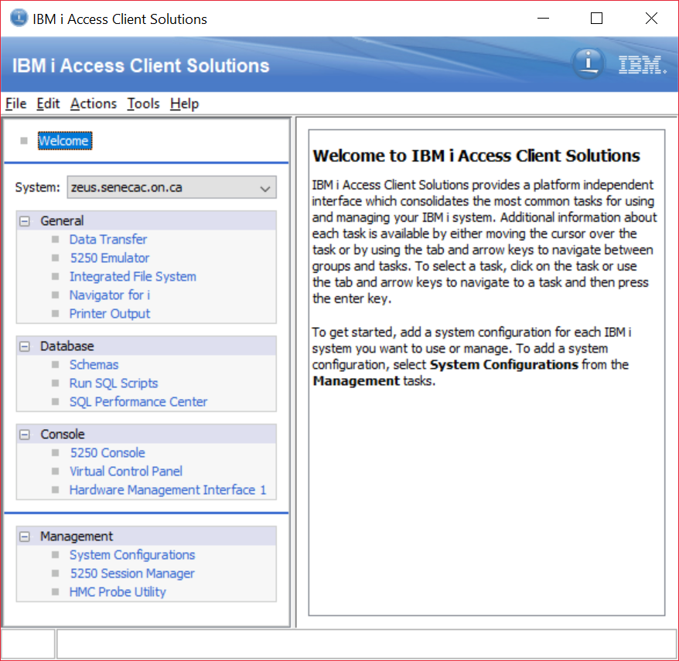

Signing on twice:

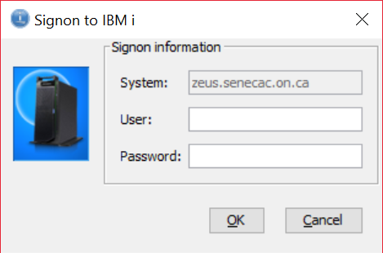

Enter you user profile, press the tab key and then enter your password.

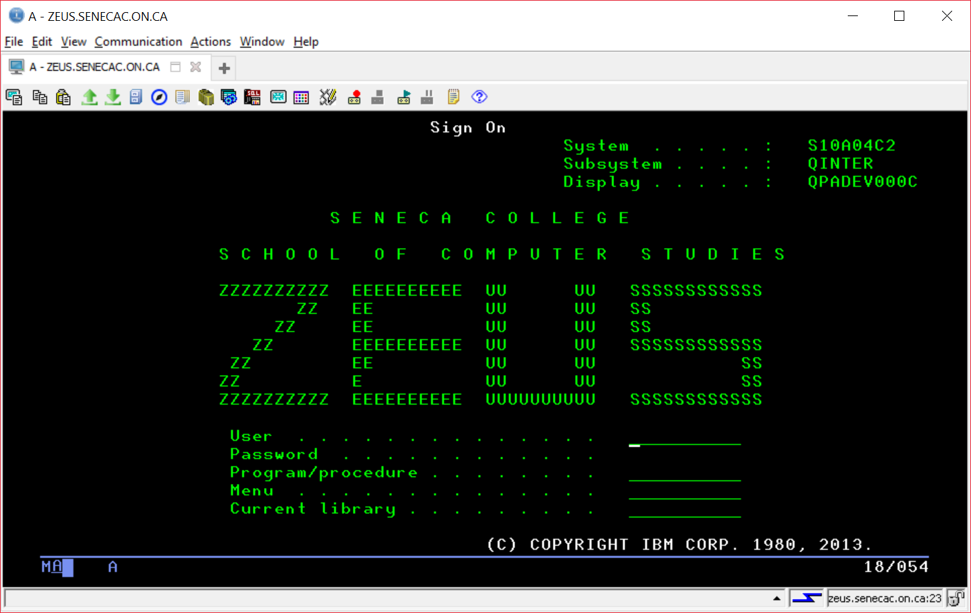

For your first signon, an initial program will run. It will provide some information, get your data and then remove itself from running for subsequent sign ons.

Read the guidelines for use of computer accounts and press enter. Read the second screen and press enter. Now you will be prompted for your name and student number. Enter your first name, then **TAB** and enter your last name, then **TAB** and enter your student number. Once you have entered all three, then press **ENTER**!

Read the confirmation screen. If the information is correct press enter. If something needs to be changed, enter an **N** (and press enter) to go back and make corrections.

Once you have confirmed your information, you will be at a Menu screen. This signon is using 5250 emulation. This is sometimes referred to as the Green Screen.

**Type the following command at the command line prompt:**

**=> GO DBS201LIB/SQLTERM**

This terminology is something you will have mastered by the end of this subject. Take a brief look at the terms to ensure all of them are accessible. On the provided answer sheet, write out a copy of the definitions for a row and for a record.

You are not expected to know all these definitions now, but are encouraged to keep familiarizing yourself with the definitions periodically when signing in. You should know the definitions by the end of the course.

Press F23 (done by pressing Shift + F11). This should ensure that anytime you start an Access Client session, the definitions will be easily accessible. This will always be the first screen you will see when signing on.

In order for your name to show at the bottom of the printout, you need to remember to always run the following command from the command line:

==>CALL STRJOB .

**Type the following command at the command line prompt:**

**=> STRSQL**

This places you into a friendly SQL environment where you can enter SQL statements interactively.

Type CREATE at the SQL command prompt and press the F4 function key.

**Type SQL statement, press Enter**

**Current connection is to relational database S10A04C2**

**===> CREATE (F4)**

Select option 2 (Collection)

For the Library prompt, provide a name that is similar to your ID. If your id is WS201A40 use WS201A40**SQ**

Indicate on the answer sheet what feedback was provided for the execution of this SQL statement.

Type SELECT and press the F4 (Prompt) key

We want to view the data in a file (table) called ALLSHIFT that is stored in a library called DBS201LIB.

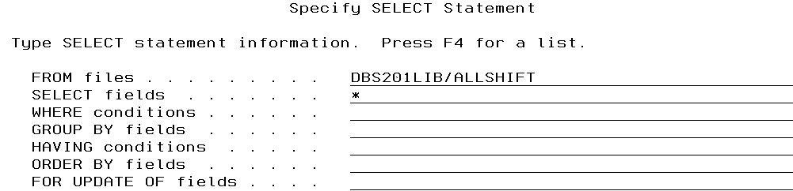

Press enter to view the data

Press F9 to retrieve the previous command and write it down on the answer sheet.

We want this output to go to the system printer and we want to ensure the student name is included in the printout. If you have signed out and signed in, the effects of the CALL STRJOB action have been lost. Since we have not instructed you to sign out, there is no problem here. (Some instructors will insist on system generated printouts with a system generated (not written) student name – so take note)

To redirect the output to the system printer, press the F14 key (Shift + F1)

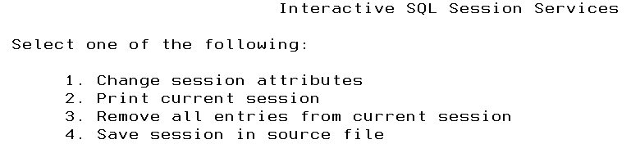

We want to change the session attributes from Display, to Printer.

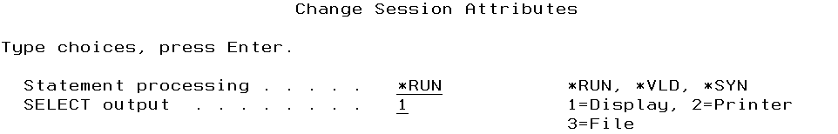

After you have changed the session attributes you can keep pressing the enter key until you are back at your SQL interactive session.

Press F9 to retrieve the statement and re run it. You should not see any output on your screen, because it has gone to a spooled file on the system.

In order to see that spooled file, exit from your interactive SQL session by pressing F3.

Always use option 1 so you do not lose your history of statements. Even if you have entered a whole lot of error statements in one session, you still want a history of the working statements entered during the entire semester.

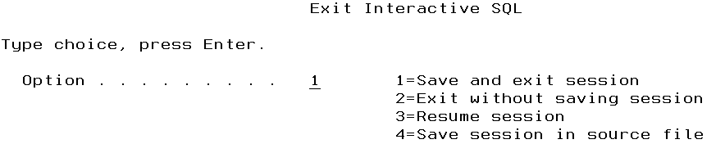

The command to see your spooled file entered at the command prompt is WRKSPLF.

Do this now and write down the name of the spooled file on your answer sheet.

In order to generate a printout you need to use option 2 which is the CHGSPLFA command.

File User Queue

2_ Spoolname UserId UserOutputQ

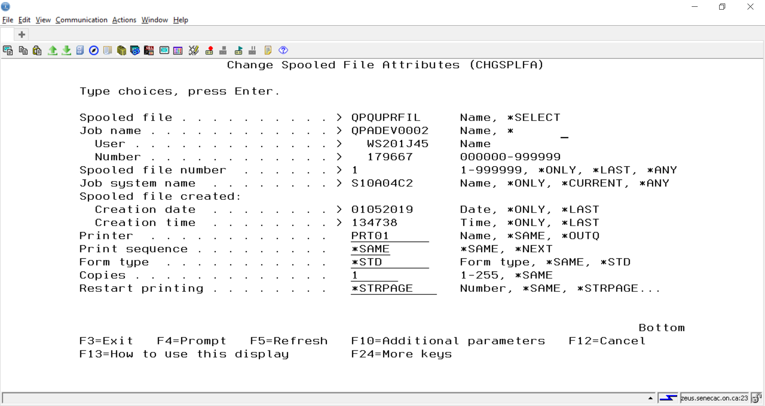

You should see your spool file appear under a different output queue.

File User Queue

2_ Spoolname UserId PRT01

If you press the refresh key (F5) the spool file should disappear from the screen because it has been printed and is ready for pickup. If it does not disappear, then the printer writer program needs to be restarted – you can ask a professor for help or get help at the help support desk in the learning center.

On the 5250 emulator screen there are a number of small icons at the top. In the screenshot below the mouse is hovering over the ninth one from the left and Magage DB2 for I databases appears.

We want to click on that icon.

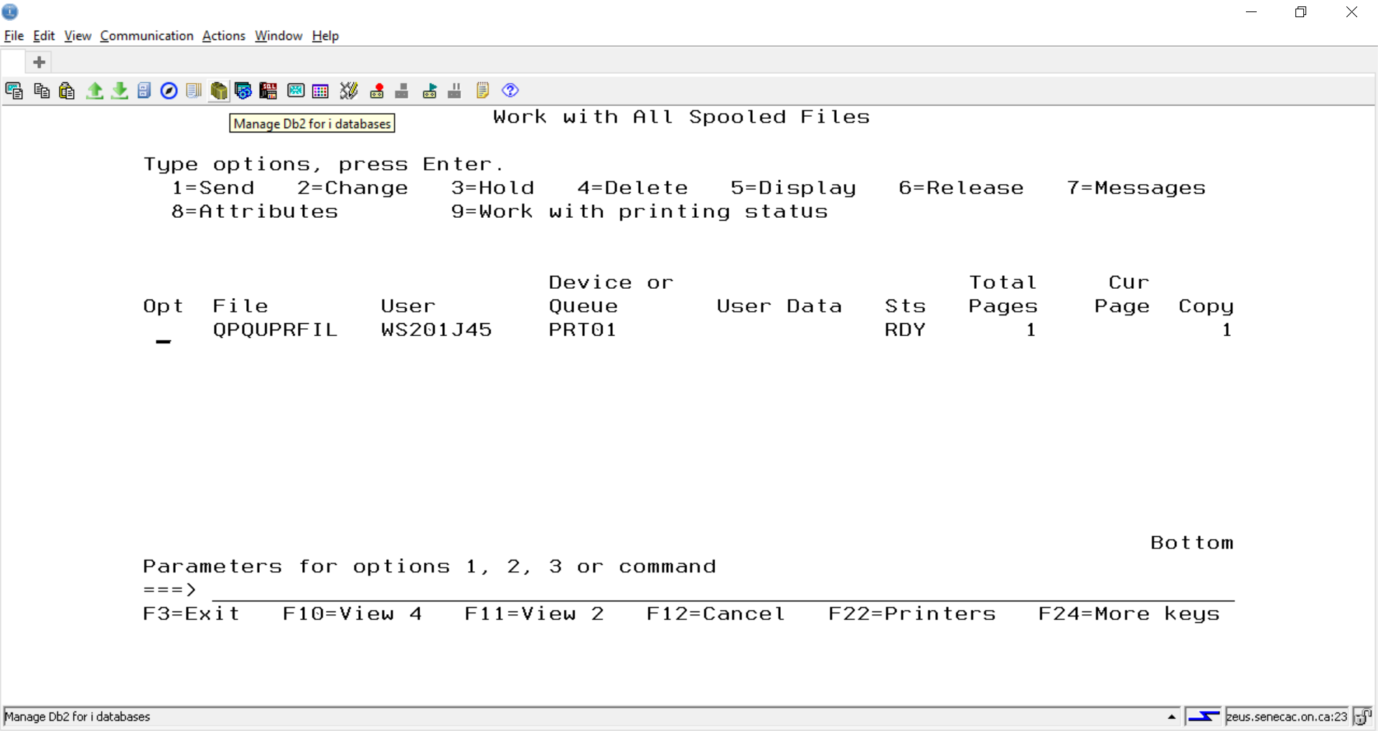

Open up the name under databases by clicking on the plus sign. Then open up Schemas.

In order to have more libraries or schemas show up you can right click on Schema and select include.

The next screen allows you to enter schema names and click the ADD button. You will add two names. DBS201LIB and the collection you created in a previous step for me that was WS201A40SQ.

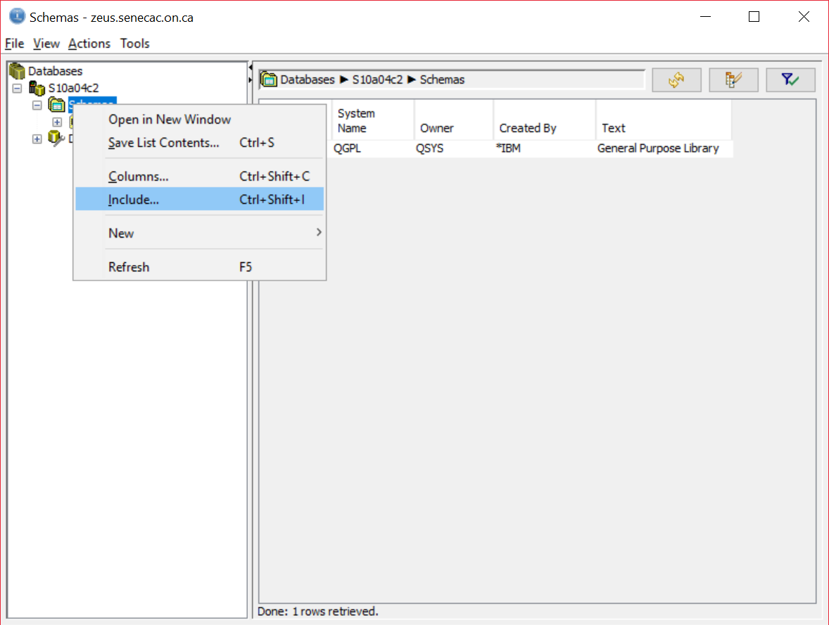

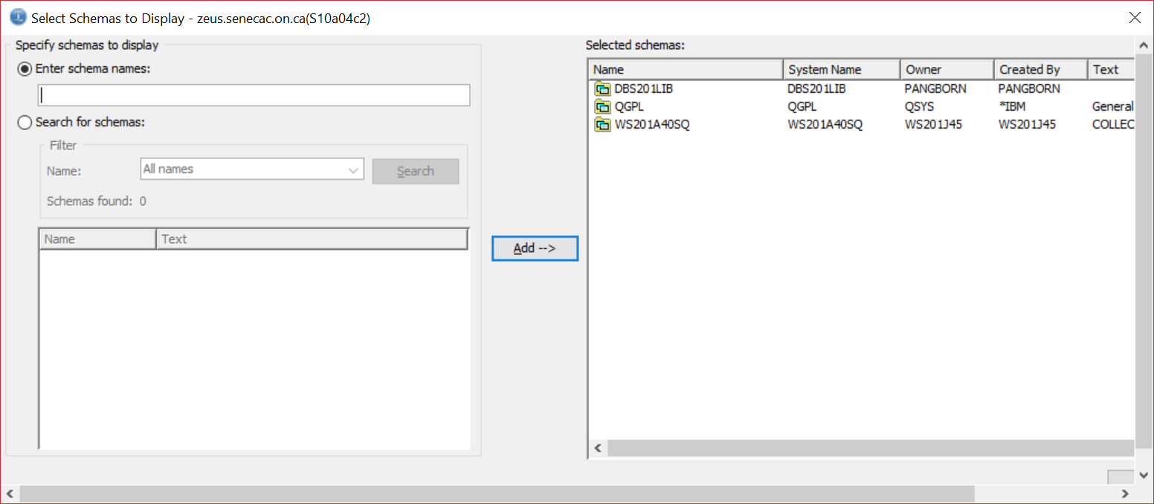

If you expand DBS201LIB you will find out it is referred to as a schema, but it does not have all the extra objects that support a schema. It was created with a CLLE command CRTLIB and no special objects to support databases were included.

If you expand WS201???SQ (your name) you will see extra objects were created for you.

Click on Journals, Journal Receivers, and Views and record the names on your answer sheet.

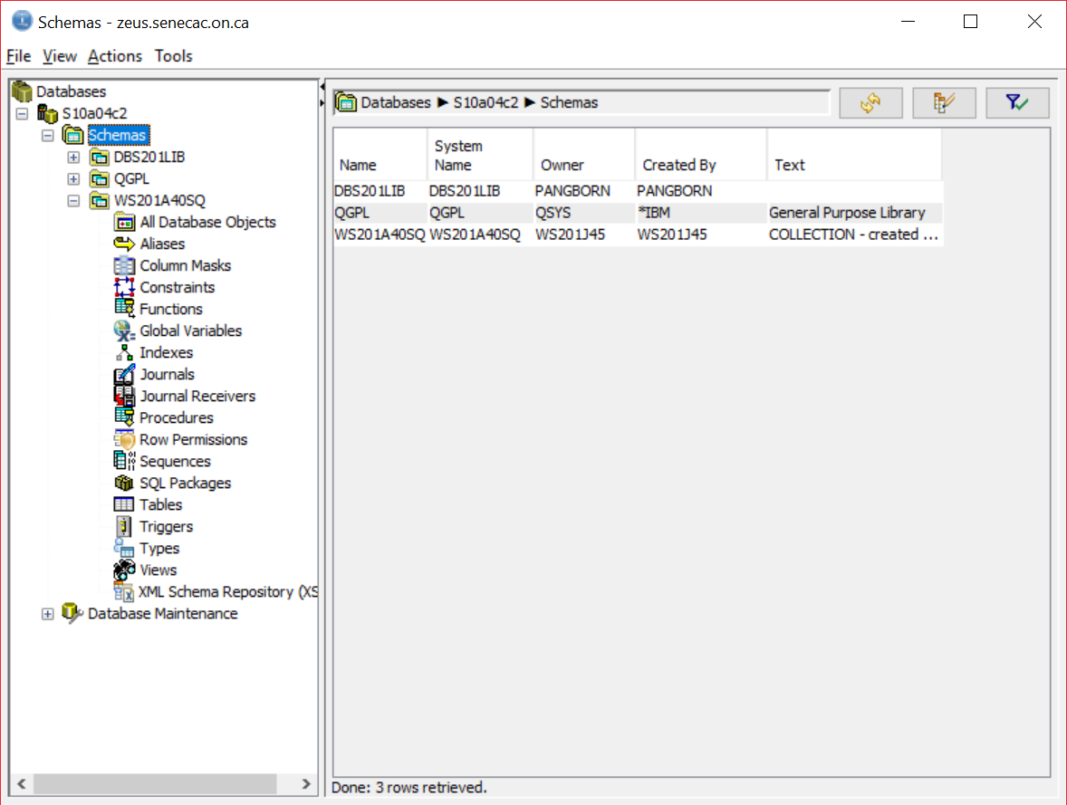

In the 5250 emulation screen, type the following commands:

WRKOBJPDM collectionname (the collection you created WS201??SQ)

WRKOBJPDM libraryname (your library name – it is the same as your id)

You have already written down most of the object names created for you in your collection.

On the answer sheet write down the objects in your account library.

The next step is optional.

If you want to change your password, type CHGPWD at the command line and press enter.

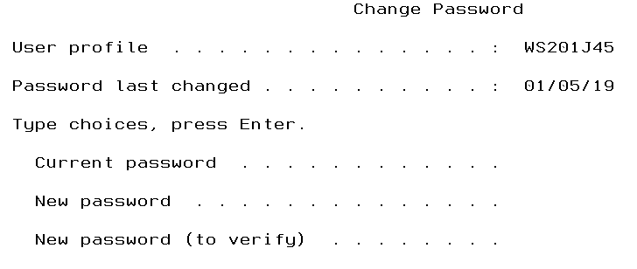

This can be frustrating if you don’t read the following information.

the password is not case sensitive

Passwords can not start with a number

The password limit is 10 characters, so don’t type in a long password

Type the current password, press the tab key and type the new password and press the tab key and retype the new password – then press enter.

You are now finished the first lab. In the next lab, we will spend some time looking at some database objects.

**Signing off:**

Type SIGNOFF at the command line and close all your windows.

If you want to install Access Client Solutions on your own PC:

Click on:

<http://inside.senecacollege.ca/its/software/>

Click on Software Downloads

Sign on and click on iSeries Tab

Download IBM I Access Client Solutions

