# *DBS 301 DE, Assign1 – Worth 10 %*

Due on Wednesday, March 07th by 4pm

# Format: Printout of all SELECT statements with OUTPUTS

**PLAGIARISM**   
When you submit an assignment, you are saying that the submission is your own work or your groups own work and as such you wish to be given credit for the work.

Occasionally, it may be necessary to ask someone for a small amount of help. You are permitted to do so, provided you meet the following two conditions.

1 You acknowledge the help on the work you hand in, including explaining the work or portion of the work done or assisted by another person.

2 You understand the work that you hand in, so that you could explain the reasoning behind the parts of the work done for you or assisted by another.

Any other assistance by another person constitutes a violation called plagiarism and will be treated as such.

If two submissions exist, that are essentially the same, then both submissions cannot possibly make the claim that the work is "solely their own". This is a serious matter and is considered plagiarism. It is recorded in accordance with College policy and may result in a penalty such as expulsion from the College. Please do not put yourself in this position. Plagiarism is very easy to detect.

**Understanding what group works means**

It is suggested that you ALL do it individually and then meet to compare answers. Those not doing the work should be dropped from your group.

**VERY IMPORTANT:**

Being part of a group is the same as being a part of a team for these assignments. When you submitted your work as part of a group you are saying that:

you understood what was submitted and that you fully participated with ALL the group members.

It does not mean letting others do your work for you.

It does not mean watching the others do the work.

For your full participation, you get a mark equal to all the others in the group. If on the test, which is very much like the assignment, you cannot answer the questions, it strongly indicates that you didn’t participate and understand the assignment but depended on others for the mark you received. That is very much like submitting their work and claiming it is your work.

Members in group listed below. Group # or Letter _______________

**Anyone not in this list at submission time, cannot be added to the group later**

|  |  |  |
| --- | --- | --- |
| Name | Student ID | Email address |
|  |  |  |
|  |  |  |
|  |  |  |
|  |  |  |
|  |  |  |
|  |  |  |
|  |  |  |

The above list of names acknowledges you understand.

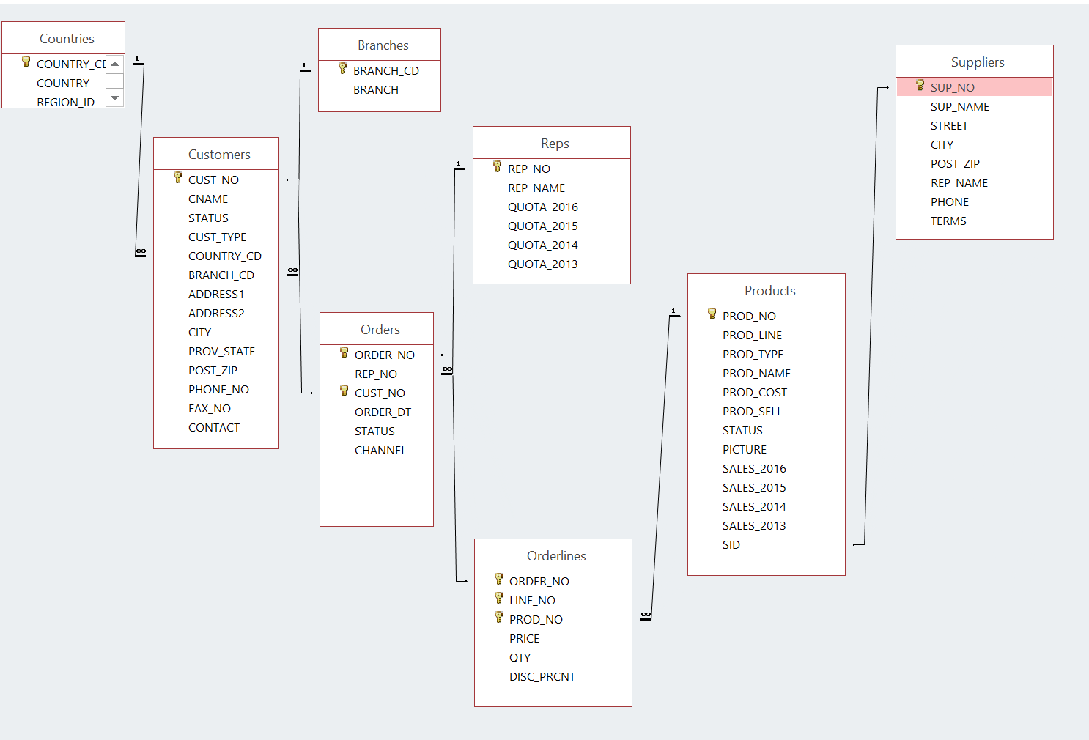

**You need to run the script called CMC.sql in order to create 6 new Tables, and the ERD with 8 tables to describe the problem here is shown above. You already have table COUNTRIES in your schema, while table BRANCHES is not needed for this assignment. That script was sent to you via BB mail.**

1. Display the customer number, customer name and country code for all the customers that are in the UK. Please note that the user could have used UK, Uk, uk, uK. Your SQL must allow for various user inputs of the code.

Restrict the output only to customer names that start on FRESH or BREATHE, again case may vary.

Sort the output per customer number ascending.

2 For any **GO** customers, list the customer number, customer name and order number if they ordered any of these products -- 40301, 40306. Put result in customer number order, followed by order number.

3. List the customer number, customer name and order number if they ordered any of these products -- 40301, 40303, 40306. Restrict the output to order numbers greater than 200 and exclude customers with name starting on U or C. Put result in customer number order, followed by order number.

4. Display all orders for United Kingdom. The word entered is United Kingdom and not UK. Show only cities that start with B.

Display the customer number, customer name, city and order number, product name, the total dollars for that line on the order.

Give that last column the name of 🡺 Total.

Put the output into customer number order, followed by order number and then Total descending. Display only order numbers greater than 120.

5. Find the total dollar value for all orders from London , if that value is smaller than $10,000. Each row will show customer name, order number and total dollars for the order. Sort by order number.

6. For all orders in the orders table supply order date and count of the number of orders on that date. Only include those from 2015 and have more then 1 order on that date. Sort by the earlier order dates firstly.

7. How many customers from AUSTRALIA and CANADA (combined) have not placed an order?

8. Show what customers (number and name) along with the country name for all customers that are in the same countries as the Supra customers. Limit the list to any customer that starts with the letters A or B