MADEGA
MADEGA FJ\
2026-04-28

EXPLORATORY DATA ANALYSIS

library(fpp2)
## ── Attaching packages ──────────────────────────────────────────── fpp2 2.5.1 ──
## ✔ ggplot2 4.0.2 ✔ fma 2.5
## ✔ forecast 9.0.2 ✔ expsmooth 2.3
## Warning: package 'ggplot2' was built under R version 4.5.3
## Warning: package 'forecast' was built under R version 4.5.3
##
library(forecast)
library(tseries)
## Warning: package 'tseries' was built under R version 4.5.3
## Registered S3 method overwritten by 'quantmod':
## method from
## as.zoo.data.frame zoo
library(stray)
require(ggplot2)
data("wmurders")
head(wmurders)
## Time Series:
## Start = 1950
## End = 1955
## Frequency = 1
## [1] 2.429415 2.363364 2.374305 2.295520 2.329716 2.233017
tail(wmurders)
## Time Series:
## Start = 1999
## End = 2004
## Frequency = 1
## [1] 3.034263 2.805041 3.304467 2.797697 2.662227 2.589383
#Z=ts(wmurders, start = 1999, frequency = 1)
par(mfrow=c(2,2))
plot(wmurders, xlab="Year", ylab="Number of women murdered", col="blue",main=" (a) Annual female murder rate")
plot(density(wmurders),xlab="Number of women murdered",col="blue", main=" (b) Density plot" )
qqnorm(wmurders,col="blue", main = "(c) normal QQ plot")
qqline(wmurders)
boxplot(wmurders, col="blue", main="(d) Box plot")
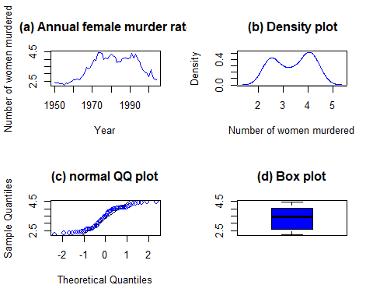
#Figure 1: (a) Plot of the annual female murders rate (top left panel), (b) A kernel density plot of the wmurders(top right panel), (c) Normal QQ plot of the wmurders
#(bottom right panel), (d) The Box plot of the wmureders(bottom right panel).
#Figure 1 (top-left panel) shows that in the 1950s and 1960s, the annual number of women murdered was relatively low, averaging around 2.5 before rising steadily throughout the 1970s and peaking above four murders per year in the 1980s, after which a slight decline is observed. The density plot (top-right panel) confirms this shift by displaying a bimodal distribution, with two distinct peaks corresponding to the lower and higher phases of the series. The normal QQ plot (bottom left panel) indicates departures from normality, particularly at the tails, further supporting the presence of non-normal and multimodal characteristics in the data. Finally, the box plot (bottom right panel) highlights that the median number of murders is approximately 3.5, with most observations falling between three and four murders annually, and no extreme outliers detected. Overall, the evidence suggests that the distribution of female murder rates is not normally distributed but instead reflects two distinct historical regimes of lower and higher violence.
summary(wmurders)
## Min. 1st Qu. Median Mean 3rd Qu. Max.
## 2.233 2.609 3.463 3.393 4.055 4.492
library(e1071)
##
## Attaching package: 'e1071'
## The following object is masked from 'package:ggplot2':
##
## element
kurtosis(wmurders)
## [1] -1.565502
skewness(wmurders)
## [1] -0.1386229
sd(wmurders)
## [1] 0.7486489
#The median of 3.463 exceeds the mean of 3.393, which points to a slight leftward skew in the distribution, in line with the skewness statistic of –0.139. Furthermore, the negative kurtosis value (–1.566) indicates a platykurtic pattern, suggesting that the data are flatter and have lighter tails compared to a normal distribution. The standard deviation of 0.749 signals a moderate level of dispersion around the average, consistent with the relatively small interquartile spread illustrated in the box plot.
outliers <- find_HDoutliers(wmurders, knnsearchtype = "brute")
display_HDoutliers(wmurders, outliers)
## Warning: `aes_string()` was deprecated in ggplot2 3.0.0.
## ℹ Please use tidy evaluation idioms with `aes()`.
## ℹ See also `vignette("ggplot2-in-packages")` for more information.
## ℹ The deprecated feature was likely used in the stray package.
## Please report the issue at <https://github.com/pridiltal/stray/issues>.
## This warning is displayed once per session.
## Call `lifecycle::last_lifecycle_warnings()` to see where this warning was
## generated.
## Don't know how to automatically pick scale for object of type <ts>. Defaulting
## to continuous.
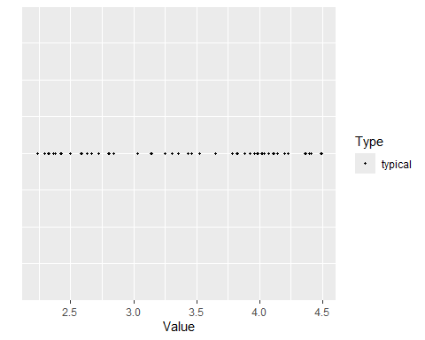
outlierss <- boxplot.stats(wmurders)$out
outlierss
## numeric(0)
#Figure 2: Shows the outlier plot.
#Figure 3: The distribution of values appears compact, with most data falling within the expected range. No observations are flagged as statistical outliers, supporting the earlier boxplot result, which also showed no extreme values outside the whiskers. Hence it means no outliers were detected under the standard boxplot rule.
#QUESTION 1
#(a)
gamma <- BoxCox.lambda(wmurders,lower = 0)
gamma
## [1] 4.102259e-05
transformed_data <- BoxCox(wmurders, gamma)
transformed_data
## Time Series:
## Start = 1950
## End = 2004
## Frequency = 1
## [1] 0.8876666 0.8601012 0.8647201 0.8309736 0.8457610 0.8033668 0.8663505
## [8] 0.8427324 0.8823594 0.9155873 0.9475958 0.9481334 0.9667342 0.9485258
## [15] 1.0009980 1.0455060 1.1457969 1.2334785 1.2115001 1.2420572 1.2940330
## [22] 1.3841012 1.3675835 1.5021132 1.5022421 1.4808690 1.3824488 1.4147069
## [29] 1.3909578 1.4353903 1.4742260 1.4417961 1.4221587 1.3315289 1.3422156
## [36] 1.3403857 1.3925980 1.4037154 1.4124708 1.3960438 1.4144315 1.4840718
## [43] 1.4136066 1.4719888 1.3760404 1.3566218 1.2598571 1.1785493 1.1442127
## [50] 1.1099938 1.0314400 1.1953045 1.0288183 0.9791827 0.9514382
## attr(,"lambda")
## [1] 4.102259e-05
par(mfrow = c(2,1))
plot(wmurders, main = "Original wmurders data")
plot(transformed_data, main = paste("Box-Cox Transformed data (lambda =", round(gamma, 5), ")"))
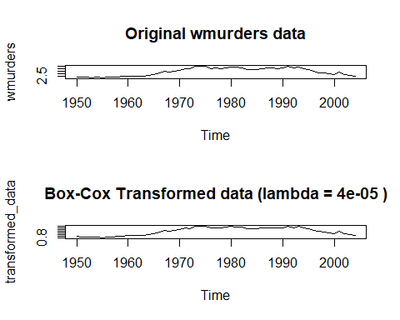
#Figure 3: Exhibit the original data(Top panel) and the transformed data( bottom panel)
#Figure 3: The original plot of the wmurders data, representing U.S. female murder rates, likely exhibits a pronounced non-linear trend and, crucially, non-constant variance, where the year-to-year fluctuations were larger when the murder rate was at its peak. The applied Box-Cox transformation, with a lambda value very near zero, effectively functions as a logarithmic transformation. This transformation successfully stabilizes the variance across the entire time series, making the fluctuations around the trend appear consistent from the 1950s to the 2000s, thereby meeting a key assumption for reliable time series modeling and forecasting
set.seed(123)
#(b)
M1 <- auto.arima(wmurders, lambda=gamma)
summary(M1)
## Series: wmurders
## ARIMA(1,2,1)
## Box Cox transformation: lambda= 4.102259e-05
##
## Coefficients:
## ar1 ma1
## -0.2954 -0.7892
## s.e. 0.1533 0.1190
##
## sigma^2 = 0.003614: log likelihood = 74.08
## AIC=-142.17 AICc=-141.68 BIC=-136.26
##
## Training set error measures:
## ME RMSE MAE MPE MAPE MASE
## Training set -0.01888661 0.2095532 0.1554779 -0.4387269 4.390317 0.9561163
## ACF1
## Training set 0.06366468
#(c)
M2 <- Arima(wmurders, order=c(1,1,1), lambda=gamma)
summary(M2)
## Series: wmurders
## ARIMA(1,1,1)
## Box Cox transformation: lambda= 4.102259e-05
##
## Coefficients:
## ar1 ma1
## -0.8555 0.7288
## s.e. 0.1872 0.2274
##
## sigma^2 = 0.003632: log likelihood = 76.02
## AIC=-146.04 AICc=-145.56 BIC=-140.07
##
## Training set error measures:
## ME RMSE MAE MPE MAPE MASE
## Training set 0.004172634 0.2060595 0.1552384 -0.02242037 4.47417 0.9546434
## ACF1
## Training set 0.09406305
M3=Arima(wmurders, order=c(1,0,1), lambda=gamma)
summary(M3)
## Series: wmurders
## ARIMA(1,0,1) with non-zero mean
## Box Cox transformation: lambda= 4.102259e-05
##
## Coefficients:
## ar1 ma1 mean
## 0.9689 -0.0437 1.0494
## s.e. 0.0262 0.1078 0.1808
##
## sigma^2 = 0.003808: log likelihood = 75.34
## AIC=-142.67 AICc=-141.87 BIC=-134.65
##
## Training set error measures:
## ME RMSE MAE MPE MAPE MASE
## Training set 0.02314326 0.2103245 0.1599841 0.3514923 4.652055 0.9838272
## ACF1
## Training set -0.01385063
M4=Arima(wmurders, order=c(2,0,2), lambda=gamma)
summary(M4)
## Series: wmurders
## ARIMA(2,0,2) with non-zero mean
## Box Cox transformation: lambda= 4.102259e-05
##
## Coefficients:
## ar1 ar2 ma1 ma2 mean
## 1.0969 -0.1446 -0.1988 0.4290 1.0781
## s.e. 0.2597 0.2579 0.2318 0.1974 0.1637
##
## sigma^2 = 0.003491: log likelihood = 78.52
## AIC=-145.03 AICc=-143.28 BIC=-132.99
##
## Training set error measures:
## ME RMSE MAE MPE MAPE MASE
## Training set 0.01831827 0.1970875 0.1537647 0.2409181 4.40774 0.945581
## ACF1
## Training set 0.01681643
#(d)
AIC_vals <- c(
fit1 = AIC(M1),
fit2 = AIC(M2),
fit3 = AIC(M3),
fit4 = AIC(M4)
)
print(AIC_vals)
## fit1 fit2 fit3 fit4
## -142.1690 -146.0391 -142.6749 -145.0302
best_fit <- list(M1,M2,M3,M4)[[ which.min(AIC_vals) ]]
best_fit
## Series: wmurders
## ARIMA(1,1,1)
## Box Cox transformation: lambda= 4.102259e-05
##
## Coefficients:
## ar1 ma1
## -0.8555 0.7288
## s.e. 0.1872 0.2274
##
## sigma^2 = 0.003632: log likelihood = 76.02
## AIC=-146.04 AICc=-145.56 BIC=-140.07
checkresiduals(best_fit)
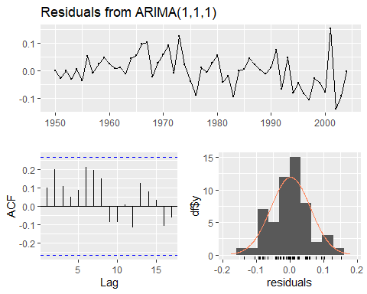
##
## Ljung-Box test
##
## data: Residuals from ARIMA(1,1,1)
## Q* = 12.065, df = 8, p-value = 0.1483
##
## Model df: 2. Total lags used: 10
#Figure 4: Shows the ACF and the residuals plots of the wmurders.
#Figure 4: Figure 4 indicates that there is no evidence of significant autocorrelation, as all autocorrelation coefficients remain within the confidence bounds. The histogram of the residuals shows the distribution of the errors from the time series model. The plot has a shape that is roughly bell-shaped, and the overlaid red curve, which represents a normal distribution, appears to be a good fit. This indicates that the residuals are normally distributed, which is a key assumption for many time series models. The mean of the residuals is centered around zero, which is also a good sign, suggesting that the model isn't systematically over- or under-predicting the values.
#(e)
autoplot(forecast(best_fit, h=20))
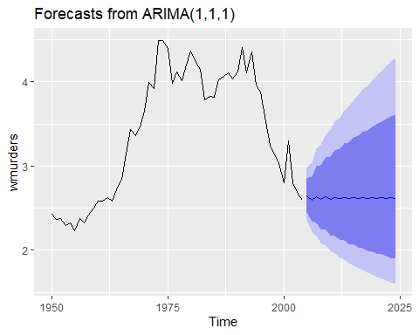
#Figure 5: Forecasts from ARIMA(1,1,1).
#Figure 5: The plot shows the historical data (the black line) from approximately 1950 to 2005, followed by the 20-step ahead forecast (the blue line). The forecast indicates that the number of murders is predicted to stabilize and remain relatively flat over the next 20 years. This is a common outcome for time series models when they don't detect a strong, continuing trend in the recent data.
#The dark blue shaded area represents the 80% prediction interval, while the light blue shaded area shows the 95% prediction interval. These intervals show the range within which the actual future values are expected to fall. The fact that the intervals widen significantly over time reflects the increasing uncertainty of the forecast as it projects further into the future. This is a normal and expected characteristic of forecasting
#QUESTION 2
data("condmilk")
head(condmilk)
## Jan Feb Mar Apr May Jun
## 1971 81.28 69.39 67.63 51.25 103.97 133.83
plot(condmilk, col="blue", xlab="year",ylab="production", main="Monthly Condensed Milk Production")
gamma1 <- BoxCox.lambda(condmilk, lower = 0)
gamma1
## [1] 4.102259e-05
frequency(condmilk)
## [1] 12
Seasonal_df<-diff(condmilk, lag = 12)
Seasonal_df
## Jan Feb Mar Apr May Jun Jul Aug Sep Oct
## 1972 -6.99 -5.41 -6.45 25.23 4.01 -8.86 -16.80 -32.71 -19.17 -12.70
## 1973 -14.11 -8.82 -25.56 -20.30 -22.54 -10.89 -11.93 -73.06 -48.26 -49.43
## 1974 -5.69 2.34 26.54 20.49 24.60 13.30 22.83 100.42 57.96 34.71
## 1975 13.64 4.27 -7.85 -16.37 -25.86 -23.33 -41.81 -62.01 -56.93 -53.14
## 1976 -23.60 -12.19 3.08 16.46 20.39 21.36 28.45 30.80 38.54 60.76
## 1977 21.76 13.91 5.58 -10.33 -3.08 2.28 -9.90 22.37 13.46 2.61
## 1978 -6.55 -10.62 -10.90 -9.05 -22.06 -26.29 -13.02 -24.34 -12.64 -20.48
## 1979 6.22 3.49 -2.50 10.95 10.89 15.66 14.50 -2.71 -6.72 4.94
## 1980 9.32 17.53 26.67 20.25 15.51 -1.22 -6.93 0.08 -9.62 -25.39
## Nov Dec
## 1972 -7.67 -13.88
## 1973 -28.82 -5.52
## 1974 25.73 9.99
## 1975 -37.06 -20.56
## 1976 32.96 12.02
## 1977 4.12 4.53
## 1978 -16.61 -4.88
## 1979 4.06 6.51
## 1980 -12.89 -25.00
plot(Seasonal_df,col="blue", xlab="year",ylab="production", main="Monthly Condensed Milk Production")
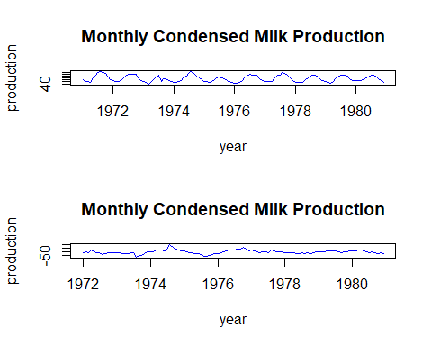
model1 <- auto.arima(condmilk, lambda=gamma1, seasonal=TRUE, stepwise=FALSE, approximation=FALSE)
summary(model1)
## Series: condmilk
## ARIMA(3,0,1)(0,1,1)[12]
## Box Cox transformation: lambda= 4.102259e-05
##
## Coefficients:
## ar1 ar2 ar3 ma1 sma1
## -0.2027 0.5846 0.2401 0.8987 -0.8164
## s.e. 0.1100 0.0975 0.1029 0.0652 0.1262
##
## sigma^2 = 0.01693: log likelihood = 62.29
## AIC=-112.58 AICc=-111.74 BIC=-96.48
##
## Training set error measures:
## ME RMSE MAE MPE MAPE MASE
## Training set -1.541429 10.99722 7.620557 -2.066646 8.584696 0.4038194
## ACF1
## Training set 0.05077901
model2 <- Arima(condmilk, order=c(2,1,2), seasonal=c(0,1,1), lambda=gamma1)
summary(model2)
## Series: condmilk
## ARIMA(2,1,2)(0,1,1)[12]
## Box Cox transformation: lambda= 4.102259e-05
##
## Coefficients:
## ar1 ar2 ma1 ma2 sma1
## -1.5330 -0.7812 1.3940 0.5211 -0.8601
## s.e. 0.1661 0.1605 0.1973 0.2074 0.1523
##
## sigma^2 = 0.01743: log likelihood = 59.67
## AIC=-107.33 AICc=-106.49 BIC=-91.29
##
## Training set error measures:
## ME RMSE MAE MPE MAPE MASE
## Training set -0.607424 11.02529 7.770985 -0.5979548 8.591463 0.4117906
## ACF1
## Training set 0.01145524
model3 <- Arima(condmilk, order=c(1,1,1), seasonal=c(1,1,0), lambda=gamma1)
summary(model3)
## Series: condmilk
## ARIMA(1,1,1)(1,1,0)[12]
## Box Cox transformation: lambda= 4.102259e-05
##
## Coefficients:
## ar1 ma1 sar1
## 0.1231 -0.4095 -0.4941
## s.e. 0.4148 0.3894 0.0842
##
## sigma^2 = 0.02485: log likelihood = 45.65
## AIC=-83.29 AICc=-82.9 BIC=-72.6
##
## Training set error measures:
## ME RMSE MAE MPE MAPE MASE
## Training set -0.7477158 13.44666 8.935372 -1.287205 10.16387 0.4734924
## ACF1
## Training set 0.01129089
model4 <- Arima(condmilk, order=c(1,1,2), seasonal=c(1,1,1), lambda=gamma1)
summary(model4)
## Series: condmilk
## ARIMA(1,1,2)(1,1,1)[12]
## Box Cox transformation: lambda= 4.102259e-05
##
## Coefficients:
## ar1 ma1 ma2 sar1 sma1
## -0.7387 0.5499 -0.3283 -0.0826 -0.7899
## s.e. 0.1139 0.1317 0.0972 0.1380 0.1547
##
## sigma^2 = 0.01847: log likelihood = 57.22
## AIC=-102.43 AICc=-101.59 BIC=-86.4
##
## Training set error measures:
## ME RMSE MAE MPE MAPE MASE
## Training set -0.553223 11.12341 7.873989 -0.6437067 8.888571 0.4172489
## ACF1
## Training set -0.03795875
AIC_values <- c(
fit5 = AIC(model1),
fit6 = AIC(model2),
fit7 = AIC(model3),
fit8 = AIC(model4)
)
print(AIC_values)
## fit5 fit6 fit7 fit8
## -112.57563 -107.33128 -83.29399 -102.43240
best_fit1 <- list(model1, model2, model3,model4)[[ which.min(AIC_values) ]]
best_fit1
## Series: condmilk
## ARIMA(3,0,1)(0,1,1)[12]
## Box Cox transformation: lambda= 4.102259e-05
##
## Coefficients:
## ar1 ar2 ar3 ma1 sma1
## -0.2027 0.5846 0.2401 0.8987 -0.8164
## s.e. 0.1100 0.0975 0.1029 0.0652 0.1262
##
## sigma^2 = 0.01693: log likelihood = 62.29
## AIC=-112.58 AICc=-111.74 BIC=-96.48
checkresiduals(best_fit1)
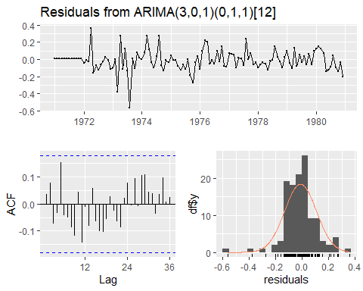
##
## Ljung-Box test
##
## data: Residuals from ARIMA(3,0,1)(0,1,1)[12]
## Q* = 19.492, df = 19, p-value = 0.4257
##
## Model df: 5. Total lags used: 24
fc_cm <- forecast(best_fit1, h=24)
fc_cm
## Point Forecast Lo 80 Hi 80 Lo 95 Hi 95
## Jan 1981 49.39289 41.78210 58.38995 38.24007 63.79829
## Feb 1981 49.64020 40.48945 60.85896 36.34937 67.79045
## Mar 1981 47.53666 38.27074 59.04587 34.12089 66.22698
## Apr 1981 60.23942 47.57887 76.26871 41.99244 86.41478
## May 1981 83.94805 65.92533 106.89757 58.00833 121.48661
## Jun 1981 106.20841 82.76584 136.29049 72.52972 155.52463
## Jul 1981 122.09631 94.83773 157.18924 82.96553 179.68207
## Aug 1981 123.36590 95.51872 159.33111 83.42030 182.43820
## Sep 1981 121.90383 94.21987 157.72155 82.20894 180.76440
## Oct 1981 107.04123 82.61704 138.68559 72.03194 159.06487
## Nov 1981 83.68255 64.53045 108.51854 56.23599 124.52389
## Dec 1981 66.83795 51.50926 86.72807 44.87385 99.55202
## Jan 1982 59.58440 45.73072 77.63469 39.75302 89.30835
## Feb 1982 56.85161 43.53337 74.24410 37.79699 85.51166
## Mar 1982 54.86766 41.96574 71.73593 36.41367 82.67333
## Apr 1982 66.26081 50.61319 86.74581 43.88649 100.04138
## May 1982 92.50871 70.62293 121.17644 61.21866 139.79075
## Jun 1982 113.96090 86.94865 149.36458 75.34688 172.36276
## Jul 1982 130.34361 99.41806 170.88852 86.13866 197.23241
## Aug 1982 129.85390 99.01938 170.28973 85.78170 196.56775
## Sep 1982 127.48173 97.19574 167.20427 84.19509 193.02167
## Oct 1982 111.03058 84.64517 145.64036 73.31970 168.13629
## Nov 1982 86.32141 65.80394 113.23584 56.99759 130.73069
## Dec 1982 68.58774 52.28510 89.97331 45.28784 103.87435
plot(fc_cm,main="24-Month Forecast - Condensed Milk Production",
ylab="Production", xlab="Year", height=600)
## Warning in plot.window(xlim, ylim, log, ...): "height" is not a graphical
## parameter
## Warning in title(main = main, xlab = xlab, ylab = ylab, ...): "height" is not a
## graphical parameter
## Warning in axis(1, ...): "height" is not a graphical parameter
## Warning in axis(2, ...): "height" is not a graphical parameter
## Warning in box(...): "height" is not a graphical parameter
#Box.test(best_fit1, lag = 12, type = "Ljung")
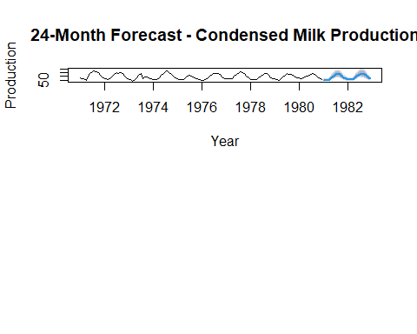
fc_cm <- forecast(best_fit1, h=24)
fc_cm
## Point Forecast Lo 80 Hi 80 Lo 95 Hi 95
## Jan 1981 49.39289 41.78210 58.38995 38.24007 63.79829
## Feb 1981 49.64020 40.48945 60.85896 36.34937 67.79045
## Mar 1981 47.53666 38.27074 59.04587 34.12089 66.22698
## Apr 1981 60.23942 47.57887 76.26871 41.99244 86.41478
## May 1981 83.94805 65.92533 106.89757 58.00833 121.48661
## Jun 1981 106.20841 82.76584 136.29049 72.52972 155.52463
## Jul 1981 122.09631 94.83773 157.18924 82.96553 179.68207
## Aug 1981 123.36590 95.51872 159.33111 83.42030 182.43820
## Sep 1981 121.90383 94.21987 157.72155 82.20894 180.76440
## Oct 1981 107.04123 82.61704 138.68559 72.03194 159.06487
## Nov 1981 83.68255 64.53045 108.51854 56.23599 124.52389
## Dec 1981 66.83795 51.50926 86.72807 44.87385 99.55202
## Jan 1982 59.58440 45.73072 77.63469 39.75302 89.30835
## Feb 1982 56.85161 43.53337 74.24410 37.79699 85.51166
## Mar 1982 54.86766 41.96574 71.73593 36.41367 82.67333
## Apr 1982 66.26081 50.61319 86.74581 43.88649 100.04138
## May 1982 92.50871 70.62293 121.17644 61.21866 139.79075
## Jun 1982 113.96090 86.94865 149.36458 75.34688 172.36276
## Jul 1982 130.34361 99.41806 170.88852 86.13866 197.23241
## Aug 1982 129.85390 99.01938 170.28973 85.78170 196.56775
## Sep 1982 127.48173 97.19574 167.20427 84.19509 193.02167
## Oct 1982 111.03058 84.64517 145.64036 73.31970 168.13629
## Nov 1982 86.32141 65.80394 113.23584 56.99759 130.73069
## Dec 1982 68.58774 52.28510 89.97331 45.28784 103.87435
plot(fc_cm,
main = "24-Month Forecast - Condensed Milk Production",
ylab = "Production", xlab = "Year")
