

PARIS PANTHE´ON-ASSAS UNIVERSITE´ AKADEMIA GO´RNICZO-HUTNICZA

Networks Protocols

Basics of Ethernet and IP

## NGAKOU TATSING FRANCK WILFRIED

## 4 mars 2024

Teacher L- ukasz Czekierda

1

**Contents**

1. Basic network-related Windows OS commands 3
2. Wireshark 3
3. A simple network – Packet Tracer simulation 4

# Basic network-related Windows OS commands

### Run ipconfig and ipconfig /all commands.

* + - **ipconfig** displays the IP address, subnet mask, and default gateway for each adapter.
    - **ipconfig /all** displays all configuration information, including DNS address, WINS node type, etc.

### What is the equivalent of this command in Linux systems ?

* + - The equivalent is often **ifconfig** or **ip a**.

### Ping (ping command) your colleague’s PC. Did the ping succeed ?

* + - Yes and It depends on network connectivity.

### Run arp -a command. What information can be found ?

* + - The **arp a** command displays the ARP table which associates IP addresses with MAC addresses.
  1. Ping 8.8.8.8 and re-run the **arp -a** command.
     + Pinger 8.8.8.8 checks Internet connectivity and the **arp -a** command will show if a new entry has been added for this address.

# Wireshark

The following fields are typically presented by Wireshark when analysing an Ethernet frame :

* 1. **Destination MAC address :** The physical address of the recipient of the frame.
  2. **Source MAC address :** The physical address of the sender of the frame.
  3. **Type/Length :** Indicates either the protocol type of the payload (e.g. IPv4, IPv6, ARP, etc.) or the length of the payload if less than 1500 bytes.
  4. **Payload/Data :** The data carried by the frame, which may include other headers for various network protocols such as IP, TCP, UDP, etc.
  5. **Frame Check Sequence (FCS) :** An error checking sequence. This is not usually displayed by Wireshark as it is used and checked by network hardware (such as network cards or switches).

Fields that are not presented by Wireshark or may not be visible in the user interface include :

1. **Preamble :** A sequence of bits used to synchronise the reception of frames between the sender and receiver. It is not usually displayed as it is processed in hardware.
2. **Start of Frame Delimiter (SFD) :** An octet which marks the end of the preamble and the beginning of the Ethernet header. Like the preamble, it is processed in hard- ware and is not displayed.
3. **Interframe Gap (IFG) :** A mandatory waiting time between frames to reduce the possibility of collision in half-duplex networks. It is not shown in the captures because it is a time gap rather than part of the frame itself.
4. **Ethernet Padding :** Data added to ensure that the frame reaches the minimum size required if the payload data is too short. Wireshark usually shows the payload size, but the padding itself may not be visible or differentiated as such.

Wireshark processes and displays information in a way that aids network analysis and de- bugging, so some low-level information that is handled by network hardware is not displayed or is integrated into the presentation of captured data.

### 8. Run a ping command (e.g., ping 9.9.9.9) and find frames related to this activity. How many frames is it ? Why ?

— When we run ping 9.9.9.9, Wireshark will capture a series of ICMP (Internet Control Message Protocol) frames for each ping request sent and each response re- ceived. If the destination is accessible, we will see a request frame and a response frame for each ping.

# A simple network – Packet Tracer simulation

### 3. How many collision domains are in the network ? How many broadcast do- mains are in the network ?

We have 3 collision domains resulting in the connection of each device to the switch.

As for the broadcast domains, there is one per VLAN. As all the ports displayed are in VLAN 1, there is a single broadcast domain for all these ports. If different VLANs were configured and used, each VLAN would represent a separate broadcast domain.

### 10. Connect two PCs to a new switch. Address the PCs using appropriate ad- dresses. Verify connectivity.How many collision and broadcast domains are now in the network ?

We have 6 collision domains resulting in the connection of each device to the switch. As for the broadcast domains, there is one per VLAN (VLAN 1).

### Verify connectivity between any pair of devices using ping command. Ping command is also present on a router. Did all pings succeed ?Why ?

Yes, it works, except in certain situations :

* + For the router, you can ping the other devices on the 2 networks because it is connected

to both networks,

* + The PCSs on the side of network 1 (all connections established before the router was added) cannot communicate with network 2 (the final state of our network after the router was added) because they cannot communicate with network 2 using the router that makes the connection, otherwise they cannot.

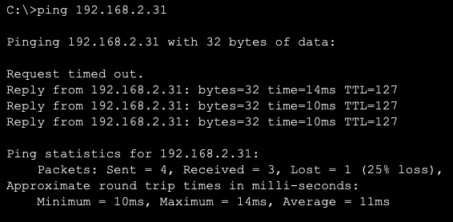

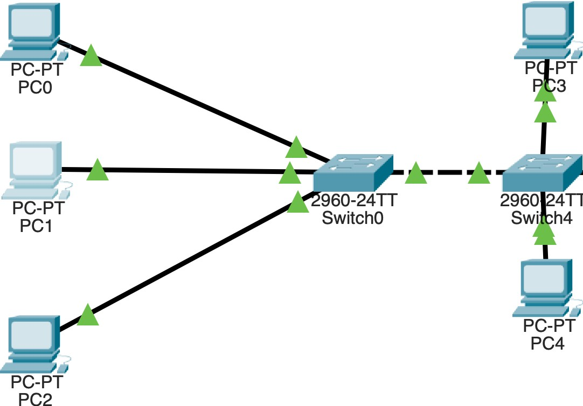Figure 3.1 – Ping on terminal

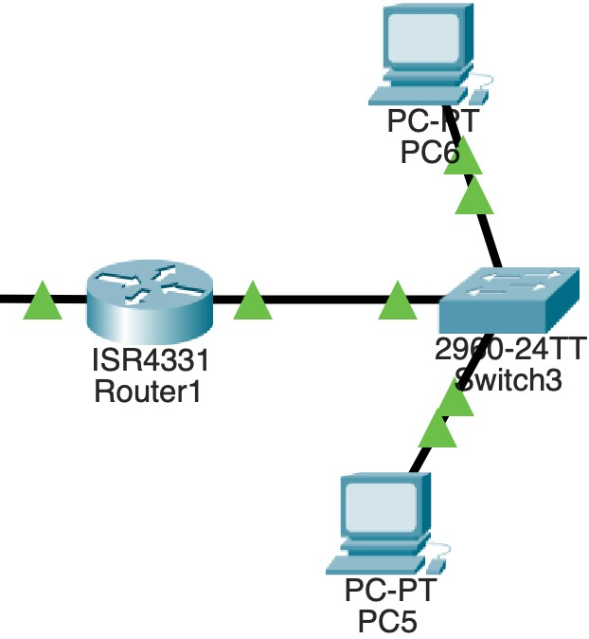Figure 3.2 – Network 1

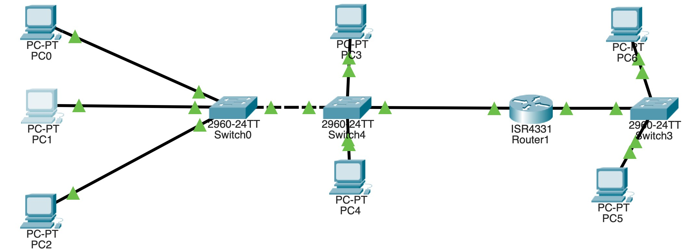Figure 3.3 – Network 2

Figure 3.4 – Assembly