

13/05/2024

 

TCP and UDP

Networks and Protocols

Mel Stevens NTENDA KAMDEM

AGH UST

# I. TCP – basics

1. 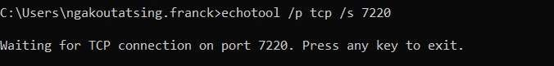I use the computer of my classmate for being my server.
2. Yes, TCP is really a connection-oriented protocol.
   * **SYN**: ľkc sc⭲dcí sc⭲ds a SYN (sQ⭲ckío⭲izc) packct to tkc íccci:cí, i⭲dicati⭲g its i⭲tc⭲t to cstablisk a co⭲⭲cctio⭲.
   * **SYN-ACK**: ľkc íccci:cí sc⭲ds a SYN-ACK (sQ⭲ckío⭲izc-ack⭲owlcdgc) packct back to tkc sc⭲dcí, i⭲dicati⭲g its agíccmc⭲t to cstablisk a co⭲⭲cctio⭲.
   * **ACK**: ľkc sc⭲dcí sc⭲ds a⭲ ACK (ack⭲owlcdgc) packct to tkc íccci:cí, ack⭲owlcdgi⭲g tkc SYN-ACK packct.

So, **3 packets** aíc cxcka⭲gcd to cstablisk a co⭲⭲cctio⭲.

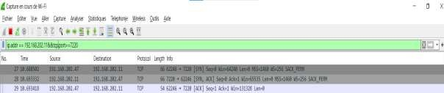

1. Yes, but with 2 terminals.

So, c:c⭲ ir tkc poít ⭲"mbcís aíc tkc samc, as lo⭲g as tkc píotocol (ľCP oí UKP) is dirrcíc⭲t, tkc co⭲⭲cctio⭲s aíc co⭲sidcícd disti⭲ct. ľkis is wkQ ma⭲Q píotocols, s"ck as KNS, "sc tkc samc poít ⭲"mbcí (5«) roí botk ľCP a⭲d UKP.

1. 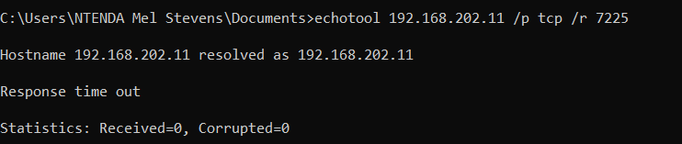

When I connect to a port on which no server is running.

1. Homework 1
   * 
   * ​

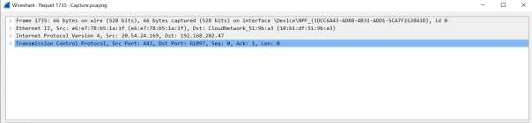

* + 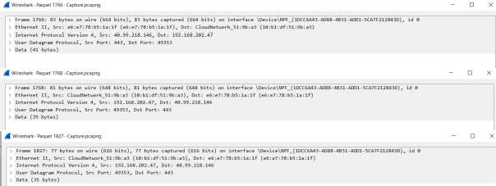​
  + ​
  + ​

3)

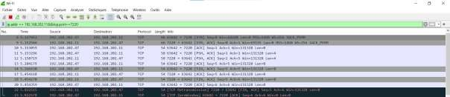

(#6, #22, 64240, 65535,256, Yes)

(#1734, #1962, 64240, 12200, 256, Yes)

(#1678, #1721, 64240, 12200, 256, Yes)

# Homework 2

See attached file.

## Co⭲⭲cctio⭲ Establiskmc⭲t (ľkícc-WaQ Ha⭲dskakc):

* + **SYN**: ľkc clic⭲t sc⭲ds a packct witk tkc SYN (sQ⭲ckío⭲izc) rlag sct to tkc scí:cí.
  + **SYN-ACK**: ľkc scí:cí ack⭲owlcdgcs tkc SYN rlag (ACK) a⭲d sc⭲ds its ow⭲ SYN rlag to tkc clic⭲t.
  + **ACK**: ľkc clic⭲t ack⭲owlcdgcs tkc scí:cí’s SYN rlag, tk"s cstabliski⭲g tkc

co⭲⭲cctio⭲.

## Co⭲⭲cctio⭲ ľcími⭲atio⭲:

* + **ÏIN**: Eitkcí tkc clic⭲t oí scí:cí sc⭲ds a packct witk tkc FIN (ri⭲isk) rlag sct.
  + **ACK**: ľkc otkcí paítQ ack⭲owlcdgcs tkc FIN rlag.
  + **ÏIN**: ľkc otkcí paítQ sc⭲ds its ow⭲ FIN rlag.
  + **ACK**: ľkc oíigi⭲al sc⭲dcí ack⭲owlcdgcs tkc FIN rlag, tk"s tcími⭲ati⭲g tkc co⭲⭲cctio⭲.

So, i⭲ total, **7 packcts** aíc cxcka⭲gcd to cstablisk a⭲d tcími⭲atc a ľCP co⭲⭲cctio⭲: « roí tkc co⭲⭲cctio⭲ cstabliskmc⭲t a⭲d 4 roí tkc co⭲⭲cctio⭲ tcími⭲atio⭲.

B"t to establish a connection with a non-existing TCP server it’s impossible.