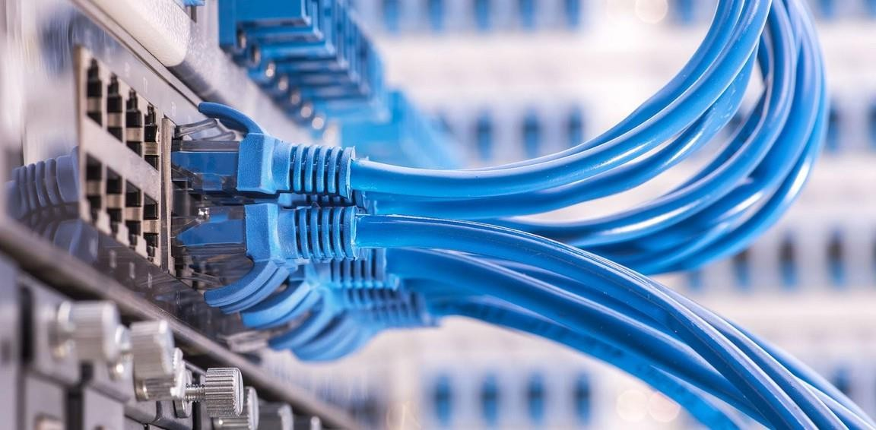

NETWORKS & PROTOCOLS

BY:

NGAKOU TATSING FRANCK WILFRIED

**10 / 05/ 2024**

**TCP and UDP**

***Łukasz Czekierda (***[***luke@agh.edu.pl***](mailto:luke@agh.edu.pl)***)***

# TCP - Basics

1. I utilize my classmate's computer as my server.

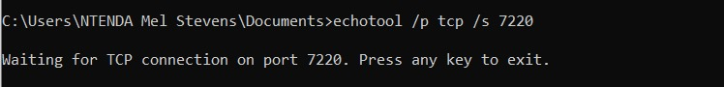

1. Indeed, TCP is undeniably a protocol focused on establishing connections.
   * SYN: The sender initiates the connection by sending a SYN (synchronize) packet to the receiver, signifying its intention to establish communication.
   * SYN-ACK: The receiver responds with a SYN-ACK (synchronize-acknowledge) packet, acknowledging the request and agreeing to establish the connection.
   * ACK: Finally, the sender acknowledges the SYN-ACK packet by sending an ACK (acknowledge) packet to the receiver, confirming the establishment of the connection.

**7 packets** are exchanged to establish a connection and terminate the connection

1. Yes, even when the port numbers match, if the protocols (TCP or UDP) differ, the connections are treated as separate. Therefore, several protocols, like DNS, allocate the same port number (53) for both TCP and UDP
2. When attempting to connect to a server that isn't running

# Homework 1

(#66, #89, #64240,65535,256, yes)

(#255, #621, #64240,65535,256, yes)

(#59, #67, #64240,65535,256, yes)

# Step 3. Single-area OSPF

Please refer to the attached file for detailed information.

1. Connection Establishment (Three-Way Handshake):

- SYN: The client initiates the connection by sending a packet with the SYN (synchronize) flag to the server.

- SYN-ACK: Upon receiving the SYN packet, the server acknowledges it (ACK) and sends its own SYN packet to the client.

- ACK: The client acknowledges the server's SYN packet, establishing the connection.

2. Connection Termination:

- FIN: Either the client or server sends a packet with the FIN (finish) flag.

- ACK: The receiving party acknowledges the FIN flag.

- FIN: The other party sends its own FIN flag.

- ACK: The original sender acknowledges the FIN flag, thereby terminating the connection.

In total, 7 packets are exchanged for both establishing and terminating a TCP connection: 3 for establishment and 4 for termination. However, establishing a connection with a non-existing TCP server is impossible.