**R/C MERT 2015 BLS Protocol Update Training**

1. Click on this link: <https://meetny.webex.com/meetny/lsr.php?RCID=1969029e585943c9869b00e4b18d4ea7>
2. Fill-in your information and hit ‘Register’
3. A new window will open to play the recorded session, watch the video in its entirety.
4. When you are done watching the video, close the video window by clicking the ‘x’ in the upper right corner of the window. This will open a new window, ‘Session Information: NYS 2015 BLS Protocol Update’
5. Click on ‘Register’ and fill-in your information
6. Click on ‘Register’ and a new page will open
7. Click on ‘Ok’. This will send you two emails with a registration ID and password for a test. In either email, use the link after ‘Go to’.
8. This will bring you to the session information page. At the bottom of the page, press ‘Take Test’ button.
9. Once you complete the test with a score of 80% or higher (passing score), either print the page that comes up that states you passed and put it in the training box, or take a screenshot and email it to training. The printed page or screen-shot will look like this:

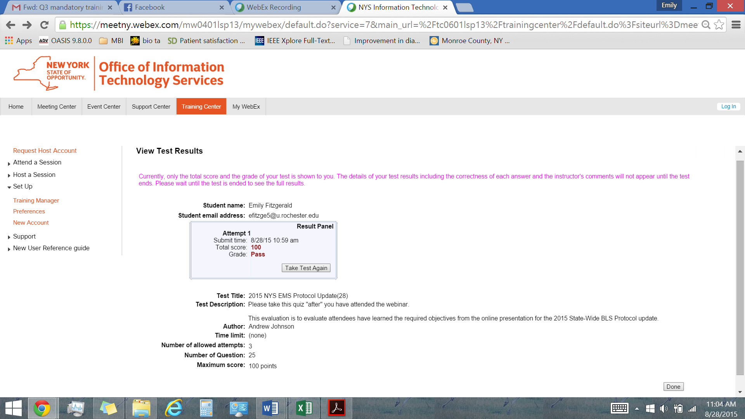

*LAST STEP = ATTEND PRACTICAL ON OCTOBER 18th DIRECTLY FOLLOWING GMM*