Course Proj Phase 1
2026-02-24
## Data Import and Overview
``` r
data <- read.csv("train.csv")
glimpse(data)
## Rows: 26,570
## Columns: 26
## $ id <int> 0, 1, 2, 3, 4, 5, 6, 7, 8, 9, 10, 11, 12, 13, 14, 15, 1…
## $ product_code <chr> "A", "A", "A", "A", "A", "A", "A", "A", "A", "A", "A", …
## $ loading <dbl> 80.10, 84.89, 82.43, 101.07, 188.06, 75.35, 161.71, 177…
## $ attribute_0 <chr> "material_7", "material_7", "material_7", "material_7",…
## $ attribute_1 <chr> "material_8", "material_8", "material_8", "material_8",…
## $ attribute_2 <int> 9, 9, 9, 9, 9, 9, 9, 9, 9, 9, 9, 9, 9, 9, 9, 9, 9, 9, 9…
## $ attribute_3 <int> 5, 5, 5, 5, 5, 5, 5, 5, 5, 5, 5, 5, 5, 5, 5, 5, 5, 5, 5…
## $ measurement_0 <int> 7, 14, 12, 13, 9, 11, 12, 4, 9, 10, 10, 7, 9, 6, 10, 8,…
## $ measurement_1 <int> 8, 3, 1, 2, 2, 4, 2, 8, 6, 4, 3, 3, 0, 9, 4, 5, 5, 6, 6…
## $ measurement_2 <int> 4, 3, 5, 6, 8, 0, 4, 8, 5, 7, 6, 2, 6, 10, 10, 9, 6, 3,…
## $ measurement_3 <dbl> 18.040, 18.213, 18.057, 17.295, 19.346, 17.564, 17.303,…
## $ measurement_4 <dbl> 12.518, 11.540, 11.652, 11.188, 12.950, 13.721, 12.643,…
## $ measurement_5 <dbl> 15.748, 17.717, 16.738, 18.576, 16.990, 16.594, 17.476,…
## $ measurement_6 <dbl> 19.292, 17.893, 18.240, 18.339, 15.746, NA, 17.679, 15.…
## $ measurement_7 <dbl> 11.739, 12.748, 12.718, 12.583, 11.306, 11.592, 12.957,…
## $ measurement_8 <dbl> 20.155, 17.889, 18.288, 19.060, 18.093, 20.810, 17.916,…
## $ measurement_9 <dbl> 10.672, 12.448, 12.715, 12.471, 10.337, 10.622, 11.370,…
## $ measurement_10 <dbl> 15.859, 17.947, 15.607, 16.346, 17.082, 14.904, 17.714,…
## $ measurement_11 <dbl> 17.594, 17.915, NA, 18.377, 19.932, 19.107, 19.924, 20.…
## $ measurement_12 <dbl> 15.193, 11.755, 13.798, 10.020, 12.428, 13.327, 11.560,…
## $ measurement_13 <dbl> 15.029, 14.732, 16.711, 15.250, 16.182, 15.354, 16.653,…
## $ measurement_14 <dbl> NA, 15.425, 18.631, 15.562, 12.760, 19.251, 17.734, 16.…
## $ measurement_15 <dbl> 13.034, 14.395, 14.094, 16.154, 13.153, NA, NA, 15.176,…
## $ measurement_16 <dbl> 14.684, 15.631, 17.946, 17.172, 16.412, 17.625, 16.637,…
## $ measurement_17 <dbl> 764.100, 682.057, 663.376, 826.282, 579.885, 832.902, 6…
## $ failure <chr> "No", "No", "No", "No", "No", "No", "Yes", "Yes", "No",…
summary(data)
## id product_code loading attribute_0
## Min. : 0 Length:26570 Min. : 33.16 Length:26570
## 1st Qu.: 6642 Class :character 1st Qu.: 99.99 Class :character
## Median :13284 Mode :character Median :122.39 Mode :character
## Mean :13284 Mean :127.83
## 3rd Qu.:19927 3rd Qu.:149.15
## Max. :26569 Max. :385.86
## NA's :250
## attribute_1 attribute_2 attribute_3 measurement_0
## Length:26570 Min. :5.000 Min. :5.00 Min. : 0.000
## Class :character 1st Qu.:6.000 1st Qu.:6.00 1st Qu.: 4.000
## Mode :character Median :6.000 Median :8.00 Median : 7.000
## Mean :6.754 Mean :7.24 Mean : 7.416
## 3rd Qu.:8.000 3rd Qu.:8.00 3rd Qu.:10.000
## Max. :9.000 Max. :9.00 Max. :29.000
##
## measurement_1 measurement_2 measurement_3 measurement_4
## Min. : 0.000 Min. : 0.000 Min. :13.97 Min. : 8.008
## 1st Qu.: 5.000 1st Qu.: 4.000 1st Qu.:17.12 1st Qu.:11.051
## Median : 8.000 Median : 6.000 Median :17.79 Median :11.733
## Mean : 8.233 Mean : 6.257 Mean :17.79 Mean :11.732
## 3rd Qu.:11.000 3rd Qu.: 8.000 3rd Qu.:18.47 3rd Qu.:12.410
## Max. :29.000 Max. :24.000 Max. :21.50 Max. :16.484
## NA's :381 NA's :538
## measurement_5 measurement_6 measurement_7 measurement_8
## Min. :12.07 Min. :12.71 Min. : 7.968 Min. :15.22
## 1st Qu.:16.44 1st Qu.:16.84 1st Qu.:11.045 1st Qu.:18.34
## Median :17.13 Median :17.52 Median :11.712 Median :19.02
## Mean :17.13 Mean :17.51 Mean :11.717 Mean :19.02
## 3rd Qu.:17.80 3rd Qu.:18.18 3rd Qu.:12.391 3rd Qu.:19.71
## Max. :21.43 Max. :21.54 Max. :15.419 Max. :23.81
## NA's :676 NA's :796 NA's :937 NA's :1048
## measurement_9 measurement_10 measurement_11 measurement_12
## Min. : 7.537 Min. : 9.323 Min. :12.46 Min. : 5.167
## 1st Qu.:10.757 1st Qu.:15.209 1st Qu.:18.17 1st Qu.:10.703
## Median :11.430 Median :16.127 Median :19.21 Median :11.717
## Mean :11.431 Mean :16.118 Mean :19.17 Mean :11.702
## 3rd Qu.:12.102 3rd Qu.:17.025 3rd Qu.:20.21 3rd Qu.:12.709
## Max. :15.412 Max. :22.479 Max. :25.64 Max. :17.663
## NA's :1227 NA's :1300 NA's :1468 NA's :1601
## measurement_13 measurement_14 measurement_15 measurement_16
## Min. :10.89 Min. : 9.14 Min. : 9.104 Min. : 9.701
## 1st Qu.:14.89 1st Qu.:15.06 1st Qu.:13.957 1st Qu.:15.268
## Median :15.63 Median :16.04 Median :14.969 Median :16.436
## Mean :15.65 Mean :16.05 Mean :14.996 Mean :16.461
## 3rd Qu.:16.37 3rd Qu.:17.08 3rd Qu.:16.018 3rd Qu.:17.628
## Max. :22.71 Max. :22.30 Max. :21.626 Max. :24.094
## NA's :1774 NA's :1874 NA's :2009 NA's :2110
## measurement_17 failure
## Min. : 196.8 Length:26570
## 1st Qu.: 619.0 Class :character
## Median : 701.0 Mode :character
## Mean : 701.3
## 3rd Qu.: 784.1
## Max. :1312.8
## NA's :2284

Failure Rates and Missing Values
data |>
count(failure) |>
mutate(percent = n / sum(n))
## failure n percent
## 1 No 20921 0.7873918
## 2 Yes 5649 0.2126082
data |>
summarise(across(everything(), ~ sum(is.na(.))))
## id product_code loading attribute_0 attribute_1 attribute_2 attribute_3
## 1 0 0 250 0 0 0 0
## measurement_0 measurement_1 measurement_2 measurement_3 measurement_4
## 1 0 0 0 381 538
## measurement_5 measurement_6 measurement_7 measurement_8 measurement_9
## 1 676 796 937 1048 1227
## measurement_10 measurement_11 measurement_12 measurement_13 measurement_14
## 1 1300 1468 1601 1774 1874
## measurement_15 measurement_16 measurement_17 failure
## 1 2009 2110 2284 0

Attribute-Based Failure Analysis
data |>
select(starts_with("attribute")) |>
summarise(across(everything(), n_distinct))
## attribute_0 attribute_1 attribute_2 attribute_3
## 1 2 3 4 4
data |>
count(attribute_0, failure) |>
group_by(attribute_0) |>
mutate(failure_rate = n / sum(n)) |>
filter(failure == "Yes")
## # A tibble: 2 × 4
## # Groups: attribute_0 [2]
## attribute_0 failure n failure_rate
## <chr> <chr> <int> <dbl>
## 1 material_5 Yes 1052 0.200
## 2 material_7 Yes 4597 0.216
ggplot(data, aes(x = attribute_0, fill = failure)) +
geom_bar(position = "fill") +
labs(
title = "Failure Rate by Attribute 0",
y = "Proportion",
fill = "Failure"
)
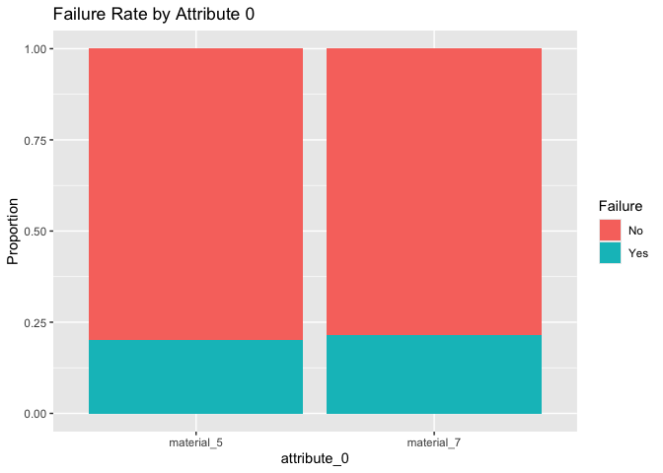

Numeric Attributes and Failure
data |>
group_by(failure) |>
summarise(
median_attr2 = median(attribute_2, na.rm = TRUE)
)
## # A tibble: 2 × 2
## failure median_attr2
## <chr> <int>
## 1 No 6
## 2 Yes 6
ggplot(data, aes(x = failure, y = attribute_2)) +
geom_boxplot() +
labs(title = "Attribute 2 by Failure Outcome")
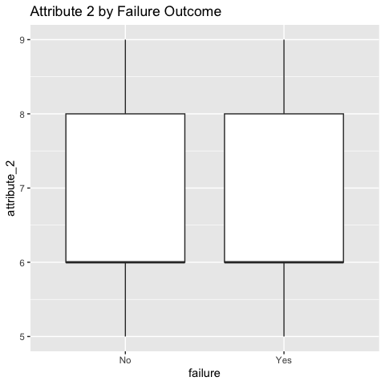

Correlation Analysis
data |>
select(where(is.numeric)) |>
cor(use = "complete.obs") |>
round(2)
## id loading attribute_2 attribute_3 measurement_0
## id 1.00 0.00 -0.74 0.56 -0.26
## loading 0.00 1.00 0.00 -0.01 -0.01
## attribute_2 -0.74 0.00 1.00 -0.54 0.18
## attribute_3 0.56 -0.01 -0.54 1.00 -0.37
## measurement_0 -0.26 -0.01 0.18 -0.37 1.00
## measurement_1 0.41 0.00 -0.39 0.33 -0.26
## measurement_2 0.00 -0.01 0.02 0.02 -0.09
## measurement_3 0.00 -0.01 0.00 0.00 0.00
## measurement_4 0.01 -0.02 -0.01 0.01 -0.02
## measurement_5 -0.01 0.02 0.01 0.00 0.01
## measurement_6 0.01 0.01 0.00 0.00 0.00
## measurement_7 -0.01 -0.01 0.00 -0.01 0.01
## measurement_8 0.01 0.00 -0.01 0.00 0.00
## measurement_9 0.00 -0.01 0.00 -0.02 0.01
## measurement_10 -0.03 0.00 0.00 -0.09 0.02
## measurement_11 0.01 0.00 0.10 -0.02 0.00
## measurement_12 -0.15 0.00 0.23 -0.13 0.02
## measurement_13 -0.04 0.00 0.06 0.02 -0.02
## measurement_14 -0.06 0.01 0.02 -0.06 0.03
## measurement_15 0.08 -0.01 -0.16 0.19 -0.06
## measurement_16 -0.06 -0.02 0.03 -0.06 0.01
## measurement_17 0.00 0.01 0.00 0.00 0.00
## measurement_1 measurement_2 measurement_3 measurement_4
## id 0.41 0.00 0.00 0.01
## loading 0.00 -0.01 -0.01 -0.02
## attribute_2 -0.39 0.02 0.00 -0.01
## attribute_3 0.33 0.02 0.00 0.01
## measurement_0 -0.26 -0.09 0.00 -0.02
## measurement_1 1.00 0.01 -0.01 0.01
## measurement_2 0.01 1.00 0.00 -0.01
## measurement_3 -0.01 0.00 1.00 0.02
## measurement_4 0.01 -0.01 0.02 1.00
## measurement_5 -0.01 0.01 0.00 0.01
## measurement_6 0.00 0.00 0.01 -0.01
## measurement_7 -0.02 0.00 0.01 0.00
## measurement_8 0.01 -0.01 0.00 0.00
## measurement_9 0.00 0.01 0.02 0.01
## measurement_10 0.02 0.02 -0.01 -0.01
## measurement_11 -0.04 0.00 -0.01 -0.01
## measurement_12 -0.08 0.01 -0.01 0.00
## measurement_13 0.00 0.03 0.01 0.01
## measurement_14 -0.02 0.02 -0.01 0.01
## measurement_15 0.07 0.00 -0.02 0.00
## measurement_16 -0.01 0.04 0.00 0.01
## measurement_17 -0.01 0.00 0.09 0.19
## measurement_5 measurement_6 measurement_7 measurement_8
## id -0.01 0.01 -0.01 0.01
## loading 0.02 0.01 -0.01 0.00
## attribute_2 0.01 0.00 0.00 -0.01
## attribute_3 0.00 0.00 -0.01 0.00
## measurement_0 0.01 0.00 0.01 0.00
## measurement_1 -0.01 0.00 -0.02 0.01
## measurement_2 0.01 0.00 0.00 -0.01
## measurement_3 0.00 0.01 0.01 0.00
## measurement_4 0.01 -0.01 0.00 0.00
## measurement_5 1.00 0.01 0.00 -0.01
## measurement_6 0.01 1.00 0.01 0.01
## measurement_7 0.00 0.01 1.00 0.01
## measurement_8 -0.01 0.01 0.01 1.00
## measurement_9 -0.01 0.01 0.00 0.00
## measurement_10 0.01 -0.01 -0.01 0.02
## measurement_11 0.00 -0.01 -0.01 -0.02
## measurement_12 0.00 -0.02 -0.01 0.00
## measurement_13 -0.01 -0.01 0.00 -0.01
## measurement_14 0.01 0.00 0.01 0.00
## measurement_15 -0.01 0.00 -0.01 0.02
## measurement_16 -0.01 -0.01 -0.01 0.01
## measurement_17 0.45 0.32 0.33 0.49
## measurement_9 measurement_10 measurement_11 measurement_12
## id 0.00 -0.03 0.01 -0.15
## loading -0.01 0.00 0.00 0.00
## attribute_2 0.00 0.00 0.10 0.23
## attribute_3 -0.02 -0.09 -0.02 -0.13
## measurement_0 0.01 0.02 0.00 0.02
## measurement_1 0.00 0.02 -0.04 -0.08
## measurement_2 0.01 0.02 0.00 0.01
## measurement_3 0.02 -0.01 -0.01 -0.01
## measurement_4 0.01 -0.01 -0.01 0.00
## measurement_5 -0.01 0.01 0.00 0.00
## measurement_6 0.01 -0.01 -0.01 -0.02
## measurement_7 0.00 -0.01 -0.01 -0.01
## measurement_8 0.00 0.02 -0.02 0.00
## measurement_9 1.00 -0.01 0.00 0.00
## measurement_10 -0.01 1.00 -0.03 0.02
## measurement_11 0.00 -0.03 1.00 0.10
## measurement_12 0.00 0.02 0.10 1.00
## measurement_13 -0.01 0.03 -0.10 0.01
## measurement_14 -0.01 0.04 -0.09 -0.03
## measurement_15 0.00 -0.05 -0.03 -0.15
## measurement_16 -0.01 0.00 0.09 0.10
## measurement_17 0.14 0.01 -0.02 -0.01
## measurement_13 measurement_14 measurement_15 measurement_16
## id -0.04 -0.06 0.08 -0.06
## loading 0.00 0.01 -0.01 -0.02
## attribute_2 0.06 0.02 -0.16 0.03
## attribute_3 0.02 -0.06 0.19 -0.06
## measurement_0 -0.02 0.03 -0.06 0.01
## measurement_1 0.00 -0.02 0.07 -0.01
## measurement_2 0.03 0.02 0.00 0.04
## measurement_3 0.01 -0.01 -0.02 0.00
## measurement_4 0.01 0.01 0.00 0.01
## measurement_5 -0.01 0.01 -0.01 -0.01
## measurement_6 -0.01 0.00 0.00 -0.01
## measurement_7 0.00 0.01 -0.01 -0.01
## measurement_8 -0.01 0.00 0.02 0.01
## measurement_9 -0.01 -0.01 0.00 -0.01
## measurement_10 0.03 0.04 -0.05 0.00
## measurement_11 -0.10 -0.09 -0.03 0.09
## measurement_12 0.01 -0.03 -0.15 0.10
## measurement_13 1.00 0.00 0.03 0.14
## measurement_14 0.00 1.00 0.01 -0.09
## measurement_15 0.03 0.01 1.00 0.02
## measurement_16 0.14 -0.09 0.02 1.00
## measurement_17 -0.01 0.01 0.00 0.00
## measurement_17
## id 0.00
## loading 0.01
## attribute_2 0.00
## attribute_3 0.00
## measurement_0 0.00
## measurement_1 -0.01
## measurement_2 0.00
## measurement_3 0.09
## measurement_4 0.19
## measurement_5 0.45
## measurement_6 0.32
## measurement_7 0.33
## measurement_8 0.49
## measurement_9 0.14
## measurement_10 0.01
## measurement_11 -0.02
## measurement_12 -0.01
## measurement_13 -0.01
## measurement_14 0.01
## measurement_15 0.00
## measurement_16 0.00
## measurement_17 1.00
data |>
select(attribute_2, attribute_3, starts_with("measurement")) |>
cor(use = "complete.obs") |>
round(2)
## attribute_2 attribute_3 measurement_0 measurement_1
## attribute_2 1.00 -0.54 0.19 -0.39
## attribute_3 -0.54 1.00 -0.37 0.33
## measurement_0 0.19 -0.37 1.00 -0.26
## measurement_1 -0.39 0.33 -0.26 1.00
## measurement_2 0.02 0.02 -0.09 0.01
## measurement_3 0.00 0.00 0.00 -0.01
## measurement_4 -0.01 0.01 -0.02 0.01
## measurement_5 0.01 0.00 0.01 -0.01
## measurement_6 0.00 0.00 0.00 0.00
## measurement_7 0.00 -0.01 0.01 -0.02
## measurement_8 -0.01 0.00 0.00 0.01
## measurement_9 0.00 -0.02 0.01 0.00
## measurement_10 0.00 -0.09 0.02 0.02
## measurement_11 0.10 -0.02 0.00 -0.05
## measurement_12 0.23 -0.13 0.02 -0.08
## measurement_13 0.06 0.02 -0.02 0.00
## measurement_14 0.02 -0.06 0.03 -0.02
## measurement_15 -0.16 0.19 -0.06 0.07
## measurement_16 0.03 -0.06 0.01 -0.01
## measurement_17 0.00 0.00 0.01 -0.01
## measurement_2 measurement_3 measurement_4 measurement_5
## attribute_2 0.02 0.00 -0.01 0.01
## attribute_3 0.02 0.00 0.01 0.00
## measurement_0 -0.09 0.00 -0.02 0.01
## measurement_1 0.01 -0.01 0.01 -0.01
## measurement_2 1.00 0.00 -0.01 0.01
## measurement_3 0.00 1.00 0.02 0.00
## measurement_4 -0.01 0.02 1.00 0.00
## measurement_5 0.01 0.00 0.00 1.00
## measurement_6 0.00 0.01 -0.01 0.01
## measurement_7 0.00 0.01 0.00 0.00
## measurement_8 -0.01 0.00 0.00 -0.01
## measurement_9 0.01 0.02 0.01 -0.01
## measurement_10 0.02 -0.01 -0.01 0.02
## measurement_11 0.00 -0.01 -0.01 0.00
## measurement_12 0.01 -0.01 0.01 0.00
## measurement_13 0.03 0.01 0.01 -0.01
## measurement_14 0.02 -0.01 0.01 0.01
## measurement_15 0.00 -0.02 0.00 -0.01
## measurement_16 0.04 0.00 0.01 -0.01
## measurement_17 0.00 0.08 0.19 0.45
## measurement_6 measurement_7 measurement_8 measurement_9
## attribute_2 0.00 0.00 -0.01 0.00
## attribute_3 0.00 -0.01 0.00 -0.02
## measurement_0 0.00 0.01 0.00 0.01
## measurement_1 0.00 -0.02 0.01 0.00
## measurement_2 0.00 0.00 -0.01 0.01
## measurement_3 0.01 0.01 0.00 0.02
## measurement_4 -0.01 0.00 0.00 0.01
## measurement_5 0.01 0.00 -0.01 -0.01
## measurement_6 1.00 0.01 0.00 0.01
## measurement_7 0.01 1.00 0.01 0.00
## measurement_8 0.00 0.01 1.00 0.00
## measurement_9 0.01 0.00 0.00 1.00
## measurement_10 -0.01 -0.01 0.02 -0.01
## measurement_11 -0.01 -0.01 -0.02 0.00
## measurement_12 -0.02 -0.01 0.00 0.00
## measurement_13 -0.01 0.00 -0.01 -0.02
## measurement_14 0.00 0.01 0.00 -0.01
## measurement_15 0.00 -0.01 0.02 0.00
## measurement_16 -0.01 -0.01 0.01 -0.01
## measurement_17 0.33 0.33 0.49 0.14
## measurement_10 measurement_11 measurement_12 measurement_13
## attribute_2 0.00 0.10 0.23 0.06
## attribute_3 -0.09 -0.02 -0.13 0.02
## measurement_0 0.02 0.00 0.02 -0.02
## measurement_1 0.02 -0.05 -0.08 0.00
## measurement_2 0.02 0.00 0.01 0.03
## measurement_3 -0.01 -0.01 -0.01 0.01
## measurement_4 -0.01 -0.01 0.01 0.01
## measurement_5 0.02 0.00 0.00 -0.01
## measurement_6 -0.01 -0.01 -0.02 -0.01
## measurement_7 -0.01 -0.01 -0.01 0.00
## measurement_8 0.02 -0.02 0.00 -0.01
## measurement_9 -0.01 0.00 0.00 -0.02
## measurement_10 1.00 -0.03 0.02 0.03
## measurement_11 -0.03 1.00 0.10 -0.10
## measurement_12 0.02 0.10 1.00 0.01
## measurement_13 0.03 -0.10 0.01 1.00
## measurement_14 0.04 -0.09 -0.03 0.00
## measurement_15 -0.05 -0.03 -0.15 0.03
## measurement_16 0.00 0.09 0.10 0.14
## measurement_17 0.01 -0.02 -0.01 -0.01
## measurement_14 measurement_15 measurement_16 measurement_17
## attribute_2 0.02 -0.16 0.03 0.00
## attribute_3 -0.06 0.19 -0.06 0.00
## measurement_0 0.03 -0.06 0.01 0.01
## measurement_1 -0.02 0.07 -0.01 -0.01
## measurement_2 0.02 0.00 0.04 0.00
## measurement_3 -0.01 -0.02 0.00 0.08
## measurement_4 0.01 0.00 0.01 0.19
## measurement_5 0.01 -0.01 -0.01 0.45
## measurement_6 0.00 0.00 -0.01 0.33
## measurement_7 0.01 -0.01 -0.01 0.33
## measurement_8 0.00 0.02 0.01 0.49
## measurement_9 -0.01 0.00 -0.01 0.14
## measurement_10 0.04 -0.05 0.00 0.01
## measurement_11 -0.09 -0.03 0.09 -0.02
## measurement_12 -0.03 -0.15 0.10 -0.01
## measurement_13 0.00 0.03 0.14 -0.01
## measurement_14 1.00 0.01 -0.09 0.01
## measurement_15 0.01 1.00 0.02 0.00
## measurement_16 -0.09 0.02 1.00 0.00
## measurement_17 0.01 0.00 0.00 1.00

Fluid Loading and Failure
ggplot(data, aes(x = failure)) +
geom_bar() +
labs(
title = "Product Failure Outcomes",
x = "Failure Status",
y = "Number of Products"
)
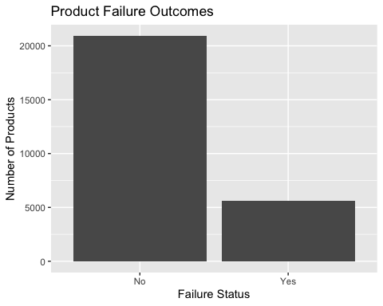
ggplot(data, aes(x = failure, y = loading)) +
geom_boxplot() +
labs(
title = "Fluid Loading by Failure Outcome",
x = "Failure Status",
y = "Fluid Loading"
)
## Warning: Removed 250 rows containing non-finite outside the scale range
## (`stat_boxplot()`).
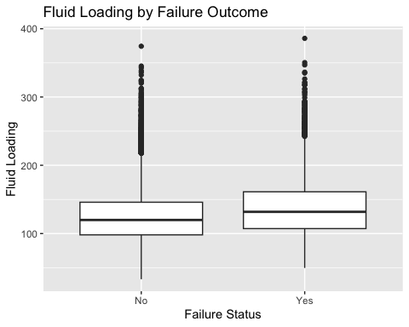

Loading Relative to Capacity
data <- data |>
mutate(loading_per_m17 = loading / measurement_17)
ggplot(data, aes(x = failure, y = loading_per_m17)) +
geom_boxplot() +
labs(
title = "Loading Relative to Measurement Capacity",
x = "Failure Status",
y = "Loading per Measurement 17"
)
## Warning: Removed 2517 rows containing non-finite outside the scale range
## (`stat_boxplot()`).
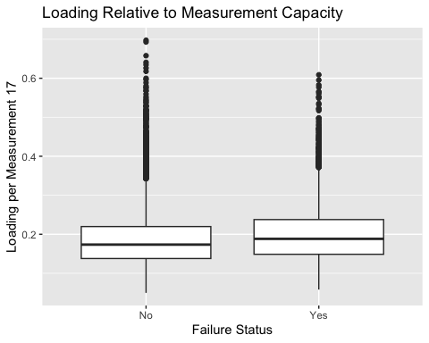
data |>
mutate(loading_bin = cut(loading, breaks = 5)) |>
count(loading_bin, failure) |>
group_by(loading_bin) |>
mutate(prop = n / sum(n)) |>
ggplot(aes(x = loading_bin, y = prop, fill = failure)) +
geom_col(position = "fill") +
labs(
title = "Failure Rate Across Fluid Loading Levels",
x = "Fluid Loading (Binned)",
y = "Proportion",
fill = "Failure"
)
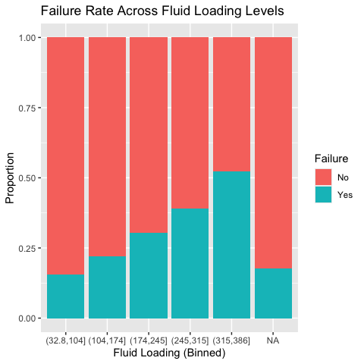
ggplot(data, aes(x = failure)) +
geom_bar() +
labs(
title = "Overall Product Failure Outcomes",
x = "Failure Status",
y = "Number of Products"
)
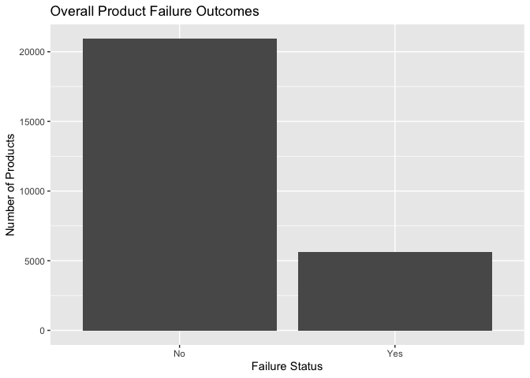
ggplot(data, aes(x = failure, y = loading_per_m17)) +
geom_boxplot() +
labs(
title = "Loading Relative to Measurement Capacity",
x = "Failure Status",
y = "Loading per Measurement 17"
)
## Warning: Removed 2517 rows containing non-finite outside the scale range
## (`stat_boxplot()`).
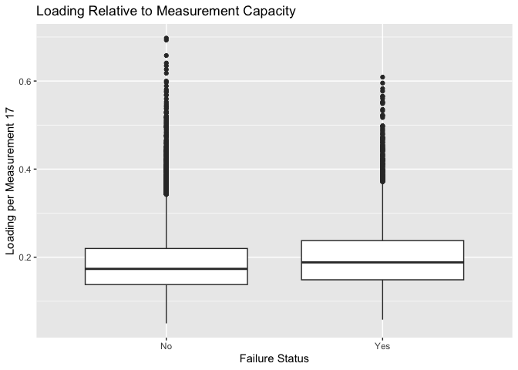
ggplot(data, aes(x = attribute_0, fill = failure)) +
geom_bar(position = "fill") +
labs(
title = "Failure Rate by Material Attribute",
x = "Material Attribute",
y = "Proportion",
fill = "Failure"
)
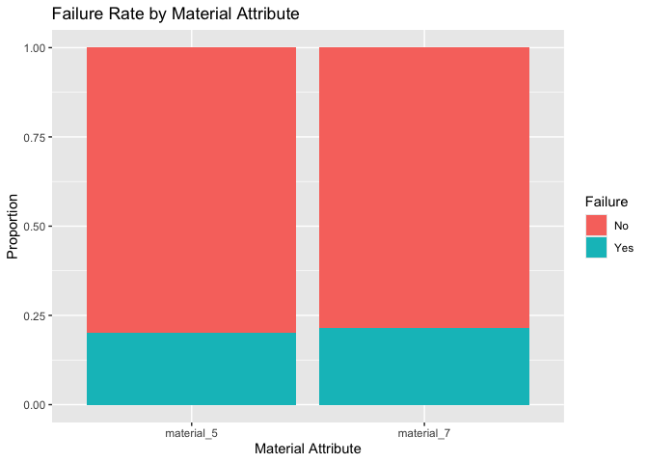
ggplot(data, aes(x = attribute_1, fill = failure)) +
geom_bar(position = "fill") +
labs(
title = "Failure Rate by Attribute",
x = "Material Attribute",
y = "Proportion",
fill = "Failure"
)
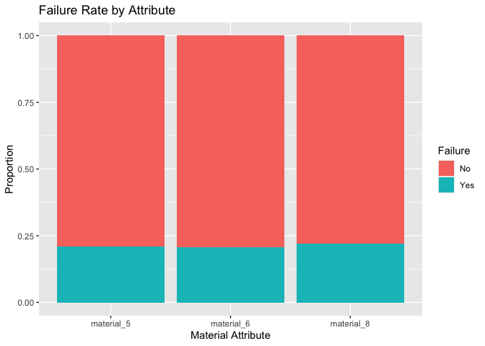
data |>
mutate(loading_bin = cut(loading, breaks = 5)) |>
count(loading_bin, failure) |>
group_by(loading_bin) |>
mutate(prop = n / sum(n)) |>
ggplot(aes(x = loading_bin, y = prop, fill = failure)) +
geom_col(position = "fill") +
labs(
title = "Failure Rate Across Fluid Loading Levels",
x = "Fluid Loading (Binned)",
y = "Proportion",
fill = "Failure"
)
