

**DEPARTMENT OF COMPUTER SCIENCE AND ENGINEERING**

**SCHOOL OF ENGINEERING**

**Project Title**

BIN

CHILLIN

**Abstract**

The Internet of Things (IoT) has revolutionized the way we interact with our environment.One application of IoT is in waste management, where a smart dustbin can make the process of disposing waste easier, cleaner and more efficient. In this project, we developed a smart dustbin that can open itself automatically when it detects motion nearby using an ultrasonic and PIR sensor connected to an Arduino. The smart dustbin also has an ultrasonic sensor installed on its lid, which can measure the level of waste inside the dustbin, and thus it can notify the user when the bin is full and needs to be emptied.

The system can be customized for different bin sizes and uses an Arduino to process the sensor data and control the motor that opens and closes the lid. The project is designed to promote smart waste management and reduce environmental impact. Our smart dustbin aims to provide a practical solution for households, offices, and other public spaces where waste management is a critical issue. The system is cost-effective, easy to use, and can be customized according to user requirements.

**Introduction**

Introducing the BinChillin - an innovative IoT-powered dustbin that is set to transform the waste management industry. With its advanced sensors and cutting-edge connectivity features, the SmartBin is designed to provide real-time data on waste levels, allowing for more efficient and effective waste collection and disposal. This groundbreaking technology is not only environmentally sustainable but also cost-effective, saving businesses and municipalities both time and money. Say goodbye to overflowing bins and hello to the future of waste management with the SmartBin.

**Motivation**

The primary motive of the IoT-powered BinChillin is to revolutionize waste management by leveraging the power of technology to make it more efficient, sustainable, and cost-effective. By providing real-time data on waste accumulation, BinChillin helps businesses and municipalities make data-driven decisions that can optimize waste collection and disposal, reduce costs, and improve environmental sustainability. The ultimate goal of the BinChillin is to improve the overall quality of life for individuals and communities by reducing the negative impacts of waste on health, hygiene, and the environment.

**Literature Survey**

The five papers contribute to the field of waste management by proposing innovative solutions that leverage IoT technology and Arduino-based systems. These solutions offer a promising approach to address the challenges associated with efficient waste management. One common aspect among the papers is the utilization of ultrasonic sensors to monitor the fill level of trash bins and dustbins. These sensors enable real-time monitoring of the waste levels and facilitate the wireless transmission of this information to a central server for further analysis.

By implementing these proposed systems, waste management can be significantly improved. The ability to send alerts to a central monitoring station when the fill level reaches a predetermined threshold ensures timely garbage collection, optimizing the utilization of resources and enhancing operational efficiency. Moreover, the integration of smart waste segregation using RFID tags allows for effective sorting of different types of waste, enabling more sustainable waste management practices.

In light of the current global health concerns, some of the papers propose additional features to mitigate the spread of germs and viruses. This includes incorporating air purification modules in the waste bins to promote contactless waste management. By activating these modules through user-friendly smartphone applications, the risk of disease transmission during pandemics, such as the ongoing COVID-19 crisis, can be minimized.

Overall, these innovative IoT-based waste management systems hold great potential in optimizing resource allocation, reducing operational costs, and promoting sustainable waste management practices. Their integration of ultrasonic sensors, wireless communication, smart waste segregation, and contactless features showcases the advancements in technology that can revolutionize waste management and contribute to a cleaner and more sustainable environment.

**Software Used**

Arduino IDE



**Hardware Specifications**

| S.No | Name of device used | Specification of device |
| --- | --- | --- |
| 1 | Arduino | UNO |
| 2 | Ultrasonic Sensor | HC-SR04 |
| 3 | PIR Sensor | HW-416 |
| 4 | Servo Motor | SG-90 |

**Pin Diagram**

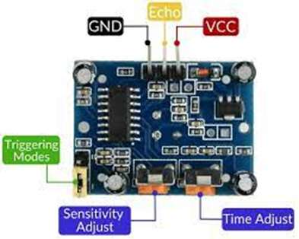 Name of Component: PIR Sensor

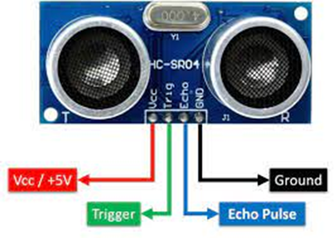 Name of Component: Ultrasonic Sensor

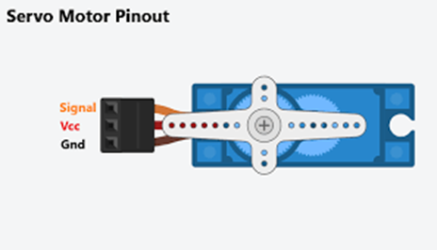 Name of Component: Servo Motor

**Block Diagram**

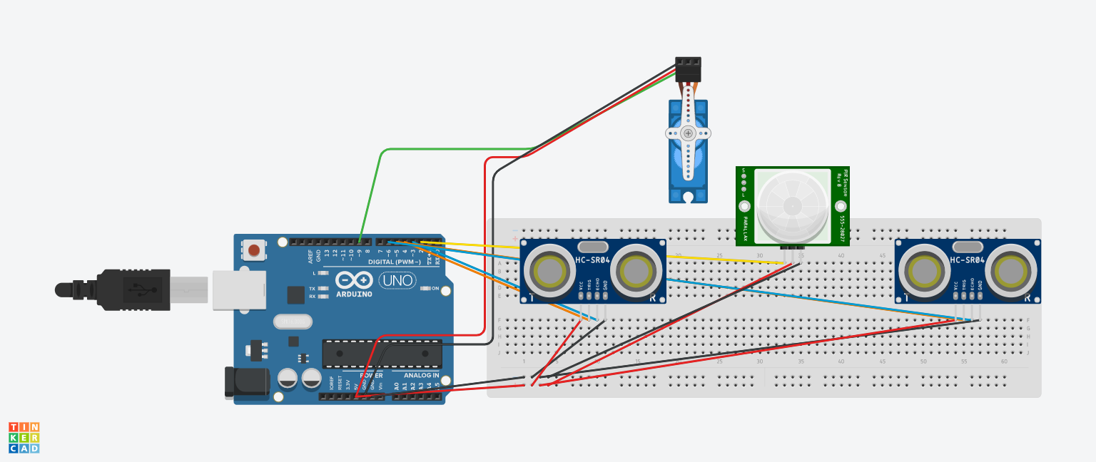

**Methodology**

1. Hardware Setup: Begin by connecting the necessary components, including the PIR sensor, ultrasonic sensors, and servo motor, to the appropriate pins on the Arduino board. Ensure proper wiring and connections for reliable operation.
2. Initialization: In the setup phase, initialize the system by configuring the necessary settings and pin modes. This includes initializing serial communication for debugging or monitoring purposes and setting the pin modes for the PIR sensor, ultrasonic sensors, and servo motor.
3. Sensing and Data Acquisition: Implement the functionality to sense and acquire data from the sensors. This involves reading the distance measurements from the ultrasonic sensors and detecting motion using the PIR sensor. Use appropriate techniques, such as pulse timing or digital signal reading, to gather accurate sensor data.
4. Data Processing and Decision Making: Process the sensor data to make informed decisions. For instance, analyze the distance measurements from the ultrasonic sensors to determine the fill level of the dustbin. Evaluate the PIR sensor output to detect any motion in the vicinity of the dustbin. Use suitable algorithms or thresholds to interpret the sensor data effectively.
5. Feedback and Control: Provide feedback and control mechanisms based on the data analysis results. For example, if the dustbin is determined to be filled, generate an alert or message indicating that it cannot be opened. Conversely, if motion is detected and the dustbin is not filled, activate the servo motor to open the dustbin lid. Control the servo motor's position and duration based on the specific requirements of the system.
6. System Loop: Design the system to operate in a loop, continuously performing the sensing, data processing, decision making, and control steps. This ensures real-time monitoring and responsiveness to changes in the environment.
7. Integration and Deployment: Integrate the developed code with the Arduino board and necessary hardware components. Ensure proper connections and test the system's functionality thoroughly. Deploy the IoT-based smart dustbin system in the desired location, considering factors such as power supply, connectivity, and user interaction.

**Code**

#include <Servo.h>

// Define pins for PIR sensor, ultrasonic sensors, and servo motor

const int pirPin = 2;

const int ultrasonicEchoPin1 = 4;

const int ultrasonicTrigPin1 = 3;

const int ultrasonicEchoPin2 = 6;

const int ultrasonicTrigPin2 = 5;

const int servoPin = 9;

// Create servo object

Servo servo;

void setup() {

// Initialize serial communication

Serial.begin(9600);

// Initialize PIR sensor pin as input

pinMode(pirPin, INPUT);

// Initialize ultrasonic sensor pins

pinMode(ultrasonicTrigPin1, OUTPUT);

pinMode(ultrasonicEchoPin1, INPUT);

pinMode(ultrasonicTrigPin2, OUTPUT);

pinMode(ultrasonicEchoPin2, INPUT);

// Attach servo to pin and set initial position to 0 degrees

servo.attach(servoPin);

servo.write(0);

}

void loop() {

// Read distances from ultrasonic sensors

long duration1, distance1, duration2, distance2;

digitalWrite(ultrasonicTrigPin1, LOW);

delayMicroseconds(2);

digitalWrite(ultrasonicTrigPin1, HIGH);

delayMicroseconds(10);

digitalWrite(ultrasonicTrigPin1, LOW);

duration1 = pulseIn(ultrasonicEchoPin1, HIGH);

distance1 = duration1 * 0.034 / 2;

digitalWrite(ultrasonicTrigPin2, LOW);

delayMicroseconds(2);

digitalWrite(ultrasonicTrigPin2, HIGH);

delayMicroseconds(10);

digitalWrite(ultrasonicTrigPin2, LOW);

duration2 = pulseIn(ultrasonicEchoPin2, HIGH);

distance2 = duration2 * 0.034 / 2;

// Print distances to Serial Monitor

Serial.print("Distance 1: ");

Serial.print(distance1);

Serial.print(" cm, Distance 2: ");

Serial.print(distance2);

// If the second ultrasonic sensor reads a distance less than 10cm, print a message

if (distance2 <= 10) {

Serial.println(" cm - Dustbin is filled and cannot be opened");

} else {

Serial.println(" cm");

}

// If an object is 30 cm away or closer

if (distance1 <= 30 && distance2 > 10) {

// Read PIR sensor input

int pirValue = digitalRead(pirPin);

// If motion is detected

if (pirValue == HIGH) {

Serial.println("Motion detected!");

// Move servo to position 90 degrees

servo.write(90);

// Wait for 5 seconds

delay(5000);

// Move servo back to position 0 degrees

servo.write(0);

}

}

// Delay for 100 milliseconds

delay(100);

**Output**

**Applications**

The IoT-powered BinChillin has a wide range of potential applications across various industries, including:

Municipal waste management: The BinChillin can be used by municipal waste management departments to optimize waste collection and disposal, reduce costs, and improve overall efficiency.

Commercial and industrial waste management: The BinChillin can be used by businesses to manage waste more efficiently, reduce waste disposal costs, and improve sustainability.

Residential waste management: The BinChillin can be used in residential areas to optimize waste collection schedules and improve overall waste management practices.

Hospitality industry: Hotels and restaurants can use the BinChillin to manage their waste more efficiently, reduce waste disposal costs, and improve environmental sustainability.

Healthcare facilities: The BinChillin can be used in healthcare facilities to manage medical waste and ensure compliance with regulatory requirements.

Educational institutions: The BinChillin can be used in schools and universities to promote sustainable waste management practices among students and staff.

Overall, BinChillin has a wide range of potential applications in any industry that generates waste and is committed to improving waste management practices.

**Inference**

The IoT-powered BinChillin is a game-changing technology that has the potential to transform the waste management industry. With its advanced sensors and connectivity features, the BinChillin offers real-time data on waste accumulation, enabling businesses and municipalities to make data-driven decisions that can optimize waste collection and disposal, reduce costs, and improve sustainability. The BinChillin has a wide range of potential applications in industries such as municipal waste management, healthcare facilities, educational institutions, and commercial businesses. By leveraging the power of technology, BinChillin can significantly improve the efficiency, cost-effectiveness, and environmental sustainability of waste management practices. Overall, the BinChillin offers a new way of thinking about waste that is data-driven, innovative, and environmentally conscious, paving the way for a more sustainable future.

**Conclusion**

In summary, the IoT-powered BinChillin is a cutting-edge technology that can transform waste management by optimizing waste collection and disposal, reducing costs, and improving sustainability. Future enhancements, such as the addition of separate compartments and computer vision models, will further improve the efficiency and effectiveness of this technology, making it an essential tool in promoting a cleaner and more sustainable future.

**Future Steps**

In order to further enhance the functionality and sustainability of the BinChillin, future steps could involve the integration of separate compartments within the dustbin to enable the sorting of different types of waste. This would not only help to improve the accuracy and efficiency of waste separation but also facilitate the recycling process. Additionally, incorporating a computer vision model that can detect the type of waste being disposed of, and subsequently open the appropriate compartments, would further streamline waste management processes and reduce contamination. By implementing these advancements, the SmartBin would become an even more sophisticated and effective waste management solution, contributing to a cleaner and more sustainable future.

**References**

IEEE Papers:

* R. P. Chand, V. B. Sri, P. M. Lakshmi, S. S. Chakravathi, O. D. M. Veerendra and C. V. Rao, "Arduino Based Smart Dustbin for Waste Management during Covid-19," 2021 5th International Conference on Electronics, Communication and Aerospace Technology (ICECA), Coimbatore, India, 2021, pp. 492-496, doi: 10.1109/ICECA52323.2021.9676003.
* P. S. N. Reddy, R. N. Naik, A. A. Kumar and S. N. Kishor, "Wireless dust bin monitoring and alert system using Arduino," 2017 Second International Conference on Electrical, Computer and Communication Technologies (ICECCT), Coimbatore, India, 2017, pp. 1-5, doi: 10.1109/ICECCT.2017.8117960.
* N. S. Kumar, B. Vuayalakshmi, R. J. Prarthana and A. Shankar, "IOT based smart garbage alert system using Arduino UNO," 2016 IEEE Region 10 Conference (TENCON), Singapore, 2016, pp. 1028-1034, doi: 10.1109/TENCON.2016.7848162.
* N. Muyunda and M. Ibrahim, "Arduino-based smart garbage monitoring system: Analysis requirement and implementation," 2017 International Conference on Computer and Drone Applications (IConDA), Kuching, Malaysia, 2017, pp. 28-32, doi: 10.1109/ICONDA.2017.8270394.
* M. R. M, G. J, M. K. Saiteja, S. N and V. K, "IoT based Trash Bin Management System," 2022 3rd International Conference on Electronics and Sustainable Communication Systems (ICESC), Coimbatore, India, 2022, pp. 495-500, doi: 10.1109/ICESC54411.2022.9885615.

Websites:

1. Arduino website: https://www.arduino.cc/

2. IEEE website: https://ieeexplore.ieee.org/Xplore/home.jsp