AI -BASED MULTIMODAL INTERVIEW CONFIDENCE ANALYSER

A PROJECT WORK PHASE – II REPORT

Submitted by

ISSAC MANOVA M. (Reg. No: 727823TUCS115)

KARAN V.S.J. (Reg. No: 727823TUCS125)
PRAVEEN KUMAR M. (Reg. No: 727823TUCS143)

in partial fulfillment for the award of the degree of

BACHELOR OF ENGINEERING
in
COMPUTER SCIENCE AND ENGINEERING


SRI KRISHNA COLLEGE OF TECHNOLOGY
(An Autonomous Institution)
(Approved by AICTE and Affiliated to Anna University, Chennai) Accredited by NAAC with ‘A’ Grade
Coimbatore – 641 042

ANNA UNIVERSITY: CHENNAI 600 025
MARCH 2026




BONAFIDE CERTIFICATE

Certified that this project report “AI BASED MULTIMODAL INTERVIEW CONFIDENCE ANALYSER” is the bonafide work of “ISSAC MANOVA M,

KARAN V.S.J, PRAVEEN KUMAR M” who carried out the project work - phase II under my supervision.

SIGNATURE SIGNATURE
Ms. VIRAJA RAVI Dr. M. UDHAYAMOORTHI
SUPERVISOR HEAD OF THE DEPARTMENT
Assistant Professor, Associate Professor,
Department of Computer Science Department of Computer Science
and Engineering and Engineering
Sri Krishna College of Technology, Sri Krishna College of Technology, Coimbatore-641042. Coimbatore-641042.

Submitted for the Project Viva Voce Examination held on .

INTERNAL EXAMINER EXTERNAL EXAMINER




DECLARATION

We affirm that the project report titled “AI-BASED MULTIMODAL INTERVIEW CONFIDENCE ANALYSER” being submitted in partial fulfilment for the award of BACHELOR OF ENGINEERING in COMPUTER SCIENCE AND ENGINEERING is the original work carried out by us. It has not formed part of any other project report or dissertation on the basis of which a degree or award was conferred on an earlier occasion on this or any other candidate.

Name Reg. No. Signature ISSAC MANOVA M 727822TUCS115
KARAN V S J 727822TUCS125 PRAVEEN KUMAR M 727822TUCS143
I certify that the declaration made by the above candidates is true to the best of my knowledge.

Name and Signature of the Supervisor with Date

iv

ABSTRACT

Night-time travel safety has become a critical concern in urban environments where increasing crime rates and unforeseen incidents pose risks to individuals commuting after dark. This situation results in heightened anxiety, lower confidence in mobility, and delays in emergency assistance. Current personal safety solutions are largely reactive, depending on manual SOS activation or static mapping, which limits their effectiveness in real-time emergencies and large-scale usage. To overcome these challenges, this study introduces Night Safe, an AI-driven personal safety and crime prediction system that proactively detects high-risk zones, tracks user movement, and sends instant alerts to guardians or emergency contacts. The system is developed using a scalable backend architecture and integrates React-Leaflet for real-time map visualization along with secure notification mechanisms to enable both online and SMS-based alert communication for reliable emergency response.Its operation is powered by three core modules—K-Means Clustering for identifying crime hotspots, Geofencing for real- time zone monitoring, and an automated Alert Trigger Mechanism—ensuring timely and reliable notifications even in low-network conditions. System testing and validation demonstrate reliable risk-zone identification and rapid alert transmission with minimal latency, highlighting its effectiveness as a scalable and real-time safety solution that enhances emergency response efficiency and coordination.The implementation of Night Safe demonstrates how artificial intelligence combined with real-time analytics can significantly enhance personal security in smart cities. Future improvements such as mobile application deployment, voice-enabled SOS features, and community-based incident reporting can further expand its functionality into a holistic urban safety platform. In conclusion, Night Safe effectively integrates predictive analytics, geospatial intelligence, and instant communication to provide a smarter, faster, and more dependable approach to ensuring safe night-time travel.

ACKNOWLEDGEMENT

First and foremost we thank the Almighty for being our light and for showering his gracious blessings throughout the course of this project.
We express our gratitude to our beloved Principal, Dr. M.G. Sumithra,
for providing all facilities.
With the grateful heart, our sincere thanks to our Head of the Department Dr. M. Udhayamoorthi, Department of Computer Science and Engineering for the motivation and all support to complete the project work.
We thank Dr. M. Kavitha Margret, Department of Computer Science and Engineering, Project Coordinator for her motivation and support
We extend our sincere thanks to our project supervisor Ms.Viraja Ravi, Assistant Professor, Department of Computer Science and Engineering, for the valuable guidance and suggestions in all aspects that aided us to ameliorate our skills.
We are thankful to all the Teaching and Non-Teaching Staff of Department of Computer Science and Engineering and to all those who have directly and indirectly extended their help to us in completing this project work successfully.
We extend our sincere thanks to our family members and our beloved
friends, who had been strongly supporting us in all our endeavours.

TABLE OF CONTENTS

CHAPTER NO | TITLE | PAGE NO
 | ABSTRACT | iv
 | ACKNOWLEDGEMENT | v
 | LIST OF FIGURES | viii
 | LIST OF ABBREVATIONS | ix
1 | INTRODUCTION | 1
2 | LITERATURE SURVEY | 2
3 | DESIGN METHODOLOGY | 4
 | 3.1 EXISTING SYSTEM | 4
 | 3.1.1 DRAWBACKS | 5
 | 3.2 PROPOSED SYSTEM | 6
 | 3.2.2 ADVANTAGES | 8
 | 3.3 MODULE DESCRIPTION | 9

- IMPLEMENTATION AND RESULTS 14
- CONCLUSION AND FUTURE WORK 19
  - CONCLUSION 19
  - FUTURE WORK 20
SDG MAPPING 21
REFERENCE 22
APPENDIX I 24

 | LIST OF FIGURES
FIGURE | TITLE | PAGE
NO. |  | NO
3.2.1 | ARCHICTURE DIAGRAM | 7
4.1 | USER REGISTRATION | 15
4.2 | USER LOGIN | 15
4.3 | MAIN DASHBOARD | 16
4.4 | LIVE ROUTE SAFETY MAP | 16
4.5 | THREAT MONITORING & NEARBY CABS | 17
4.6 | VERIFIED CAB DETAILS | 17
4.7 | EMERGENCY THREAT INTERFACE | 18
4.8 | LIVE ROUTE & SOS PANEL | 18

LIST OF ABBREVIATIONS

ABBREVATION EXPANSION
GPS Global Positioning System
REST API Representational State Transfer API
DB Database
UI User Interface
HTTP HyperText Transfer Protocol
CRUD Create , Read , Update , Delete
MVC Model View Controller
IDE Integrated Development
Environment
JSON Javascript Object Notation

CHAPTER 1

INTRODUCTION

  - NIGHT SAFE IN PERSONAL SECURITY

Night-time safety has become a major concern in today’s rapidly urbanizing world, as rising crime rates and limited emergency access during late hours increase vulnerability—especially for women, students, and night-shift workers. Fear of theft, harassment, and delayed assistance often causes anxiety, reducing public confidence and mobility at night. Although several safety applications are available, most depend on manual SOS activation and static tracking, offering limited predictive capability and minimal real-time situational awareness. These systems may also fail in low- connectivity areas and lack continuous monitoring, reducing their effectiveness during emergencies.To overcome these challenges, the proposed Night Safe system introduces an AI-powered framework that integrates predictive analytics, geospatial intelligence, and real-time alert mechanisms to enhance personal safety. It uses machine learning algorithms to identify crime-prone zones and geofencing to monitor user movement during travel. Automated emergency features notify guardians or nearby authorities in critical situations. The platform also includes real-time cab booking and verification to ensure ride authenticity and prevent unsafe travel.Additionally, users can report theft or suspicious incidents through live map feedback, dynamically updating risk zones for better awareness. Voice recognition and real-time image capture enable hands-free emergency activation and evidence collection. Supported by a robust backend, map APIs, and hybrid internet–SMS communication, Night Safe ensures uninterrupted protection even in low-network regions. With live route tracking, safety scores, instant alerts, and seamless integration with smart city systems and law enforcement, the platform delivers a scalable and comprehensive solution for safer night travel.

CHAPTER 2

LITERATURE REVIEW

  - CRIME PREDICTION AND URBAN SAFETY

Existing literature highlights that personal safety during night-time travel has become a critical challenge in modern cities, with increasing crime rates and delayed emergency responses posing serious risks to individuals. Studies show that unsafe routes, limited surveillance, and unpredictable threats contribute significantly to fear and restricted mobility, especially among women and night- shift workers. Researchers emphasize that predictive analysis using artificial intelligence and geospatial data can help identify high- risk zones and alert users in advance. Poor street lighting, unmonitored areas, and lack of real-time information further intensify vulnerability during late-hour commutes. Consequently, there is a growing need for scalable, technology-driven solutions that can combine machine learning, GPS tracking, and alert automation to enhance safety and awareness in urban environments.

AI-BASED SAFETY AND ALERT SYSTEMS

Digital AI-based safety and alert systems, including mobile applications and geospatial monitoring platforms, have been widely explored as effective tools to enhance public safety and emergency response efficiency. These systems assist users in identifying unsafe zones, receiving real-time alerts, and sharing location data with trusted contacts during potential threats. Many platforms also integrate GPS tracking and data analytics to predict risk levels in specific areas. However, most existing safety applications are limited to manual SOS triggers or depend solely on internet connectivity, which reduces reliability during emergencies.
Literature indicates that scalable, hybrid systems combining artificial intelligence, machine learning, and offline communication channels are essential to ensure continuous protection and rapid alert delivery.

CHALLENGES IN PERSONAL SAFETY MANAGEMENT

Individuals often face safety risks during night-time travel due to limited situational awareness, delayed emergency response, or unreliable connectivity. These challenges can lead to increased vulnerability, fear, and restricted mobility, especially in areas with poor lighting or low public presence. Existing safety systems largely depend on manual SOS triggers, which require user action and may fail during sudden or high-stress situations. The absence of predictive intelligence and real-time monitoring tools further reduces their effectiveness. Women, students, and night-shift workers are particularly at risk due to irregular travel patterns and lack of access to reliable safety platforms. Studies identify these issues as major barriers to ensuring consistent personal security. Reliable prediction models and automated alert mechanisms are therefore essential for improving responsiveness and reducing safety- related incidents.

ROLE OF AUTOMATED ALERT AND NOTIFICATION SYSTEMS

Automated alert and notification systems have proven effective in improving personal safety and emergency responsiveness, particularly for individuals traveling during night hours or in high-risk areas. By sending timely notifications and alerts to guardians or nearby authorities, these systems ensure that users receive immediate assistance during potential danger. Integrating automated alerts with backend servers allows for precise triggering, geofencing-based monitoring, and automatic escalation during connectivity loss. This minimizes delays in communication and ensures that safety alerts are transmitted even without manual intervention. Such automation also reduces dependency on user action, making the system reliable in panic or unconscious situations. Studies indicate that automated alert systems significantly enhance user confidence, reduce response time, and help prevent critical incidents. They are particularly beneficial for vulnerable populations, including women, students, and night-shift workers, who may otherwise face delayed help. Overall, these systems contribute to safer, smarter, and more connected urban mobility.

CHAPTER 3

DESIGN METHODOLOGY

  - EXISTING SYSTEM

Night-time safety is a growing concern in rapidly urbanizing areas, where rising crime rates and limited late-hour emergency access increase vulnerability, particularly for women, students, and night-shift workers. Fear of theft, harassment, and delayed help reduces confidence and mobility at night. Existing safety apps mainly rely on manual SOS alerts and static tracking, offering limited predictive capability, minimal real-time awareness, and weak performance in low-connectivity areas.
The proposed Night Safe system addresses these gaps through an AI-powered framework that combines predictive analytics, geospatial intelligence, and real-time alerts to improve personal safety. It uses machine learning to detect crime-prone zones, geofencing to track movement, and automated emergency notifications to alert guardians or authorities. The platform also supports cab verification, live incident reporting with dynamic risk updates, voice-activated emergency triggers, and real- time image capture for evidence. With a robust backend, map APIs, hybrid internet– SMS communication, live tracking, safety scores, and smart city integration, Night Safe provides a scalable and comprehensive solution for safer night travel.
In addition to these capabilities, the Night Safe system emphasizes reliability and accessibility for users in real-world situations. The application is designed with a user-friendly mobile interface that allows individuals to quickly access safety features during emergencies. By integrating location-based services, historical crime data, and intelligent risk analysis, the system can provide safer route suggestions and proactive warnings when users approach high-risk areas.

DRAWBACKS OF EXISTING SYSTEM

Dependence on Internet Connectivity:
Many available safety tools operate solely through online communication. In areas with weak or no network coverage, these applications become ineffective, preventing users from sending alerts or receiving live location updates.

Manual SOS Activation:
Current systems often require users to manually press an SOS button during emergencies. In sudden or threatening situations, users may not have the time or ability to perform this action, delaying help and reducing response efficiency.

Absence of Intelligent Zone Monitoring:
Existing solutions display crime-prone areas based only on historical data. They lack dynamic geofencing and real-time monitoring, which are essential for detecting when users enter unsafe zones and automatically triggering alerts.

Limited Guardian Communication:
Many safety applications fail to provide automated multi-channel communication (SMS and Internet alerts) to guardians. This limits their reliability in ensuring that alerts are received promptly, especially during connectivity failures.

Poor Scalability and Adaptability:
The majority of current systems cannot adapt to changing city conditions or large- scale deployments. They lack a scalable architecture to process continuous data from multiple users, reducing their effectiveness in rapidly evolving urban environments. Current systems struggle to adjust to rapidly changing urban dynamics or handle large-scale user data, resulting in delayed responses and reduced reliability in ensuring consistent night-time safety.

PROPOSED SYSTEM

The NightSafe system was designed as an integrated personal safety platform that combines continuous monitoring, geospatial awareness, and automated communication mechanisms to enhance nighttime travel security. The system employs intelligent safety analytics and geofencing techniques to continuously observe user movement and identify potential risks based on dynamic assessment of surrounding conditions. A real-time travel verification feature allows users to identify nearby rides and confirm journey details before starting a trip, ensuring authenticity and improved safety. The core processing framework manages location tracking, alert generation, incident recording, and communication services, while the user interface provides live visualization of routes, safety zones, and risk updates. When a user’s location indicates a potential threat or an emergency is triggered through manual or voice activation, the system automatically gathers contextual information and sends alert notifications along with live location details to registered family members, guardians, and relevant authorities, ensuring immediate response even in low- connectivity environments. Evaluation results demonstrated high accuracy in detecting unsafe zones, reliable travel verification, and minimal delay in alert transmission, confirming its effectiveness in real-world scenarios. The system was designed for scalability and adaptability, enabling continuous updates through evolving safety datasets and community feedback to improve situational awareness over time. Overall, NightSafe provides a proactive and intelligent personal safety solution that integrates continuous monitoring, automated alerts, and multi-channel communication to enhance urban security and support safer smart-city environments.
In addition, the system’s modular architecture supports future enhancements such as advanced behavior prediction, intelligent safety scoring, and deeper integration with emergency response networks for faster coordination. These advancements will further expand NightSafe’s capability to provide real-time, context-aware protection and strengthen its role in ensuring nighttime safety across smart urban ecosystems.

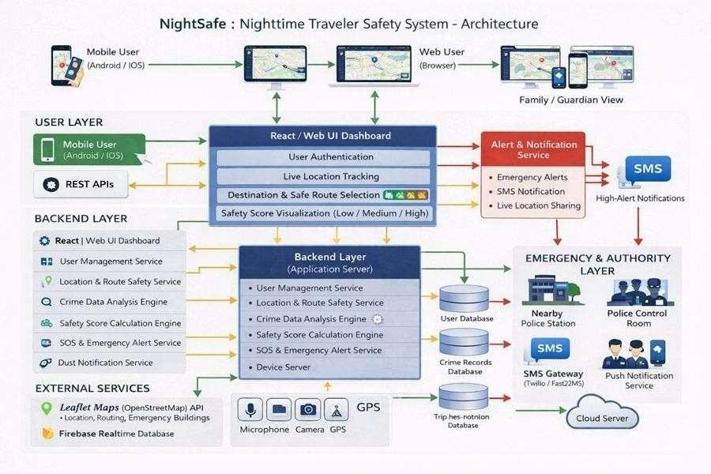
Figure 3.2.1 ARCHITECTURE DIAGRAM

3.2.2 ADVANTAGES OF PROPOSED SYSTEM

Predictive Intelligence:
The system uses live analytics, geospatial monitoring, and dynamic risk assessment to identify potential threats instantly, enabling proactive safety measures instead of reactive alerts.

Automated SOS and Multi-Channel Alerts:
Night Safe automatically sends alerts to guardians, logged-in family members, and nearby police stations through both Internet and SMS channels, ensuring faster response during emergencies.

Hybrid Communication Model:
The system operates efficiently in both online and offline modes using SMS- based alerts and push notifications, making it highly reliable in areas with weak or no internet connectivity..

Real-Time Incident and Theft Feedback Mapping:
By combining live user reports with safety data, the system dynamically updates the city’s risk zones and displays theft or incident markers for improved situational awareness..

Dynamic Geofencing and Live Monitoring:
The application continuously tracks the user’s location using GPS and geofencing technology and instantly triggers warings when unsafe zones or suspicious patterns are detected.

User-Friendly Interactive Interface:
The interface allows users to real-time safety maps, manage emergency contacts, and receive live notifications through a simple, intuitive dashboard and allowing users to capture the suspicious images.

Scalability and Smart City Integration:
The system is designed to handle large-scale deployment across cities and can be integrated with smart city infrastructures or law enforcement databases for broader urban safety management.

MODULE DESCRIPTION

Purpose:
To enhance personal safety during night-time travel through real-time monitoring, intelligent threat detection, and automated emergency communication using an AI- powered safety framework.

Functionality:
The system integrates live GPS tracking, real-time cab verification, voice-activated SOS, image capture, and dynamic theft feedback mapping. It continuously monitors user movement, detects potential threats, and sends alerts to guardians and nearby police stations through SMS and internet channels.

Evaluation:
Evaluate the System performance is evaluated using metrics such as alert response time, tracking accuracy, verification success rate, and reliability of emergency communication under varying network conditions.

Inputs:
  - User live GPS location
  - Cab details / vehicle number
  - Historical crime dataset of the city
  - Guardian and police contact data
  - Geographical data via Google Maps API
  - Voice input triggers
  - Image capture data

Outputs:
  - Crime hotspot visualization on the map
  - SOS alerts to guardians and emergency contacts
  - Real-time safety alerts
  - Verified cab details
  - SMS notifications
  - Updated risk-level indicators for each area
  - Live location sharing

Dependencies:
  - Map & Geospatial API (React-Leaflet / OpenStreetMap)
  - SMS Gateway API (Twilio / Fast2SMS)
  - Voice Recognition Service (Web Speech API / Speech-to-Text Engine)
  - Camera & Media Capture Module
  - GPS & Location Services Module
  - Real-Time Database (Firebase / MongoDB / PostgreSQL)

Assumptions:
  - Crime data used for training is accurate and updated regularly
  - Users have GPS enabled and valid guardian contact information
  - Mobile devices have at least intermittent network or SMS connectivity
  - Guardians are available to receive and respond to alerts
  - Users allow necessary permissions for location, camera, and microphone access
  - Map services and APIs remain accessible and functional
  - Emergency contacts are reachable through mobile networks
  - Users provide correct cab details when entering ride information

Limitations:
  - Alert accuracy may occasionally be affected in areas with weak GPS or low network connectivity, which can be optimized through improved signal handling techniques.
  - Limited availability of real-time official crime data may impact prediction precision, but integration with authorized public safety databases can strengthen accuracy.
  - Image capture during night-time conditions may not always be perfectly clear due to low-light environments, and advanced image enhancement techniques can improve clarity and reliability.
  - Dependence on external APIs may affect system performance if services become unavailable
  - The system cannot physically prevent crimes but helps in early detection and response

Data Preprocessing:
Collect and clean historical crime data, remove duplicate or incomplete entries, and normalize coordinates for clustering. Integrate user GPS data with timestamped movement logs to map location behavior patterns.

Feature Engineering:
  - Extract spatial features such as latitude and longitude clusters.

  - Analyze temporal patterns like crime occurrence time

  - Calculate crime density in specific regions

  - Generate safety scores based on historical crime trends

  - Create distance-based features for hotspot proximity detection

  - Identify high-frequency crime zones

Model Training:

  - Train the K-Means clustering algorithm on processed crime datasets to identify and label crime-prone areas.
  - Label clusters as high-risk, medium-risk, or safe zones

  - Store trained model parameters for real-time prediction

Prediction:
Apply the trained model to live user data and dynamically classify current zones as safe or unsafe. Generate risk-level indicators based on cluster proximity and alert status. The system continuously updates the risk evaluation as the user moves, ensuring that safety alerts and recommendations reflect the most recent location and environmental conditions.

Alert Triggering:
Use geofencing logic to detect when a user enters a high-risk zone. Instantly trigger SOS alerts to registered guardians through internet and SMS channels. The alert mechanism also shares the user’s live location and timestamp to enable faster response and improved situational awareness for emergency contacts.

PLATFORM
Visual Studio Code is used as the primary development environment for implementing NightSafe. It provides developers with integrated debugging, version control, and code management capabilities essential for building a reliable real-time safety application. The platform supports both frontend and backend development, enabling seamless integration of location tracking, risk analysis, and alert mechanisms within a single workspace.

KEY FEATURES

Interactive Development Environment:
Provides real-time debugging, testing, and extension support, enabling developers to quickly detect and resolve logic or integration issues during system development.

Support for Multiple Technologies:
Supports frontend development using React along with backend services for real-time processing, API integration, and communication modules for alerts and notifications.

Integrated Map Visualization:
Enables visualization and testing of real-time geospatial data, route tracking, and risk zone mapping within the development environment.

Built-in Version Control:
Integrated Git support allows efficient tracking of code changes, collaborative development, and maintenance of system stability.

Extensive Library Support:
Provides compatibility with essential libraries for machine learning, data analysis, and map rendering, enabling implementation of hotspot prediction and dynamic visualization.

Lightweight and Efficient:
Optimized performance ensures smooth execution during development, testing, and debugging even on standard hardware configurations.

WORKFLOW

Data Collection and Preprocessing:
Historical crime data and user location information are collected from available datasets and cleaned to ensure consistency and accuracy for analysis.

Data Segmentation:
The dataset is divided into training and testing sets to train the clustering model and evaluate prediction performance.

Model Training and Optimization:
A clustering algorithm is trained using spatial crime data to identify high- risk zones and optimize detection accuracy

Real-Time Monitoring:
The system continuously tracks the user’s live location and compares it
with predefined risk zones to determine safety levels.

Geofencing Detection:
When the user enters a high-risk area, the system automatically detects the event and prepares an alert response.

Alert Generation:
Emergency notifications along with live location details are sent to registered contacts through communication channels.

Continuous Feedback and Updates:
Newly collected data is stored and used to periodically update risk prediction models, improving system accuracy over time.

Live Data Integration:

Real-time safety updates from external sources such as public safety datasets and community reports are incorporated to keep risk mapping current and reliable.

CHAPTER 4

IMPLEMENTATION AND RESULTS

The NightSafe system was successfully implemented and executed as a real- time personal safety platform that continuously monitored user movement and evaluated surrounding risk conditions during nighttime travel. During execution, the system tracked live location data and compared it with pre-identified high-risk zones using geofencing and risk analysis techniques, enabling proactive detection of unsafe situations. The travel verification functionality allowed users to confirm journey details before starting trips, improving reliability and reducing uncertainty. The system processed location updates, generated alerts, maintained incident logs, and displayed live route visualization along with safety indicators. When a simulated threat condition was introduced or an emergency trigger was activated, the system immediately generated alerts and shared live location details with registered emergency contacts, demonstrating reliable response behavior.
Execution results showed accurate detection of risk zones, consistent monitoring performance, and rapid alert delivery with minimal delay, validating the operational effectiveness of the platform. The system maintained stable performance during continuous tracking and demonstrated its capability to function reliably under different test scenarios. Overall, the execution phase confirmed that NightSafe effectively delivers proactive monitoring, automated emergency response, and real- time situational awareness to enhance personal safety.
In addition, the execution results highlighted the flexibility of the modular architecture, enabling easy integration of additional safety features and continuous improvement through updated data inputs. The system demonstrated readiness for further enhancements such as predictive risk modeling, adaptive safety scoring, and expanded coordination with emergency services.

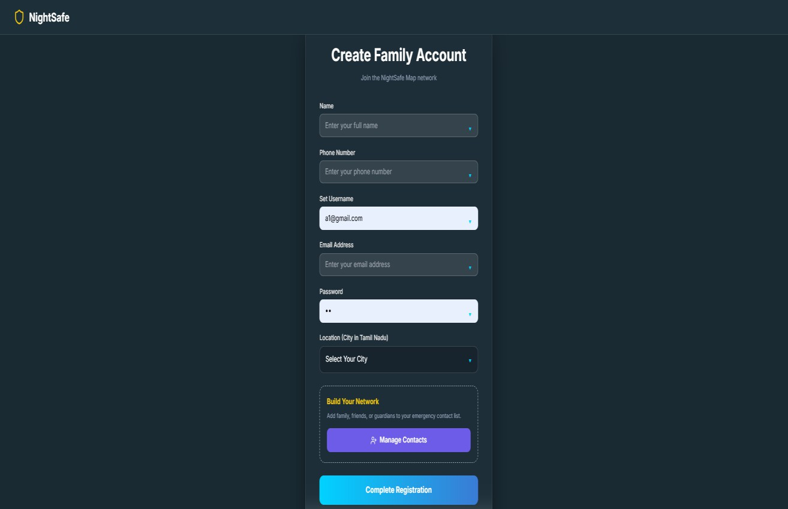

Figure 4.1 User Registration

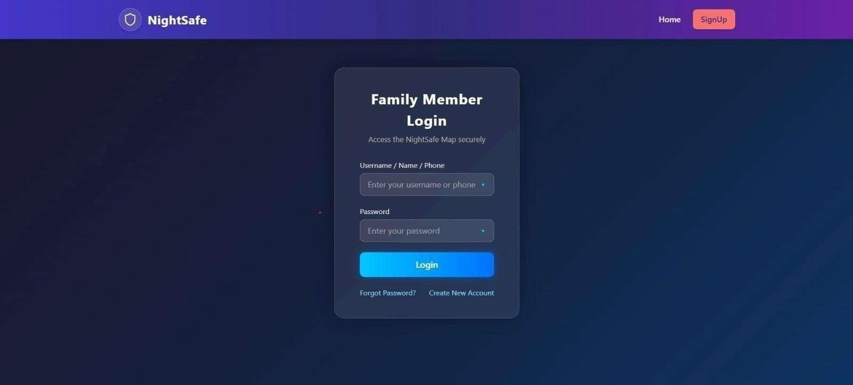

Figure 4.2 User Login

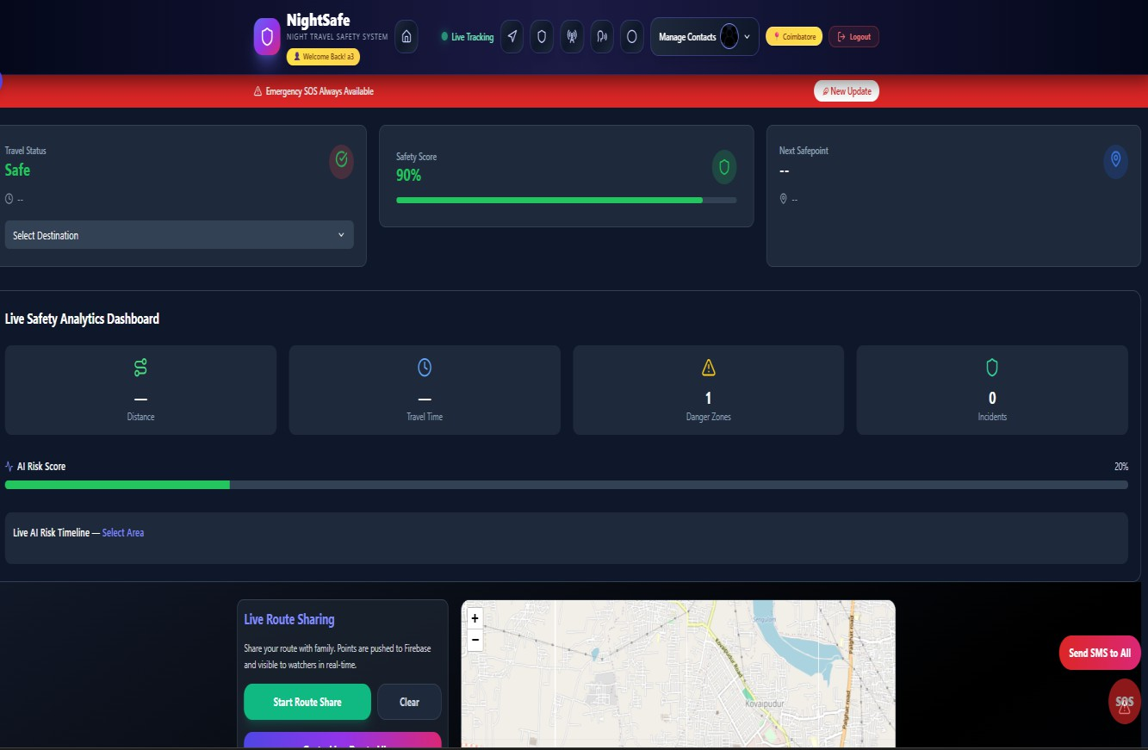

Figure 4.3 Main Dashboard

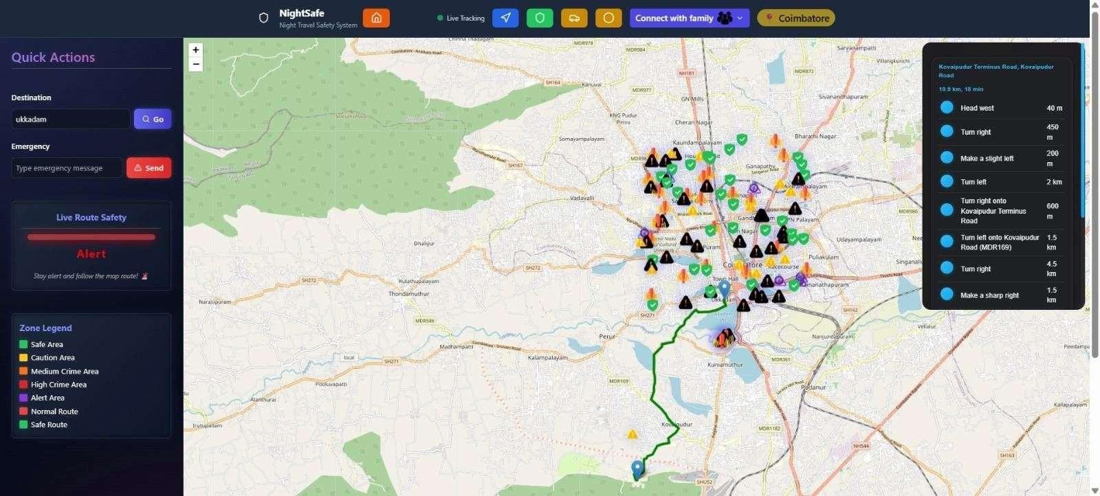

Figure 4.4 Live Route Safety Map

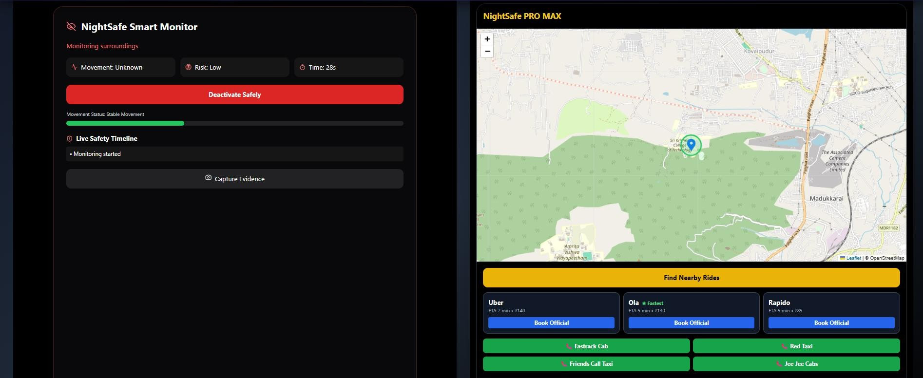

Figure 4.5 Threat Monitoring & Nearby Cabs

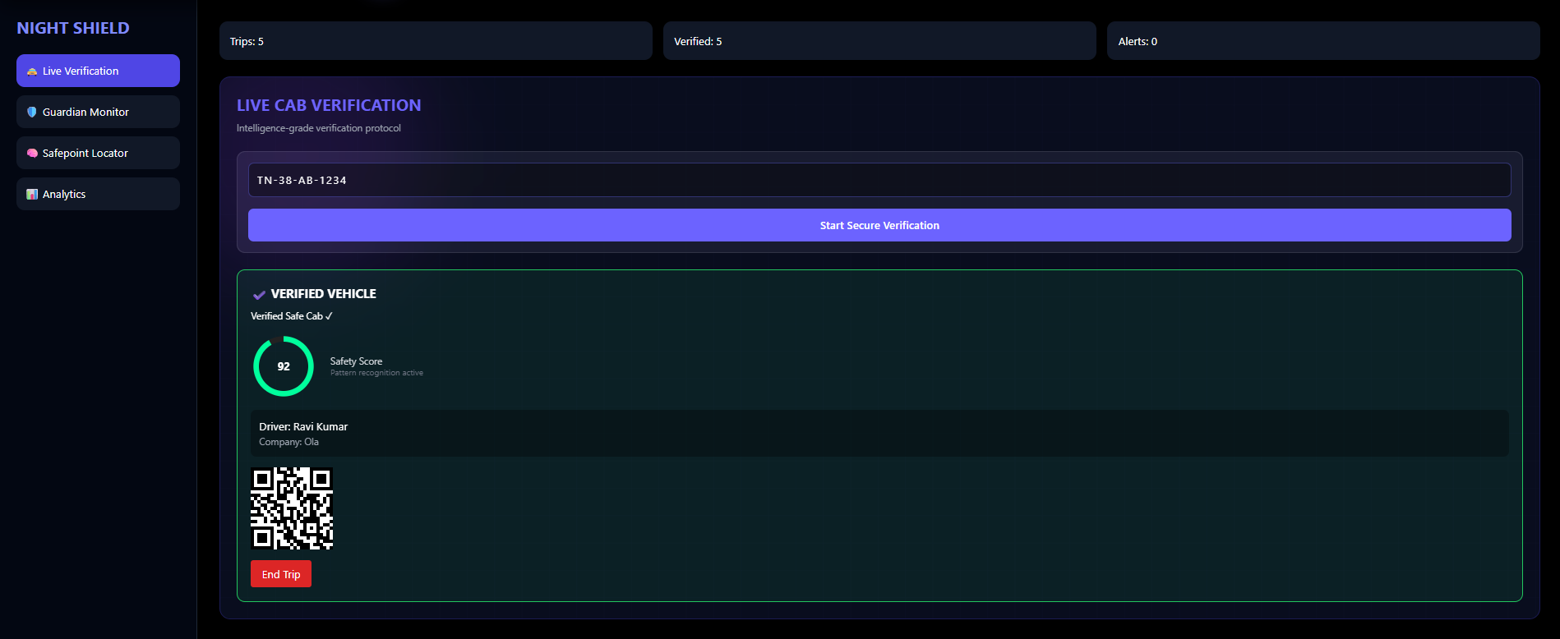

Figure 4.6 Verified Cab Details

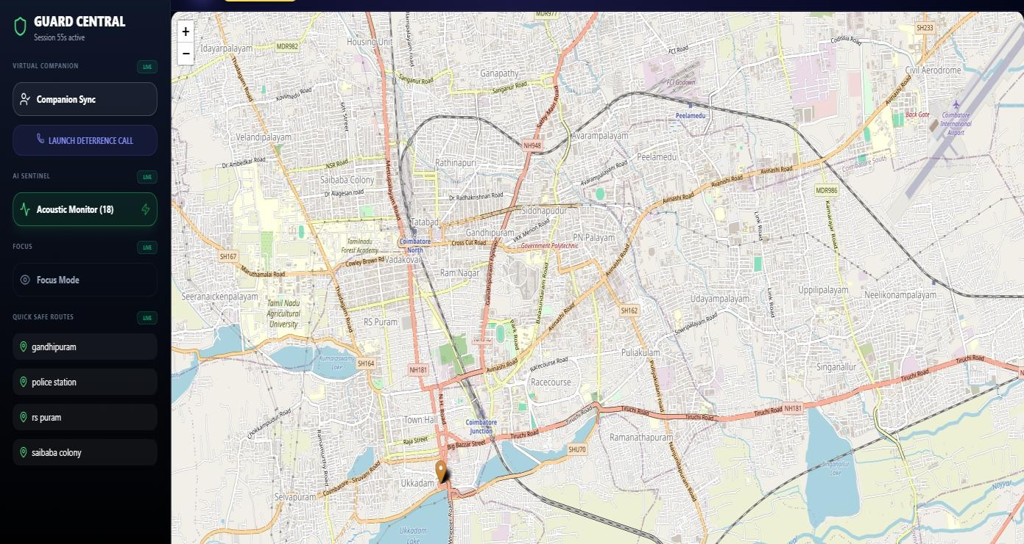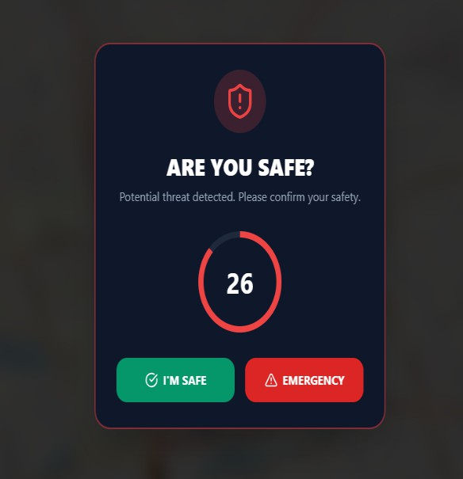

Figure 4.7 Emergency Threat Interface

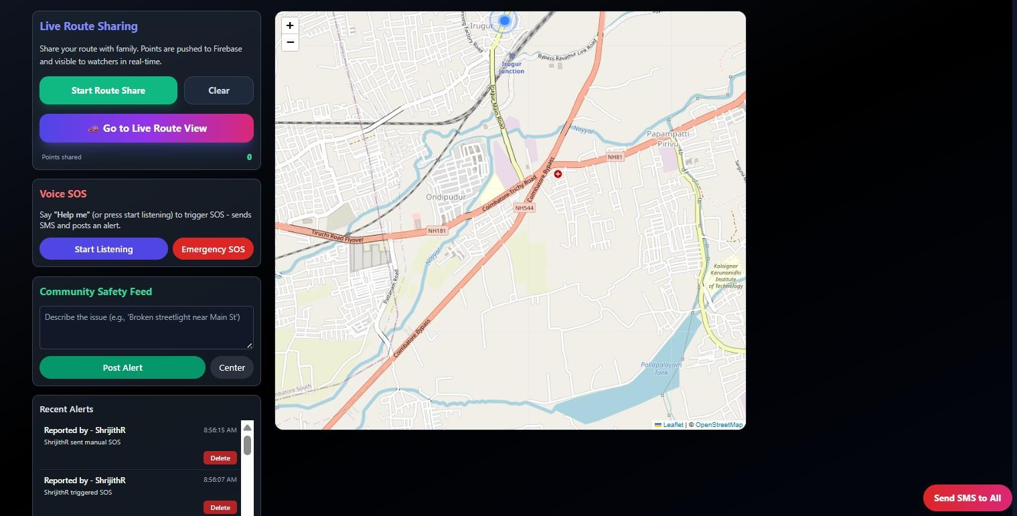

Figure 4.8 Live Route & SOS Panel

CHAPTER 5 CONCLUSION AND FUTURE WORK

CONCLUSION

The proposed NightSafe system effectively addresses the growing concern of personal safety during night-time travel by integrating continuous monitoring, intelligent risk prediction, and automated communication within a unified safety framework. Conventional safety solutions largely depend on manual SOS activation or static location sharing, which may not provide timely assistance in sudden or high- risk situations.
In contrast, NightSafe incorporates real-time location tracking, machine learning–based crime risk analysis, geofencing, and automated alert mechanisms to proactively identify unsafe conditions and respond dynamically. By continuously comparing user location with identified high-risk zones, the system ensures early risk detection and minimizes response time during emergencies. Through its automated alert process, NightSafe shares live location updates and notifications with registered family members and guardians, enabling reliable assistance even when the user is unable to interact manually.
The system framework efficiently handles location analysis, risk evaluation, and incident logging while providing users with clear safety insights and real-time situational awareness. Its adaptive design allows incorporation of updated crime datasets and user feedback to refine risk assessment over time, making it a scalable and future-ready solution for smart urban environments. By combining predictive analytics, automated alerts, and continuous monitoring, NightSafe represents a significant advancement in proactive personal safety systems. It not only enhances individual protection but also contributes to data-driven urban safety management by improving responsiveness and coordination among users and emergency contacts.

FUTURE WORK

The proposed NightSafe system has demonstrated strong potential in enhancing personal safety through continuous monitoring, intelligent risk prediction, and automated emergency response during night-time travel. However, several opportunities exist for future research and development to further improve its accuracy, scalability, and real-world applicability. One important direction is the integration of more advanced predictive analytics to analyze behavioral patterns, travel history, and contextual environmental factors for earlier and more precise risk detection. This would enable the system to anticipate unsafe situations proactively and provide personalized safety recommendations. Another potential enhancement involves incorporating adaptive learning mechanisms that allow the system to refine risk evaluation models based on real-world usage patterns and evolving safety datasets.
Future versions of NightSafe could expand travel verification capabilities by enabling deeper connectivity with transportation and mobility ecosystems to improve journey authentication and trust. Integration with wearable safety devices, environmental sensors, and public monitoring infrastructures can significantly enhance situational awareness and automated threat detection. Additionally, incorporating multilingual interaction support and adaptive notification strategies would improve accessibility for diverse user groups.
Exploration of privacy-preserving data handling techniques and secure information sharing frameworks will further strengthen user trust and data protection. Continuous optimization to reduce alert latency, improve scalability across multiple regions, and incorporate broader safety datasets will enhance reliability in large-scale deployments.
With these advancements, NightSafe can evolve into a more comprehensive and intelligent safety ecosystem capable of providing context-aware protection across diverse urban environments. Future integration with emergency response coordination systems and large-scale analytics platforms can enable faster decision- making and improved collaboration with safety authorities.


SRI KRISHNA COLLEGE OF TECHNOLOGY
(An Autonomous Institution)
Affiliated to Anna University and Approved by AICTE
KOVAIPUDUR, COIMBATORE – 641 042

SUSTAINABLE DEVELOPMENT GOALS MAPPING

The Sustainable Development Goals are a collection of 17 global goals designed to blue print to achieve a better and more sustainable future for all. The SDGs, set in 2015 by the United Nations General Assembly and intended to be achieved by the year 2030, In 2015, 195 nations agreed as a blue print that they can change the world for the better. The project is based on one of the 17 goals.

Questions | Answer
Which SDGs does the project directly address? | SDG 11 – Sustainable Cities and Communities.
What strategies or actions are being implemented to achieve these goals? | Using AI and machine learning techniques to identify crime-prone zones and enhance personal safety through real-time monitoring and  alerts during night travel.
How is progress measured and reported in relation to the SDGs? | Measured using metrics such as crime hotspot prediction accuracy, alert response time, and location  tracking reliability.
How were these goals identified as relevant to the project’s objectives? | The project focuses on improving urban safety and supporting secure mobility in cities, aligning with SDG 11.
Are there any partnerships or collaborations in place to enhance this impact? | Currently developed as an academic project with potential future collaboration with healthcare smart city initiatives and  public safety authorities.

REFERENCES

- P. Sravani, B. Sindhu, N. Shashank, P. Pranaya and S. Tejaswi, “Women Safety System Using GPS and GSM Tracking,” Int. J. Eng. Sci. Res., vol. 15, no. 2, pp. 738–748, Apr.–June 2025.
- J. Bengare, R. Jadhav, G. Kapale and R. Chandan, “Android-Based Women Safety Application with Real-Time Alerts and Location Tracking,” Int. J. Sci. Inno. Eng.
Technol., vol. 2, no. 10, pp. 1400–1406, Oct. 2025.
- A. Biradar, K. Dhargave, K. Rangari, G. Musale and R. M. Moharle, “Android Safety App: A Mobile-Based Framework for Emergency Assistance Using GPS and Real-Time Alerts,” Int. J. Res. Appl. Sci. Eng. Technol. (IJRASET), Oct. 2025.
- T. Wang, C. Rudin, D. Wagner and R. Sevieri, “Learning to Predict Crime Hotspots,” Proc. 19th ACM SIGKDD Int. Conf. Knowl. Discov. Data Mining,
pp. 271–279, 2013.
- A. Bogomolov et al., “Once Upon a Crime: Towards Crime Prediction from Demographics and Mobile Data,” Proc. 16th ACM Int. Conf. Multimodal Interaction, 2014.
- J. Salamon, C. Jacoby and J. P. Bello, “A Dataset and Taxonomy for Urban Sound Research,” Proc. 22nd ACM Int. Conf. Multimedia, pp. 1041–1044, 2014.
- S. Sathyadevan and S. Gangadharan, “Crime Prediction Using Machine Learning Techniques,” Proc. Int. Conf. Advances in Computing, Communications and Informatics (ICACCI), IEEE, 2014.
- Y.Zhang, Q. Li and X. Chen, “SafeRoute: Learning-Based Safe Route Recommendation System,” Proc. IEEE Int. Conf. Smart City Innovations, 2018.

- C. E. Dietrich and G. Palmieri, “Acoustic Gunshot Detection in Urban Environments Using Sensor Networks,” IEEE Sensors Journal, vol. 15, no. 3,
pp. 1493–1502,
- H. Yu, Z. Chen and S. Ma, “Deep Learning for Spatio-Temporal Crime
Prediction,” Proc. IEEE Int. Conf. Data Mining Workshops (ICDMW), 2017.

- J. Kim, S. Lee and H. Kim, “Risk-Aware Route Planning for Urban
Navigation,” Proc. IEEE Intell. Transportation Systems Conf. (ITSC), 2016.

- A. Candia, M. González and P. Wang, “Detecting Anomalous Urban Events Using Mobile Phone Data,” IEEE Pervasive Computing, vol. 7, no. 4, pp. 36– 43, 2008.
- S. Chainey, L. Tompson and S. Uhlig, “The Utility of Hotspot Mapping for Predicting Spatial Patterns of Crime,” Security Journal, vol. 21, no. 1–2, pp. 4–28, 2008.
- M. N. K. Boulos et al., “Geofencing in Location-Based Services: A Survey
and Applications,” Int. J. Health Geographics, vol. 10, no. 1, 2011.
- G. O. Mohler et al., “Self-Exciting Point Process Modeling of Crime,” J. Amer. Statistical Assoc., vol. 106, no. 493, pp. 100–108, 2011.
- S. Hasan, C. M. Schneider, S. V. Ukkusuri and M. C. González, “Spatiotemporal Patterns of Urban Human Mobility,” Journal of Statistical Physics, vol. 151, no. 1– 2, pp. 304–318, 2013.
- J. Salamon and J. P. Bello, “Deep Convolutional Neural Networks for Urban Sound Classification,” IEEE Signal Processing Letters, vol. 24, no. 3, pp. 279– 283, 2017.

ANNEXURE I

SOURCE CODE

SignUp Page:

import React, { useState, useEffect } from "react"; import "./FamilySignup.css";
import { Shield, UserPlus, ArrowLeft, Users } from "lucide-react";
import { toast } from "sonner";

import { ENDPOINTS } from "../lib/api"; const FamSign = () => {
const [step, setStep] = useState("account"); // 'account' or 'members'
const [formData, setFormData] = useState({ name: "",
phone: "",

username: "",

password: "",

email: "",

location: "",

});

const [memberInput, setMemberInput] = useState({ role: "",
name: "",

phone: "",

});

const [memberList, setMemberList] = useState([]);

const [showMembers, setShowMembers] = useState(false); const [editingId, setEditingId] = useState(null);
const [error, setError] = useState(""); const [success, setSuccess] = useState(""); useEffect(() => {
// No longer loading from localStorage as everything is in DB
}, []);

const handleChange = (e) => {

setFormData({ ...formData, [e.target.name]: e.target.value
});

setError("");

};

const handleMemberChange = (e) => {

setMemberInput({ ...memberInput, [e.target.name]: e.target.value });
};

const addMember = () => {

if (!memberInput.role || !memberInput.name ||
!memberInput.phone) {
setError("Please fill all member details."); return;

}

if (editingId) { setMemberList( memberList.map((m) =>
m.id === editingId ? { ...memberInput, id: editingId } : m

)

);

setEditingId(null); setSuccess("Member updated!");
} else {

setMemberList([...memberList, { ...memberInput, id: Date.now() }]);
setSuccess("Member added!");

}

setMemberInput({ role: "", name: "", phone: "" }); setError("");
setTimeout(() => setSuccess(""), 2000);

};

const editMember = (member) => { setMemberInput({
role: member.role, name: member.name, phone: member.phone,
});

setEditingId(member.id); setShowMembers(false);
};

const removeMember = (id) => { setMemberList(memberList.filter(m => m.id !== id));
};

const handleSaveMembers = () => { toast.success("Local contacts updated!"); setStep("account");
};

const handleSubmit = async (e) => { if (e) e.preventDefault();
const missingFields = [];

if (!formData.name) missingFields.push("Name"); if (!formData.phone) missingFields.push("Phone");
if (!formData.username) missingFields.push("Username"); if (!formData.password) missingFields.push("Password"); if (!formData.email) missingFields.push("Email");
if (missingFields.length > 0) {

const errorMsg = `Required fields missing:
${missingFields.join(", ")}`; setError(errorMsg); toast.error(errorMsg);
return;

}

try {

// 1. Register User in MySQL via Spring Boot (including contacts)
const response = await fetch(ENDPOINTS.AUTH.REGISTER, {
method: "POST",

headers: { "Content-Type": "application/json" }, body: JSON.stringify({
username: formData.username, password: formData.password, email: formData.email,
name: formData.name, phone: formData.phone, location: formData.location,
contacts: memberList.map(member => ({ name: member.name,
phone: member.phone, relationship: member.role
}))

})

});

if (!response.ok) {

const errorText = await response.text();

throw new Error(errorText || "Registration failed");

}

toast.success("Account created successfully!"); setTimeout(() => {
window.location.href = "/FamilyLogin";

}, 1500);

} catch (err) { setError(err.message); toast.error(err.message);
}

};

return (

<div className="signup-container">

{/* Redesigned Header */}

<nav className="nav-header">

<div className="nav-brand">

<Shield size={32} className="logo-icon" />

<span className="brand-name">NightSafe</span>

</div>

<div className="nav-links">

{/* Links removed as per user request */}

</div>

</nav>

<div className="signup-card">

{step === "account" ? (

<>

<h2 className="signup-title">Create Family Account</h2>
<p className="signup-subtitle">Join the NightSafe Map network</p>
<form onSubmit={handleSubmit}>

<div className="input-group">

<label className="input-label">Name</label>

<input type="text" name="name"
className="input-field" value={formData.name} placeholder="Enter your full name" onChange={handleChange} required
/>

</div>

<div className="input-group">

<label className="input-label">Phone Number</label>

<input type="tel" name="phone"

className="input-field" value={formData.phone} placeholder="Enter your phone number" onChange={handleChange}
pattern="[0-9]{10}" required
/>

</div>

<div className="input-group">

<label className="input-label">Set Username</label>

<input type="text" name="username"
className="input-field" value={formData.username} placeholder="Choose a username" onChange={handleChange} required
/>

</div>

<div className="input-group">

<label className="input-label">Email Address</label>

<input type="email"

name="email" className="input-field" value={formData.email}
placeholder="Enter your email address" onChange={handleChange}
required

/>

</div>

<div className="input-group">

<label className="input-label">Password</label>

<input type="password" name="password"
className="input-field" value={formData.password} placeholder="Create a strong password" onChange={handleChange}
required

/>

</div>

<div className="input-group">

<label className="input-label">Location (City in Tamil Nadu)</label>
<select

name="location" className="select-field" value={formData.location} onChange={handleChange} required
>

<option value="">Select Your City</option>

{[

"Chennai", "Coimbatore", "Madurai", "Tiruchirappalli", "Salem",
"Erode", "Tirunelveli", "Vellore", "Thanjavur", "Dindigul",

"Thoothukudi", "Nagercoil", "Karur", "Cuddalore", "Kanchipuram"
].map((city) => (

<option key={city} value={city}>{city}</option>

))}

</select>

</div>

<div className="network-box">

<h3 className="network-title">Build Your Network</h3>

<p className="network-desc">

Add family, friends, or guardians to your emergency contact list.
</p>

<button

type="button" className="manage-btn"
onClick={() => setStep("members")}

>

<UserPlus size={18} /> Manage Contacts

</button>

</div>

{error && <p className="error-msg text-center mb- 4">{error}</p>}
<button type="submit" className="primary-btn"> Complete Registration
</button>

</form>

<p className="login-footer">

Already have an account? <a href="/FamilyLogin" className="login-link">Login</a>
</p>

</>

) : (

<>

<div className="back-link" onClick={() => setStep("account")}>
<ArrowLeft size={18} /> Back to Sign Up

</div>

<h2 className="signup-title">Add Family Members</h2>

<p className="signup-subtitle">Build your NightSafe contact network</p>
<div className="form-sub-card">

<h3 className="manage-contacts-header">Manage Contacts</h3>
<div className="input-group">

<select name="role"
className="select-field" value={memberInput.role} onChange={handleMemberChange}
>

<option value="">Select Role</option>

<option value="Father">Father</option>

<option value="Mother">Mother</option>

<option value="Sister">Sister</option>

<option value="Brother">Brother</option>

<option value="Friend">Friend</option>

</select>

</div>

<div className="input-group">

<input type="text" name="name"

className="input-field" placeholder="Enter Name" value={memberInput.name} onChange={handleMemberChange}
/>

</div>

<div className="input-group">

<input type="tel" name="phone"
className="input-field" placeholder="Enter Phone Number" value={memberInput.phone} onChange={handleMemberChange}
/>

</div>

<div className="action-row">

<button type="button" className="add-btn" onClick={addMember}>
{editingId ? "Update Member" : "Add Member"}

</button>

<button type="button"
className="view-btn"

onClick={() => setShowMembers(true)}

>

<Users size={16} style={{ display: 'inline', marginRight: '5px' }} />
View Members ({memberList.length})

</button>

</div>

</div>

{showMembers && (

<div className="fixed inset-0 bg-black/60 backdrop-blur- sm z-[2000] flex items-center justify-center p-4">
<div className="bg-[#1e303a] border border-white/10 rounded-2xl p-6 w-full max-w-md shadow-2xl">
<div className="flex justify-between items-center mb-6">

<h3 className="text-xl font-bold text-white">Added Members</h3>
<button

onClick={() => setShowMembers(false)} className="text-gray-400 hover:text-white"
>

✕

</button>

</div>

<div className="space-y-4 max-h-[400px] overflow-y- auto pr-2">

{memberList.length === 0 ? (

<p className="text-gray-400 text-center py-8">No members added yet.</p>
) : (

memberList.map((member) => (

<div key={member.id} className="flex justify-between items-center bg-black/20 p-4 rounded-xl border border- white/5">
<div className="text-left">

<p className="text-sm font-bold text- white">{member.name}</p>
<p className="text-xs text-blue-400">{member.role}</p>

<p className="text-xs text-gray-400 mt- 1">{member.phone}</p>
</div>

<div className="flex gap-2">

<button

onClick={() => editMember(member)}

className="text-blue-400 hover:text-blue-300 text-sm font-bold bg-blue-500/10 px-3 py-1 rounded-lg"
>

Edit

</button>

<button

onClick={() => removeMember(member.id)}

className="text-red-400 hover:text-red-300 text-sm font- bold bg-red-500/10 px-3 py-1 rounded-lg"
>

Remove

</button>

</div>

</div>

))

)}

</div>

<button

className="primary-btn mt-6 mb-0" onClick={() => setShowMembers(false)}
>

Done

</button>

</div>

</div>

)}

{error && <p className="error-msg text-center mt- 4">{error}</p>}
{success && <p className="success-msg text-center mt- 4">{success}</p>}
<button

type="button"

className="primary-btn mt-8" onClick={handleSaveMembers}
>

Save and Register

</button>

</>

)}

</div>

</div>

);

};

export default FamSign;

Login Page:

import React, { useState } from "react"; import "./FamilyLogin.css";
import { toast } from "sonner"; import Lognav2 from "./Lognav2";
import { ENDPOINTS } from "../lib/api";

import { Shield, PhoneCall, Mail, MapPin, Github, Linkedin } from "lucide-react";
const FamilyLogin = () => {

const [emailOrUsername, setEmailOrUsername] = useState("");
const [password, setPassword] = useState("");

const [error, setError] = useState(""); const handleSubmit = async (e) => { if (e) e.preventDefault(); setError("");
try {

const response = await fetch(ENDPOINTS.AUTH.LOGIN,
{

method: "POST",

headers: { "Content-Type": "application/json" }, body: JSON.stringify({
username: emailOrUsername, password: password,
})

});

if (!response.ok) {

const errorText = await response.text();

throw new Error(errorText || "Invalid credentials");

}

const data = await response.json(); console.log("Login successful, user data:", data);
// Store session info

const userId = data.userId ? String(data.userId) : null;

localStorage.setItem("loggedInUser", data.name || data.username);

localStorage.setItem("currentUserName", data.username); if (userId) {
localStorage.setItem("currentUserId", userId);

} else { localStorage.removeItem("currentUserId");
}

localStorage.setItem("userRole", data.role); console.log("Session stored:", {
name: data.name, username: data.username, userId: userId
});

toast.success(`Welcome back, ${data.username}! ˙·~ª.˙~‘.˛ 3`); setTimeout(() => {
window.location.href = "/home";

}, 1500);

} catch (err) { setError(err.message); toast.error(err.message);
}

};

return (

<>

<Lognav2 />

<div className="login-container">

<div className="login-card">

<h2 className="login-title">Login</h2>

<p className="login-subtitle">Access the NightSafe Map securely</p>
<form className="login-form" onSubmit={handleSubmit}>
<div className="input-group">

<label>Username / Name / Phone</label>

<input type="text"
value={emailOrUsername}

onChange={(e) => setEmailOrUsername(e.target.value)} placeholder="Enter your username or phone"
required

/>

</div>

<div className="input-group">

<label>Password</label>

<input type="password" value={password}
onChange={(e) => setPassword(e.target.value)}

placeholder="Enter your password" required
/>

</div>

{error && <p className="error-msg">{error}</p>}

<button type="submit" className="login-btn"> Login
</button>

<div className="extra-options">

<a href="#">Forgot Password?</a>

<a href="/famsign">Create New Account</a>

</div>

</form>

</div>

</div>

<footer className="bg-gradient-to-r from-indigo-800 via- indigo-900 to-purple-900 text-gray-200 py-8 px-6 shadow- inner border-t border-white/10">
<div className="max-w-7xl mx-auto grid grid-cols-1 md:grid-cols-3 gap-8 items-start">
<div className="flex flex-col items-start space-y-3">

<div className="flex items-center space-x-3">

<div className="bg-white/10 p-2 rounded-full border border-white/20">
<Shield size={26} className="text-yellow-300" />

</div>

<h2 className="text-xl font-semibold text-white tracking- wide">NightSafe</h2>
</div>

<p className="text-sm text-gray-400">

Empowering communities with safety insights and live location alerts.
Stay safe, stay informed.

</p>

</div>

<div className="flex flex-col space-y-2">

<h3 className="text-lg font-semibold text-yellow-300 mb-2">Quick Links</h3>
<a href="/" className="hover:text-yellow- 400">Home</a>
<a href="/FamilyLogin" className="hover:text-yellow- 400">Member Login</a>
<a href="/famsign" className="hover:text-yellow- 400">Create Account</a>
<a href="/NightSafeMap" className="hover:text-yellow- 400">Map</a>
</div>

<div className="flex flex-col space-y-3">

<h3 className="text-lg font-semibold text-yellow-300 mb-2">Contact Us</h3>
<div className="flex items-center gap-2"><PhoneCall

size={18} /><span>+91 94981 11191</span></div>

<div className="flex items-center gap-2"><Mail size={18} /><span>support@nightsafe.in</span></div>
<div className="flex items-center gap-2"><MapPin size={18} /><span>Coimbatore, Tamil Nadu</span></div>
<div className="flex items-center space-x-4 pt-2">

<a href="https://github.com" target="_blank"><Github size={22} /></a>
<a href="https://linkedin.com" target="_blank"><Linkedin size={22} /></a>
</div>

</div>

</div>

<div className="border-t border-white/10 mt-8 pt-4 text- center text-sm text-gray-400">
© {new Date().getFullYear()} <span className="text- yellow-300 font-semibold">NightSafe</span> — All Rights Reserved.
</div>

</footer>

</>

);

};

export default FamilyLogin;

Main Dashboard:

import React from "react";

import SafetyAlerts from "./SafetyAlerts"; import SafetyAnalytics from "./SafetyAnalytics";
import TechnicalSpecs from "./AdvancedSafetyMap";

import TravelStatusOverview from "./TravelStatusOverview";
import FloatingSOSButton from "./FloatingSOSButton"; import { useState } from "react";
import AppHeader from "./AppHeader";

import EmergencySOSBar from "./EmergencySOSBar"; import { Side } from "../pages/Side";
import { Shield, PhoneCall, Mail, MapPin, Github, Linkedin, ChevronRight, ChevronLeft } from "lucide- react";
const Home = () => {

const [selectedCity, setSelectedCity] = useState(""); const [showSide, setShowSide] = useState(false); return (
<div className="flex flex-col min-h-screen bg-slate-900 overflow-hidden">
<AppHeader />

<div className="flex flex-1 overflow-hidden relative">

{/* Safety Side Panel */}

<Side isOpen={showSide} onClose={() =>

setShowSide(false)} />

{/* Main Content Area */}

<div className={`flex-1 overflow-y-auto transition-all duration-300 ${showSide ? "ml-80" : "ml-0"}`}>
{/* Toggle Button for Side Panel */}

<button

onClick={() => setShowSide(!showSide)}

className={`fixed left-2 top-24 z-[800] p-2 bg-indigo-600 rounded-full shadow-lg hover:bg-indigo-500 transition-all
${showSide ? "left-[310px]" : "left-2"}`}

title={showSide ? "Close Safety Panel" : "Open Safety Panel"}
>

{showSide ? <ChevronLeft size={20} /> : <ChevronRight size={20} />}
</button>

<FloatingSOSButton />

<EmergencySOSBar />

<br></br>

<div className="px-6">

<TravelStatusOverview onSelect={setSelectedCity} />

<SafetyAnalytics selectedCity={selectedCity} />

<TechnicalSpecs />

<br></br>

<SafetyAlerts />

</div>

<footer className="bg-gradient-to-r from-indigo-800 via- indigo-900 to-purple-900 text-gray-200 py-8 px-6 shadow- inner border-t border-white/10">
<div className="max-w-7xl mx-auto grid grid-cols-1 md:grid-cols-3 gap-8 items-start">
<Shield size={26} className="text-yellow-300" />

</div>

<h2 className="text-xl font-semibold text-white tracking- wide">NightSafe</h2>
</div>

<p className="text-sm text-gray-400">

Empowering communities with safety insights and live location alerts.
Stay safe, stay informed.

</p>

</div>

<h3 className="text-lg font-semibold text-yellow-300 mb-2">Quick Links</h3>
<a href="/" className="hover:text-yellow-400 transition- colors duration-200">Home</a>
<a href="/FamilyLogin" className="hover:text-yellow- 400 transition-colors duration-200">Member Login</a>
<a href="/famsign" className="hover:text-yellow-400 transition-colors duration-200">Create Account</a>
<a href="/NightSafeMap" className="hover:text-yellow- 400 transition-colors duration-200">Map</a>

</div>

{/* Contact & Socials */}

<div className="flex flex-col space-y-3">

<h3 className="text-lg font-semibold text-yellow-300 mb-2">Contact Us</h3>
<div className="flex items-center gap-2">

<PhoneCall size={18} />

<span className="text-sm">+91 94981 11191</span>

</div>

<div className="flex items-center gap-2">

<div className="flex items-center space-x-4 pt-2">

<a href="https://github.com" target="_blank" className="hover:text-yellow-400 transition-transform transform hover:scale-110">
<Github size={22} />

</a>

<a href="https://linkedin.com" target="_blank" className="hover:text-yellow-400 transition-transform transform hover:scale-110">
<Linkedin size={22} />

</a>

</div>

</div>

</div>

</div>

);

};

export default Home;

LiveRoute Safety Map:

import { useState } from "react";

export default function LiveTrackingMap({ currentLocation, onSelect }) {
const [selectedCity, setSelectedCity] = useState("");

const [dropdownOpen, setDropdownOpen] = useState(false);
const cities = [];

const handleSelect = (city) => { setSelectedCity(city);
if (onSelect) onSelect(city); setDropdownOpen(false);
};

return (

<div className="bg-slate-800 border border-slate-700 rounded-xl overflow-hidden" data-testid="live-tracking- map">
{/* Dropdown */}

<div className="mt-20">

<h1 className="ml-12 text-xl">Check Safety Status</h1>

<br></br>

<div className="w-72 ml-10 mb-4">

<button

onClick={() => setDropdownOpen(!dropdownOpen)}

className="w-full bg-slate-800 text-slate-200 rounded-xl p-3 flex justify-between items-center shadow-md hover:bg- slate-700 focus:outline-none focus:ring-2 focus:ring-green- 500"
>

{selectedCity || "Select a city"}

<svg

className={`w-5 h-5 transition-transform
${dropdownOpen ? "rotate-180" : ""}`} fill="none"
stroke="currentColor" strokeWidth="2" viewBox="0 0 24 24"
>

<path strokeLinecap="round" strokeLinejoin="round" d="M19 9l-7 7-7-7" />
</svg>

</button>

{/* FIX: Made dropdown push content instead of overlap
*/}

{dropdownOpen && (

<ul className="mt-2 w-full bg-slate-800 rounded-xl shadow-lg max-h-60 overflow-y-auto relative z-10">
{cities.map((city) => (

<li key={city}
className="px-4 py-2 cursor-pointer hover:bg-green-500 hover:text-white transition-colors"
onClick={() => handleSelect(city)}

>

{city}

</li>

))}

</ul>

)}

</div>

</div>

<div className="p-6 border-b border-slate-700">

<div className="flex items-center justify-between">

<h3 className="text-lg font-semibold text-white">Live Route Tracking</h3>
<div className="flex items-center space-x-2">

<div className="w-2 h-2 bg-green-500 rounded-full animate-pulse"></div>
<span className="text-sm text-slate-400">Live</span>

</div>

</div>

</div>

<div className="relative h-80 bg-slate-900">

<div

className="absolute inset-0 bg-cover bg-center opacity- 60"
style={{

backgroundImage: "url('https://images.unsplash.com/photo-1477959858617- 67f85cf4f1df?auto=format&fit=crop&w=800&h=600')"
}}

></div>

<div className="absolute inset-0 p-4">

<svg className="w-full h-full" viewBox="0 0 400 300">

<path

d="M50 250 Q150 200 200 150 T350 100"

stroke="#10b981" strokeWidth="4" fill="none" strokeDasharray="10,5" className="animate-pulse"
/>

<circle cx="200" cy="150" r="8" fill="#3b82f6" className="animate-pulse">
<animate attributeName="r" values="8;12;8" dur="2s" repeatCount="indefinite"/>
</circle>

<circle cx="120" cy="220" r="20" fill="#ef4444"

fillOpacity="0.3" stroke="#ef4444" strokeWidth="2"/>

<circle cx="300" cy="120" r="15" fill="#f59e0b" fillOpacity="0.3" stroke="#f59e0b" strokeWidth="2"/>
</svg>

</div>

</div>

<div className="p-4 border-t border-slate-700">

<div className="flex items-center justify-between text- sm">
<span className="text-slate-400">Current Location:</span>
<span className="text-slate- 200">{currentLocation}</span>
</div>

</div>

</div>

);

}

Threat Monitoring:

import React, { useState, useEffect } from "react"; import { motion } from "framer-motion";
import { ShieldAlert, CheckCircle, AlertTriangle } from "lucide-react";
export default function ThreatAlert({ onSafe, onEmergency }) {

const [countdown, setCountdown] = useState(30); useEffect(() => {
if (countdown <= 0) { onEmergency(); return;
}

const timer = setInterval(() => setCountdown((c) => c - 1), 1000);
return () => clearInterval(timer);

}, [countdown, onEmergency]); return (
<div className="fixed inset-0 z-[1000] flex items-center justify-center p-4 bg-black/80 backdrop-blur-md">
<motion.div

initial={{ scale: 0.9, opacity: 0 }}

animate={{ scale: 1, opacity: 1 }}

exit={{ scale: 0.9, opacity: 0 }}

className="bg-slate-900 border-2 border-red-500/50 p-8 rounded-3xl shadow-2xl max-w-md w-full text-center"
>

</div>

<CheckCircle size={20} /> I'M SAFE

</button>

}

Verify Cabs:

import { Route, Clock, AlertTriangle, Shield, Activity } from "lucide-react";
import { useEffect, useMemo, useState } from "react"; export default function SafetyAnalytics({ selectedCity }) { const [analytics, setAnalytics] = useState({
totalDistance: "—", travelTime: "—", dangerZones: 1,
safetyIncidents: 0, riskEvents: [], riskScore: 20,
});

}, [selectedCity]);

const incidents = Math.max( 0,
prev.safetyIncidents + Math.floor(Math.random() * 2 - 1)

);

const riskScore = Math.min( 100,
Math.max( 0,
danger * 15 +

incidents * 20 +

Math.floor(Math.random() * 20)

)

);

const riskLevel = riskScore > 70
? { label: "High Risk", color: "red" }

: riskScore > 40

? { label: "Medium Risk", color: "yellow" }

: { label: "Safe Zone", color: "green" }; const newEvent = {
description: "AI detected environmental variation", time: new Date().toLocaleTimeString(),
risk: riskLevel.label, color: riskLevel.color,
};

return {

...prev,

dangerZones: danger, safetyIncidents: incidents, riskScore,
riskEvents: [newEvent, ...prev.riskEvents.slice(0, 5)],

};

});

}, 2500);

return () => clearInterval(interval);

}, [selectedCity]);

const riskColor = useMemo(() => {

if (analytics.riskScore > 70) return "bg-red-500";

if (analytics.riskScore > 40) return "bg-yellow-500"; return "bg-green-500";
}, [analytics.riskScore]);

const getRiskDot = (color) => {

if (color === "green") return "bg-green-500";

if (color === "yellow") return "bg-yellow-500"; if (color === "red") return "bg-red-500";
return "bg-slate-400";

};

return (

<div className="mt-8">

<div className="bg-slate-900 border border-slate-700 rounded-2xl p-6 shadow-2xl">
<h3 className="text-xl font-bold text-white mb-6"> Live Safety Analytics Dashboard
</h3>

<div className="grid grid-cols-1 md:grid-cols-2 lg:grid- cols-4 gap-6 mb-8">
{[

{

icon: <Route className="text-green-400 w-7 h-7" />, label: "Distance",
value: analytics.totalDistance,

},

{

icon: <Clock className="text-blue-400 w-7 h-7" />, label: "Travel Time",
value: analytics.travelTime,

},

{

icon: <AlertTriangle className="text-yellow-400 w-7 h- 7" />,
label: "Danger Zones",

value: analytics.dangerZones,

},

{

icon: <Shield className="text-emerald-400 w-7 h-7" />, label: "Incidents",
value: analytics.safetyIncidents,

},

].map((item, i) => (

<div key={i}
className="bg-slate-800 rounded-xl p-4 text-center

hover:scale-105 transition"

>

<div className="mb-3 flex justify- center">{item.icon}</div>
<p className="text-2xl font-bold text- white">{item.value}</p>
<p className="text-sm text-slate-400">{item.label}</p>

</div>))}

</div>

<div className="mb-8">

<div className="flex items-center justify-between mb-2">

<p className="text-white font-medium flex items-center gap-2">
<Activity className="w-4 h-4 text-indigo-400" /> AI Risk Score
</p>

Emergency Threat Interface:

import React from "react";

import AppHeader from "../Component/AppHeader"; import { Side } from "./Side";
import { MapView } from "./MapView";

import { useDestination } from "./DestinationContext"; export default function Real() {
const { destination } = useDestination();

return (

<div className="flex flex-col h-screen bg-slate-950 overflow-hidden">
<AppHeader />

<div className="flex flex-1 overflow-hidden relative">

<Side isOpen={true} onClose={() => { }} />

<main className="flex-1 ml-80 relative overflow- hidden"><div className="h-full w-full">
<MapView destination={destination} /></div>

<div className="absolute top-6 left-6 z-10 pointer-events- none">
<div className="bg-slate-950/80 backdrop-blur-xl border border-white/10 p-4 rounded-2xl shadow-2xl">
<h1 className="text-xl font-black text-white tracking- tight flex items-center gap-2">
REAL-TIME <span className="text-indigo- 500">MONITOR</span></h1>
<p className="text-[10px] text-slate-400 font-bold uppercase tracking-widest mt-1">
Active Precinct Tracking</p>

</div></div>

</main>

</div>

</div>

);

}

