IPL CRICKET ANALYSIS REPORT

Player Performance and Team Strategy Analysis
2008-2025

Prepared By: Madhav Bhatnagar
Date: March 2026
Tools Used: Python|SQL|PowerBI

Executive Summary

This report presents a comprehensive data analysis of the Indian Premier League (IPL) spanning 17 seasons from 2008 to 2025, covering 278,205 ball-by-ball records across 1,169 matches.
The analysis was conducted using Python for data cleaning and exploration, SQL for structured querying, and Power BI for interactive dashboard visualization.
Three key areas were investigated:
1. Season Growth Trends- How IPL has evolved over 17 years in terms of matches, runs and scoring rates.

2. Player Performance- Identifying the most dominant batsmen and bowlers across all seasons.

3.Venue and Tactical Intelligence- Understanding which grounds favour batting or bowling and identifying the best death over specialist.

Key findings suggest that IPL scoring rates have increased significantly since 2008, Virat Kohli and YS Chahal dominate batting and bowling records respectively, and Eden Gardens is the most batting friendly venue in IPL.

Key Finding 1: IPL Has Become a Batsmen’s Game

Over 17 seasons, IPL has witnessed a dramactic shift in scoring patterns. The average runs per ball has increased from 1.33 in 2008 to 1.53 in 2025- a 15% increase in scoring rate over 17 years.

The 2022 season marked a turning point with the league expanding from 8 to 10 teams, resulting in 74 matches and record total runs of 24,395 in single season.

The 2025 season recorded the highest ever average runs per ball (1.53), suggesting that modern batsmen are increasingly aggressive and boundary-hitting has become the primary scoring strategy.

Notable Observation:
- 2009 recorded the lowest runs (16,329)- the only season held entirely outside India (South Africa).
- 2020 was held entirely in UAE due to COVID-19, resulting in slightly lower scoring due to different pitch conditions.
- Total runs have grown from 17,937 to 26,503 – a 48% increase overall.

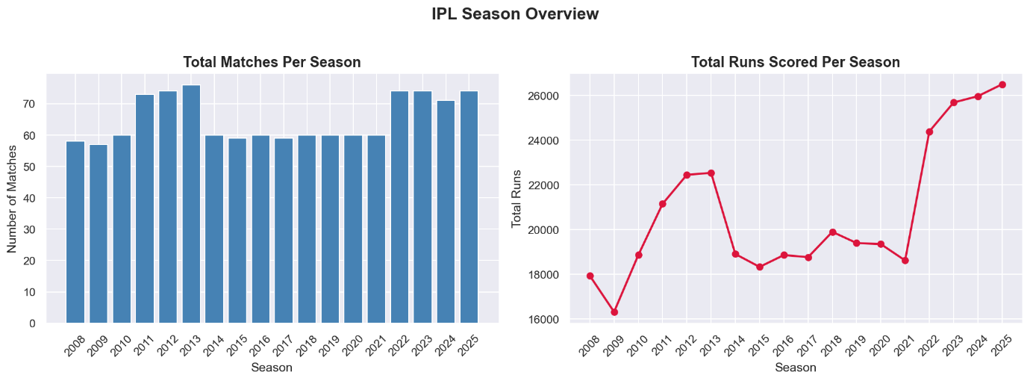

Key Finding 2: Elite Players Dominate Across Eras

BATTING DOMINANCE
Virat Kohli stands as the undisputed king of IPL batting with8,661 runs across 259 matches – nearly 1,600 runs ahead of second placed Rohit Sharma.
However, raw runs alone don’t tell the complete story. AB de Villiers recorded the highest strike rate among all top 15 runs scorers, making him the most destructive batsman in IPL history.
Chris Gayle hit 357 sixes- almost 100 more than any other player in the top 15, earning him the title of the greatest power hitter in IPL history.
Key Batting Insights:
- Kohli: 8,661 runs — all-time leading scorer
- AB de Villiers: 152.18 strike rate — most destructive
- CH Gayle: 357 sixes — greatest power hitter
- MS Dhoni: 241 matches — most experienced player

BOWLING DOMINANCE
YS Chahal leads all-time wicket takers with 221 wickets, while Sunil Narine stands out as the most valuable bowler combining high wickets (192) with the best economy rate 6.80) among all top bowlers.
Jasprit Bumrah's record is particularly impressive - 183 wickets in just 145 matches gives him the best wickets per match ratio among all top bowlers.
Key Bowling Insights:
- YS Chahal: 221 wickets - all-time leading wicket taker
- SP Narine: 6.80 economy -hardest to score off
- JJ Bumrah: 183 wickets in 145 matches -most impactful
- SL Malinga: 170 wickets in just 122 matches -most lethal strike bowler.
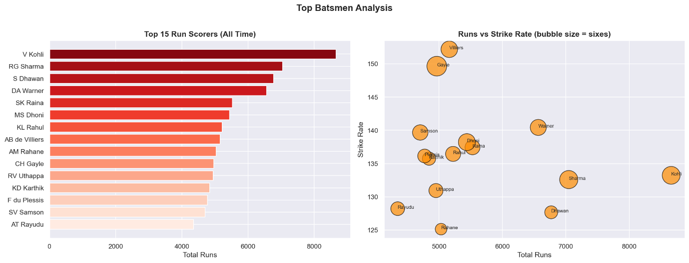

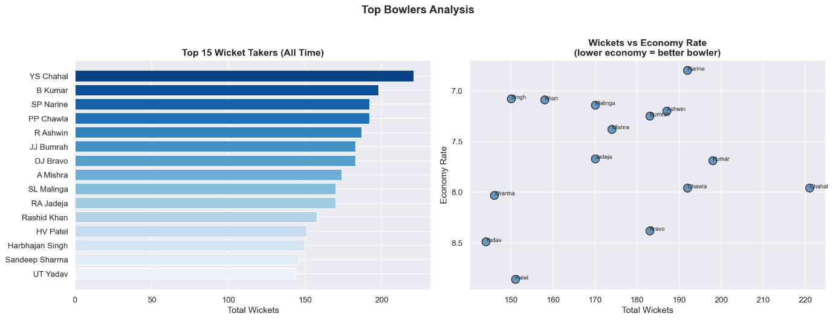

Key Findings 3: Venue and Death Overs Decide Matches

VENUE ANALYSIS
IPL venues vary dramatically in their batting and bowling friendliness. Eden Garden, Kolkata records the highest average runs per over , making it the most batting friendly ground in IPL history.

In contrast, the Maharaja Yadavindra Singh Stadium in Mullanpur records the highest wickets per match (13.50), making it the most bowler friendly venue.
Wankhede Stadium in Mumbai has hosted the most matches (52) making it the home of IPL cricket.
Key Venue Insights:
- Eden Gardens: 9.43 runs/over — most batting friendly
- Mullanpur: 13.50 wickets/match — most bowling friendly
- Wankhede Stadium: 52 matches — most used IPL venue
- Dubai International Stadium featured due to COVID-19
2020 season held in UAE
DEATH OVER SPECIALISTS
The final 5 overs (16-20) are match defining moments in T20 cricket. AB de Villiers recorded an extraordinary strike rate of 225.33 in death overs - the highest among all batsmen who faced 200+ balls in this phase.
Among bowlers, Sohail Tanvir recorded the best death over economy (6.82) while SL Malinga took the most death wickets (108) -cementing his status as the greatest death bowler in IPL history.
Key Death Over Insights:
- AB de Villiers: 225 SR — greatest death over batsman
- AD Russell: 128 sixes in death overs — most destructive
- SL Malinga: 108 death wickets — greatest death bowler
- SP Narine: Elite in both batting and bowling death overs

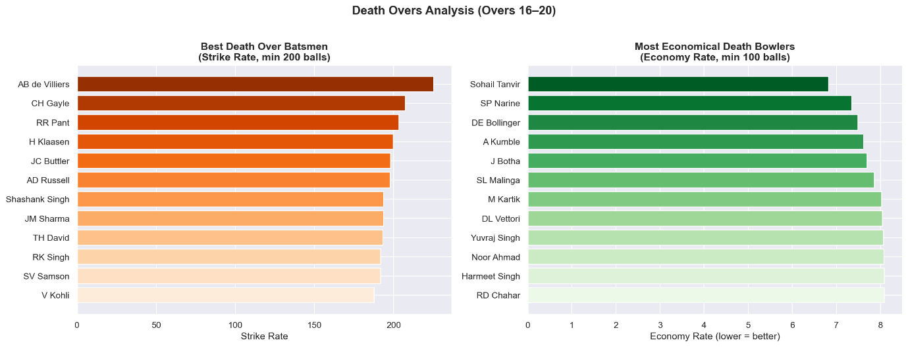

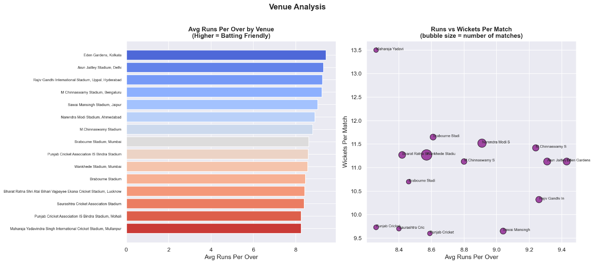
Strategic Recommendation for IPL Franchises

Based on the analysis of 278,205 deliveries across 17 IPL seasons, the following strategic recommendations are presented for IPL franchise management teams:

RECOMMENDATION 1: PRIORITIZE DEATH OVER SPECIALISTS
With scoring rates increasing every season, franchises must invest heavily in death over specialists both in batting and bowling. Players like AB de Villiers, AD Russell and Rishabh Pant consistently deliver 200+ strike rates in overs 16-20.
For bowling, economy rate below 7.50 in death overs should be the benchmark for identifying quality death bowlers in the auction.

RECOMMENDATION 2: VENUE-SPECIFIC TEAM COMPOSITION
Teams should tailor their playing XI based on venue characteristics. At batting friendly venues like Eden Gardens and Arun Jaitley Stadium, teams should field an extra batsman. At bowling friendly venues like Mullanpur, an additional specialist bowler is advisable.

RECOMMENDATION 3: TARGET UNDERVALUED ALL-ROUNDERS
Data shows that all-rounders like SP Narine who contribute in both batting and bowling provide significantly higher value per rupee in the auction.
Franchises should prioritize players with:
- Batting strike rate above 140
- Bowling economy below 7.50
- Ability to contribute in both innings phases

RECOMMENDATION 4: INVEST IN SPIN BOWLING
Among the top 15 wicket takers, 7 are spin bowlers (Chahal, Narine, Chawla, Ashwin, Mishra, Jadeja, Rashid Khan). Spin bowling dominates IPL conditions and franchises should ensure at least 2 quality spinners in their squad.
Conclusion

This analysis of 17 seasons of IPL data demonstrates the power of data-driven decision making in cricket.
Key takeaways:
1. IPL batting has become 15% more aggressive since 2008.
2. Elite players like Kohli, ABD, Chahal and Narine consistently outperform across multiple seasons.
3. Venue selection and death over specialists are the two most critical factors in match outcomes.
4. All-round players provide the highest auction value

The interactive Power BI dashboard accompanying this report allows franchise management to dynamically filter and explore these insights by season, team
and player.
Tools & Technologies Used:
- Python (pandas, matplotlib, seaborn)-Data cleaning and exploratory analysis
- SQL (SQLite)-Structured data querying and views
- Power BI-Interactive dashboard visualization
- Dataset: 278,205 ball-by-ball IPL records (2008-2025)

