**Dataset: -**

Data of Bitcoin, Ethereum, Litecoin, Ethereum Classic and Wrapped Bitcoin has been taken into consideration between 30.01.19 to 27.06.21. As these are the Standard Coins out there, a few minimum Fundamentals are attached below for Reference.

<https://coinmarketcap.com/currencies/bitcoin/>

<https://coinmarketcap.com/currencies/ethereum/>

<https://coinmarketcap.com/currencies/wrapped-bitcoin/>

<https://coinmarketcap.com/currencies/ethereum-classic/>

<https://coinmarketcap.com/currencies/litecoin/>

**NOTE: -**

The market Cap, Volume of Bitcoin and Ethereum are so huge that they outweigh other coins in my analysis.

WBTC is Wrapped Bitcoin which mimics the price of Bitcoin.WBTC is an ERC 20 token in the Ethereum chain which you can hold in your Metamask wallet for easier transactions and trading in Decentralized Exchanges.

You can find a minimum change in prices among WBTC & BTC because of the volume traded, supply and demand in different exchanges.

Ethereum Classic is a Hard Fork of Ethereum created after a hack in Ethereum in 2016, where a few members of the community opted for a separate ICO in a DAO voting.

Litecoin is an early competitor of BTC with a few advantages of fast, simple, low transaction fees with a supply around 4 times that of Bitcoin.

**Opening Price: -**

It’s the opening price at the start of the trading day. The price of BTC is much high compared to all the other coins, which can be noticed below.

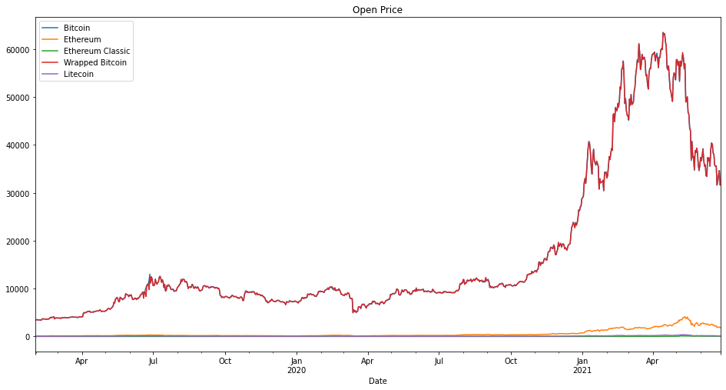

Since only Bitcoin and Ethereum are clearly shown in the above diagram, I have plotted the opening price of other coins separately below.

**Volume Traded: -**

Volume traded can be said as the cryptos that traded and changed hands in a day. It's an important parameter to look into as it decides the liquidity and the number of people getting into it.

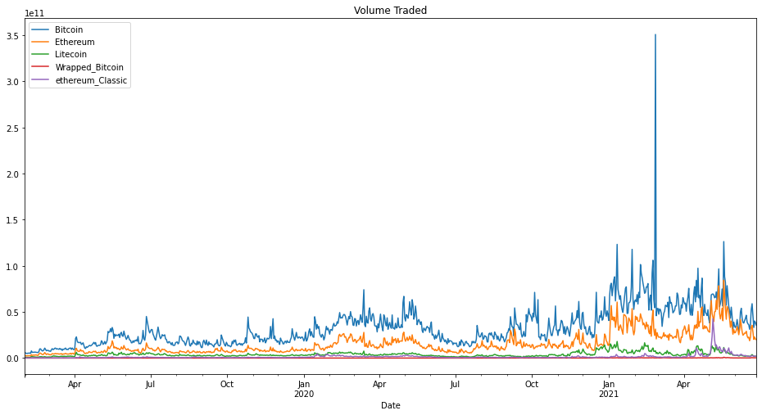

**Market Capitalization: -**

It can be said to be the total price value of a cryptocurrency.

Eg:- The market cap of BTC can be calculated by its current market price multiplied by its total supply (21 Million)

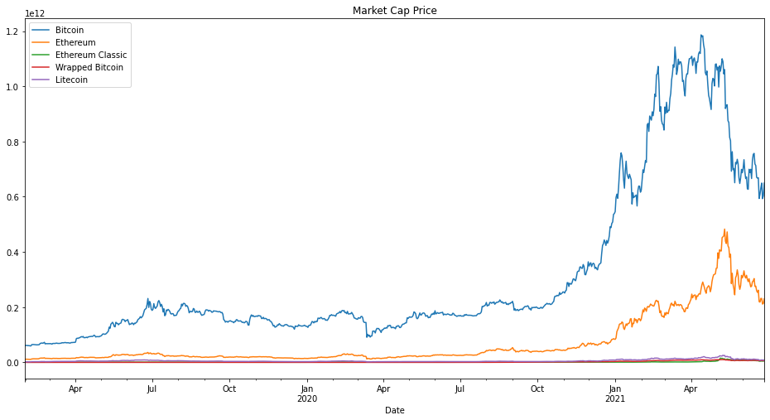

The Crypto Markets are highly volatile, and the market Capitalization of each coin keeps changing except for Bitcoin and Ethereum which stands at position 1 and 2 respectively.

**Moving Average: - (50 & 200)**

The 50 Day moving average is the sum of the closing price of the past 50 days divided by 50, similarly for 200 days as well.

It is a technical indicator to analyze price trends

Above is the Moving average of BTC, and most of the coins follow similar trends as Bitcoin.

**Scatter Matrix: -**

To find the linear correlation between different variables, a scatter matrix is used.

A straight 45-degree line indicates that there is a high correlation between two cryptos.

This can be a good parameter to predict which trend the other coins can open up based on a single coin.

Here below, the scatter matrix is plotted with the opening prices.

This is a matrix to find the correlation between all the different coins to one another.

Generally, when BTC rallies other cryptos follow the trend.

In, the above Scatter Plot BTC & WBTC's graph is a Straight line because Wrapped BTC mimics the price of BTC.

**Daily Returns: -**Daily returns are the profit/loss made by the coin compared to the previous day.

The daily returns of BTC have been plotted above. This can be used to find variations in prices and check volatility on a daily basis.

Various statistical measures like histogram, KDE plot, and Box plot are also plotted below.

**Histogram: -**

The histogram plot of Daily returns is plotted to find the Volatility among these cryptos.

One could use such parameters to find out the most stable coin among the given data.

**KDE Plot: -**

A Kernel density estimate (KDE) plot is a method for visualizing the distribution of observations in a dataset, analogous to a histogram. Unlike histogram, KDE represents the data using a continuous probability density curve.

**Box Plot: -**

A boxplot shows the distribution of the data with more detailed information. It shows the outliers more clearly, maximum, minimum, quartile(Q1), third quartile(Q3), interquartile range (IQR), and median.

It also gives you the information about the skewness of the data, how tightly closed the data is and the spread of the data.

Reference: -

**Scatter Matrix for Daily Returns:-**

**Cumulative Daily Returns:-**

Cumulative returns give the investors an immediate insight into the gains he had made to date, especially if the coins are highly volatile.

**Correlation Coefficient: -**

It is a specific measure that quantifies the strength of the linear relationship between two variables in a correlation analysis.

Pearson is most appropriate for measurements taken from an interval scale(linear relationship between two continuous variables), while the spearman is more appropriate for measurements taken from ordinal scales. (monotonic relationship)

**Pearson Correlation Coefficient: -**

**Spearman Correlation Coefficient: -**

From the above coefficients, one could easily say that it was bitcoin’s power to move the prices of all the coins.

The correlation was stronger, and the effect was well noticed.

Here are a few reasons why bitcoin fell and rallied at different instances during this period.

**Pandemic Effect**

In March 2020, many countries Started Imposing Lockdown. So, Stocks, as well as Crypto markets, Crashed. (Panic Selling)

BTC went down to 5000 range from 8000 Dollars.

Soon as Markets began rallying, BTC went the same way too. Factors like being an Additional Source of Income, Heavy returns, hedge to Inflation and Various Other Factors had a great impact on Bitcoin.

**Tesla Effect**

Tesla Bought 1.5B dollars’ worth of BTC in Feb 2021 around the price of 35k$ and announced on Feb 8 that it is accepting BTC for Telsa Purchases. BTC soared more than 20-25 % and tesla booked a profit of 1 billion Dollars by Feb end itself when BTC was at 57,500 Dollars. BTC touched the market Cap of 1 trillion Dollars during that rally.

on May 13, Tesla due to Environmental issues said that it will no longer accept BTC for its Purchases. The value went down to a 30% low.

Elon's Tweets played an important role at times in deciding the prices too

**CHINA EFFECT**

China banned Few Crypto Exchanges & ICOs on May 18.

in June China announced a ban on crypto mining. The fact is that more than 2/3rd of mining happens in China.

This had a great impact as well.

**Time-series Analysis:-**

For future predictions of coins, we will be using different time series models.

Models like ARIMA need stationary time series. So, we check the stationarity with the help of Dicky fuller test.

Since the time series is not stationary, we will be differencing the models to check if they are stationary again.

Also, the Seasonality distribution is here below to check if the trend is the same as the observed pattern to avoid seasonality.

**Additive model:-**

**Multiplicative Model:-**

The spikes in 2018 are because of the great crypto crash where these coins crashed up to 80% and there was another such incident in 2014 as well.

**First-order Differenced Series:-**

Testing again with the Dicky fuller test tells us the model is stationary and can be used for testing.

1. ADF : -7.243754888662608
2. P-Value : 1.8551860534942282e-10
3. Num Of Lags : 20
4. Num Of Observations Used For ADF Regression: 854
5. Critical Values : 1% : -3.43803040357387 5% : -2.864930295955726 10% : -2.568575256706284

This is how ACF and PACF look before and after differencing.

The value of p and q is found using the autocorrelation and partial autocorrelation curve. The value of p for the AR model is determined using the partial autocorrelation and the value of q for the MA model is determined using the autocorrelation curve and differencing is done once as the series is non-stationary.

p= autocorrelation order

d= integration order (differentiation)

q= moving averages

Now ARIMA(2,1,1) suits the best of all the models for BTC.

Checking with the Residuals and errors before predictions

Now the first 200 rows are used to train the Data and the remaining are used to test.

Now, the Actual vs fitted data looks like this below:-

The Prediction using ARIMA(2,1,1) is done above, and the forecast lies within the Confidence limit.

Same predictive models can be used for WBTC as well

Similarly for **ETH**, ARIMA(7,0,1) suits better and here is the prediction below and calculation can be done the same way to predict others too.

