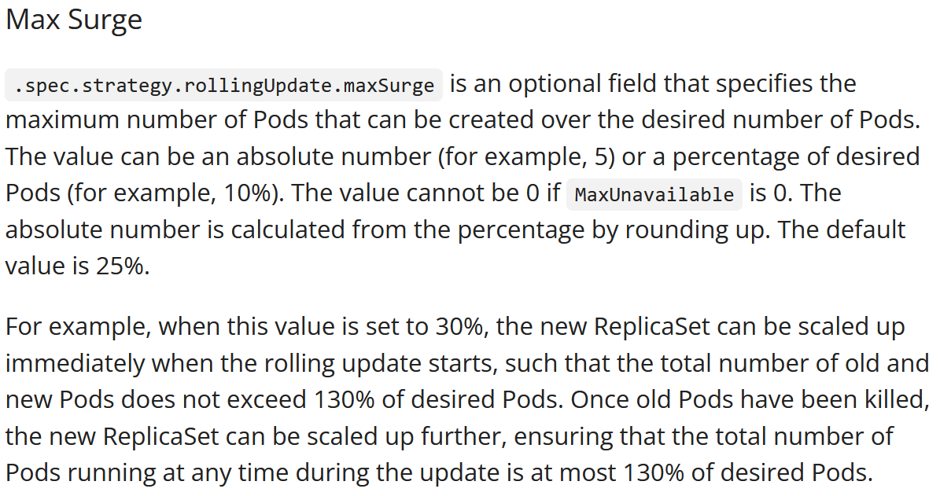

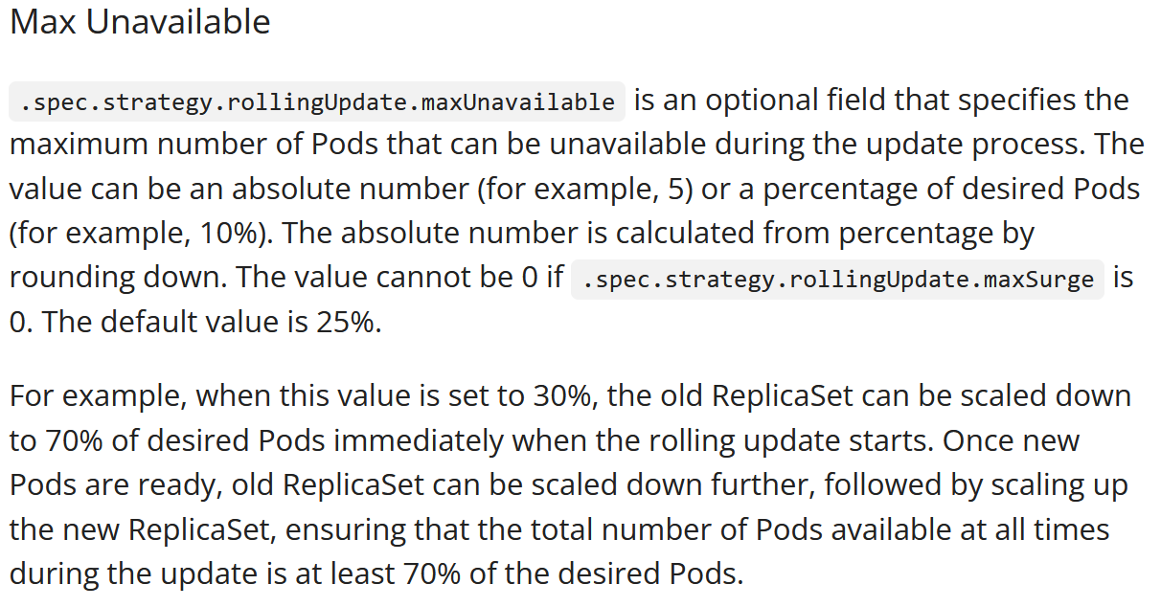

#https://www.bluematador.com/blog/kubernetes-deployments-rolling-update-configuration

apiVersion: apps/v1

kind: Deployment

metadata:

name: nginx-deployment

labels:

app: nginx

spec:

minReadySeconds: 60

replicas: 8

strategy:

type: RollingUpdate

rollingUpdate:

maxSurge: 1

maxUnavailable: 0

selector:

matchLabels:

app: nginx

template:

metadata:

labels:

app: nginx

spec:

containers:

- name: nginx

image: sreeharshav/rollingupdate:v5

ports:

- containerPort: 80

**kubectl rollout undo deployment/app --to-revision=2**

**kubectl set image deployment myapp1 rollingupdate=sreeharshav/rollingupdate:v5 --record**

**kubectl rollout history deployment/app**

**kubectl rollout status deployment/myapp1**

**kubectl rollout pause deployment/myapp1**

