1. Deploy 3 x t2.medium server with 15GB root volume. In the user data give the following to disable swap.

sudo swapoff -a

sudo sed -i '/ swap / s/^\(.*\)$/#\1/g' /etc/fstab

sudo apt update && apt install -y net-tools unzip

1. Connect to each server using public ip and install Container Runtime .

apt update && apt install containerd -y

ps -ef | grep -i containerd | grep -v grep

netstat -nltp | grep -i containerd | grep -v grep

1. Following Install steps in the official documentation.

<https://kubernetes.io/docs/setup/production-environment/tools/kubeadm/install-kubeadm/>

sudo apt-get update && sudo apt-get install -y apt-transport-https ca-certificates curl

mkdir -p /etc/apt/keyrings

curl -fsSL https://packages.cloud.google.com/apt/doc/apt-key.gpg | sudo gpg --dearmor -o /etc/apt/keyrings/kubernetes-archive-keyring.gpg

echo "deb [signed-by=/etc/apt/keyrings/kubernetes-archive-keyring.gpg] https://apt.kubernetes.io/ kubernetes-xenial main" | sudo tee /etc/apt/sources.list.d/kubernetes.list

sudo apt-get update

sudo apt-get install -y kubelet kubeadm kubectl

sudo apt-mark hold kubelet kubeadm kubectl

1. Installing control plane of k8s cluster

modprobe br_netfilter

echo 1 > /proc/sys/net/ipv4/ip_forward

kubeadm init --cri-socket /run/containerd/containerd.sock \

--pod-network-cidr=192.168.0.0/16

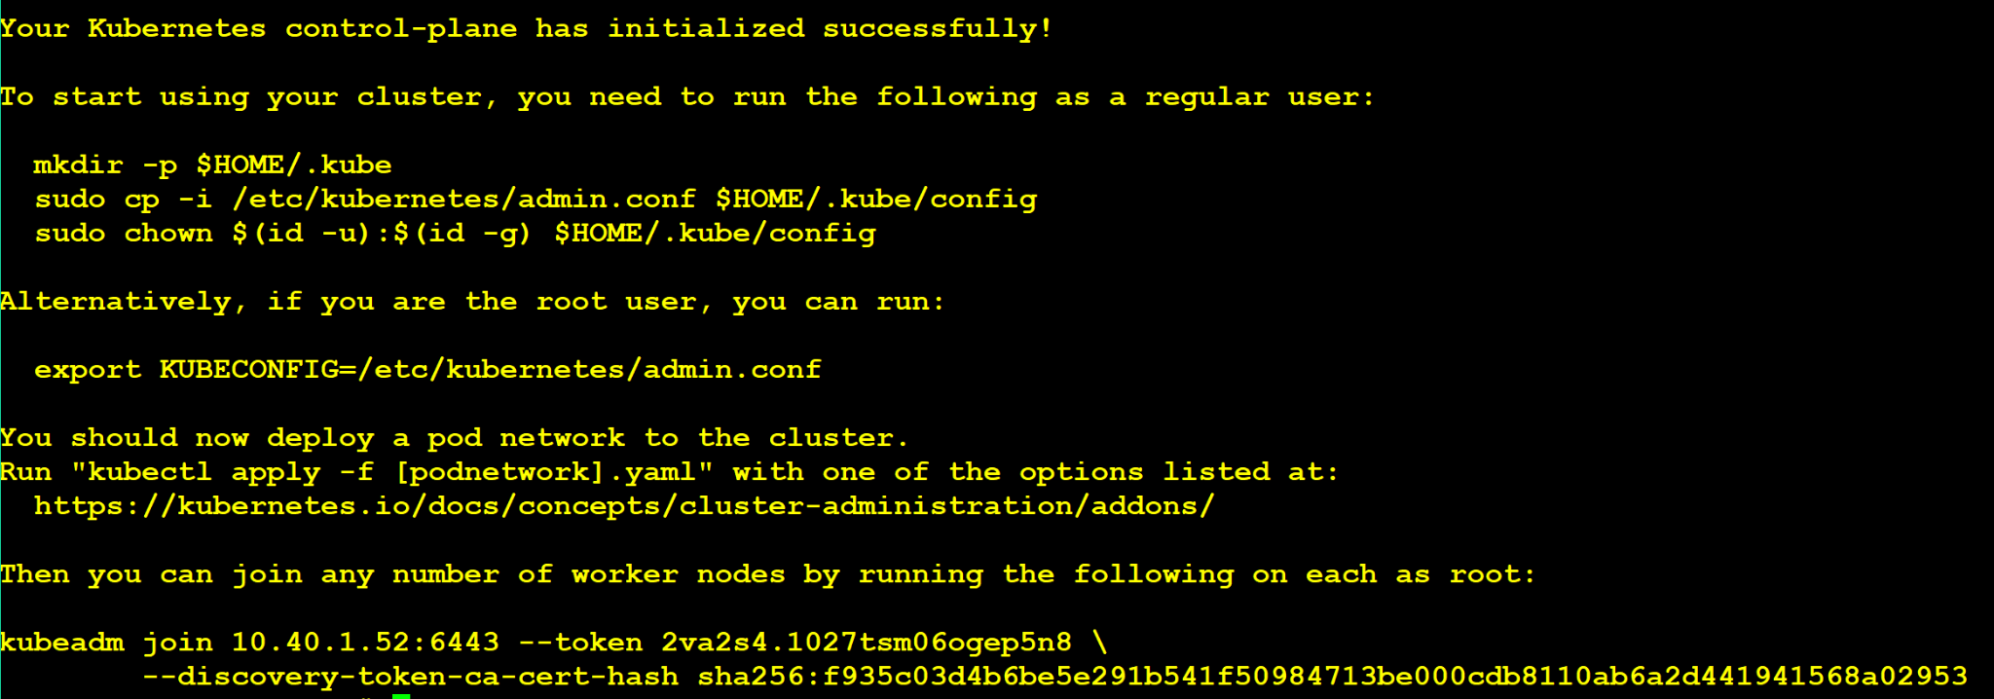

1. Run following steps to configure kubeconfig.

mkdir -p $HOME/.kube

sudo cp -i /etc/kubernetes/admin.conf $HOME/.kube/config

sudo chown $(id -u):$(id -g) $HOME/.kube/config

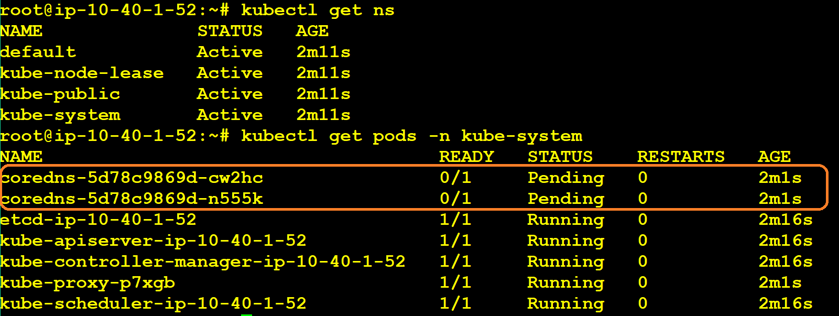

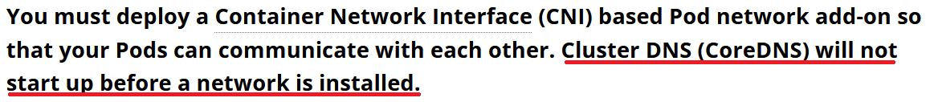

1. We need to install CNI for cross pod communication.

<https://kubernetes.io/docs/concepts/cluster-administration/addons/#networking-and-network-policy>

Install Calico CNI by running following two commands:

kubectl create -f <https://raw.githubusercontent.com/projectcalico/calico/v3.26.1/manifests/tigera-operator.yaml>

kubectl create -f <https://raw.githubusercontent.com/projectcalico/calico/v3.26.1/manifests/custom-resources.yaml>

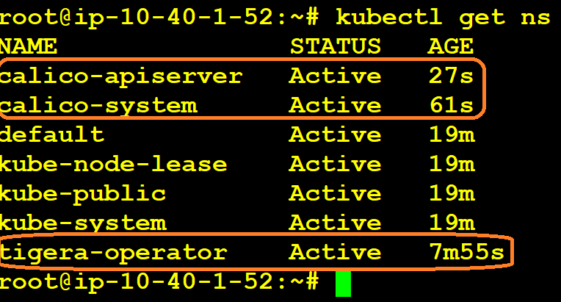

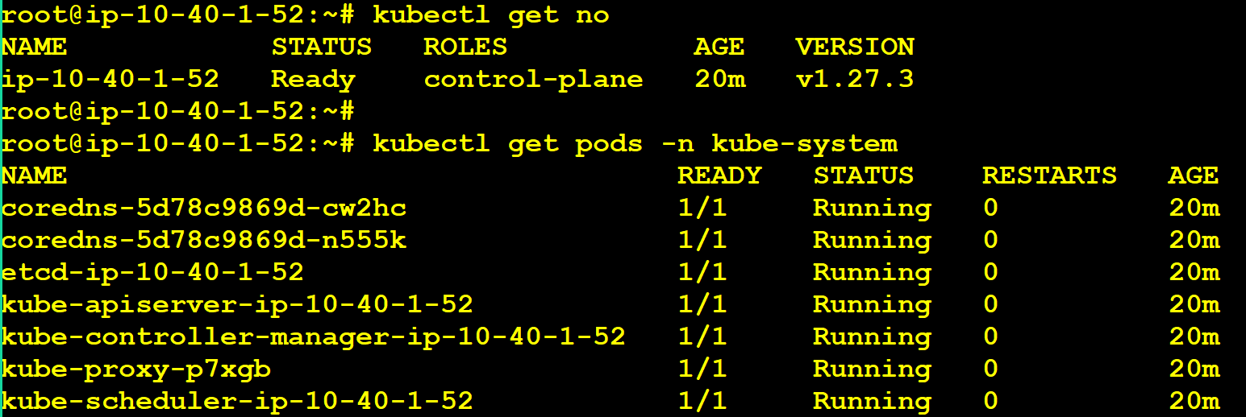

Adding Worker Nodes To The Cluster:

1. Install Steps 1,2,3 and 4 on all worker nodes as well.
2. kubeadm token generate
3. kubeadm token create <token> --print-join-command



4. Execute the join command in the worker node.

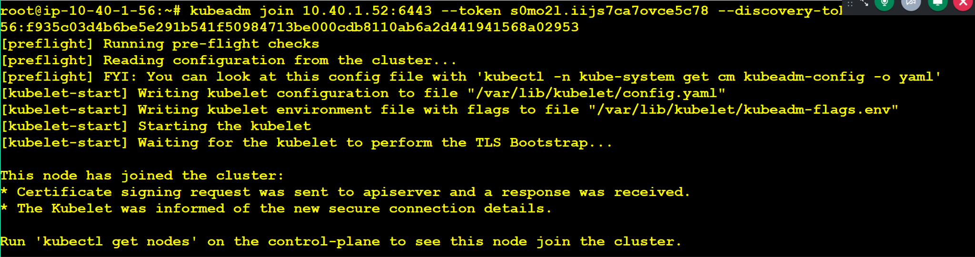

5. Check the master server for worker node.

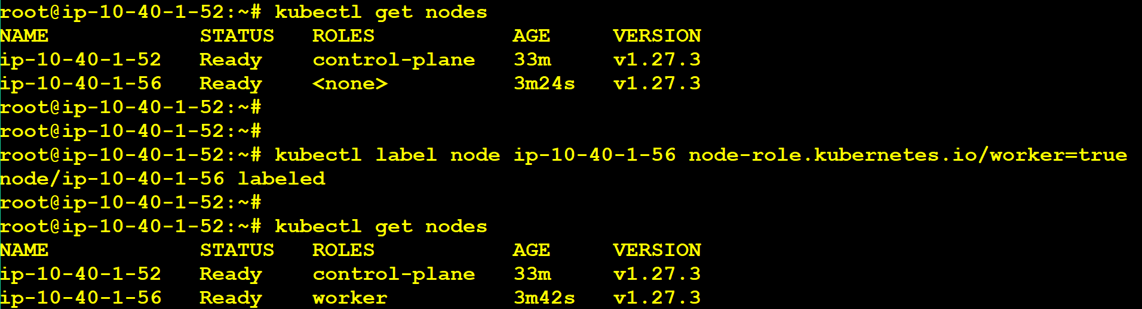

kubectl label node ip-10-40-1-56 node-role.kubernetes.io/worker=true

