<https://www.shellhacks.com/kubectl-debug-increase-verbosity/>

<https://kubernetes.io/docs/tasks/debug/debug-application/_print/>

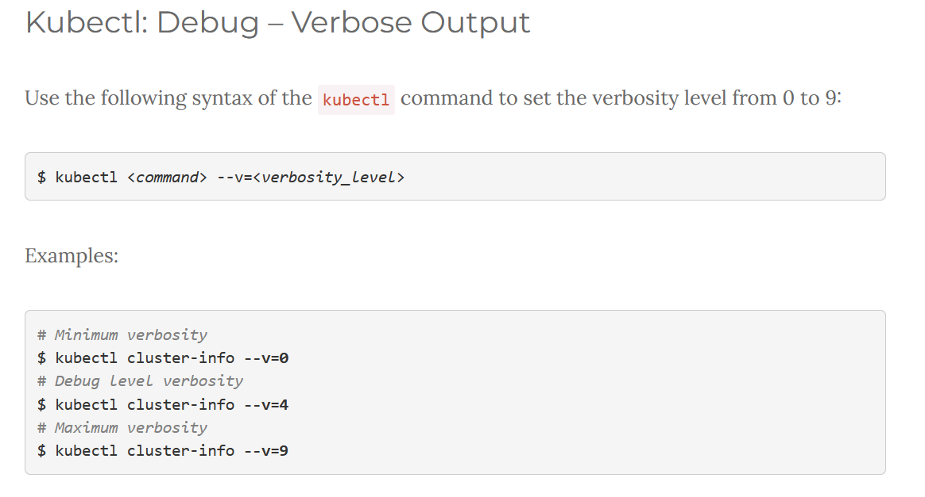

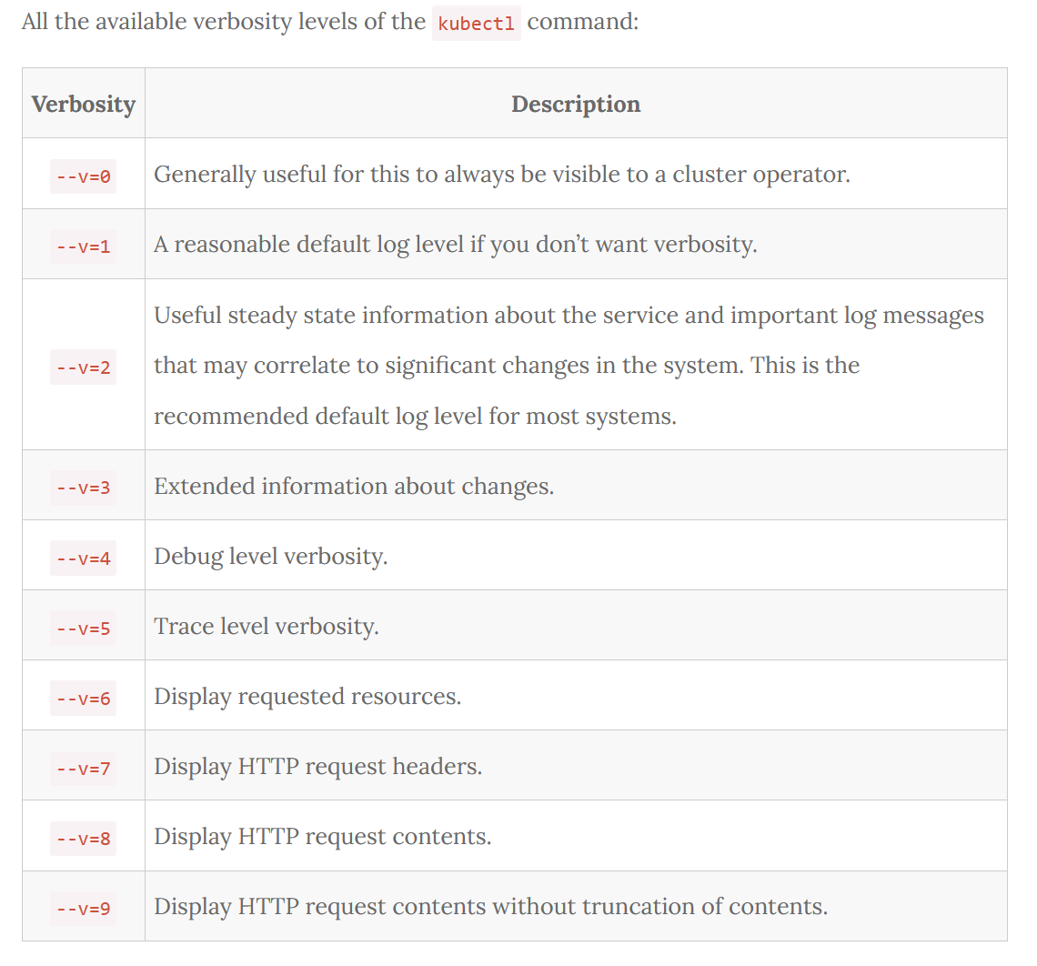

**Tracing is a process about getting information regarding program's execution.** **On the other hand debugging is about finding errors in the code**.