**REPORT**

**ON**

**“MARITIME BORDER ALERT SYSTEM”**

**Submitted by**

**Madhan.T**

**Nagarajan.R**

**MKCE**

**GUIDED BY**

**Asst Prof S.Mohan Raj**

**ABSTRACT:**

The Tamil Nadu factor in India-Sri Lanka relations that had been quiet for long has come to the fore in the form of the fishermen issue. Frequent incidents of fishermen from Tamil Nadu getting shot in the Sri Lankan’s maritime boundary have enraged all citizen of the state. From Tamil Nadu about 18,000 boats of different kinds conduct fishing along the India - Sri Lanka maritime border. Ever since violence broke out in Sri Lanka two decades ago, fishing activity has not been peaceful. Tamil Nadu fishermen are arrested, or shot, by the Sri Lankan Navy.

This problem can be solved by using An Intelligent Boundary Alert System called “MARITIME BORDER ALERT SYSTEM” which induces the new methodology for saving the fishermen valuable life and their properties from the Sri Lankan’s navy. The main objective of this system is used to help the fishermen to navigate inside our maritime country border.

This paper comes with a reliable solution for this problem and protects the Indian fisherman from dangerous situation and being crossing the maritime boundary and save their life and improve the safety of fisherman. Keeping the lives of Fisher men in mind, this system has been developed to help them not to move beyond Indian Boundaries. On the whole it’s an attempt to build a suitable device for fisherman at low cost & user friendly.

**INTRODUCTION:**

There have been several alleged incidents of Sri Lankan Navy personnel firing on Indian fishermen fishing in the Palk Strait, where India and Sri Lanka are only separated by 12 nautical miles. Indian Government has always taken up the issue of safety of Indian fishermen on a priority basis with the Government of Sri Lanka. A Joint Working Group (JWG) has been constituted to deal with the issues related to Indian fishermen straying in Sri Lankan territorial waters, work out modalities for prevention of use of force against them and the early release of confiscated boats and explore possibilities of working towards bilateral arrangements for licensed fishing. The JWG last met in Jan 2006. India officially protested against Sri Lanka Navy for its alleged involvement in attacks on Indian fishermen on January 12, 2011. Over 530 fishermen have been killed in the last 30 years. The apathetic attitude of the Indian government and the national media towards the alleged killing of Tamil Nadu fishermen by the Sri Lankan Navy is being strongly condemned. Several politicians have condemned the Indian Government for not doing enough to stop the killing of Indian Tamil fishermen, and for offering training, equipment, and strategic cooperation for the Sri Lankan Navy.

From the fishermen's point of view, straying takes place inadvertently, due to sheer ignorance about maritime boundaries. At times, the drift is because of engine failure or strong currents. At the same time however, quite a few Indian fishermen engage in free floating to exploit marine resources in Sri Lankan waters, knowing full well, the risks involved in crossing the International Maritime Boundary Line (IMBL). Growing markets for marine resources has forced Tamil Nadu fishermen to take risks.The Indian Coast Guard in spite of having a large fleet at its disposal has not been able to detect foreign intruders in some cases.

Indian Coastguard has openly admitted its failure in preventing 26/11 Mumbai attack even after getting a warning from intelligence sources prior to the attack. This clearly indicates that our sea defense is weaker than we believe. Occasionally the fishermen sight a foreign traveler poaching in their fishing grounds, they are forced to watch helplessly in fear that they might be injured or killed. The trawler would often leave without fear of penalty. Poaching is getting a serious problem since this would cause environmental crisis in coastal zones. The system that we propose not only prevents the fisherman from crossing the International Maritime Boundary Line but also enables the fishermen to report to the Coast Guard on spotting an intruder. This increases the overall security of coast line and also reduces the necessity for periodic patrolling of sea by the coast guard.

The Tamil Nadu fishermen even today invoke the historical rights and routinely stay into the International Maritime Boundary Line (IMBL) for fishing. From Tamil Nadu about 18,000 boats of different kinds conduct fishing along the India-Sri Lanka maritime border. But by accidentally crossing the border without knowledge, they get shot by the Lankan navy. This leads to loss in the both humans as well as their economic incomes. We have developed a system which eliminates such problems and saves the lives of the fishermen.

**EXISTING SYSTEM**

At present there is few system which runs in certain environment and support user for to locate the position and navigation and also guide in hazardous situation. The systems are radar and computer based GPS which were run over coastal guards based which needs regular monitoring and has chance of manual errors which leads to dangerous situation. In some system this manual monitoring are been supervised by computer programmed application run in PC which is not compact and less power consumable device and also not able to understand by common man which means not user friendly. In some system uses GPS when vessel cross the border it cuts off the fuel. The limitation of existing system are not being user friendly, cannot be understand by common man, more expensive, not reliable, dangerous in some case and not effective.

**PROPOSED SYSTEM**

The proposed system uses a GPS receiver which receives signal from the satellite and gives the current position of the boat. The proposed system is used to detect the border of the country through the specified longitude and latitude of the position, not only between Sri Lanka and India but all over the world. The particular layer level i.e. border can be predefined and this can be stored in microcontroller memory. The current value is compared with predefined values and if these values are same, immediately the particular operation will be done i.e., the microcontroller gives instruction to the alarm to buzzer. It also uses a message transmitter to send message to the base station which monitors the boats in the sea. The system provides an indication to both fisherman and to coastal guard. Thus it saves the lives of the fisherman and alerts the base station to provide help.

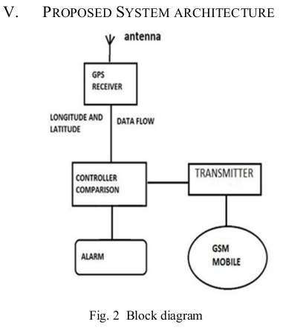

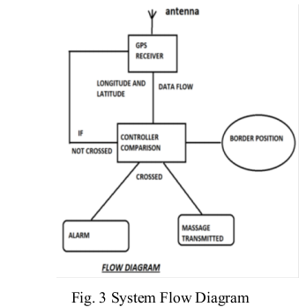

Microcontroller receives the data from the GPS receiver through UART. The data received contains many details along with latitude and longitude. The latitude and Longitude of the current position is separated from the detailed data from GPS. The current positions are compared with already stored latitude and longitude of countries boundary locations. At first the latitude is compared with stored latitude which identifies if the current position is located near to the boundary. If the latitude matches then the adjacent latitudes and longitudes of the present latitude is retrieved from the microcontroller. The current position received from GPS is stored as S1 (latitude), S2 (longitude). The latitude S1 is compared with stored latitudes. If latitude match, then adjacent latitude and longitudes (X1, Y1 and X2, Y2) are retrieved from stored table and substituted in the equation given below:

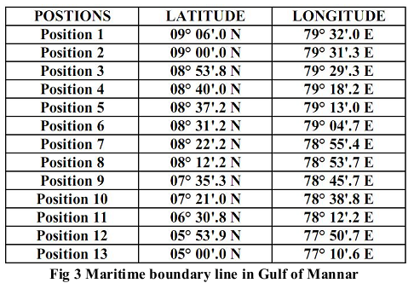

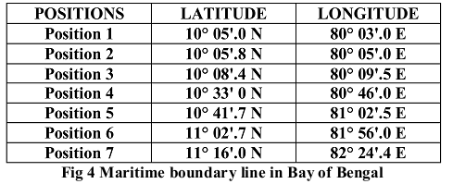

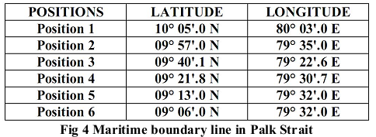

Because GPS receivers do not have atomic clocks, there is a great deal of uncertainty when measuring the size of The Spheres. Each radius corresponds to the distance calculated to the satellite. All possible distances to the satellite are located on the circumference of the circle. If the position above the satellites is excluded, the location of the receiver is at the exact point Where the three circles intersect beneath the satellites. Although the distance to the satellites can only be roughly estimated at first, a GPS receiver can precisely calculate these distances relative to each other. Because the relative size of the spheres is known, there is only one possible point where they can intersect.

**CONCLUSION**

Thus the fishermen can easily identify the national sea borders and therefore prevents them from entering their area. Thus saving their lives and providing good relationship with the neighboring countries. Also, the piracy of ship can be easily brought under control. This system can be proved to be efficient in not only protecting our fishermen but can also aid us in maintaining a check on unauthorized poaching. Reduction in conflicts will improve the bilateral relation between the countries. This system requires minimum human interference for communication thus it can be quick and reliable. The only in this system is that it uses GSM technique which is a queue based technique thus delay in communication might occur. It can be overcome by prioritizing the signals sent by these modules.