**AUTOMATIC TITLE VERIFICATION SYSTEM**

**SIBIDEV RR 23Z367**

**MADHAN KJ 23Z340**

**HARISH KARTHIC R 23Z324**

**23Z411 – APPLICATION DEVELOPMENT LABORATORY**

report submitted in partial fulfillment of the requirement for the award of

degree of

**BACHELOR OF ENGINEERING**

**Branch: COMPUTER SCIENCE AND ENGINEERING**

Of Anna University



May 2025

**DEPARTMENT OF COMPUTER SCIENCE AND ENGINEERING**

**PSG COLLEGE OF TECHNOLOGY**

**(Autonomous Institution)**

**COIMBATORE – 641 004**

**CONTENTS**

**1. PROBLEM STATEMENT**

**2. SOFTWARE REQUIREMENTS SPECIFICATIONS SPECIFICATIONS**

**3. USER INTERFACE DESIGN**

**4. ENTITY RELATIONSHIP DIAGRAM**

**5. DESIGNING TEST SUITES**

**6. HARDWARE AND SOFTWARE REQUIREMENTS**

**7. PROJECT IMPLEMENTATION**

**8. CONCLUSION**

**APPENDIX A**

**APPENDIX B**

**CHAPTER 1**

**PROBLEM STATEMENT**

Problem Statement Title:

An online system to automatically verify new title submissions by checking for similarities with existing titles.

Description:

Background: Press Registrar General of India (PRGI) maintains a database containing approximately 160,000 titles. When a user submits a new title for verification, we need to check its similarity against the existing titles in our database. The goal is to ensure that the new title does not duplicate or closely resemble any existing title to avoid confusion and maintain uniqueness. Additionally, the system must enforce specific guidelines to ensure that certain words are not used, combinations of existing titles are not allowed, and titles with similar meanings or periodicity modifications are rejected.

Problem Description: Develop a system to automatically verify new title submissions by checking for similarities with existing titles in the database and ensuring compliance with specific guidelines. The system should reject titles that are too similar to existing ones, contain disallowed words, or violate other outlined rules. Additionally, the system should provide a probability score indicating the likelihood of a title being verified.

Requirements:

1. Similarity Check:

a. Implement a mechanism to check for similar-sounding names using phonetic similarity algorithms (e.g., Soundex, Metaphone).

b. Identify titles that have common prefixes or suffixes (e.g., The, India, Samachar, News).

c. Ensure that variations in spelling or slight modifications do not bypass the similarity check (e.g., Namaskar vs. Namascar).

d. Calculate a similarity percentage for each title comparison.

2. Prefix/Suffix Handling:

a. Maintain a list of disallowed prefixes and suffixes.

b. Reject any new titles that include these disallowed prefixes or suffixes if they cause the new title to resemble an existing title closely.

3. Guideline Enforcement:

a. Maintain a list of disallowed words (e.g., Police, Crime, Corruption, CBI, CID, Army).

b. Ensure that titles containing these disallowed words are rejected.

c. Prevent the creation of new titles by combining existing ones (e.g., if "Hindu" and "Indian Express" exist, "Hindu Indian Express is not allowed").

d. Check for titles with similar meanings in other languages and reject them (e.g., "Daily Evening" and "Pratidin Sandhya").

e. Disallow adding periodicity (e.g., daily, weekly, monthly) to existing titles to form new ones.

4. Verification Probability:

a. Provide a probability score indicating the likelihood of a title being verified.

5. Database Interaction:

a. Efficiently search and compare new titles against the database of 160,000 titles.

b. Track current applications and use them for future reference to reject similar titles submitted later.

c. Use indexing and optimised search techniques to handle the large dataset and ensure quick responses.

6. User Feedback:

a. Provide clear feedback to the user if their submitted title is too similar to an existing title, contains disallowed prefixes/suffixes, violates guidelines, or is created by combining existing titles.

b. Display the verification probability to the user.

c. Allow the user to modify their title and resubmit it for verification.

7. Scalability:

a. Design the system to handle an increasing number of titles and user submissions.

b. Ensure that the system remains performant as the database grows

**Expected Solution:**

1. The system will provide the probability of a title being verified. For instance, if a title has a similarity score of 80%, the verification probability shall not be more than 100%-80%=20%

2. The system will reject any new title that is too similar to existing ones, contains disallowed words or prefixes/suffixes, combines existing titles, or has similar meanings in other languages.

3. The system will track current applications and use them for future reference, rejecting similar titles submitted later by other users.

Acceptance Criteria:

1. Accuracy:

a. The system correctly identifies similar-sounding titles and provides consistent results.

b. The system accurately rejects titles with disallowed prefixes, suffixes, and words.

c. The system prevents the creation of titles by combining existing titles and identifies titles with similar meanings in other languages.

d. The system disallows adding periodicity to existing titles.

e. The system provides an accurate verification probability score. 2. Performance:

a. Title verification is completed within a reasonable time frame (e.g., under 2 seconds per title).

b. The system can handle multiple title verification requests simultaneously without significant performance degradation.

3. User Experience:

a. Users receive clear and actionable feedback on why their title was rejected.

b. Users see a probability score indicating the likelihood of their title being verified.

c. The interface for title submission and feedback is user-friendly and intuitive.

4. Robustness:

a. The system handles edge cases and variations in spelling effectively.

b. The system is resilient to errors and provides meaningful error messages when issues occur.

**CHAPTER 2**

**2. Software Requirements**

**Specification**

For

**AUTOMATIED TITLE VERIFICATION AND REGISTRATION SYSTEM**

Version 1.0

**CONTENTS:**

**1. INTRODUCTION**

1.1 Purpose

1.2 Scope

1.3 References

1.4 Overview

**2. USE CASE MODEL:**

2.1 Use case diagram

2.2 Use case subsystems

2.3 Use case specifications

2.3.1 User Access & Management Subsystem

* Sign Up
* Log In
* Manage Account Settings
* Approve/Reject Official Accounts
* Manage User Accounts

2.3.2 Title Processing & Management Subsystem

* Submit Title for Verification
* View Title Analysis and Result
* Register Title
* Approve/Reject Title Registrations
* Manage Restricted Words and Affixes

2.3.3 Title Exploration & Records Subsystem

* Search and View Existing Titles
* View Submission History
* Monitor Title Registration History

2.3.4 Support & Help Subsystem

* Access Help & Guidelines
* Contact Support
* Respond to Support Queries

**3. ACTORS OF THE SYSTEM**

**3.1 Title Applicant**

* + Can register, log in, and manage their account
  + Can submit titles for automated verification
  + Can view verification results and modify/register title, if needed
  + Can search and view existing title records and personal history
  + Can access help resources and contact support

**3.2 PRGI Official**

* + Can log in and manage their official profile
  + Can manage restricted words and banned affixes
  + Can view real-time title registrations
  + Can approve/reject title registrations after other legal processes
  + Can browse, filter, and view existing title records

**3.3 System Administrator**

* + Can manage all user accounts and access controls
  + Can approve PRGI official account registrations
  + Can respond to support queries from users
  + Can access and monitor all user activities

**4. STAKEHOLDERS**

4.1 Press Registrar General of India (PRGI) Officials

4.2 Applicants (Publishers, Media Houses, Individuals)

4.3 System Administrators & Developers

4.4 Government & Regulatory Bodies

4.5 Legal & Compliance Teams

4.6 General Public & Readers

**5. REQUIREMENTS**

5.1 Functional Requirements

5.1.1 Similarity Detection System

5.1.2 Guideline Rule Enforcement

5.1.3 Multilingual Title Handling

5.1.4 User Feedback and Guidance

5.1.5 Title Submission and Tracking

5.1.6 Role-Based Access System

5.2 Non-Functional Requirements

5.2.1 Scalability

5.2.2 Performance

5.2.3 Usability

5.2.4 Accuracy

5.2.5 Maintainability

5.2.6 Security

**1. Introduction**

**1.1 Purpose**

This Software Requirements Specification (SRS) document provides a comprehensive overview of the Online Title Verification System. It defines the system’s objectives, functional and non-functional requirements, use case model, key actors, and overall system behaviour. The document serves as a reference for stakeholders, including title applicants, PRGI officials, and system administrators, ensuring a clear understanding of the system's capabilities and constraints. It includes:

• System Overview: A high-level description of the system and its purpose.

• Use Case Model: Identification of key functionalities through well-structured use cases.

• Actors & Interactions: Definition of different user roles and their interactions with the system.

• Functional & Non-Functional Requirements: Detailed specifications guiding the system’s development.

This document is essential for aligning all stakeholders and ensuring the successful design, implementation, and deployment of the system.

**1.2 Scope**

This Software Requirements Specification (SRS) document outlines the requirements for the Online Title Verification System, which automates the process of verifying new title submissions by checking their similarity with existing titles in the PRGI database. The system is designed to:

• Prevent duplication or misleading similarities in submitted titles.

• Enforce predefined guidelines, such as rejecting disallowed words, prefixes, and suffixes.

• Provide probability-based verification to assess title uniqueness.

• Offer user-friendly feedback and allow modifications for rejected titles.

• Support PRGI officials in managing verification rules and reviewing flagged titles.

• Enable system administrators to oversee and maintain system functionality and security.

This document defines the system’s functionalities, user interactions, and constraints, serving as a guide for developers, testers, and stakeholders throughout the software development lifecycle.

**1.3 References**

<https://prgi.gov.in/>

**1.4 Overview**

The Press Registrar General of India (PRGI) is responsible for maintaining a comprehensive database containing approximately 160,000 registered titles. When a user submits a new title for verification, it is essential to ensure that the proposed title does not duplicate or closely resemble any existing title. This process is critical in preventing confusion, maintaining the uniqueness of registered publications, and ensuring adherence to specific regulatory guidelines. However, the current method of title verification presents several challenges that necessitate the development of an automated system.

**2. Use case model**

**2.1 Use case diagram**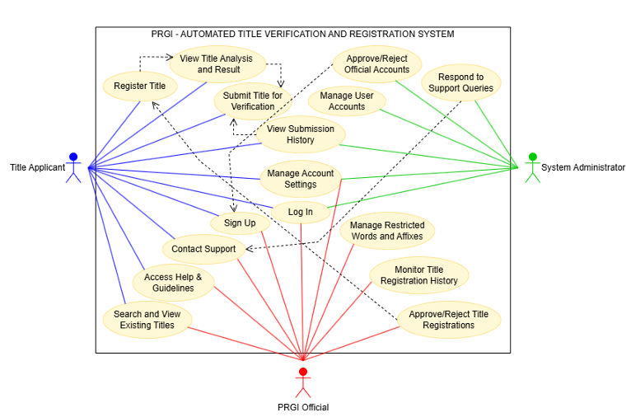

**2.2 Use case subsystems**

The features of PRGI - Automated Title Verification and Registration system are grouped into subsystems and their use cases are listed below.

2.1. User Access & Management Subsystem:

(Handles identity, roles, and user-related configurations)

1. Sign up (Applicant, PRGI official)
2. Log In (All Users)
3. Manage Account Settings (All Users)
4. Approve/Reject Official Accounts (System Admin)
5. Manage User Accounts (System Admin)

2.2 Title Processing & Management Subsystem:

(Covers all functions related to title verification and registration)

1. Submit Title for Verification (Title Applicant)
2. View Title Analysis and Result (Title Applicant)
3. Register Title (Title Applicant)
4. Approve/Reject Title Registrations (PRGI Official)
5. Manage Restricted Words and Affixes (PRGI Official)

2.3 Title Exploration & Records Subsystem:

(Focused on search and view features of existing data)

1. Search and View Existing Titles (Title Applicant, PRGI Official)
2. View Submission History (Title Applicant, System Admin)
3. Monitor Title Registration History (PRGI Official)

2.4 Support & Help Subsystem:

(Assists users and manages their issues and guidance needs)

1. Access Help & Guidelines (Title Applicant, PRGI Official)
2. Contact Support (Title Applicant, PRGI Official)
3. Respond to Support Queries (System Admin)

**2.3 USE CASE SPECIFICATIONS**

1. **USER ACCESS & MANAGEMENT SUBSYSTEM:**
   1. **Sign Up**

|  |  |
| --- | --- |
| **Name** | Sign Up |
| **Description** | Allows new users to create an account. |
| **Actor(s)** | Title Applicant, PRGI Official. |
| **Basic Flow** | 1. The user navigates to the Sign-Up page. 2. The system displays options to select their role (Title Applicant or PRGI Official). 3. The user selects a role, and the respective registration form appears. 4. The user enters required details:    * Full Name    * Email (unique, valid format: [example@domain.com)](mailto:example@domain.com)    * Username (unique, alphanumeric, 5-15 characters)    * Password (minimum 8 characters, including uppercase, lowercase, number, and special character)    * Confirm Password 5. The system validates the input:    * Ensures email and username are unique.    * Checks password strength and match with confirmation. 6. If all validations pass, an email verification link is sent to the user. 7. The system displays "Check your email to verify your account." 8. After email verification, users are taken to their respective dashboards. 9. The use case ends successfully. |
| **Alternate Flows** | 1. **User chooses PRGI Official role**    * The user is taken to official dashboard only after getting verified by the system admin.    * Until then, the user can stay in the signup page or close signup and login directly after getting verification from admin. 2. **Email or Username Already Exists**    * The system prompts: "Email/Username already registered. Try a different one." 3. **Invalid Input Format**    * If any field fails validation, an error message is displayed with guidelines. |

|  |  |
| --- | --- |
|  | 1. **Password Doesn’t Meet Criteria**    * The system prompts: "Password must be at least 8   characters, including uppercase, lowercase, number, and special character."   1. **User Fails to Verify Email**    * If the user doesn’t verify their email within 24 hours, the system deactivates the incomplete registration.    * The user can request a new verification link. 2. **Registration Abandoned**    * If the user leaves mid-registration, no data is stored unless the form is submitted. |
| **Pre-conditions** | The user must have internet access, a valid email, and unique credentials. |
| **Post-conditions** | If successful, the account is created, and the user can log in after email verification. |

* 1. **Log In**

|  |  |
| --- | --- |
| **Name** | Log In |
| **Description** | Allows registered users to access their accounts. |
| **Actor(s)** | Title Applicant, PRGI Official, System Administrator. |
| **Basic Flow** | 1. The user navigates to the login page. 2. The system displays role selection options (Title Applicant, PRGI Official, System Administrator). 3. The user selects their role, and the corresponding login form appears. 4. The user enters their credentials:    * Username or registered email (must match a valid account).    * Password (case-sensitive, must match stored credentials). 5. The system validates the credentials:    * If correct, the system grants access and redirects the user to their dashboard.    * If incorrect, an error message is displayed. 6. If login is successful, the system logs the session and updates last login timestamp. 7. The use case ends successfully. |
| **Alternate Flows** | 1. **Incorrect Username or Password**    * The system displays: "Invalid username or password. Please try again."    * After three failed attempts, the system temporarily locks the account for 5 minutes. 2. **Forgotten Password**    * The user clicks “Forgot Password?”    * The system prompts for a registered email.    * If valid, the system sends a password reset link.    * The user resets the password and logs in successfully. 3. **Account Not Verified (For new official users)**    * If the admin hasn’t verified the new official account after sign-up, the system displays: "Admin verification pending.”    * The user can wait till the admin verifies the account and grants access. 4. **Email Not Verified (For new users)**    * If the user hasn’t verified their email during sign-up, the system displays: "Email verification required. Check your inbox."    * The user can do a new registration through signup. 5. **Inactive or Suspended Account** |

|  |  |
| --- | --- |
|  | * If the account is deactivated by the system administrator, the system displays: "Your account has been suspended. Contact support."  1. **User Navigates Away Before Logging In**    * If the user leaves the page before entering credentials, no action is recorded. |
| **Pre-conditions** | The user must be registered and have an active account. |
| **Post-conditions** | If successful, the user is logged in and can access authorized functionalities. |

* 1. **Manage Account Settings**

|  |  |
| --- | --- |
| **Name** | Manage Account Settings |
| **Description** | Allows users to modify system and account settings. |
| **Actor(s)** | Title Applicant, PRGI Official, System Administrator |
| **Basic Flow** | 1. The user logs into the system and navigates to the "Settings" section. 2. The system displays available preference options categorized as follows:    1. **Account Settings** – Update personal information (name, email, username) or Reset password.    2. **Notification Preferences** – Manage in-app notifications for approval of registration and query responses. 3. The user selects a category and makes the desired modifications. 4. The system validates and saves the changes. 5. A confirmation message is displayed, and the use case ends. |
| **Alternate Flows** | 1. **Invalid Input**    * If the user enters an invalid format for email, password, or other fields, the system displays an error message and prompts for corrections. 2. **Reverting Changes**    * If the user wishes to discard modifications before saving, they can cancel the operation, and no changes will be applied. 3. **Logging Out**    * If the user wishes to log out from the system, then the user can proceed with the “Log out” option from the account settings and securely log out of the system. |
| **Pre-conditions** | The user must be logged into the system. |
| **Post-conditions** | The modified preferences are saved, and the system reflects the updates accordingly. |

* 1. **Approve/Reject Official Accounts**

|  |  |
| --- | --- |
| **Name** | Approve/Reject Official Accounts |
| **Description** | Admin reviews and acts on PRGI official signup requests. |
| **Actor(s)** | System Administrator |
| **Basic Flow** | 1. The system administrator navigates to **Official Signup Requests**. 2. The system displays a list of pending PRGI official signup requests. 3. The admin reviews each request, including the entered details. 4. If applicable, external info is cross-verified for authenticity. 5. The admin either **approves** or **rejects** the request. 6. If approved, the official is granted access and redirected to their dashboard (from signup page) or allowed to login. 7. If rejected, the system discards the request along with provided signup details. 8. The use case ends successfully. |
| **Alternate Flows** | 1. **Insufficient Info**    * If the admin finds insufficient information, they can hold the request. |
| **Pre-conditions** | PRGI official must have completed the signup request form. |
| **Post-conditions** | The PRGI official account is either activated or denied access. |

* 1. **Manage User Accounts**

|  |  |
| --- | --- |
| **Name** | Manage User Accounts |
| **Description** | Allows the system administrator to manage user accounts. |
| **Actor(s)** | System Administrator |
| **Basic Flow** | 1. The system administrator logs into the system and navigates to the "User Management" section. 2. The system displays a list of all registered users, along with their roles and submission history (if Title Applicant) or registration approval history (if PRGI Official). 3. The system administrator selects a specific user account to manage. 4. The system presents available account management options:    1. **Freeze an account** – Temporarily restrict user access based on violations or suspicious activity.    2. **Delete an account** – Permanently remove a user account from the system. 5. The system administrator selects the desired action and confirms the operation. 6. The system processes the request and updates the user account accordingly. 7. The administrator receives a success message. 8. The use case ends successfully. |
| **Alternate Flows** | 1. **Reversal of an Action**    * If the administrator needs to undo a freeze of an account, they can navigate to the affected user’s profile and revert the action. |
| **Pre-conditions** | The system administrator must be logged in with administrative privileges. |
| **Post-conditions** | The selected account is updated based on the performed action, and the changes are logged in the system. |

1. **TITLE PROCESSING & MANAGEMENT SUBSYSTEM:**
   1. **Submit Title for Verification**

|  |  |
| --- | --- |
| **Name** | Submit Title for Verification |
| **Description** | Allows title applicants to enter and submit their titles for analysis. |
| **Actor(s)** | Title Applicant |
| **Basic Flow** | 1. The title applicant logs into the system. 2. The system allows the user to enter the title they wish to verify, through their dashboard. 3. The user enters the title and submits it for verification. 4. The system processes the title and redirects the user to the   **Analysis Page.**   1. The use case ends successfully. |
| **Alternate Flows** | 1. **Invalid Title Entry**    * If the user enters an empty or improperly formatted title, the system prompts for correction before proceeding. 2. **System Processing Delay**    * If title verification takes longer than expected, the system displays a loading indicator and notifies the user to wait. |
| **Pre-conditions** | The title applicant must be logged into the system. |
| **Post-conditions** | The system processes the title, and redirects the user to the Title Analysis Page. |

* 1. **View Title Analysis and Result**

|  |  |
| --- | --- |
| **Name** | View Title Analysis and Result |
| **Description** | Allows title applicants the view the verification analysis for the submitted title along with the verification result. |
| **Actor(s)** | Title Applicant |
| **Basic Flow** | 1. The title applicant successfully submits a title for verification through their dashboard. 2. The system processes the title and redirects the user to the   **Analysis Page**, where the following information is displayed:   * 1. **Similar Titles –** A list of top 50 most similar existing titles is displayed along with their similarity percentage with the submitted title.   2. **Similarity Score** – Displays the highest percentage of similarity with existing titles.   3. **Verification Probability** – Shows the likelihood of approval based on similarity score and some predefined criteria.   4. **View Verification Result** – Displays whether the title is   accepted or rejected based on the verification probability and predefined acceptance threshold.   * 1. **Feedback for Rejections** – If rejected, the system provides reasons for rejection like, too similar to an existing title, usage of restricted words, etc...   2. **Modify & Resubmit** – If the title is rejected, then the user can make changes and resubmit the title.   3. **Register Title** – If the title is accepted, then the user can proceed with title registration.   5. The applicant reviews the analysis results and takes appropriate action. |
| **Alternate Flows** | 1. **Not registering Accepted Title**    * If the user doesn’t want to register an accepted title, then the user is allowed to come out of the analysis page.    * User can use their history section to register these titles. 2. **Access through History**    * If the applicant wants to access the Analysis page of a particular previously submitted title, then the submission history section can be used.    * All unregistered but accepted titles can be registered only through this option. |
| **Pre-conditions** | The title applicant must have submitted a title for verification. |
| **Post-conditions** | The analysis page is displayed with similarity scores, verification probability, verification result and feedback (if rejected) or Register option (if accepted). |

* 1. **Register Title**

|  |  |
| --- | --- |
| **Name** | Register Title |
| **Description** | Allows the title applicant to register an approved title. |
| **Actor(s)** | Title Applicant |
| **Basic Flow** | 1. The title applicant views the analysis page and sees that the title has been accepted. 2. The **"Register Title"** button is enabled for the applicant. 3. The applicant clicks the **"Register Title"** button. 4. The system navigates to the registration page. 5. The system prompts the user to fill out the necessary details including title details and ownership details. 6. The applicant fills out the registration form and confirms the registration. 7. The system takes this form to the PRGI officials. 8. An official verifies other external documents and processes and approves the registration. 9. The title is registered and stored in database. 10. User is notified about the approval of registration. 11. The use case ends successfully. |
| **Alternate Flows** | 1. **Registration Pending**    * The title after submitting the registration form would fall under ‘Pending’ category.    * It would change to ‘Registered’, once the title is approved by an official. 2. **User Cancels Registration**    * The applicant chooses not to proceed and exits the registration page or the applicant cancels a pending submitted registration.    * The title remains approved but unregistered. |
| **Pre-conditions** | The submitted title must be approved in the verification result. |
| **Post-conditions** | The title is successfully registered and stored in the system, with a confirmation message provided to the applicant. |

* 1. **Approve/Reject Title Registrations**

|  |  |
| --- | --- |
| **Name** | Approve/Reject Title Registrations |
| **Description** | Officials act on submitted title registration requests. |
| **Actor(s)** | PRGI Official |
| **Basic Flow** | 1. The PRGI official accesses the **Registration Requests** section. 2. The system displays all pending title registration requests. 3. The official selects a request and reviews the submitted registration form. 4. External legal procedures (outside the website) are verified and confirmed. 5. If all external requirements are met, the official **approves** the registration. 6. The system sends success notifications to both the applicant and the responsible official. 7. The registered title is added to the **Existing Titles** section for public reference. 8. If legal requirements are not met or discrepancies exist, the official may **reject** the request. |
| **Alternate Flows** | 1. **Verification Pending**    * The official may postpone action if external legal procedures are incomplete.    * In that case, the registration is kept as pending. |
| **Pre-conditions** | The title applicant must have submitted the title registration form. |
| **Post-conditions** | The title is either registered or rejected and removed from pending requests. |

* 1. **Manage Restricted Words and Affixes**

|  |  |
| --- | --- |
| **Name** | Manage Restricted Words and Affixes |
| **Description** | Allows PRGI officials to manage the list of restricted words and affixes. |
| **Actor(s)** | PRGI Official |
| **Basic Flow** | 1. The PRGI official navigates to the **"Manage Restrictions"** page. 2. The system provides two sections, “**Restricted Words**” and “**Restricted Affixes**”. Official can choose the one, they need to manage. 3. The system displays the list of all restricted words/affixes along with their details (e.g., category (if affixes), last   modified/added by, date modified/added).   1. The official can perform the following actions:    * **Add a New Restricted Word/Affix:**      1. Enter the new word/affix in the space provided.      2. Select the category as prefix or suffix (if affix).      3. Confirms to add the word/affix to the list.    * **Modify an Existing Word/Affix:**      1. Selects a word/affix from the list.      2. Edits its details (e.g., spelling, category).      3. Saves the changes.    * **Delete a Word/Affix:**      1. Selects a word/affix from the list.      2. Clicks **"Delete"** and confirms the deletion. 2. The page includes the following features:    * **Search Bar:** To find specific words.    * **Sorting:** By word/affix name and date modified.    * **Filters:** To view words/affixes based on categories or date range.    * **Pagination:** To navigate large lists efficiently. 3. After adding, modifying or deleting a word/affix, the system saves the changes in the database along with the officials’ username and date of action. 4. A notification is sent to all the officials mentioning the action, official name and date of the action. 5. These restrictions are updated and will be applied for further verification processes. |
| **Alternate Flows** | 1. **User Cancels an Action**    * At any point, the PRGI official can cancel adding, modifying, or deleting a word/affix.    * No changes are saved. 2. **Attempt to Add a Duplicate Word/Affix** |

|  |  |
| --- | --- |
|  | * The system checks if the word/affix already exists. * If found, an error message is displayed, preventing duplication. |
| **Pre-conditions** | The PRGI official must be logged into the system. |
| **Post-conditions** | The restricted words/affixes list is updated based on the PRGI official's actions and a notification mentioning the changes is sent to all the officials. |

1. **TITLE EXPLORATION & RECORDS SUBSYSTEM:**
   1. **Search and View Existing Titles**

|  |  |
| --- | --- |
| **Name** | Search and View Existing Titles |
| **Description** | Allows users to search, filter, and view existing titles. |
| **Actor(s)** | Title Applicant, PRGI Official |
| **Basic Flow** | 1. The user navigates to the **"Existing Titles"** page. 2. A list of all existing titles is displayed. 3. The user can enter keywords in the search bar to find specific titles. 4. The system filters the list dynamically based on the search input. 5. The user can apply sorting and filtering options, including:    * **Sort by:** Alphabetical order, Date of registration, etc...    * **Filter by:** Category, Language, etc... 6. The user selects a title from the list. 7. The system displays the title’s detailed description. 8. The use case ends successfully. |
| **Alternate Flows** | 1. **No Matching Titles Found**    * If no titles match the search criteria, the system displays a message: **"No matching titles found."**    * The user can modify the search query or reset filters. |
| **Pre-conditions** | The user must be logged into the system. |
| **Post-conditions** | The user successfully searches and views existing title details. |

* 1. **View Submission History**

|  |  |
| --- | --- |
| **Name** | View Submission History |
| **Description** | Allows title applicants to view their past title submissions. |
| **Actor(s)** | Title Applicant, System Administrator |
| **Basic Flow** | 1. The applicant navigates to the **History** section. 2. The system provides two sections namely, verification history and registration history. 3. Applicant can choose either verification or registration history to view.   **Verification History:**   1. All the previously submitted titles for verification are listed along with the details like status and date of submission. 2. User can open the analysis page of a title by clicking the info button provided. 3. If the applicant wants to register a pre-verified accepted title, then the info button can be used to register the title through analysis page.   **Registration History:**   1. All the previously submitted titles for registrations are listed along with the details like status and date of submission. 2. User can check whether a title registration is approved by any official and got registered in the system. 3. The Applicant can cancel any registration if the registration is not approved by any official. 4. The use case ends successfully. |
| **Alternate Flows** | 1. **Pre-verified Registration**    * A pre-verified accepted title can be registered only through this history page.    * The titles that are accepted during verification process are stored in a buffer, so that no other similar titles can be accepted during verifications. 2. **Delete Title**    * If the user wants to delete a title from verification history.    * The title is also removed from the buffer to allow further similar titles during verification. 3. **Cancel registration**    * Once a pending registration is cancelled, the registration is marked as “Cancelled” in the place of status. 4. **Admin access**    * The system admin can also view the submission history of any applicant through the “Manage Users” section. |

|  |  |
| --- | --- |
| **Pre-conditions** | The user must have submitted at least one title for verification. |
| **Post-conditions** | The applicant can view the history of submissions and manage them. |

* 1. **Monitor Title Registration History**

|  |  |
| --- | --- |
| **Name** | Monitor Title Registration History |
| **Description** | PRGI officials can view recently registered titles and their details. |
| **Actor(s)** | PRGI Official |
| **Basic Flow** | 1. PRGI official opens their dashboard. 2. A list of recently registered titles is displayed with details such as:    * Title name    * Registration date    * Publisher name 3. The most recently registered title is present at the top of the list. 4. The official can click on any title to view its full description. |
| **Alternate Flows** | 1. **Accessing older titles**    * If the official wants to access any title that is not present in the recently registered title list, then it can be accessed from the Existing titles section, with appropriate filters and sorting. |
| **Pre-conditions** | The PRGI official must be logged in with the necessary permissions. |
| **Post-conditions** | Officials gain insights into recent registrations of Titles. |

1. **SUPPORT & HELP SUBSYSTEM:**
   1. **Access Help & Guidelines**

|  |  |
| --- | --- |
| **Name** | Access Help & Guidelines |
| **Description** | Provides guidance on using the software. |
| **Actor(s)** | Title Applicant, PRGI Officials |
| **Basic Flow** | 1. The user navigates to the **Help and Guidelines** section. 2. The system displays a categorized list of topics, including:    * **General Overview:** Introduction to the system and its purpose.    * **Title Submission Process:** Steps to submit, modify, and verify a title.    * **Analysis Page Explanation:** Understanding similarity   scores, verification probability, and rejection feedback.   * + **Title registration:** How the registration process works, when and how to register.   + **Accessing Submission History:** How and why to use History section.   + **Existing Titles:** How to access existing titles list.   + **Notification:** Getting Support and Registration responses.   + **Guidelines for Officials:** Managing restrictions and registrations.  1. If further assistance is needed, users can access contact support. |
| **Alternate Flows** | 1. **Downloadable Help Documents**    * Users can download PDFs or guides for ofline reference. |
| **Pre-conditions** | The user must be logged into the system. |
| **Post-conditions** | The user gains knowledge about the system and its functionalities. |

* 1. **Contact Support**

|  |  |
| --- | --- |
| **Name** | Contact Support |
| **Description** | Allows users to message the system administrator. |
| **Actor(s)** | Title Applicant, PRGI Officials |
| **Basic Flow** | 1. The user navigates to the **Contact Support** section. 2. The system prompts the user to provide a detailed description of the issue faced. 3. The user enters the problem description in the space provided and submits the request. 4. The system sends the message to the **System Administrator**. 5. The administrator reviews the issue and responds via the system. 6. The user receives a notification when a response is available. |
| **Alternate Flows** | 1. **Response Delay**    * If the system admin takes time to respond to support requests, then the user will not get any notification.    * User may need to wait till he/she gets a response. |
| **Pre-conditions** | The user must be logged into the system. |
| **Post-conditions** | The user receives assistance from the system administrator. |

* 1. **Respond to Support Queries**

|  |  |
| --- | --- |
| **Name** | Respond to Support Queries |
| **Description** | Allows the system administrator to view and respond to support requests. |
| **Actor(s)** | System Administrator |
| **Basic Flow** | 1. The system administrator navigates to the **Support Requests**   section.   1. The system displays a list of all support requests, including:    * Username    * User role (Title Applicant / PRGI Official)    * Submission Date and Time 2. The administrator selects a support request to review. 3. The system displays detailed information of the issue, provided by the user. 4. The administrator types a response and submits it. 5. The system sends the response to the user as a notification. |
| **Alternate Flows** | 1. **Filter and Sort Requests**    * The administrator can filter or sort requests by user type or date. |
| **Pre-conditions** | The system administrator must be logged into the system and Users (title applicants or PRGI officials) must have submitted support queries. |
| **Post-conditions** | The user receives a response or resolution to their support query. |

**3. Actors of the System**

**3.1 Title Applicant**

1 Title Submission & Analysis

* + Users can submit a new title through their dashboard input field.
  + Upon submission, the system redirects them to an analysis page.
  + The **left sidebar displays the top 50 most similar titles** from the database for user comparison.
    - *Example:* If a user submits “India Morning Express,” they might see “India Evening Express” at the top with 93%

similarity.

* + The **top match's similarity score is shown**, and the **verification**

**probability** is calculated as 100 - similarity score.

* + If a disallowed word or rule violation is detected, **verification probability becomes 0%** immediately.
    - *Example:* If the title contains the word “CBI,” even if the similarity score is low, it will still get a 0% probability.
  + Based on the PRGI-set threshold (e.g., 30% minimum probability), the title gets:
    - Status: Accepted if above threshold.
    - Status: Rejected if below.

2. Feedback for Rejected Titles

* + If a title is rejected, the user is shown a **feedback explanation**

based on the failed rules.

* + - *Example:* “Rejected due to disallowed word: ‘Police’” or “Too similar to existing title: ‘India Police Weekly’.”

3. Modify and Resubmit Option

* + Users can edit the rejected title and try again using a **“Modify and Resubmit”** button.

4. Title Registration (Post-Approval)

* + If a title is accepted, users can **fill out required registration details**

to officially register the title.

* + The title is registered once an official approves the registration, after all other legal processes.
    - *Example:* They may need to enter publisher name, location, language, etc.

5. Search and View Existing Titles

* + Users can **search for and explore existing verified titles** in the database.
  + Filter and sort options (by language, region, etc.) may be available.

6. Verification & Registration History

* + Full **history of submissions and registration attempts** with status shown in table.
    - *Example:* “My Submissions: India Morning Express – Rejected – Submitted on 03/02/2025.”

7. Notification System

* + Real-time **notifications** for:
    - Admin responses to contact queries.
    - Official approvals for title registrations.

8. Help & Guidelines Section

* + A **user help centre** that includes:
    - Guidelines for creating valid titles.
    - Visual examples of accepted vs. rejected titles.
  + The document includes explanations of the features available for any Title Applicant.

9. Contact Support

* + Users can **submit a query or report a problem** to the system administrator.
  + Responses are shown as **notifications** within the user's panel.

10. Account Settings

* + Modify profile details like email, password, and personal info.
  + *Example:* Update registered email address from [user1@mail.com](mailto:user1@mail.com) to [user2@mail.com.](mailto:user2@mail.com)

**PRGI Official:**

1. Dashboard Overview

* + Monitor trends such as title registrations, along with the timestamp of registration.

2. Approval of Title registrations

* + Approve or reject any registration manually based on other legal documents.
  + All other activities except verification and registration of titles are done externally.

3. Restricted Vocabulary Management

* + Add or edit restricted words and banned affixes (prefixes/suffixes).
  + All changes directly affect automated guideline enforcement.

4. Existing Titles Explorer

* + Search and filter the database of registered titles by language, status, publisher, etc.
  + View full metadata of each title (e.g., submitter, acceptance date, approving official).

5. Help and Guidance Access

* + Access the guideline documentation to understand the system and the process of title verification.
  + The document includes explanations of the features available for any PRGI official.

6. Support Communication

* + Send queries to admins through an internal messaging system.

7. Account and Settings Management

* + Update login details, change password, and configure system preferences.

**System Administrator:**

1. Support Query Management

* + View all support queries submitted via the "Contact Support" feature.
  + Respond to user queries, with replies sent as in-app notifications.

2. User Activity Monitoring

* + View detailed profiles of all users (applicants and officials).
  + View activity history such as title submissions, registrations, etc.
  + Monitor behaviour for misuse, inactivity, or anomalies.

3. Official Account Verification

* + Access a list of all official signup requests.
  + Manually verify the legitimacy of official credentials.
  + Approve or reject official registrations.
  + Only upon approval can an official log in.

4. User Account Management

* + View a list of all registered users (both applicants and officials).
  + Temporarily freeze user accounts to restrict access.
  + Permanently remove users from the system.

5. Exclusive Admin Access

* + Only one admin account exists.
  + No public sign-up route for admin.
  + Admin credentials are securely maintained and cannot be changed by other user roles.

6. Platform Integrity Oversight

* + Periodically check the functional behaviour of modules (title verification, registration, etc…).
  + Verify that the database reflects the correct and expected data entries.
  + Although most non-functional checks are done outside the app (e.g., server tools), the admin ensures feature integrity.

**4. Stakeholders**

The key stakeholders involved in this system include,

4.1. Press Registrar General of India (PRGI) Officials

* Oversee and manage the registration of titles.
* Ensure compliance with regulatory guidelines.
* Utilize the system for efficient title verification.

4.2. Applicants (Publishers, Media Houses, Individuals)

* Submit new titles for verification.
* Receive feedback and modify submissions if required.
* Rely on the system for a transparent approval process.

4.3. System Administrators & Developers

* Maintain, update, and optimize the automated verification system.
* Ensure database integrity and performance.
* Address technical issues and implement new features.

4.4. Government & Regulatory Bodies

* Define and enforce title registration guidelines.
* Monitor compliance with national media and publication laws.

4.5. Legal & Compliance Teams

* Handle disputes related to title rejections.
* Ensure that the system aligns with copyright and trademark regulations.

4.6. General Public & Readers

* Benefit indirectly from clear, unique, and distinguishable publication titles.
* Avoid confusion due to duplicate or misleading publication names.

Each stakeholder plays a crucial role in ensuring the system functions efficiently and maintains the integrity of the title verification process.

**5 REQUIREMENTS**

**5.1 Functional Requirements:**

5.1.1 Similarity Detection System:

Detect phonetic, spelling-variant, and semantic similarities between submitted titles and existing ones. Uses algorithms like Soundex, Metaphone, Levenshtein distance, and optional NLP-based embeddings.

Example: A user submits "Namaskar Bharat". The system finds it 88% similar to "Namascar Bharat Times" using Soundex + Levenshtein, and f lags it for review.

5.1.2 Guideline Rule Enforcement:

Automatically checks titles against PRGI rules such as banned words, restricted prefixes/suffixes, prohibition of combination of titles and addition of periodicities to other titles.

Example: A user submits "Crime Reporter Daily". The system flags it due to the banned word "Crime" and improper suffix usage.

5.1.3 Multilingual Title Handling:

Detects semantic duplicates across different languages. Involves using multilingual synonym dictionaries or translation APIs to find meaning overlaps.

Example: A Hindi title "Dainik Samachar" is flagged for being semantically equivalent to the English title "Daily News".

5.1.4 User Feedback and Guidance:

Gives clear, actionable reasons for title rejections to help users identify the problem in the submitted title.

Example: A title like "Indian Express Chronicle" is rejected with explanation: “Combination of two existing titles: Indian Express + Chronicle.” Suggestions are provided to modify the name.

5.1.5 Title Submission and Tracking:

Tracks submissions, prevents duplicate applications, and maintains user specific title history.

Example: If "Economic Post" is already submitted by one user and under review, another user submitting the same title will be notified of the conflict.

5.1.6 Role-Based Access System:

Different interfaces and permissions for Title Applicants, PRGI Officials, and System Administrators.

Example: Only PRGI Officials can manage banned words or approve title registrations. Admin responds to queries**.**

**5.2 Non-Functional Requirements**

5.2.1 Scalability: The system must efficiently handle a large volume of data and users.

Example: Even with 200,000 titles and 2,000 daily submissions, the system should not crash or lag.

5.2.2 Performance: Fast response time for similarity checks and feedback.

Example: Title similarity and rule validation completes under 2 seconds even during peak usage.

5.2.3 Usability: The interface should be intuitive and assist users throughout the process.

Example: A user gets suggestions as they type, like "Avoid banned words such as ‘CBI’, ‘Crime’, etc.”

5.2.4 Accuracy: High correctness in similarity detection and rule enforcement.

Example: Two visually different titles like "Desh ki Awaaz" and "Voice of Nation" are correctly flagged as similar.

5.2.5 Maintainability: Easy to update rules and logic without full system redeployment.

Example: Official adds "Forces" to the disallowed list from their dashboard, no code changes required.

5.2.6 Security: Secure authentication and protection of title data and user accounts. Example: Titles submitted by one applicant can't be viewed or edited by another. Passwords are hashed and stored securely.

**CHAPTER 3**

**USER INTERFACE DESIGN**

**Log in**

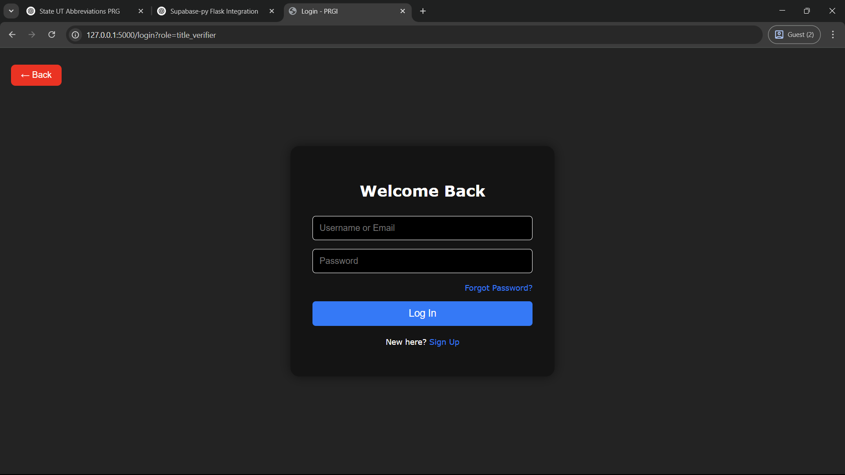

**Sign up**

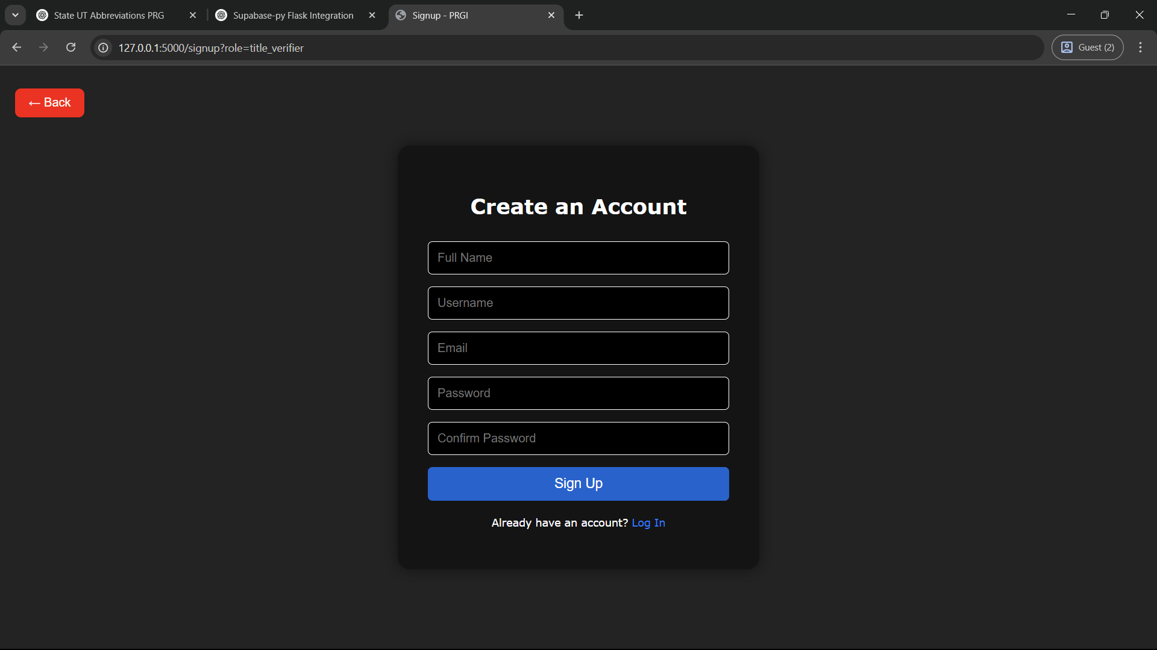

**Manage Account Settings**

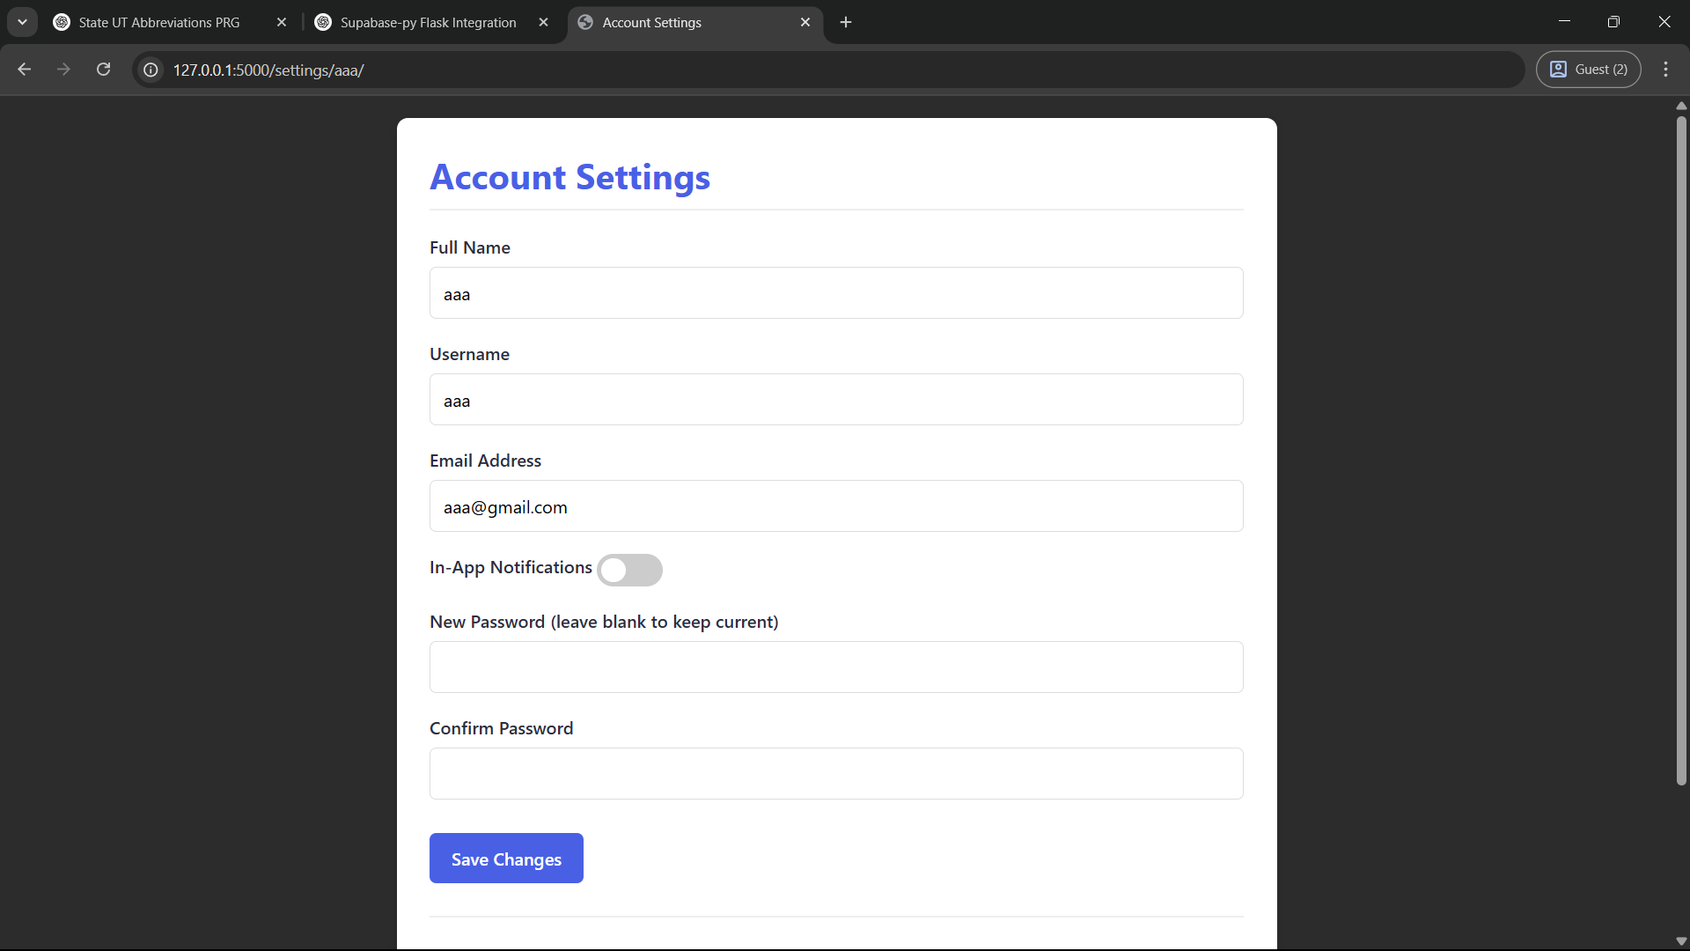

**Approve/Reject Official Accounts**

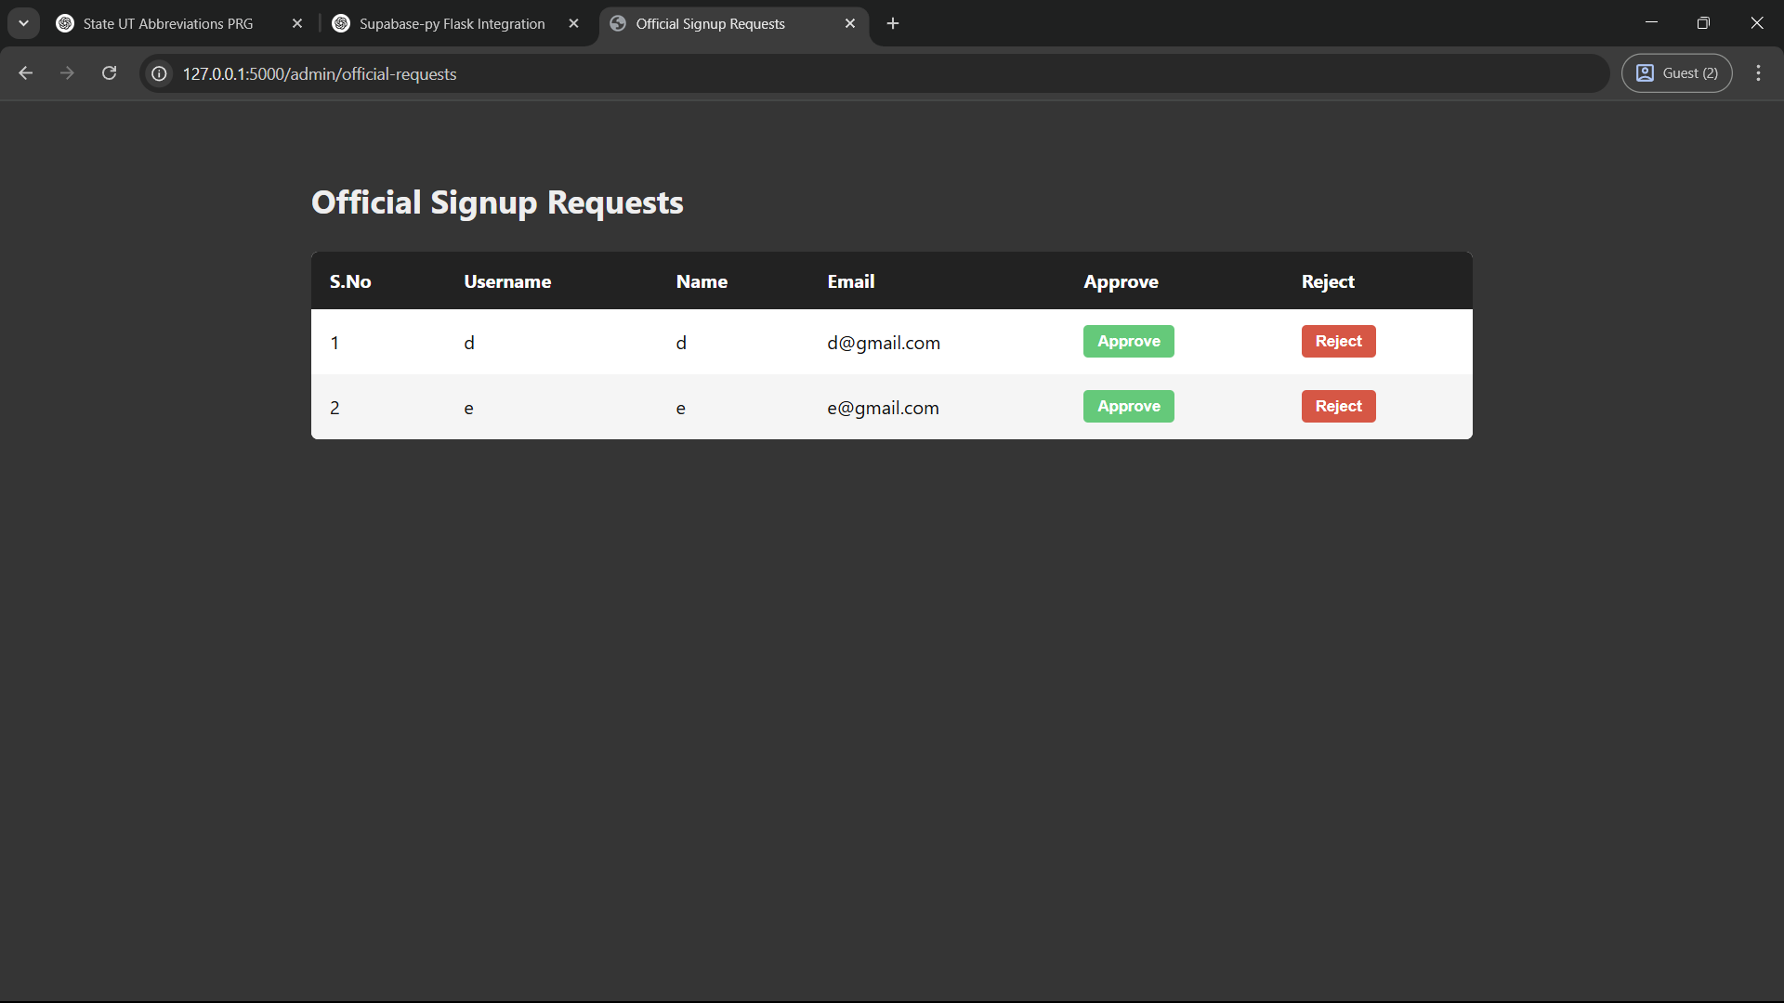

**Manage User Accounts**

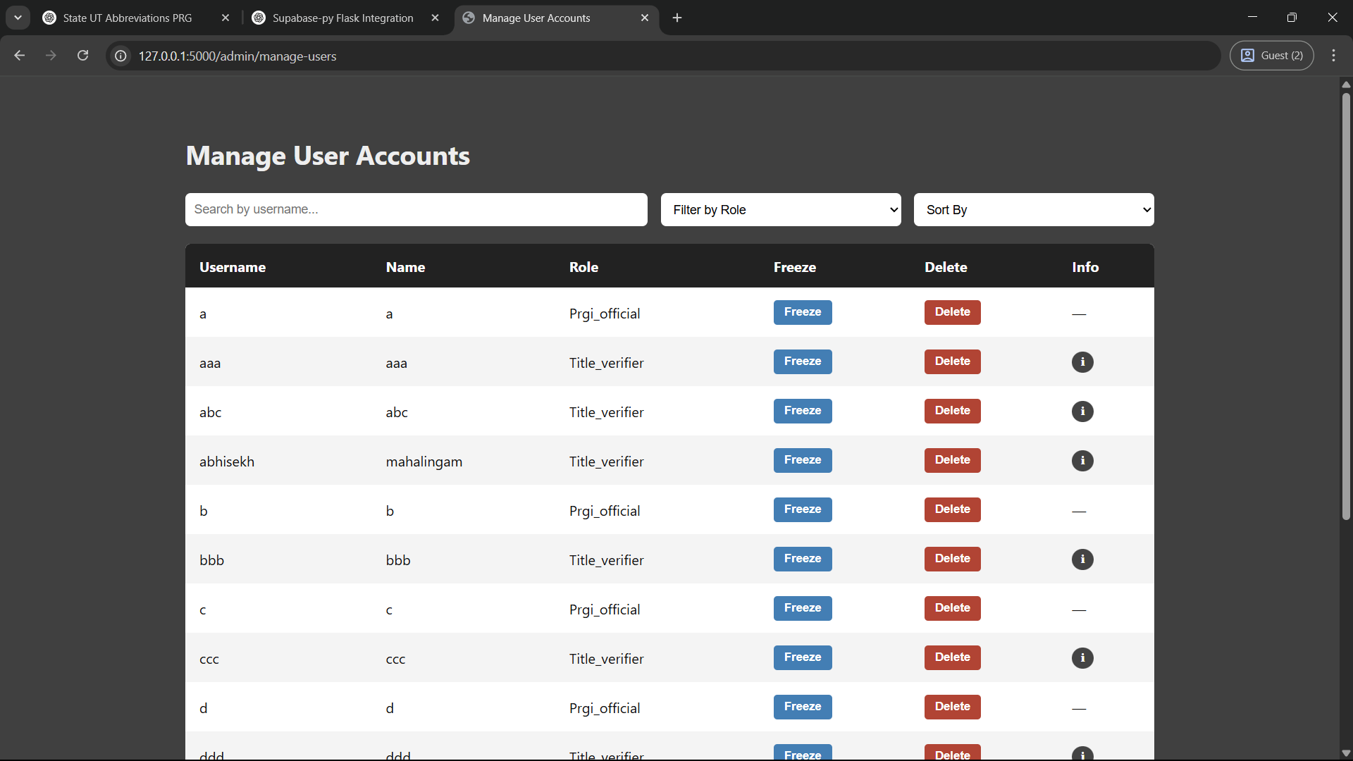

**Submit Title for Verification**

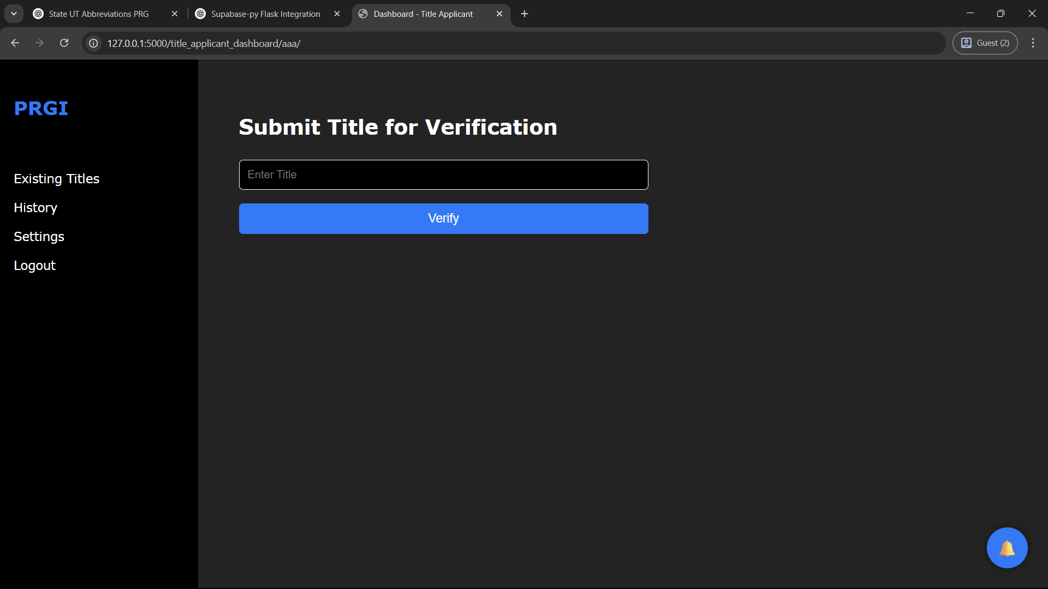

**View Title Analysis and Result**

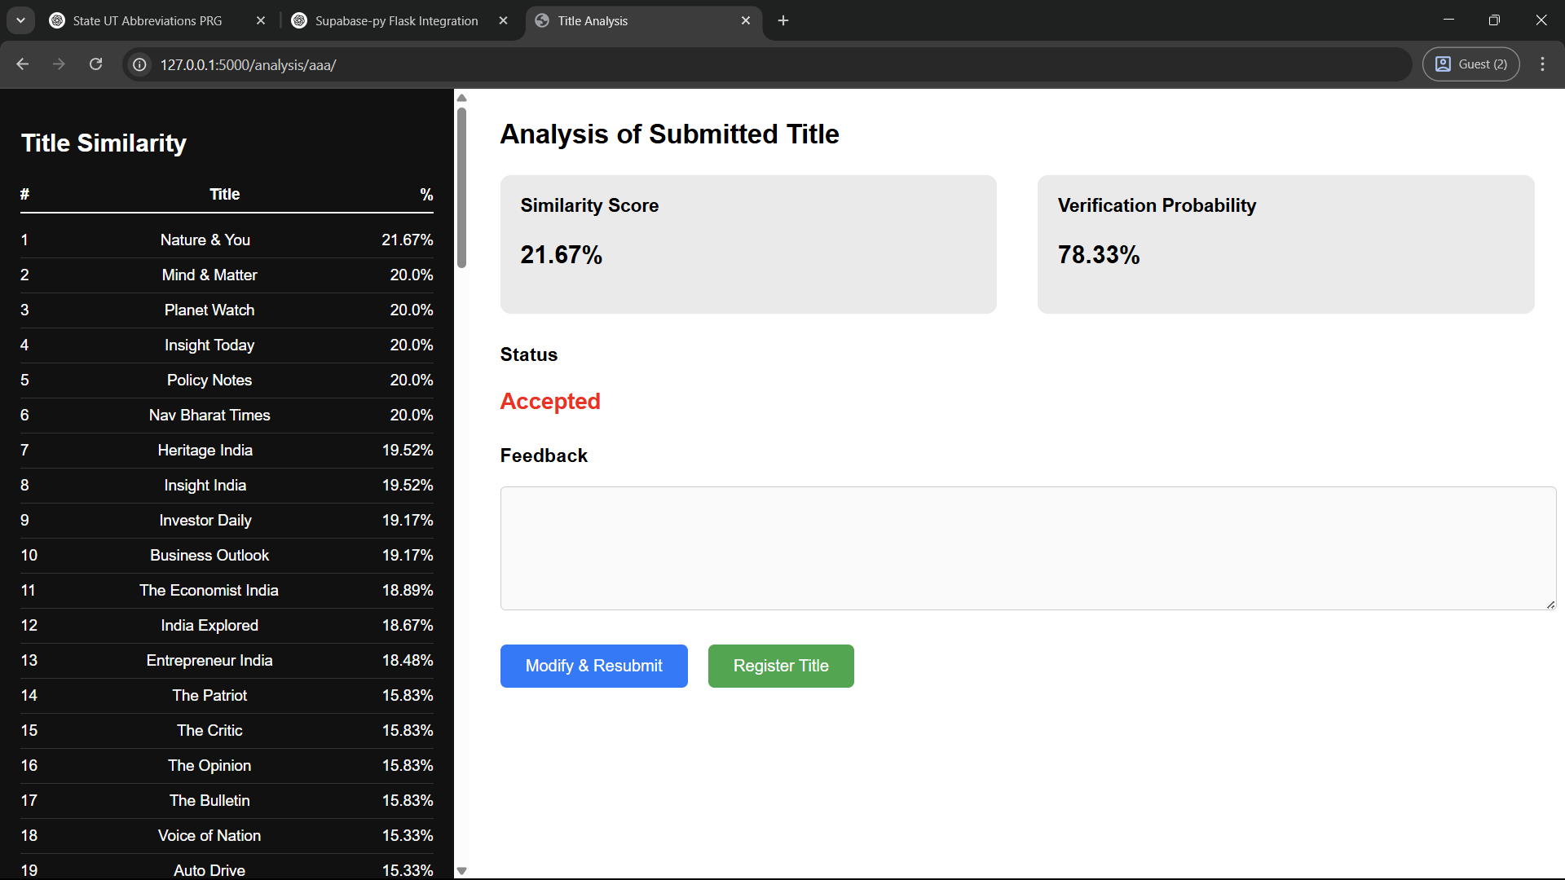

**Register Title**

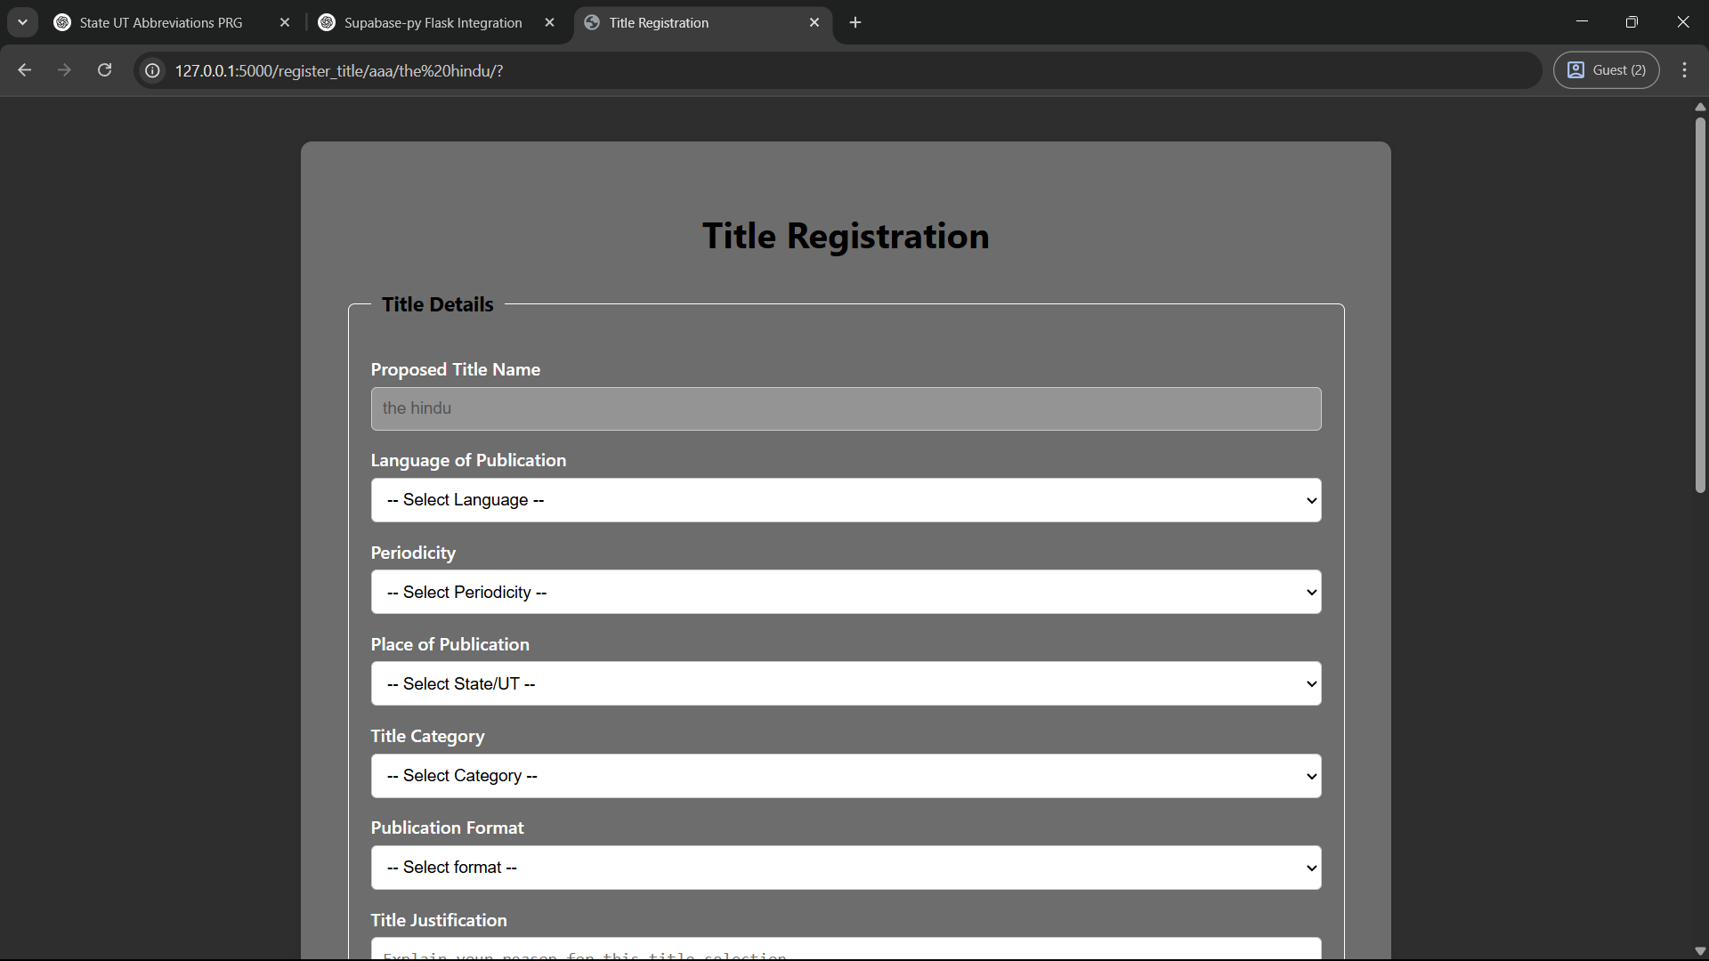

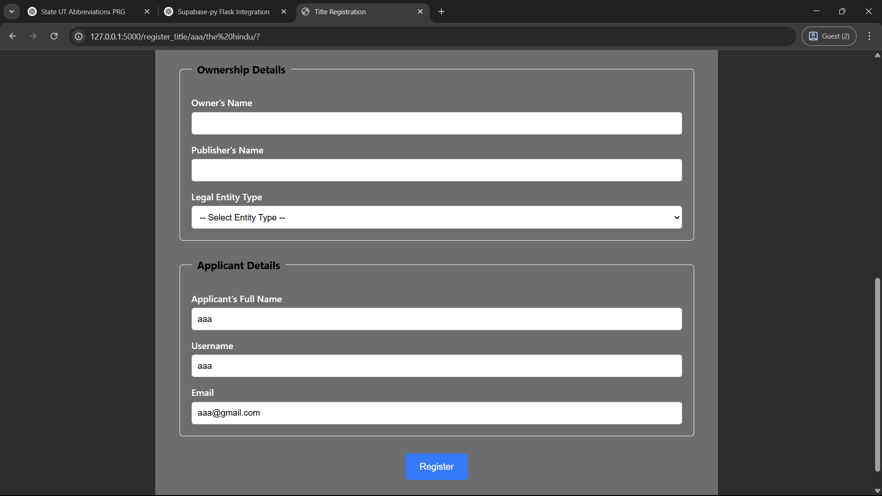

**Approve/Reject Title Registrations**

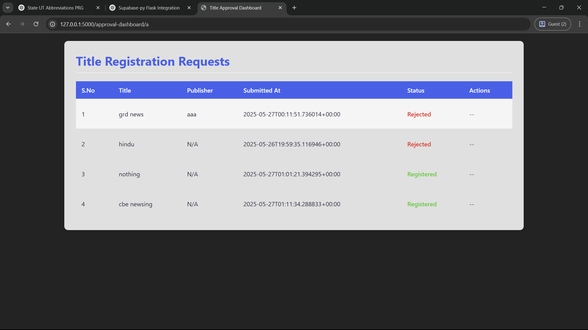

**Manage Restricted Words and Affixes**

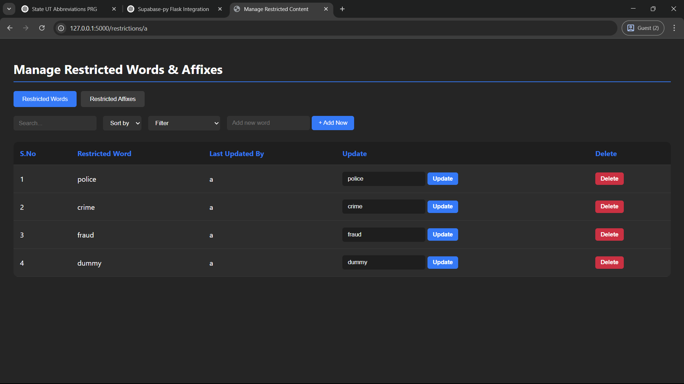

**Search and View Existing Titles**

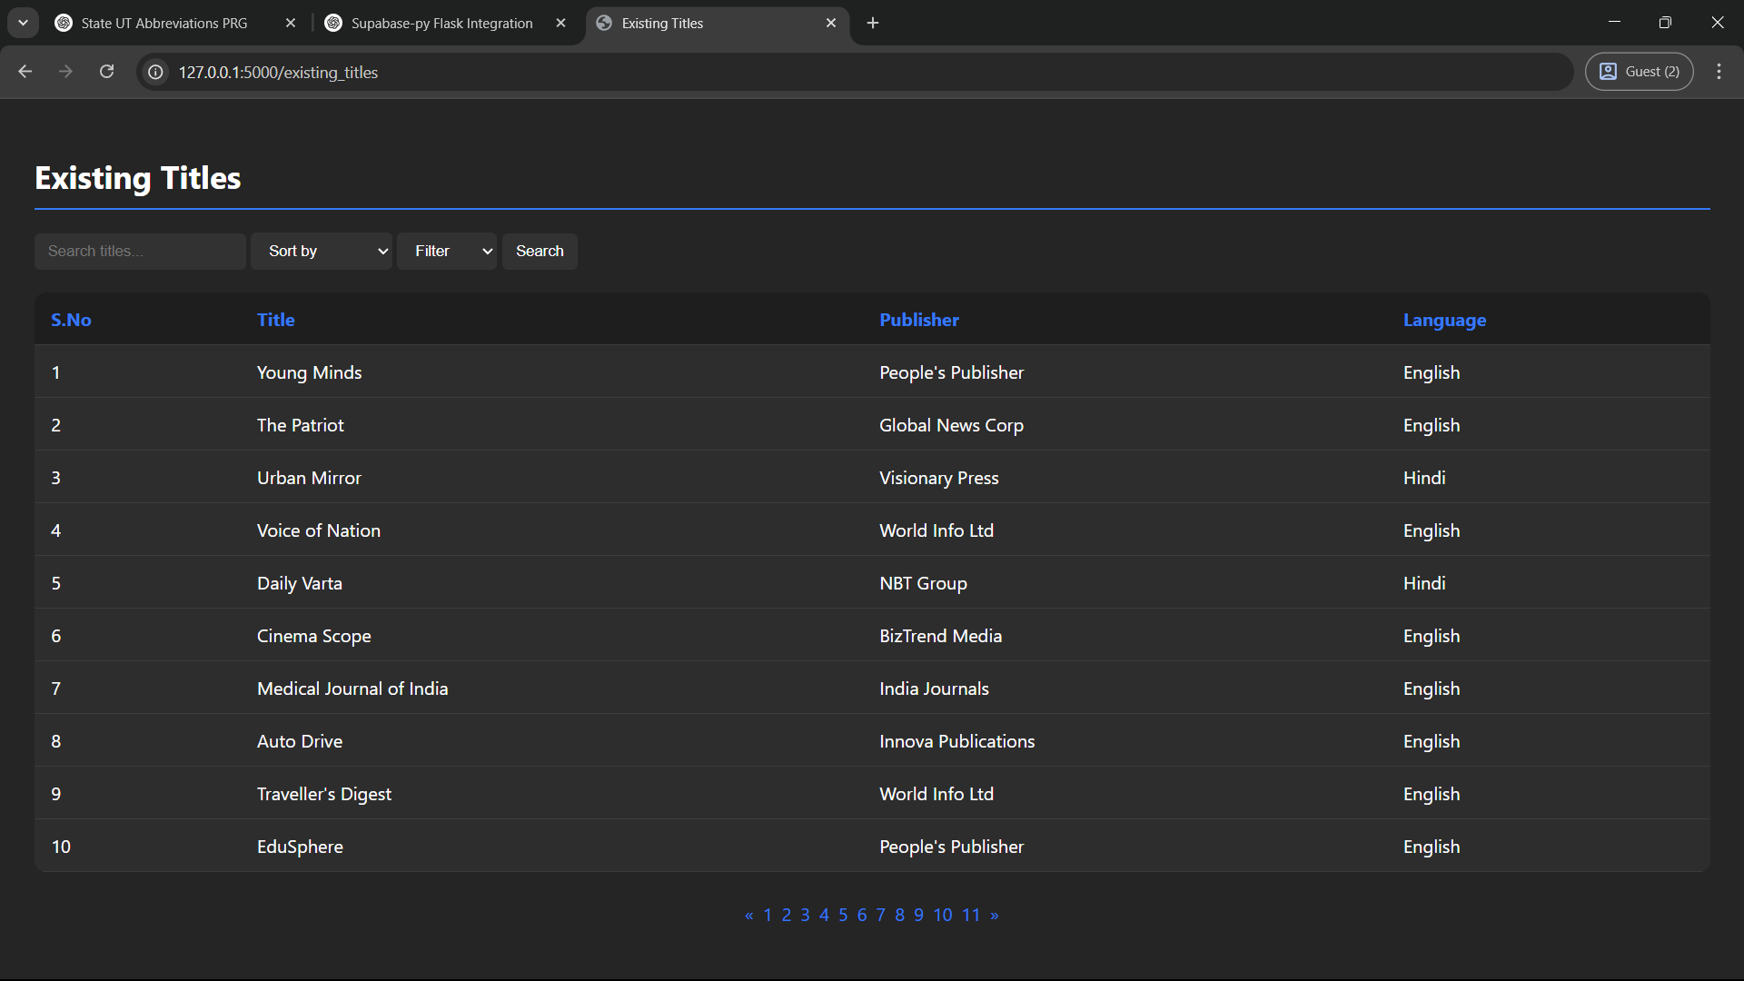

**View Submission History**

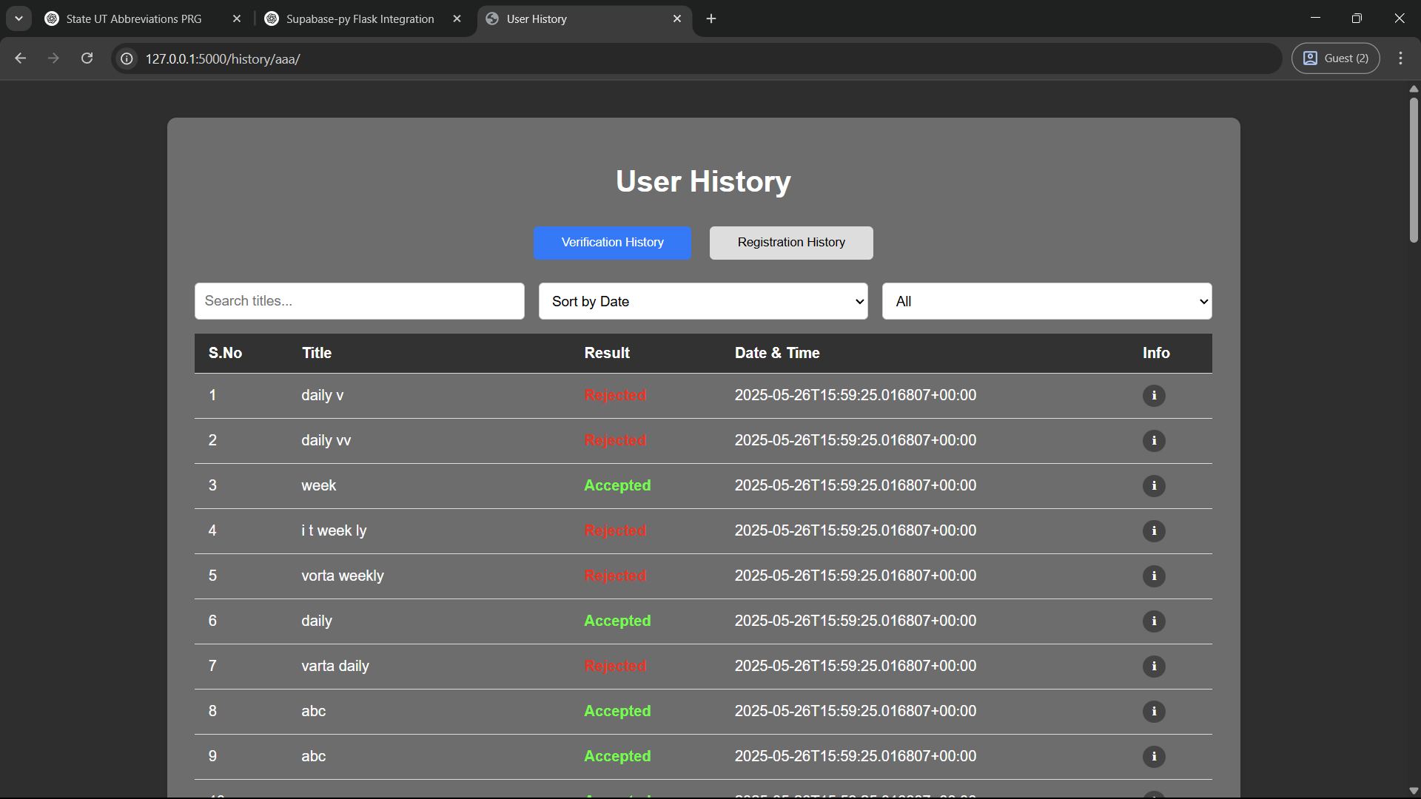

**Monitor Title Registration History**

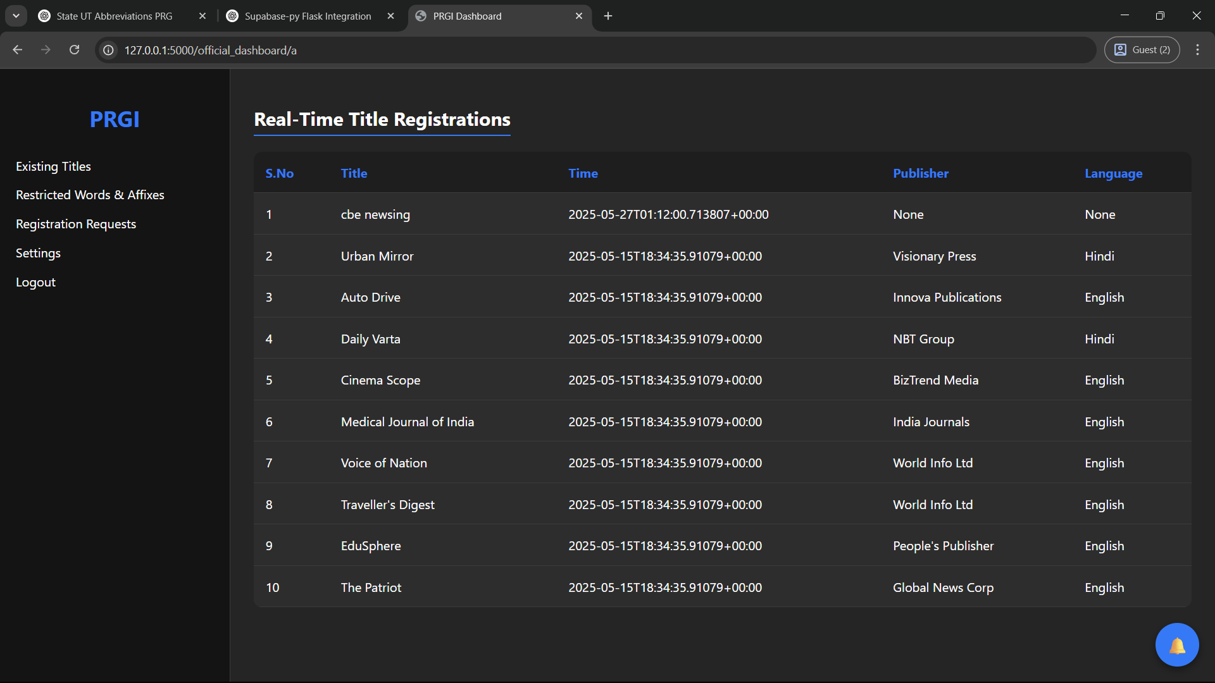

**Access Help & Guidelines**

**-**

**Contact Support**

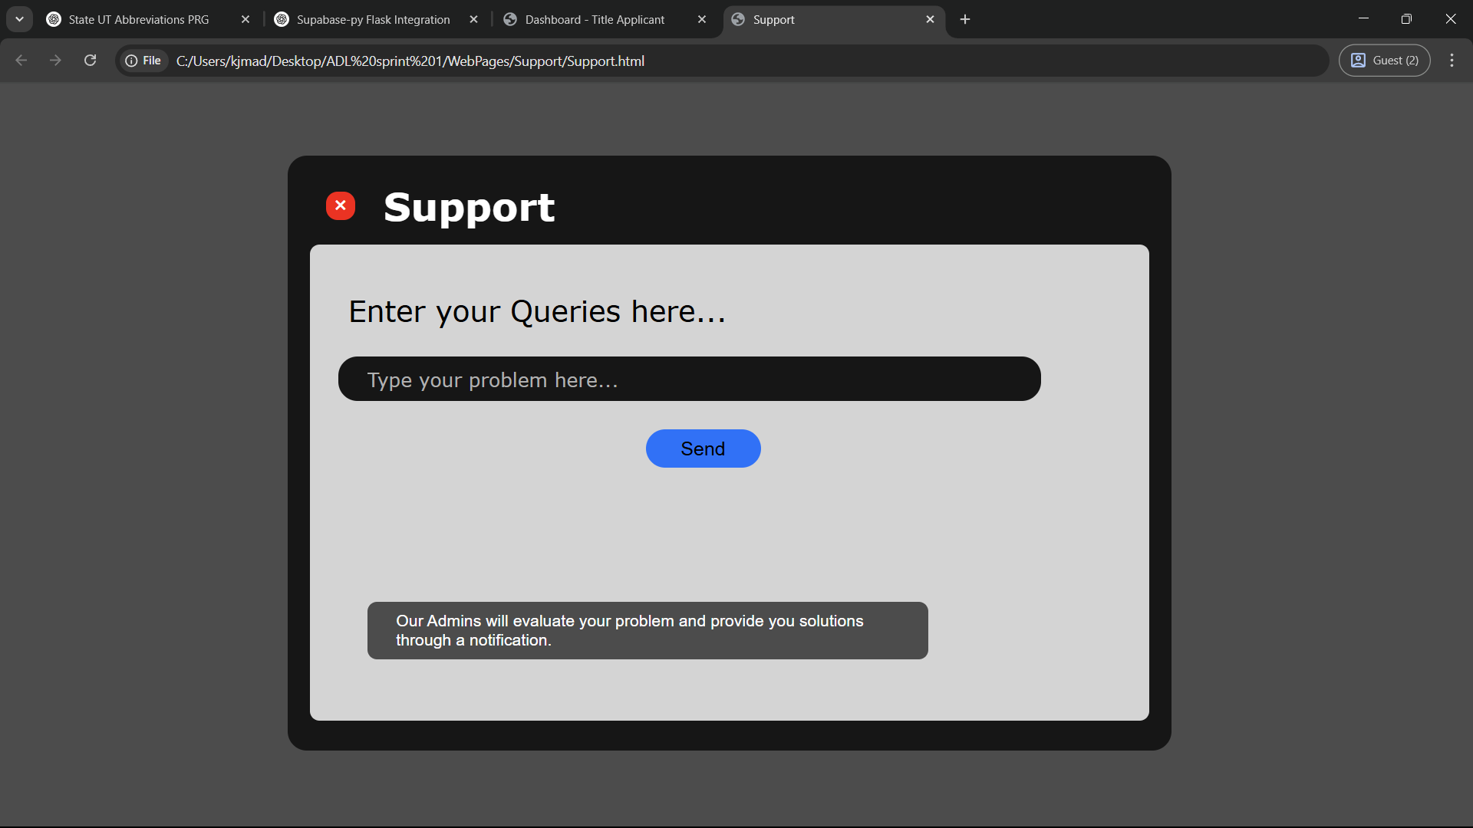

**Respond to Support Queries**

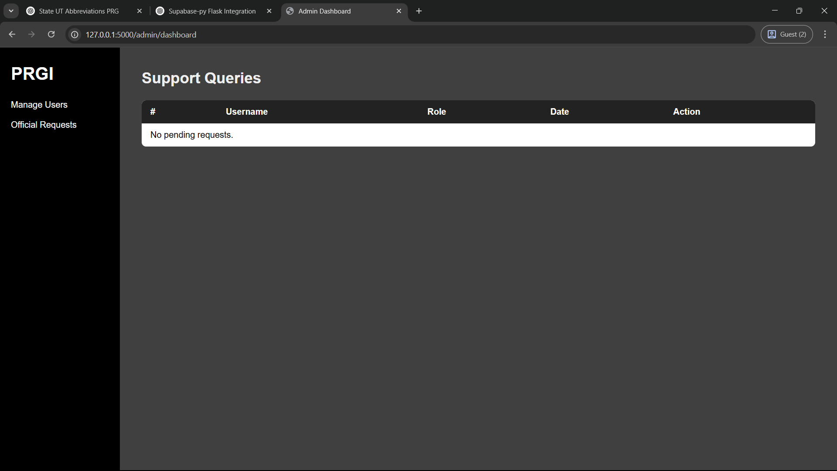

**CHAPTER 4**

**ENTITY RELATIONSHIP DIAGRAM**

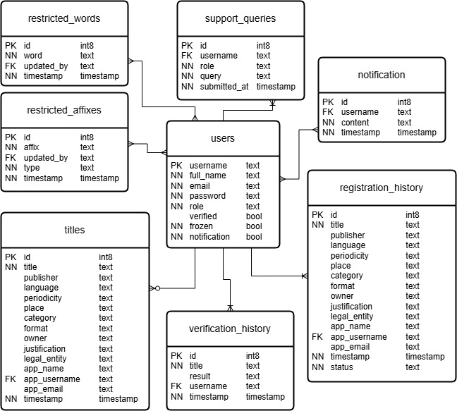

**CHAPTER 5**

**TEST CASES**

**1. USER ACCESS & MANAGEMENT SUBSYSTEM:**

**1.1. Sign Up**

|  |  |
| --- | --- |
| **#** | TS1 |
| **Title** | Verify "Sign up" functionality |
| **Description** | To test the different scenarios that might arise while a user is trying to signup |

|  |  |  |  |  |  |  |  |
| --- | --- | --- | --- | --- | --- | --- | --- |
| **#** | **Summary** | **Dependency** | **Pre-condition** | **Post-condition** | **Execution Steps** | **Expected Output** | **Actual Output** |
| TC1 | Successful sign-up for Title Applicant | – | Valid user info provided | Account created; verification email sent | 1. Navigate to Sign-Up 2. Select "Title Applicant" 3. Fill valid details 4. Submit | Message: “Check your email to verify your account” | Passed |
| TC2 | Successful sign-up for PRGI Official | – | Valid official info provided | Account created; awaits admin approval | 1. Select "PRGI Official" 2. Enter valid details 3. Submit | Message: “Account pending admin verification” | Passed |
| TC3 | Email already exists | – | Email registered earlier | Submission blocked | 1. Enter duplicate email 2. Submit | Error: “Email already registered” | Passed |
| TC4 | Username already exists | – | Username already in use | Submission blocked | 1. Enter duplicate username 2. Submit | Error: “Username already taken” | Passed |
| TC5 | Invalid email format | – | Email is malformed | Submission blocked | 1. Enter "user@@mail" 2. Submit | Error: “Invalid email format” | Passed |
| TC6 | Username too short or contains invalid characters | – | Username violates rules | Submission blocked | 1. Enter “ab” or “user!@#” 2. Submit | Error: “Invalid username format” | Passed |
| TC7 | Weak password input | – | Password doesn’t meet criteria | Submission blocked | 1. Enter weak password like “abc123” 2. Submit | Error: “Password must include uppercase, lowercase, number, and special character” | Passed |
| TC8 | Password and confirm password mismatch | – | Passwords do not match | Submission blocked | 1. Enter mismatched values 2. Submit | Error: “Passwords do not match” | Passed |
| TC9 | Submit with all valid input then abandon verification | – | Verification email not clicked | Account remains inactive | 1. Complete sign-up 2. Do not verify email | Email not verified; account pending /inactive | Passed |
| TC10 | Resend email verification link | TC9 | Account inactive due to email not verified | Link resent | 1. Click “Resend Verification” 2. Confirm action | Message: “Verification email sent again” | Passed |
| TC11 | Verification link expired | TC9 | 24 hours passed without clicking link | Verification fails | 1. Wait 24 hours 2. Click email link | Message: “Link expired. Request new verification email” | Passed |
| TC12 | Registration abandoned mid-way | – | Form not submitted | No account created | 1. Enter partial data 2. Close tab | No record saved in database | Passed |
| TC13 | Email verification successful (for title applicant) | TC1 | Email is verified | User is authenticated | 1. Click “sign up” button 2. Email verification sent 3. Verify email | User is redirected to their dashboard | Passed |
| TC14 | Admin verification successful (for official signups) | TC2 | Admin approved the official signup request | Admin is authenticated and granted permissions for modifying the system | 1. Click “sign up” button 2. Request sent to admin 3. Admin verifies the signup | Official is redirected to their dashboard | Passed |

**1.2. Log In**

|  |  |
| --- | --- |
| **#** | TS2 |
| **Title** | Verify "Log In" functionality |
| **Description** | To test the different scenarios that might arise while a user is trying to login |

|  |  |  |  |  |  |  |  |
| --- | --- | --- | --- | --- | --- | --- | --- |
| **#** | **Summary** | **Dependency** | **Pre-condition** | **Post-condition** | **Execution Steps** | **Expected Output** | **Actual Output** |
| TC1 | Successful login for Title Applicant | – | User account is verified and active | Redirected to applicant dashboard | 1. Navigate to login page 2. Select "Title Applicant" 3. Enter valid credentials 4. Click Login | Dashboard loaded; session logged | Passed |
| TC2 | Successful login for PRGI Official | – | Official account is admin-approved | Redirected to official dashboard | 1. Select "PRGI Official" 2. Enter valid credentials 3. Submit | Dashboard loaded; session logged | Passed |
| TC3 | Successful login for System Admin | – | Admin account exists | Redirected to admin dashboard | 1. Select "System Administrator" 2. Enter credentials 3. Login | Admin panel opened | Passed |
| TC4 | Incorrect password attempt | – | User account exists | Login blocked | 1. Enter valid username and wrong password | Error: “Invalid username or password” | Passed |
| TC5 | Incorrect username attempt | – | No such account | Login blocked | 1. Enter incorrect username 2. Click Login | Error message shown | Passed |
| TC6 | Login without email verification | – | Email not verified | Access denied | 1. Use unverified user credentials 2. Login | Message: “Email verification required” | Passed |
| TC7 | Login before admin approval (PRGI Official) | – | Official signup not yet approved | Login blocked | 1. Use official credentials before approval | Message: “Admin verification pending” | Passed |
| TC8 | Login to a suspended account | – | Account is deactivated | Access denied | 1. Try logging into a suspended account | Message: “Your account has been suspended” | Passed |
| TC9 | Forgot password – valid email | – | Email exists in system | Reset link sent | 1. Click “Forgot Password?” 2. Enter valid email | Message: “Reset link sent to your email” | Passed |
| TC10 | Forgot password – invalid email | – | Email not in system | Reset blocked | 1. Click “Forgot Password?” 2. Enter invalid email | Error: “Email not found” | Passed |
| TC11 | Reset password and login successfully | TC9 | Reset process completed | User can access account | 1. Open reset email 2. Set new password 3. Login | Dashboard accessed with new credentials | Passed |
| TC12 | Navigate away before login | – | User doesn’t submit form | No login recorded | 1. Open login page 2. Leave without entering credentials | No action taken | Passed |
| TC13 | Login with uppercase /lowercase mismatch in password | – | Correct password is case-sensitive | Login fails | 1. Enter correct username and wrong case password | Error: “Invalid password” | Passed |
| TC14 | Login using username instead of email | – | Username is valid | Login successful | 1. Enter username and password instead of email | Redirected to dashboard | Passed |
| TC15 | Login using email instead of username | – | Email is valid | Login successful | 1. Enter email and password instead of username | Login works as expected | Passed |

**1.3. Manage Account Settings**

|  |  |
| --- | --- |
| **#** | TS3 |
| **Title** | Verify "Manage Account Settings" functionality |
| **Description** | To test the different scenarios that might arise while a user is trying to manage their account settings |

|  |  |  |  |  |  |  |  |
| --- | --- | --- | --- | --- | --- | --- | --- |
| **#** | **Summary** | **Dependency** | **Pre-condition** | **Post-condition** | **Execution Steps** | **Expected Output** | **Actual Output** |
| TC1 | Access account settings section | – | User is logged in | Settings page displayed | 1. Navigate to "Settings" | Settings categories (Account, Notifications) shown | Passed |
| TC2 | Update username successfully | – | Valid new username entered | Username updated | 1. Go to Account Settings 2. Change username 3. Save | Success: “Username updated successfully” | Passed |
| TC3 | Username already exists | – | Username already in use | Change blocked | 1. Enter duplicate username 2. Save | Error: “Username already taken” | Passed |
| TC4 | Username too short or contains invalid characters | – | Username violates rules | Change blocked | 1. Enter “ab” or “user!@#” 2. Save | Error: “Invalid username format” | Passed |
| TC5 | Update email with valid format | – | New email is valid and unique | Email updated | 1. Enter new valid email 2. Click Save | Confirmation message shown | Passed |
| TC6 | Update email with invalid format | – | Incorrect format used | Change blocked | 1. Enter “user@@mail” 2. Submit | Error: “Invalid email format” | Passed |
| TC7 | Update email to one already in use | – | Email already exists | Change blocked | 1. Enter registered email 2. Click Save | Error: “Email already in use” | Passed |
| TC8 | Change password with valid criteria | – | New password meets all conditions | Password updated | 1. Enter current password 2. Set new password with proper format 3. Confirm change | Message: “Password changed successfully” | Passed |
| TC9 | Change password with weak format | – | New password does not meet policy | Submission blocked | 1. Set password as “abc123” 2. Submit | Error: “Password too weak” | Passed |
| TC10 | Password and confirm password mismatch | – | Fields do not match | Update blocked | 1. Enter different values in both fields 2. Submit | Error: “Passwords do not match” | Passed |
| TC11 | Update notification preferences | – | Preferences selected | Notification settings saved | 1. Select /deselect notification checkboxes 2. Save | “Notification preferences updated” message shown | Passed |
| TC12 | Cancel changes before saving | – | Changes made but not saved | No changes applied | 1. Modify any setting 2. Click “Cancel” | Fields revert to original state | Passed |
| TC13 | Submit empty fields | – | All fields cleared | Submission blocked | 1. Clear all input fields 2. Click Save | Error: “Fields cannot be empty” | Passed |
| TC14 | Log out through account settings | – | User is logged in | Session terminated | 1. Click “Log out” from settings | Redirected to login page | Passed |
| TC15 | View changes reflected after update | TC2–TC11 | Setting successfully changed | Changes applied throughout system | 1. Modify name /email /password 2. Revisit profile | Updated info displayed correctly | Passed |
| TC16 | Attempt to access settings without login | – | User is not authenticated | Redirected to login | 1. Try accessing settings URL directly | System redirects to login page | Passed |

**1.4. Approve/Reject Official Accounts**

|  |  |
| --- | --- |
| **#** | TS4 |
| **Title** | Verify "Approve/Reject Official Accounts" functionality |
| **Description** | To test the different scenarios that might arise while the admin is trying to approve or reject official signup requests |

|  |  |  |  |  |  |  |  |
| --- | --- | --- | --- | --- | --- | --- | --- |
| **#** | **Summary** | **Dependency** | **Pre-condition** | **Post-condition** | **Execution Steps** | **Expected Output** | **Actual Output** |
| TC1 | View list of pending official signup requests | – | PRGI official requests exist | List is displayed | 1. Log in as admin 2. Navigate to Official Signup Requests | All pending requests are listed with user info | Passed |
| TC2 | Approve a valid official request | – | Signup details are complete and authentic | Official is approved and can log in | 1. Select a request 2. Review details 3. Click “Approve” | Message: “Request accepted” | Account created | Passed |
| TC3 | Reject an invalid official request | – | Signup info is incomplete or invalid | Request is discarded | 1. Select a request 2. Click “Reject” 3. Confirm rejection | Message: “Request rejected” | No account created | Passed |
| TC4 | Hold a request due to insufficient info | – | Details are incomplete | Request remains in pending state | 1. Neither “Accept” nor “Reject” | Request stays visible in pending list | Passed |
| TC5 | View official signup details before approval | – | Request is in list | Full profile shown | 1. Click on a request row | Signup form data shown in detail | Passed |
| TC6 | Attempt to approve without being logged in | – | Admin not authenticated | Access denied | 1. Open approval URL directly without logging in | Redirected to login page | Passed |
| TC7 | Official waiting in signup page is taken to their dashboard | TC2 | Official is waiting in the signup page and admin approves | Directly taken to the dashboard | 1. Official waits in signup page 2. Admin verifies | Official is redirected to their dashboard | Passed |
| TC8 | Approved official can login | TC2 | Official left signup page midway and admin approves | Login successful | 1. Approve request 2. Official logs in | Official is redirected to their dashboard | Passed |
| TC9 | Rejected official cannot log in | TC3 | Request denied earlier | Login blocked | 1. Try to log in with rejected credentials | Error: “Account does not exist or not approved” | Passed |

**1.5. Manage User Accounts**

|  |  |
| --- | --- |
| **#** | TS5 |
| **Title** | Verify "Manage User Accounts" functionality |
| **Description** | To test the different scenarios that might arise while the admin is trying to manage general user accounts |

|  |  |  |  |  |  |  |  |
| --- | --- | --- | --- | --- | --- | --- | --- |
| **#** | **Summary** | **Dependency** | **Pre-condition** | **Post-condition** | **Execution Steps** | **Expected Output** | **Actual Output** |
| TC1 | View list of all registered users | – | Admin is logged in | User list displayed | 1. Go to “User Management” section | List of users with roles and activity history shown | Passed |
| TC2 | Freeze a user account | – | User exists and is active | Account access restricted | 1. Select a user 2. Click “Freeze” 3. Confirm action | Message: “Account has been frozen” | Passed |
| TC3 | Delete a user account permanently | – | User exists | Account removed | 1. Select user 2. Click “Delete” 3. Confirm deletion | Message: “User deleted successfully” | Passed |
| TC4 | View submission / approval history per user | – | User has past activity | History shown in detail | 1. Click on a specific user row | Display verification /registration history | Passed |
| TC5 | Revert a frozen account to active status | TC2 | User account is frozen | Access restored | 1. Select frozen user 2. Click “Unfreeze” | Account status: “Active” again | Passed |
| TC6 | Manage account from search result | – | User searched by name /email | Actions still allowed | 1. Use search bar 2. Select user 3. Perform action | Freeze/delete available as normal | Passed |
| TC7 | Filter users by role (Applicant /Official) | – | Multiple user roles exist | Filtered list shown | 1. Select role filter | Only users of selected role appear | Passed |
| TC8 | Sort users by registration date | – | Multiple users in list | Ordered by date | 1. Click “Sort by Date” | List reorders chronologically | Passed |
| TC9 | Attempt to access management without admin login | – | Not authenticated | Access denied | 1. Open URL for user management 2. Not logged in | Redirected to login | Passed |

**2. TITLE PROCESSING & MANAGEMENT SUBSYSTEM:**

**2.1. Submit Title for Verification**

|  |  |
| --- | --- |
| **#** | TS6 |
| **Title** | Verify "Submit Title for Verification" functionality |
| **Description** | To test the different scenarios that might arise while a title applicant is trying to submit a title for verification |

|  |  |  |  |  |  |  |  |
| --- | --- | --- | --- | --- | --- | --- | --- |
| **#** | **Summary** | **Dependency** | **Pre-condition** | **Post-condition** | **Execution Steps** | **Expected Output** | **Actual Output** |
| TC1 | Submit a valid title for verification | – | User is logged in with access to dashboard | Title processed and user redirected to analysis page | 1. Log in 2. Enter valid title (e.g., "India Today Bulletin") 3. Click Submit | Redirect to Title Analysis Page | Passed |
| TC2 | Submit a title with leading /trailing spaces | – | User is logged in | Title trimmed and submitted correctly | 1. Enter “ India Times ” 2. Submit | System trims whitespace and processes normally | Passed |
| TC3 | Submit empty title | – | User is logged in | Submission blocked | 1. Leave title field blank 2. Submit | Error: “Title cannot be empty” | Passed |
| TC4 | Submit title with only spaces | – | User is logged in | Submission blocked | 1. Enter " " (only spaces) 2. Submit | Error: “Title cannot be empty” | Passed |
| TC5 | Submit title with only numbers | – | User is logged in | Submission rejected | 1. Enter “123456” 2. Submit | Error: “Invalid title format” | Passed |
| TC6 | Submit title with special characters only | – | User is logged in | Submission rejected | 1. Enter “@#%&*!” 2. Submit | Error: “Invalid title format” | Passed |
| TC7 | Submit a very long title (exceeding limit) | – | User is logged in | Submission rejected | 1. Enter a title over 100 characters 2. Submit | Error: “Title too long. Limit: 100 characters.” | Passed |
| TC8 | Submit a title with mixed casing | – | User is logged in | Title accepted and normalized | 1. Enter “tHe NatIonAl PosT” 2. Submit | System processes normally, case preserved or normalized | Passed |
| TC9 | Submit with special characters or numbers in between | – | User is logged in | Submission approved | 1. Enter “India@News#Today2” 2. Submit | Redirect to Title Analysis Page | Passed |
| TC10 | Submit title when not logged in | – | User is not logged in | User denied access | 1. Try to access dashboard directly 2. Attempt to submit title | Redirected to login page | Passed |
| TC11 | Refresh page after typing title (before submit) | – | User is logged in | Title input cleared, nothing processed | 1. Enter a title 2. Refresh browser before clicking submit | Page reloads with empty field; no processing triggered | Passed |
| TC12 | Submit title, then navigate away mid-processing | – | User is logged in | Process may be interrupted or requeued | 1. Enter title 2. Submit 3. Navigate away before loading finishes | System handles gracefully or reprocesses on next visit | Passed |
| TC13 | Submit previously accepted title | – | User is logged in | System notifies about previous trial | 1. Enter a previously accepted title 2. Submit | System provides proper message and doesn’t undertake a fresh analysis | Passed |
| TC14 | Submit previously rejected title | – | User is logged in | System accepts for fresh analysis | 1. Enter a previously rejected title 2. Submit | Redirect to analysis page for new result | Passed |
| TC15 | Submit title with valid multilingual characters | – | User is logged in | Title accepted if format is valid | 1. Enter title like “प्रति दिन समाचार” 2. Submit | System accepts and processes multilingual title | Passed |
| TC16 | A valid submission is stored in history | TC1 | The submitted title is valid | The submission is stored in history | 1. Access submission history page 2. Look at the list of title verifications | The title is stored in the verification history for later access | Passed |

**2.2. View Title Analysis and Result**

|  |  |
| --- | --- |
| **#** | TS7 |
| **Title** | Verify "View Title Analysis and Result" functionality |
| **Description** | To test the different scenarios that might arise while a title applicant is trying to view the analysis page and verification result for a title |

|  |  |  |  |  |  |  |  |
| --- | --- | --- | --- | --- | --- | --- | --- |
| **#** | **Summary** | **Dependency** | **Pre-condition** | **Post-condition** | **Execution Steps** | **Expected Output** | **Actual Output** |
| TC1 | View analysis for a newly submitted valid title | TS6 | Title has been submitted successfully | Analysis page with all sections displayed | 1. Submit a valid title 2. System redirects to Analysis Page | List of similar titles, similarity score, verification probability, result shown | Passed |
| TC2 | View analysis with high similarity score | – | Title matches existing titles closely | System shows rejection with feedback | 1. Submit a similar title 2. Access analysis page | Rejected due to high similarity with feedback | Passed |
| TC3 | Title with phonetic similarity with existing ones | – | Title has phonetic similarity | Similarity calculation considers phonetics | 1. Submit a title with phonetic similarity | Similarity score is calculated accordingly | Passed |
| TC4 | Title with spelling similarity with existing ones | – | Title has spelling similarity | Similarity calculation considers spelling | 1. Submit a title with spelling similarity | Similarity score is calculated accordingly | Passed |
| TC5 | Title with semantic similarity with existing ones | – | Title has semantic similarity | Similarity calculation considers semantics | 1. Submit a title with semantic similarity | Similarity score is calculated accordingly | Passed |
| TC6 | Title is a combination of existing ones | – | Title combines of 2 existing titles | Title is rejected | 1. Submit a title which is a combination of 2 existing titles | Title is rejected with a feedback | Passed |
| TC7 | View analysis with usage of restricted word | – | Submitted title includes disallowed term | System shows rejection with relevant feedback | 1. Submit a title like “CBI News Weekly” 2. Open analysis | Rejected with message: “Restricted word: CBI” | Passed |
| TC8 | Verification probability calculated from similarity | – | Title has moderate similarity | Probability shown based on formula | 1. Submit title 2. View analysis page | Verification probability = 100 - similarity | Passed |
| TC9 | View analysis with acceptable probability score | – | Title is sufficiently unique | System shows acceptance | 1. Submit valid title with high probability 2. Access analysis | Accepted; option to register shown | Passed |
| TC10 | Feedback displayed for rejected title | – | Title is rejected | Rejection reason shown clearly | 1. Submit problematic title 2. View feedback section | Feedback: “Too similar to 'Daily India News'” | Passed |
| TC11 | Modify and resubmit from analysis page | – | Title is rejected | System allows editing and resubmission | 1. View rejected title 2. Click “Modify and Resubmit” 3. Enter new version | Redirected to resubmission flow | Passed |
| TC12 | Register title from analysis page | – | Title is accepted | System redirects to registration form | 1. Submit accepted title 2. Click “Register Title” | Registration form displayed | Passed |
| TC13 | Leave analysis without registering accepted title | – | Title is accepted | Title saved for future registration | 1. Submit valid title 2. Leave analysis page | Title marked in history as “Accepted – Not Registered” | Passed |
| TC14 | Access analysis of previously submitted title | – | Title is in user history | Analysis data retrievable from history | 1. Open history page 2. Select a submitted title | Redirect to corresponding analysis page | Passed |
| TC15 | Register from history for accepted title | – | Title was accepted previously but not registered | System allows late registration | 1. Open history 2. Click on accepted title 3. Click “Register” | Redirects to title registration form | Passed |
| TC16 | Title rejected for both similarity and restriction | – | Title fails on both criteria | Multiple feedback messages shown | 1. Submit “CBI India Daily” 2. View analysis | Rejected; Feedback: “Too similar” and “Restricted word” | Passed |
| TC17 | Analysis data includes empty similarity list | – | Title has no significant match | Similarity list is empty, title likely accepted | 1. Submit very unique title 2. View analysis | “No major matches found”; Accepted | Passed |
| TC18 | System handles analysis page reload | – | Analysis page refreshed | Results persist or reload cleanly | 1. View analysis 2. Refresh browser | Page reloads with same title data | Passed |
| TC19 | Attempt to access analysis without submitting title | – | No title submission | Access is denied | 1. Directly enter analysis page URL without submission | Redirected to dashboard or error page | Passed |

**2.3. Register Title**

|  |  |
| --- | --- |
| **#** | TS8 |
| **Title** | Verify "Register Title" functionality |
| **Description** | To test the different scenarios that might arise while a title applicant is trying to register a title |

|  |  |  |  |  |  |  |  |
| --- | --- | --- | --- | --- | --- | --- | --- |
| **#** | **Summary** | **Dependency** | **Pre-condition** | **Post-condition** | **Execution Steps** | **Expected Output** | **Actual Output** |
| TC1 | Register an approved title successfully | TS7 | Title is accepted and not registered | Title form submitted and status set to “Pending” | 1. View analysis page 2. Click “Register Title” 3. Fill registration form 4. Submit | Confirmation: “Your registration is under review” | Passed |
| TC2 | Access registration form from history | – | Title is accepted but not registered | Access form via history page | 1. Go to Submission History 2. Click accepted title 3. Click “Register Title” | Redirect to registration form | Passed |
| TC3 | Submit incomplete registration form | – | Form is open | Form submission blocked | 1. Leave mandatory fields empty 2. Click Submit | Error: “Please fill out all required fields” | Passed |
| TC4 | Register title with invalid data formats | – | User is on form | Validation fails | 1. Enter incorrect formats (e.g., number in name field) 2. Submit | Error: “Invalid input format” | Passed |
| TC5 | Cancel registration mid-process | – | Form open or registration submitted | Registration not created or saved as unsubmitted | 1. Open form 2. Click “Cancel” or close page | Returned to dashboard; title stays “Accepted – Not Registered” | Passed |
| TC6 | View status after registration submission | TC1 | Registration is submitted | Status shown as “Pending” | 1. Go to Submission History 2. View registration status | Title marked as “Registration Pending” | Passed |
| TC7 | View final registration approval | – | Official has approved registration | Title marked as “Registered” | 1. Wait for approval 2. Open history | Status: “Registered” and notification received | Passed |
| TC8 | Try to register an already registered title | – | Title already registered | Access denied or button disabled | 1. Open analysis or history 2. Attempt re-registration | Message: “Title already registered” | Passed |
| TC9 | Submit form with special characters in restricted fields | – | Special characters in restricted fields | Submission blocked | 1. Enter “John@Doe” in owner name field 2. Submit | Error: “Special characters not allowed” | Passed |
| TC10 | Skip optional fields and register | – | Optional fields left empty | Title registered if required fields filled | 1. Fill only required fields 2. Submit | Registration proceeds; success message shown | Passed |
| TC11 | Resubmit after initial registration cancel | TC5 | User cancelled registration earlier | Form re-accessible, new attempt possible | 1. Open title from history 2. Click “Register Title” 3. Resubmit form | Form submitted; status “Pending” | Passed |
| TC12 | Receive notification after approval | TC1, TC7 | Title approved by PRGI Official | Notification shown | 1. Wait for official approval 2. Login to view updates | Notification: “Your title has been registered successfully” | Passed |
| TC13 | Attempt registration without title approval | – | Title is not yet accepted | Access denied | 1. Submit unverified title 2. Try to access register button | Message: “Title not yet approved for registration” | Passed |

**2.4. Approve/Reject Title Registrations**

|  |  |
| --- | --- |
| **#** | TS9 |
| **Title** | Verify "Approve/Reject Title Registration" functionality |
| **Description** | To test the different scenarios that might arise while an official is trying to approve or reject a title registration request |

|  |  |  |  |  |  |  |  |
| --- | --- | --- | --- | --- | --- | --- | --- |
| **#** | **Summary** | **Dependency** | **Pre-condition** | **Post-condition** | **Execution Steps** | **Expected Output** | **Actual Output** |
| TC1 | Approve a valid registration request | TS8 | Valid registration form is submitted | Title marked as “Registered”; added to official records | 1. Official logs in 2. Opens Registration Requests 3. Reviews form 4. Confirms external verification 5. Clicks Approve | Title status: “Registered”; Notification sent to applicant | Passed |
| TC2 | Reject an invalid or incomplete registration | – | Form exists but is legally non-compliant | Request removed; applicant notified | 1. Open Registration Requests 2. Identify discrepancies 3. Click Reject | Title removed from pending list; “Rejected” notice sent | Passed |
| TC3 | Postpone action for incomplete external verification | – | External legal steps not completed | Status remains “Pending” | 1. Open request 2. Decide to wait 3. Take no action | Title remains in pending list | Passed |
| TC4 | View pending registration requests list | – | Official is logged in | All pending titles listed | 1. Navigate to Registration Requests section | Display list of unprocessed registration forms | Passed |
| TC5 | View full registration form details | – | Request is selected | All user-submitted data shown | 1. Select a pending title 2. Open full form | Title and applicant data shown in detail | Passed |
| TC6 | Title becomes public after approval | TC1 | Title is registered | Visible in “Existing Titles” section | 1. Approve registration 2. Go to Existing Titles | Newly registered title appears | Passed |
| TC7 | Official receives confirmation of approval action | TC1 | Registration approved | Acknowledgment shown to official | 1. Approve title 2. Complete action | Message: “Title registered successfully” shown | Passed |
| TC8 | Applicant receives notification after decision | TC1, TC2 | Request is approved or rejected | Message sent to applicant’s dashboard | 1. Submit registration 2. Wait for official decision 3. Login again | Notification: “Your title was approved” or “Registration rejected” | Passed |
| TC9 | Title status changed in the applicant’s registration history | TC1, TC2 | Official approves or rejects title registration request | The status is changed according to the action | 1. Access registration history section 2. Look at the status field for a title | The title’s status field is changed to registered or rejected | Passed |

**2.5. Manage Restricted Words and Affixes**

|  |  |
| --- | --- |
| **#** | TS10 |
| **Title** | Verify "Manage Restricted Words and Affixes" functionality |
| **Description** | To test the different scenarios that might arise while an official is trying to manage restricted words and affixes |

|  |  |  |  |  |  |  |  |
| --- | --- | --- | --- | --- | --- | --- | --- |
| **#** | **Summary** | **Dependency** | **Pre-condition** | **Post-condition** | **Execution Steps** | **Expected Output** | **Actual Output** |
| TC1 | View existing restricted words and affixes | – | Official is logged in | List of all restricted terms shown | 1. Navigate to Manage Restrictions 2. View displayed list | Words and affixes are listed with metadata | Passed |
| TC2 | Add new restricted word successfully | – | Word does not exist in list | Word added to list and visible to all | 1. Click “Add Word” 2. Enter valid word 3. Confirm addition | Success: “Word added successfully”; Notification sent | Passed |
| TC3 | Add new restricted affix with category | – | Affix is new | Affix saved with prefix /suffix type | 1. Click “Add Affix” 2. Enter affix 3. Choose category (prefix/suffix) 4. Confirm | Affix added and categorized; Notification sent | Passed |
| TC4 | Attempt to add duplicate word/affix | – | Word/affix already exists | Entry rejected | 1. Enter an existing word/affix 2. Submit | Error: “This word/affix already exists” | Passed |
| TC5 | Modify existing word | – | Word selected from list | Word spelling or details updated | 1. Select a word 2. Edit the text 3. Save changes | Word updated; date and user saved | Passed |
| TC6 | Modify existing affix | – | Affix selected from list | Affix spelling or category changed | 1. Select affix 2. Change spelling or category 3. Save | Affix updated; changes recorded | Passed |
| TC7 | Delete a restricted word | – | Word selected from list | Word removed from restrictions | 1. Select word 2. Click Delete 3. Confirm action | Word deleted; notification sent | Passed |
| TC8 | Delete a restricted affix | – | Affix selected from list | Affix removed | 1. Select affix 2. Delete and confirm | Affix removed from list and system | Passed |
| TC9 | Cancel addition of a word/affix | – | Add form is open | No change occurs | 1. Click Add Word/Affix 2. Enter word /affix 3. Click Cancel | Form closes; word/affix not added | Passed |
| TC10 | Cancel modification of word/affix | – | Edit form is open | No update saved | 1. Select word /affix 2. Edit field 3. Cancel before saving | No change applied | Passed |
| TC11 | Cancel deletion of word/affix | – | Delete confirmation dialog shown | Word/affix remains unchanged | 1. Select word /affix 2. Click Delete 3. Click “No” on confirm dialog | Nothing is removed | Passed |
| TC12 | Search for a restricted word by keyword | – | Words exist in list | Filtered result shown | 1. Enter partial or full word in search bar | Matching terms displayed | Passed |
| TC13 | Filter affixes by category | – | List contains affixes | Filter result shown | 1. Select filter: Prefix or Suffix | Only matching affixes displayed | Passed |
| TC14 | Sort restrictions by name | – | List is visible | Sorted list displayed | 1. Click on Name column header | Words sorted alphabetically | Passed |
| TC15 | Sort restrictions by date modified | – | List is visible | Sorted by latest /oldest | 1. Click Date Modified column | List updates by date | Passed |
| TC16 | Paginate through a long list of restrictions | – | Many items in list | Paginated data navigable | 1. Click next/previous page | Page loads next set of results | Passed |
| TC17 | Validate metadata logging after changes | – | Add/edit/delete performed | Username and timestamp recorded | 1. Modify a word 2. Save 3. View metadata | Metadata shows who and when it was changed | Passed |
| TC18 | Notification sent after restriction update | TC2, TC3, TC5 – TC8 | Change successfully applied | All officials are notified | 1. Add /edit /delete any item 2. Confirm action | Notification: “[Official Name] updated restrictions on [Date]” | Passed |
| TC19 | Restrictions affect future title verification | – | A new word is added to list | New title with word is flagged | 1. Add “XYZ” to restriction list 2. Submit title with “XYZ” | Title rejected: “Contains restricted word ‘XYZ’” | Passed |

**3. TITLE EXPLORATION & RECORDS SUBSYSTEM:**

**3.1. Search and View Existing Titles**

|  |  |
| --- | --- |
| **#** | TS11 |
| **Title** | Verify "Search and View Existing Titles" functionality |
| **Description** | To test the different scenarios that might arise while a user is trying to search and view existing titles |

|  |  |  |  |  |  |  |  |
| --- | --- | --- | --- | --- | --- | --- | --- |
| **#** | **Summary** | **Dependency** | **Pre-condition** | **Post-condition** | **Execution Steps** | **Expected Output** | **Actual Output** |
| TC1 | View all existing titles | – | User is logged in | Complete list of titles is visible | 1. Navigate to “Existing Titles” page | List of titles loaded and displayed | Passed |
| TC2 | Search by exact title keyword | – | User is on titles page | Matching titles displayed | 1. Enter full title name in search bar (e.g., “India Today”) | Only relevant results shown | Passed |
| TC3 | Search by partial keyword | – | Titles exist with matching substring | Filtered titles displayed | 1. Enter “India” 2. View updated results | Titles with “India” in name are listed | Passed |
| TC4 | Apply alphabetical sort | – | List is loaded | Titles rearranged alphabetically | 1. Select sort option: A–Z | Titles reordered accordingly | Passed |
| TC5 | Apply date-based sort | – | List is loaded | Sorted by most recent or oldest first | 1. Choose “Date of Registration” 2. Select sort order | Titles listed by date | Passed |
| TC6 | Filter by category | – | Categories are available | Results filtered | 1. Select a category filter (e.g., “News”) | Only titles under that category are shown | Passed |
| TC7 | Filter by language | – | Language data available | Titles listed for selected language | 1. Choose language filter (e.g., “Hindi”) | Only Hindi titles appear | Passed |
| TC8 | Combined search and filter usage | – | Filters and keywords used together | Narrowed result set shown | 1. Apply filter 2. Enter keyword | Filtered search results based on both | Passed |
| TC9 | View title details | – | Titles are listed | Detailed metadata shown | 1. Click on a listed title | Full title details shown in a new section /page | Passed |
| TC10 | No matching titles for search | – | Entered keyword does not match any title | User informed, no data shown | 1. Enter nonsensical term like “xzyq” | Message: “No matching titles found” | Passed |
| TC11 | Reset search/filter options | – | Search or filters are applied | List returns to full view | 1. Click “Reset” or clear filters | Full list of titles displayed again | Passed |
| TC12 | Pagination through titles list | – | List exceeds one page | Next/Previous controls work | 1. Click “Next Page” or scroll | Page navigates to next group of titles | Passed |
| TC13 | Navigate away and return | – | User leaves page mid-use | List reloads correctly | 1. Navigate away 2. Return to titles page | Titles page reloads or retains state | Passed |
| TC14 | Attempt to search with empty input | – | User leaves search field blank | No change in list | 1. Leave search bar empty 2. Click Search | Full title list remains | Passed |
| TC15 | Access denied if not logged in | – | User not logged in | Redirected to login or error | 1. Try to access “Existing Titles” page directly | Redirected to login page | Passed |

**3.2. View Submission History**

|  |  |
| --- | --- |
| **#** | TS12 |
| **Title** | Verify "View Submission History" functionality |
| **Description** | To test the different scenarios that might arise while a user is trying to view their submission history |

|  |  |  |  |  |  |  |  |
| --- | --- | --- | --- | --- | --- | --- | --- |
| **#** | **Summary** | **Dependency** | **Pre-condition** | **Post-condition** | **Execution Steps** | **Expected Output** | **Actual Output** |
| TC1 | View verification history list | – | User is logged in with at least one verification attempt | List of submitted titles shown | 1. Navigate to History 2. Select “Verification History” | Table of previously verified titles with status | Passed |
| TC2 | View registration history list | – | At least one title has been submitted for registration | List of registrations displayed | 1. Navigate to History 2. Select “Registration History” | Table of registered and pending titles shown | Passed |
| TC3 | View status and date for each submission | – | Submissions exist | Details loaded with each row | 1. View either history list | Each title shows status and date | Passed |
| TC4 | Access analysis page from verification history | – | Title is listed in history | System opens analysis data | 1. Click “Info” on a title in verification history | Redirects to analysis page with full details | Passed |
| TC5 | Register accepted title from verification history | – | Title is accepted but not yet registered | Form access provided | 1. Click “Info” 2. Click “Register Title” | Redirected to registration page | Passed |
| TC6 | View approved registration info | – | Title was registered by an official | Status shows “Registered” | 1. Open registration history 2. Find title | Registered title info shown | Passed |
| TC7 | Cancel a pending registration | – | Registration status is “Pending” | Status updated to “Cancelled” | 1. Open history 2. Click “Cancel” on a pending item | Confirmation and status changed | Passed |
| TC8 | Delete a title from verification history | – | Title exists in history | Title removed from history and buffer | 1. Open verification history 2. Click “Delete” on a title | Title deleted and similar titles no longer blocked | Passed |
| TC9 | Attempt to register rejected title from history | – | Title was rejected in verification | Registration disabled | 1. Click info on rejected title | No registration option shown | Passed |
| TC10 | Search for a title in history | – | User has many titles | Matching records displayed | 1. Enter keyword in history search bar | Titles filtered by keyword | Passed |
| TC11 | Sort history by submission date | – | List of entries exists | History list rearranged | 1. Click on “Date” column to sort | Entries sorted accordingly | Passed |
| TC12 | View history when no titles exist | – | New user or no submissions yet | Blank state or message shown | 1. Open history with no data | Message: “No submissions yet” | Passed |
| TC13 | System admin views applicant’s history | – | Admin is logged in | Applicant history displayed | 1. Go to Manage Users 2. Open a user 3. Click “View History” | Verification and registration lists for that user shown | Passed |

**3.3. Monitor Title Registration History**

|  |  |
| --- | --- |
| **#** | TS13 |
| **Title** | Verify "Monitor Title Registration History" functionality |
| **Description** | To test the different scenarios that might arise while an official is trying to monitor the recent title registrations history |

|  |  |  |  |  |  |  |  |
| --- | --- | --- | --- | --- | --- | --- | --- |
| **#** | **Summary** | **Dependency** | **Pre-condition** | **Post-condition** | **Execution Steps** | **Expected Output** | **Actual Output** |
| TC1 | View recently registered titles on dashboard | – | PRGI official is logged in | List of registered titles shown | 1. Log in as PRGI official 2. View dashboard | List of recently registered titles with details | Passed |
| TC2 | Verify order of registration list | – | At least two registered titles exist | List sorted by most recent first | 1. Open registration list 2. Check top entries | Latest registered title appears first | Passed |
| TC3 | View title metadata from list | – | Titles are listed | Title description loaded | 1. Click on a title from the list | Full registration details shown | Passed |
| TC4 | Refresh registration list view | – | Titles recently updated | List refreshed correctly | 1. Refresh dashboard 2. Check title order | Updated title list shown | Passed |
| TC5 | Attempt to view registration list when not logged in | – | Official is logged out or session expired | Access denied | 1. Try accessing dashboard directly 2. System checks session | Redirected to login page | Passed |

**4. SUPPORT & HELP SUBSYSTEM:**

**4.1. Access Help & Guidelines**

|  |  |
| --- | --- |
| **#** | TS14 |
| **Title** | Verify "Access Help & Guidelines" functionality |
| **Description** | To test the different scenarios that might arise while a user is trying to access help & guidelines section |

|  |  |  |  |  |  |  |  |
| --- | --- | --- | --- | --- | --- | --- | --- |
| **#** | **Summary** | **Dependency** | **Pre-condition** | **Post-condition** | **Execution Steps** | **Expected Output** | **Actual Output** |
| TC1 | Access Help & Guidelines section | – | User is logged in | Help topics are displayed | 1. Click on “Help & Guidelines” in menu | System loads help topics list | Passed |
| TC2 | View general overview topic | – | Help page is open | General system overview displayed | 1. Open Help 2. Click “General Overview” | Introductory content is shown | Passed |
| TC3 | View title submission process guide | – | Help page is open | Steps for submission explained | 1. Open Help 2. Click “Title Submission Process” | Guidelines for submitting titles shown | Passed |
| TC4 | View analysis page explanation | – | Help page is open | User understands score and feedback | 1. Click “Analysis Page Explanation” topic | Explanation of scores and feedback shown | Passed |
| TC5 | View title registration process | – | Help page is open | Title registration info shown | 1. Open Help 2. Click “Title Registration” | Registration process steps are displayed | Passed |
| TC6 | Access submission history guidance | – | Help section open | History usage instructions shown | 1. Open Help 2. Click “Accessing Submission History” | Info on using history page displayed | Passed |
| TC7 | Learn about existing titles access | – | Help section open | Title search and filter guidance shown | 1. Open Help 2. Click “Existing Titles” | Instructions on exploring titles appear | Passed |
| TC8 | Understand notification system | – | Help page open | Notification details provided | 1. Click “Notification” topic | Info on alerts, registration updates displayed | Passed |
| TC9 | View official guidelines | – | PRGI official is logged in | Topic related to official roles appears | 1. Click “Guidelines for Officials” | Details on managing restrictions, approvals | Passed |
| TC10 | Download help document | – | Downloads are available | Help file saved locally | 1. Click “Download PDF” on any help topic | File downloaded successfully | Passed |
| TC11 | Attempt to access help without login | – | User not authenticated | Access granted | 1. Try to access help document | Help document is shown without any restrictions | Passed |

**4.2. Contact Support**

|  |  |
| --- | --- |
| **#** | TS15 |
| **Title** | Verify "Contact Support" functionality |
| **Description** | To test the different scenarios that might arise while a user is trying to contact support6 |

|  |  |  |  |  |  |  |  |
| --- | --- | --- | --- | --- | --- | --- | --- |
| **#** | **Summary** | **Dependency** | **Pre-condition** | **Post-condition** | **Execution Steps** | **Expected Output** | **Actual Output** |
| TC1 | Access Contact Support page | – | User is logged in | Contact form displayed | 1. Navigate to “Contact Support” | Form with issue description field shown | Passed |
| TC2 | Submit valid support request | – | User has entered a valid message | Request sent to admin | 1. Type issue in input box 2. Click “Submit” | Message sent; confirmation shown | Passed |
| TC3 | Submit request with empty message | – | User submits form with no text | Submission blocked | 1. Leave message box blank 2. Click “Submit” | Error: “Please enter a message” | Passed |
| TC4 | Submit extremely long message | – | Message exceeds limit (e.g., 1000+ chars) | Submission blocked | 1. Paste long content into box 2. Submit | Error: “Message too long” | Passed |
| TC5 | Submit message with special characters | – | Special characters included | Message accepted | 1. Enter “#@! Issue with login” 2. Submit | Request submitted successfully | Passed |
| TC6 | System sends message to admin inbox | TC2 | Valid submission made | Admin receives message | 1. User submits request 2. Admin logs in | Support request visible to admin | Passed |
| TC7 | Admin responds to message | – | Admin opens request | User receives response notification | 1. Admin types reply 2. Submits response | Message reaches user inbox/notification panel | Passed |
| TC8 | User views support response | TC7 | Response available | Message displayed | 1. Click on notification or view inbox | Full response content shown | Passed |
| TC9 | User navigates away before submitting | – | Message typed but not submitted | Message lost if not saved | 1. Type message 2. Leave page | Form cleared; no data saved | Passed |
| TC10 | Multiple support queries from same user | – | User submits more than one issue | All listed in user history or inbox | 1. Submit several issues over time | Multiple entries tracked individually | Passed |
| TC11 | Notification delay for admin response | – | Admin takes time to respond | User sees message only when available | 1. Submit request 2. Wait without reply | No immediate notification shown | Passed |
| TC12 | Access Contact Support as official | – | PRGI Official is logged in | Same form shown | 1. Official opens “Contact Support” | Form to submit issue is available | Passed |
| TC13 | Attempt to submit contact message without login | – | User not authenticated | Access denied | 1. Open contact page URL directly | Redirect to login page | Passed |

**4.3. Respond to Support Queries**

|  |  |
| --- | --- |
| **#** | TS16 |
| **Title** | Verify "Respond to Support Queries" functionality |
| **Description** | To test the different scenarios that might arise while the admin is trying to respond to submitted support queries |

|  |  |  |  |  |  |  |  |
| --- | --- | --- | --- | --- | --- | --- | --- |
| **#** | **Summary** | **Dependency** | **Pre-condition** | **Post-condition** | **Execution Steps** | **Expected Output** | **Actual Output** |
| TC1 | View list of support requests | – | Admin is logged in and support queries exist | Requests are listed | 1. Go to “Support Requests” section | List of support tickets with username, role, and timestamp | Passed |
| TC2 | View details of a specific request | TC1 | At least one query listed | Full query content shown | 1. Click on a support request | Message content from user is displayed | Passed |
| TC3 | Respond to a support query | – | Admin has opened a support ticket | Message delivered to user as notification | 1. Enter reply 2. Click “Send” | Confirmation shown; user receives notification | Passed |
| TC4 | Attempt to respond with empty message | – | No text in reply box | Submission blocked | 1. Leave reply field blank 2. Click “Send” | Error: “Response message cannot be empty” | Passed |
| TC5 | Respond using multiline message | – | Admin enters multiline text | Format preserved in response | 1. Enter multi-line response 2. Submit | Response appears with line breaks preserved | Passed |
| TC6 | Filter requests by user role | – | Multiple tickets from different roles exist | Filtered list shown | 1. Select filter: “PRGI Official” | Only requests from PRGI Officials are listed | Passed |
| TC7 | Sort support queries by submission date | – | Support queries have varied timestamps | List sorted accordingly | 1. Apply sort by “Date: Newest First” | Requests reordered by date | Passed |
| TC8 | Cancel a draft response | – | Admin types reply but cancels | No response sent | 1. Type message 2. Click Cancel | Text cleared; no action taken | Passed |
| TC9 | Respond to multiple requests in sequence | – | Several requests exist | All get responded individually | 1. Open each query 2. Type and send replies | Responses recorded for each user | Passed |
| TC10 | View request with long message | – | User’s message is lengthy | Scrollable or expanded view shown | 1. Select request with long description | Full message is readable | Passed |
| TC11 | Respond after long inactivity | – | Admin responds after delay | User still receives notification | 1. Respond to an older support query | Notification still delivered to user | Passed |
| TC12 | Attempt to view support section without login | – | Admin is logged out | Access denied | 1. Open direct URL to support panel | Redirected to login page | Passed |

**CHAPTER 6**

**HARDWARE AND SOFTWARE REQUIREMENTS**

**Software Requirements**

This project is developed using a web-based architecture with a structured and scalable technology stack. The selected tools and libraries are optimized for performance, modularity, and ease of learning.

**1. Frontend**

* **Technologies**: HTML, CSS
* **Description**: The frontend is developed using standard HTML for structure and CSS for styling. It includes user interfaces for title submission and administrative controls.

**2. Backend**

* **Technology**: Python with Flask Framework
* **Description**: Flask is used as the backend framework for handling routing, form submissions, title verification logic, and database interactions. It provides a minimal and flexible foundation suitable for building web applications and APIs.

**3. Database**

* **Technology**: PostgreSQL (Hosted on Supabase)
* **Description**: PostgreSQL is used as the primary relational database to store titles, restricted words or affixes, user records, and logs. Supabase offers a managed cloud environment for hosting the PostgreSQL instance, providing scalability, security, and administrative tools.

**4. Libraries for Similarity Checking**

* **Libraries Used**:
  + sklearn.feature_extraction.text.TfidfVectorizer: Used for vectorizing text data and calculating semantic similarity through cosine similarity.
  + metaphone (from the fuzzy or similar phonetic library): Used to encode phonetic representations of words for comparing pronunciation similarity.
  + jaro_winkler_similarity (from jellyfish or equivalent): Used for computing phonetic similarity scores between encoded titles.
  + Python standard operations (set, split, string preprocessing): Used for calculating spelling similarity through Jaccard similarity and for stopword filtering.
* **Purpose**: These tools are used in combination to compare submitted titles with existing ones using a multi-dimensional similarity approach, incorporating spelling, phonetic, and semantic matching. The final similarity score determines whether a title is unique enough to be registered.

**CHAPTER 7**

**IMPLEMENTATION**

|  |  |  |  |  |
| --- | --- | --- | --- | --- |
| **Use Case No.** | **Use Case Name** | **Test Case No.** | **Status** | **Screenshot** |
| TS1 | Sign Up | TC1 – TC14 | Pass | – |
| TS2 | Log In | TC1 – TC16 | Pass | – |
| TS3 | Manage Account Settings | TC1 – TC14 | No Run | – |
| TS4 | Approve/Reject Official Accounts | TC1 – TC11 | Pass | – |
| TS5 | Manage User Accounts | TC1 – TC14 | Pass | – |
| TS6 | Submit Title for Verification | TC1 – TC10 | Pass | – |
| TS7 | View Title Analysis and Result | TC1 – TC11 | Pass | – |
| TS8 | Register Title | TC1 – TC12 | Pass | – |
| TS9 | Approve/Reject Title Registrations | TC1 – TC11 | Pass | – |
| TS10 | Manage Restricted Words and Affixes | TC1 – TC19 | Pass | – |
| TS11 | Search and View Existing Titles | TC1 – TC15 | Pass | – |
| TS12 | View Submission History | TC1 – TC15 | Pass | – |
| TS13 | Monitor Title Registration History | TC1 – TC8 | Pass | – |
| TS14 | Access Help & Guidelines | TC1 – TC14 | No Run | – |
| TS15 | Contact Support | TC1 – TC13 | Pass | – |
| TS16 | Respond to Support Queries | TC1 – TC12 | Pass | – |

**CHAPTER 8**

**CONCLUSION**

The *Automated Title Verification and Registration System* offers a scalable, intelligent, and user-friendly solution to streamline the title verification process managed by the Press Registrar General of India (PRGI). By leveraging phonetic and semantic similarity detection, enforcing regulatory guidelines, and integrating multilingual awareness, the system ensures that newly submitted titles are both unique and compliant.

With distinct user roles — Title Applicants, PRGI Officials, and System Administrator — the platform provides a well-defined access hierarchy, automated decision-making through similarity scoring, and manual override for special cases. The integrated feedback, history tracking, and support modules enhance transparency and usability.

Extensive use case design and test case coverage have ensured that the system is functionally complete, reliable, and ready for deployment. This project not only solves a real-world administrative bottleneck but also demonstrates a practical application of full-stack development principles, database management, role-based access control, and system validation through comprehensive testing.

Ultimately, this solution fosters fairness, avoids duplication, supports policy enforcement, and sets the stage for future enhancements such as advanced NLP.

**APPENDIX A**

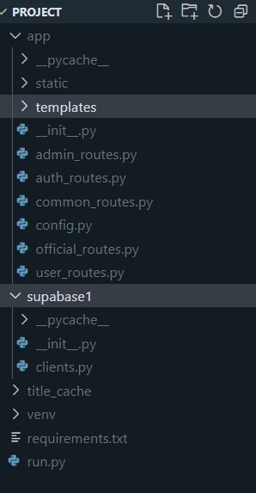

**GitHub repository link:** <https://github.com/Madhan-KJ/PRGI>

**Website link:** <https://prgi-vkwq.onrender.com>

**APPENDIX B**





