**INTERACTIVE PRODUCT ENQUIRY CHATBOT WITH VIDEO CALL INTEGRATION**

1st M Rekha, 2A Madhan, 3M Mahesh,4Sk Muzammil

1Associate Professor, 234Scholar

1 Department of Computer Science and Engineering

1,2,3,4 Lingaya’s Institute of Management and Technology, Andhra Pradesh, India

**Abstract— In today's digital era, customer engagement and accessibility are pivotal in ensuring a seamless shopping experience. This project presents the development of an Interactive Product Enquiry Chatbot with Video Call Integration, aimed at enhancing user interaction and accessibility in product inquiries. The chatbot leverages modern technologies such as image-based product identification, object detection, and text-to-speech conversion to give users a dynamic and engaging experience. The key features of the chatbot include real-time camera preview and picture capture functionalities, allowing users to capture images of products they wish to inquire about. These images are then processed using TensorFlow.js and the COCO-SSD model for object detection, enabling the chatbot to identify and display the names of objects within the images. Additionally, the detected object names are converted into speech using TextToSpeech functionality, enhancing accessibility for users with visual impairments. The project is implemented using Ionic React for the frontend interface, integrating various Ionic components for user interaction. Capacitor plugins are utilized to access device features such as the camera and text-to-speech functionality, while TensorFlow.js handles the object detection tasks. The backend manages communication between the front end and external services, facilitating seamless integration and operation of the chatbot. Challenges encountered during the project include the integration of TensorFlow.js and the COCO-SSD model into the front end, ensuring compatibility across different devices and platforms, and optimizing performance and responsiveness. Future enhancements may include additional features such as natural language processing for more advanced interactions and integration with external databases for product information. Overall, the Interactive Product Enquiry Chatbot with Video Call Integration offers a novel solution for enhancing customer engagement and accessibility in product inquiries, paving the way for more interactive and personalized shopping experiences.**

**Keywords: TensorFlow, COCO-SSD, Capacitor.**

# Introduction

In the rapidly evolving landscape of e-commerce and digital communication, businesses strive to enhance customer engagement and accessibility to ensure a seamless and personalized shopping experience. The advent of chatbots has revolutionized customer interaction, offering an efficient and interactive platform for addressing inquiries and providing assistance. However, traditional text-based chatbots may sometimes lack the visual context necessary for certain types of inquiries, particularly in product-related queries. To address this challenge, we present the development of an Interactive Product Enquiry Chatbot with Video Call Integration. This project aims to augment traditional chatbot functionalities with advanced features such as real-time image-based product identification, object detection, and text-to-speech conversion. By integrating these technologies, the chatbot provides users with a dynamic and engaging platform for querying products and receiving personalized assistance. The primary objective of the project is to enhance user interaction and accessibility in product inquiries by leveraging modern technologies and innovative approaches. The chatbot allows users to capture images of products using their device camera and utilizes TensorFlow.js and the COCO-SSD model for object detection. This enables the chatbot to identify objects within the images and provide users with immediate feedback on the detected objects. Furthermore, the project incorporates text-to-speech functionality to convert the detected object names into speech, thereby enhancing accessibility for users with visual impairments. By offering both visual and auditory feedback, the chatbot caters to a diverse range of users and ensures a seamless and inclusive user experience. The implementation of the project utilizes Ionic React for the frontend interface, integrating various Ionic components for user interaction. Capacitor plugins enable access to device features such as the camera and text-to-speech functionality, while TensorFlow.js handles the object detection tasks. The backend facilitates communication between the front end and external services, ensuring seamless integration and operation of the chatbot. Through this project, we aim to demonstrate the potential of integrating advanced technologies to create interactive and personalized shopping experiences. By providing users with a platform that combines visual and auditory feedback, the Interactive Product Enquiry Chatbot with Video Call Integration redefines customer engagement in the digital age, paving the way for more immersive and efficient interactions in e-commerce environments.

# LITERATURE SURVEY

Karanbir Singh Chahal, Kuntal Dey. Object detection is the identification of an object in the image along with its localisation and classification. It has widespread applications and is a critical component for vision-based software systems. This paper seeks to perform a rigorous survey of modern object detection algorithms that use deep learning. As part of the survey, the topics explored include various algorithms, quality metrics, speed/size trade-offs and training methodologies. This paper focuses on the two types of object detection algorithms- the SSD class of single-step detectors and the Faster R-CNN class of two-step detectors. Techniques to construct detectors that are portable and fast on low-powered devices are also addressed by exploring new lightweight convolutional base architectures. Ultimately, a rigorous review of the strengths and weaknesses of each detector leads us to the present state of the art. AppsMax Lynch, Capacitor is a cross-platform native runtime that makes it easy to build performant mobile applications that run natively on iOS, Android, and more using modern web tooling. Representing the next evolution of Hybrid apps, Capacitor creates Web Native apps, providing a modern native container approach for teams who want to build web-first without sacrificing full access to native SDKs when they need it.

Capacitor provides a consistent, web-focused set of APIs that enable an app to stay as close to web standards as possible while accessing rich native device features on platforms that support them. If it works in the browser, it probably works in a mobile app when using Capacitor. Adding native functionality is straightforward with a Plugin API for Swift on iOS, Java on Android, and JavaScript for the web.

# SYSTEM ARCHITECTURE:

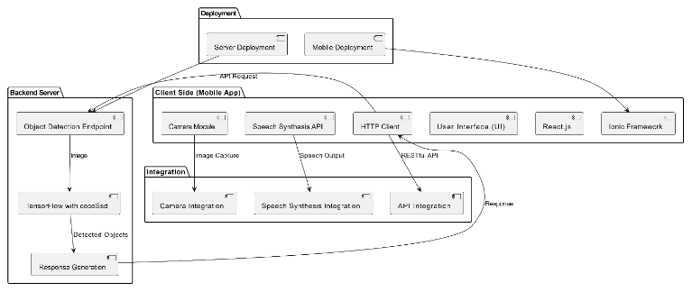

**METHODOLOGY**

Project Definition and Scope Identification:

Define the scope and objectives of the project, including the goals to be achieved and the problem to be addressed. Identify the target audience and stakeholders for the project.

Literature Review: Conduct a comprehensive review of existing literature, research papers, and

relevant projects related to interactive chatbots, image processing, object

detection, and video call integration. Analyze and synthesize findings from the literature review to inform the

project's approach and methodology.

Requirement Elicitation and Analysis: Engage with stakeholders, including faculty advisors, project supervisors, and potential end-users, to gather requirements and define the functionalities of the project.

Document functional and non-functional requirements based on stakeholder

inputs and project goals.

Technology Selection and Research: Research and evaluate various technologies, frameworks, and tools suitable for implementing the project requirements. Select appropriate technologies for developing the chatbot interface, integrating image processing and object detection capabilities, and incorporating real-time video call functionalities.

System Design: Design the system architecture, data flow, and component interactions based on the defined requirements and selected technologies. Create wireframes and mockups to visualize the user interface and user interactions.

Implementation and Development: Develop the project components, including the chatbot interface, image

processing module, real-time camera preview feature, and text-to-speech integration. Follow best practices and coding standards while implementing the project to

ensure maintainability and scalability.

Testing and Quality Assurance: Conduct thorough testing of the project components to verify functionality,

usability, and performance. Perform unit tests, integration tests, and system tests to identify and address

any bugs or issues. Solicit feedback from peers, advisors, and potential end-users to validate the project's effectiveness and usability.

Documentation and Report Writing: Document the project development process, including design decisions,

implementation details, testing procedures, and results. Write a comprehensive project report that outlines the project's objectives, methodology, findings, and conclusions. Include diagrams, screenshots, and code snippets to illustrate key aspects of the project.

Presentation: Prepare a presentation to showcase the project to faculty advisors, project evaluators, and peers.

# RESULT AND DISCUSSION

Login page



Main Page

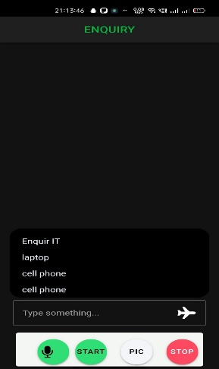

CONCLUSION AND FUTURE WORK

Android Ionic app for object detection using TensorFlow's cocoSsd model represents a significant achievement in leveraging cutting-edge technology to address real-world challenges. Throughout the development process, careful consideration was given to the design, functionality, and usability of the application to ensure its effectiveness and user satisfaction. By implementing features such as user authentication, camera preview, image capture for object detection, and display of detected objects in an HTML div, the app provides users with a seamless and intuitive experience. The integration of speech capabilities further enhances accessibility and user engagement by providing spoken feedback at each step of the process. threats. Furthermore, collaboration with industry stakeholders and policymakers will be essential

# REFERENCES

1. TensorFlow. (n.d.). TensorFlow Lite (v2.16.1)2024. Retrieved from <https://www.tensorflow.org/lite>.
2. Ionic Framework. (n.d.) (v7.8.6)2024. Ionic Documentation. Retrieved from <https://ionicframework.com/docs>.
3. React. (n.d.) (v8.0.1)2024. React Documentation. Retrieved from <https://reactjs.org/docs/getting-started.html>.
4. OpenAI. (n.d.). GPT-3.5(v3.5) 2022. Retrieved from <https://openai.com/>.
5. PlantUML. (n.d.) (v2.0). PlantUML Documentation. Retrieved from <https://plantuml.com/>.
6. Capacitor. (n.d.). Capacitor Documentation. Retrieved from <https://capacitorjs.com/docs>.
7. IEEE. (n.d.). IEEE Xplore Digital Library. Retrieved from <https://ieeexplore.ieee.org/Xplore/home.jsp>.
8. Google Chrome. (n.d.). Google Chrome Help Center. Retrieved from <https://support.google.com/chrome>