**1.Find all the information about each products**

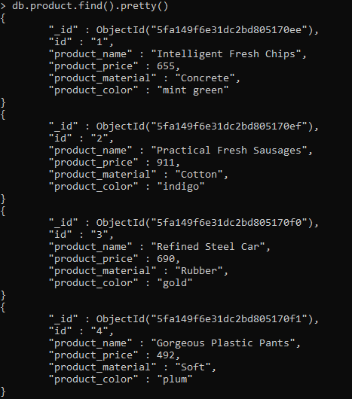

**2.Find the product price which are between 400 to 800**

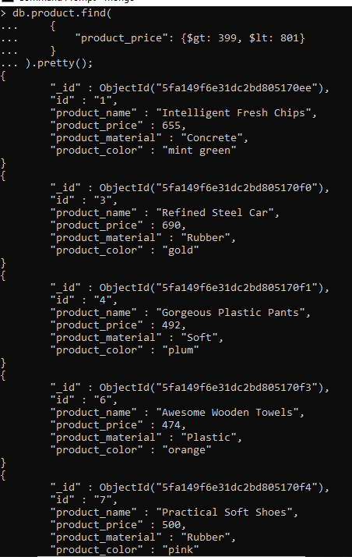

**3.Find the product price which are not between 400 to 600**

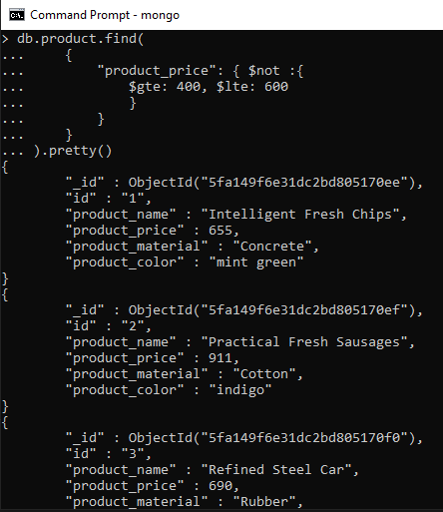

**4.List the four products which are grater than 500 in price**

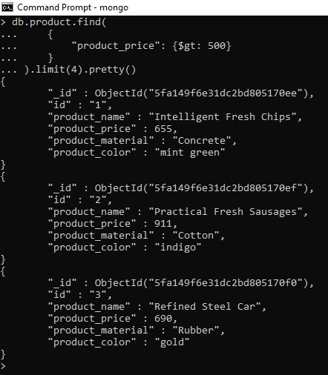

**5.** **Find the product name and product material of each products**

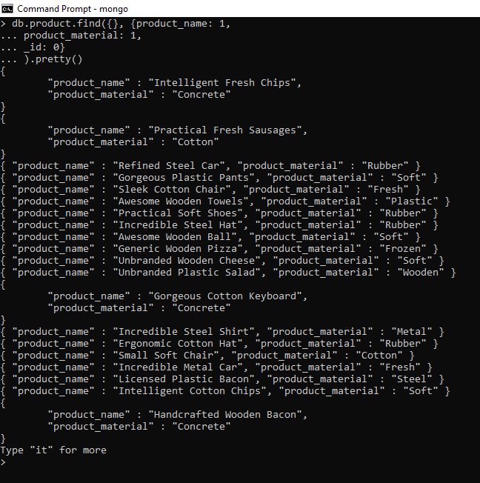

**6.** **Find the product with a row id of 10**

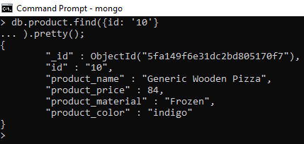

**7.** **Find only the product name and product material**

**8.** **Find all products which contain the value of soft in product material**

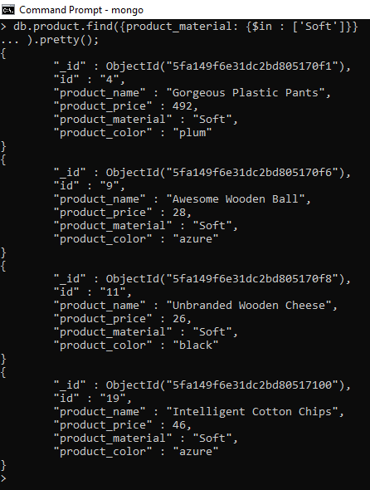

**9.** **Find products which contain product color indigo and product price 492.00**

**No matches found !**

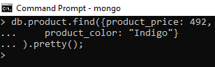

**10.** **Delete the products which product price value are same**

