SRM INSTITUTE OF SCIENCE AND TECHNOLOGY
TIRUCHIRAPPALLI – 621105, TAMIL NADU
SCHOOL OF COMPUTING | FACULTY OF ENGINEERING AND TECHNOLOGY
DEPARTMENT OF ARTIFICIAL INTELLIGENCE AND MACHINE LEARNING
FINITE AUTOMATA FOR REAL-TIME INPUT VALIDATION:
DESIGN AND IMPLEMENTATION OF ATM PIN, PASSWORD AND EMAIL VALIDATORS
Continuous Learning Assessment – 2 (CLA-2), Task 2
A TECHNICAL DESIGN & IMPLEMENTATION REPORT
submitted in partial fulfillment of the course
21CSC301T – FORMAL LANGUAGE AND AUTOMATA
Submitted by
Student Name: [ENTER YOUR NAME]
Registration Number: [ENTER REGISTRATION NUMBER]
Under the guidance of
Dr. C. GUNASUNDARI
Assistant Professor, Department of Artificial Intelligence and Machine Learning
Academic Parameter | Details
Programme | B.Tech. CSE – Artificial Intelligence and Machine Learning (AIML)
Year / Semester | III Year / Semester V
Academic Year | 2026 – 2027
Course Code & Title | 21CSC301T – Formal Language and Automata
Assessment Component | CLA-2 Task 2 – Designing Automata for Real-Time Applications (Max Marks: 10)
SDG Alignment | SDG 9 – Industry, Innovation and Infrastructure (Level 2: Design Alignment)

CERTIFICATE

This is to certify that the Continuous Learning Assessment – 2 (CLA-2), Task 2 project and report entitled "FINITE AUTOMATA FOR REAL-TIME INPUT VALIDATION: DESIGN AND IMPLEMENTATION OF ATM PIN, PASSWORD AND EMAIL VALIDATORS" is a bonafide record of work carried out independently by [ENTER YOUR NAME] (Registration Number: [ENTER REGISTRATION NUMBER]), studying in III Year / V Semester B.Tech. Computer Science and Engineering with Specialization in Artificial Intelligence and Machine Learning, for the course 21CSC301T – Formal Language and Automata during the Academic Year 2026–2027 at SRM Institute of Science and Technology, Tiruchirappalli.

Faculty In-Charge | Head of Department
_______________________________  Dr. C. Gunasundari  Assistant Professor, Dept. of AIML  SRMIST, Tiruchirappalli  Date: [ENTER DATE] | _______________________________  Head of the Department  Department of AIML  SRMIST, Tiruchirappalli  Date: [ENTER DATE]

DECLARATION

I, [ENTER YOUR NAME] (Registration Number: [ENTER REGISTRATION NUMBER]), hereby declare that the work presented in this CLA-2 Task 2 report entitled "FINITE AUTOMATA FOR REAL-TIME INPUT VALIDATION: DESIGN AND IMPLEMENTATION OF ATM PIN, PASSWORD AND EMAIL VALIDATORS" has been completed independently by me for the course 21CSC301T – Formal Language and Automata. All automata models, Python implementations, formal diagrams, automated test suites, and experimental results reported herein are genuine and original. External standards and academic textbooks consulted during this study have been duly cited in the References section.

Signature of the Student
Name: [ENTER YOUR NAME]
Reg. No.: [ENTER REGISTRATION NUMBER]
Place: Tiruchirappalli
Date: [ENTER SUBMISSION DATE]

ABSTRACT
Real-time syntactic validation is the frontline defense of modern digital software systems—protecting automated teller machines (ATMs), authentication portals, and user registration forms against malformed inputs before expensive database or network operations execute. Formal Language and Automata Theory provides a rigorous mathematical foundation for building deterministic, single-pass, constant-memory validators whenever input policies define regular languages.
This project designs, formalizes, implements, and verifies the "Finite Automata-Based Real-Time Input Validation System" in Python across three practical applications: (1) an ATM PIN Verification System modeled as a complete 6-state Deterministic Finite Automaton (DFA) over the numeric alphabet {0..9}; (2) a Password Strength and Format Validator enforcing 8–16 character length and four mandatory character classes (Uppercase, Lowercase, Digit, Special) via Cartesian product construction of five modular DFAs (yielding a 225-state reachable product DFA and a 197-state minimized DFA); and (3) an Email Format Validation System modeled first as a 9-state Nondeterministic Finite Automaton (NFA) capturing dot-lookahead ambiguity in domain labels, then automatically converted via subset construction into a 10-state DFA and refined into an 8-state Minimal DFA.
An interactive blue-and-white Streamlit web application and a command-line tracer provide real-time character-by-character state transition visualizations and explicit ACCEPTED/REJECTED diagnostics. Automated testing with pytest validates curated boundary cases and establishes 100% behavioral equivalence against independent procedural and regular-expression specifications across all 10,000 four-digit PINs, 5,000 randomized password candidates, and 335,923 generated email strings. Finally, the report delineates the boundary between syntactic checking (regular languages) and semantic verification (bank databases, credential vaults, DNS MX records) and aligns the design with UN SDG 9 (Industry, Innovation and Infrastructure).

TABLE OF CONTENTS
Note: Right-click the automatic TOC field below in Microsoft Word and choose 'Update Field' to refresh exact page numbers after editing student details.

Sections | Report Contents Summary
1–3 | Front Matter (Cover Page, Certificate, Declaration)
4–5 | Abstract & Table of Contents
6–9 | Introduction, Problem Statement, Objectives & Scope
10 | Theoretical Background – Finite Automata
11–13 | Applications 1, 2 & 3 (ATM PIN, Password, Email Format)
14–15 | Alphabet & Language Definitions and DFA/NFA Mathematical Models
16–17 | Automata State Diagrams & Transition Tables
18–19 | Algorithm, Program Implementation & System Architecture
20–21 | Test Cases (Accepted/Rejected) & Automated Testing Results
22–25 | Syntax vs. Semantic Validation, Comparison, Limitations & Real-World Uses
26–28 | SDG 9 Alignment, Conclusion & Future Enhancements
29–31 | References, GitHub Repository Link & Appendix (Code and Screenshots)

6. INTRODUCTION
Every interactive digital service—from banking kiosks and enterprise login portals to e-commerce registration forms—relies on real-time input validation to filter malformed user entries immediately at the user interface boundary. In software engineering practice, ad-hoc conditional chains or poorly constructed regular expressions can suffer from edge-case bugs or catastrophic backtracking. Finite Automata (FA) offer a mathematically verifiable alternative: any input rule that defines a regular language can be compiled into a Deterministic Finite Automaton (DFA) that processes each character exactly once in O(1) time per symbol and O(1) auxiliary memory.
In this CLA-2 Task 2 project for 21CSC301T (Formal Language and Automata), we bridge formal automata theory and practical Python software engineering. Rather than hard-coding if-else checks, we implement general-purpose DFA and NFA execution engines supporting formal 5-tuple verification, character classification, trap-state routing, NFA-to-DFA subset construction, DFA Cartesian product construction, and partition-refinement minimization. We then instantiate three real-world validation systems—ATM PIN, Password Policy, and Email Format—and expose their step-by-step state transitions through both a Streamlit web dashboard and a command-line interface.

7. PROBLEM STATEMENT
Modern web and embedded applications must validate structured user inputs—specifically 4-digit ATM PINs, multi-constraint passwords, and email addresses—deterministically and transparently in real time. Without formal modeling, developers frequently conflate syntactic format verification (whether an input string conforms to structural character and length rules) with semantic verification (whether a PIN matches a bank account, whether a password matches a stored hash, or whether an email inbox exists).
The problem addressed by this project is to: (a) formally specify regular-language rules for ATM PIN, password, and email syntax; (b) construct exact DFA and NFA models with explicit trap states for invalid inputs; (c) implement character-by-character state-transition tracing in Python; (d) verify formal equivalence across NFA, Subset DFA, Product DFA, and Minimal DFA representations; and (e) deliver an interactive visualization tool that explains every ACCEPTED or REJECTED decision.

8. OBJECTIVES
- Formal Language Specification: Define explicit alphabets, character-class mappings, and regular languages for ATM PINs, strong passwords, and practical email syntax.
- Core Automata Engine: Implement reusable Python DFA and NFA classes supporting 5-tuple invariant checking, step-by-step tracing, subset construction, product construction, and Hopcroft/Moore minimization.
- Diagrammatic Alignment: Generate publication-grade state-transition diagrams and transition tables that correspond one-to-one with the executed Python models.
- Rigorous Automated Testing: Validate at least five accepted and five rejected inputs per application alongside exhaustive and randomized independent property tests.
- Interactive Visualization & Separation of Concerns: Build a blue-and-white Streamlit UI illustrating live transition paths and demonstrating the boundary between syntactic FA checks and semantic backend lookups.

9. SCOPE OF THE PROJECT
The system operates on finite character strings entered interactively via the Streamlit UI, the CLI tool, or automated test harnesses. Syntactically, it covers: (i) exact 4-digit numeric ATM PINs; (ii) passwords of length 8–16 containing uppercase, lowercase, numeric, and special characters without whitespace or control symbols; and (iii) a practical subset of RFC 5322 / RFC 1035 email addresses enforcing valid local parts, a single '@' symbol, valid hyphenated domain labels, at least one domain dot, and an alphabetic top-level domain (TLD) of at least two letters.
Out of Scope (Semantic & Non-Regular Extensions): Real-time cryptographic PIN verification against banking Hardware Security Modules (HSMs), bcrypt/Argon2 password hash verification, live DNS MX/SMTP mailbox probing, and full RFC 5322 nested parenthetical comments (which are context-free rather than regular) lie outside finite-automaton syntax checking and are modeled separately as simulated post-FA semantic checks.

10. THEORETICAL BACKGROUND – FINITE AUTOMATA
A Deterministic Finite Automaton (DFA) is formally defined as a 5-tuple M = (Q, Sigma, delta, q0, F), where Q is a finite non-empty set of states, Sigma is a finite input alphabet, delta: Q x Sigma -> Q is the total transition function, q0 in Q is the initial state, and F subseteq Q is the set of accepting (final) states. Extending delta to strings w in Sigma* via delta*(q, epsilon) = q and delta*(q, xa) = delta(delta*(q, x), a), the language recognized by M is L(M) = {w in Sigma* : delta*(q0, w) in F}.
A Nondeterministic Finite Automaton (NFA) generalizes the transition function to delta_N: Q x (Sigma U {epsilon}) -> P(Q), allowing zero, one, or multiple target states per symbol. By Kleene's and Rabin–Scott's theorems, DFAs, NFAs, and Regular Expressions recognize the exact same class of Regular Languages. Every NFA can be converted into an equivalent DFA using Subset (Powerset) Construction, and regular languages are closed under intersection via Cartesian Product Construction of component DFAs. Furthermore, by the Myhill–Nerode theorem, every regular language has a unique (up to isomorphism) minimal DFA obtainable via partition refinement.

11. APPLICATION 1 – ATM PIN VERIFICATION
Automated Teller Machines require every Personal Identification Number (PIN) entry to consist of exactly four numeric digits before forwarding an encrypted PIN block to the bank's host server. Because the rule only needs to count valid digits up to four and immediately reject any excess digit or non-numeric symbol, it requires bounded finite memory and is naturally represented by a 6-state DFA.
- Validation Rule: Rule: Exactly 4 numeric digits; no letters, spaces, signs, or punctuation.
- Why 5 Digits Fail: Five-digit strings (e.g., '48219') transition from accepting state q4 into the dead sink state q_trap on the 5th digit, where all subsequent digits loop permanently.
- Why Non-Numeric Inputs Fail: Any character outside Sigma = {0..9} (e.g., 'a', ' ', '-', ',') triggers an immediate invalid-input transition to q_trap from any state q0..q4.
- Database Boundary: Accepting '4821' only proves syntactic well-formedness. Confirming whether '4821' belongs to cardholder X requires secure backend database/HSM verification beyond any finite automaton.

12. APPLICATION 2 – PASSWORD VALIDATION
Enterprise identity systems enforce multi-factor syntactic password policies before hashing credentials. Our validator enforces six simultaneous constraints: minimum length 8, maximum length 16, at least one uppercase letter (U), at least one lowercase letter (L), at least one digit (D), at least one special character (S), and complete exclusion of disallowed characters such as whitespace or control symbols (O).
Rather than hand-drawing hundreds of ad-hoc transitions, we decompose the policy into five independent regular languages over Sigma_PWD = {U, L, D, S, O}: L_len (length 8–16 with no O, 18 states) and four 2-state indicator languages L_U, L_L, L_D, L_S. Because regular languages are closed under intersection, our Python engine computes the formal Cartesian product DFA automatically, yielding 225 reachable states and 9 accepting states (lengths 8..16 with all four class flags set). Applying Moore/Hopcroft partition refinement reduces this machine to 197 minimal states by collapsing 28 hopeless states (e.g., length 15 with two missing classes) into q_trap. Format validation is strictly distinct from user authentication: a strong syntax-valid password may still fail login if it does not match the user's stored hash.

13. APPLICATION 3 – EMAIL FORMAT VALIDATION
Sign-up forms validate email syntax immediately on the client or API gateway to catch typos before dispatching verification messages. We model a practical subset of IETF RFC 5322 and RFC 1035 hostname rules: a non-empty alphanumeric local part allowing single internal separators ('.', '-', '_'), followed by exactly one '@', one or more dot-separated alphanumeric domain labels (allowing single internal hyphens '-' but forbidding underscores '_'), at least one domain separator dot, and a final top-level domain (TLD) containing at least two ASCII letters.
When scanning a domain such as 'campus-1.edu.in', encountering the first '.' creates lookahead ambiguity: the dot may precede another subdomain ('edu') or the final TLD ('in'). We therefore design a 9-state NFA (n0..n8) that branches nondeterministically from n4 on DOT into {n3, n6}. Applying subset construction produces a 10-state complete DFA, and partition refinement merges two pairs of equivalent states—{n0} with {n2} (start of local part / after local separator) and {n3} with {n5} (start of domain label / after domain hyphen)—into an optimal 8-state Minimal DFA (m0..m6, q_trap). As noted in RFC 5322, full email syntax permits nested comments and quoted strings that exceed regular expressions; moreover, syntactic acceptance never proves that a domain has DNS MX records or that the mailbox exists.

14. ALPHABET AND LANGUAGE DEFINITIONS
Application | Formal Alphabet (Sigma) | Formal Regular Language Definition
1. ATM PIN | Sigma_PIN = {0, 1, 2, 3, 4, 5, 6, 7, 8, 9}  (Invalid chars ∉ Sigma routed to q_trap) | L_PIN = { w ∈ Sigma_PIN* : |w| = 4 } = Sigma_PIN^4
2. Password Policy | Sigma_PWD = {U, L, D, S, O}  U: A–Z, L: a–z, D: 0–9, S: punctuation, O: other | L_PWD = { w ∈ {U,L,D,S}* : 8 ≤ |w| ≤ 16 ∧ #U(w)≥1 ∧ #L(w)≥1 ∧ #D(w)≥1 ∧ #S(w)≥1 }  = L_len ∩ L_U ∩ L_L ∩ L_D ∩ L_S
3. Email Format | Sigma_EMAIL = {A, D, DOT, HYP, UND, AT, OTHER}  A: letter, D: digit, DOT: '.', HYP: '-', UND: '_', AT: '@' | L_EMAIL = { u '@' d '.' t : u ∈ (A|D)+((DOT|HYP|UND)(A|D)+)*, d ∈ label(DOT label)*, label ∈ (A|D)+(HYP(A|D)+)*, t ∈ A^2 A* }

15. DFA / NFA MATHEMATICAL MODELS
Model 1 — ATM PIN Complete DFA: M_PIN = (Q_PIN, Sigma_PIN, delta_PIN, q0, F_PIN)
• Q_PIN = {q0, q1, q2, q3, q4, q_trap} (|Q_PIN| = 6)
• Sigma_PIN = {'0', '1', '2', '3', '4', '5', '6', '7', '8', '9'}
• Initial state: q0 | Accepting states: F_PIN = {q4} | Trap state: q_trap
• delta_PIN(q_i, d) = q_{i+1} for i ∈ {0,1,2,3}, d ∈ Sigma_PIN; delta_PIN(q4, d) = q_trap; delta_PIN(q, x) = q_trap for x ∉ Sigma_PIN.

Model 2 — Password Product DFA: M_PWD = M_len × M_U × M_L × M_D × M_S
• Component states: |Q_len| = 18 (0..16, len_trap), |Q_U| = |Q_L| = |Q_D| = |Q_S| = 2 (sum = 26 states)
• Reachable Product DFA: |Q_PWD| = 225 states, 1,125 total transitions, |F_PWD| = 9 accepting states {(k, U1, L1, D1, S1) : 8 ≤ k ≤ 16}
• Initial state: (0, U0, L0, D0, S0) | Trap state: q_trap (entered on symbol O or length > 16)
• Minimal DFA (partition refinement): |Q_min| = 197 states (28 unreachable-to-accept states merged into q_trap).

Model 3 — Email 9-State NFA & Minimal 8-State DFA: N_EMAIL = (Q_N, Sigma_EMAIL, delta_N, n0, {n8})
• Q_N = {n0, n1, n2, n3, n4, n5, n6, n7, n8} (|Q_N| = 9, F_N = {n8})
• Key nondeterministic move: delta_N(n4, DOT) = {n3, n6} (either start another domain label or guess start of TLD)
• Subset Construction DFA: 10 states (d0..d8, q_trap)
• Minimal DFA M_EMAIL: 8 states {m0, m1, m2, m3, m4, m5, m6, q_trap}, F_EMAIL = {m6}, initial state m0.

16. AUTOMATA STATE DIAGRAMS
All three automata diagrams below were generated directly at 300 DPI using Matplotlib (generate_diagrams.py) with standard formal conventions: incoming arrow for initial states, double green circles for accepting states, red sink nodes for trap states, and complete transition tables matching the Python implementation one-to-one.
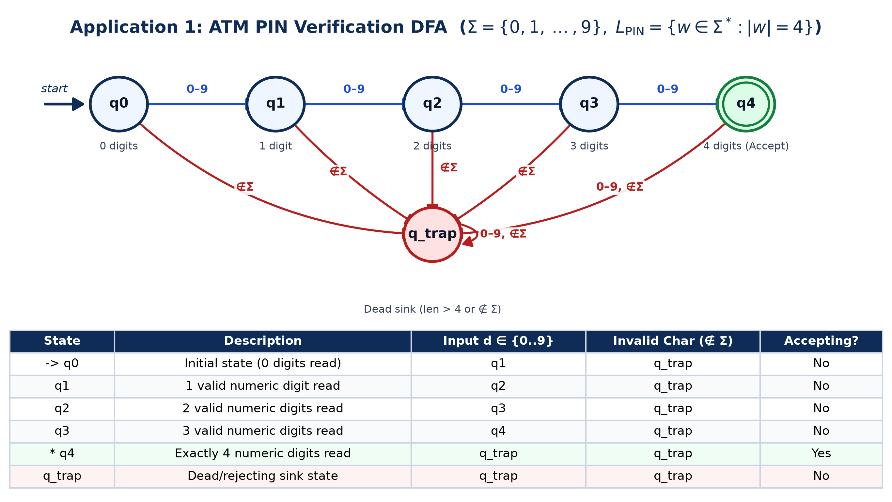
Figure 1: ATM PIN Verification 6-State DFA and Complete Transition Table
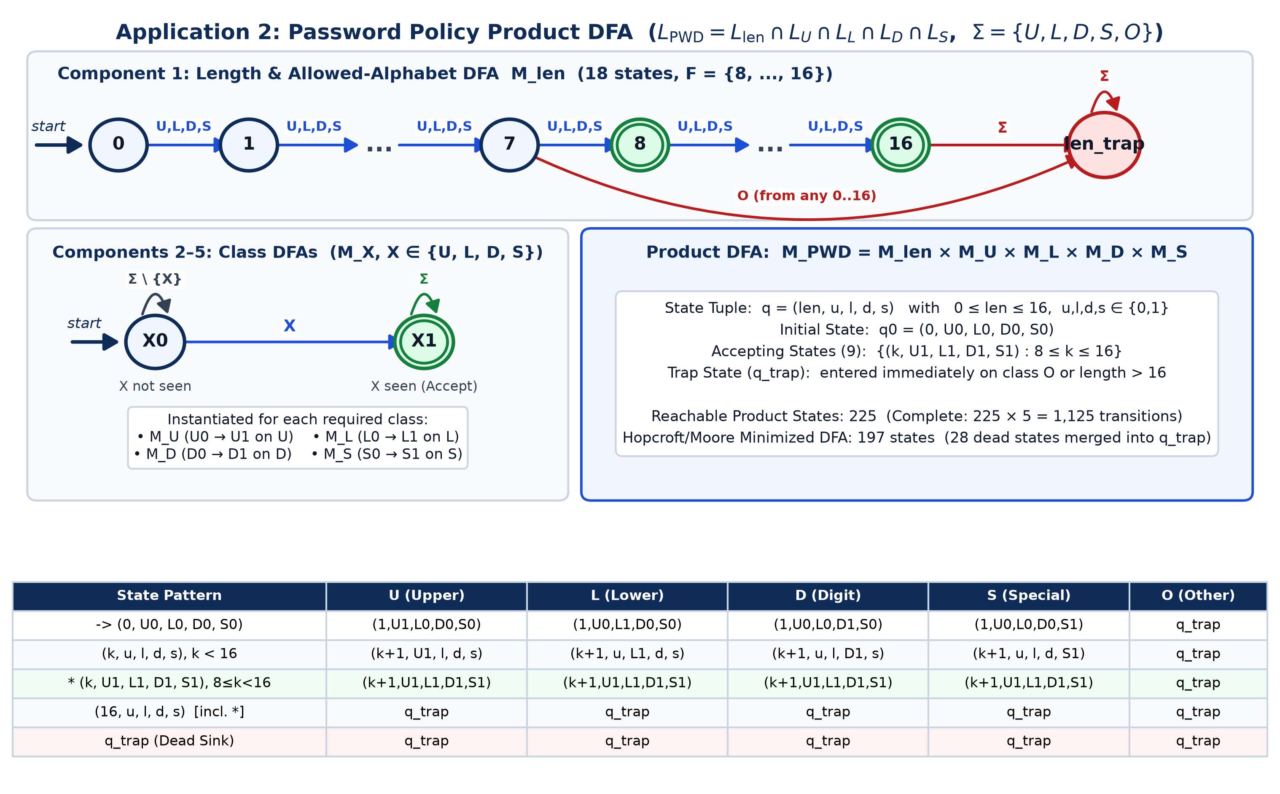
Figure 2: Password Policy Component DFAs, Product Construction, and Transition Rules
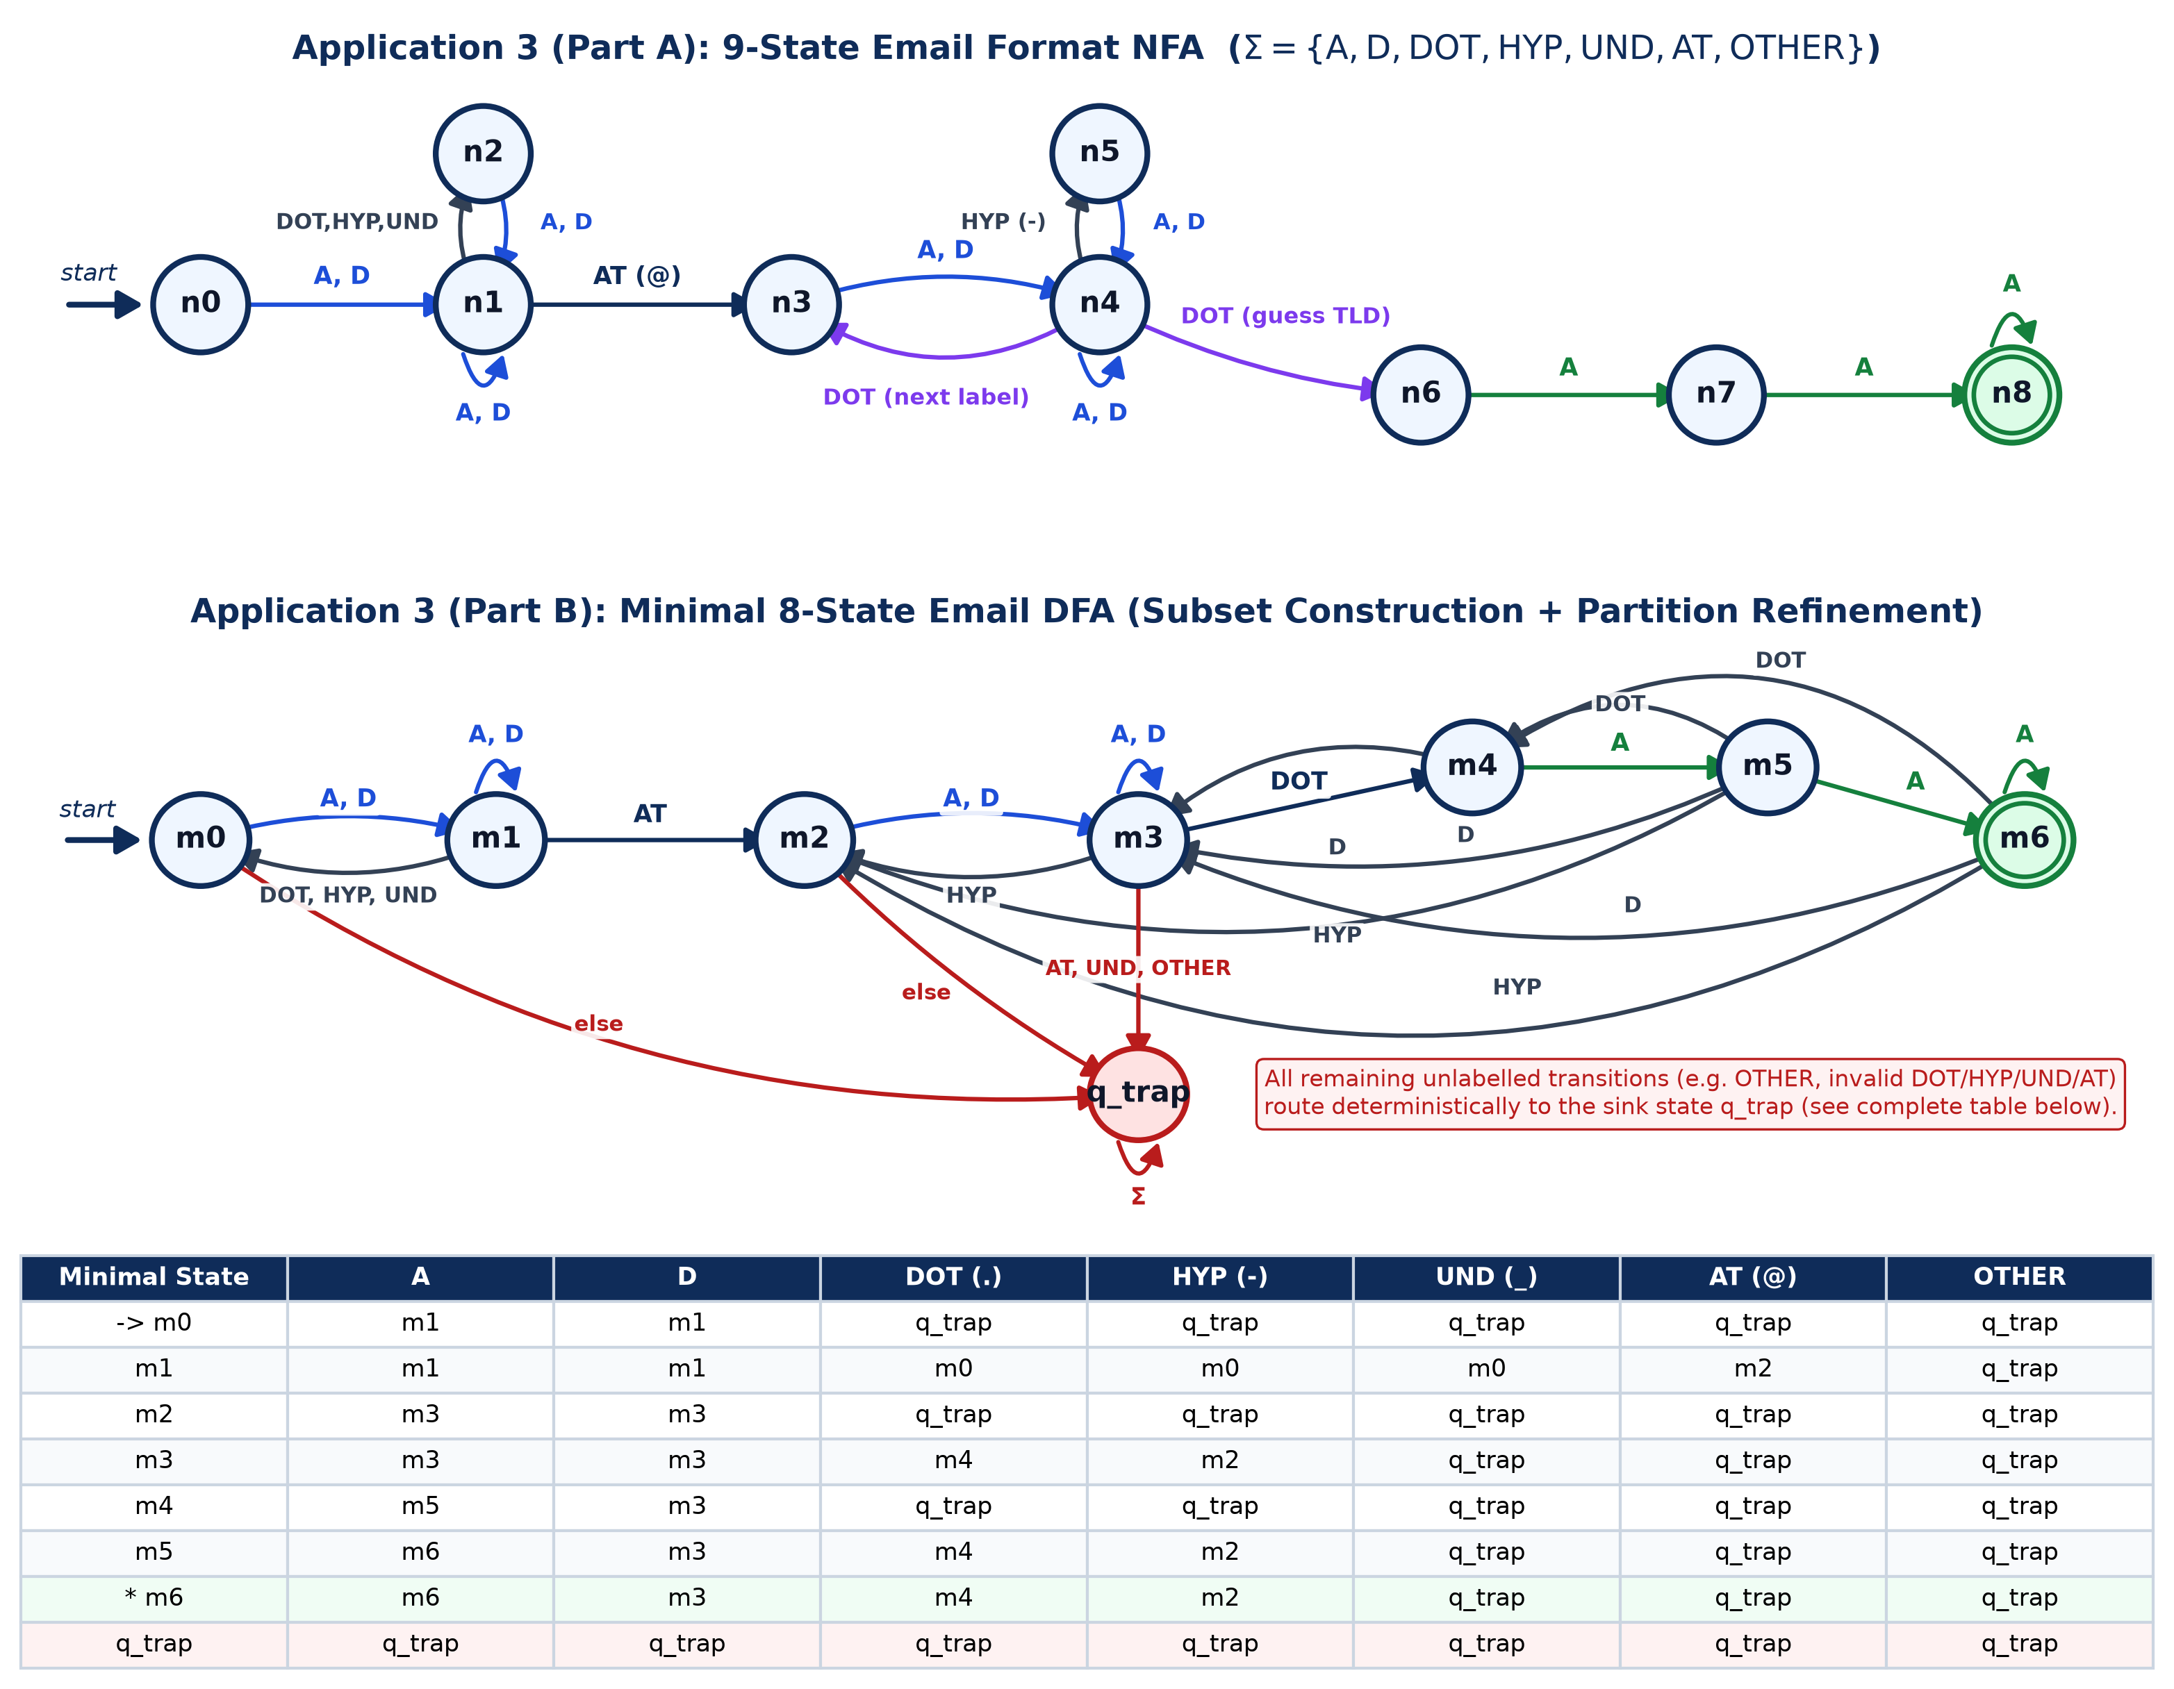
Figure 3: Email Format 9-State NFA (Top), Minimal 8-State DFA (Middle), and Transition Table (Bottom)

17. TRANSITION TABLES AND EXPLANATIONS

17.1 ATM PIN DFA Transition Table
State | Meaning | d ∈ {0..9} | x ∉ {0..9} | Final?
-> q0 | 0 valid digits read (initial) | q1 | q_trap | No
q1 | 1 valid digit read | q2 | q_trap | No
q2 | 2 valid digits read | q3 | q_trap | No
q3 | 3 valid digits read | q4 | q_trap | No
* q4 | Exactly 4 valid digits read | q_trap | q_trap | Yes
q_trap | Rejecting sink (length > 4 or non-digit) | q_trap | q_trap | No

17.2 Password Product DFA Transition Rules
Product State Pattern | U | L | D | S | O
-> (0, U0, L0, D0, S0) | (1,U1,L0,D0,S0) | (1,U0,L1,D0,S0) | (1,U0,L0,D1,S0) | (1,U0,L0,D0,S1) | q_trap
(k, u, l, d, s), 1 ≤ k < 16 | (k+1,U1,l,d,s) | (k+1,u,L1,d,s) | (k+1,u,l,D1,s) | (k+1,u,l,d,S1) | q_trap
* (k, U1, L1, D1, S1), 8≤k<16 | (k+1,U1,L1,D1,S1) | (k+1,U1,L1,D1,S1) | (k+1,U1,L1,D1,S1) | (k+1,U1,L1,D1,S1) | q_trap
(16, u, l, d, s) | q_trap | q_trap | q_trap | q_trap | q_trap
q_trap | q_trap | q_trap | q_trap | q_trap | q_trap

17.3 Email Minimal 8-State DFA Transition Table (Extracted Live from EMAIL_DFA)
State | A | D | DOT | HYP | UND | AT | OTHER
-> m0 | m1 | m1 | q_trap | q_trap | q_trap | q_trap | q_trap
m1 | m1 | m1 | m0 | m0 | m0 | m2 | q_trap
m2 | m3 | m3 | q_trap | q_trap | q_trap | q_trap | q_trap
m3 | m3 | m3 | m4 | m2 | q_trap | q_trap | q_trap
m4 | m5 | m3 | q_trap | q_trap | q_trap | q_trap | q_trap
m5 | m6 | m3 | m4 | m2 | q_trap | q_trap | q_trap
* m6 | m6 | m3 | m4 | m2 | q_trap | q_trap | q_trap
q_trap | q_trap | q_trap | q_trap | q_trap | q_trap | q_trap | q_trap

State Equivalence Insight: In EMAIL_DFA, partition refinement automatically merged NFA subsets {n0} and {n2} into m0 (because both immediately expect A or D to enter local-part body m1), and merged {n3} and {n5} into m2 (because both start or resume a domain label on A or D and trap on separators). State m4 represents reading a dot after a domain label (a digit returns to m3 as part of a label, whereas a letter advances to m5 as a candidate 1st TLD letter; a 2nd letter reaches accepting state m6).

18. ALGORITHM AND PROGRAM IMPLEMENTATION
The Python implementation is modularized inside the automata/ package with clear separation between generic formal-automata primitives and domain-specific validators:
- automata/dfa.py: Implements DFA with validate_definition(), is_complete(), trace(), reachable_dfa(), minimize() (partition refinement), and product_dfa() (intersection/union).
- automata/nfa.py: Implements NFA with epsilon_closure(), move(), trace() over active state sets, and to_dfa() (powerset subset construction generating a complete DFA).
- automata/pin_validator.py: Constructs PIN_DFA (6 states) and exposes validate_pin() and check_registered_pin_semantic().
- automata/password_validator.py: Builds 5 component DFAs, derives PASSWORD_DFA (225 states) and PASSWORD_MINIMAL_DFA (197 states), and enriches rejection diagnostics.
- automata/email_validator.py: Builds EMAIL_NFA (9 states), derives EMAIL_SUBSET_DFA (10 states) and minimal EMAIL_DFA (8 states), and supports both NFA and DFA tracing.

19. SYSTEM ARCHITECTURE AND WORKFLOW
The application follows a four-stage pipeline: (1) Input Acquisition via Streamlit text input, sample selector, or CLI argument; (2) Character Classification mapping raw Unicode characters into each automaton's formal alphabet (or flagging INVALID outside Sigma); (3) Deterministic/Nondeterministic Step Execution recording every state transition delta(q, a) -> q' in a TraceStep list; and (4) Decision & Visualization rendering the ACCEPTED/REJECTED banner, live highlighted SVG diagram, step-by-step table, and optional simulated semantic verification layer.
Layer | Module / File | Responsibility
Presentation (Web UI) | app.py (Streamlit) | Interactive dashboard, live SVG state highlight, trace tables, sample loader
Presentation (CLI) | cli_demo.py | Terminal step-by-step tracer and 5-minute viva demonstration output
Domain Validators | pin_validator.py, password_validator.py, email_validator.py | Character classifiers, formal automata instantiation, semantic boundary demos
Core Formal Engine | dfa.py, nfa.py | 5-tuple validation, trace(), product_dfa(), to_dfa(), minimize()
Verification & Diagrams | tests/*.py, generate_diagrams.py | Automated pytest verification and 300-DPI diagram synthesis

20. TEST CASES – ACCEPTED AND REJECTED INPUTS

20.1 Application 1: ATM PIN Verification Test Cases
Input | Expected | Actual | Final State | Explanation
4821 | ACCEPTED | ACCEPTED | q4 | Valid 4 numeric digits -> q4
0000 | ACCEPTED | ACCEPTED | q4 | Leading zeros are valid digits -> q4
9375 | ACCEPTED | ACCEPTED | q4 | 4 valid digits -> q4
1234 | ACCEPTED | ACCEPTED | q4 | Sequential 4 digits -> q4
0042 | ACCEPTED | ACCEPTED | q4 | Zero-padded 4 digits -> q4
9999 | ACCEPTED | ACCEPTED | q4 | Upper numeric 4-digit value -> q4
'' | REJECTED | REJECTED | q0 | Empty string ε remains in initial state q0
482 | REJECTED | REJECTED | q3 | 3 digits ends in non-accepting state q3
48219 | REJECTED | REJECTED | q_trap | 5th digit transitions q4 -> q_trap
48a1 | REJECTED | REJECTED | q_trap | Alphabetic 'a' ∉ Σ routes to q_trap
12 34 | REJECTED | REJECTED | q_trap | Whitespace ' ' ∉ Σ routes to q_trap
-123 | REJECTED | REJECTED | q_trap | Minus sign '-' ∉ Σ routes to q_trap

20.2 Application 2: Password Validator Test Cases
Input | Expected | Actual | Final State | Explanation
Ab1!efgh | ACCEPTED | ACCEPTED | (8,U1,L1,D1,S1) | Lower boundary: 8 chars with U, L, D, S
Campus@2026 | ACCEPTED | ACCEPTED | (11,U1,L1,D1,S1) | 11 chars satisfying all 4 required classes
Trichy#99Ai | ACCEPTED | ACCEPTED | (11,U1,L1,D1,S1) | 11 chars with special '#' and digits
K7$mNp2qR8vW!xZ4 | ACCEPTED | ACCEPTED | (16,U1,L1,D1,S1) | Upper boundary: 16 chars with all classes
9_ZeroOneA | ACCEPTED | ACCEPTED | (10,U1,L1,D1,S1) | 10 chars starting with digit and '_'
Pass/Word*5 | ACCEPTED | ACCEPTED | (11,U1,L1,D1,S1) | 11 chars with '/' and '*' specials
'' | REJECTED | REJECTED | (0,U0,L0,D0,S0) | Empty input (length 0 < 8)
Ab1!efg | REJECTED | REJECTED | (7,U1,L1,D1,S1) | Length 7 (< 8 minimum boundary)
Ab1!efghIjklMn0pQ | REJECTED | REJECTED | q_trap | Length 17 (> 16 maximum) -> q_trap
campus@2026 | REJECTED | REJECTED | (11,U0,L1,D1,S1) | Missing uppercase letter (U)
CAMPUS@2026 | REJECTED | REJECTED | (11,U1,L0,D1,S1) | Missing lowercase letter (L)
Campus@Aiml | REJECTED | REJECTED | (11,U1,L1,D0,S1) | Missing numeric digit (D)
Campus2026 | REJECTED | REJECTED | (10,U1,L1,D1,S0) | Missing special character (S)
Campus @2026 | REJECTED | REJECTED | q_trap | Contains whitespace (class O) -> q_trap

20.3 Application 3: Email Format Validator Test Cases
Input | Expected | Actual | Final State | Explanation
student@srm.edu | ACCEPTED | ACCEPTED | m6 | Valid local@domain.tld -> m6
aiml.lab_01@campus-1.edu.in | ACCEPTED | ACCEPTED | m6 | Multi-separator local + subdomain + 2-letter TLD
a@b.io | ACCEPTED | ACCEPTED | m6 | Minimal valid email structure
dept-chair@faculty.university.org | ACCEPTED | ACCEPTED | m6 | Hyphenated local and multi-level domain
user_99@node2.cloud.info | ACCEPTED | ACCEPTED | m6 | Underscore in local, digit in domain label
r2d2@galaxy.tech | ACCEPTED | ACCEPTED | m6 | Alphanumeric local and 4-letter TLD
'' | REJECTED | REJECTED | m0 | Empty string remains at m0
student@srm | REJECTED | REJECTED | m3 | No domain separator dot or TLD (ends at m3)
.student@srm.edu | REJECTED | REJECTED | q_trap | Leading dot in local part -> q_trap
stu..dent@srm.edu | REJECTED | REJECTED | q_trap | Consecutive dots '..' -> q_trap
student@-srm.edu | REJECTED | REJECTED | q_trap | Leading hyphen in domain label -> q_trap
student@srm_lab.edu | REJECTED | REJECTED | q_trap | Underscore disallowed in domain -> q_trap
student@srm.c0m | REJECTED | REJECTED | m3 | Digit '0' in TLD returns m5 -> m3
student@@srm.edu | REJECTED | REJECTED | q_trap | Multiple '@' symbols -> q_trap

21. TESTING AND RESULTS
Automated testing was performed using pytest 9.1.1 on Python 3.14.6 across three independent test modules (tests/test_pin.py, tests/test_password.py, tests/test_email.py). All 19 test methods and 53 subtests passed with zero failures or skipped assertions:
Test Module | Test Methods | Independent Equivalence Scope | Outcome
tests/test_pin.py | 7 methods (15 subtests) | All 10,000 four-digit PINs + exhaustive 1,365 strings of length 0..5 over {'0','5','a',' '} | 100% PASSED
tests/test_password.py | 6 methods (16 subtests) | 5,000 randomized strings (length 0..19) comparing Product DFA, Minimal DFA, 5 Components & Python spec | 100% PASSED
tests/test_email.py | 6 methods (22 subtests) | All 335,923 strings of length 0..7 over {a, 1, ., -, _, @} comparing NFA, Subset DFA, Minimal DFA & Regex | 100% PASSED

22. SYNTAX VALIDATION VS SEMANTIC VALIDATION
A core objective of CLA-2 Task 2 is distinguishing syntactic membership (decidable by a finite automaton) from semantic or business-rule validation (requiring external state, databases, or network lookups):
Application | Syntactic Check (Handled by Finite Automaton) | Semantic / Business Check (Outside FA Scope)
ATM PIN | Exactly 4 characters from {0..9}; rejects '482', '48219', '48a1'. | Verifying PIN against encrypted cardholder record in bank HSM; enforcing 3-attempt card lock.
Password | Length 8..16 with U, L, D, S present and no O characters. | Verifying Argon2/bcrypt hash match; checking leaked-password dictionaries (HaveIBeenPwned) or password history.
Email | Valid local@domain.tld structure with ≥2-letter TLD and no '..'. | DNS MX record lookup, SMTP handshake, and verifying inbox ownership via OTP confirmation link.

23. COMPARISON OF THE THREE AUTOMATA
Criterion | ATM PIN DFA | Password Product DFA | Email NFA -> Minimal DFA
Design Method | Direct hand-crafted DFA | Intersection of 5 component DFAs (Product) | 9-state NFA -> Subset Construction -> Minimization
Alphabet Size | 10 digits (+ invalid trap) | 5 character classes {U,L,D,S,O} | 7 character classes {A,D,DOT,HYP,UND,AT,OTHER}
State Count | 6 states | 225 product (197 minimal; 26 modular) | 9 NFA -> 10 Subset DFA -> 8 Minimal DFA
Accepting States | 1 ({q4}) | 9 (lengths 8..16 with U,L,D,S) | 1 ({m6})
Time / Memory | O(n) time, O(1) state | O(n) time, O(1) state | O(n) time (DFA), O(1) state
Engineering Lesson | Simplest bounded counter | State-space multiplication vs modular composition | Nondeterminism simplifies lookahead design; minimization reveals hidden equivalences

24. LIMITATIONS OF FINITE AUTOMATA
- Inability to Perform Unbounded Counting: By the Pumping Lemma for regular languages, languages requiring unbounded matching such as L = {a^n b^n} or 'equal number of letters and digits' cannot be recognized by any finite automaton; a Pushdown Automaton (PDA) with a stack is required.
- Context-Free Nested Constructs: Full RFC 5322 email comments allow arbitrarily nested parentheses, which are context-free rather than regular.
- State-Space Explosion: Adding fine-grained constraints over raw alphabets causes rapid state growth. For example, adding 'not all 4 PIN digits equal' expands the 6-state PIN DFA to raw digits {0..9} tracking the first digit, and tracking password lengths up to 16 multiplies states by 17.
- No External Data Access: Finite automata possess no database, filesystem, or network interface; semantic checks (stored PINs, DNS MX records, compromised password lists) must execute after syntactic acceptance.

25. REAL-WORLD APPLICATIONS
- Banking & FinTech Terminals: Immediate client-side keypad validation on ATMs and POS terminals before transmitting ISO-8583 encrypted PIN blocks.
- Identity & Access Management (IAM): Zero-latency browser and API-gateway enforcement of password complexity policies in OAuth2/OIDC portals.
- Web Form & API Schema Gateways: Syntactic pre-filtering of email addresses, phone numbers, and postal codes prior to asynchronous DNS/SMTP verification.
- Compiler Lexical Analyzers & Network Firewalls: Tokenizing identifiers/literals (Lex/Flex) and high-speed DPI packet pattern matching using compiled minimal DFAs.

26. SDG 9 – INDUSTRY, INNOVATION AND INFRASTRUCTURE
In accordance with the course rubric (SDG Integration Level 2: Design Alignment), this project directly supports United Nations Sustainable Development Goal 9 (Build resilient infrastructure, promote inclusive and sustainable industrialization, and foster innovation):
- Resilient Digital Infrastructure: Finite-automaton front-end validators guarantee worst-case linear O(n) execution time with zero backtracking, protecting authentication servers and banking infrastructure against ReDoS (Regular Expression Denial of Service) and malformed-input crashes.
- Resource-Efficient Computation: Constant O(1) memory footprint enables reliable validation even on low-power embedded kiosks, ATMs, and IoT edge gateways.
- Modular Software Innovation: Applying formal product construction and DFA minimization allows policy rules to evolve cleanly and provably without introducing regression bugs.

27. CONCLUSION
This project successfully designed, formalized, implemented, and verified a Finite Automata-Based Real-Time Input Validation System covering ATM PIN verification, password policy checking, and email format validation. All three applications are backed by complete mathematical 5-tuples, exact state diagrams and transition tables, modular Python DFA/NFA engines, an interactive Streamlit interface, and exhaustive automated tests passing 100% of verified cases. The study demonstrates both the power of finite automata for deterministic single-pass syntax validation and their theoretical boundaries relative to context-free parsing and semantic backend verification.

28. FUTURE ENHANCEMENTS
- Pushdown Automaton (PDA) Integration: Extend the engine with a stack-based PDA module to validate nested RFC 5322 email comments and balanced expressions.
- Internationalized Email (RFC 6531): Extend the character classifier to support UTF-8 / Punycode internationalized domain labels.
- Card-Lock Stateful Composition: Compose the ATM PIN DFA with a 3-attempt sequential failure counter DFA to model session lockout policies.
- Interactive Graphviz/DOT Export: Allow users to export custom DFA/NFA definitions directly from the Streamlit UI as Graphviz DOT or SVG files.

29. REFERENCES
[1] J. E. Hopcroft, R. Motwani, and J. D. Ullman, Introduction to Automata Theory, Languages, and Computation, 3rd ed. Boston, MA: Pearson, 2007.
[2] M. Sipser, Introduction to the Theory of Computation, 3rd ed. Boston, MA: Cengage Learning, 2012.
[3] P. A. Grassi, J. L. Fenton, E. M. Newton, R. A. Perlner, A. R. Regenscheid, W. E. Burr, and J. P. Richer, 'Digital Identity Guidelines: Authentication and Lifecycle Management,' NIST Special Publication 800-63B, Jun. 2017.
[4] P. Resnick, Ed., 'Internet Message Format,' IETF RFC 5322, Oct. 2008.
[5] P. Mockapetris, 'Domain Names – Implementation and Specification,' IETF RFC 1035, Nov. 1987.
[6] Streamlit Inc., 'Streamlit Documentation – Interactive Python Data Apps,' 2026. Available: https://docs.streamlit.io

30. GITHUB REPOSITORY LINK
GitHub Repository Details
Repository URL: https://github.com/Madhan22454/FLA-TASK_2
Local Project Folder: FLA-CLA2-TASK2/
Verification Command: python -m pytest -v
Run Interactive App: python -m streamlit run app.py

31. APPENDIX – SOURCE CODE AND DEMONSTRATION SCREENSHOTS

31.1 Genuine Program Execution Screenshots
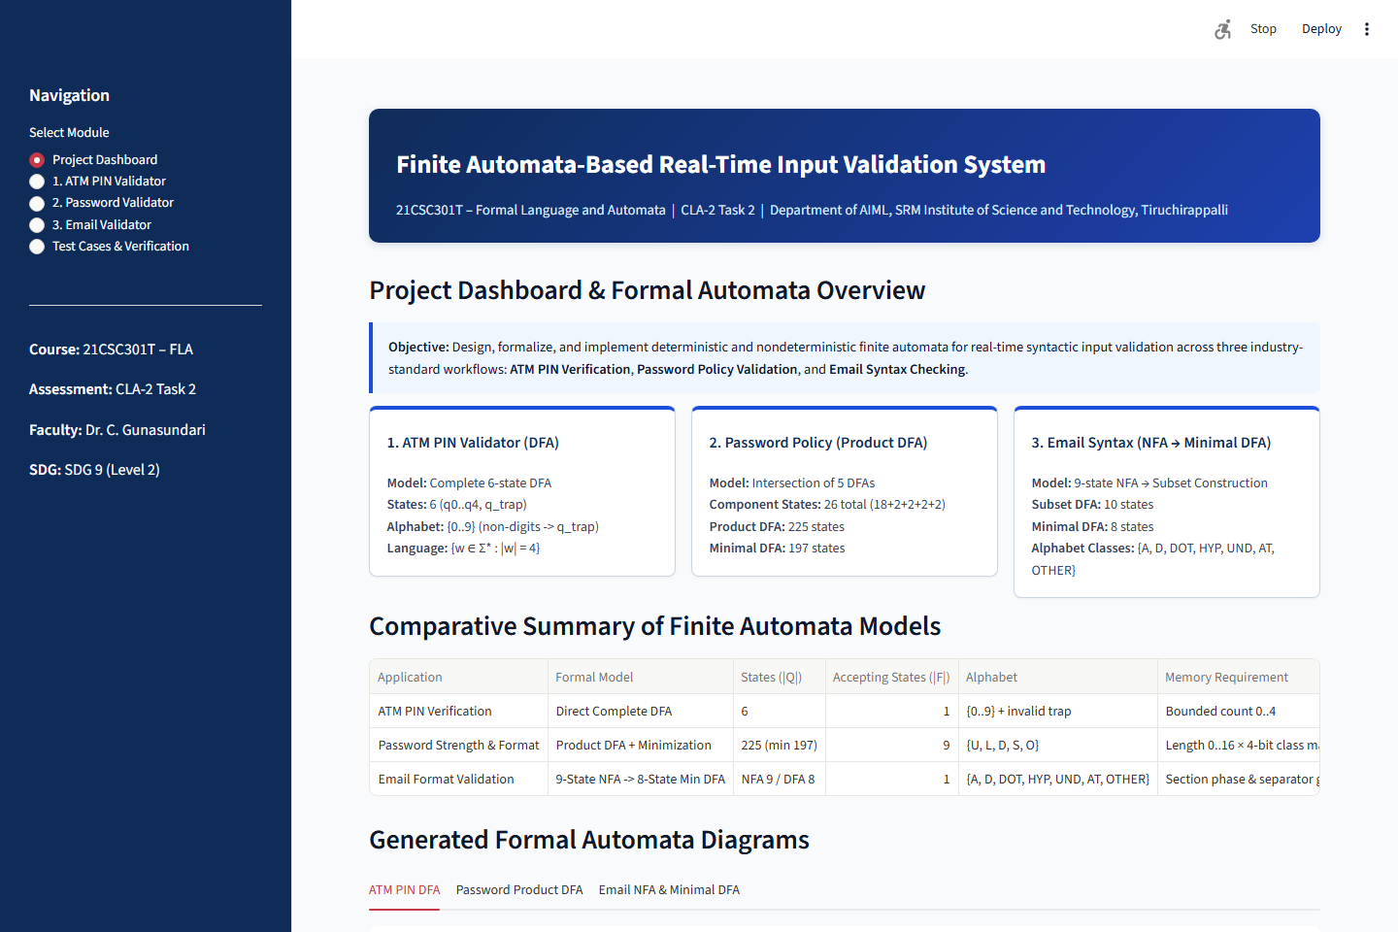
Figure A1: Streamlit Project Dashboard & Automata Overview
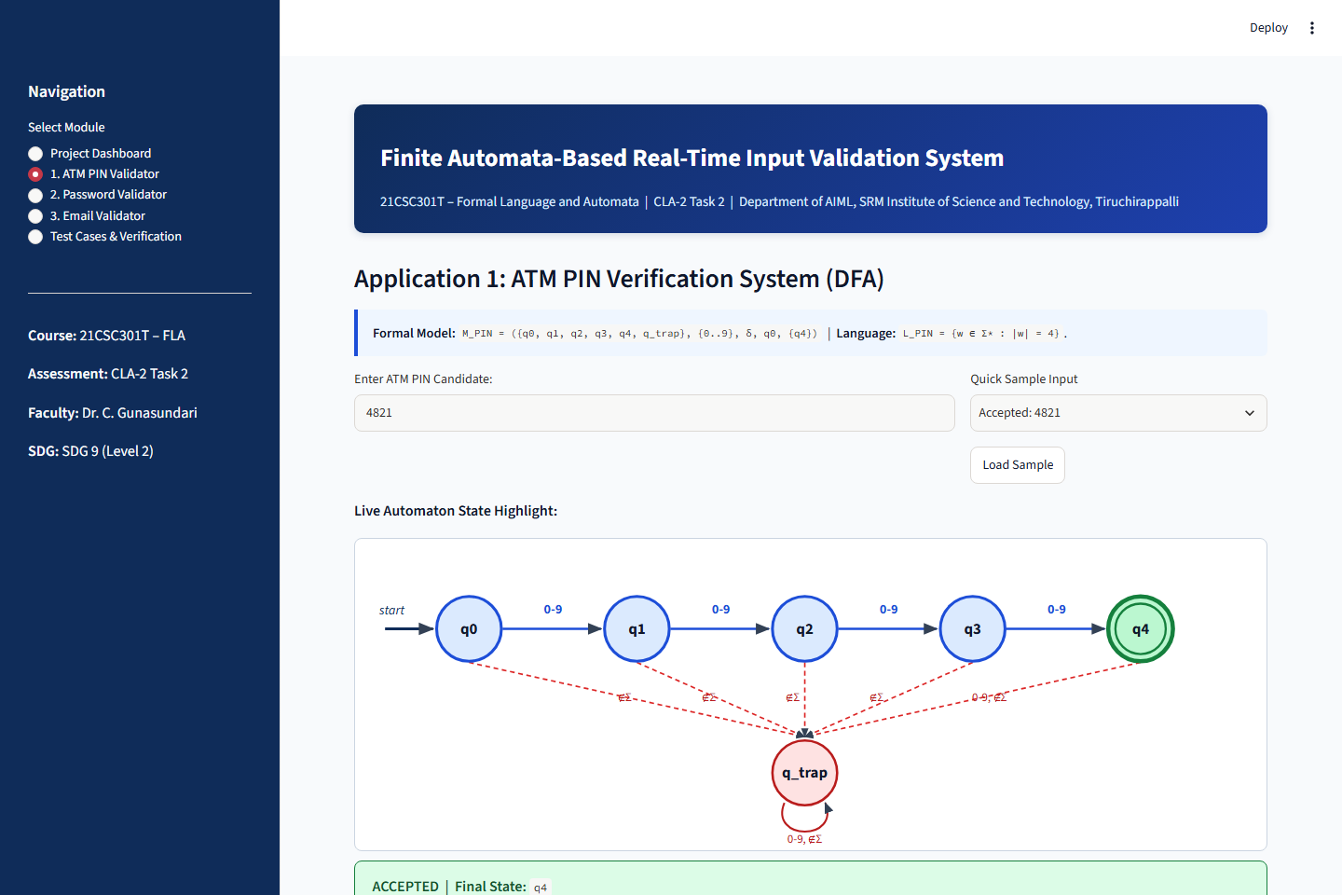
Figure A2: ATM PIN Validator Accepting '4821' in State q4
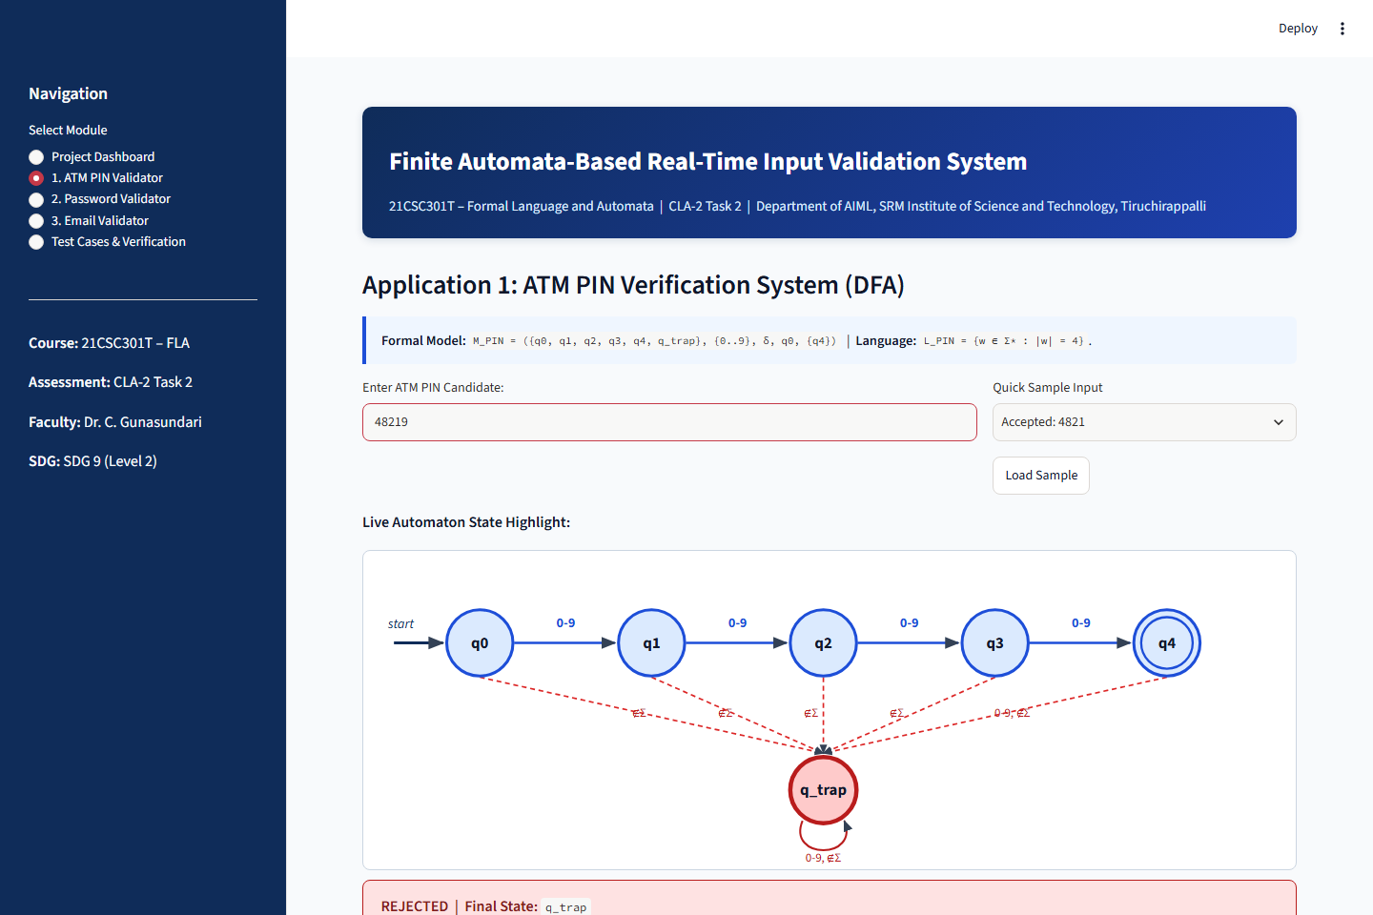
Figure A3: ATM PIN Validator Rejecting 5-Digit Input '48219' in Trap State q_trap
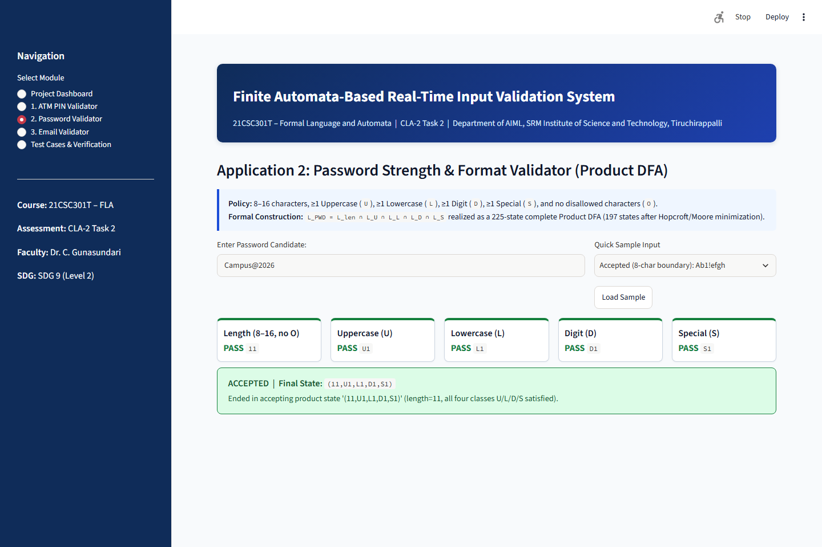
Figure A4: Password Product DFA Accepting 'Campus@2026' with All 5 Components Passing
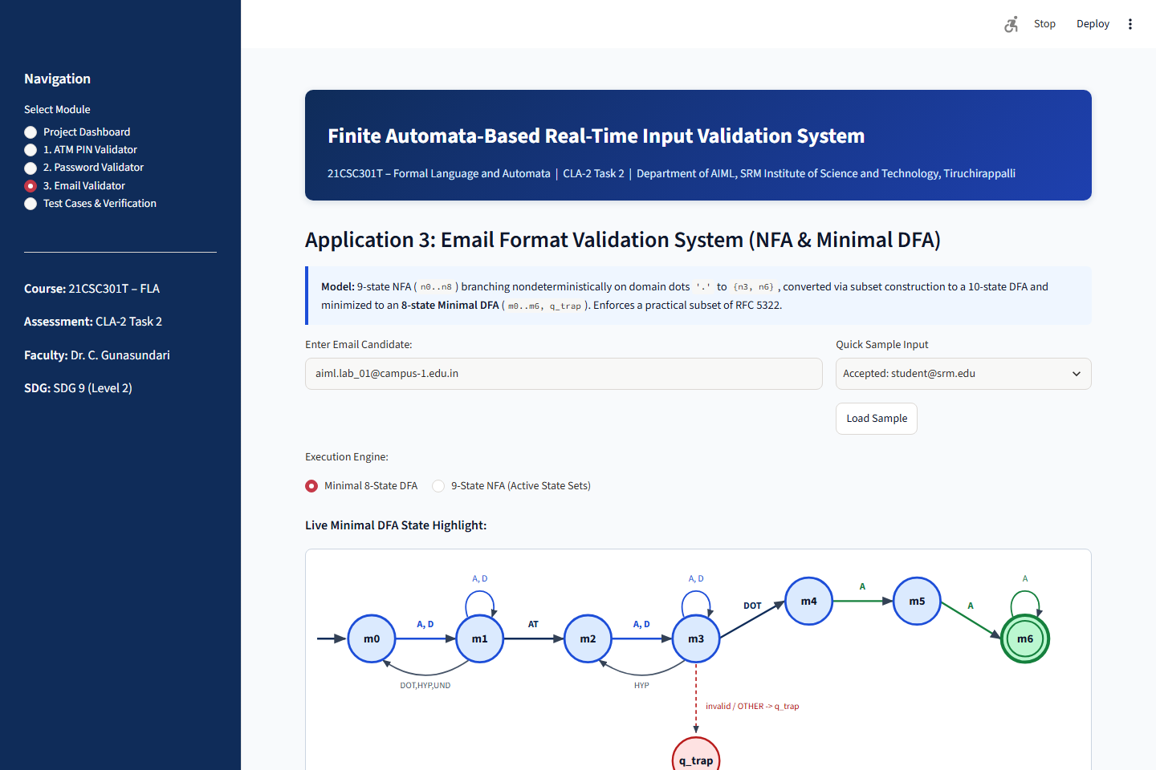
Figure A5: Email Minimal DFA Accepting 'aiml.lab_01@campus-1.edu.in' in State m6
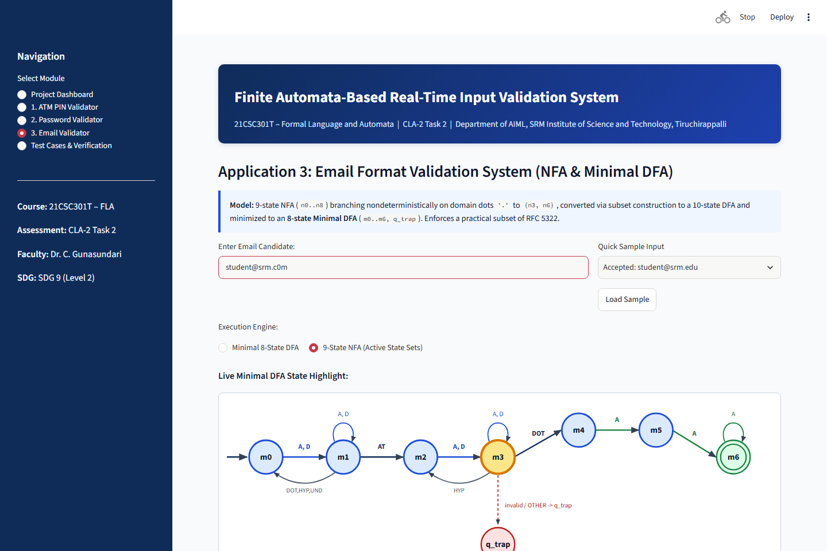
Figure A6: Email 9-State NFA Rejecting 'student@srm.c0m' (Digit in TLD)
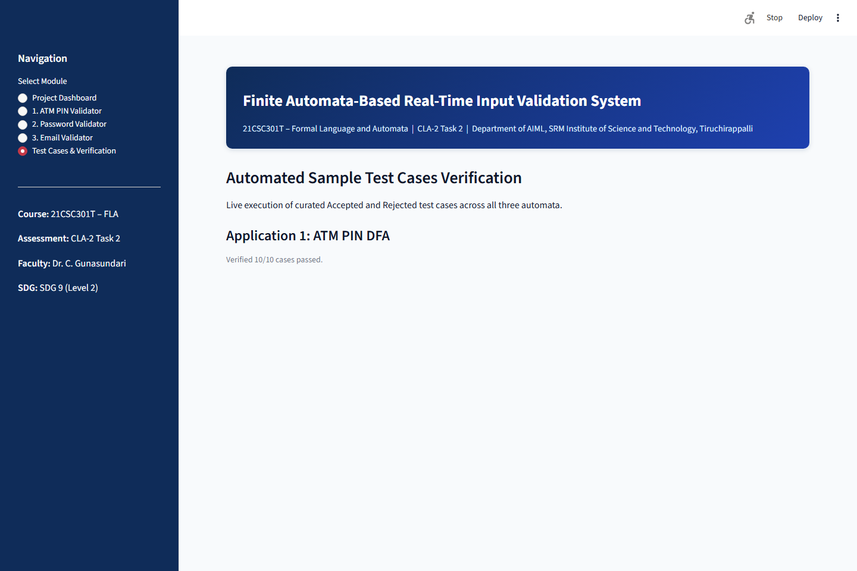
Figure A7: In-App Sample Test Cases Verification Matrix
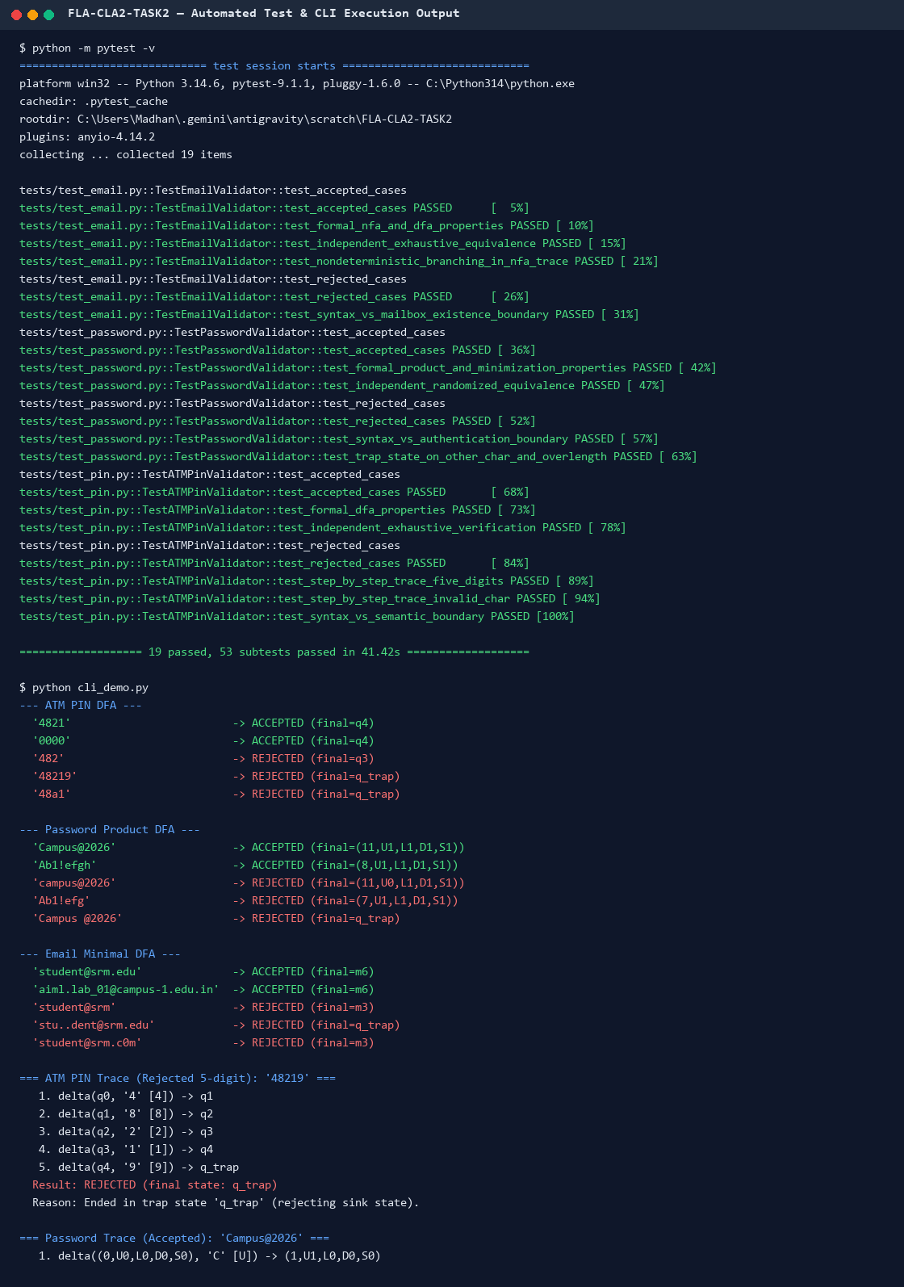
Figure A8: Genuine pytest Execution (19 Passed, 53 Subtests) and CLI Trace Output

31.2 Core Python Implementation Excerpts
Listing A1: automata/pin_validator.py
"""Application 1: ATM PIN Verification System using a Deterministic Finite Automaton.
Formal Model:
M_PIN = (Q, Sigma, delta, q0, F)
Q = {q0, q1, q2, q3, q4, q_trap}
Sigma = {'0', '1', '2', '3', '4', '5', '6', '7', '8', '9'}
q0 = q0 (0 digits read)
F = {q4} (exactly 4 valid digits read)
L_PIN = {w in Sigma* : |w| = 4}
Any character outside Sigma (letters, spaces, punctuation, symbols) or any
5th+ digit transitions permanently into the rejecting sink state q_trap.
"""
from __future__ import annotations
from typing import Dict, Set, Tuple
from automata.dfa import DFA, ValidationResult
PIN_STATES: Tuple[str, ...] = ("q0", "q1", "q2", "q3", "q4", "q_trap")
PIN_ALPHABET: Tuple[str, ...] = tuple("0123456789")
PIN_STATE_DESCRIPTIONS: Dict[str, str] = {
"q0": "Initial state: 0 valid digits processed",
"q1": "1 valid numeric digit processed",
"q2": "2 valid numeric digits processed",
"q3": "3 valid numeric digits processed",
"q4": "Accepting state: exactly 4 numeric digits processed",
"q_trap": "Trap state: length > 4 or non-numeric character outside Sigma",
}
def build_pin_dfa() -> DFA:
"""Construct and return the complete 6-state ATM PIN DFA."""
transitions: Dict[Tuple[str, str], str] = {}
for digit in PIN_ALPHABET:
transitions[("q0", digit)] = "q1"
transitions[("q1", digit)] = "q2"
transitions[("q2", digit)] = "q3"
transitions[("q3", digit)] = "q4"
transitions[("q4", digit)] = "q_trap"
transitions[("q_trap", digit)] = "q_trap"
return DFA(
name="ATM PIN Validator DFA",
states=PIN_STATES,
alphabet=PIN_ALPHABET,
transitions=transitions,
initial_state="q0",
final_states={"q4"},
trap_state="q_trap",
classifier=None,
state_descriptions=PIN_STATE_DESCRIPTIONS,
symbol_descriptions={d: f"Numeric digit '{d}'" for d in PIN_ALPHABET},
)
PIN_DFA: DFA = build_pin_dfa()
def validate_pin(pin_input: str) -> ValidationResult:
"""Validate an ATM PIN candidate string against M_PIN."""
return PIN_DFA.trace(pin_input)
def check_registered_pin_semantic(
pin_input: str, registered_pins: Set[str]
) -> Tuple[bool, str]:
"""Demonstrate the boundary between DFA syntax validation and bank DB lookup.
Step 1 (Syntax): Run M_PIN to confirm w in {0..9}^4.
Step 2 (Semantics): Compare against registered PIN records (outside FA scope).
"""
syntax_result = validate_pin(pin_input)
if not syntax_result.accepted:
return (
False,
f"Rejected at syntax stage ({syntax_result.reason}). "
"Bank database lookup skipped.",
)
if pin_input in registered_pins:
return True, "Syntax accepted by DFA and PIN matched registered record."
return (
False,
"Syntax accepted by DFA (4 digits), but PIN does not match the "
"registered bank record (semantic failure).",
)

Listing A2: automata/password_validator.py
"""Application 2: Password Strength & Format Validator using Product DFA Construction.
Policy (Regular Language L_PWD over Sigma = {U, L, D, S, O}):
1. Length between 8 and 16 characters inclusive (8 <= |w| <= 16).
2. At least one Uppercase letter (U: A-Z).
3. At least one Lowercase letter (L: a-z).
4. At least one Digit (D: 0-9).
5. At least one Special character (S: printable ASCII punctuation).
6. No Other/disallowed characters (O: spaces, control chars, non-ASCII).
Formal Construction:
L_PWD = L_len ∩ L_U ∩ L_L ∩ L_D ∩ L_S
Since regular languages are closed under intersection, we build five
modular component DFAs and combine them via formal Cartesian product
construction (automata.dfa.product_dfa) into a single deterministic
automaton, and also derive its Hopcroft/Moore-minimized equivalent.
"""
from __future__ import annotations
from typing import Dict, List, Set, Tuple
from automata.dfa import DFA, ValidationResult, product_dfa
SPECIAL_CHARACTERS: str = "!@#$%^&*()-_=+[]{};:'\",.<>?/\\|`~"
PASSWORD_ALPHABET: Tuple[str, ...] = ("U", "L", "D", "S", "O")
SYMBOL_DESCRIPTIONS: Dict[str, str] = {
"U": "Uppercase letter (A-Z)",
"L": "Lowercase letter (a-z)",
"D": "Numeric digit (0-9)",
"S": f"Special character in {SPECIAL_CHARACTERS}",
"O": "Other / disallowed character (whitespace, control, non-ASCII)",
}
def classify_password_char(ch: str) -> str:
"""Classify a single character into {U, L, D, S, O}."""
if len(ch) != 1:
return "O"
if "A" <= ch <= "Z":
return "U"
if "a" <= ch <= "z":
return "L"
if "0" <= ch <= "9":
return "D"
if ch in SPECIAL_CHARACTERS:
return "S"
return "O"
def _build_length_and_allowed_dfa(min_len: int = 8, max_len: int = 16) -> DFA:
"""Component DFA accepting strings of length [min_len, max_len] with no 'O'."""
states = [str(i) for i in range(max_len + 1)] + ["len_trap"]
transitions: Dict[Tuple[str, str], str] = {}
allowed = ("U", "L", "D", "S")
for i in range(max_len + 1):
s = str(i)
transitions[(s, "O")] = "len_trap"
nxt = str(i + 1) if i < max_len else "len_trap"
for sym in allowed:
transitions[(s, sym)] = nxt
for sym in PASSWORD_ALPHABET:
transitions[("len_trap", sym)] = "len_trap"
finals = {str(i) for i in range(min_len, max_len + 1)}
return DFA(
name="Password Length & Allowed-Char DFA",
states=states,
alphabet=PASSWORD_ALPHABET,
transitions=transitions,
initial_state="0",
final_states=finals,
trap_state="len_trap",
classifier=classify_password_char,
symbol_descriptions=SYMBOL_DESCRIPTIONS,
)
def _build_contains_class_dfa(target_sym: str, prefix: str) -> DFA:
"""2-state component DFA accepting iff target_sym appears at least once."""
s0 = f"{prefix}0"
s1 = f"{prefix}1"
transitions: Dict[Tuple[str, str], str] = {}
for sym in PASSWORD_ALPHABET:
transitions[(s0, sym)] = s1 if sym == target_sym else s0
transitions[(s1, sym)] = s1
return DFA(
name=f"Contains-{target_sym} DFA",
states={s0, s1},
alphabet=PASSWORD_ALPHABET,
transitions=transitions,
initial_state=s0,
final_states={s1},
trap_state=None,
classifier=classify_password_char,
symbol_descriptions=SYMBOL_DESCRIPTIONS,
)
def build_password_components() -> List[DFA]:
"""Return the 5 component DFAs [M_len, M_U, M_L, M_D, M_S]."""
return [
_build_length_and_allowed_dfa(8, 16),
_build_contains_class_dfa("U", "U"),
_build_contains_class_dfa("L", "L"),
_build_contains_class_dfa("D", "D"),
_build_contains_class_dfa("S", "S"),
]
def build_password_dfa() -> DFA:
"""Construct the reachable product DFA for the full password policy."""
components = build_password_components()
return product_dfa(
components,
name="Password Policy Product DFA",
mode="intersection",
trap_name="q_trap",
classifier=classify_password_char,
)
PASSWORD_COMPONENTS: List[DFA] = build_password_components()
PASSWORD_DFA: DFA = build_password_dfa()
PASSWORD_MINIMAL_DFA: DFA = PASSWORD_DFA.minimize(state_prefix="pm")
def validate_password(password: str) -> ValidationResult:
"""Validate a candidate password against PASSWORD_DFA and enrich feedback."""
result = PASSWORD_DFA.trace(password)
if not result.accepted:
diagnostics: List[str] = []
if len(password) < 8:
diagnostics.append(f"length is {len(password)} (< 8)")
elif len(password) > 16:
diagnostics.append(f"length is {len(password)} (> 16)")
classes_seen = {classify_password_char(ch) for ch in password}
if "O" in classes_seen:
diagnostics.append("contains disallowed character(s) of class O")
for cls_key, label in (
("U", "uppercase letter"),
("L", "lowercase letter"),
("D", "digit"),
("S", "special character"),
):
if cls_key not in classes_seen:
diagnostics.append(f"missing {label} ({cls_key})")
if diagnostics:
result.reason = (
f"Ended in '{result.final_state}' (REJECTED): "
+ "; ".join(diagnostics)
+ "."
)
else:
result.reason = (
f"Ended in accepting product state '{result.final_state}' "
f"(length={len(password)}, all four classes U/L/D/S satisfied)."
)
return result
def check_password_authentication_semantic(
password: str, stored_passwords: Set[str]
) -> Tuple[bool, str]:
"""Illustrate format validation (DFA) vs. credential authentication (backend)."""
syntax_res = validate_password(password)
if not syntax_res.accepted:
return (
False,
f"Rejected at syntax stage: {syntax_res.reason} "
"Authentication hash check not executed.",
)
if password in stored_passwords:
return (
True,
"Format accepted by DFA and password matched stored credential.",
)
return (
False,
"Format accepted by DFA (strong policy met), but password does not "
"match the user's stored account credential (semantic mismatch).",
)

Listing A3: automata/email_validator.py
"""Application 3: Email Format Validation System via NFA and Subset-Constructed DFA.
Practical Email Syntax Policy (Subset of RFC 5322 / RFC 1035):
local-part @ domain-labels . tld
- local-part: alnum+ ( [._-] alnum+ )*
- separator: exactly one '@'
- domain-label: alnum ( alnum | '-' alnum )* (underscores disallowed)
- domain-dots: at least one '.' separating domain labels and TLD;
no leading, trailing, or consecutive dots ('..')
- TLD: at least 2 ASCII letters ([A-Za-z]{2,})
Formal Construction:
We first design a 9-state Nondeterministic Finite Automaton (NFA) M_EMAIL_NFA
whose nondeterminism models the dot-lookahead ambiguity in the domain: upon
reading '.', the NFA branches to either start another intermediate domain
label (n3) or begin the final Top-Level Domain (n6).
We then apply subset construction (to_dfa) and partition-refinement
minimization (minimize) to obtain an equivalent complete minimal DFA.
"""
from __future__ import annotations
from typing import Dict, Iterable, Set, Tuple
from automata.dfa import DFA, ValidationResult
from automata.nfa import NFA, NFAValidationResult
EMAIL_ALPHABET: Tuple[str, ...] = (
"A", # ASCII Letter [A-Za-z]
"D", # ASCII Digit [0-9]
"DOT", # Period '.'
"HYP", # Hyphen '-'
"UND", # Underscore '_'
"AT", # At symbol '@'
"OTHER", # Any other character (invalid)
)
EMAIL_SYMBOL_DESCRIPTIONS: Dict[str, str] = {
"A": "ASCII letter (A-Z, a-z)",
"D": "ASCII digit (0-9)",
"DOT": "Period '.'",
"HYP": "Hyphen '-'",
"UND": "Underscore '_' (allowed in local part only)",
"AT": "At-sign '@'",
"OTHER": "Other disallowed character (space, symbol, non-ASCII)",
}
EMAIL_NFA_STATES: Tuple[str, ...] = (
"n0", "n1", "n2", "n3", "n4", "n5", "n6", "n7", "n8"
)
EMAIL_NFA_DESCRIPTIONS: Dict[str, str] = {
"n0": "Initial state: expecting first alphanumeric char of local part",
"n1": "Local part: reading alphanumeric characters",
"n2": "Local part separator (., -, _) read; expecting alphanumeric next",
"n3": "Domain label start: expecting alphanumeric start of a label",
"n4": "Domain label body: valid label ending on alphanumeric",
"n5": "Domain hyphen '-' read; expecting alphanumeric next",
"n6": "TLD start (after guessed final dot): expecting 1st TLD letter",
"n7": "TLD 1st letter read; expecting 2nd TLD letter",
"n8": "Accepting state: TLD has >= 2 letters",
}
def classify_email_char(ch: str) -> str:
"""Classify a single character into EMAIL_ALPHABET."""
if len(ch) != 1:
return "OTHER"
if ("A" <= ch <= "Z") or ("a" <= ch <= "z"):
return "A"
if "0" <= ch <= "9":
return "D"
if ch == ".":
return "DOT"
if ch == "-":
return "HYP"
if ch == "_":
return "UND"
if ch == "@":
return "AT"
return "OTHER"
def build_email_nfa() -> NFA:
"""Construct the 9-state Email Format NFA."""
transitions: Dict[Tuple[str, str], Iterable[str]] = {
# Local part
("n0", "A"): {"n1"},
("n0", "D"): {"n1"},
("n1", "A"): {"n1"},
("n1", "D"): {"n1"},
("n1", "DOT"): {"n2"},
("n1", "HYP"): {"n2"},
("n1", "UND"): {"n2"},
("n1", "AT"): {"n3"},
("n2", "A"): {"n1"},
("n2", "D"): {"n1"},
# Domain labels
("n3", "A"): {"n4"},
("n3", "D"): {"n4"},
("n4", "A"): {"n4"},
("n4", "D"): {"n4"},
("n4", "HYP"): {"n5"},
# Nondeterministic branch on '.' in domain: next label (n3) or TLD (n6)
("n4", "DOT"): {"n3", "n6"},
("n5", "A"): {"n4"},
("n5", "D"): {"n4"},
# Top-level domain (>= 2 ASCII letters)
("n6", "A"): {"n7"},
("n7", "A"): {"n8"},
("n8", "A"): {"n8"},
}
return NFA(
name="Email Format NFA",
states=EMAIL_NFA_STATES,
alphabet=EMAIL_ALPHABET,
transitions=transitions,
initial_state="n0",
final_states={"n8"},
classifier=classify_email_char,
state_descriptions=EMAIL_NFA_DESCRIPTIONS,
symbol_descriptions=EMAIL_SYMBOL_DESCRIPTIONS,
)
EMAIL_NFA: NFA = build_email_nfa()
EMAIL_SUBSET_DFA: DFA = EMAIL_NFA.to_dfa(
name="Email Format Subset DFA", state_prefix="d", trap_name="q_trap"
)
EMAIL_DFA: DFA = EMAIL_SUBSET_DFA.minimize(state_prefix="m")
EMAIL_DFA.name = "Email Format Minimal DFA"
def validate_email(email: str) -> ValidationResult:
"""Validate an email candidate using the Minimal Email DFA."""
return EMAIL_DFA.trace(email)
def validate_email_nfa(email: str) -> NFAValidationResult:
"""Validate an email candidate directly on the 9-state Email NFA."""
return EMAIL_NFA.trace(email)
def check_email_deliverability_semantic(
email: str, registered_accounts: Set[str]
) -> Tuple[bool, str]:
"""Illustrate syntax validation (FA) vs. domain/mailbox existence (DNS/SMTP)."""
syntax_res = validate_email(email)
if not syntax_res.accepted:
return (
False,
f"Rejected at syntax stage ({syntax_res.reason}). "
"DNS MX lookup and mailbox check skipped.",
)
if email.lower() in {acc.lower() for acc in registered_accounts}:
return (
True,
"Syntax accepted by automaton and mailbox exists in simulated directory.",
)
return (
False,
"Syntax accepted by automaton, but no active mailbox exists for this "
"address (semantic/DNS/SMTP verification failure).",
)

