

VIBRATION ANALYSIS OF PRINTED CIRCUIT BOARD BOX USING FINITE ELEMENT METHOD

A PROJECT REPORT

Submitted by

B.MATHAN
V.MURUGAN
R.SUGADHEEP

In partial fulfillment for the award of the degree
of
BACHELOR OF ENGINEERING
in
MECHANICAL ENGINEERING
CHRSIT THE KING ENGINEERING COLLEGE
COIMBATORE
ANNA UNIVERSITY::CHENNAI 600025
JUNE 2022
BONAFIDE CERTIFICATE
Certified that this project report “VIBRATION ANALYSIS OF PRINTED CIRCUIT BOARD BOX USING FINITE ELEMENT METHOD” is the bonafide work of “B.MATHAN (710418114032), V.MURUGAN (710418114034), R.SUGADHEEP (710418114057), who carried out the project work under my supervision.

SIGNATURE  Prof. R. HariPrasath  HEAD OF THE DEPARTMENT  Department of Mechanical Engg.  Christ the King Engineering  College  Coimbatore–641104 | SIGNATURE  Mr.R.K.Sanjeev  SUPERVISOR  Assistant Professor  Department of Mechanical Engg.  Christ the King Engineering  College  Coimbatore–641104

Submitted for the project viva voice held on ___________________

INTERNALEXAMINER EXTERNALEXAMINER

ACKNOWLEDGEMENT
We are very grateful and gifted in taking up this opportunity to thank the LORD ALMIGHTYfor showering his unlimited blessing upon us and we expressour sincere and heartfelt obligation to our honorable Founder Father Rev. Dr. J. E. Arul Raj, for giving us the opportunity to display our professional skills in CKEC.
We profusely thank to our Principal Dr. M. Jeyakumar and Rev. Fr. R. John Britto, Administrator who has greatly helped and encouraged us by providing necessary equipment’s and facilities required for the project completion.
We are deeply indebted to our Head of the Department Mechanical Engineering, Prof. R. Hari Prasath, and our Project Coordinator, Dr. S. Om Prakash, Associate Professor for his constructive suggestion and valuable technical inputs while carrying out the project work.
We are extremely grateful and thank our Project Supervisor, Mr.R.K.Sanjeev, Assistant Professor ofDepartment Mechanical Engineering, for his motivation and guidance throughout the duration of the project, by way of valuable suggestions and ideas.
We wish to express our sincere and grateful thanks to the entire teaching and non-teaching staff of the Department of Mechanical Engineering, Christ the King Engineering College

~ Project Members
ABSTRACT

VIBRATION ANALYSIS OF PRINTED CIRCUIT BOARD BOX USING FINITE ELEMENT ANALYSIS METHOD

In this Project, vibration analyses of electronic assemblies that consist of an electronic box, printed circuit board and electronic components are presented. A detailed vibration analysis of a real electronic assembly is performed by finite element methods and vibration tests. Effects of component addition and component modeling are investigated by finite element analysis in detail. Results are compared in order to identify the most efficient, reliable and suitable method depending on the type of problem. Experimental results for the vibration of an electronic box, PCB and components are presented and discussed. Furthermore, an analytical model that represents a printed circuit board and electronic component is suggested for fixed and simply supported boundary conditions of the PCB. Different types of electronic components are modeled analytically to observe different dynamic characteristics.

The validity of the analytical model is computationally checked by comparing results with those of finite element solution.
Keywords: Electronic Assembly, Printed Circuit Board, Electronic System Vibration

 | TABLE OF CONTENTS
CHAPTER NO. | TITLE | PAGE NO.
 | ABSTRACT | iv
 | LIST OF TABLE | viii
 | LIST OF FIGURES | ix
 | LIST OF ABBREVIATION | Xii
1 | INRODUCTION | 1
 | - Indian space research organization | 1
 | 1.2 Indian spacecraft and satellites  1.2.1 Communication satellites  1.2.2 Earth observation satellites  1.2.3 Scientific spacecraft  1.2.4 Navigation satellites  1.2.5 Experimental satellites  1.2.6 Small satellites  1.2.7 Student satellites | 1  1  2  2  2  3  3  3
 | 1.3 Rocket | 3
 | 1.4 Electronic box  1.4.1 Electronic components  1.4.2 PCBs  1.4.3 Mechanical housing/Tray  1.5 Aluminium and its alloy  1.5.1 Properties  1.5.2 Application  1.6 Concept of the project  1.7 Scope of the project  1.8 Objectives of the project | 4  4  5  5  5  7  7  8  8  9
2 | LITERATURE REVIEW | 10
3 | PROBLEM IDENTIFICATION | 20
4 | METHODOLOGY | 21
5 | 2D AND 3D MODEL DESIGNS | 25
 | 5.1.1 Different designs of 3D model with dampers assembly  5.1.2 The 2D geometry details for the PCB box  with rubber washer assembly design  5.1.3 The 2D geometry details for the PCB box with helical spring assembly design  5.1.4 The 2D geometry details for the PCB box with sliding type assembly design | 25  25  25  25
6 | FINITE ELEMENT METHOD RESULT | 31
 | 6.1 Boundary conditions of PCB box | 31
 | - Boundary conditions applied  6.2.1 PCB box with rubber washer assembly design with mesh  6.2.2 PCB box with spring assembly design with mesh  6.2.3 PCB box with sliding type assembly design with mesh | 32  32  32  32
7 | RESULT AND DISCUSSION | 41
 | 7.1 Frequency response of three models  7.2 Maximum deflection attained in each models | 41  42
8 | CONCLUSION | 45
 | REFERENCES | 46

LIST OF TABLE
TABLE NO | NAME OF THE TABLE | PAGE NO
7.1 | FREQUENCY RESPONSE OF  THREE MODELS | 41
7.2 | MAXIMUM DEFLECTION ATTAINED IN EACH MODELS | 42

LIST OF FIGURES
FIGURE NO | NAME OF THE FIGURE | PAGE NO
1 | Different designs of 3D model with  dampers assembly | 25
2 | Two dimensional drawings for PCB box  with rubber assembly rubber  washer dimension | 26
3 | Two dimensional drawings for  Rubber washer | 27
4 | Two dimensional drawings for PCB box with Helical spring assembly dimensions | 28
5 | Two dimensional drawings for Helical spring assembly | 29
6 | Two dimensional drawings for PCB box with sliding assembly | 30
7 | Boundary conditions of PCB box | 32
8 | Rubber washer assembly mesh PCB box | 33
9 | First mode frequency for rubber washer assembly | 33
10 | Second mode frequency for rubber  washer assembly | 34
11 | Third mode frequency for rubber | 34
12 | Spring assembly mesh PCB box | 35
13 | First mode frequency for spring assembly | 36
14 | Second mode frequency for  spring assembly | 36
15 | Third mode frequency for spring assembly | 37
16 | Sliding type assembly mesh PCB box | 38
17 | First mode frequency for sliding  type assembly | 38
18 | Second mode frequency for sliding  type assembly | 39
19 | Third mode frequency for sliding  type assembly | 40

LIST OF ABBREVIATION

SYMBOL ABBREVIATION
ISRO Indian Space Research Organisation
ISAC Internet Speech Audio Codec
ISSP Indian Scientific Satellite Project
INSAT Indian National Satellite
ISITE ISRO Satellite Integration and
Testing Establishment
CATVAC Comprehensive Assembly and Test
Vacuum Chamber
ICs Integrated Chips
PCB Printed Circuit Boards
Al Aluminium
Si Silicon
ASTM American Society for Testing and
Material
FEM Finite Element Method
DMAP Direct Mtrix Absorption Programm
NASA National Aeronautics and Space
Administration
FEA Finite Element Analysis
CAD Computer Aided Design
ANSYS Analysis of System

CHAPTER I
INTRODUCTION

  - INDIAN SPACE RESEARCH ORGANISATION
The ISRO Satellite Centre (ISAC) is the leading centre of ISRO for design, development, fabrication and testing of all Indian made satellites. It was established in the year of 1972 as Indian Scientific Satellite Project (ISSP) in Peenya Industrial Estates of Bengaluru. ISAC at Bangalore is engaged in developing satellite technology and implementation of satellite systems for scientific, technological and application missions. ISAC is functionally organised into five major areas: mechanical systems area including structures, thermal systems and spacecraft mechanisms; digital and communications area including digital systems and communication systems; integration and power area comprising spacecraft checkout, systems integration and power systems; controls and mission area consisting of control system, mission development and computer and information; and facilities. Reliability and components area and programme planning and evaluation group provide relevant support to the centre. Project management teams co-ordinate the implementation of INSAT and IRS projects. Space astronomy and instrumentation division is engaged in space science activities.
ISRO Satellite Integration and Test Establishment (ISITE) including a Comprehensive Assembly, Test and Thermo-vacuum Chamber (CATVAC) provide necessary support for qualification of sub-systems and systems to meet the requirement of space environment. Achievements include design and development of more than 50 satellites so far of various types like scientific, communication and remote sensing.

1.2 INDIAN SPACECRAFT AND SATELLITES

1.2.1 Communication Satellites

Supports telecommunication, television broadcasting, satellite news gathering, societal applications, weather forecasting, disaster warning and Search and Rescue operation services

1.2.2 Earth Observation Satellites

The largest civilian remote sensing satellite constellation in the world - thematic series of satellites supporting multitude of applications in the areas of land and water resources; cartography; and ocean & atmosphere

1.2.3 Scientific Spacecraft

Spacecraft for research in areas like astronomy, astrophysics, planetary and earth sciences, atmospheric sciences and theoretical physics.

1.2.4 Navigation Satellites

Satellites for navigation services to meet the emerging demands of the Civil Aviation requirements and to meet the user requirements of the positioning, navigation and timing based on the independent satellite navigation system.

1.2.5 Experimental Satellites

A host of small satellites mainly for the experimental purposes. These experiments include Remote Sensing, Atmospheric Studies, Payload Development, Orbit Controls, recovery technology etc.

1.2.6 Small Satellites

Sub 500 kg class satellites - a platform for stand-alone payloads for earth imaging and science missions within a quick turn around time.

1.2.7 Student Satellites

ISRO's Student Satellite programme is envisaged to encourage various Universities and Institutions for the development of Nano / Pico Satellites.
  - ROCKET
A rocket is a missile, spacecraft, aircraft or vehicles that obtains thrust from a rocket engine. Rocket engine exhaust is formed entirely from Rocket propellants carried within the rocket before use. Rocket engines work by action and reaction. Rocket engines push rockets forward by expelling their exhaust in the opposite direction at high speed. Rockets are relatively lightweight and powerful, capable of generating large accelerations and of attaining extremely high speeds with reasonable efficiency. Rockets are not reliant on the atmosphere and work very well in space.
Commercially, rocketry is the enabler of all space technologies particularly satellites, many of which impact people's everyday lives in almost countless ways. Scientifically, rocketry has opened a window on the universe, allowing the launch of space probes to explore the solar system and space-based telescopes to obtain a clearer view of the rest of the universe.
A spaceship is a vehicle, vessel or machine designed to fly in outer space. Spacecraft are used for a variety of purposes, including communications, earth observation, meteorology, navigation, space colonization, planetary exploration and transportation of humans and cargo.
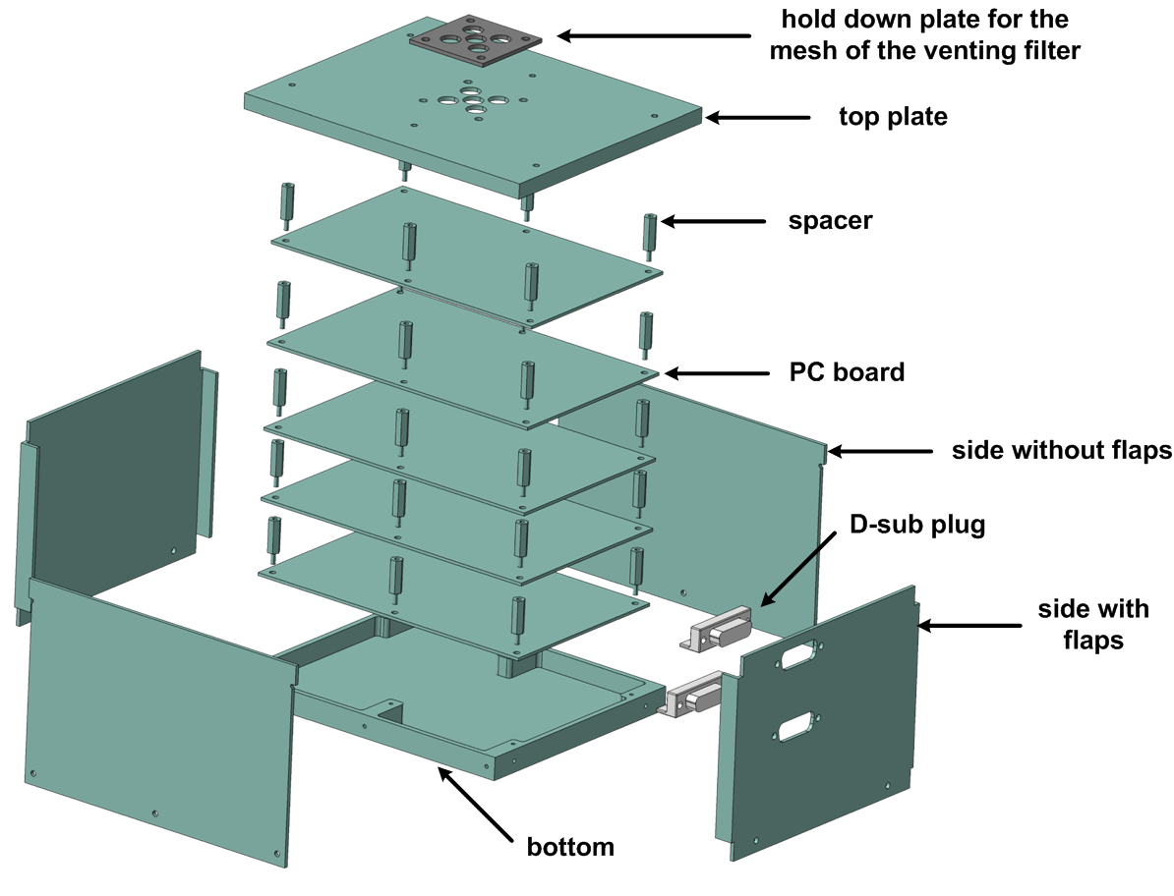
Figure 1.1 Components of PCB box assembly
  - ELECTRONIC BOX
Typical electronic package mainly consists of three different elements:
1.4.1 Electronic components like integrated chips (ICs), power resistors, capacitors and transformers etc. Adequate packaging design will be done at component level.
1.4.2 PCBs (Printed Circuit Boards) will accommodate the electronic devices to perform electrical functions with suitable manufacturing processes like brazing, soldering etc.
1.4.3 Mechanical housing/Tray is made out of space qualified Aluminum alloy and there are two/three such housings that encompass PCBs and these will be stacked together to increase the volumetric efficiency of the spacecraft. This electronic package will be accommodated on a mounting platform in the spacecraft.
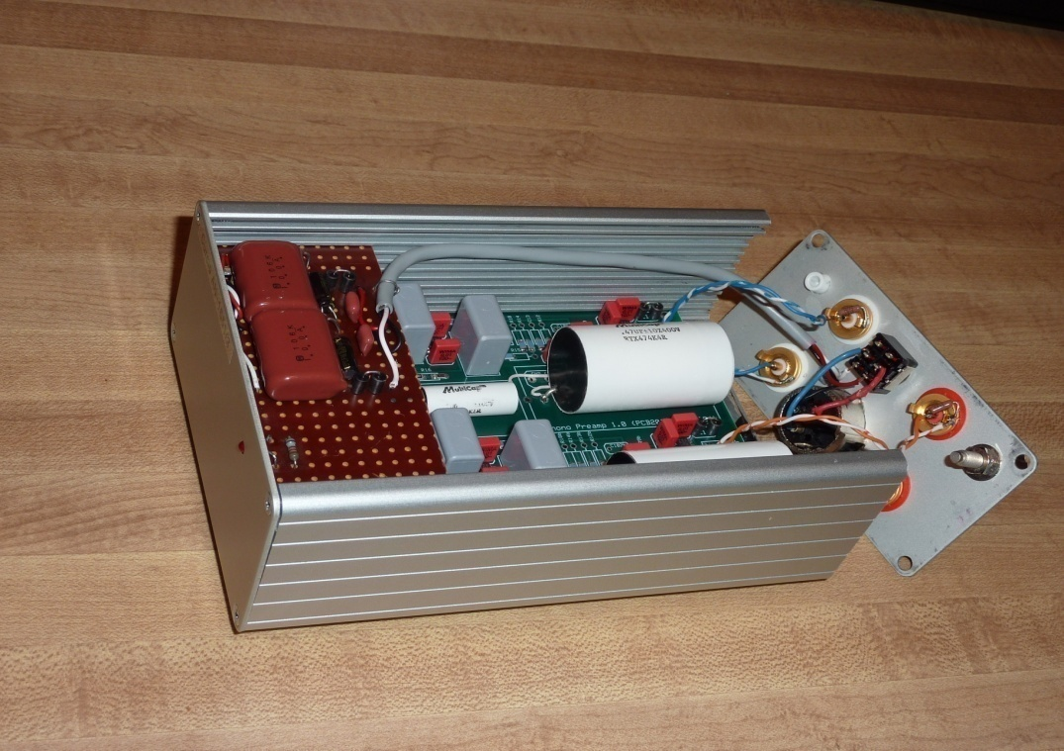
Figure 1.2 Typical electronic box
Material
Aluminium alloy
1.5 ALUMINIUM AND ITS ALLOY
Aluminium alloys are alloys in which aluminium (Al) is the predominant metal. The typical alloying elements are copper, magnesium, manganese, silicon, tin and zinc. There are two principal classifications, namely casting alloys and wrought alloys, both of which are further subdivided into the categories heat-treatable and non-heat-treatable. About 85% of aluminium is used for wrought products, for example rolled plate, foils and extrusions. Cast aluminium alloys yield cost-effective products due to the low melting point, although they generally have lower tensile strengths than wrought alloys. The most important cast aluminium alloy system is Al–Si, where the high levels of silicon (4.0–13%) contribute to give good casting characteristics. Aluminium alloys are widely used in engineering structures and components where light weight or corrosion resistance is required.
Alloys composed mostly of aluminium have been very important in aerospace manufacturing since the introduction of metal skinned aircraft. Aluminium-magnesium alloys are both lighter than other aluminium alloys and much less flammable than alloys that contain a very high percentage of magnesium.
Aluminium alloy surfaces will formulate a white, protective layer of corrosion aluminium oxide if left unprotected by anodizing and/or correct painting procedures. In a wet environment, galvanic corrosion can occur when an aluminium alloy is placed in electrical contact with other metals with more negative corrosion potentials than aluminium, and an electrolyte is present that allows ion exchange. Referred to as dissimilar metal corrosion this process can occur as exfoliation or inter granular corrosion. Aluminium alloys can be improperly heat treated. This causes internal element separation and the metal corrodes from the inside out. Aircraft mechanics deal daily with aluminium alloy corrosion.
Aluminium alloy compositions are registered with The Aluminium Association. Many organizations publish more specific standards for the manufacture of aluminium alloy, including the Society of Automotive Engineers standards organization, specifically its aerospace standards subgroups, and ASTM International.
1.5.1 Properties
1. High corrosion resistance
2. Excellent machining properties
3. Light weight
4. High thermal/electrical conductivity
5. High ductility/easily deformable
1.5.2 Applications
Climate and environment
1. Earth observation
2. Satellite communication
3. Disaster management
4. Satellite navigation
5. Climate and environment

1.6 CONCEPT OF THE PROJECT
Electronic devices used in control, guidance and communication systems are among the most important parts of modern avionic systems. Common aim in the aerospace industry is to design and produce systems which have a life of at least 20 years with high reliability levels. The electronic assembly consisting of three parts, the components, PCB and the electronic housing, requires special attention in order to meet the expectations of the aerospace industry.
In terms of preventing mission failure, an analysis will be needed to find the natural frequencies of each part, and also for the assembly and the electronic housing. It is generally the practice to find deflection of the package enclosure at PCB mounting locations by analysis. Hence, the deflections of the board will be considered to be acceptable for reliable design.

1.7 THE PROJECT SCOPE OF
Commercially, rocketry is the enabler of all space technologies particularly satellites, many of which impact people's everyday lives in almost countless ways. Scientifically, rocketry has opened a window on the universe, allowing the launch of space probes to explore the solar system and space-based telescopes to obtain a clearer view of the rest of the universe. In terms of preventing mission failure, an analysis will be needed to find the natural frequencies of each part, and also for the assembly and the electronic housing.

1.8 OBJECTIVES OF THE PROJECT
The electronic package consists of few PCBs accommodated in mechanical housing/tray using sufficient interfaces and will be used in spacecraft applications. Several components like resistors, capacitors, flat pack components will be mounted on the PCBs based on electrical requirements. It is essential to perform dynamic analyses to get the dynamic characteristics of the package like natural frequencies and mode shapes at electronic package levels. This present work involves normal modes and natural frequency analyses.

CHAPTER II
LITERATURE REVIEW
Dave. S. Steinberg et al.,(2000), There are many journals have been published regarding the electronic box used in spacecraft. Therefore in this papers concentrated on improving the life of electronic enclosure used in spacecraft. There are lot of methods are available to select the best methods and to choose the parameters the literature review are most helpful.
The literature review is collected based on improving the strength of electronic box used in spacecraft. There are 30 most relevant journals are reviewed for this project [5].

Conor D et al.,(2009), A rocket is a missile, spacecraft, aircraft or vehicles that obtains thrust from a rocket engine. Rocket engine exhaust is formed entirely from Rocket propellants carried within the rocket before use. Rocket engines work by action and reaction. Rocket engines push rockets forward by expelling their exhaust in the opposite direction at high speed. Rockets are relatively lightweight and powerful, capable of generating large accelerations and of attaining extremely high speeds with reasonable efficiency. Rockets are not reliant on the atmosphere and work very well in space.
Commercially, rocketry is the enabler of all space technologies particularly satellites, many of which impact people's everyday lives in almost countless ways. Scientifically, rocketry has opened a window on the universe, allowing the launch of space probes to explore the solar system and space-based telescopes to obtain a clearer view of the rest of the universe. A spaceship is a vehicle, vessel or machine designed to fly in outer space. Spacecraft are used for a variety of purposes, including communications, earth observation, meteorology, navigation, space colonization, planetary exploration and transportation of humans and cargo[7].
Hua Ye et al., (2002) During a spacecraft launch, very harsh and high intensity vibrations are transmitted from the launch vehicle into the spacecraft structure; wherein the severity of these vibrations can be much strong enough that damages electronic components and may cause spacecraft failures[1]. A study on hardware failure rates of military aircraft electronic systems, show that 40% of failures are found in electrical connectors, 30% are found in cables and harnesses, 20% are related to electronic components and 10% are due to other factors[2]. Another study based on environmental failure rates shows that thermal, vibration, humid and dusty environments are the major reasons of environmental failures [2]. Distribution of these failures is shown in Fig. For electronic equipment, generally, the launch survival is the major mechanical design driver. From mechanical failure point of view, 80% of the failures are due to thermal stress levels and 20% is due to severe shock or vibration. In 1970’s, NASA showed that 45% of the first-day spacecraft failures were due to damage caused by vibrations during launch [3]. At the time, several studies looked into the problem of the harsh vibration environment experienced by Printed Circuit Boards(PCB) during launch, and various solutions were proposed,[3] [4].
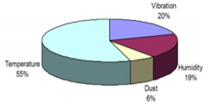
Figure 2.1 Failure mode

Dave. S. Steinberg et al.,(2000), Electronic boxes used in airplanes and missiles often have odd shapes that permit them to make maximum use of the volume available in tight spaces. Since volume and weight are generally quite critical, the electronic boxes usually have a high packaging density. This value normally ranges from about 0.03 to about 0.04 lb/in.3, depending on the severity of the environmental requirements. The weight of a typical electronic box will range from about 10 to about 80 lb.
The vibration frequency spectrum for airplanes will vary from about 3 to about 1000 Hz, with acceleration levels that can range from about 1 G to about 5 G peak. The highest accelerations appear to occur in the vertical direction in the frequency range of about 100-400 Hz. The lowest accelerations appear to occur in the longitudinal direction, with maximum levels of about 1 G in the same frequency range.
For helicopters, the frequency spectrum will vary from about 3 to about 500 Hz and acceleration will range from about 0.5 to about 4 G. The highest accelerations appear to occur in the vertical direction at frequencies near 500 Hz. The displacement at low frequency are very large, with values of about 0.20-in. double amplitude at about 10 Hz.
Missiles have the highest frequency range in this group, with values that generally go up to 5000 Hz [7]. The lower frequency limit is about 3 Hz, and this appears to be due to bending modes in the airframe structure. Acceleration levels range from about 5 to about 30 G peak, with the maximum levels occurring during power-plant ignition at frequencies above 1000 Hz.
The vibration environment in supersonic airplanes and missiles is actually more random in nature than it is periodic. However, sinusoidal vibration tests are still being used to evaluate and to qualify electronic equipment that will be used in these vehicles.
Because the forcing frequencies in airplanes and missiles are so high, it is virtually impossible to design resonance-free electronic systems for these environments. Of course, it is always possible to completely encapsulate an entire electronic box with some expanding rigid type of foam, which could drive the resonant frequency well above 1000 Hz (possibly to 2000 Hz) for a small box. This is generally considered to be impractical, however, because it becomes too expensive to maintain, troubleshoot, and repair such a system.
The obvious conclusion is that the forcing frequencies present in airplanes and missiles will excite many resonant modes in every electronic box. What becomes equally obvious is that extra care must be taken in the design and analysis of an electronic system, or it can literally shake itself to pieces. The electronic support structure must be dynamically tuned with respect to the electronic components to prevent coincident resonances that can lead to rapid fatigue failures.
The first thought that comes to the mind of an experienced mechanical design engineer, when confronted with a severe vibration specification, is to mount the electronic equipment on vibration isolators. There is no doubt that a set of isolators, properly designed, can control shock and vibration. There are four major factors that must be considered when isolation mounts are being discussed.

P.J. Zulueta,(2005) Electronic devices used in control, guidance and communication systems are among the most important parts of modern avionic systems. Common aim in the aerospace industry is to design and produce systems which have a life of at least 20 years with high reliability levels [5]. The electronic assembly consisting of three parts, the components, PCB and the electronic housing, requires special attention in order to meet the expectations of the aerospace industry. In terms of preventing mission failure, an analysis will be needed to find the natural frequencies of each part, and also for the assembly and the electronic housing. Each part will have its own-dynamic response, however, the combined assembly of the PCB and the enclosure will have a dynamic response different than the two independent responses. Mass, CG and the response of electronic packages are used to analyse package installation, layout design and local assembly analysis [6]. More importantly, it must be determined if the two parts will couple dynamically, i.e. each part affects the dynamic response of the other. It is generally the practice to find deflection of the package enclosure at PCB mounting locations by analysis. Hence, the deflections of the board will be considered to be acceptable for reliable design
Alloys composed mostly of aluminium have been very important in aerospace manufacturing since the introduction of metal skinned aircraft. Aluminium-magnesium alloys are both lighter than other aluminium alloys and much less flammable than alloys that contain a very high percentage of magnesium.
Aluminium alloy surfaces will formulate a white, protective layer of corrosion aluminium oxide if left unprotected by anodizing and/or correct painting procedures. In a wet environment, galvanic corrosion can occur when an aluminium alloy is placed in electrical contact with other metals with more negative corrosion potentials than aluminium, and an electrolyte is present that allows ion exchange. Referred to as dissimilar metal corrosion this process can occur as exfoliation or inter granular corrosion. Aluminium alloys can be improperly heat treated. This causes internal element separation and the metal corrodes from the inside out. Aircraft mechanics deal daily with aluminium alloy corrosion.
Aluminium alloy compositions are registered with The Aluminium Association. Many organizations publish more specific standards for the manufacture of aluminium alloy, including the Society of Automotive Engineers standards organization, specifically its aerospace standards subgroups, and ASTM International.
Epoxy fiberglass is hard and tough and can resist the pounding of many sharp points during a resonant condition. The bulkhead, of course, then becomes a composite lamination.
PCBs often use metal-strip laminations of aluminum or copper to conduct away the heat. In some cases, thin copper strips are bonded to a circuit board; electronic component parts such as resistors, diodes, flat packs, and transistors are cemented to these copper strips; and their electrical lead wires are soldered to the PCB.
Aluminum plates have been laminated to PCBs in order to conduct away the heat. In some cases, the components are mounted directly on the aluminum, which has clearance holes for the electrical lead wires to permit soldering to the circuit board on the back side of the aluminum plate. In other cases, the components may be mounted on a circuit board only 0.005 in. thick. The heat will then flow right through the epoxy fiberglass circuit board, with a moderate temperature rise, and be conducted away by the aluminum plate .
PCBs with many high-power-dissipating components will run very hot unless the heat is removed. Therefore aluminum and copper, which have high thermal conductivities, are often bonded to the epoxy fiberglass circuit boards to act as heat sinks.
Terms such as “low” resonant frequency and “high” resonant frequency are only relative. In general, however, the term “low” applies to resonant frequencies below about 100 Hz. The term “high” applies to resonant frequencies above about 400 Hz. Most circuit boards appear to have their fundamental resonant frequencies between about 200 and 300 Hz when used in military electronic systems.
Suresh C., Jiwan Kumar Pandit et al.,(2012) This section considers the actual forces that act on the components to cause them to fail. Ultimately, it is always stress/strain that causes any component to fail, but it is very difficult to measure these stresses within the component, so it is much more convenient to define the variables (board displacement or bending, acceleration and displacements causing impacts) that correlate with failure, as they are easier to measure and identify[6].
O'Connor et al.,(1981) When a PCB is subjected to vibration it bends periodically, some of this bending moment is resisted by the components that are attached to the PCB. This means that there must be forces transmitted through the component leads; therefore stress must be present in the leads. Bending failures of PCB’s occur most often at the corner or end leads of a component package, where the stresses are the greatest [9]. It has also been shown that bi-directional curvature (i.e. a PCB that is curved in both the x and y axis) causes greater damage than uni-directional curvature. Bending stresses are significant failure drivers for components which cover a large area and thus for a given curvature experience greater relative displacement at their edges. Heavy components are less susceptible as they are usually stiff enough to reduce the PCB curvature.
K. Ramachandra, M.R. Thyagaraj et al., (2012) During resonance, the PCB and the soldered components experience very high inertia forces. As a result of the component's mass, large inertial forces are transmitted through the component leads. The greater the mass of the component the higher these axial forces become. Additionally, the accelerations may excite internal resonances of smaller sub-components which are within the package. High acceleration is defined as 20Grms, although accelerations of higher than 100Grms are often observed in spacecraft electronics, causing non-identifiable failures [5].
K.P. Subramanya, Jiwan Kumar Pandit,et al., (2014) If the PCB has very large dynamic displacement and it has very small clearance with nearby objects, then it is possible that the PCB or components may impact these nearby objects[10].
Dave. S. Steinberg et al., (2000) Damping is usually defined as the conversion of kinetic energy into heat. Material damping relates to the energy lost due to internal friction or hysteresis in the molecular structure of the material. Structural damping relates to the energy lost due to friction in rubbing, scraping, slapping, and impacting at various interfaces and joints. The total system damping is the sum of the material damping and the structural damping. All real systems produce some damping when they are vibrated.
When a system with light damping is disturbed, it will continue to oscillate for a long time after the disturbing force has been removed. A system with heavy damping may oscillate once or twice after the disturbing force has been removed, similar to a good automobile shock absorber. The damping in all systems will always bring the system back to a state of rest some time after the disturbing force has been removed. Damping removes some of the energy within the system so there is less energy available to distort and damage the system. This means there is less energy available to deform structures such as PCBs in vibration and shock environments.
A reduction in the kinetic energy reduces the forces and stresses in PCBs, which increases the fatigue life, so damping increases the PCB reliability. Increasing the damping in a PCB increases the amount of energy that is lost, which decreases the transmissibility, and further increases the fatigue life and the reliability of the PCB[5]
Dr. T. E. Wong, Dr. F. W. Palmieri, et al (2000) A macro/micro (or global/sub) modeling technique is utilized to estimate the stress/strain of the BGA solder joint. The FEMs are constructed with a ANSYS code. The linear dynamic and static analyses are performed with a ANSYS finite element code on a SUN workstation. Table 1 lists the material properties of aluminum, polyimide/glass, copper, 63Sn/37Pb solder, dry film solder mask, polyimide tape, silicon, mold compound, and epoxy adhesive (ASM, 1979; IFI/Plenum, 1977; Rohde and Swearengen, 1980; Darveaux and Mawer, 1995). In the macro level analysis, a 3-D global FEM of the electronic module,, is constructed to simulate major structural elements and to determine the module dynamic responses when subjected to an excitation normal to the PWB. Three BGA mounting locations are selected and shown in this figure. However, only one 600- pin BGA (at location #1) is mounted on the PWB in the present study. A 3-D finite element local model with refined mesh solid elements to simulate the local region is constructed to determine the solder effective stress/strain. The detailed modeling information can be found in Wong, et al. (1999)[12]

CHAPTER III
PROBLEM IDENTIFICATION
Basic failure mechanisms due to the combination of thermal, shock and vibrations coming from different aspects of the spacecraft can be specified as follows.

1. Electronic box/ Mechanical Housing for electronics.
i) Structural failure due to vibration
ii) High stress level failures
In terms of preventing mission failure, an analysis will be needed to find the natural frequencies of each part, and also for the assembly and the electronic housing.

CHAPTER IV
METHODOLOGY
4.1 Vibration Analysis
Determination of natural frequency and mode shapes for different vibration environment, response can be displacement of the different locations on Electronic box.

4.2 Approaches for vibration analysis
Vibration analysis can be done through three methods they are
- Analytical method.
- Finite element analysis method.
- Experimental studies.
In these above methods am undergoing through Finite element analysis method approach in the process of
1. Modeling of different damper assembled PCB box and
2. FEM and simulation approaches

4.3 Finite element method.
Many practical problems in engineering are either extremely difficult or impossible to solve by conventional analytical methods. For structural dynamic analysis Finite Element Methods can give valuable insight into the dynamics of structures for the majority of problems found in industry, these problems however can be solved alternatively by using approximate numerical solution techniques but the Finite element methods are the most versatile approaches. With the advent of computer technology, the Finite element method (FEM) found its application for the first time in industrial problems from the pioneering works and has proven itself as a very flexible numerical analysis technique to obtain approximate solutions for otherwise unmanageable problems.
All Finite element modeling methods involve dividing the physical domain, the geometry of the structure, into small sub-regions called elements. Each element forms essentially a simple unit, the behavior of which can be easily analyzed. The set of points in space interconnecting each element are known as nodes and the discretized geometry is called the meshed model. The discretisation of the structure determines the accuracy of the representation, and if model updating procedures are to follow, the mesh density often needs to be finer than usual.
Complexities in geometry are frequently accommodated by using a larger number of Finite elements and a dynamic analysis of the structure can still be performed by assembling all the elements into the system equation in matrix form. The choice of elements, the solution algorithms used and the level of discretisation all influence the result significantly. Surveys have shown that dynamic FE analysis is not always completely as reliable. The compromise that must be made for flexibility and simplicity of individual element analysis is the amount of numerical computation required. Very large sets of simultaneous algebraic equations have to be solved. The storage needed for such calculations can be well in excess of the local memory available on the computer and hence can be time consuming without the proper resources.
Finite element analysis uses computational power to solve large amounts of stiffness matrices, extremely quickly. In the ANSYS software, the controlling internal language is called the Direct Matrix Absorption Program (DMAP), and has been a mainstay of the engineering industry since developed by NASA in the 1960’s.

4.4 ANSYS 14
ANSYS is the world's most widely used pre/post-processing software for Finite Element Analysis (FEA), providing solid modeling, meshing, analysis setup and post-processing for multiple solvers including MSC Nastran, Marc, Abaqus, LS-DYNA, ANSYS, and Pam-Crash.
ANSYS provides a rich set of tools that streamline the creation of analysis ready models for linear, nonlinear, explicit dynamics, thermal, and other finite element solutions. From geometry cleanup tools that make it easy for engineers to deal with gaps and slivers in CAD, to solid modeling tools that enable creation of models from scratch, ANSYS makes it easy for anyone to create FE models. Meshes are easily created on surfaces and solids like using fully automated meshing routines, manual methods that provide more control, or combinations of both. Finally, loads, boundary conditions, and analysis setup for most popular FE solvers is built in, minimizing the need to edit input decks.
ANSYS comprehensive and industry tested capabilities ensure that your virtual prototyping efforts provide results fast so that you can evaluate product performance against requirements and optimize your designs.

4.5 ANSYS Capabilities
Direct access of cad geometry
ANSYS enables access to geometry from leading CAD systems for creating finite element models. Support for many industry-standard geometry exchange formats is also provided. An option is also available for direct import from and export into Para solid format supported by several CAD systems. All finite elements, loads, boundary conditions, and material properties can be associated to the geometry.
Advanced geometry creation, editing and feature recognition
ANSYS contains an advanced set of geometry creation tools in addition to the direct CAD access capabilities for generating finite element model geometry.
ANSYS also has a sophisticated feature recognition capability that allows users to delete or edit holes, fillets, and chamfers. For 3D solid geometry, existing meshes and loads will be automatically re-applied to the model after a change is made to the geometry.
4.6 SOLIDWORKS 2013
SOLIDWORKS 13 is used developed by Dasult systems. It is used to draw 2D and 3D geometry with full dimensions, it is easy for sub assemblies and flexible assembly designs. Most of the industries are using SOLIDWORKS due to user friendly.

CHAPTER V
2D AND 3D MODEL DESIGNS
5.1 Design approach
In the existing model it is investigated that PCB are assembled directly without any dampers in the PCB box. Here the different types of 3D models are drawn with different dampers attached to reduce the vibration transmission.
- PCB box with rubber washer assembly design
- PCB box with spring assembly design
- PCB box with sliding type assembly design
5.1 Different designs of 3D model with dampers assembly
Figure 5.1 Different designs of 3D model with dampers assembly

Model : 1
5.2 The 2D geometry details for the PCB box with rubber washer assembly design
Figure 5.2 Two dimensional drawings for PCB box with rubber assembly
Rubber washer dimension
Figure 5.3 Two dimensional drawings for Rubber washer

Model :2
5.3 The 2D geometry details for the PCB box with helical spring assembly design

Figure 5.4 Two dimensional drawings for PCB box with helical spring assembly
Helical spring assembly dimensions

Figure 5.5 Two dimensional drawings for helical spring assembly
Model : 3
5.4 The 2D geometry details for the PCB box with sliding type assembly design

Figure 5.6 Two dimensional drawings for PCB box with sliding assembly
CHAPTER VI
FINITE ELEMENT METHOD RESULT

6.1 Boundary conditions of PCB box

- Bottom side of the box is fixed
- Displacements are arrested in all Degree of Freedom
- Analysis type : Model analysis
- Frequency ranges : up to 5000 Hz
- Number of Modes : 10
- Elements for box : 30000
- Element for PCB : 2500

  - Boundary conditions applied

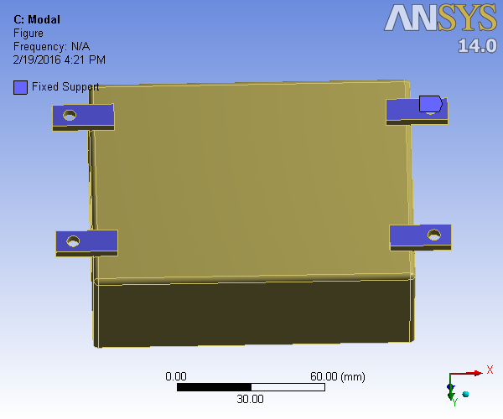
Figure 6.1 Boundary conditions of PCB box

  - PCB box with rubber washer assembly design with mesh

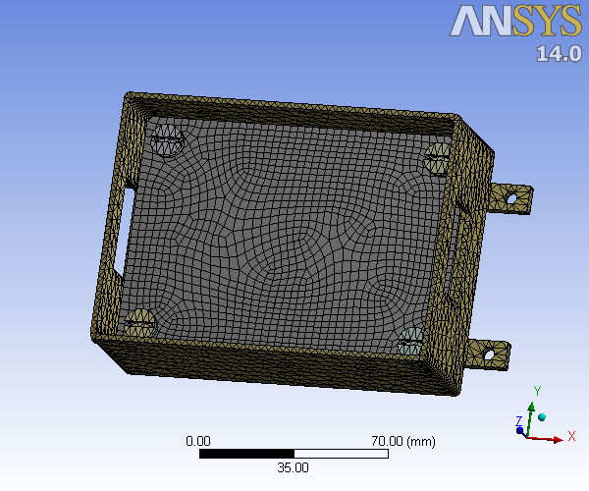
Figure 6.2 Rubber washer assembly mesh PCB box
Simulation Results in different modes
Mode 1

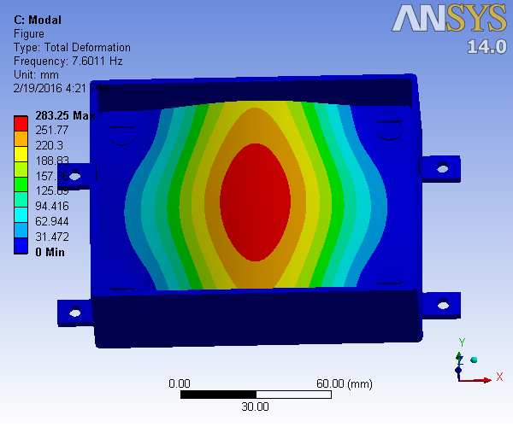
Figure 6.3 First mode frequency for rubber washer assembly
Mode 2

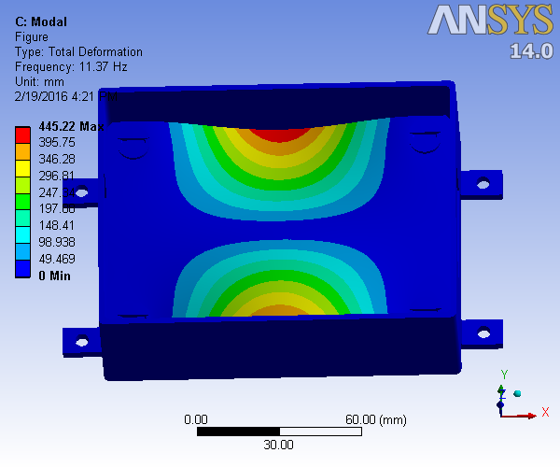
Figure 6.4 Second mode frequency for rubber washer assembly
Mode 3
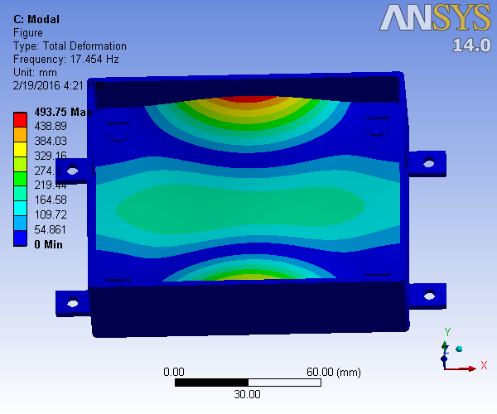
Figure 6.5 Third mode frequency for rubber washer assembly

5.4 PCB box with spring assembly design with mesh

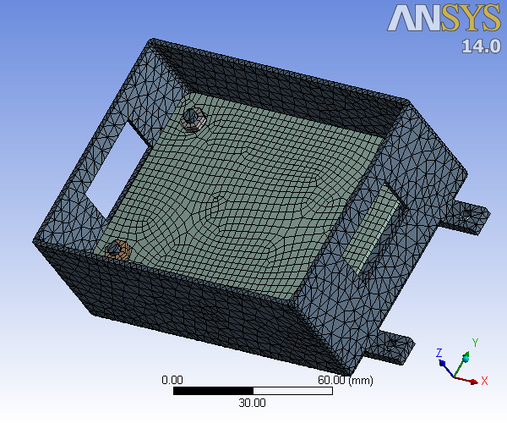
Figure 6.6 Spring assembly mesh PCB box

Simulation Results in different modes
Mode 1
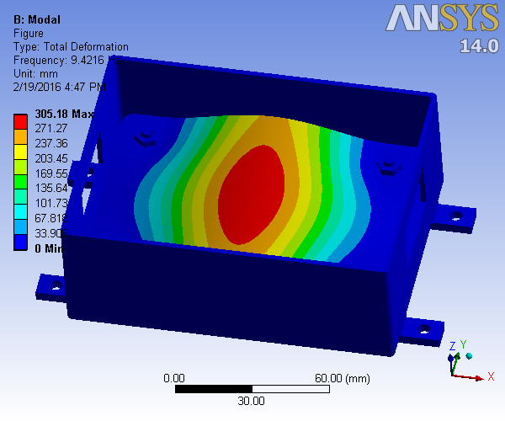
Figure 6.7 First mode frequency for spring assembly

Mode 2
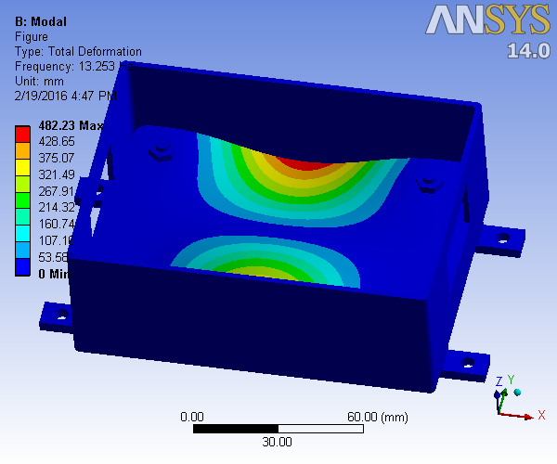
Figure 6.8 Second mode frequency for spring assembly
Mode 3
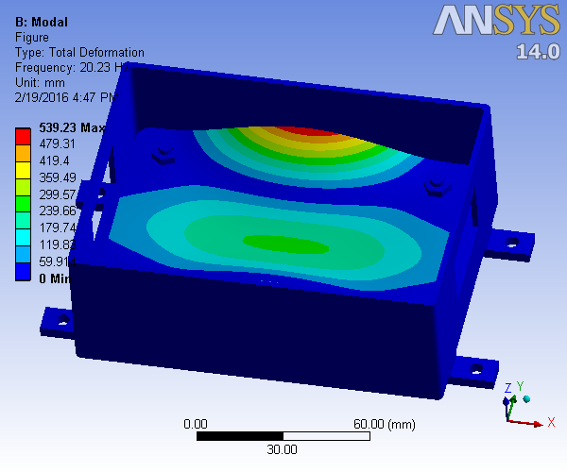

Figure 6.9 Third mode frequency for spring assembly

  - PCB box with sliding type assembly design with mesh
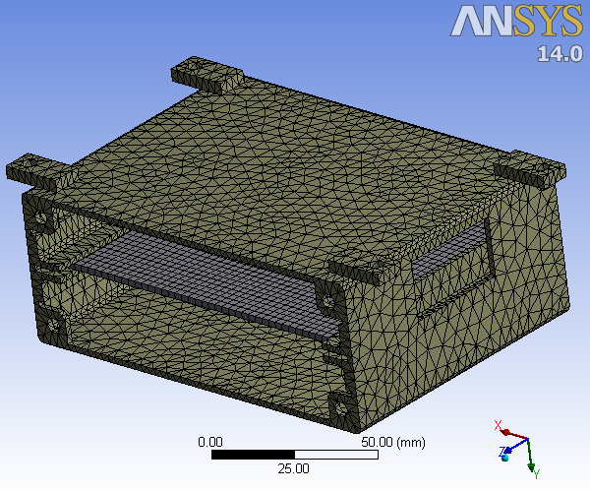
Figure 6.10 Sliding type assembly mesh PCB box

Simulation Results in different modes
Mode 1
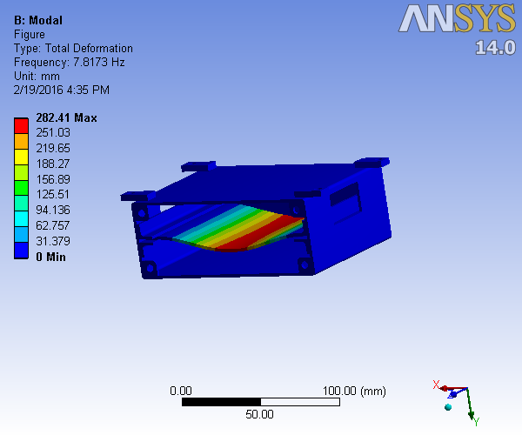
Figure 6.11 First mode frequency for sliding type assembly

Mode 2
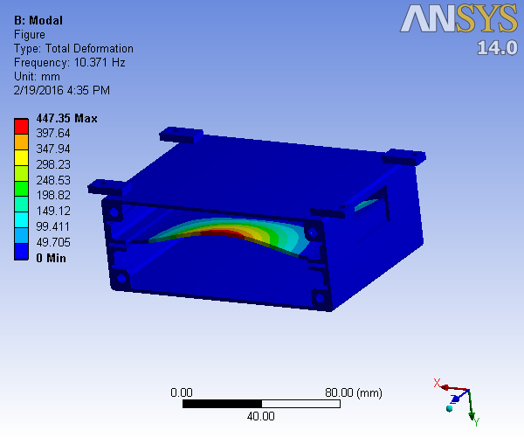
Figure 6.12 Second mode frequency for sliding type assembly

Mode 3

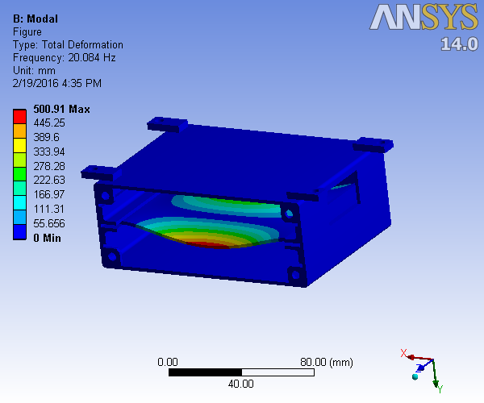 Figure 6.13 Third mode frequency for sliding type assembly

CHAPTER VII
RESULT AND DISCUSSION
7.1 FREQUENCY RESPONSE OF THREE MODELS
The three models are compared with frequency response and its displacements is noted. The first ten modes are taken to find the frequency and displacement of each models in this the first three modes are taken for the resonance condition.
Table 7.1 Frequency response of three models
Mode | Frequency [Hz] with Washer | Frequency [Hz] with spring | Frequency [Hz] with Sliding fit
1 | 9.4216 | 7.6011 | 7.8173
2 | 13.253 | 11.37 | 10.371
3 | 20.23 | 17.454 | 20.084
4 | 23.162 | 18.157 | 21.504
5 | 31.311 | 25.816 | 25.153
6 | 32.143 | 27.246 | 36.428
7 | 32.642 | 27.701 | 40.25
8 | 41.128 | 36.246 | 42.031
9 | 41.146 | 37.089 | 46.095
10 | 47.273 | 41.459 | 56.544

7.2 MAXIMUM DEFLECTION ATTAINED IN EACH MODELS

Table 7.2 Deflection attained of three models

Mode | Max. Deflection with Washer | Max. Deflection with spring | Max. Deflection with Sliding fit
1 | 305.18 | 283.25 | 282.41
2 | 482.23 | 445.22 | 447.35
3 | 539.23 | 493.75 | 500.91
4 | 338.34 | 314.07 | 283.61
5 | 612.03 | 520.08 | 415.8
6 | 595.99 | 533.34 | 468.78
7 | 446.92 | 405.29 | 504.39
8 | 619.59 | 518.34 | 282.79
9 | 626.97 | 459.17 | 406.91
10 | 547.78 | 536.04 | 502.32

COMPARISON OF FREQUENCY IN THREE MODELS
Graph 7.1 Comparison of frequency in three models

COMPARISON OF MAX. DEFLECTION IN THREE MODELS
Graph 7.2 Comparison of max. deflection in three models

CHAPTER VIII
CONCLUSION
CONCLUSION
Vibration analysis of electronic box is carried out to determine the fundamental frequencies and corresponding mode shapes. An equivalent FE simulation model for a standard electronic boxes has been established corresponding to fixed/clamped boundary conditions. Normal mode analysis performed to obtain the frequencies of boxes individually and predicted the frequencies for the assembly.
In this project the spring assembly design is taken as the best design comparing to rubber washer and sliding type assembly design. In this the spring assembly design the spring acts as the best damper due less vibration transmission and deflection attained in the PCB board.

REFERENCES

- P.J. Zulueta, Electronics Packaging Considerations for Space Applications, 4800 Oak Grove Drive, Pasadena, CA 91 109.

- G.S. Aglietti et al., Analysis of Enclosures and Anti Vibration Devices for Electronic Equipment for Space Applications, Aeronautics and Astronautics, University of Southampton, UK

- Hua Ye et al., Failure modes and FEM analysis of power electronic packaging Finite Elements in Analysis and Design 38 (2002) 601– 612.

- Marc A. Zampino, Vibration Analysis of an Electronic Enclosure using Finite Element Analysis, Lambda Novatronics Inc, 500 SW 12th Avenue, FL 33061(305)-942-5200.

- Dave. S. Steinberg, Vibration Analysis of Electronic Equipment, Wiley, 3rd Edition, June 2000.

- Suresh C., Jiwan Kumar Pandit, K. Ramachandra, M.R. Thyagaraj; Estimation of Mass Properties of a Spacecraft using Unigraphics, International Conference on Challenges and Opportunities in Mechanical Engineering Industrial Engineering and Management Studies (ICCOMIM - 2012), Bangalore, India. July 2012.

- Conor D et al., Protecting satellites from the dynamics of the launch environment, American Institute of Aeronautics and Astronautics,2009, CA 210-9000

- Barker et al., Local PWB and component bowing of an assembly subjected to bending, Journal of electronic packaging, 116(2), 92-97, june, 1993

- O'Connor et al., A statistical model for data analysis- Network statistics, International journal of data analytics, 17(3), 207-213, 1983, 1981

- K.P. Subramanya, Jiwan Kumar Pandit, C.S. Prasad, M.R. Thyagaraj, International Journal of Science, Engineering and Technology Research (IJSETR), Volume 3, Issue 3, March 2014

- G.S. Aglietti, and C. Schwingshackl School of Engineering Sciences, Aeronautics and Astronautics, University of Southampton, UK

- Dr. T. E. Wong, Dr. F. W. Palmieri, B. A. Reed and H. M. CohenMicro Electronic Components Vibration Fatigue Damage Evaluation 2000
- M.I. SakriȦ, P.V.Mohanramb, Experimental Investigations on Board Level Electronic Packages Subjected to Sinusoidal Vibration Loads, International Journal of Current Engineering and Technology

- Guemmaz, M., A. Mosser, R. Ahuja, and J. C. Parlebas (2001), Theoretical and experimental investigations on elastic properties of substoichiometric titanium nitrides: Influence of lattice vacancies, Int. J. Inorg. Mat., 3, 1319–1321.

- P.J. Zulueta, Electronics Packaging Considerations for Space Applications, 4800 Oak Grove Drive, Pasadena, CA 91 109.

- G.S. Aglietti et al., Analysis of Enclosures and Anti Vibration Devices for Electronic Equipment for Space Applications, Aeronautics and Astronautics, University of Southampton, UK

- De Aragon AM, Mura F, Dionisio C, Howes S, Slim R, and Erickson PD,Future satellite services, concepts and technologies, European Space Agency Bulletin- (95): 99-107 Aug 1998.

- Laura P.A.A., Ercoli L., and., 1995, Dynamic Stiffening of a Printed Circuit Board, Acustica, Vol. 81, pp 196-197.

- De Aragon AM, Mura F, Dionisio C, Howes S, Slim R, and Erickson PD, Future satellite services, concepts and technologies, European Space Agency Bulletin- (95): 99-107 Aug 1998.

- J.R. Gaier, W.C. Hardebeck, J.R.T. Bunch, M.L. Davidson, D.B. Beery, Effect of Intercalation in Graphite Epoxy Composites on the Shielding of High Energy Radiations, Journal of Material Research 13 (8), 1998.

- Timmis A.R., 1971, A Study of First Day Space Malfunctions, NASA TN D6474.

- Hain H.L., and Patel B.M., 1979, Improved Printed-Circuit Board Dynamics Characteristics Using Structural Damping Ribs, Proceedings of the NAECON 1971, IEEE, New York, USA, pp.222-232

- Wicks A. and Barrington-Brown A.J., 1999, Development of the MiniSIL Structural design, Journal of Aerospace Engineering, Vol 213 part G, ISSN 0954-4100, pp. 255-263.

- G.S.Aglietti, A Lighter Enclosure for Electronics for Space

- Applications, Journal of Aerospace Engineering, part G Vol 216-3, pp 131-142, 2002

