**Module-1**

Introduction Languages

1. What is Language?
2. Types of Languages
3. Introduction to Translators
   1. Interpreter
   2. Compiler
4. What is scripting Language
5. Difference between programming language and scripting language
6. What is programming paradigm
   1. Procedural Oriented Programming
   2. Object Oriented Programming

**What is Language?**

Language acts as a mediator between user and computer.

Language is software which provides set of instructions to communicate with computer.

**What is program?**

Set of instructions executed by computer is called program.

A program is set of instructions and data.

A language is tool, which is used to develop programs or applications or softwares.

**Types of programming languages**

1. Low Level Languages
   1. Machine Language
   2. Assembly Language
2. High Level Language

**Low Level Languages**

Computer understandable languages are called low level languages.

1. Machine Language
2. Assembly Language

**Machine Language**

In machine language instructions are represented in 0’s and 1’s.

These instructions are executed by computer directly without using translator.

Each machine is having one machine language.

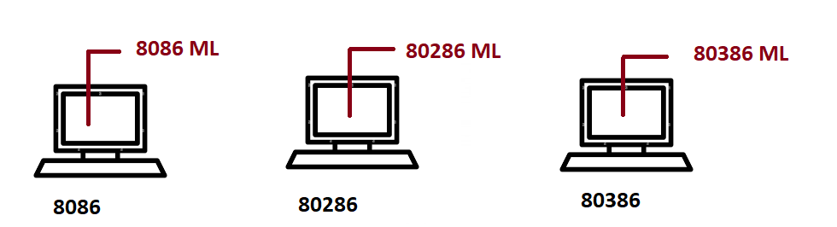

**Disadvantage of Machine Language**

1. Not easy to understand by humans
2. Non portable or machine dependent

**Advantage**

1. It is only language understand by computer
2. Not required any translator

**Assembly Language**

Assembly language is a low level programming language.

In assembly languages instructions are given in the form mnemonics.

Assembly language is one type of machine language.

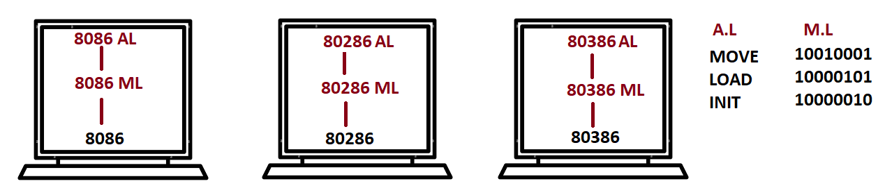

**What is Assembler?**

Assembler is a translator, which converts or translates instructions of assembly language into machine language.

**Advantage of Assembly Language**

1. Easy to understand

**Disadvantage of Assembly Language**

1. Required translator
2. It is non portable (OR) hardware dependent

**High Level Languages**

All high level languages are in simple English.

High level languages are portable, it allows to develop and run applications on different hardware architectures.

Example: C, C++, Java, Python, C#, .Net…

**What is translator?**

Translator is software, which converts instructions of one language to another language.

1. Interpreter
2. Compiler

**What is Program?**

A program is set of instructions.

**What is source program?**

The program or code written in any high-level programming language is called source program or code. This code is understood programmer.

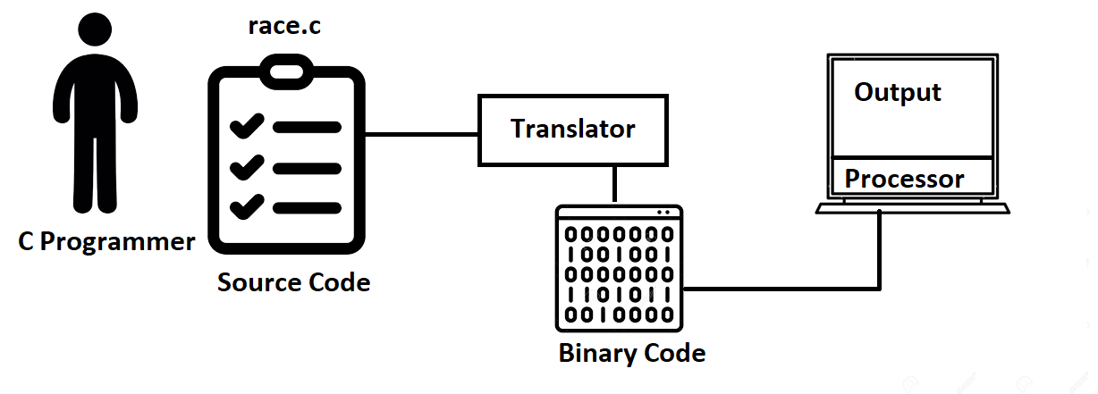

**What is Interpreter?**

Interpreter is a translator, which translates and executes instructions line by line.

1. Read/Fetching
2. Tokens
3. Verify Syntax
4. Translate
5. Execute

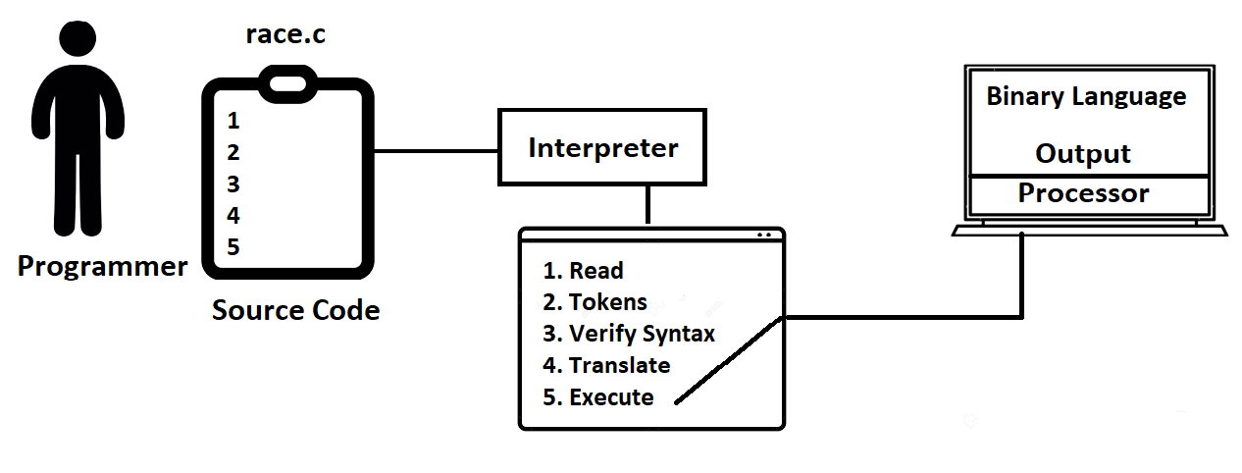

**What is Disadvantage of Interpreter?**

1. Interpreter stop translating if there is a syntax error in one line.
2. Interpreter required translating source program every time before execution because it cannot store translated code.
3. It shows only one error, debugging is complex.

**Compiler:**

Compilers translate whole program and execute.

Compiler performs the following operations.

1. Read/fetch
2. Token
3. Verify Syntax
4. Translate
5. Store
6. Execute

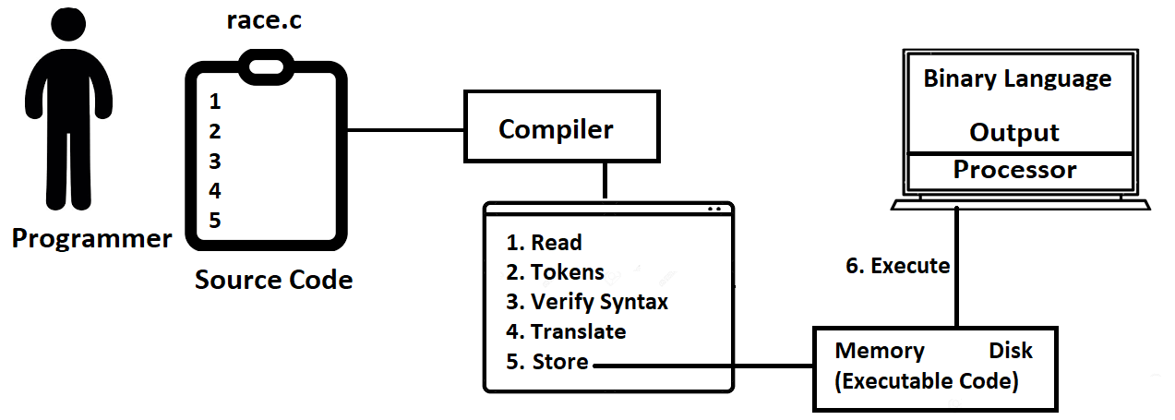

Scripting Languages:

Scripting language