**.**

**TEJUS FACILITY MANAGEMENT SERVICES**

**We Care Your Health & Wellbeing First**

**E-Mail**, [**tejusfacilitymanagementservice@gmail.com**](mailto:tejusfacilitymanagementservice@gmail.com)

#**6,3rd main,Thimmiah Garden,R.T.Nagar,Bangalore-560032**

**Ph-08105852348/09986371198**

**To**

**Mr. Puneeth Date-07/11/2015**

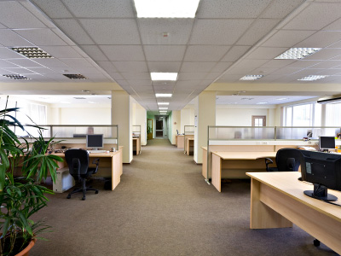

**Entrance/Lobby:** Empty & clean waste receptacles. Clean metal hardware and polish if needed. Clean glass entrance doors inside and out. Clean and disinfect reception area. Pick up and arrange any reading material in lobby.

**Offices/Workstations:** Empty and clean waste receptacles and change liners. Vacuum areas, Sweep and/or dust mop office floors. Clean and disinfect chairs, desks, tables, filing cabinets and other furniture, Disinfect telephones, Clean and disinfect office machines, Dust high ledges, partitions, moldings and other flat surfaces, Rearrange furniture to original order.

**Rest Rooms:** Clean and disinfect fixtures and chrome fittings. Clean, disinfect and refill dispensers from stock. Clean and disinfect toilet seats and undersides. Spot wash walls, partitions and doors. Clean mirrors and polish hardware. Clean and disinfect floors.

**Lunch/Break Rooms:** Clean and disinfect counter tops. Wash appliances, coffee pots, teapots, toaster, and refrigerator as needed, clean and disinfect floors.

**Hallways & Public Areas:** Clean and disinfect drinking fountains. Dust and/or sweep stairs, landings and handrails. Vacuum air grills. Vacuum carpeted areas.

Optional Available Services:  
**Floor Waxing:** **Stripping, reapplying and sealing of commercial flooring services**.  
**Window Cleaning:** **Clean windows and sills inside and out.**  
**Garages & Sidewalks**: Pick up trash daily. Sweep and hose down debris. Pressure washing is also available.

**Carpet Cleaning:** Carpet shampoo available upon request.

**HospitalityHousekeeping services**

Housekeeping services division is responsible for the upkeep of offices, hospitals, pubs, hotels, Cineplex’s, it parks, airports, libraries and industrial units. Services rendered include daily cleaning, vacuuming, trash removal, floor care, restroom cleaning and interior glass cleaning of the premises

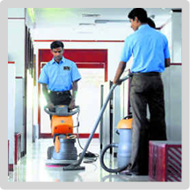

**Housekeeping services includes :**

* Upkeep and maintenance of the premises
* Floor care such as buffing or refinishing
* Window cleaning, wall washing and graffiti removal
* Carpet/upholstery shampooing
* Pantry management
* Gardening
* Pest control

The company offers a one-stop solution to all housekeeping needs. Our trained manpower with sophisticated equipment consistently delivers way ahead of our client’s expectations.

**One Time Services**

We are counted amongst the foremost service providers regarding onetime cleaning. Our offered service is highly reliable in nature and performed within the given deadline. Onetime cleaning is an area, where our professionals have expertise to offer supreme quality service to satisfy the customers. We have been hired by various reputed clients, due to our performance and result achieved. In order to provide utmost satisfaction to our clients, this is offered at highly competitive prices.

Housekeeping services includes:

**1. One Time Cleaning All B.H.K and Office Needs**

**2. Upkeep and maintenance of the premises**

**3. Floor care such as buffing or refinishing**

**4. Window cleaning, wall washing**

**and graffiti removal**

**5. Carpet/upholstery shampooing**

**6. Marble polishing**

**7. Pantry management**

**8. Gardening**

**9. Pest control**

|  |  |  |
| --- | --- | --- |
|  | **Particulars** | **Amount.** |
|  | * **Towards the charges for** **at your Premises. Providing for Carpet Laying Services**      * 1. **Carpet(Professional) – POO3 – Blue – Rs.100/sft**   2. **Effect(FX) – EF01 – Blue – Rs.105/sft**   **With laying, service and labor including transport charges + 1 year warranty with tax**   * 1. **Vega – 611 – Rs.90/sft**   2. **Zenich – 511 – Rs.95/sft**   **With laying, service and labor including transport charges + 14%tax** |
|  | | |

**Regards yadava Call As 8105852348**