Lync Sign-In Procedure

1. Go to Internet Explorer **Tools-> internet options ->connections-> LAN settings**

* Don’t check **“Use Automatic Configuration script”**
* Proxy server needs to be checked since we will be connecting using India domain
* Delete all the entries in Exceptions under Advanced>>Proxy settings.

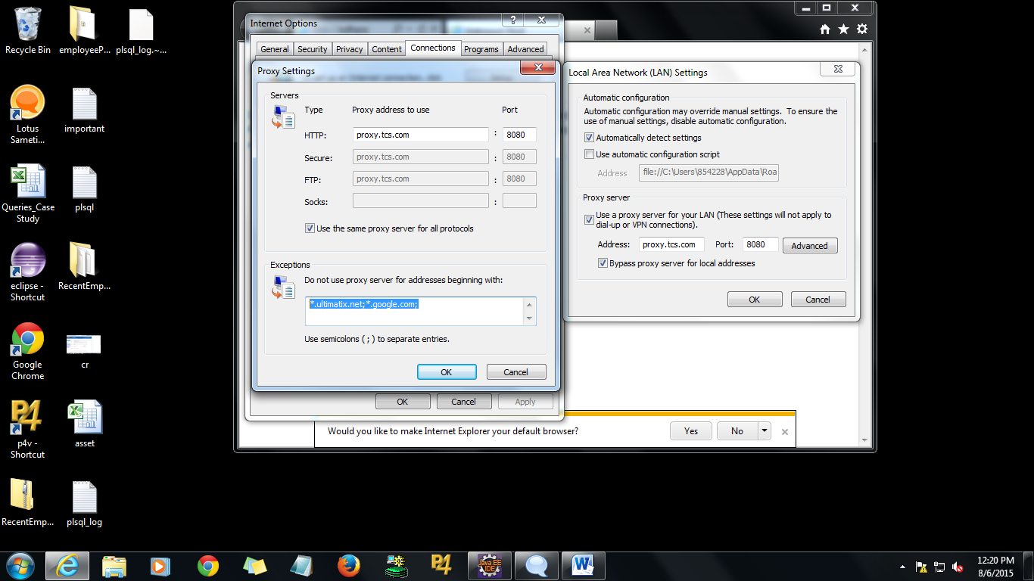

1. Go to **Control Panel > Credential > Manager**
2. 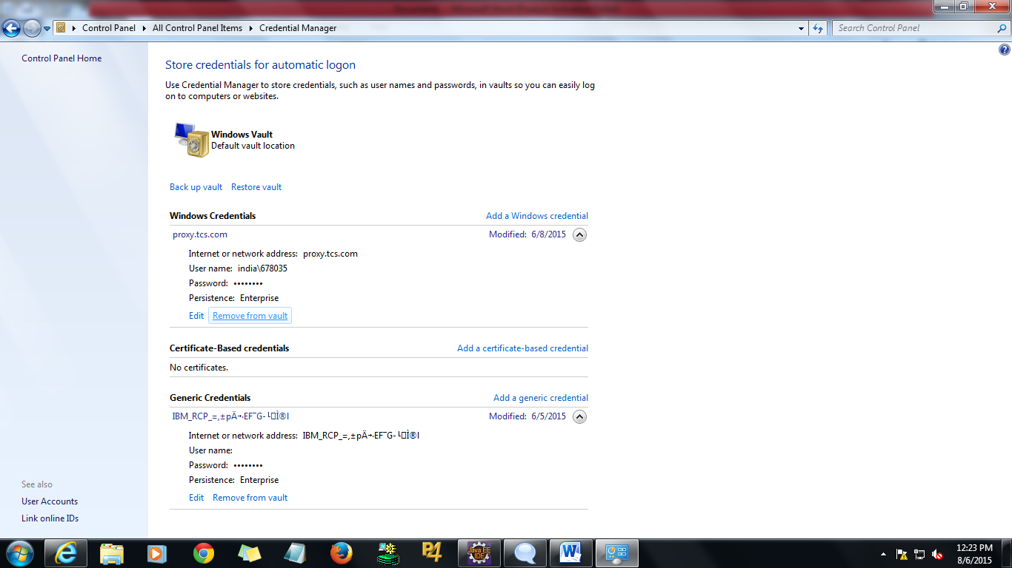

Delete all the entries which are in windows credentials and generic credentials using option **Remove from vault.**

1. Go to **\\10.132.10.61\Qualcomm File Share\Projects\ITHR** -> **entrust_2408_ca**. Double click on the file.

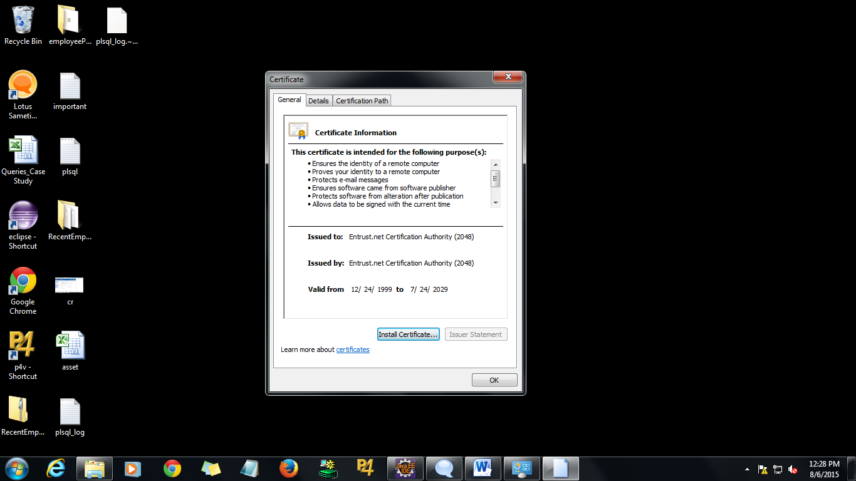

Click on **Install Certificate->Next->Finish to** install the certificate.

1. Go to Start > Run> %temp%

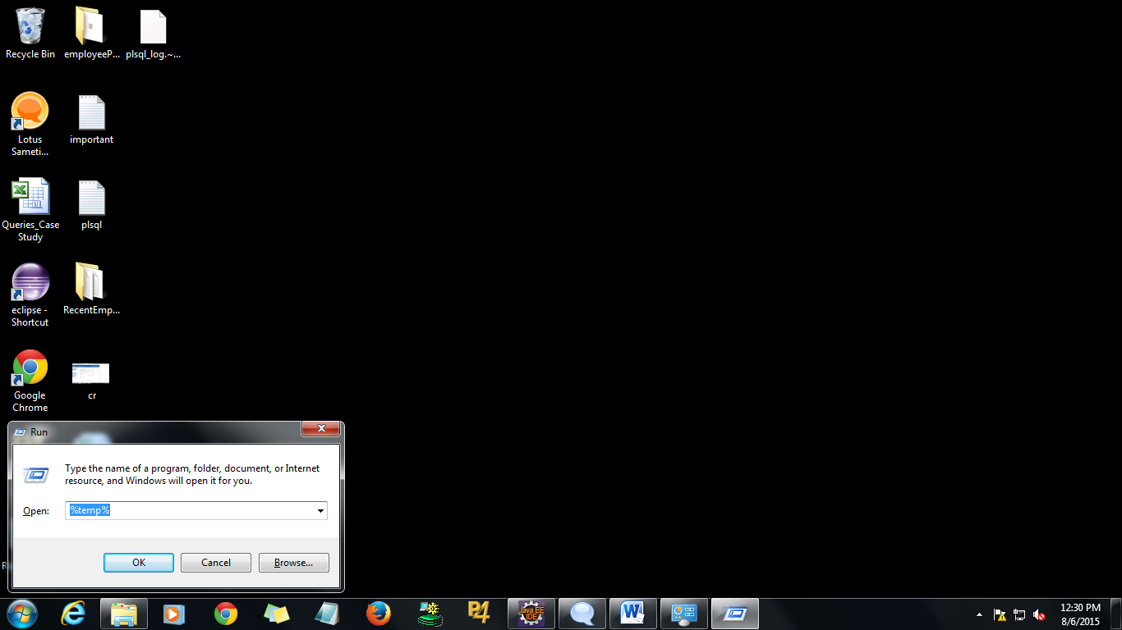

Delete all the files in that folder. ( **C:\Users\Empid\AppData\Local\Temp**)

1. Open Lync and sign-in.
2. Please enter India domain credentials for the network prompt.
3. Then in the next prompt, login with your Qualcomm credentials.

**Points to remember:**

Juniper is not required for Lync to sign-in

If you have issues connecting to Lync, please disconnect Juniper, try the above steps and log-in. Then, log back into Juniper.