PDF Signature Verification Steps

Overview

This document helps the end user to verify the Inline PDF Signature when viewed in Adobe Reader his/her Form16.

Pre-requisites

User should have Adobe Reader 6.0 or above versions to view and/or verify inline PDF Signatures. If the certificate chain is not included in the signature, then it is preferable for the user to have the issuer certificate file of the signer.

1.2. Need to Copy below TCS Certificate file (Cer.cer) on to your desktop.


- Steps to add certificate to the Trusted Identities in Adobe Reader

Open Adobe Reader

- Click Document → Manage Trusted Identities (in Adobe Reader 8) or Document → Trusted Identities in other versions of Adobe Reader

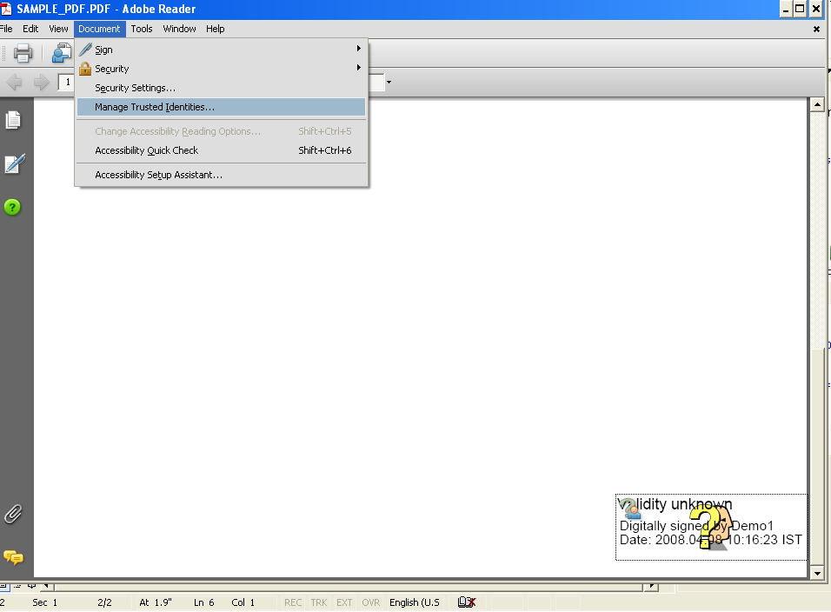

- Following dialog box is displayed

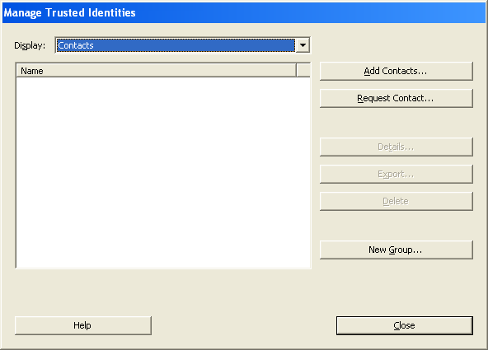

Select ‘Certificates’ in the Display combo-box. Click ‘Add Contacts…’ button.

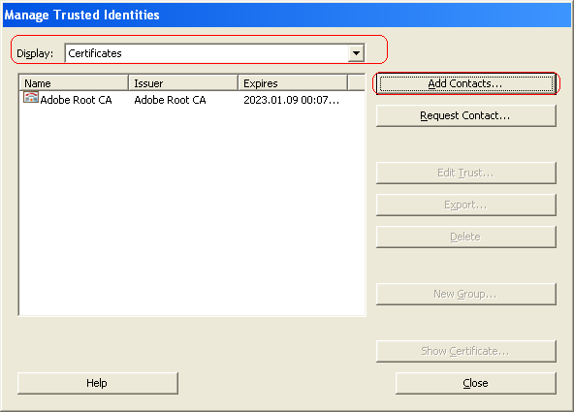

- Click ‘Browse’ button to select the certificate to be added to the trusted identities and then click ‘Import’ button.
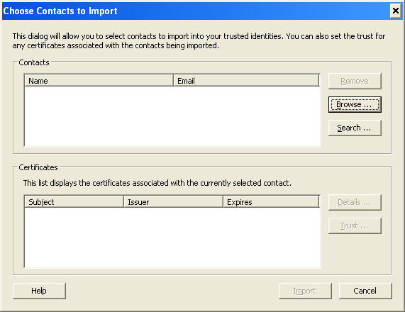

On clicking ‘Browse’, select the certificate file (Cer.cer) to be added to the trusted identities from Desktop .

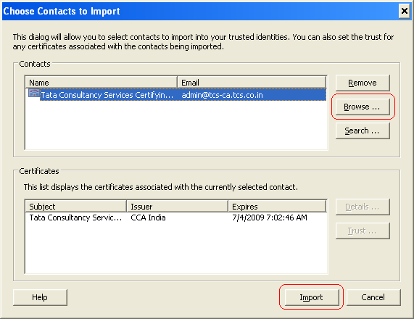

Once the import is successful, following message is displayed

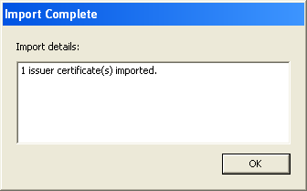

Issuer certificate will get added the list of Trusted Identities as shown below.
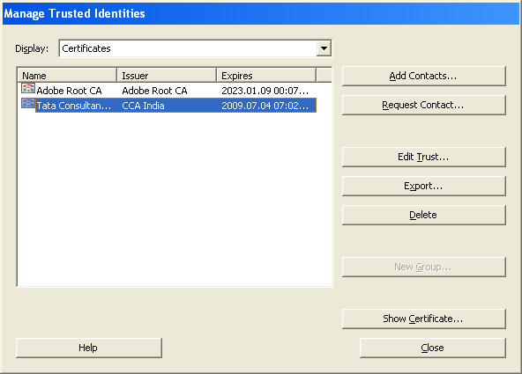

- Edit the trust of the added certificate. Select the certificate and click ‘Edit Trust’ button. Following dialog box is displayed.

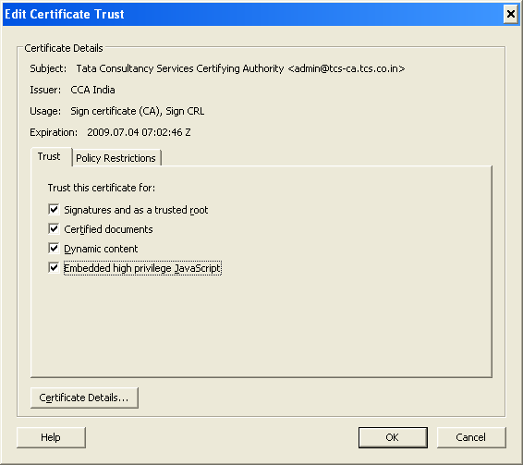

- Check all the checkbox as displayed above and click ‘OK’.

- Steps to remove the revocation check

Verify the PDF signature. Click the signature and check if the following message is displayed.
“The signer’s identity was valid when it was issued, but no revocation checks could be made to validate the identity at this time.”

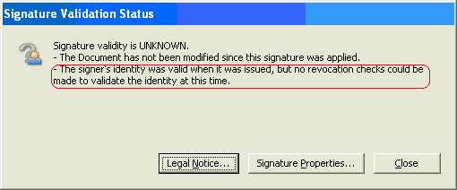

- To remove the revocation check option, click Edit → Preferences

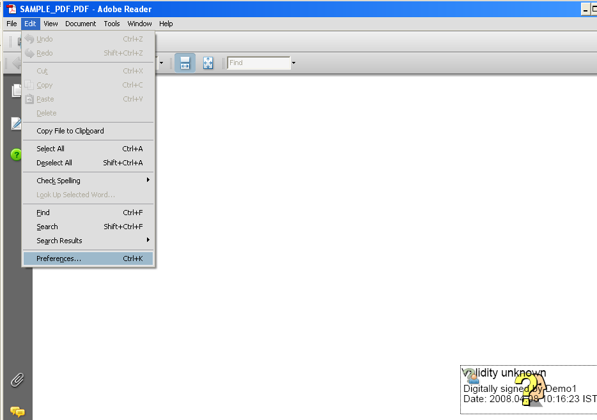

- Select ‘Security’ in the left pane. Click the ‘Advanced Preferences…’ button.

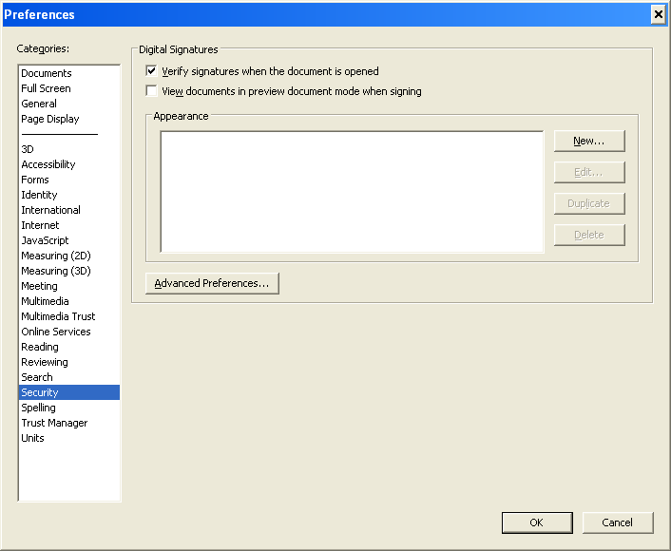

- Uncheck the checkbox corresponding to the revocation check as shown below

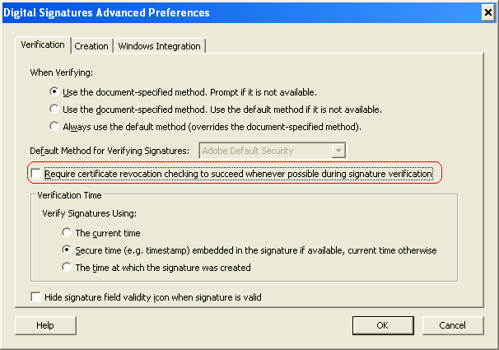

- Click ‘OK’ and save the settings.

Now, verify the signature by clicking the signature field again.

