Devops
What is devops:
Devops is a culture and the process of improving the application delivery with having proper automation, quality with continuous monitoring and testing.

SDLC: software development life cycle
A set of standars which was followed in software industry to design, test and develop with high quality. We can improve the SDLC with help of devops culture.
planning -> defining -> designing - > building -> testing -> deploy

We can automate building , testing and deploy with help of devops tools
1. building is nothing but developing, he develops the code and push the code into git repo
2. in testing phase, tester take the code from git and deploy thr code into sever
3. in deployment phase we will promote the application into production server(customer)
devops engineer basically fastens the process, he will improve the process to deliver faslty with out manual process, everything is in automated way
devops engineer automate these 3 phase of your SDLC.

Virtual machines:
virtualization : with help of hypervisor we can install no. of servers (virtual machines) in a 1 physical server, it will use same physical components for all the vm’s (all vm’s has their own memory, cpu and hardware.)
Server is nothing but a computer that provides services, data to other computers( called clients) over a n/w

Installing vm’s via oracle virtual box manually:
command to see ipaddress: ip addr show
centosVM: ssh madhan@192.168.1.12
LinuxVM:
Installing vm’s via oracle virtual box automatically using vagrant:
Vagrant: vm automation tool, its not a hypervisor, it uses those tools to create and manage vm’s
initiallision vagrant:
step1: open git bash and use below command in respective directory
step2: vagrant init eurolinux-vagrant/centos-stream-9
step3: vagrant up(it will install the vagrant box from cloud):
vagrant status( to check its running ot not)
step4: vagrant ssh (to launch and connect vm)
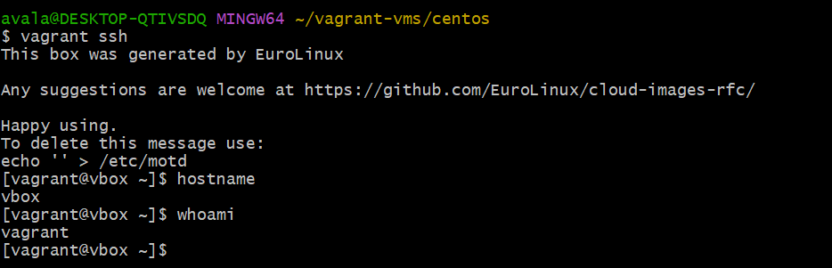
Step5: vagrant halt( poweroff the vm)
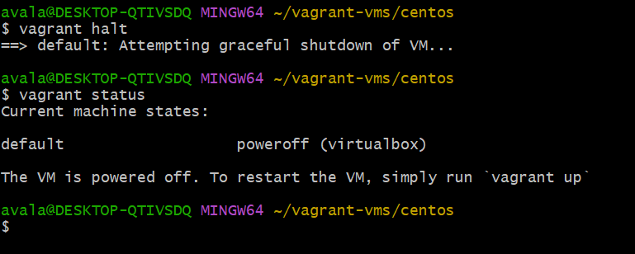

Vagrant reload to reboot the vm
Vagrant destroy to delet the vm

Building website in linux servers:

Create vm and install httpd service
If centos: yum install httpd wget vim unzip zip -y
After installing we need to start the service: systemctl start httpd
And enable the server : systemctl enable httpd
Once enable u can check in browser with Ip.
In /var/www/html folder you can create any html content will disppay on browser u opened with the ip. After creating html file restart the service: systemctl restart httpd
to create a brand new website formate fetch for the link of sample website (in chrome) index and download in /tmp folder with command wget <link>
Once downloaded unzip it and change the directory. Once installed copy all the file to /var/www/html folder and restart the service
Make sure u have stop and disabled firewall
Systemctl stop firewalld ; Systemctl disable firewalld
To automate the website setup we can use provisioning
open the vagrant file and edit the provision shell as below and up the VM
config.vm.provision "shell", inline: <<-SHELL
yum install httpd wget vim unzip zip -y
systemctl start httpd
systemctl enable httpd
mkdir -p /tmp/finance
cd /tmp/finance
wget https://www.tooplate.com/zip-templates/2135_mini_finance.zip
unzip 2135_mini_finance.zip
cp -r 2135_mini_finance/* /var/www/html/
systemctl restart httpd
cd /tmp/
rm -rf /tmp/finance
SHELL
creating multiple vms in single vagrant file
-----------------------------------
Use the below code
Vagrant.configure("2") do |config|

# WEB01 VM
config.vm.define "web01" do |web01|
web01.vm.box = "ubuntu/focal64"
web01.vm.hostname = "web01"

web01.vm.network "private_network", ip: "192.168.56.11"

web01.vm.provider "virtualbox" do |vb|
vb.memory = "512"
vb.cpus = 1
end
end

# WEB02 VM
config.vm.define "web02" do |web02|
web02.vm.box = "ubuntu/focal64"
web02.vm.hostname = "web02"

web02.vm.network "private_network", ip: "192.168.56.12"

web02.vm.provider "virtualbox" do |vb|
vb.memory = "512"
vb.cpus = 1
end
end

# DB01 VM
config.vm.define "db01" do |db01|
db01.vm.box = "centos/7"
db01.vm.hostname = "db01"

db01.vm.network "private_network", ip: "192.168.56.13"

db01.vm.provider "virtualbox" do |vb|
vb.memory = "512"
vb.cpus = 1
end

# Provisioning for DB01
db01.vm.provision "shell", inline: <<-SHELL
echo "Provisioning DB Server"
yum update -y
yum install -y mariadb-server
systemctl enable mariadb
systemctl start mariadb
SHELL
end

end

use below commands to login to separate separate vm’ss
vagrant up
vagrant ssh <vm name>
eg: vagrant up web01
vagrant halt <vm name>

