Ansible: configuration management tool
Ansible is an open-source automation tool used in DevOps for configuration management, application deployment, and task automation.
Ansible helps you automate repetitive tasks like:
- Installing software
- Configuring servers
- Deploying applications
All without manually logging into servers
It use yaml language.
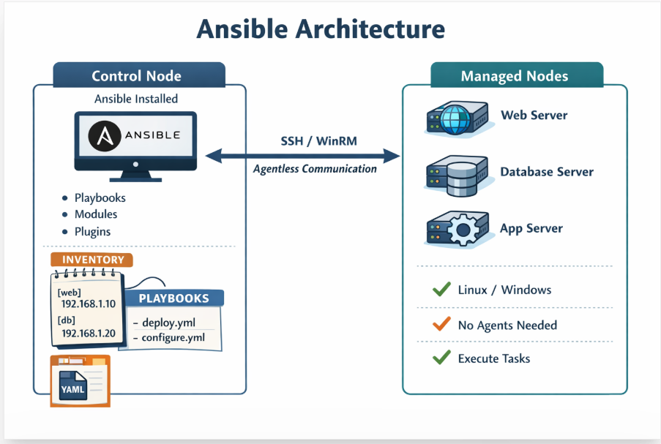

Installation:
Launch 1 ubuntu instance and install ansible (sg 22 from myip), 3 other centos instances (2 will webserver 1 db server).
Selrct below one for centos
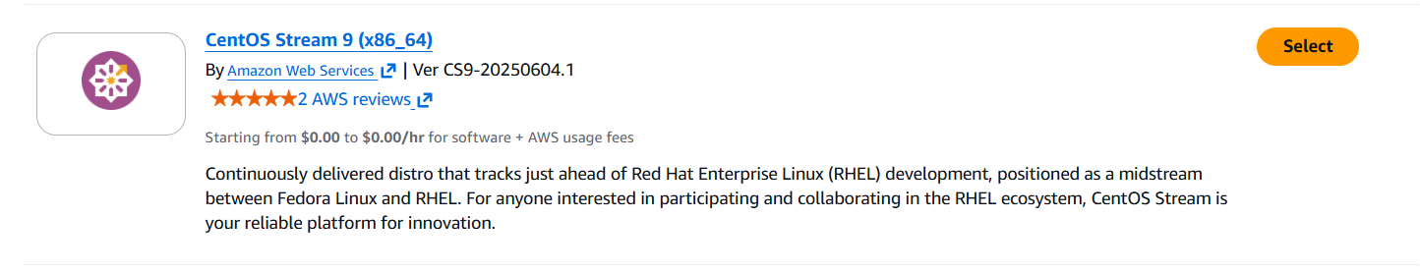
Install 3 instance with same centos and rename as below
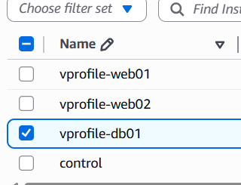

Select the control-sg group in security group of these 3 centos instances 22 from myip ans 22 from controller-sg

Ssh to control instance and instal ansible
Apt update
apt install -y software-properties-common
add-apt-repository --yes --update ppa:ansible/ansible
apt install ansible -y
check the version.
Now we will establish connect from controller to target machines (web01,02 and db01)
Create 1 dir in contoll so we can write few yaml config files., before these mak e shure u have inventory file in that dir.
To connect them we need inventory file , vi inventory and add below info
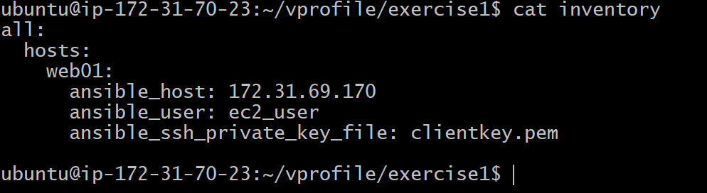
For that clientkey.pem, we ned to copy the client-key pair which we created earlier, and vi clientkey.pem and paste that key.
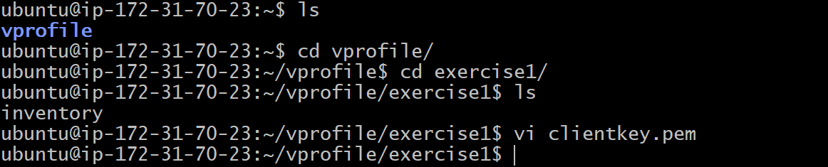
We can ping to that web01, before that follow below steps to avoid giving yes everytime of connections
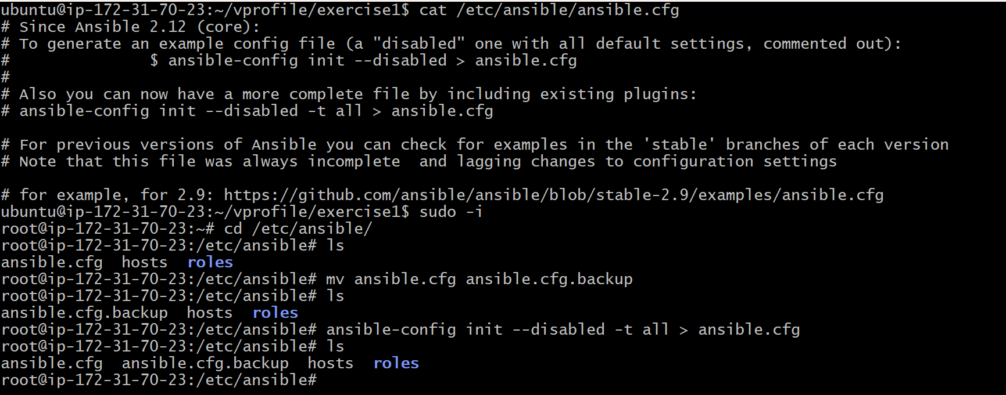
Vi into that ansible.cfg search host_key_checking make it false save and exit.
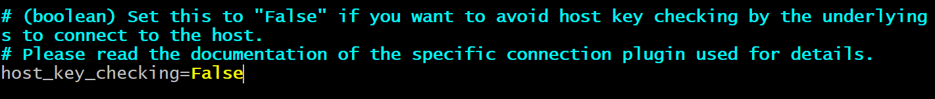
Give the permission for .pem file and ping the web01
Chmod 400 clientkey.pem
Ansible web01 -m ping -i inventory
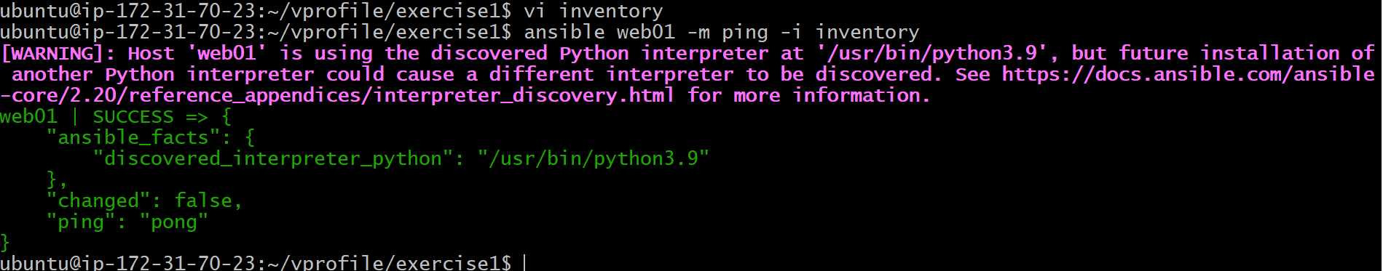

Adhoc commads:
Without any playbook we can install services in commadine itself eg:
ansible web01 -m ansible.builtin.yum -a "name=httpd state=present" -i inventory --become

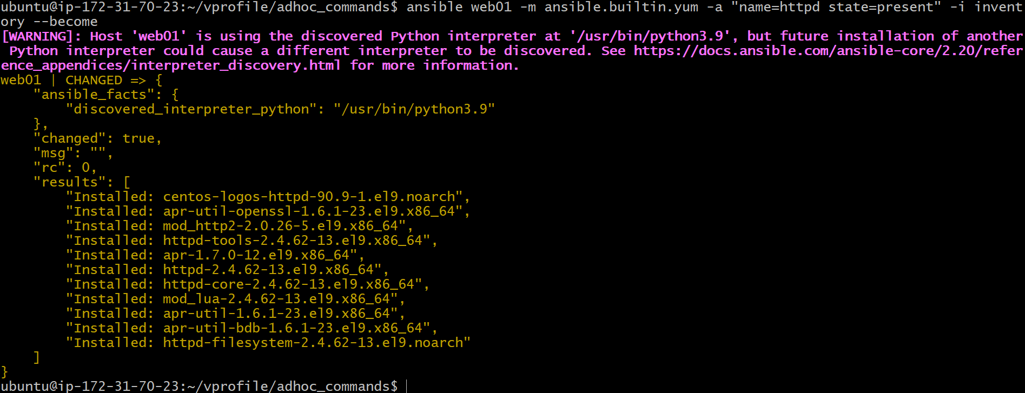

ansible webservers -m ansible.builtin.service -a "name=httpd state=started enabled=yes" -i inventory –become
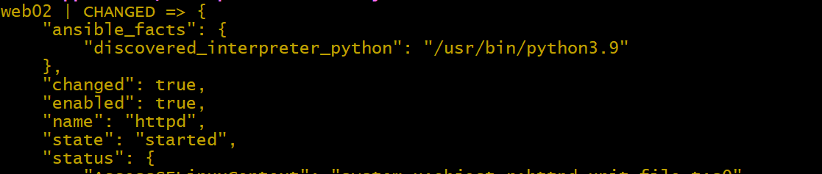
the above commad will start the server and enable it.

ansible webservers -m ansible.builtin.copy -a "src=index.html dest=/var/www/html/index.html/ -i inventory –become
the above comad will compy the .html from source to webservers(create 1 sample index.html)
once copied add port 80 from ipv4 and access the web01 or web02 ip in chrome
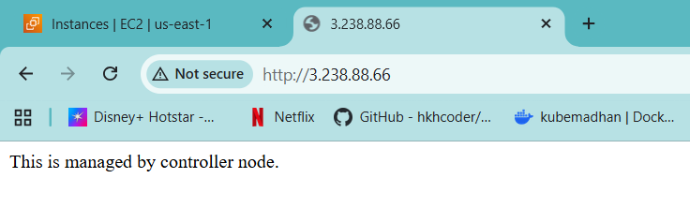
Playbooks.
Create 1 sample playbook with below code
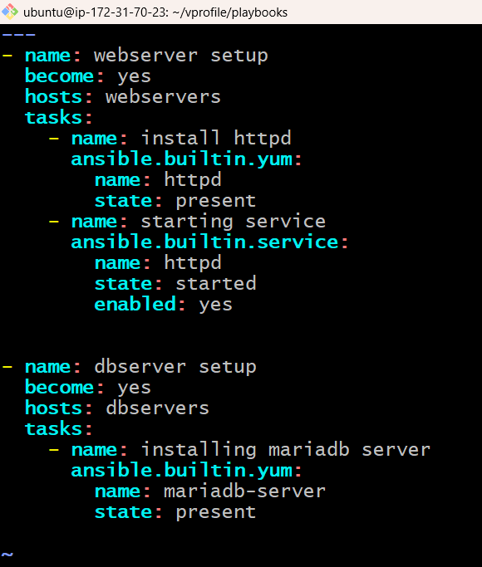
To run use below command
Make sure u have inventory like below
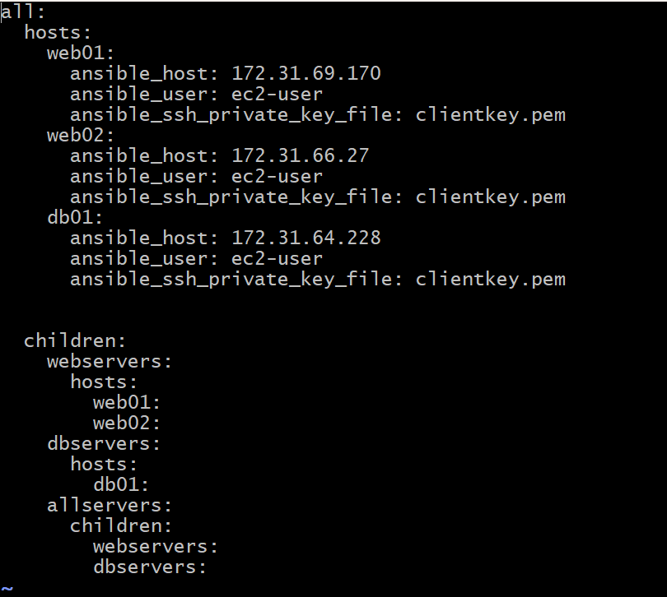Ansible-playbook -I inventory filename.yml
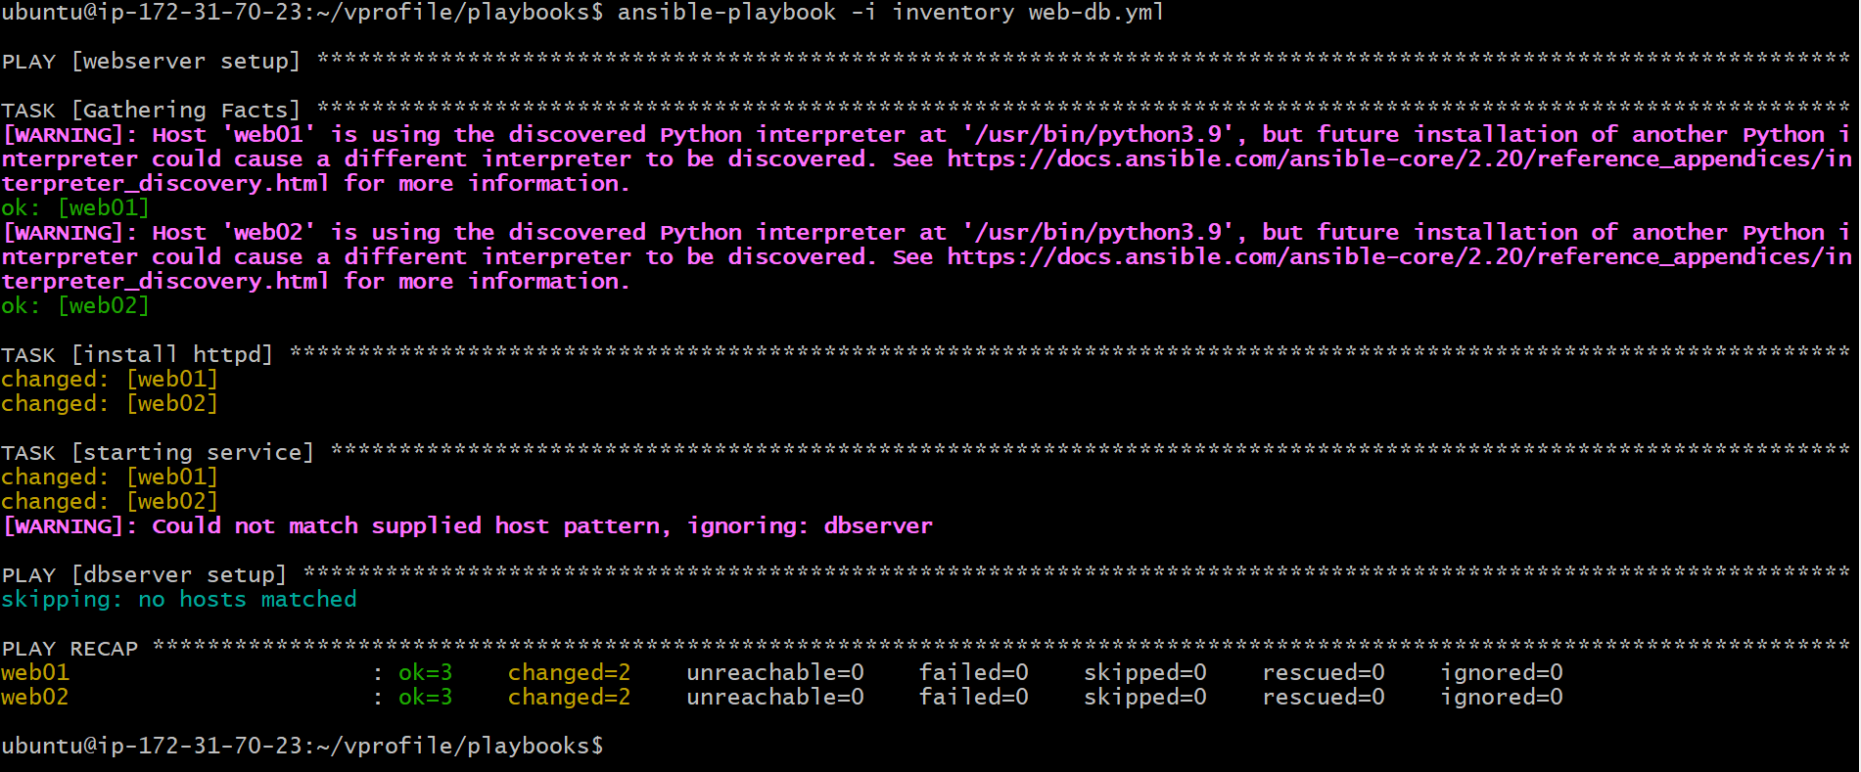

ansible-playbook -i inventory web-db.yml --syntax-check to check syntax
ansible-playbook -i inventory web-db.yml -C for dry run

we can create 1 ansible.cfg file in same working dir and mentions all the settings
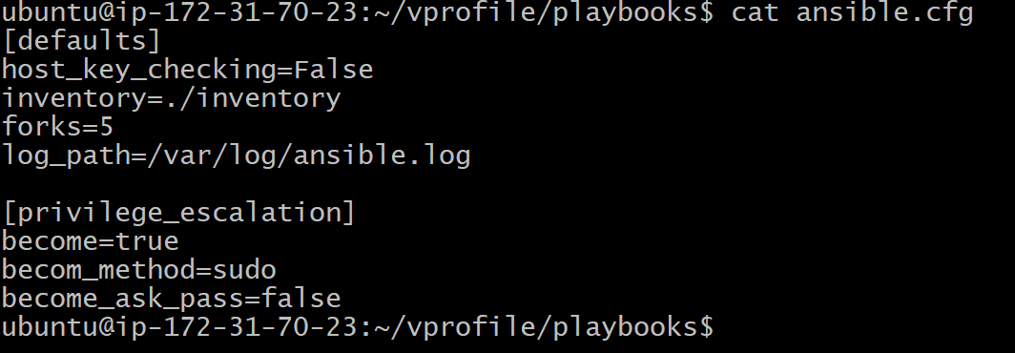

directly we can run playbook without mention -I inventory and all and also add log folder as well.
before the we nend to create one foldwr and give chown as ubuntu
sudo touch /var/log/ansible.log
sudo chown ubuntu:ubuntu /var/log/ansible.log
variable:
we can define our own carriable for no to hard code every time
eg:
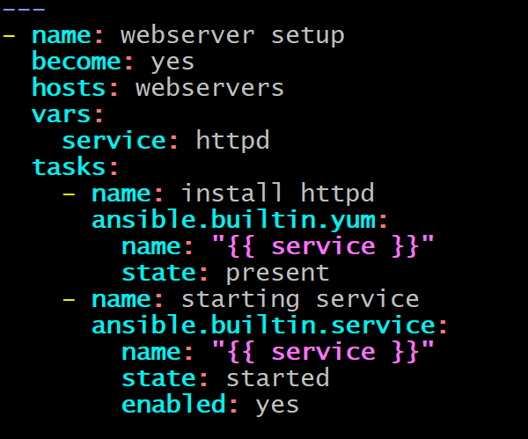
Debug use for printing msgs
Register: for storing output of the task
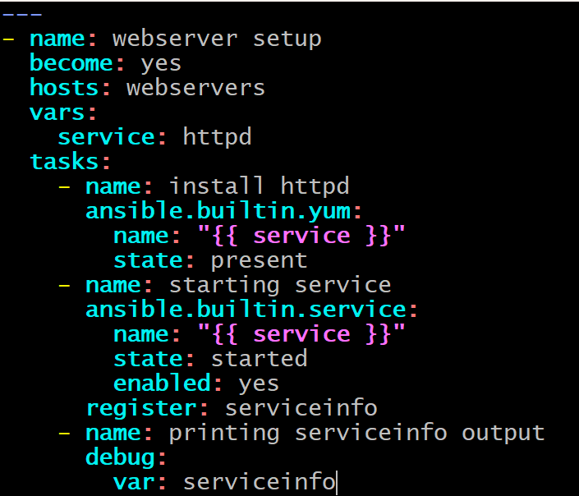
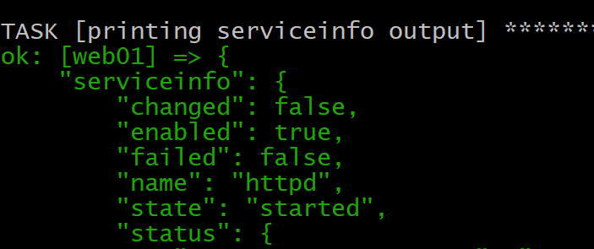

Facts:
If we ran below code it automatically fetch the facrts of the servers and pring thr info.
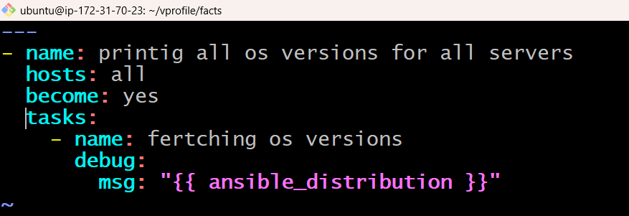

Provisioning server:
Add one more instance with ubuntu
In this session we learn
- Ntp service on multi OS
- User and groups
- Configuration files
- Decision making
- Loops
- Template
- Handlers
- Ansible roes
Take ssh to control node and add provision.yml make sure u have
ansible.cfg clientkey.pem inventory

decision making:
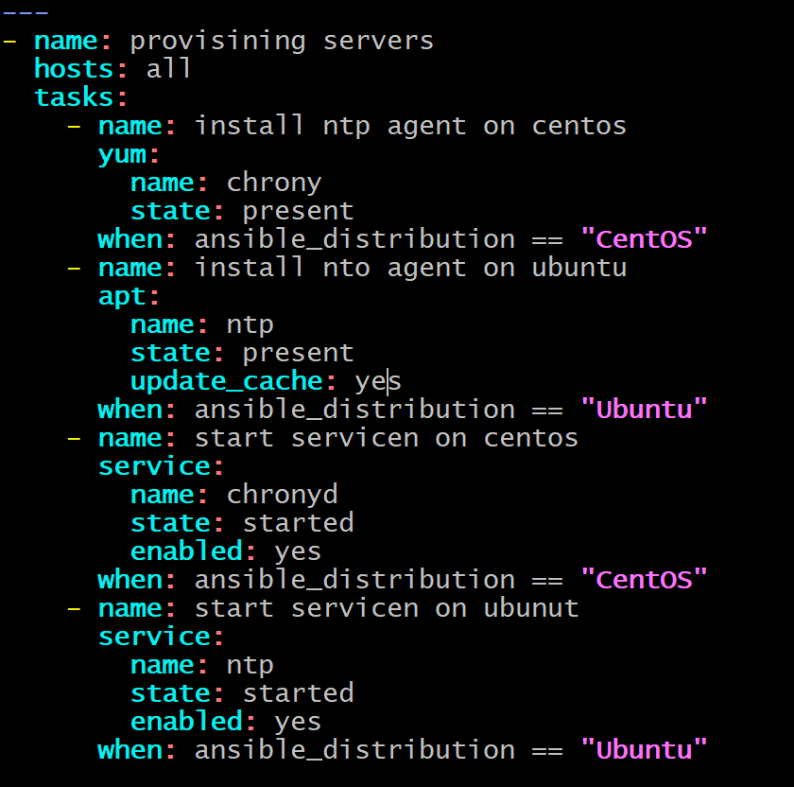
Loops:
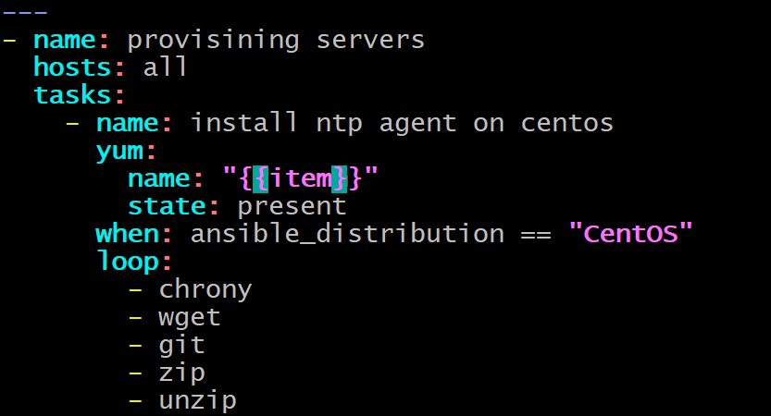

Banner file:
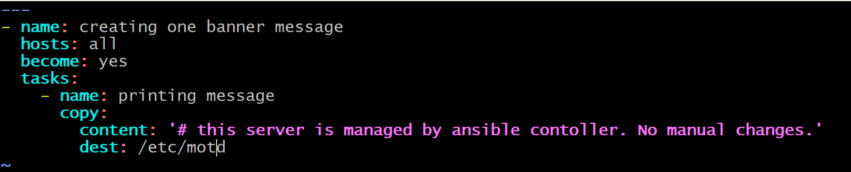

Handlers:
Execute tasks based on the changes happened on previous tasks
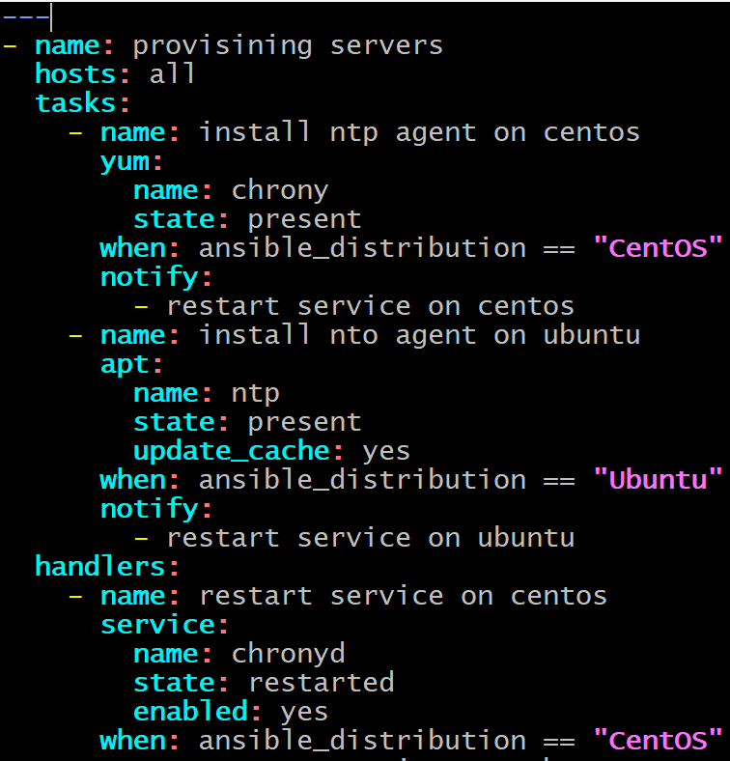

Roles:
Roles are a way to organize your Ansible code into reusable, structured components.
Instead of writing one big playbook, roles let you split things into clean, modular parts.

Create 1 yml file with bunch of tasks as we can seggerrigate the task with help of roles
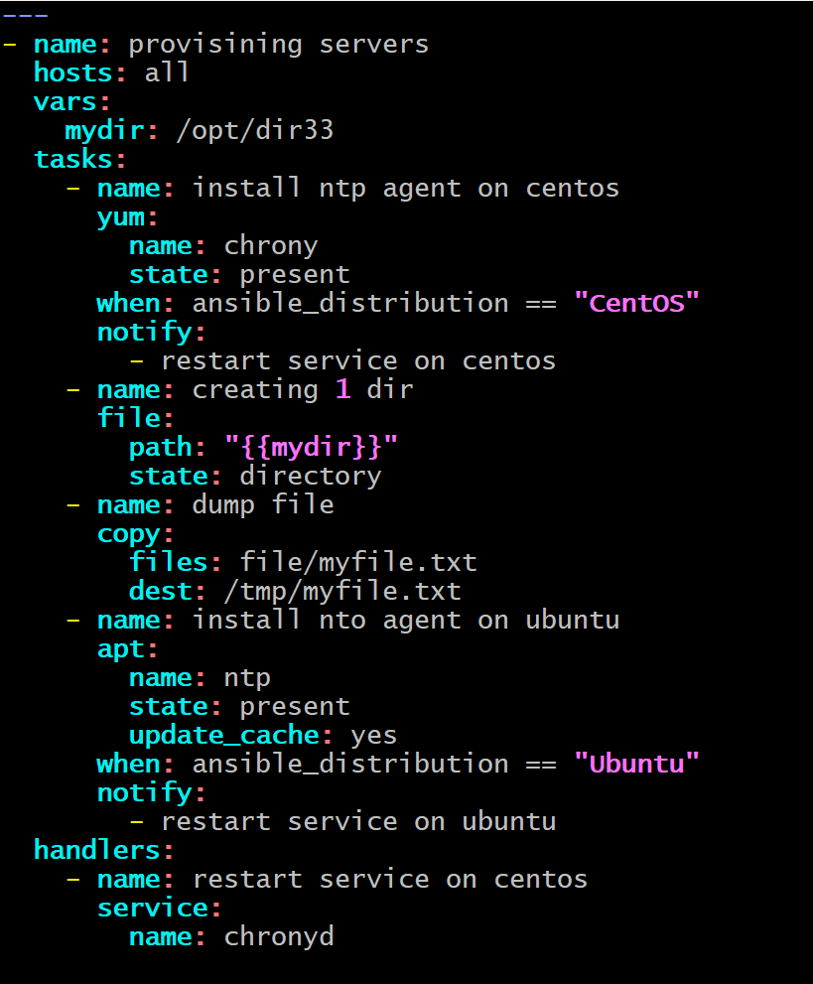

In the above code we have tasks like, creating dir, copy file, install package and start service
And run the file before configure with roles
Instal tree module in instance to chek the aomplete structure
Sudo apt install tree
Tree <filename>
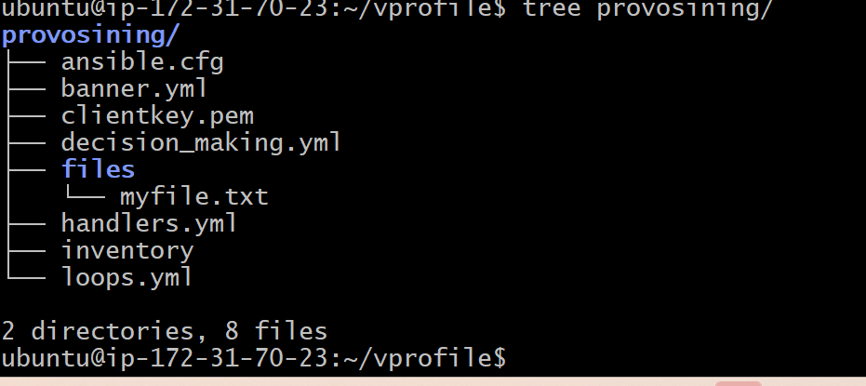

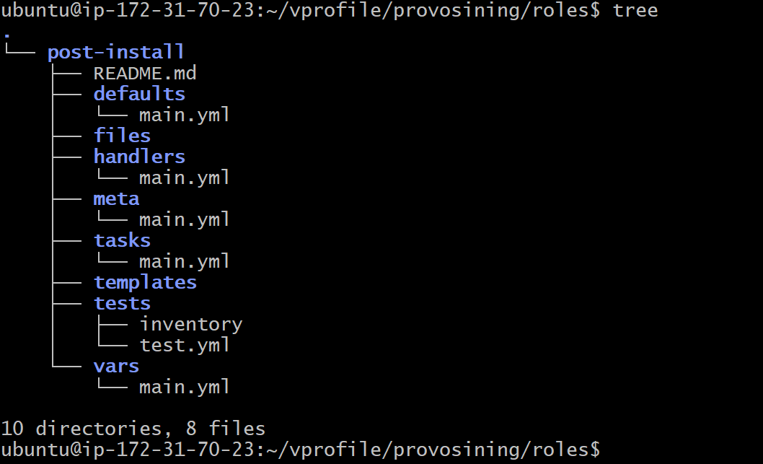
Default tree has created by roles galaxy
Now we copy all the tasks, vars, handlers into the folders which created by galaxy(called simply)
Copy all the contents the their respective .yml file
Make 1 dir with roles and intalls roles inti to the dir
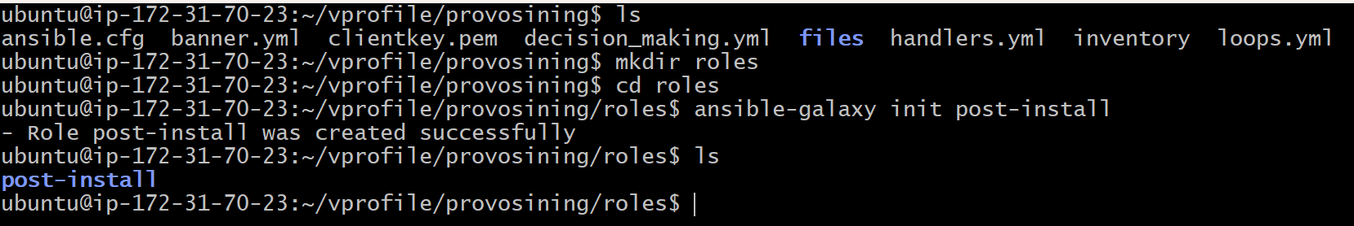
To remove xtra space use below tip
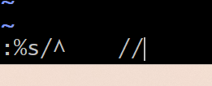

Once all are replaced you can remove all the info from ur yaml file and finally ur yaml looks like below (simple and supre)
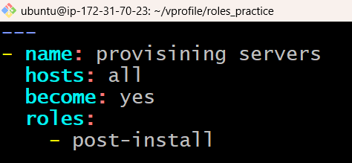
If u run the above yaml file u will get same output

Ansible in aws.
Crearting instances and all.

First we create 1 user in IAM and create access key as well and download the csv file
Ssh to control instgace and open .bashrc file
Vi .bashrc
Add these 2
export AWS_ACCESS_KEY_ID="your_access_key"
export AWS_SECRET_ACCESS_KEY="your_secret_key"
export AWS_DEFAULT_REGION="ap-south-1"

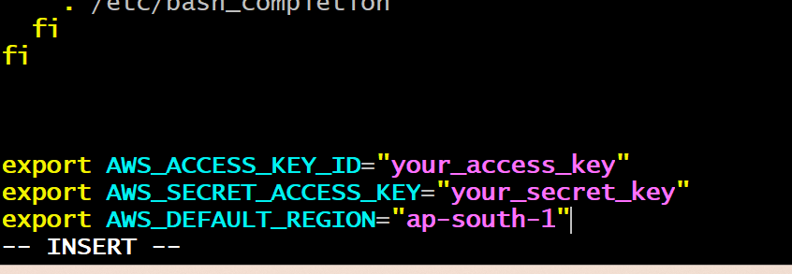
Replace with ur keys
And craet 1 yaml file to create key-pair
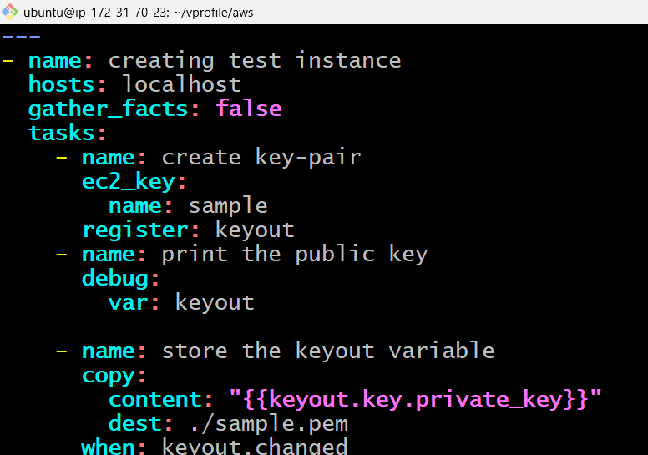
Sample.pem will created nd sample is created on aws instance as well.
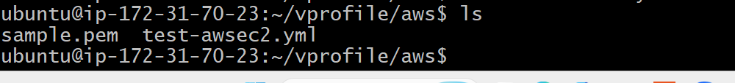
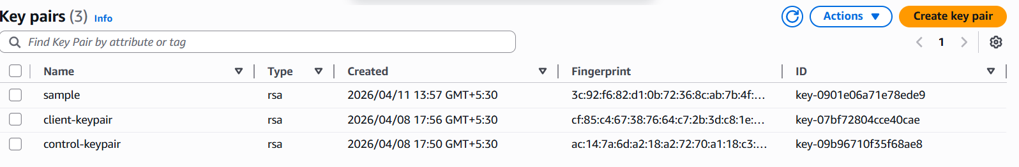

Inorde to install key maku sure with requiementos python and all.

Now we will modify yaml file, which will launch instance
Before thagt we need req:
ansible-galaxy collection install amazon.aws
