Docker is a platform used to build, package, and run applications in containers.
Docker allows you to bundle an application with all its dependencies (libraries, configs, etc.) into a container, so it runs the same everywhere.

Container (thin read/write layer)
- A lightweight, portable environment
- Runs your application with everything it needs
👉 Think of it like a mini virtual machine, but faster and smaller
Docker Engine
- The core service that runs and manages containers
Dockerfile
- A script with instructions to build an image
Example:
FROM python:3.9
COPY . /app
RUN pip install -r requirements.txt
CMD ["python", "app.py"]
Image
- A blueprint/template to create containers
- Example: An image may include:
  - OS (like Ubuntu)
  - Python/Java
  - Your app code
Handson to run few containers
Lanunch 1 ubuntn ec2 instance

# Add Docker's official GPG key:
sudo apt update
sudo apt install ca-certificates curl
sudo install -m 0755 -d /etc/apt/keyrings
sudo curl -fsSL https://download.docker.com/linux/ubuntu/gpg -o /etc/apt/keyrings/docker.asc
sudo chmod a+r /etc/apt/keyrings/docker.asc

# Add the repository to Apt sources:
sudo tee /etc/apt/sources.list.d/docker.sources <<EOF
Types: deb
URIs: https://download.docker.com/linux/ubuntu
Suites: $(. /etc/os-release && echo "${UBUNTU_CODENAME:-$VERSION_CODENAME}")
Components: stable
Architectures: $(dpkg --print-architecture)
Signed-By: /etc/apt/keyrings/docker.asc
EOF

sudo apt update
sudo apt install docker-ce docker-ce-cli containerd.io docker-buildx-plugin docker-compose-plugin
sudo systemctl status docker

sudo docker images (root user can connect the docker)
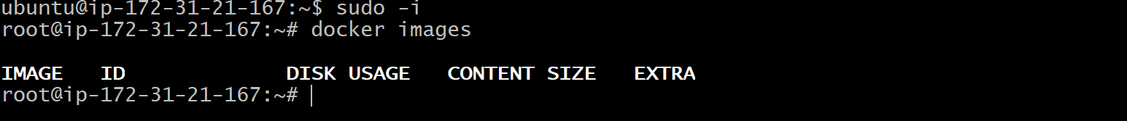
Add ubuntu use to docker group . so u can run docker commands
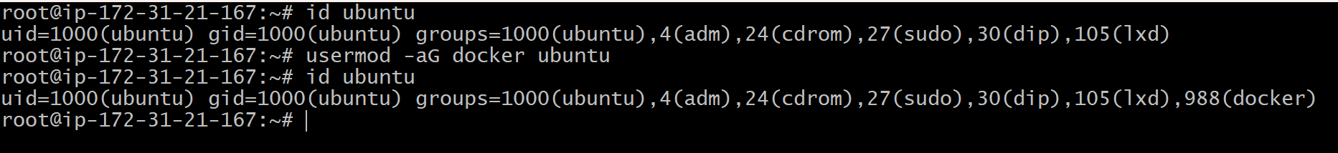

U can run docker imgae by
docker run hello-world and check by (docker ps -a)

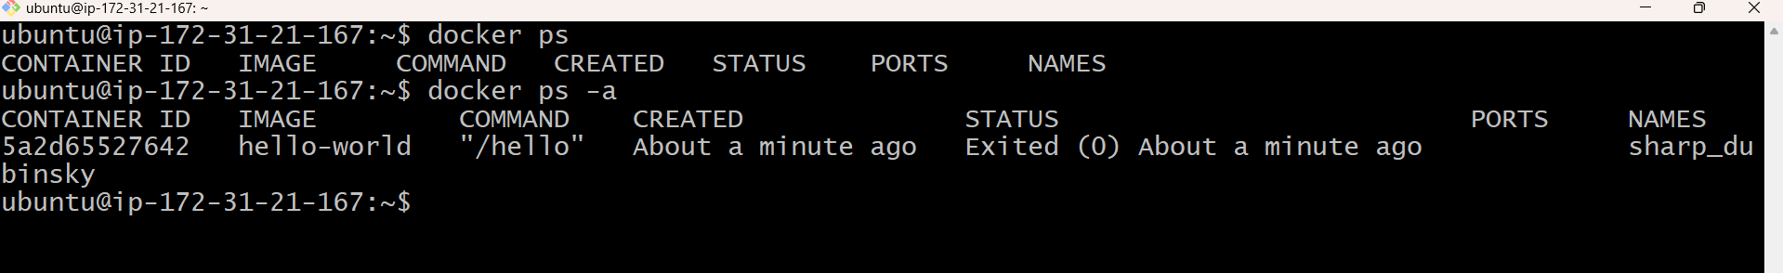

We can pull images from docker hub with bellow commacd
docker pull <image_name>

Docker pull nginx
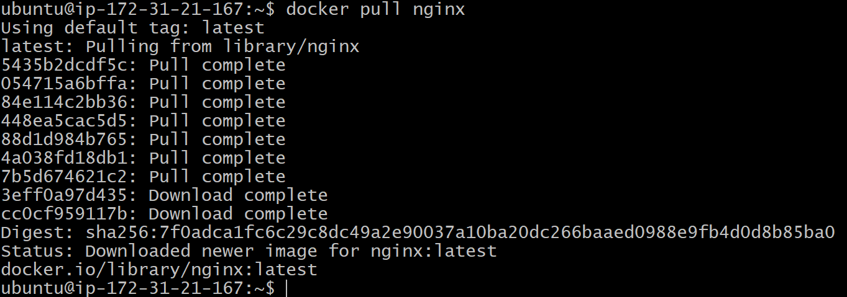
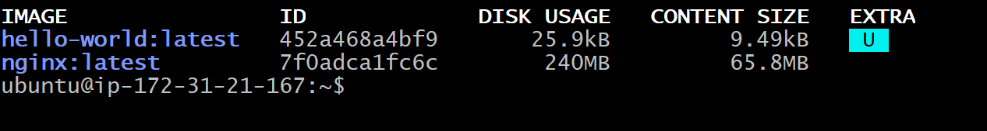
U can run that pulled nginx server like below
Docker run –name myweb -p 8080:80 -d nginx

Access with insracne puplic ip wit port 8080
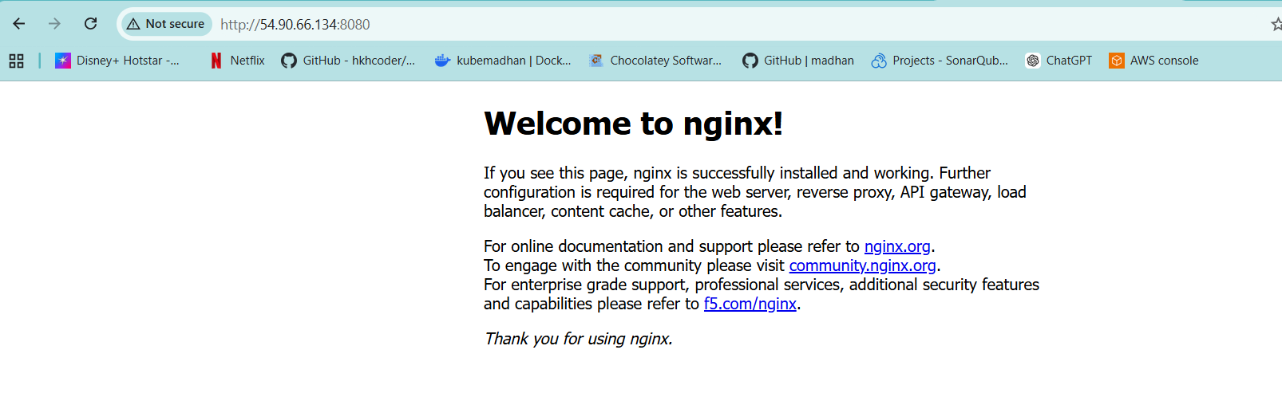

U can stop with image id or container name
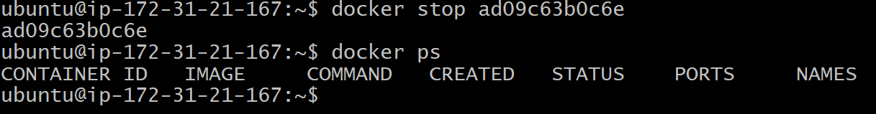
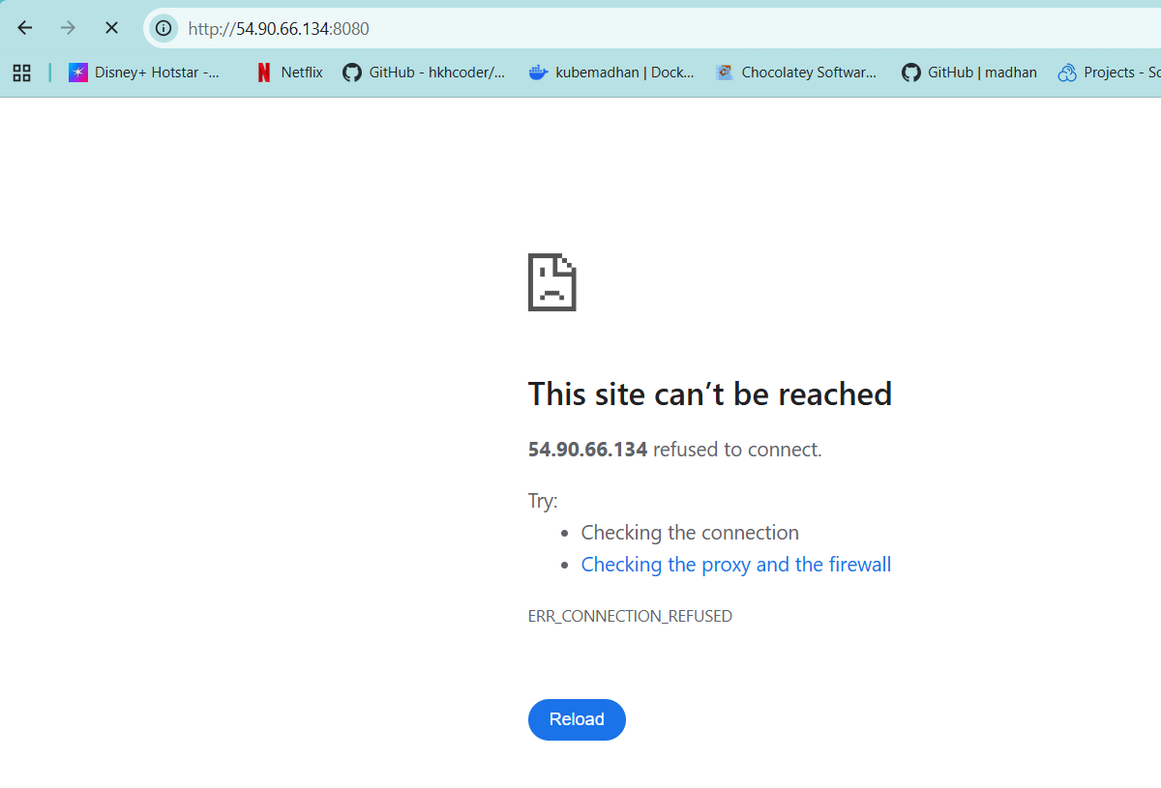

We can attach to the containers with exce
docker exec myweb ls /
if u wat to connect to that container we can use
docker exce -it myweb /bin/bash
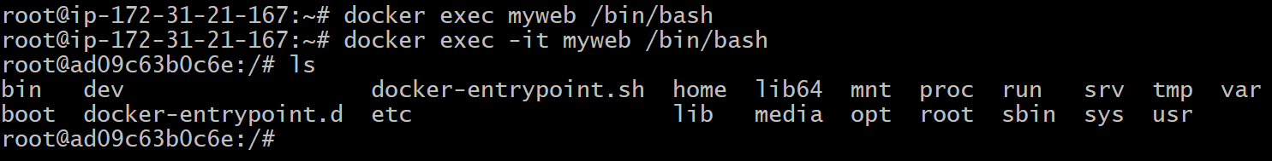
We can remove images by the below commad
Docker rmi <image_name>
Before that we nned to stope ans remove the container which is runnog this image
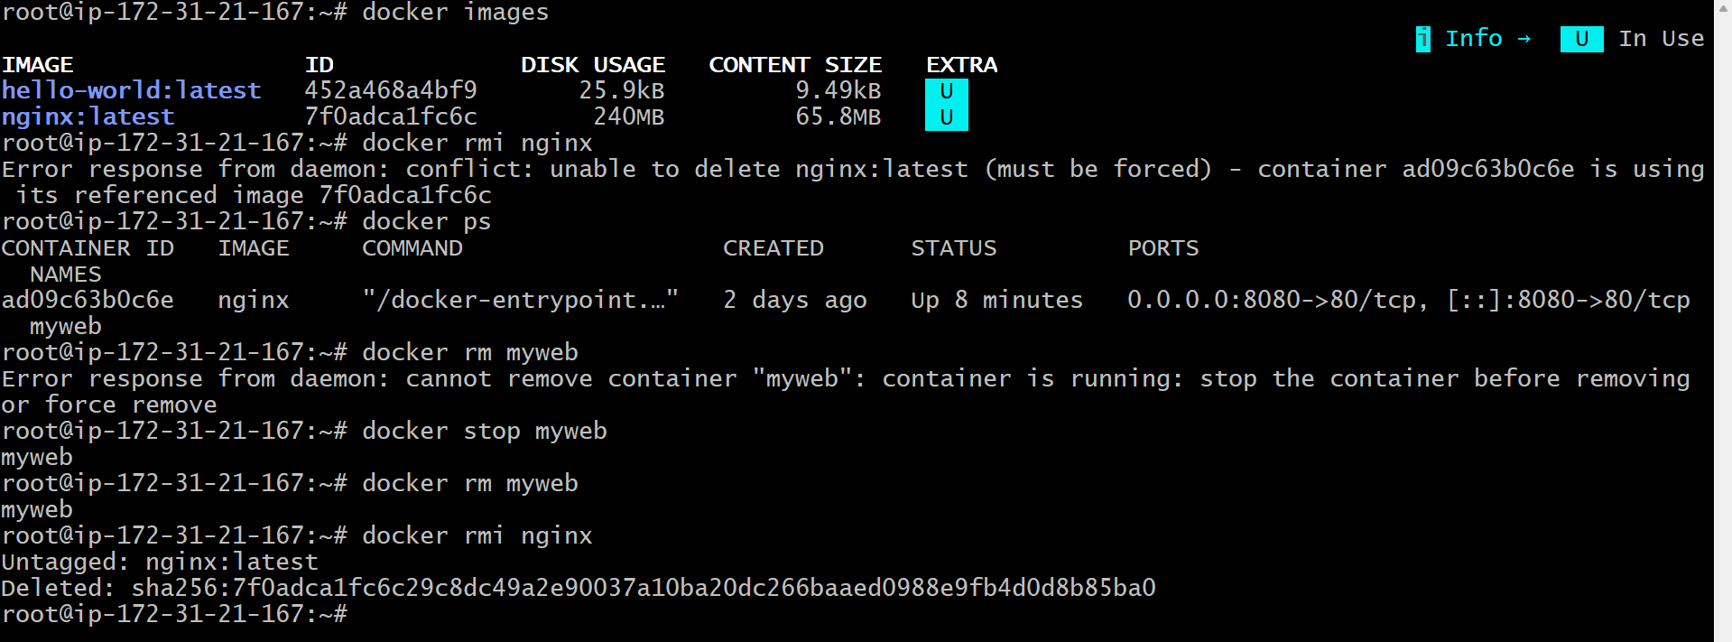
Docker volume
Docker volumes are how you persist data outside of containers so it doesn’t disappear when the container stops or is deleted.
Install 1 sql image
Docker pull mysql:5.7
We are running the container by specifying path /home/ubuntu/mydb, so all the info will stored on this fodler. If the comntaier gor deleted the info will present in hrere this is called volumes
docker run --name mydb -d -e MYSQL_ROOT_PASSWORD=pass123 -p 3030:3306 -v /home/ubuntu/mydb:/var/lib/mysql mysql:5.7
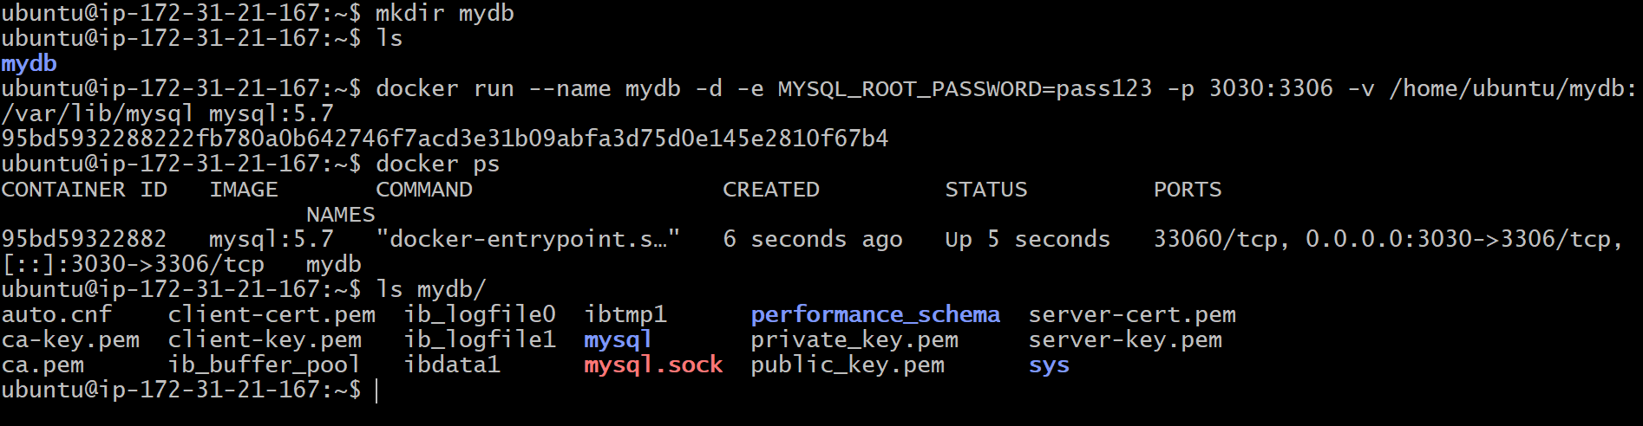
Cross check the contect by logging in to container
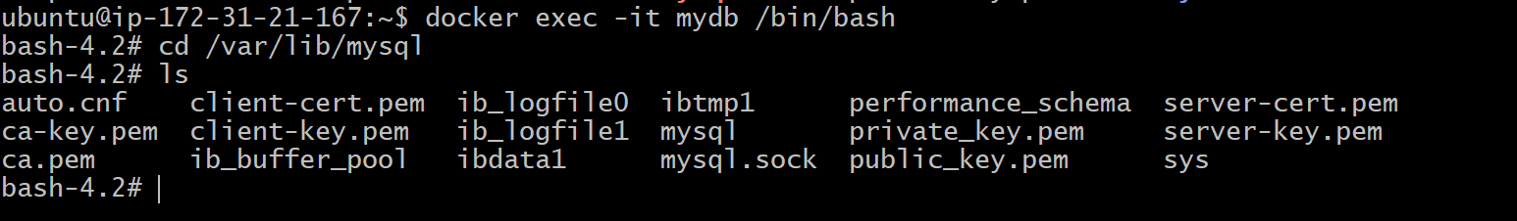
After stopping and deleteing the data still present
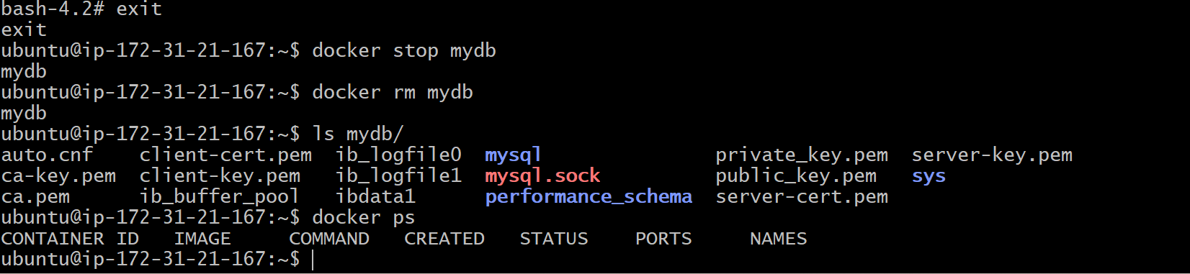
Instead of providing folder path we can creatre volumes
Docker volume create my_volume
Re-run the running command nad replace the path
docker run --name mydb -d -e MYSQL_ROOT_PASSWORD=pass123 -p 3030:3306 -v my_volume:/var/lib/mysql mysql:5.7

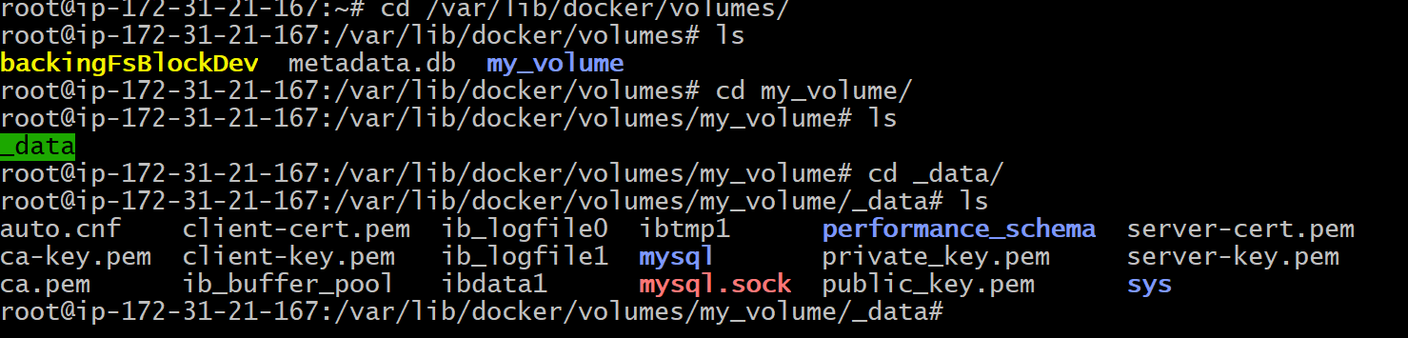
We can connect to databse (ip address u will find in docker inspect <containername>)
Mysql -h <iP> -u root -p

Build images:
To build docker images we need docker file
For this we will take website from tooplate.com and we will host it from apache2 service running in ubuntu container
Create 1 dir and wge the tooplate website
wget https://www.tooplate.com/zip-templates/2122_nano_folio.zip
unzip it and taz it
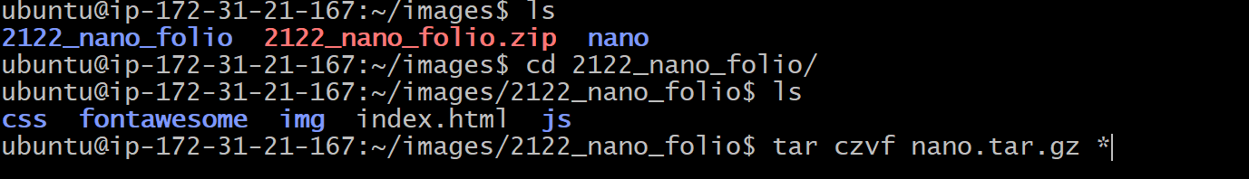
We need tar ball remove everything except that .gz( artifact)
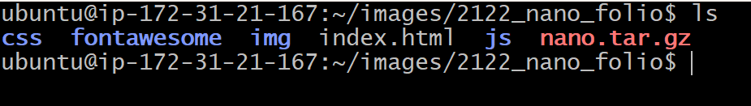
Now move thatg tar bal to nano dir inside the images dir.
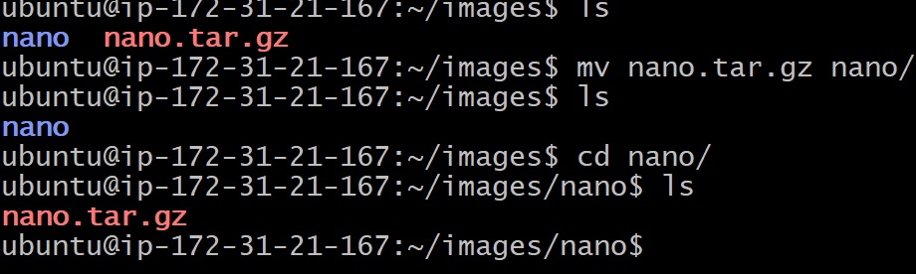
Now we can write the docker file insite the folcer which we have the artifact.
Vi dockerfile (d capita)
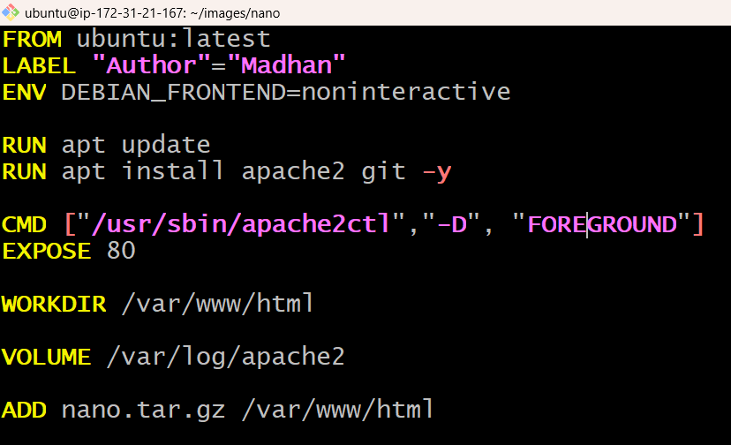
docker build -t nanoimg . (build the docker image)
Docker run --name -d mywebsite -p 9080:80 nanoimg
Take tha pubip:9080
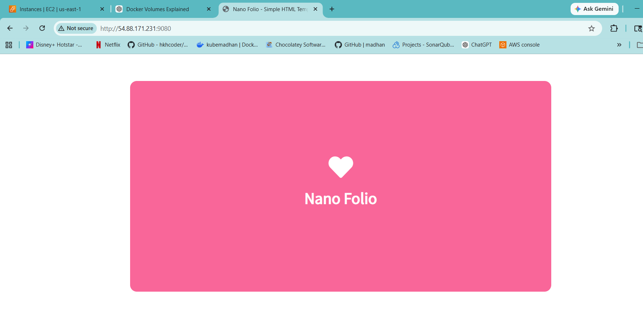
Now we will host this into dockerhub repos
For that built he image onemore time
docker build -t kubemadhan/nanoimg:V2 .
now logint to ur dockerhub
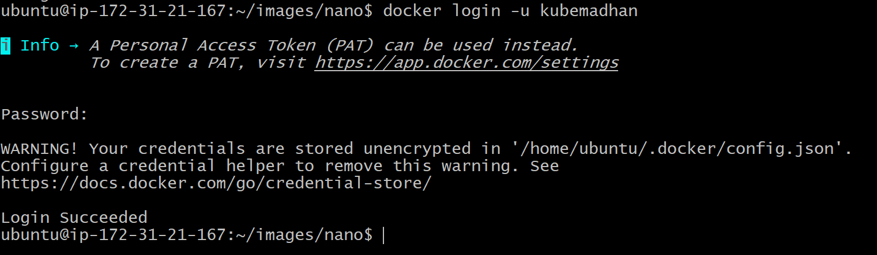
Docker push <image_nmae_with_version>
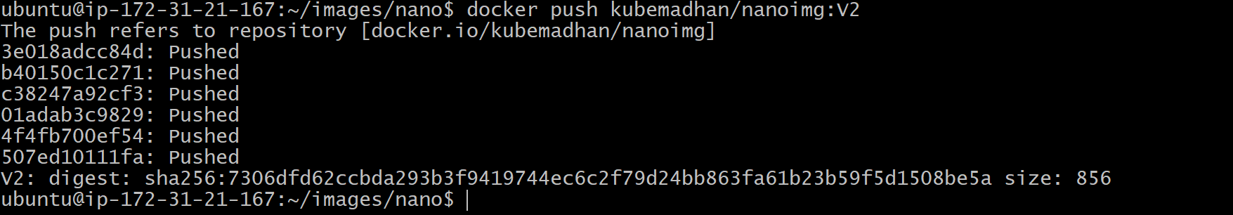
So we can removwe thje image locally and remove the container and remove the image
We eill try to pull the image
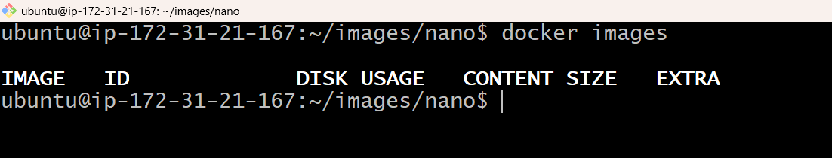
so we have pulled docekr image from kubemadhan repo
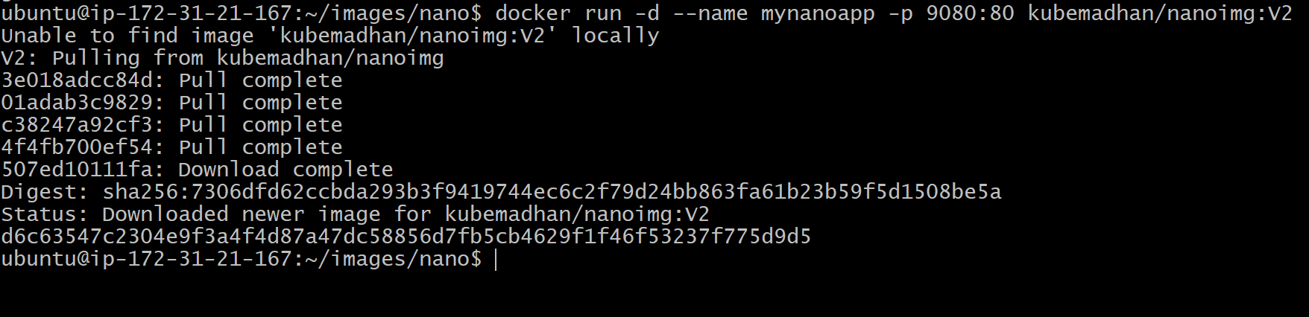

Multi-stage docker file
A multi-stage Dockerfile is used to optimize image size, improve security, and separate build-time dependencies from runtime.

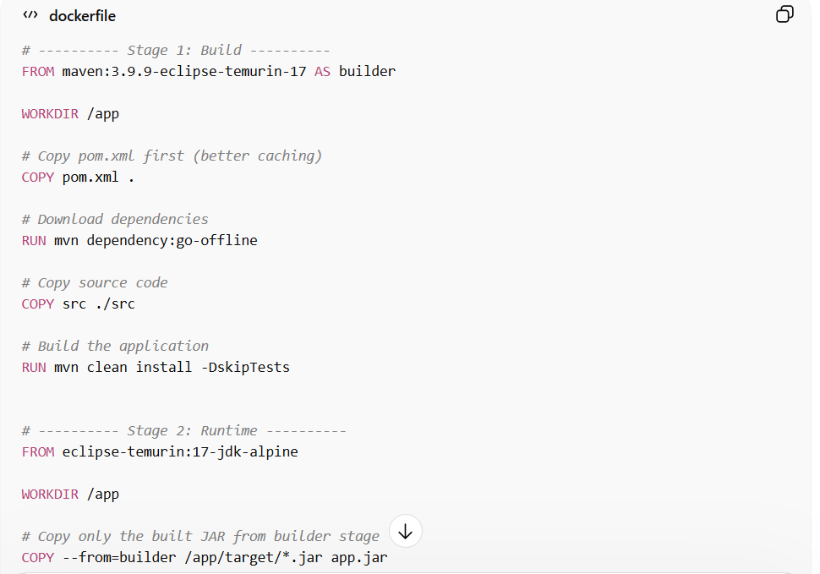
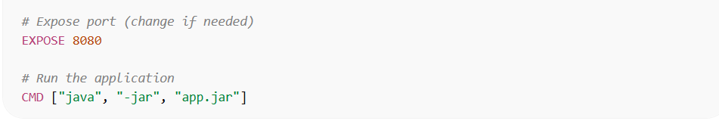

Containerization:
Containerization is the process of packaging an application along with its dependencies, libraries, and configuration into a single unit called a container so it can run consistently across different environments.
A widely used platform for this is Docker.
In containers Deployments are done via images reusable and repeatable.
Handson to containerized vprofile application
  - We will find the right base image from docker hub ( nginx, mysql, tomcat Memcached)
  - We will write docker file
  - We use docker-compose.yml to run multi containers
  - Test it and push our images to docker hub
Flow:
We will fetch source code m=from repo and write docker file and docker build (need to pull 3 base images i.e., tomcat, nginx, MySQL and we use docker-compose and test and push to hub.
First we needto fetch what we need to install, versions and all.
Setup should be done in below mentioned order
MySQL (Database SVC) 8.0.33
Memcache (DB Caching SVC) 1.6
RabbitMQ (Broker/Queue SVC) 4.0
JDK jdk 21
MAVEN maven 3.9.9
Tomcat (Application SVC) 10, jdk21
Nginx (Web SVC) 1.27

We found the below versions form default docker hub
Mysql:8.0.33
Memcache:latest
Rabbitmq:latest
Maven:3.9.9-eclipse-temurin-21-jammy
Tomcat:10-jdk21
Nginx:latest

For this handson we will use virtualbox, vagrants
Close the repos and swith to containers
And up the vm with vagrant up
/c/Devops/containerization/vprofile-project/vagrant/windowsAndMacIntel
After up vagrant ssh it
Install docker in it, follow the above steps in docer installation
After successful installation halt the vm.

Now we will create 3 repos in docker hub as public (vprofileapp, vpropiledb, vprofileweb)
So we need 3 docker files to build our image and host and push to docker hub.

First we will set tomcat app docker file , in the vscode opne docker_file and open app.
To setup tomcat app (vprofileapp) we need maven and jdk.
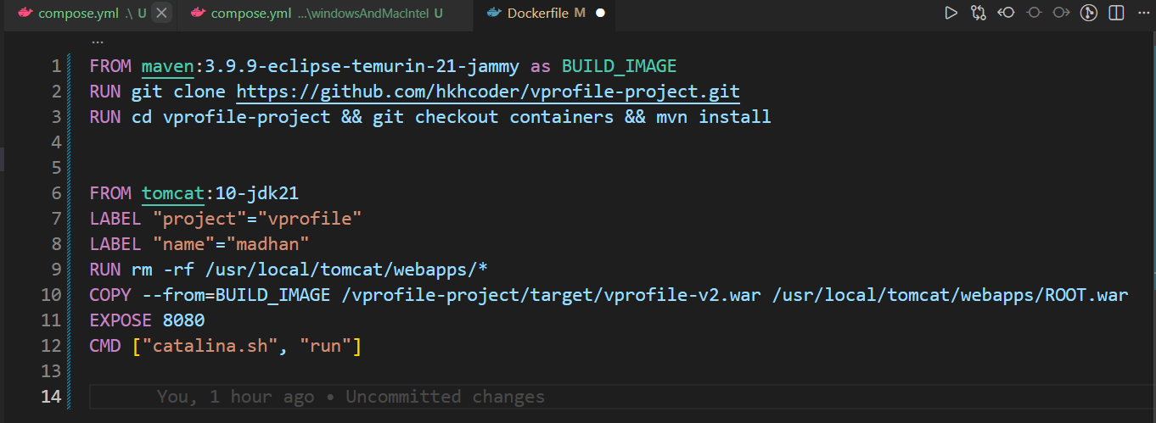
we will set db app(vprofiledb) docker file , in the vscode opne docker_file and open db.
To setup db app we need Mysql:8.0.33
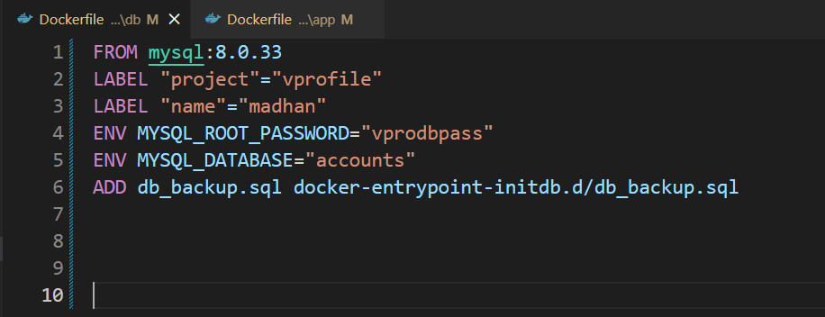
we will set web app(vprofileweb) docker file , in the vscode opne docker_file and open web.
To setup web app we need nginx:latest

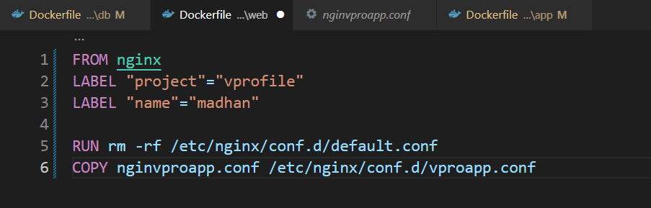

For memchached and rabbitmq we don’t need any docker file we directly pull form default image fomr docekr hub

Now we will create docker-compose.yml to run all these 3 docker files to build images and run containers along with rabbitmq and memchaned ( tolat 5 caontainer we need to run)
So we use docker-compose.yml to run all 5 images and containers
5 containers (requirements gathering)
  - App
We have docer file
Ports: 8080:8080
Containername: vproapp
Volume: /usr/local/tomcat/webapps
  - Db
We have docker file
Containername: vprodb
Ports: 3306:3306
Password: MYSQL_ROOT_PASSWORD
Volume: /var/lib/mysql
  - Web
We have docker file
Containername: vproweb
Ports:80:80
  - Memchached
We use image
Containername: vprocache01
Ports: 11211:11211
  - Rabbibtmq
We use image
Containername: vpromq01
Ports: 5672:5672
Variable:
User: guest
Password: guest

Below find the docekr-compose.yml file with all the builds
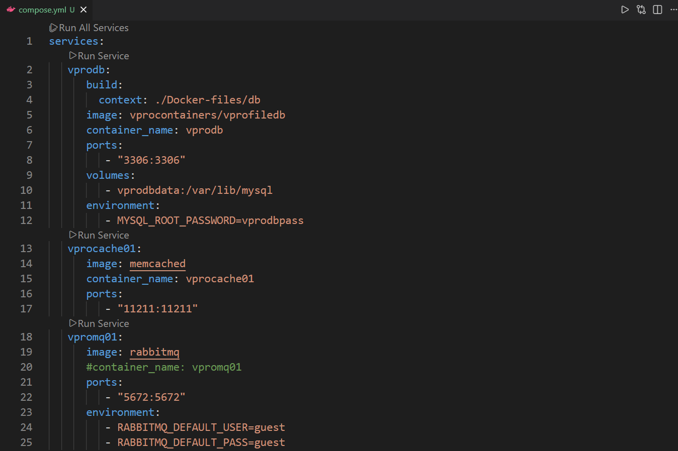
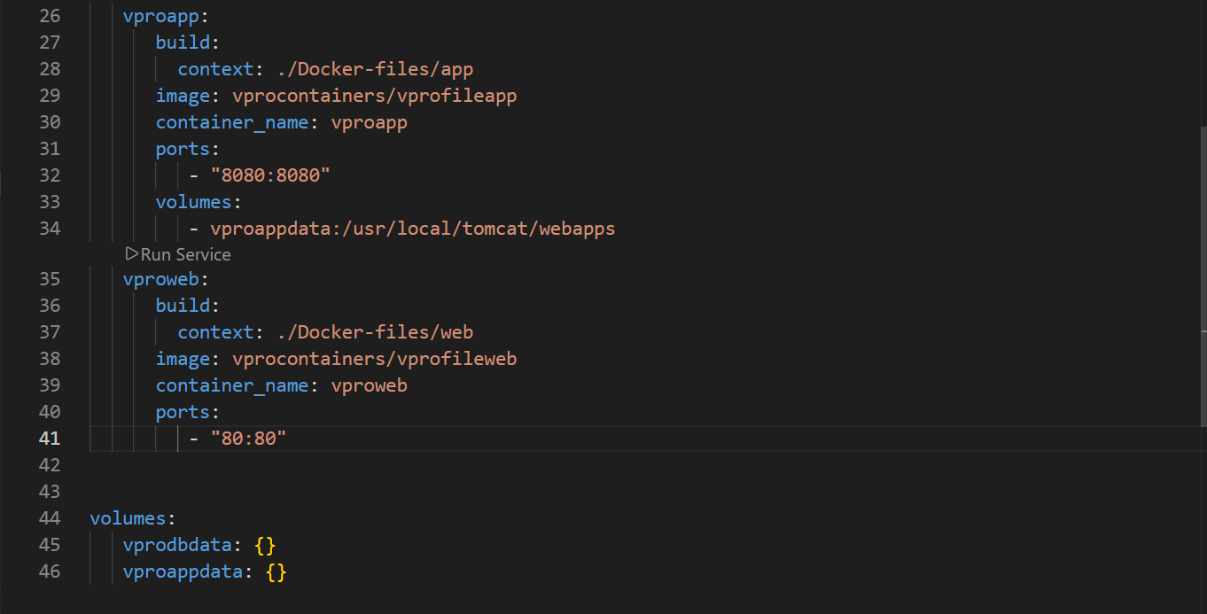
BUILD AND RUN:
Now opne the folder and up the vm using vagrant up and ssh.
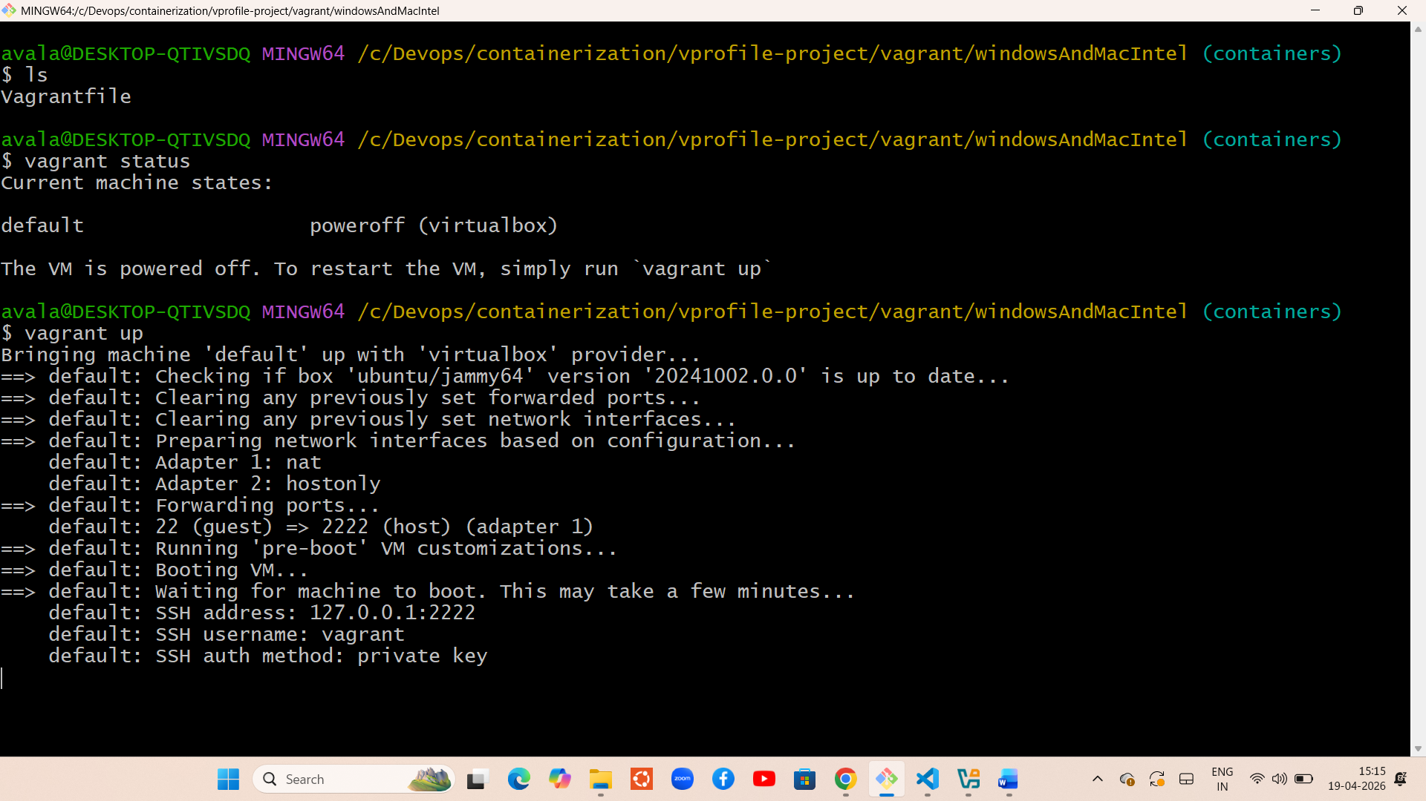

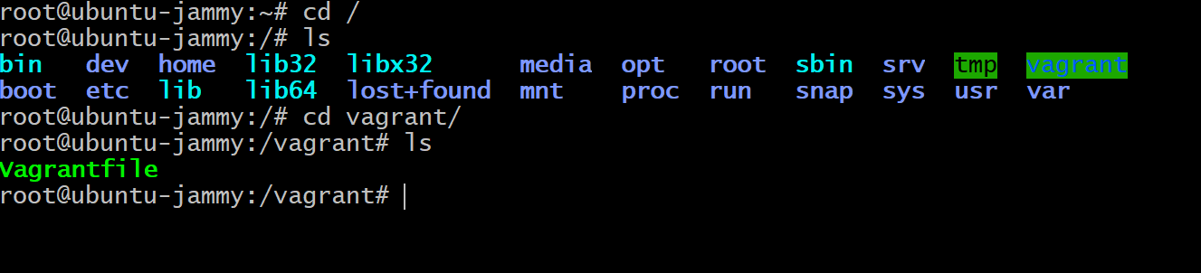

Chage to root user and cd to /vagrant
And copy docker_files folder and compose.yml file in the location of vagrant via vscode (inside the windowsandmacintel)
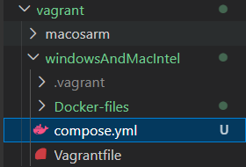
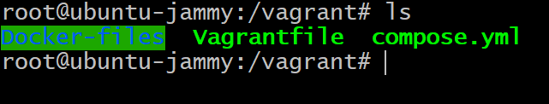
docker compose build
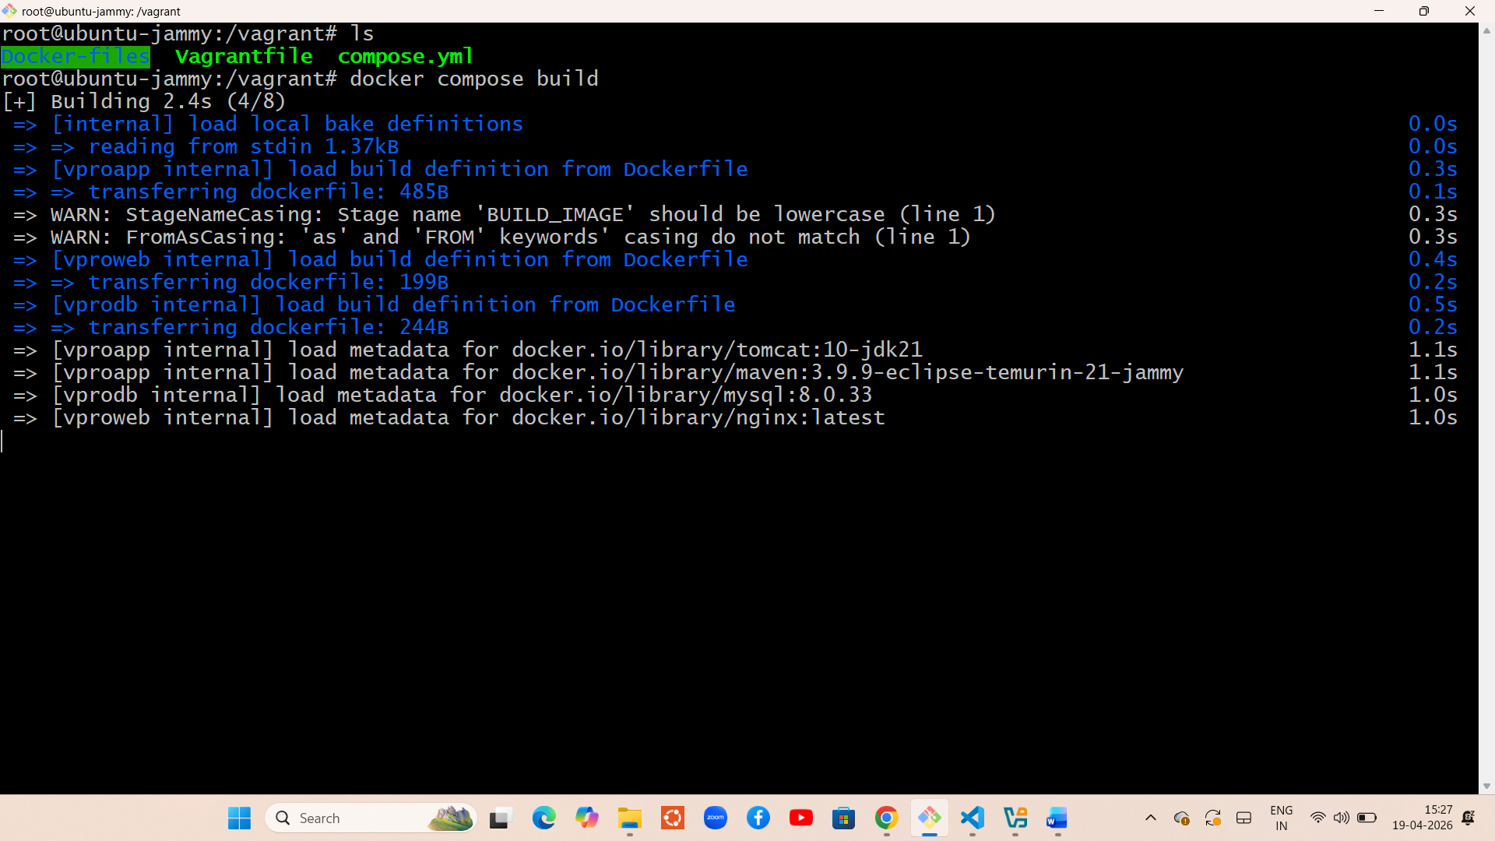
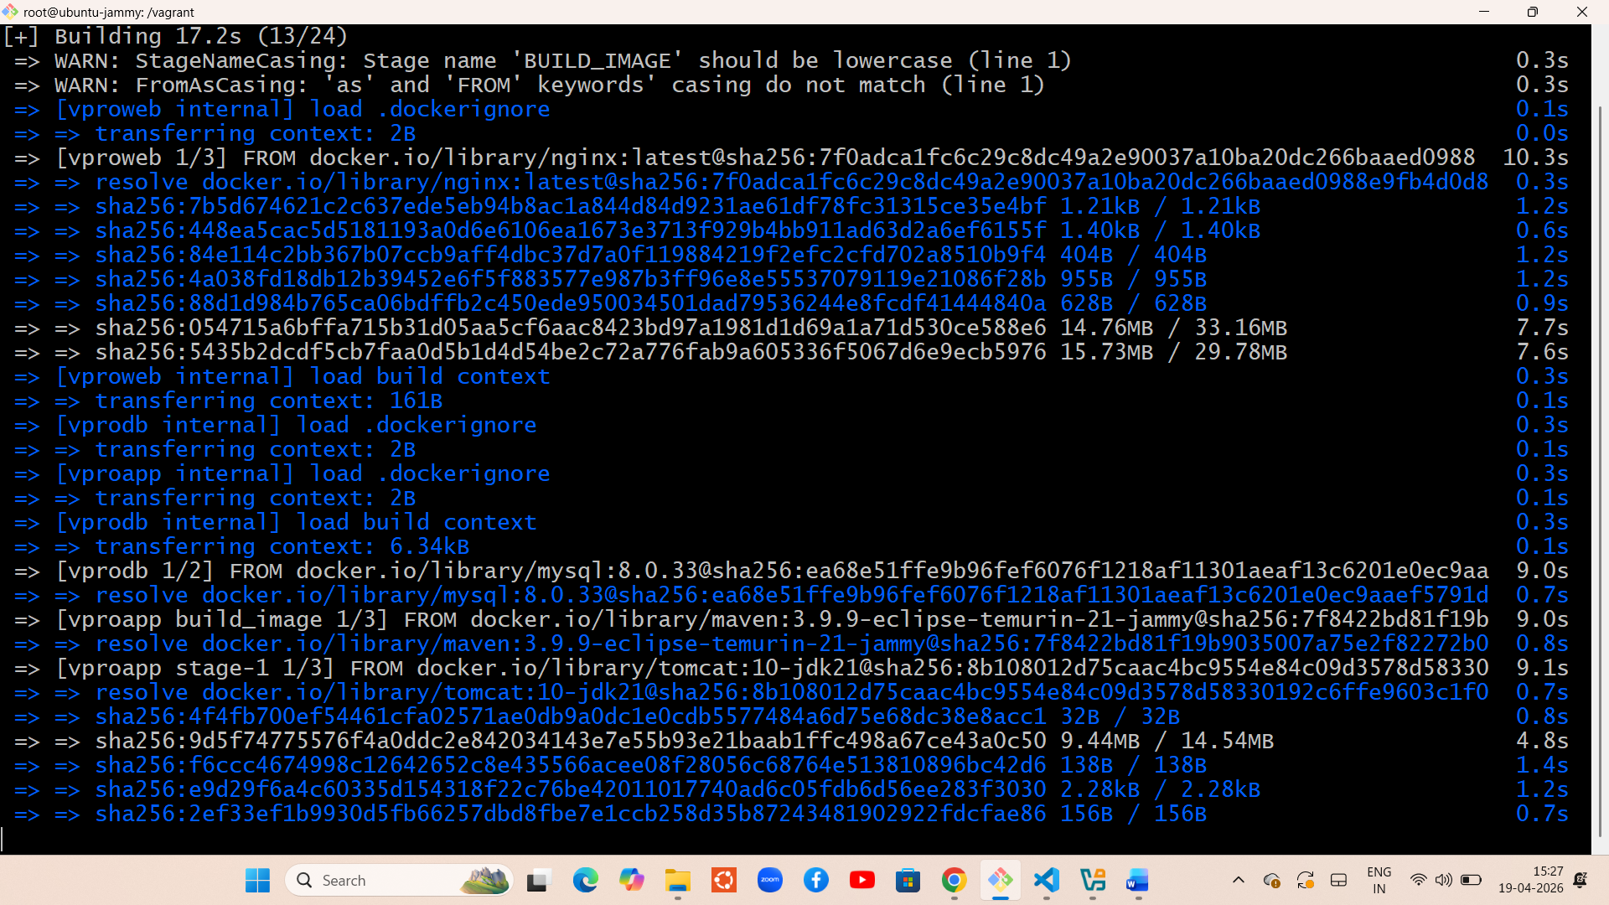
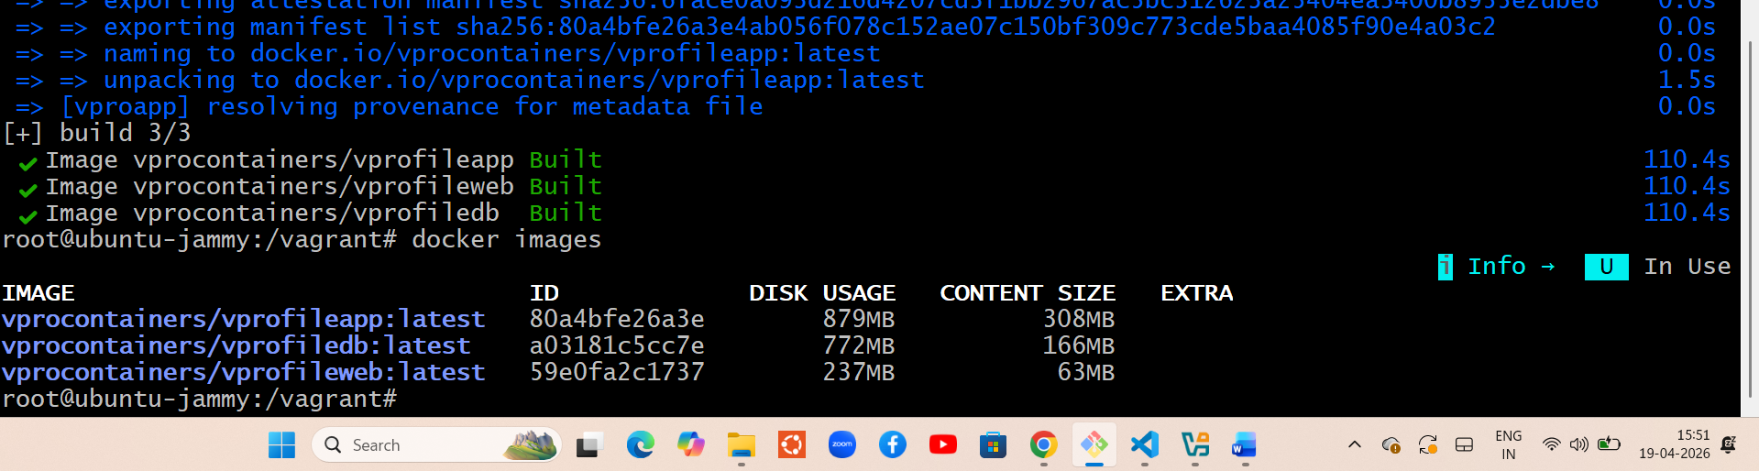now run docker compose up -d

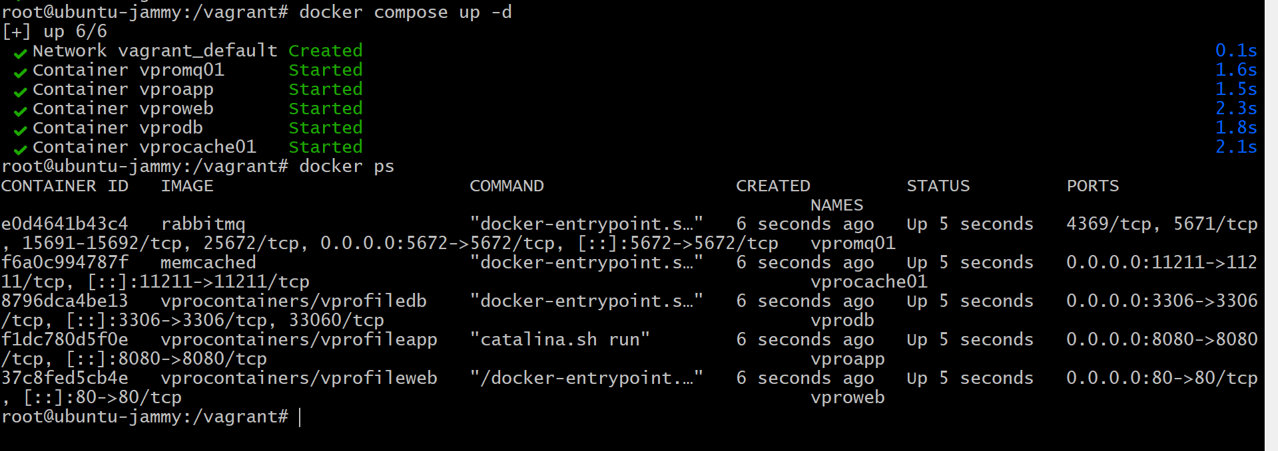
Now take the ip and access in browser check in vagrant file
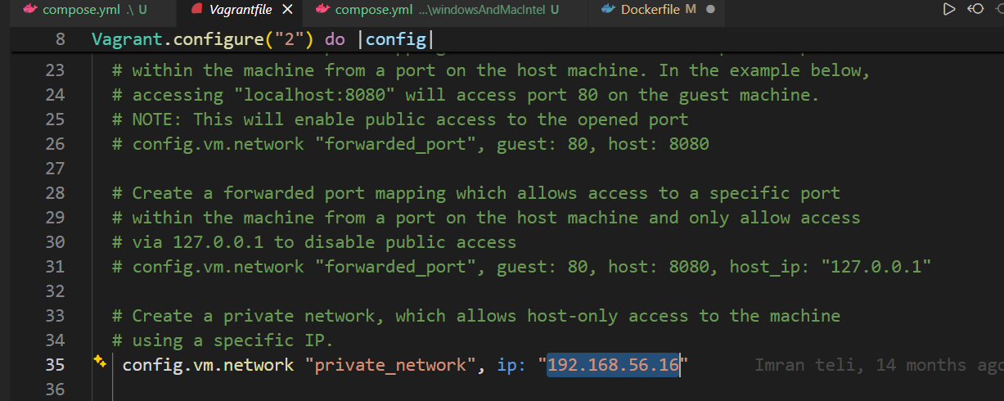
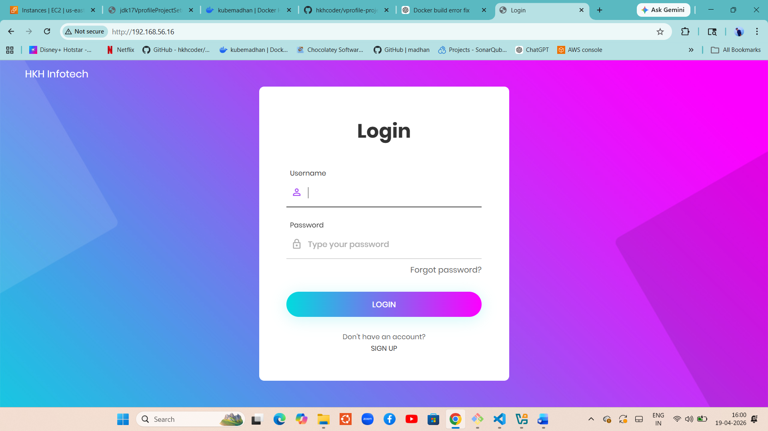
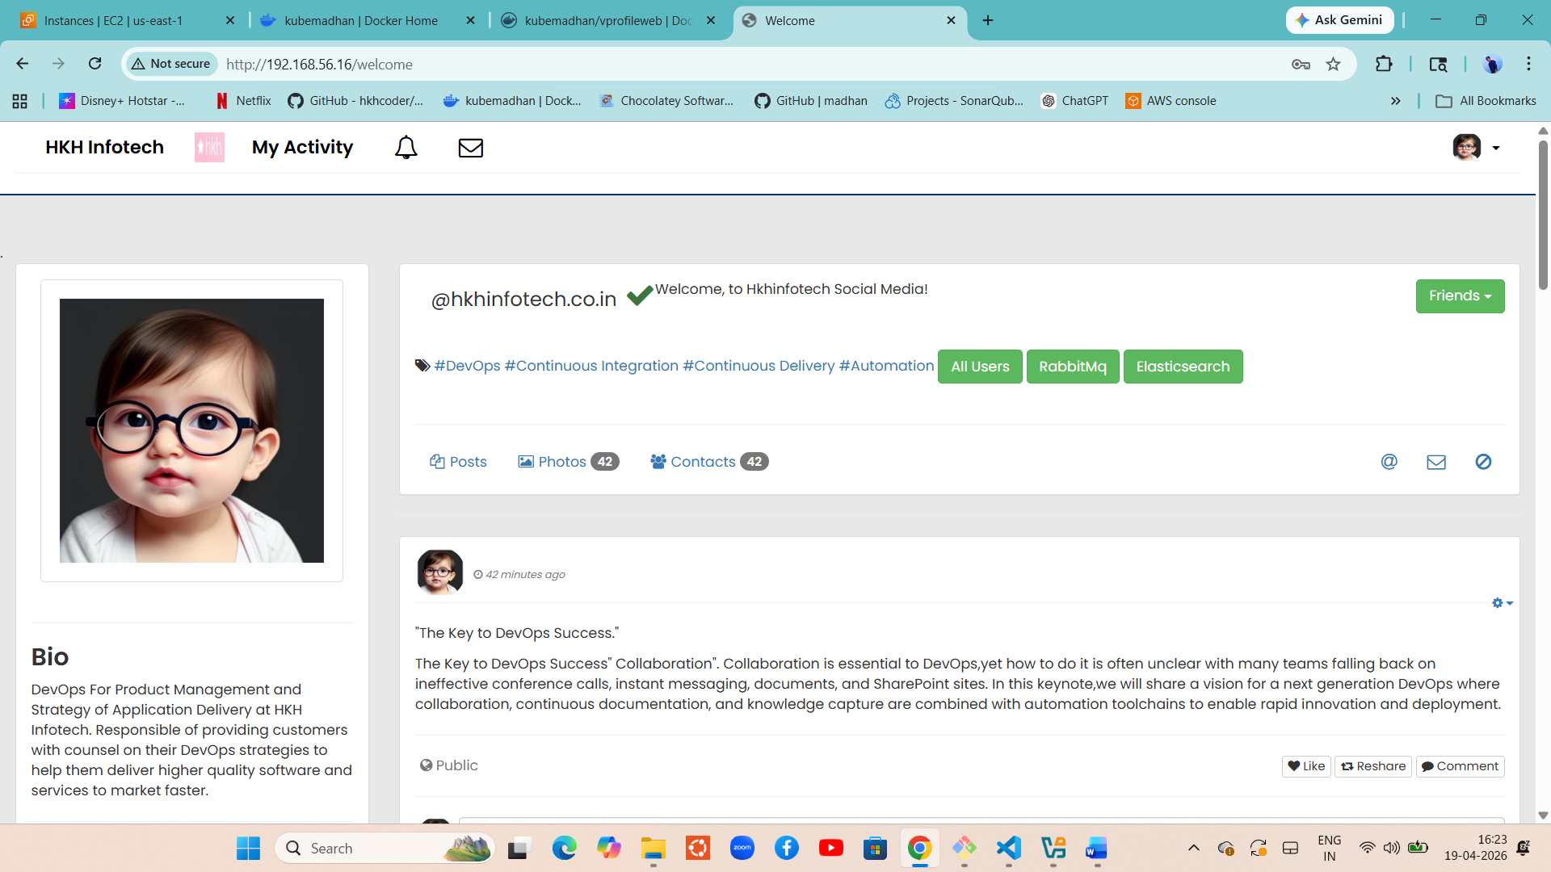

Now we will host images into docker dub

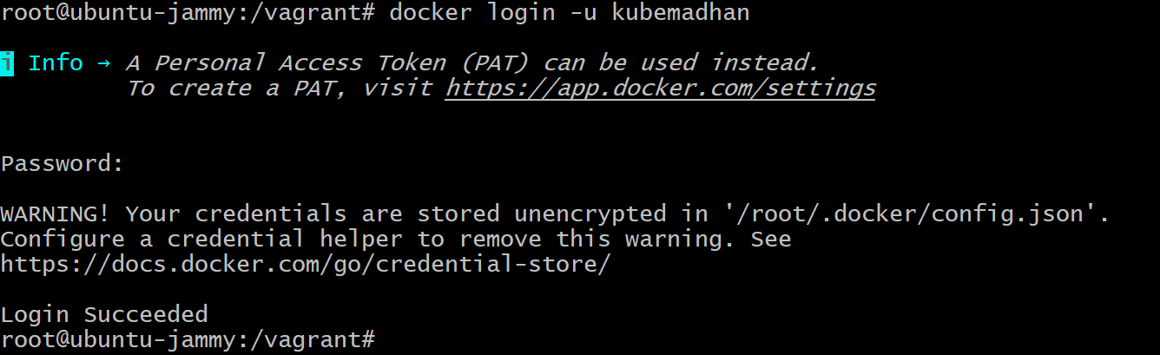

Docker push <image_name>
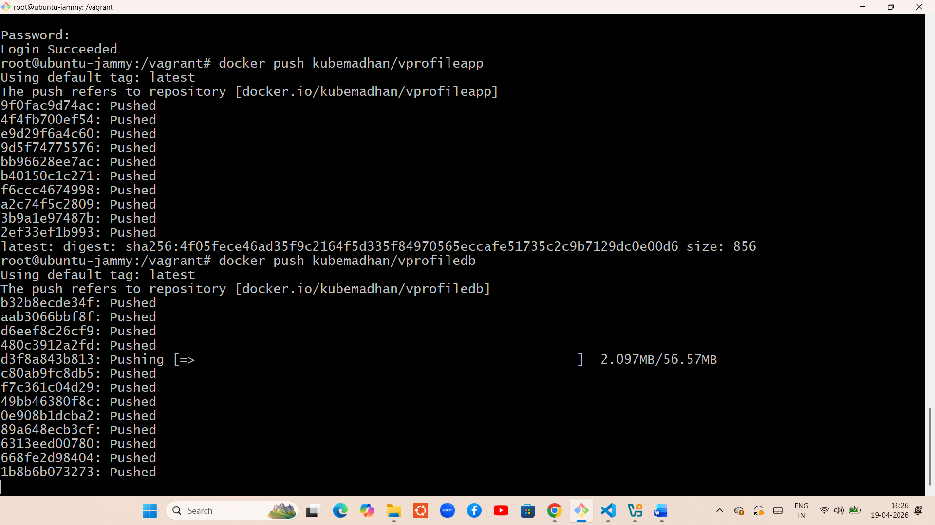

After pushed u can clean up everything
Docker compose down
Docker volume prune
Docker system prune -a
Exit and stop the vm

