GitHub Actions is a CI/CD (Continuous Integration and Continuous Deployment) tool built into GitHub. It lets you automate tasks like building, testing, and deploying your code whenever something happens in your repository (like a push or pull request).

Whenever you push code to GitHub, GitHub Actions can automatically:
- Build your project
- Run tests
- Deploy your application
- Send notifications
Key Concepts
1. Workflow
- A YAML file that defines automation steps
- Stored in: .github/workflows/
2. Event
- What triggers the workflow
Example:
  - push
  - pull_request
  - schedule
3. Job
- A group of steps that run on a machine
4. Step
- Individual task (run command or action)
5. Runner
- The machine (VM) where jobs run (Linux, Windows, macOS)
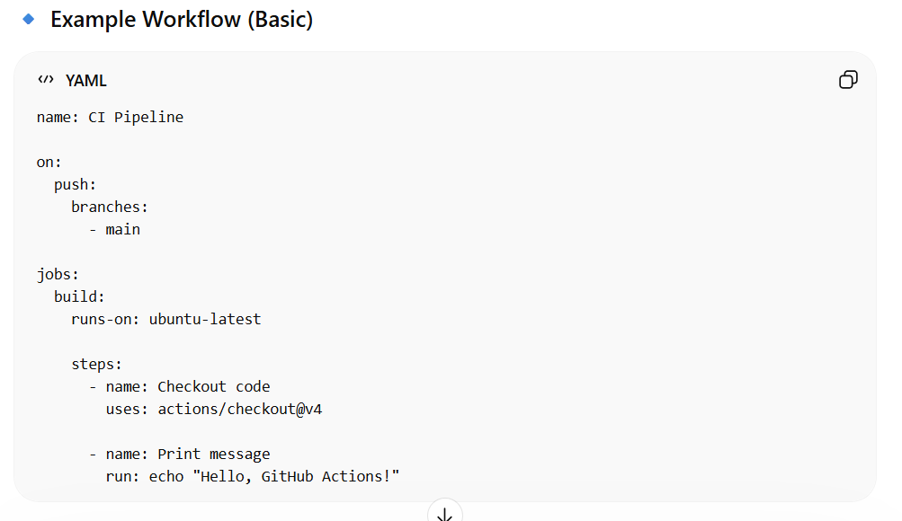

Java-app project
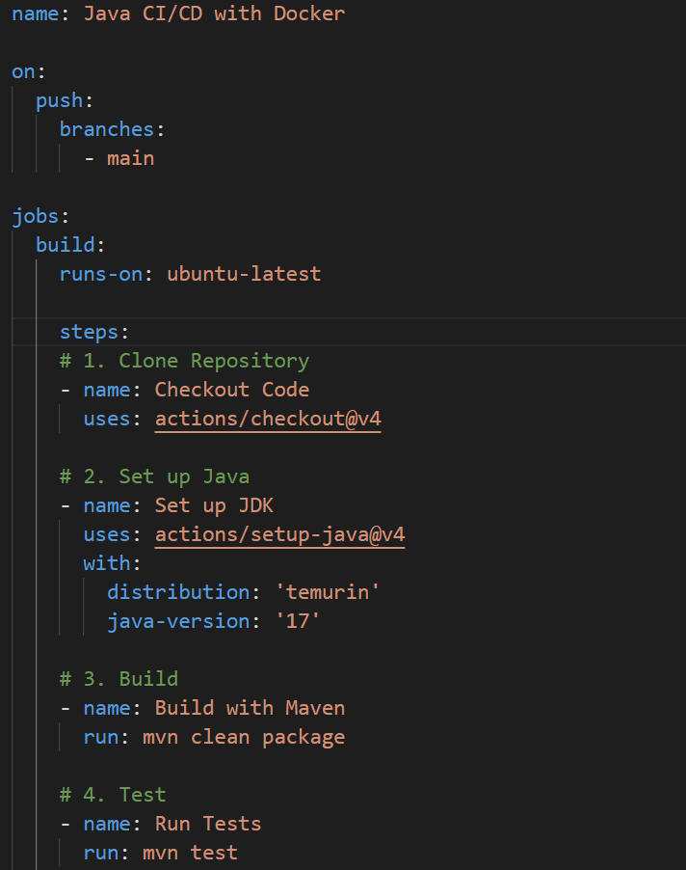
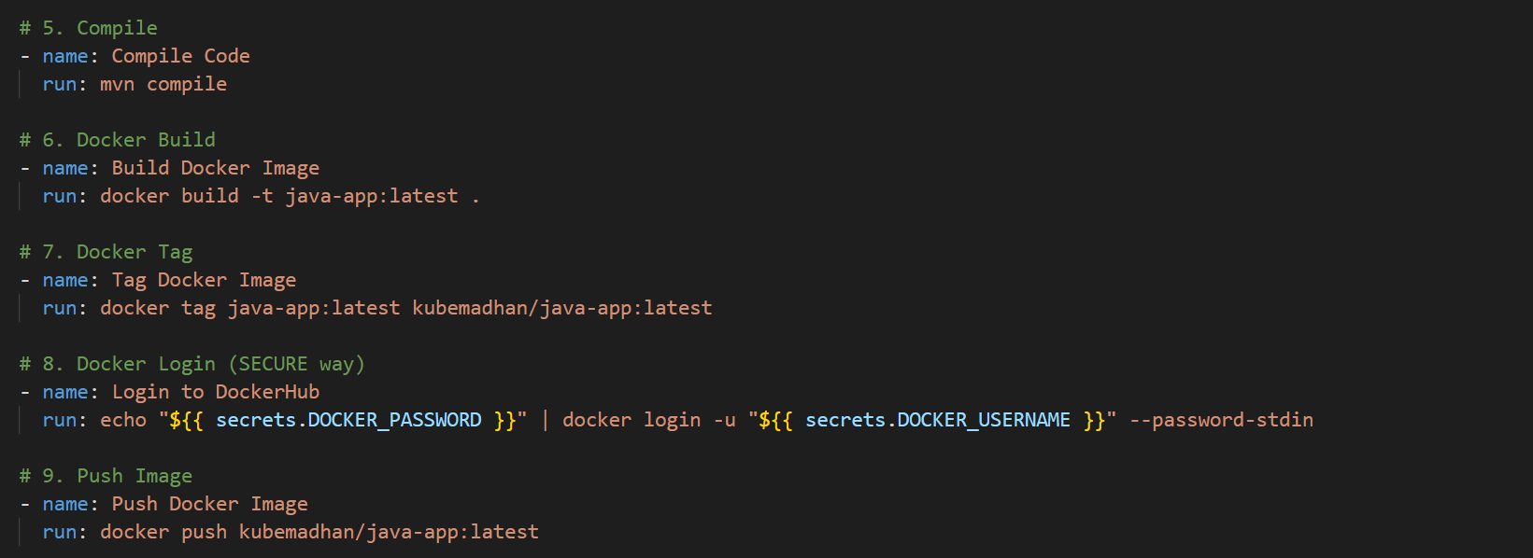

Check this path for source code
C:\Users\avala\githubactions\javaapp

