Create 1 ubuntu instance create security groupm as well (8080)

Execute below commands to install jenkins
sudo apt update
sudo apt install openjdk-21-jdk -y
java -version
(need to install jdk before installing Jenkins)
sudo wget -O /etc/apt/keyrings/jenkins-keyring.asc \
https://pkg.jenkins.io/debian-stable/jenkins.io-2026.key

echo "deb [signed-by=/etc/apt/keyrings/jenkins-keyring.asc]" \
https://pkg.jenkins.io/debian-stable binary/ | sudo tee \
/etc/apt/sources.list.d/jenkins.list > /dev/null

sudo apt update
sudo apt install jenkins -y
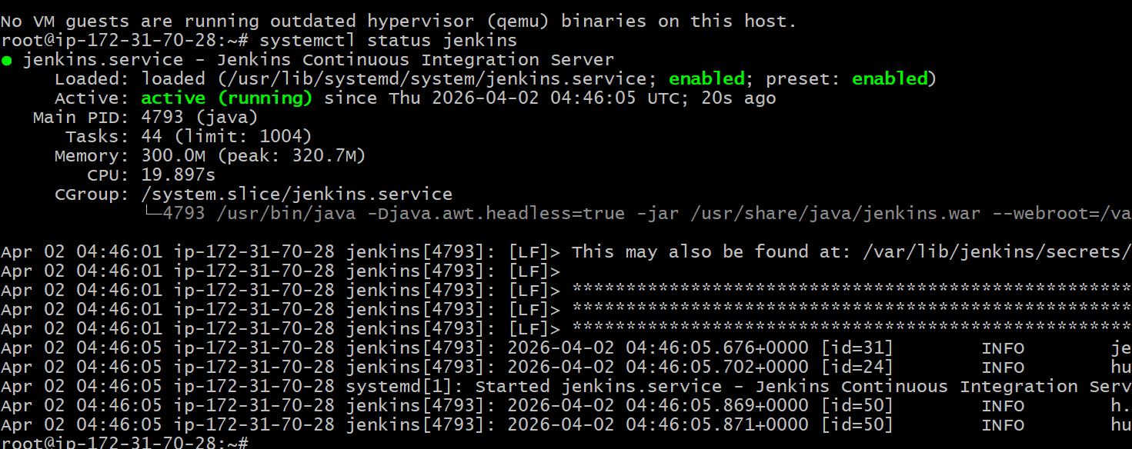

Jenkins home directory /var/lib/Jenkins
Now take public ip and paste in chrome
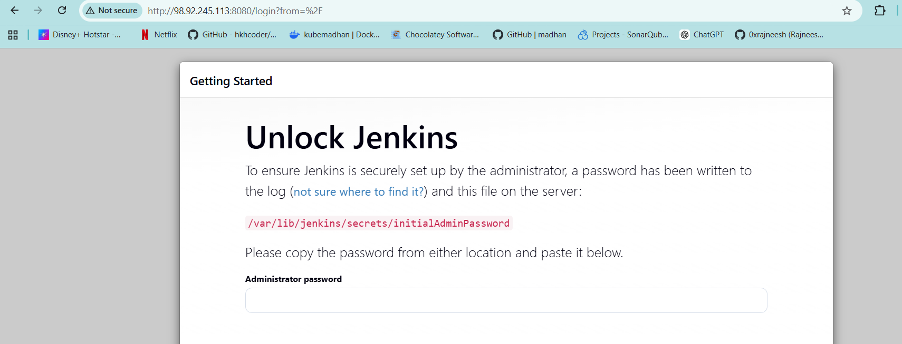
Goto the shown location and take password and launch
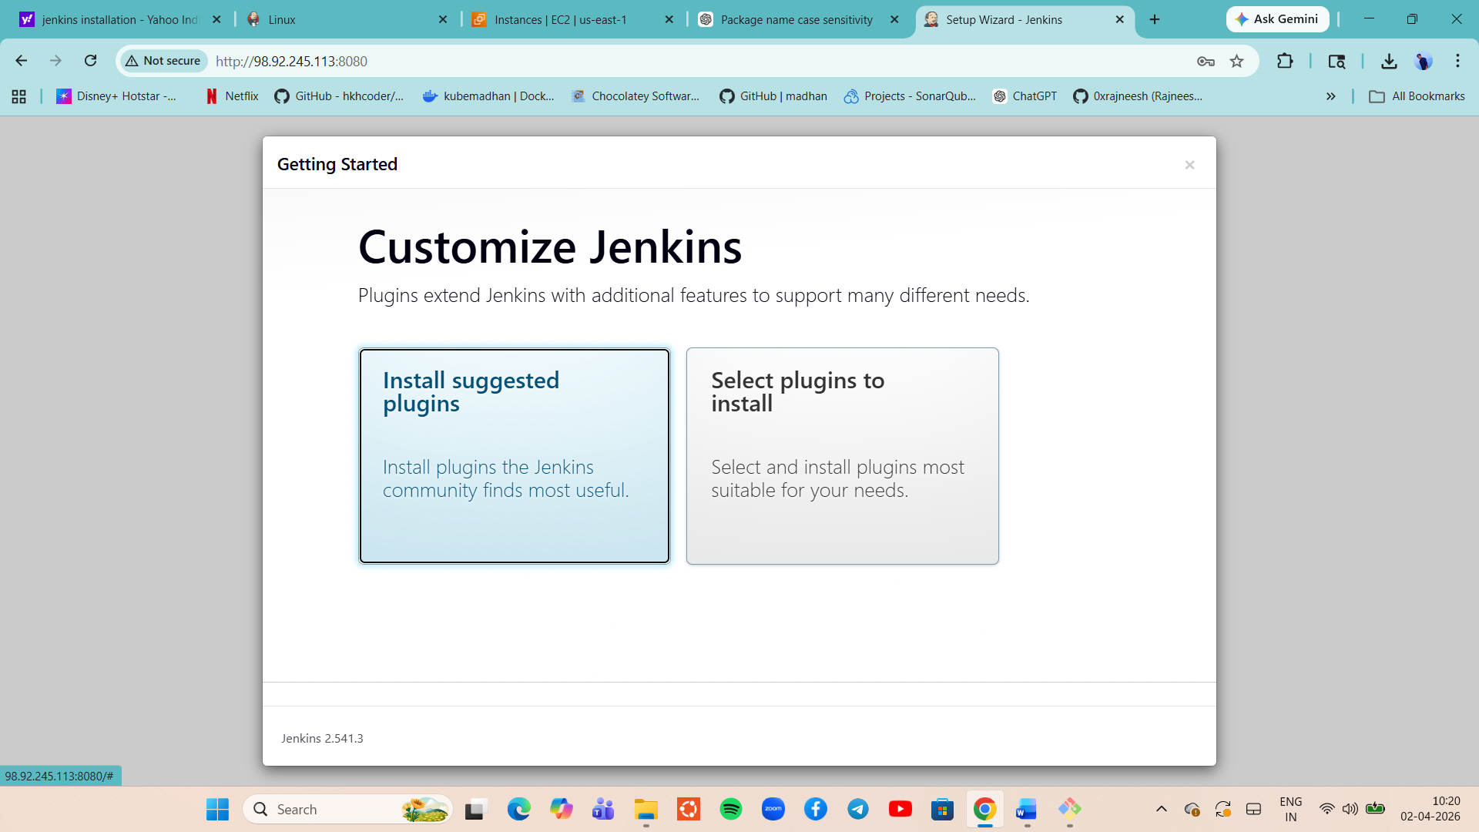

We can install lot of plugins as desired click on selcect plugins addisnally selecr nodejs
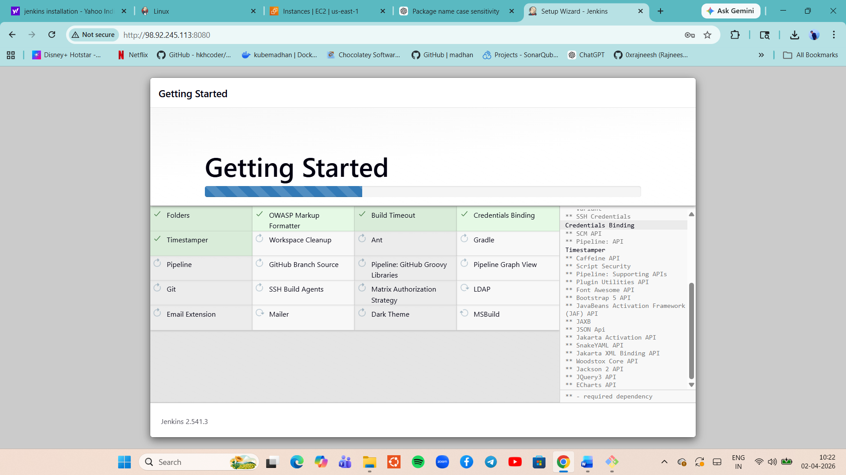
And create 1 user and chance the instance URL http://madhan.com save and start using Jenkins.
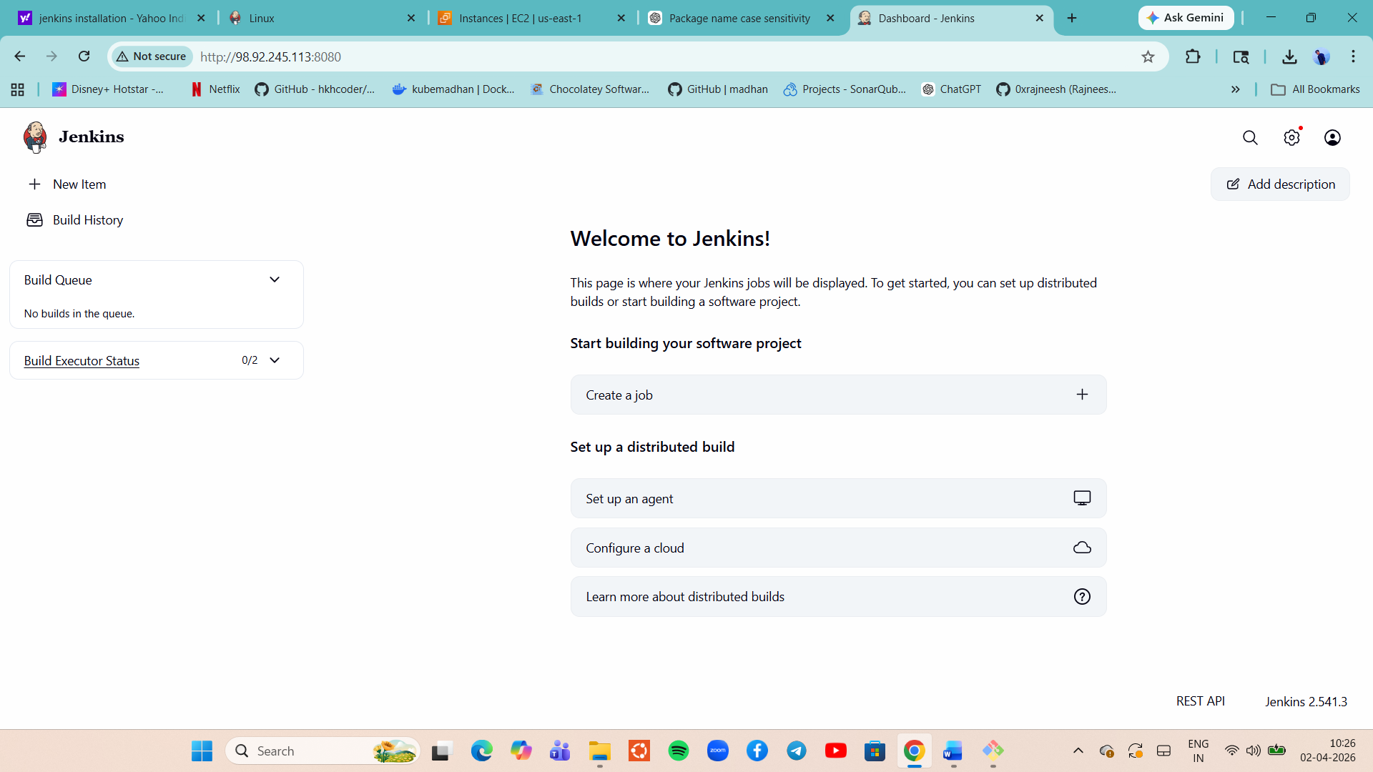

Flow:
Developer push code to git hub repo
If any code change, jenking will detech a change and fetch the code using git tool(plugin)
Code will built with maven tool, it build success it will generate artifacts(,war file)
We will conduct unit test with maven (generate reports in xml formate)
Next, code analysis with help of sonar qube(generate reports in xml formate), these reports uploaded to sonarqube server
If code passed in sonarqube, we have a verifird copy of the artifact. Now we can deploy the artifct to servers, before deploying we will version the artifacts will be uploades to nexus sonartype repo.

In Jenkins we create jobs , nothing but workloads.
2 types: 1. freestyle jobs 2.pipekine as a code.

Tools in Jenkins
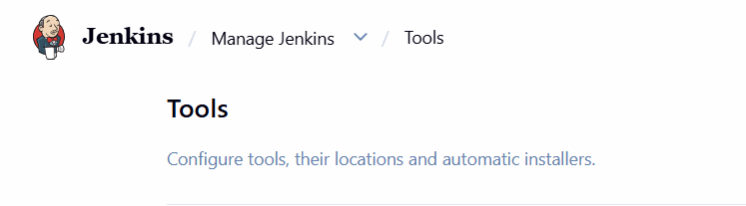

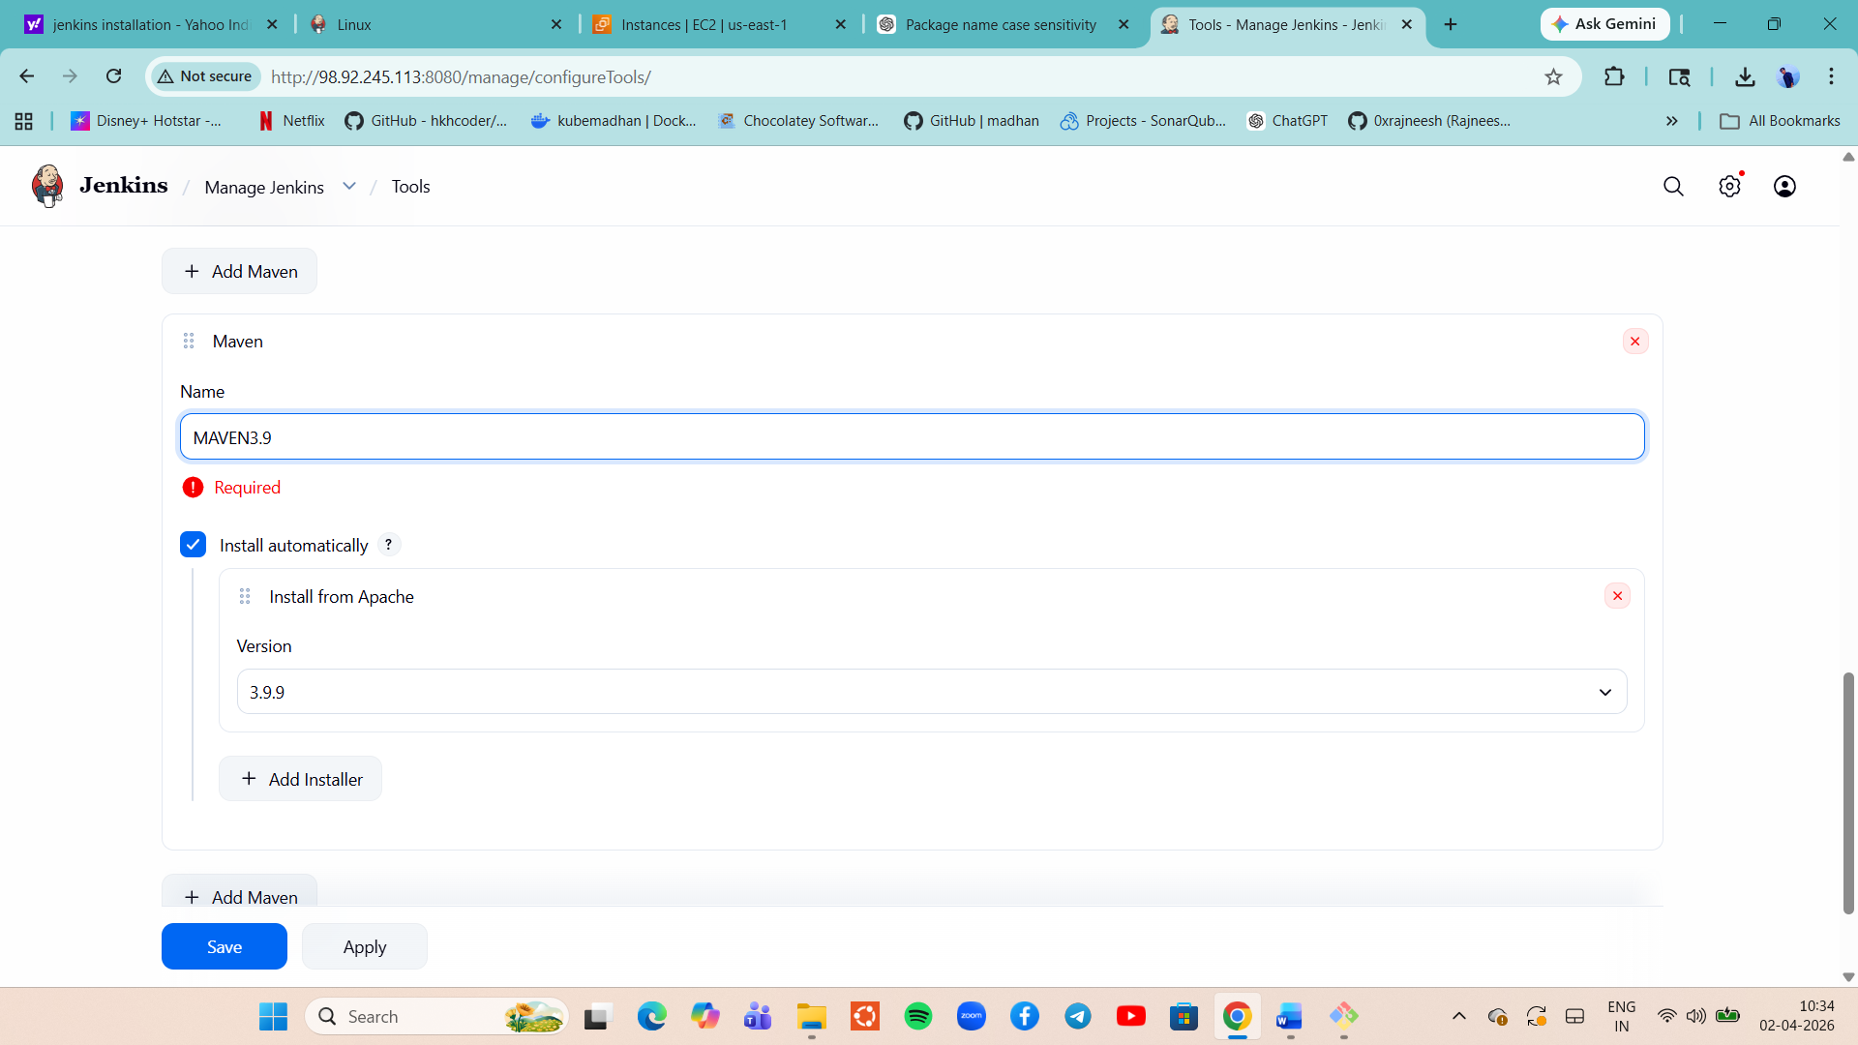
Add jdk as well
apt install openjdk-17-jdk -y (in Jenkins instance)
ls /usr/lib/jvm

/usr/lib/jvm/java-17-openjdk-amd64 (plca this path over ther if u need add jdk as well) under tools
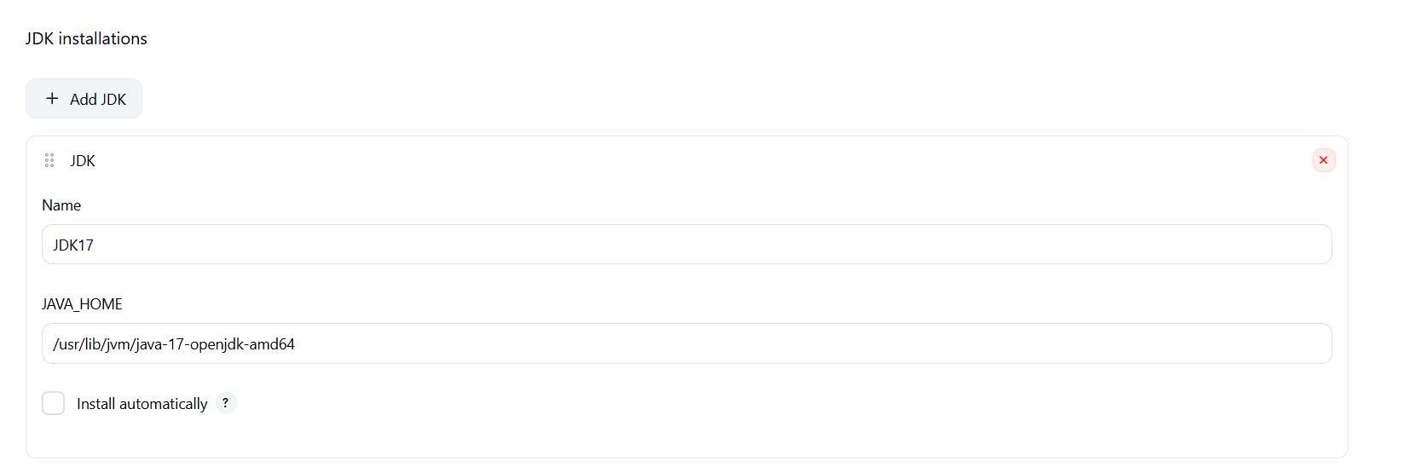
And save it.
Creating First JOB. (set of instructions )
A job is basically a task or process that Jenkins runs automatically.
Think of it like:
- A script
- A build process
- A pipeline
- Or any automated workflow

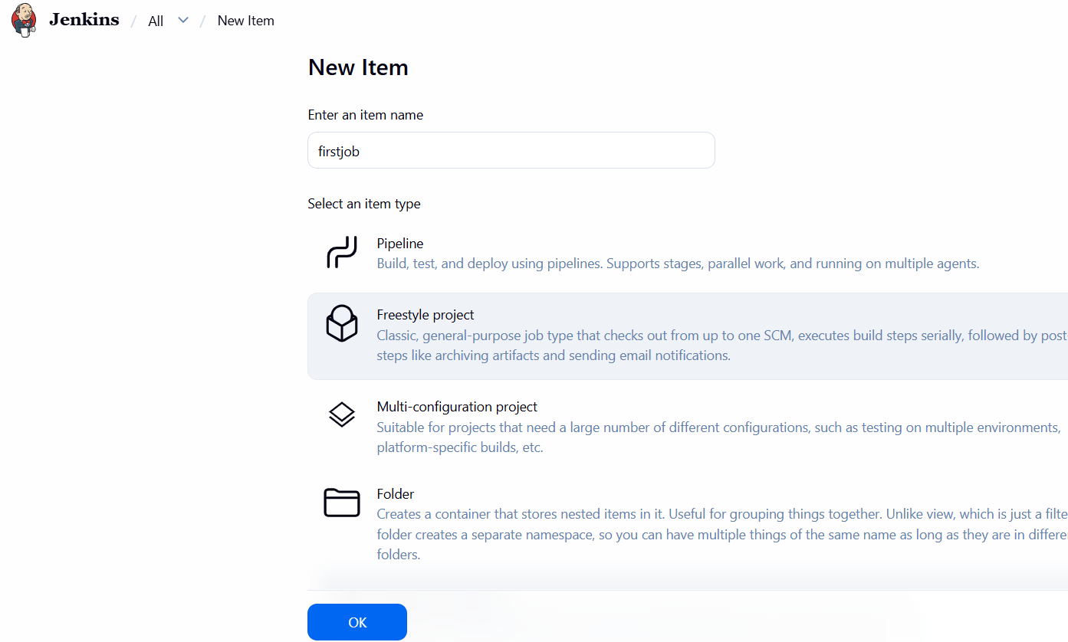
Give name and selct free-style project.
add desc and add build steps
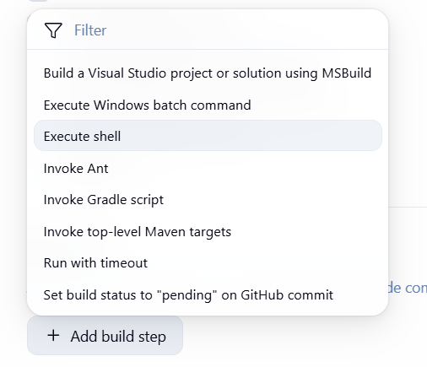
Select execute shell an dadd few commads and save it.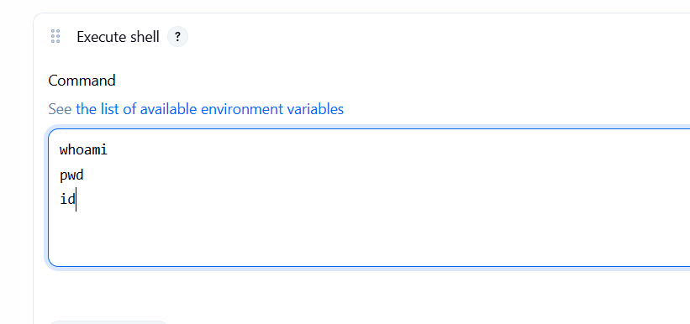
If u click on buildnow it will work
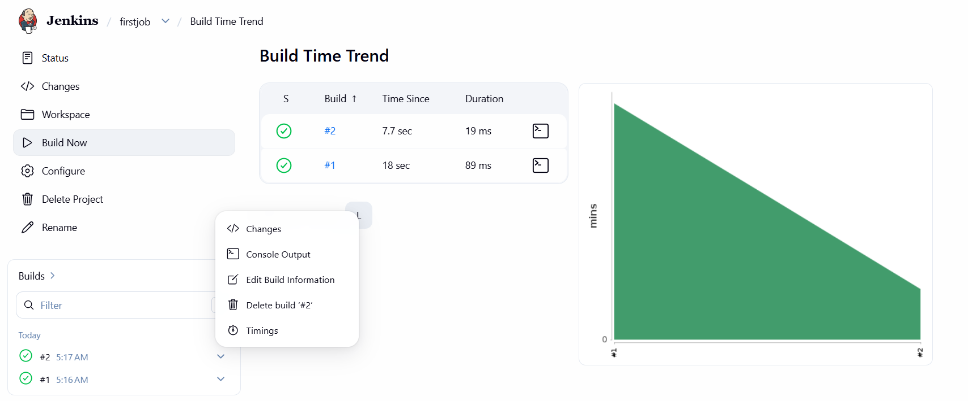
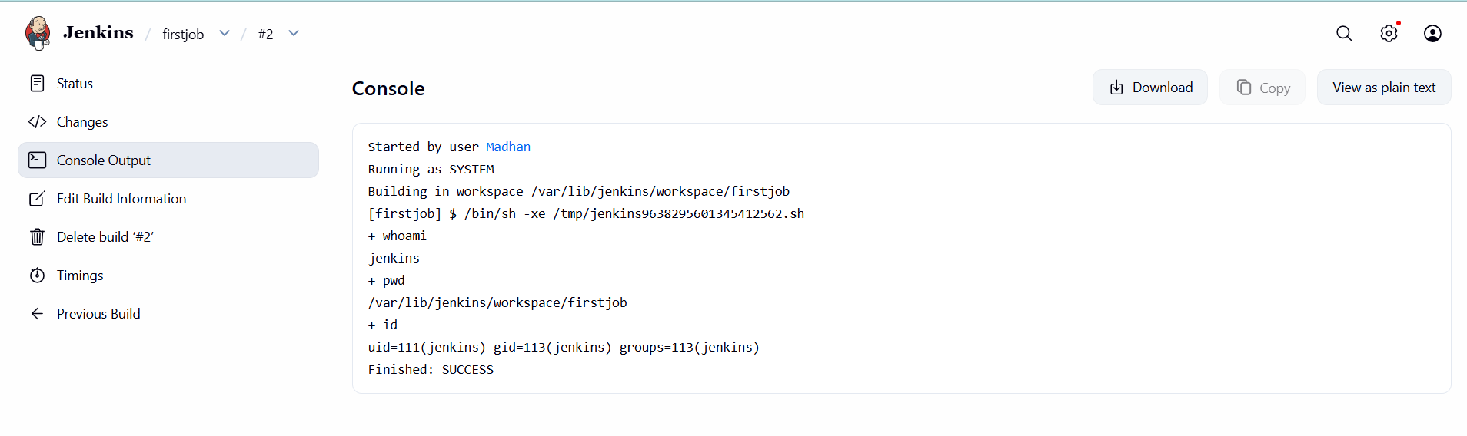
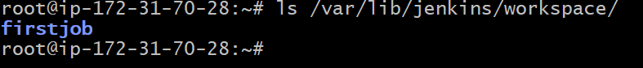

First build job.( we will fetch source coce and bulit the code and archive the arifcact)

Add jdk in tools as 21
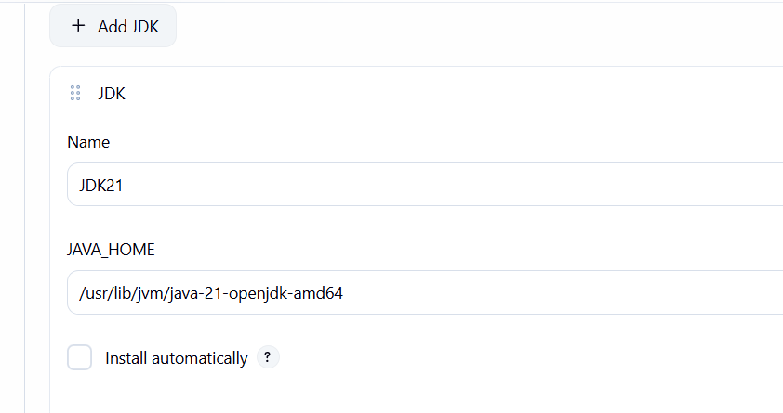
Create new item and add name as vprofile and select jdk version

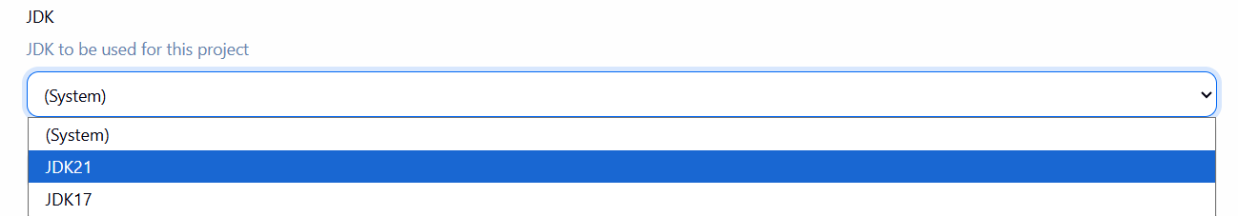
Select git in Source Code Management
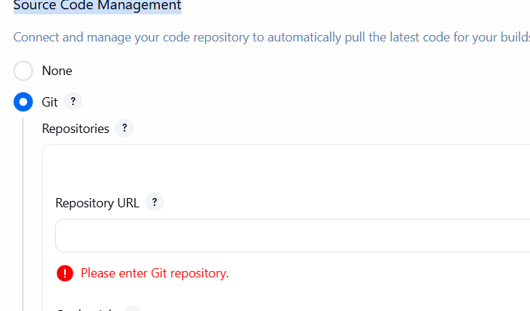
Give necessary info
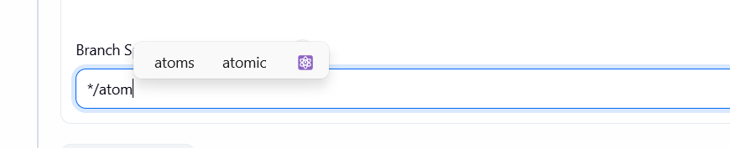

Select invoke top level maven target or u can selcet execute shell and write all commands
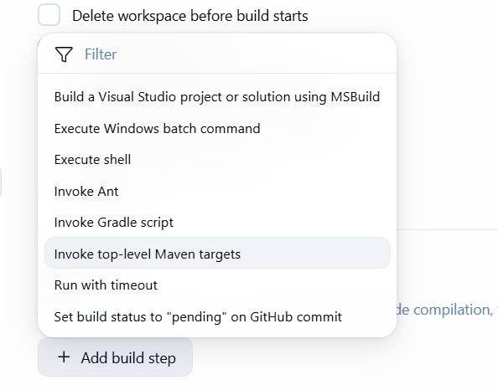
Goals install and save it.
Now click on build now option , built will start now.
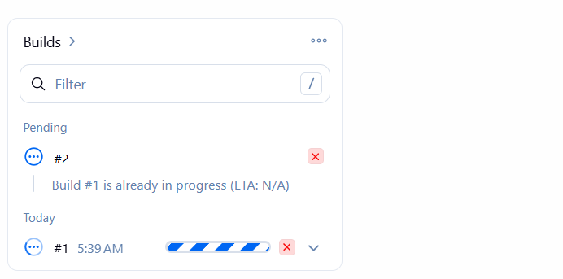
So, buitt will success nad .war will found under target folder.

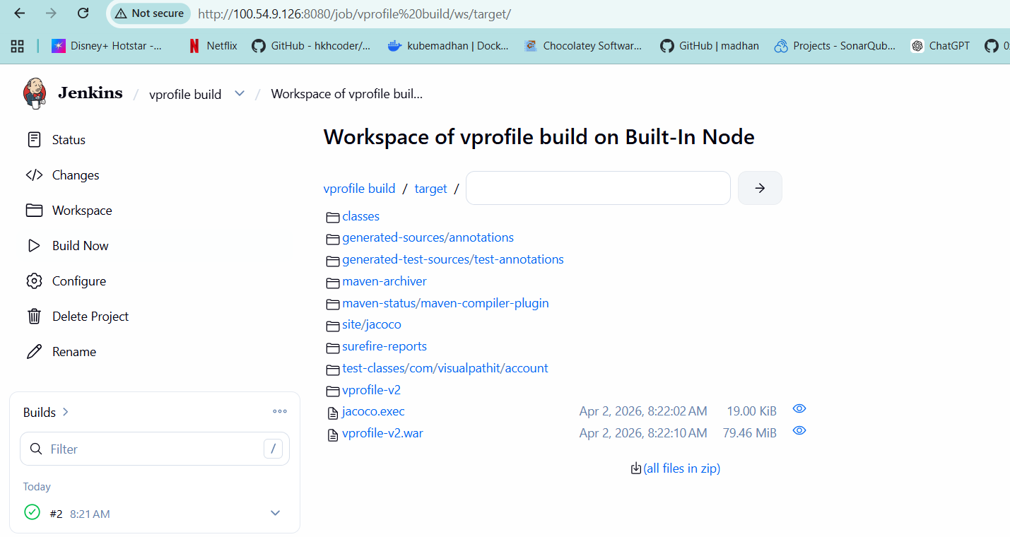

Plugins in jenkins
First install s3 plugin. We have to move the artifact to s3 bucket
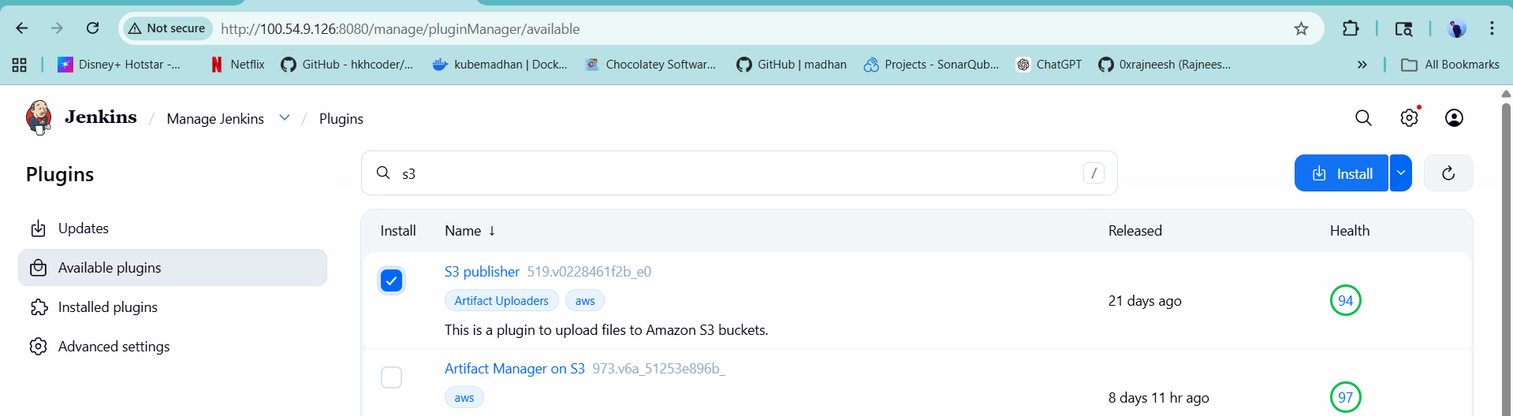

We need to setup few instances to execute the flow
- Jenkins setup( we have already)
- Nexus setup
- Sonarqube setup
- Security group
- Plugnis (nexu, sonarqube, )
- Integrate nexu and sonarcube
- Write pipeline script.
- Set notification
In vprofile build configure add post-build action select s3 bucket
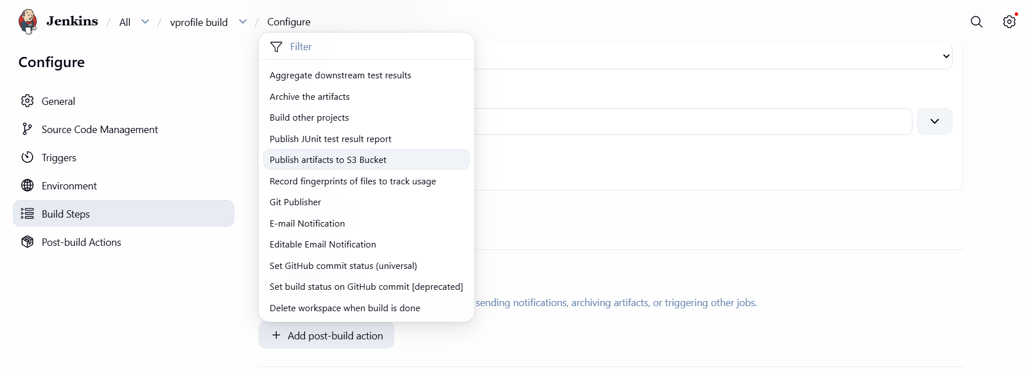

Setting up nexus (amzon linuz) and sonarqube(ubuntu) on ec2 instance
(on branch atom uhave .sh files for provisioning)
For nexus setup added additional secutity group jenking-sg as 8081 add userdats from .sh file and launch instance

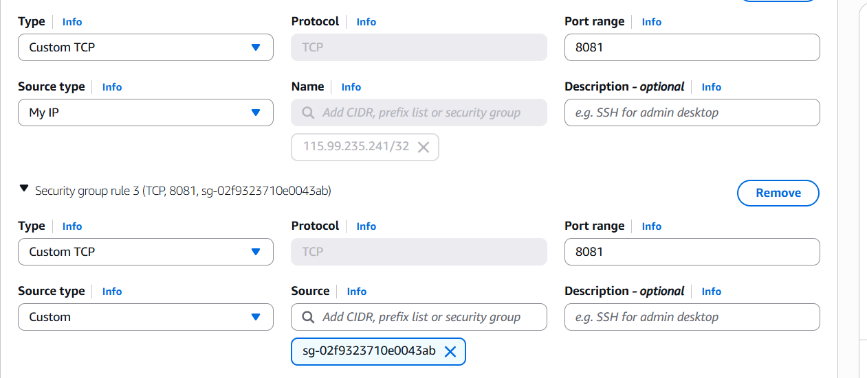

For sonarqube instance
Add Jenkins-sg as port 80
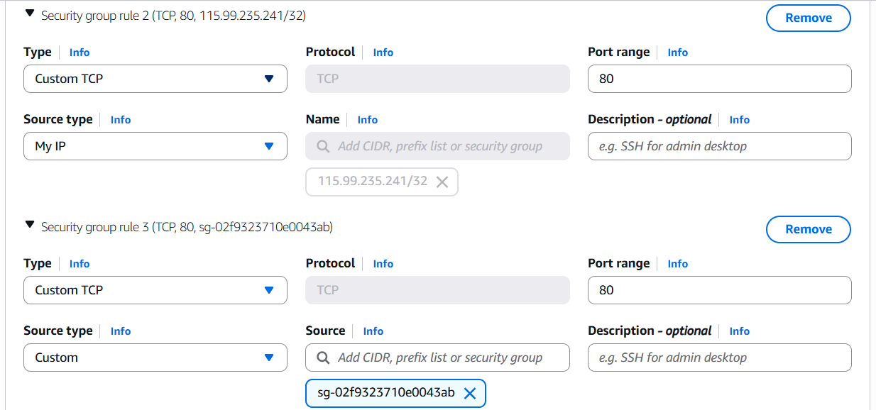
Copy .sh and add to usersdata and launch instance.

