It’s a orchestration to handles running apps in ur container.
By default Kubernetes it’s a cluster , group of nodes
Kubernetes (often shortened to K8s) is an open-source system for automating the deployment, scaling, and management of containerized applications.

🧠 What it actually does
Think of Kubernetes as a control system for your apps running in containers (like Docker). Instead of manually starting, stopping, and monitoring containers, Kubernetes handles it for you.

Master and node components:

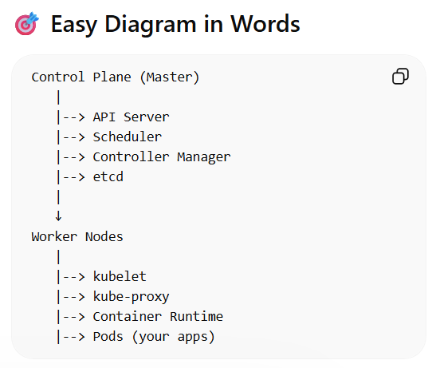
1. Control Plane (Master Components)
The control plane manages the entire cluster — it makes decisions and keeps everything in the desired state.
🔑 Key Components
1. API Server (kube-apiserver)
- Entry point to Kubernetes
- All commands (kubectl, UI, automation tools) go through this
- Validates and processes requests
👉 Think: Front door of Kubernetes

2. etcd
- Key-value database
- Stores cluster state (pods, services, configs, secrets)
👉 Think: Brain memory (database)

3. Scheduler (kube-scheduler)
- Decides which node a pod should run on
- Considers CPU, memory, policies, etc.
👉 Think: Task assigner

4. Controller Manager (kube-controller-manager)
- Runs controllers that maintain desired state
- Examples:
  - Node Controller (checks node health)
  - Replication Controller (ensures correct pod count)
👉 Think: Automation engine (keeps things running correctly)

🖥️ 2. Worker Node Components
Worker nodes are where your actual applications run.
🔑 Key Components
1. Kubelet
- Agent running on each node
- Talks to API Server
- Ensures containers are running as expected
👉 Think: Node supervisor

2. Container Runtime
- Software that runs containers
- Examples:
  - Docker
  - containerd
  - CRI-O
👉 Think: Engine that runs containers

3. Kube Proxy (kube-proxy)
- Manages networking rules
- Handles communication between pods and services
👉 Think: Network traffic manager

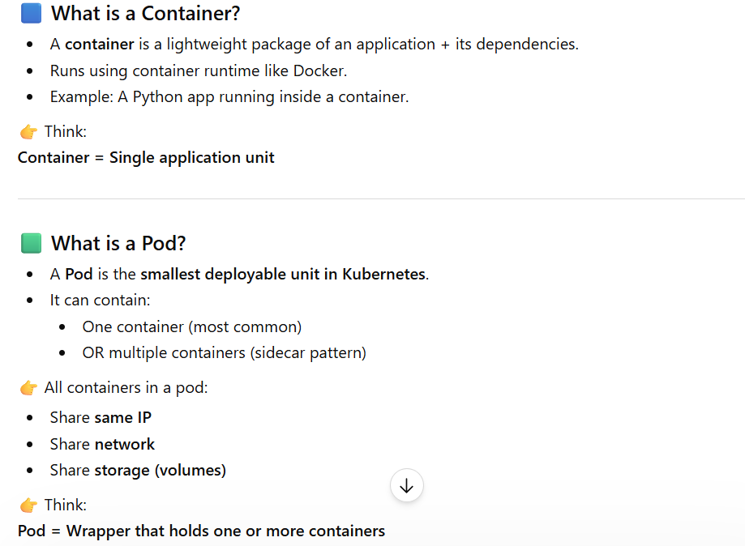

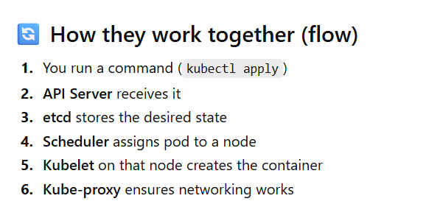
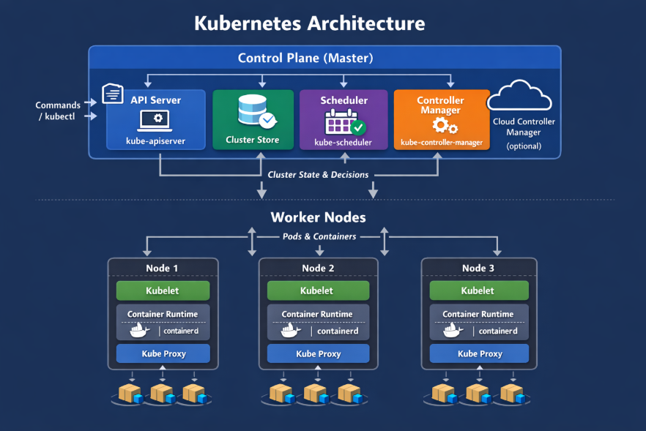
An overlay network is a virtual network built on top of an existing physical network. In Kubernetes, it allows pods across different nodes to communicate as if they are on the same network.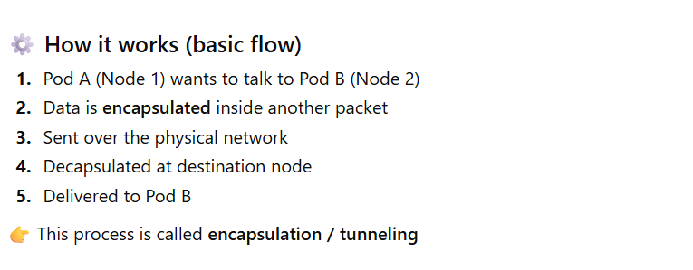
Hands-on

Setting up kubernites cluster in aws instance with help of minikube
Launch ec2 instance and install minikube, kubectl and docker in it
curl -LO https://github.com/kubernetes/minikube/releases/latest/download/minikube-linux-amd64
sudo install minikube-linux-amd64 /usr/local/bin/minikube && rm minikube-linux-amd64
sudo apt update
sudo apt install -y docker.io
sudo systemctl start docker
sudo systemctl enable docker
sudo usermod -aG docker $USER
newgrp docker
docker --version
docker ps

minikube start --driver=docker
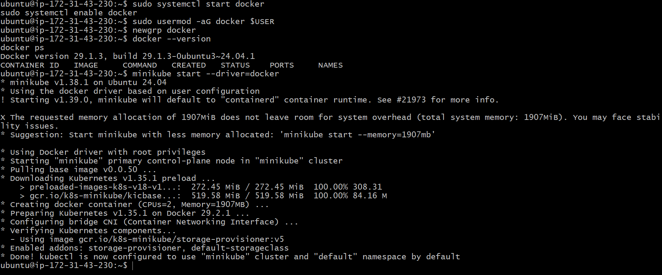
Kubectl get nodes
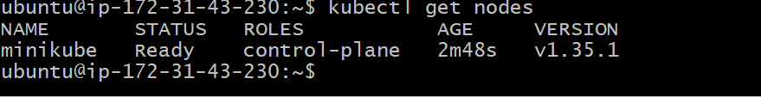

Now we can run pods init
Take one yaml file and make 1 yaml file
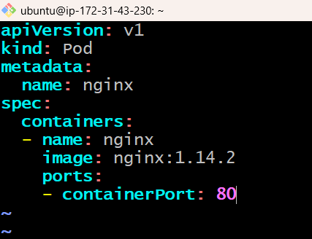

Kubectl create -f pod.yml
Kubectl get pods
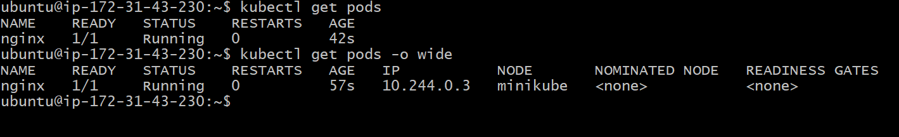
Minikube ssh (to connect to the cluster)
Curl <ip>
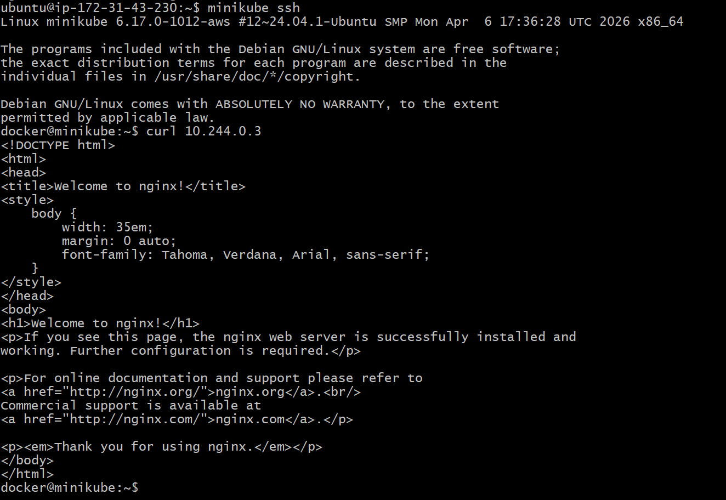

Setting up kubernites cluster in aws instance with help of kops.
Launch 1 ubuntu instance and follow below steps
Create 1 aws role and attach to this instance with below access:

AmazonEC2FullAccess
AmazonRoute53FullAccess
AmazonS3FullAccess
IAMFullAccess
AmazonVPCFullAccess
AmazonSQSFullAccess
AmazonEventBridgeFullAccess

Install AWS CLI:

sudo apt update
sudo apt install unzip curl -y

curl "https://awscli.amazonaws.com/awscli-exe-linux-x86_64.zip" -o "awscliv2.zip"
unzip awscliv2.zip
sudo ./aws/install
aws –version

install kops:
curl -Lo kops https://github.com/kubernetes/kops/releases/latest/download/kops-linux-amd64
chmod +x kops
sudo mv kops /usr/local/bin/

instal kubectl:
curl -LO https://storage.googleapis.com/kubernetes-release/release/$(curl -s https://storage.googleapis.com/kubernetes-release/release/stable.txt)/bin/linux/amd64/kubectl

chmod +x kubectl
sudo mv kubectl /usr/local/bin/

check both version:
kubectl version --client
kops version

aws configure the access key for the root aws user:
aws configure

create 1 s3 bucket:
aws s3 mb s3://devopsengg2028.k8s.local

enable versioning:
aws s3api put-bucket-versioning \
--bucket devopsengg2028.k8s.local \
--versioning-configuration Status=Enabled

Set env variable and echo it:
export NAME=devopsengg2028.k8s.local
export KOPS_STATE_STORE=s3://devopsengg2028.k8s.local
echo "export NAME=devopsengg2028.k8s.local" >> ~/.bashrc
echo "export KOPS_STATE_STORE=s3://devopsengg2028.k8s.local" >> ~/.bashrc
source ~/.bashrc
cross-check:
echo $NAME
echo $KOPS_STATE_STORE

generate ssh key:
ssh-keygen -t rsa -b 4096

create cluster:
kops create cluster \
--name ${NAME} \
--zones us-east-1a \
--control-plane-size t3.medium \
--control-plane-count 1 \
--node-size t3.small \
--node-count 2 \
--node-volume-size 20 \
--control-plane-volume-size 20

Create secret for ssh connectios:

kops create secret \
--name ${NAME} sshpublickey admin \
-i ~/.ssh/id_rsa.pub

Deploy cluster:
kops update cluster ${NAME} --yes

validate cluster:
kops validate cluster
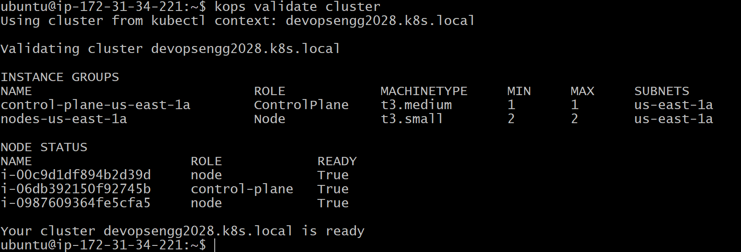

configure kubectl:
kops export kubecfg ${NAME} --admin

check clusters:
kubectl get nodes
kubectl get pods -A
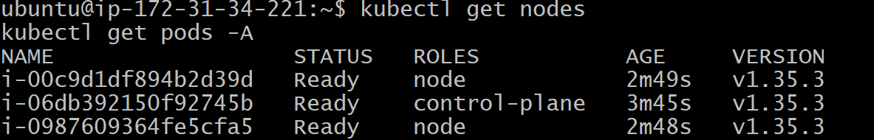
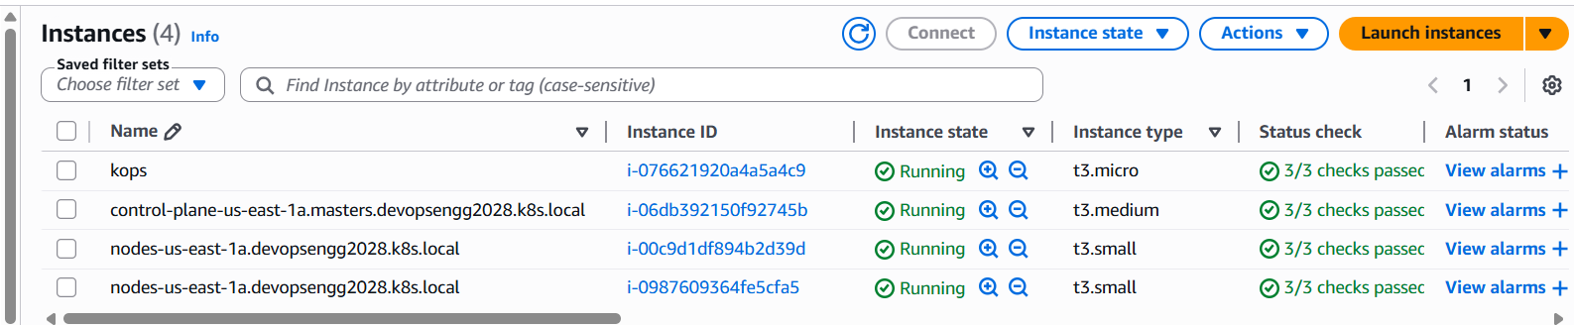
All instance have launched succes

deleting cluster:
kops delete cluster ${NAME} –yes

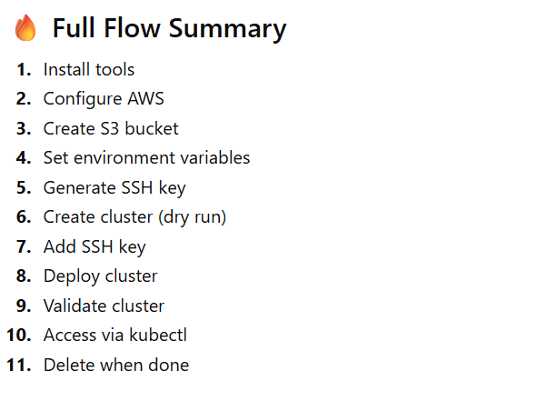

A Kubeconfig file (commonly called kubeconfig) is the configuration file used by Kubernetes tools like kubectl to connect to a cluster.
we can aces the cluster from our base machine if we have kubeconfig file along with kubectl.
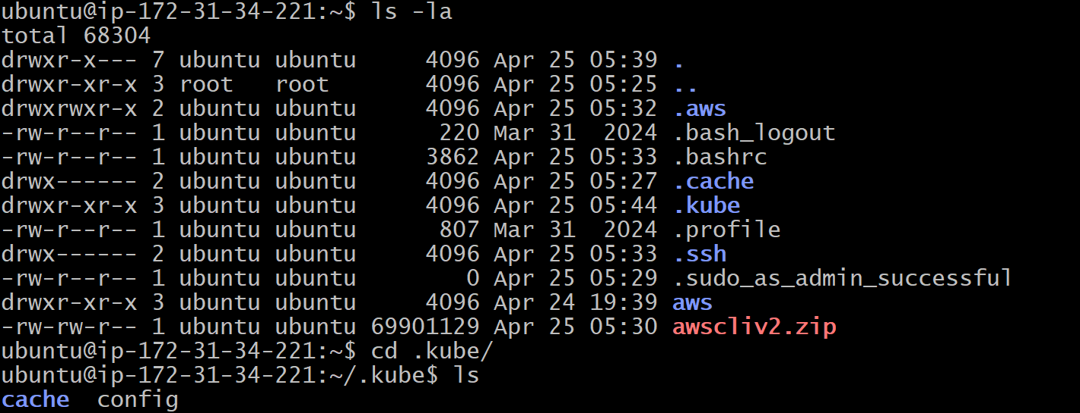

Pods: In Kubernetes, a Pod is the smallest and simplest deployable unit.
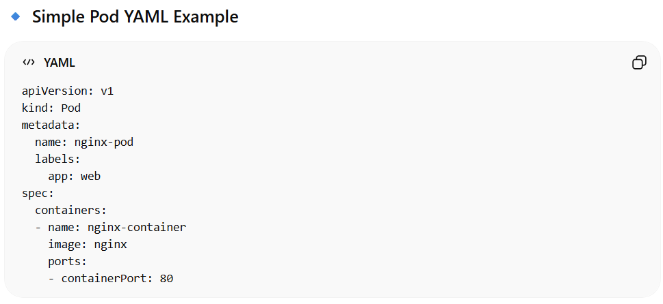

kubectl apply -f pod.yaml
kubectl get pods
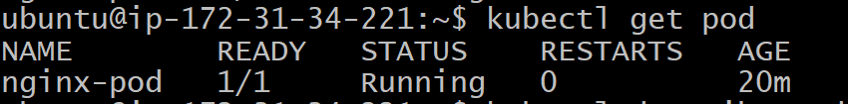
kubectl describe pod <pod_name>
kubectl logs nginx-pod
kubectl delete pod <pod_name>

Namespace:
A Namespace is a way to logically divide a Kubernetes cluster into multiple virtual environments.

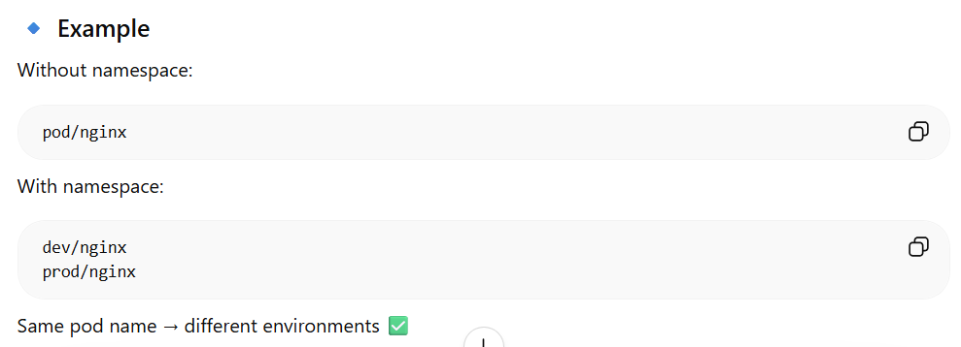
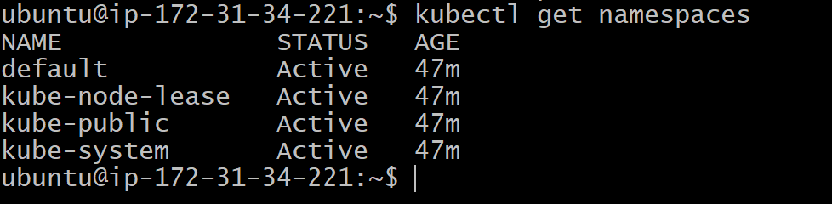

Service:
Expose ur pod, it is similar to load balancers
In Kubernetes, a Service is used to expose your Pods and make them accessible—either inside the cluster or from outside.
Created one service alng with pod
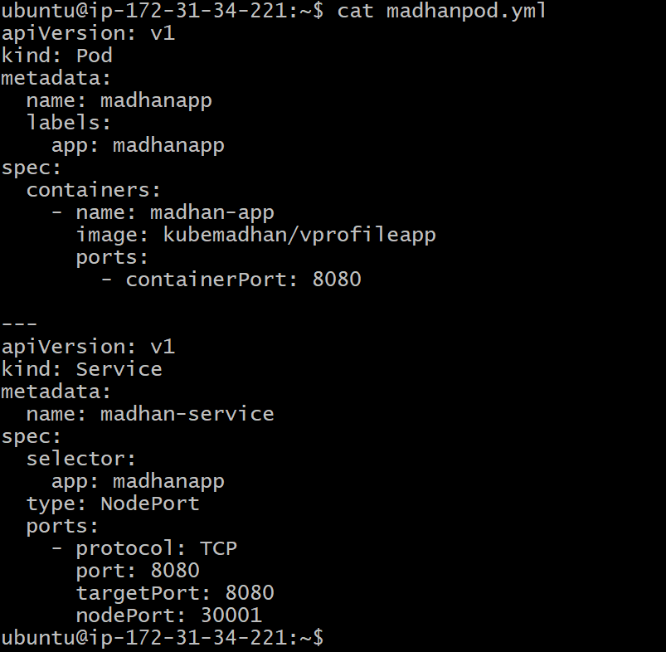

Kubectl apply -f <file_name.yml>
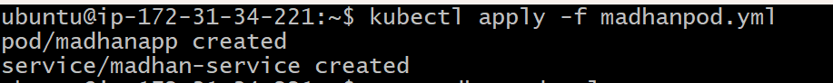
Kubectl get svc
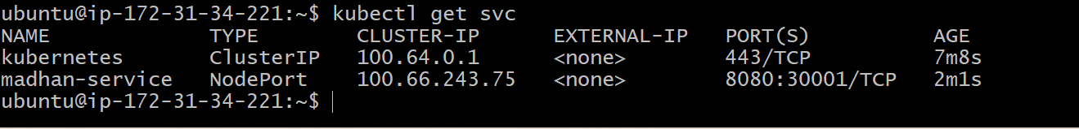
Now u can access anu worker node ip via browser to access the website through nodeport
Before that chage the security group to all traffic from my ip

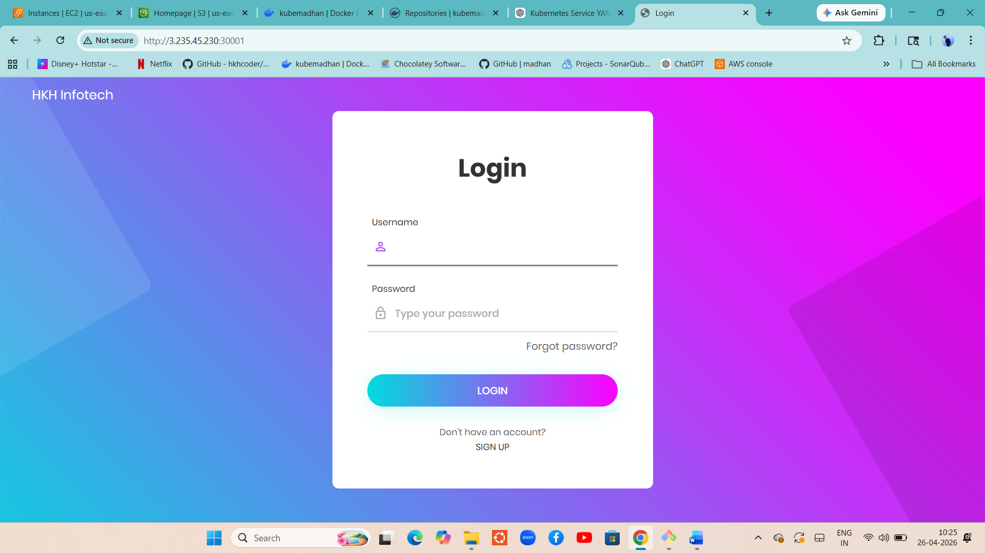

And cleane everything
Kubectl get all
Kubecle delete
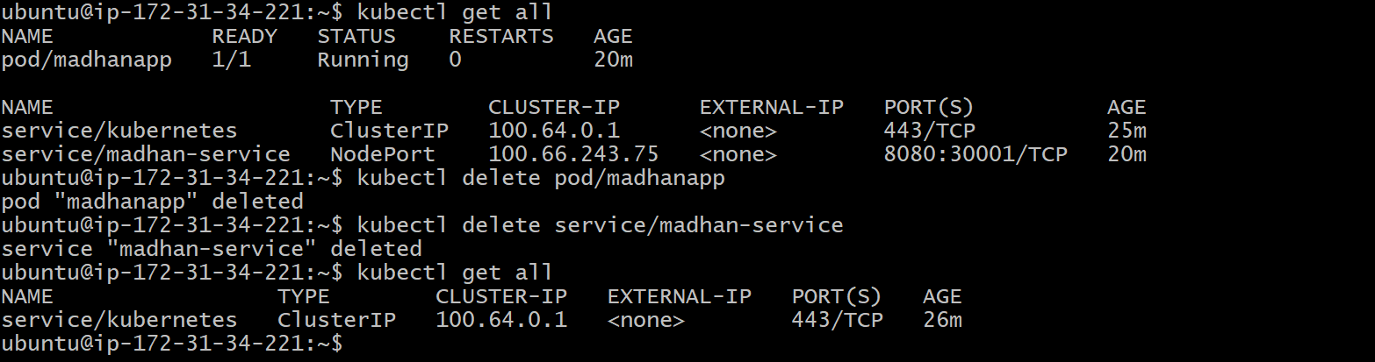

Replica set:
Maintain replica of pod
In Kubernetes, a replica means multiple identical copies of a Pod running at the same time to ensure availability and scaling.

Create 2 repicat yaml file
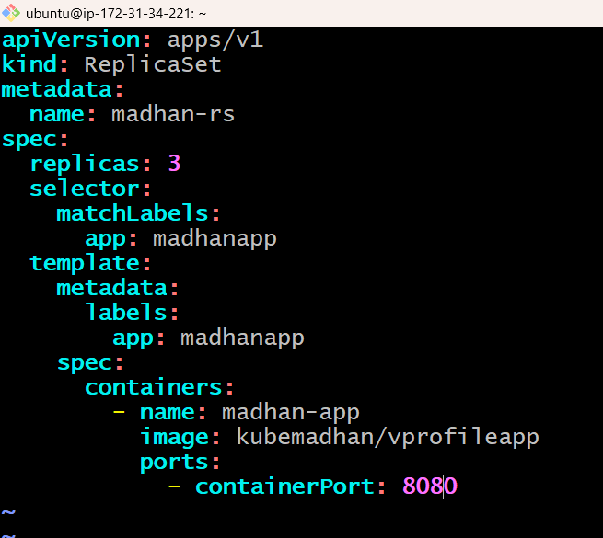
Apply it
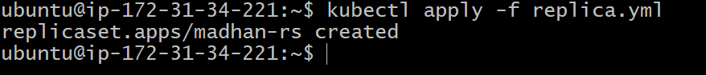
Check pods of 3
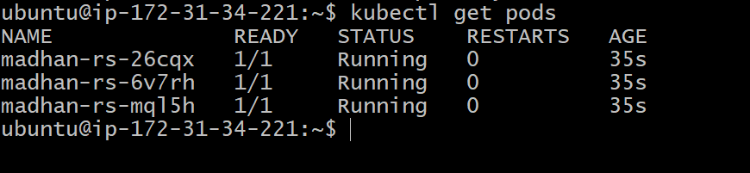
Deletye 1 pod now an will check if replicat replace it
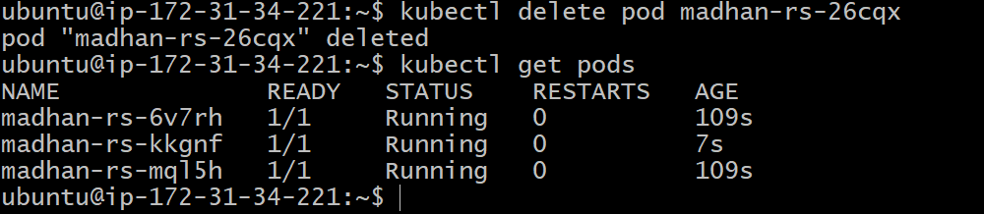
After deleting new pod is created with help of replica
Now delete the replicaset
Kubectl delete rs madhan-rs
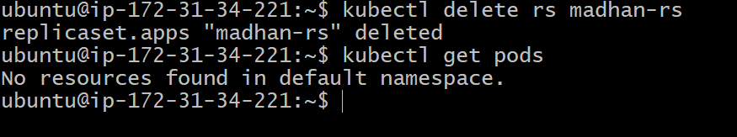

Deployments:
A Deployment in Kubernetes is the most commonly used resource to run applications. It manages your Pods automatically using ReplicaSets and gives you features like scaling, updates, and rollback.

Create 1 deployment.yml file
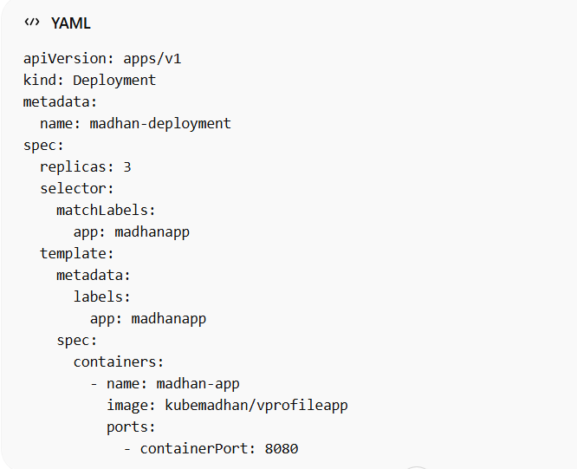

It created 3 deploys and replicasret
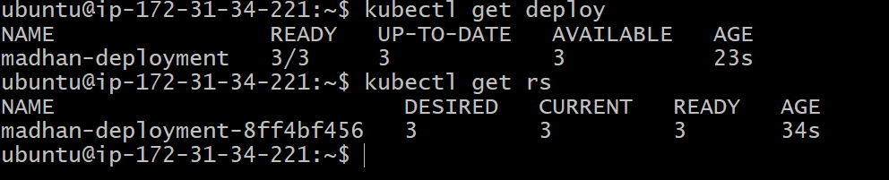
Scalling
kubectl scale deployment madhan-deployment --replicas=5
rolling updates
kubectl set image deployment/madhan-deployment madhan-app=nginx
Image changed to nginx
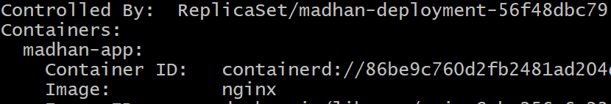

roll back
kubectl rollout undo deployment madhan-deployment
Back to my vprofile image
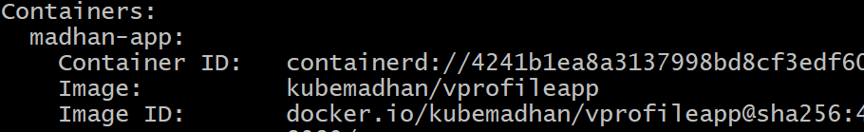
To delete the deployment
Kubectl delete deploy madhan-deployment
All were deleted
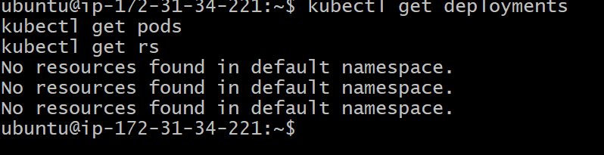

Volumes in Kubernetes (Kubernetes)
In Kubernetes, a volume is a way to provide persistent or shared storage to containers inside a Pod.
By default:
- Containers are ephemeral (data is lost when container restarts)
- Volumes solve this by storing data outside the container filesystem
Config maps:
Collections of variable and we can inject those variable into pods.
“ConfigMap is used to externalize application configuration in Kubernetes so containers remain portable and reusable.”
🔐 Secrets in Kubernetes
In Kubernetes, a Secret is used to store sensitive data like:
- Passwords
- API keys
- Tokens
- Certificates
👉 Basically: anything you should NOT expose in plain text
How Kubernetes stores Secrets
- Stored as Base64 encoded (⚠️ not encryption by default)
- Can be encrypted using etcd encryption (recommended in production)

“Kubernetes Secret is used to securely store and manage sensitive data like passwords and API keys, which can be injected into Pods as environment variables or volumes.”

Hands-on.
First encode username adsn passeword
echo -n "admin" | base64
echo -n "pass123" | base64
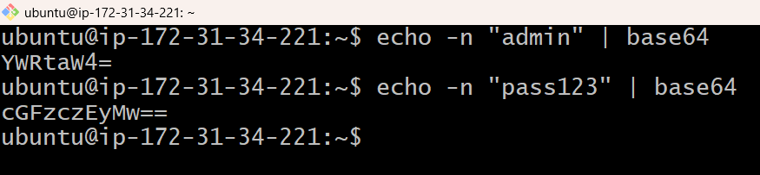

Cretae Single YAML (Secret + Pod)
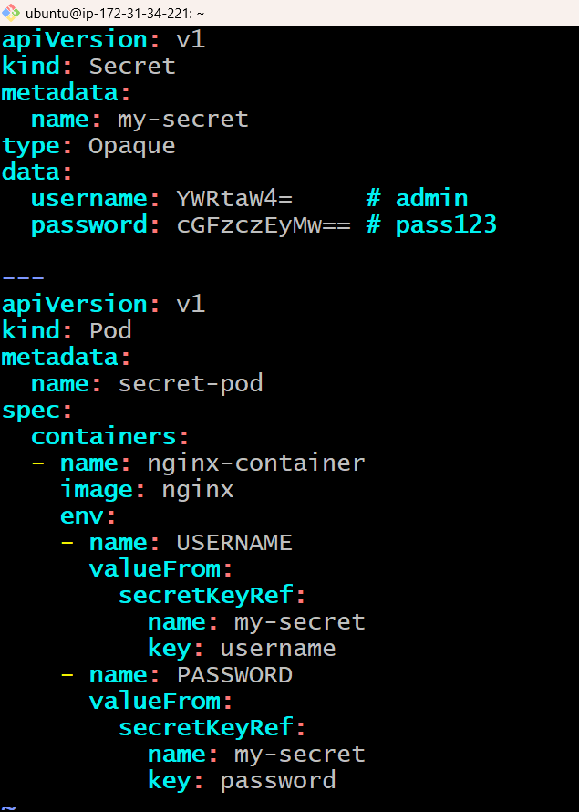
Apply it
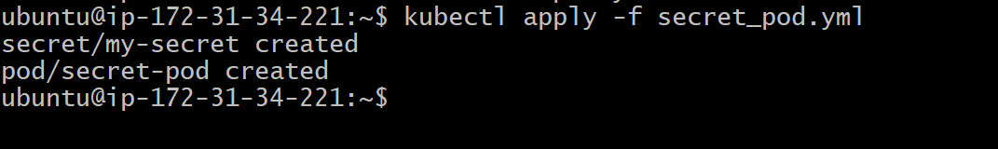

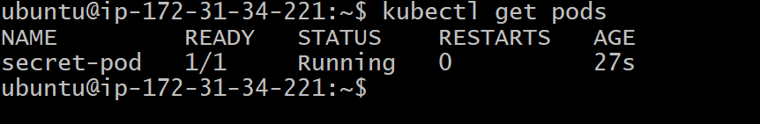
Verigy it by logging inside the containere
kubectl exec -it secret-pod -- /bin/bash
echo $USERNAME
echo $PASSWORD
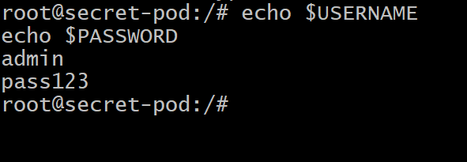

Ingress:
In Kubernetes, an Ingress is used to expose your services externally (HTTP/HTTPS) and manage routing rules.
Why Ingress?
Without Ingress:
- You expose each service using NodePort / LoadBalancer
With Ingress:
- One entry point
- Route traffic based on:
  - URL path (/app1, /app2)
  - Domain (app1.example.com)
Hands0n:
We use nginx ingress controller
In aws we use network load balancer to exposee nginx ingress controller
For that we need to appy the below commad for NLB.
kubectl apply -f https://raw.githubusercontent.com/kubernetes/ingress-nginx/controller-v1.15.1/deploy/static/provider/aws/deploy.yaml
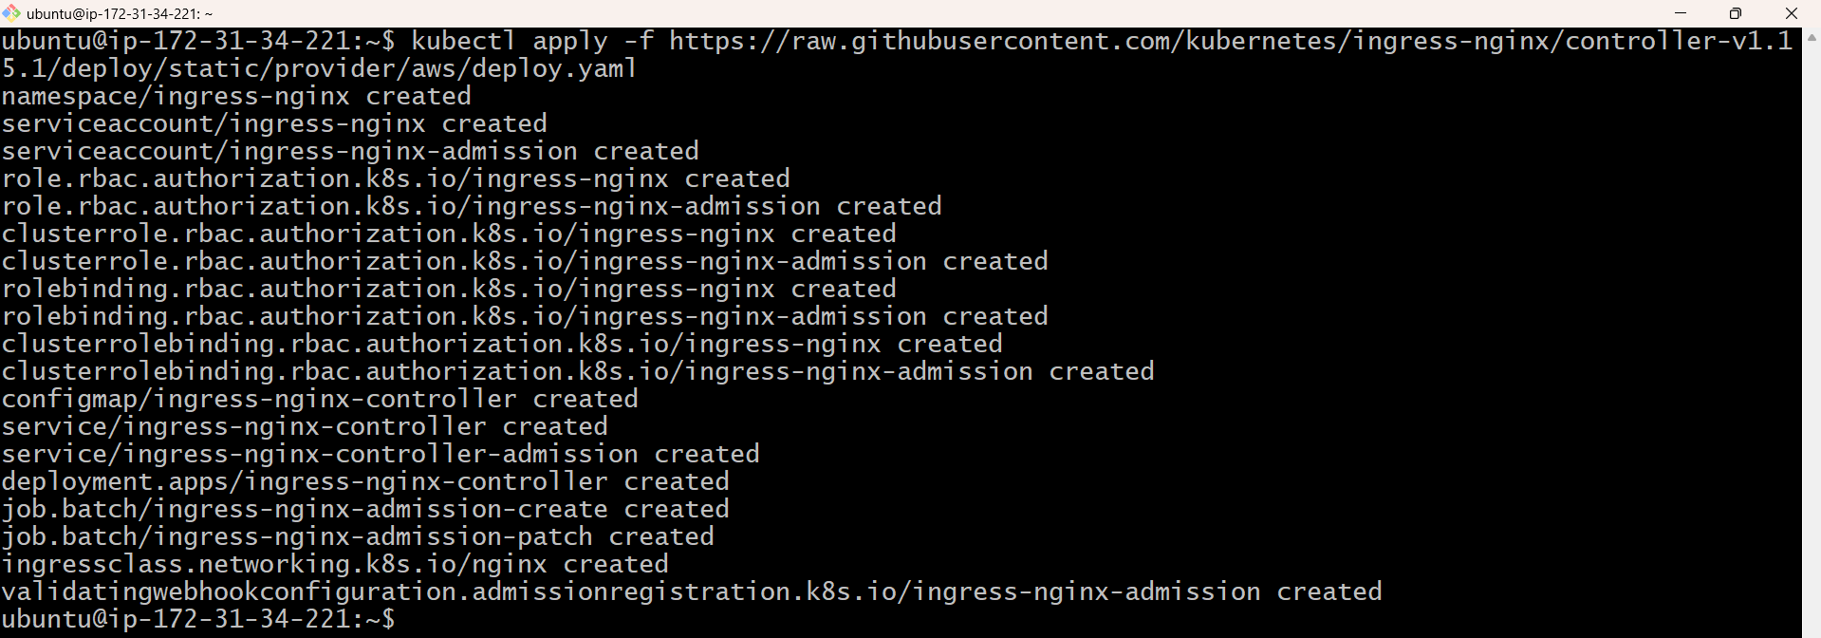

It will create namespace
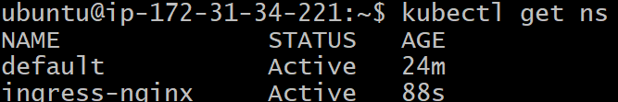
We have 1 pod running and load balancer is added
