Crate 1 instance as ubuntu, login use below commands
Apt update
Need to install jdk
Apt search jdk | grep 17
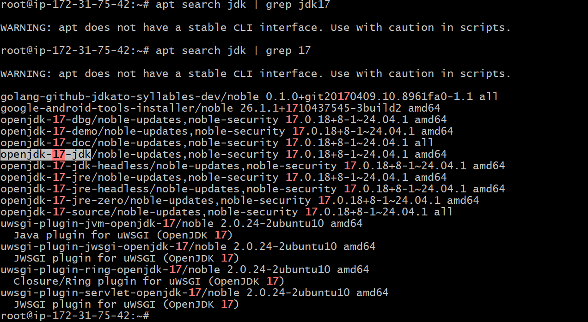
We can install 21 as we;l
apt install openjdk-21-jdk -y
Check version as weel
And need to install maven now
Apt install maven -y
copy the souces code to instance
Git clone https://github.com/hkhcoder/vprofile-project.git
U should in local branch , once code copied
Run maven commands now

Mvn validate
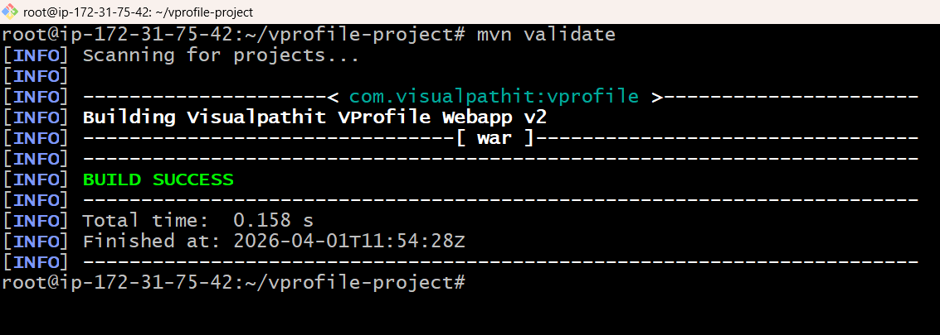
Mvn test (it will test testcases) unit testcases (optional)
We can diretly run : mvn clean install or mvn install
Clean install will deleted the target folder and re-install it
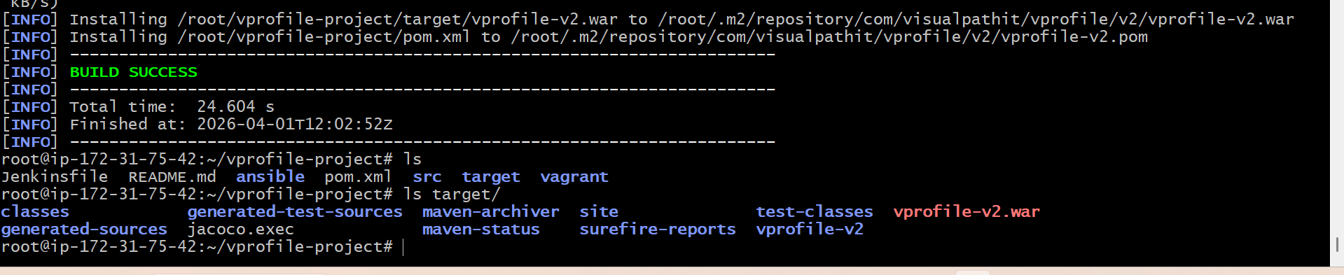
U will generate a target folder in ur path
one more technique:
delete the target and repo and vi to pom.xml search jacoco and downgrade the version to 0.8.8 and run the mvn install now
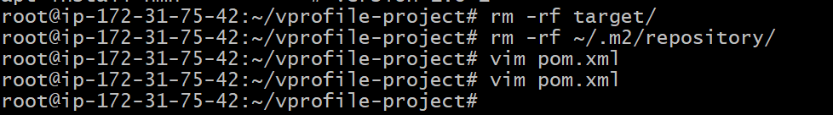

Ur build will success with lot of failure because the jacoco version we need to upgrate the jacoco version
Upgrate the version to 0.8.11
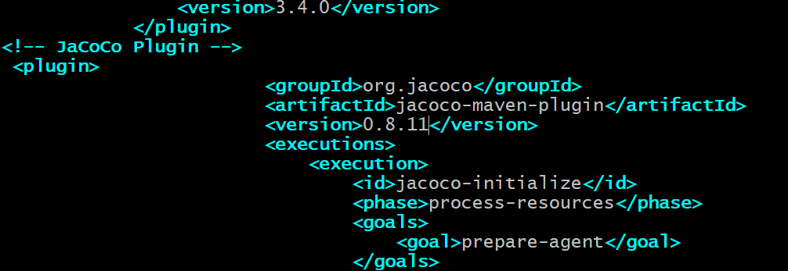

Finally build is success
