Terraform:
Terraform is an Infrastructure as Code (IaC) tool used in DevOps to create, manage, and automate infrastructure like servers, networks, databases, and cloud resources.
It is developed by HashiCorp.
Instead of manually creating resources in AWS/Azure/GCP, you write code and Terraform will build everything automatically.
Install terraform
Choco install terraform
We need to setup access key , goto aws acout asn set up iam user and create acceskey
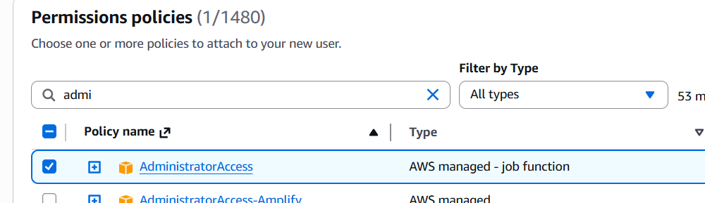
After creating access key open git in ur base macine and type below commad
Aws configure
Give access keys and hit enter
and we can start writing terraform scripts

We need ami id’s to setup ami for aws instances. Go and fetch from aws instances or from google or we can find with help of terraform as well.

Creatre one folder in machine ands we can write .tf scripts(install extensions in vscode)
-------------------------------------------------------------------------------------------------------
data "aws_ami" "amiID" {
most_recent = true

filter {
name = "name"
values = ["ubuntu/images/hvm-ssd/ubuntu-jammy-22.04-amd64-server-*"]
}

filter {
name = "virtualization-type"
values = ["hvm"]

}

owners = ["099720109477"]
}

output "instance_id" {
description = "AMI ID OF UBUNTU INSTANCE"
value = data.aws_ami.amiID.id
}
Adter writing .tf code , use below terraform commads to cross-verify

Terraform fmt (format the code)
Terraform init (initialize the terraform, check the all resources and download few plugins)
Terraform validate
Terraform plan
Terraform apply

After applying w irll get the instance id visible on cli.

Now we launch ec2 instance .
create one more folder and crete this file it it
instance.tf, instID.tf, keypair.tf, provider.tf, securitygroup.tf
PFP: C:\Devops\terraform\exercise2 (add details mentioned as same) create keypair in saem path

In git move to rhis path /c/Devops/terraform/exercise2 and follow below cmds
Terraform init
Terraform fmt
Terraform validate
Terraform plan
Terraform apply

A new instance will created in ur aws instance/ check

And destroy If u want to terminate
Terraform destroy

