Devops
What is devops:
Devops is a culture and process of improving the application delivery and efficiency before giving to end users. It’s nothing but a integration of development and operation with complete automation and intergration

SDLC: software development life cycle
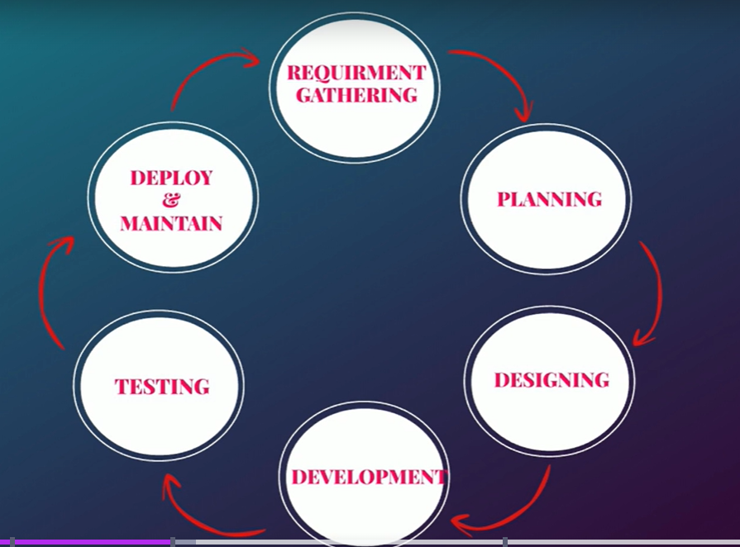
Devops lifecycle
code: developers commits code
Code built: deployed software artifat
Code test: unit and integrations testing
Code analysis: vulnerability
Delivery: deploy changes to staging
DB/sec changes:
Software testing: qa/functional loads
Deploy to prod:
Go live:
User approval:
Keep monitoring:
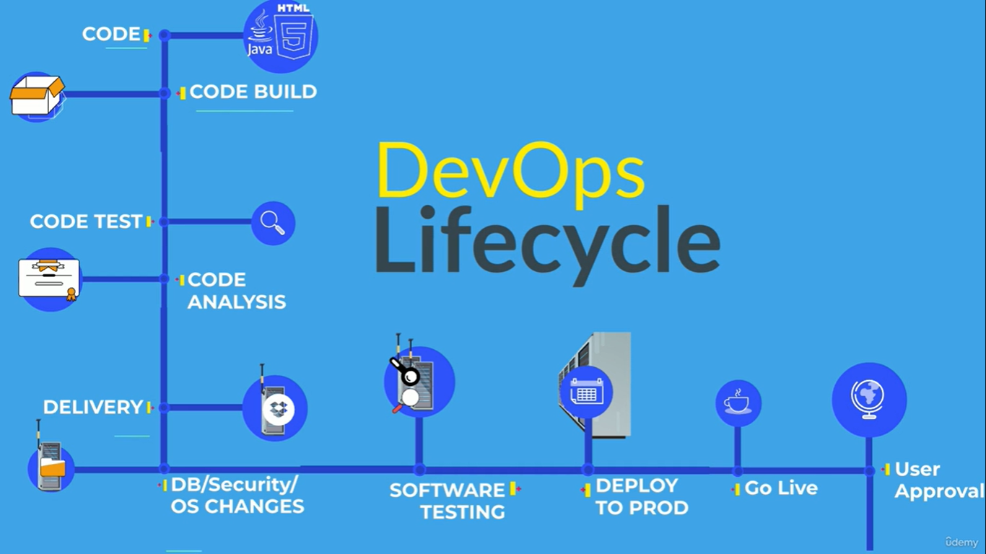
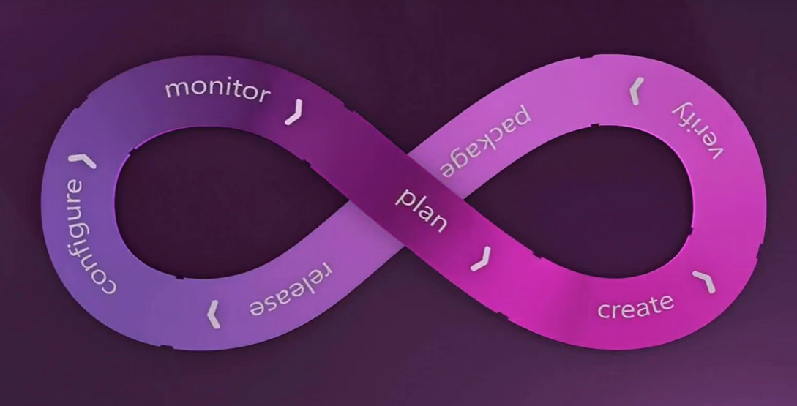

Continuous integration
Automation for our code, built and test, to detects bugs in early stage
developer code pushes into git repo code pushed to build server if any errors if no issues found pushed to artifact software repo.

IDE for coding eclipse, vs, PyCharm
Verions contro git, svn,
Built tools maven, ant, Gradle
Software repo sonatype nexus
CI tools Jenkins

Continuous delivery
Extension of continuous integrations to delivery code changes to servers
artifact software repo deploy to production(dev/test/prod environment)

