**Project: Capstone**

**Jenkins:**

**Login Page:**

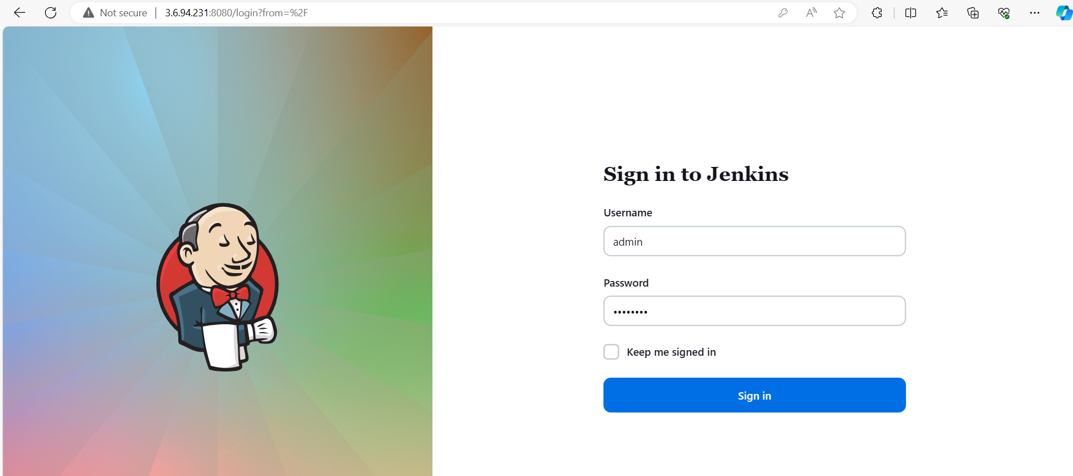

**Execute Configuration (Pipeline):**

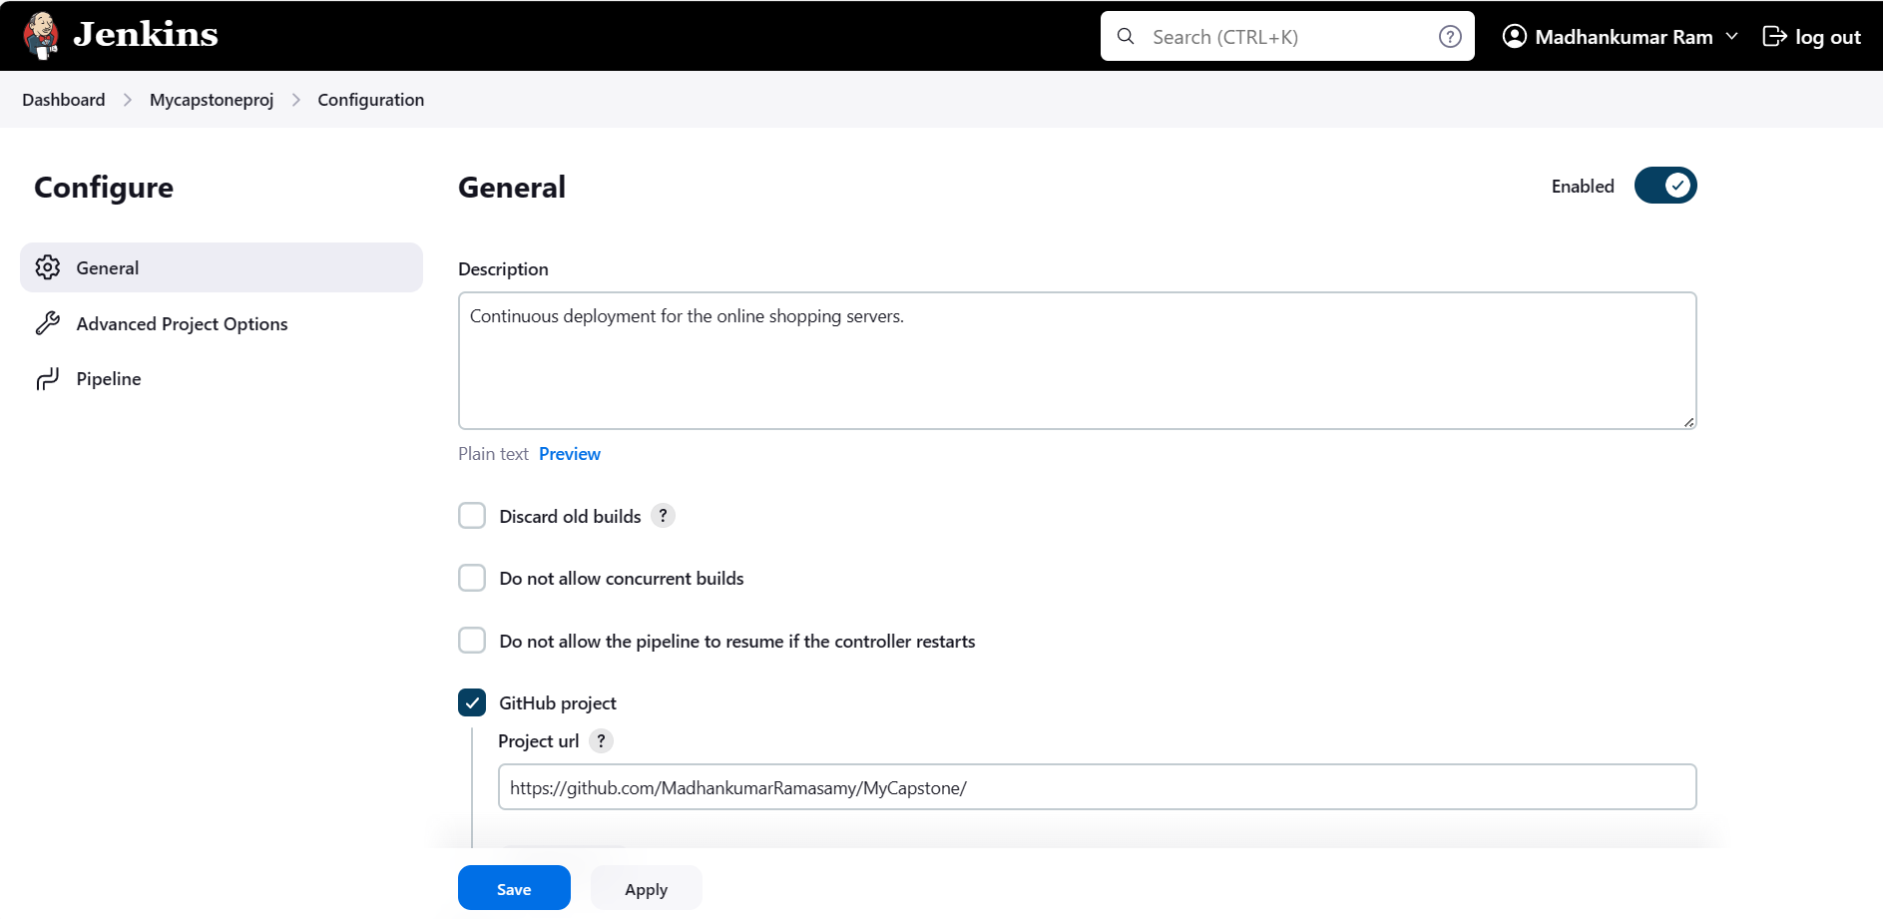

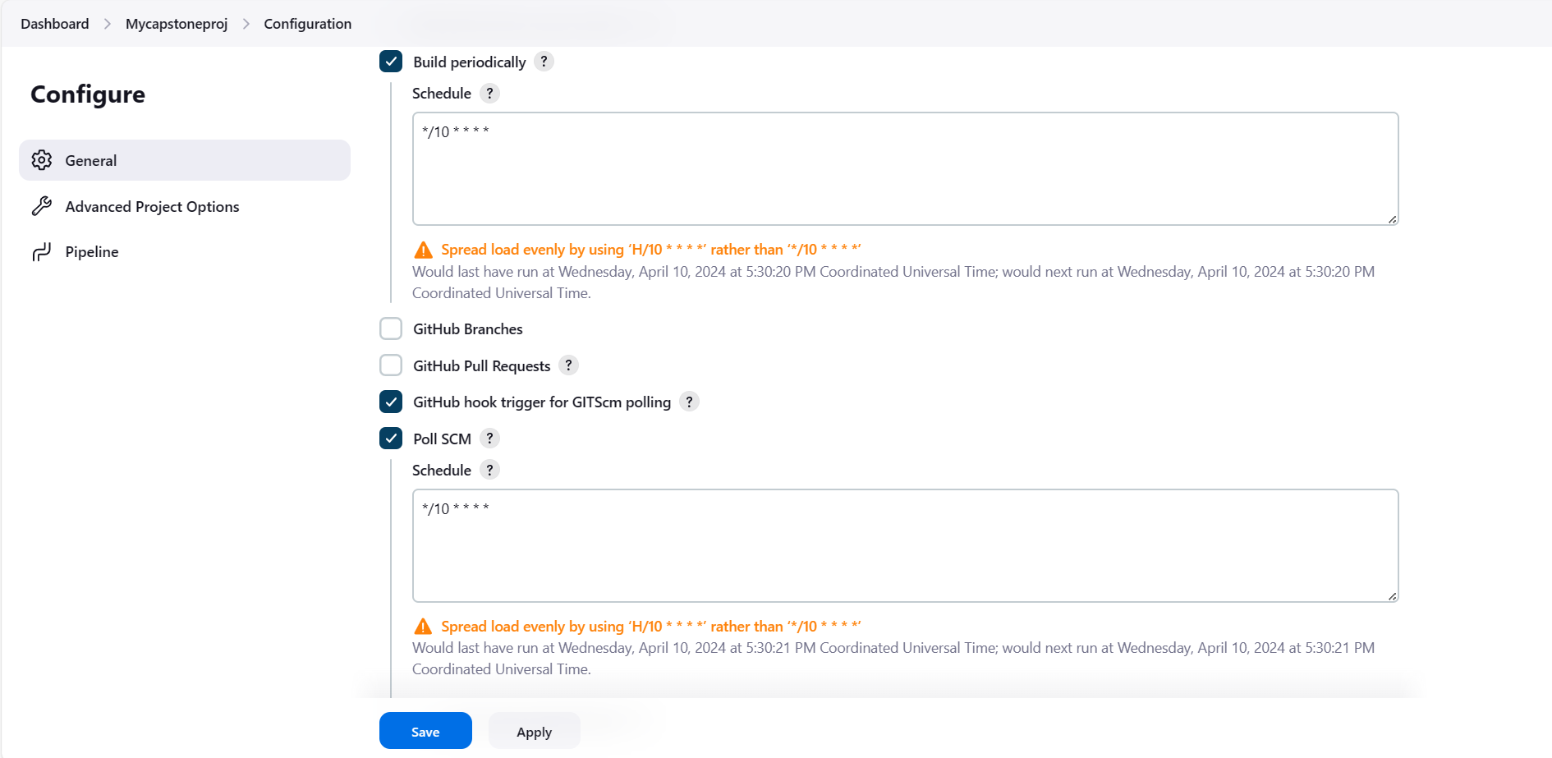

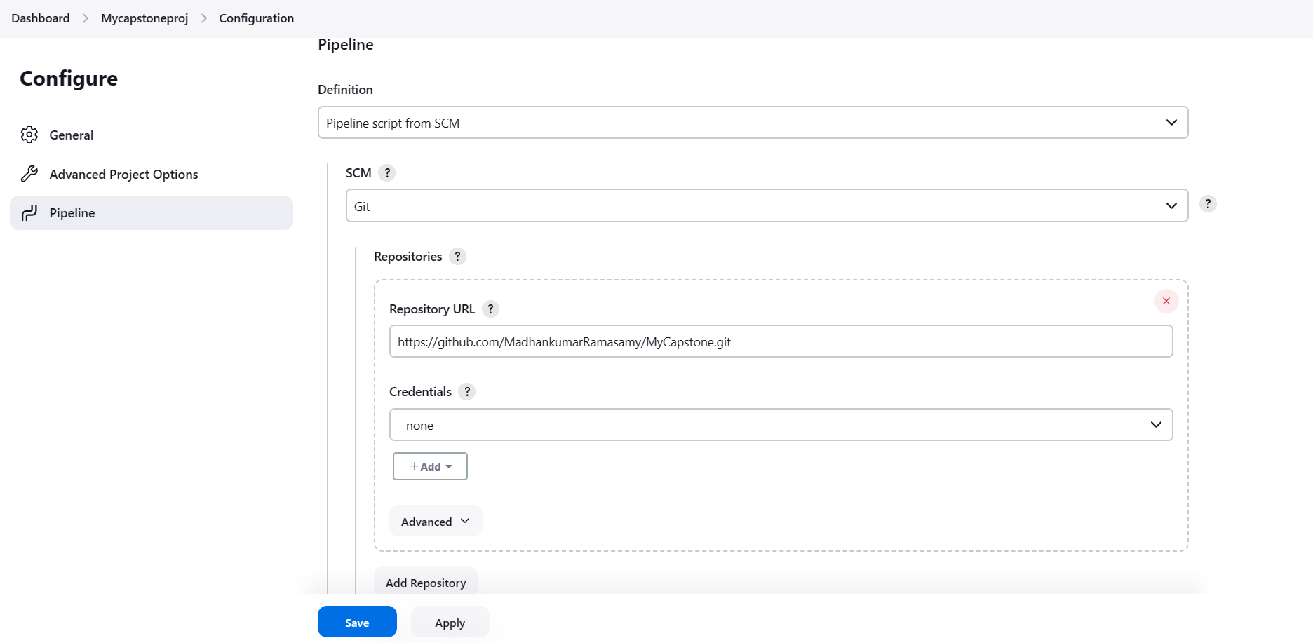

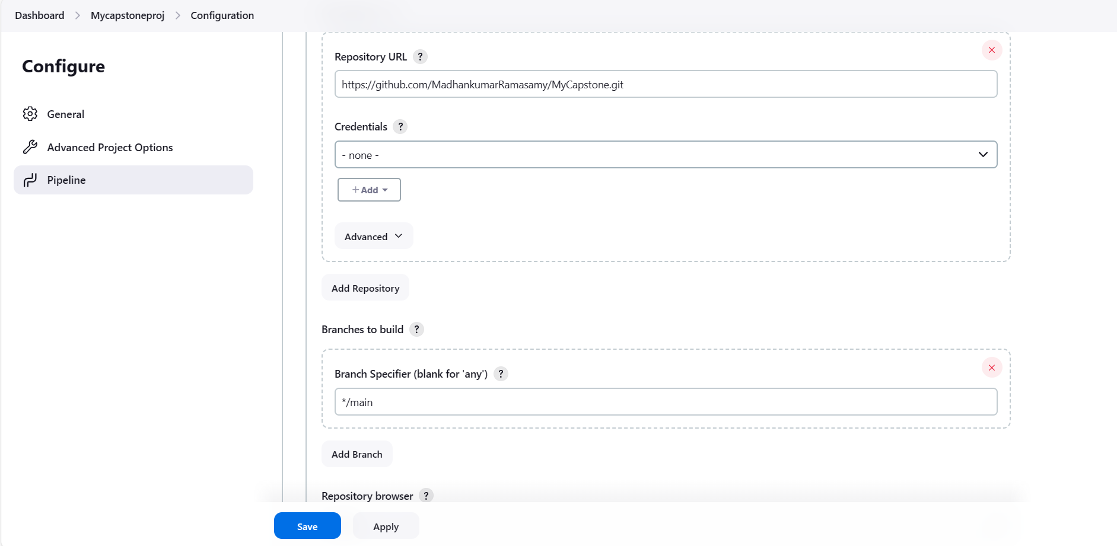

**Configuration Setting:**

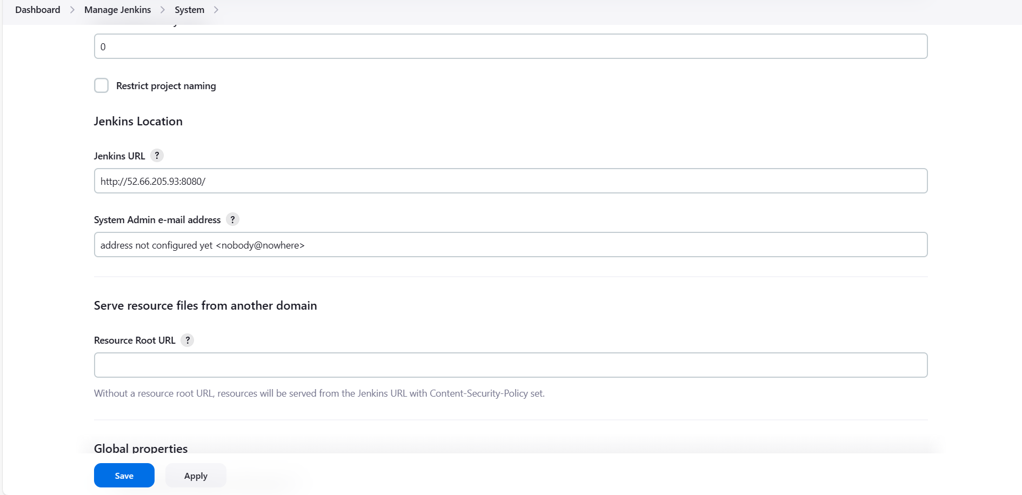

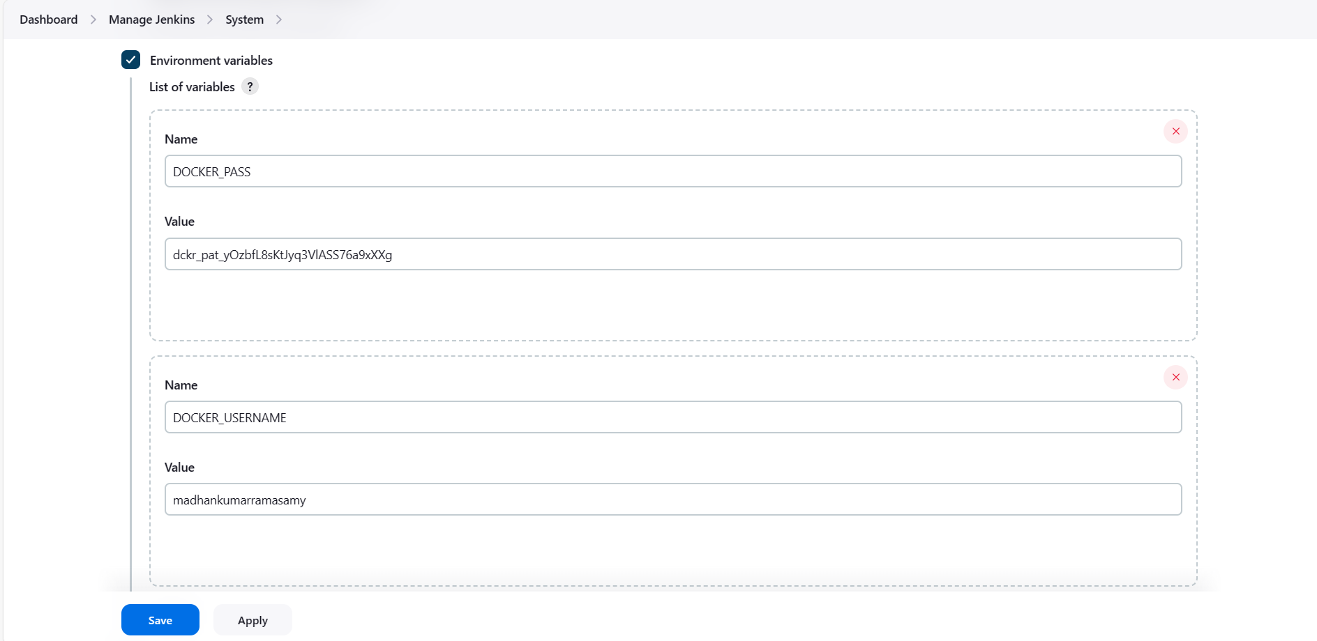

**Results:**

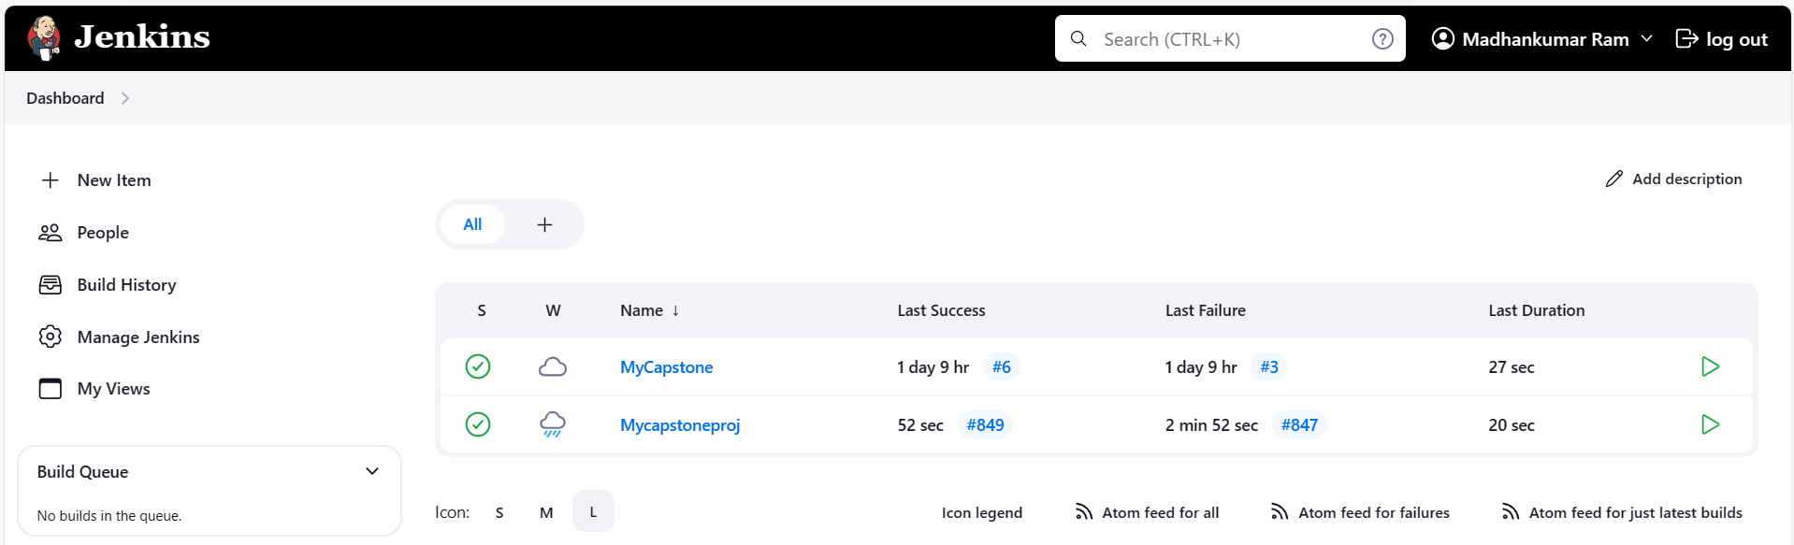

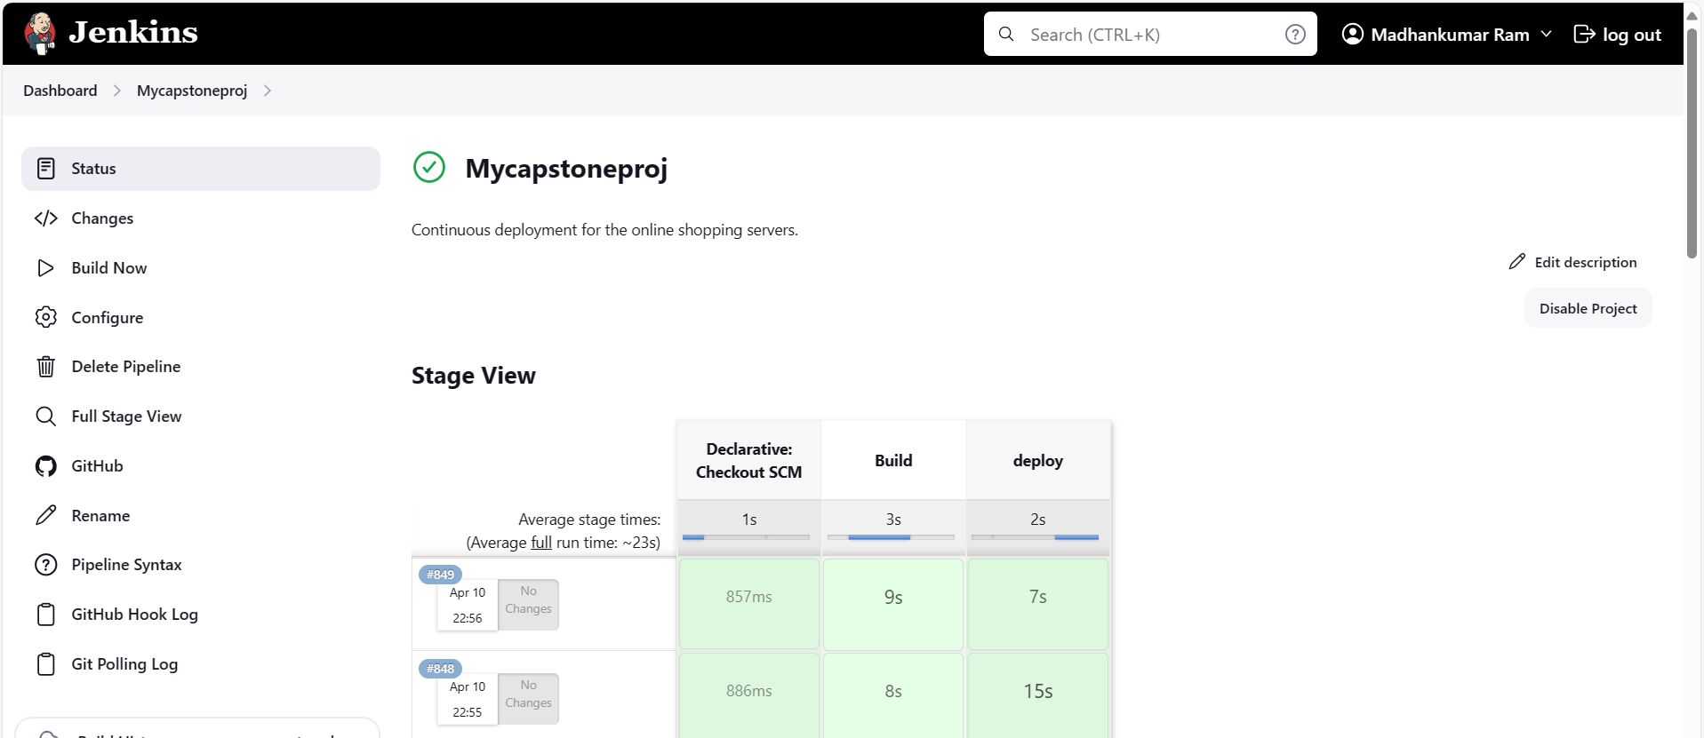

**AWS:**

**EC2 Console:**

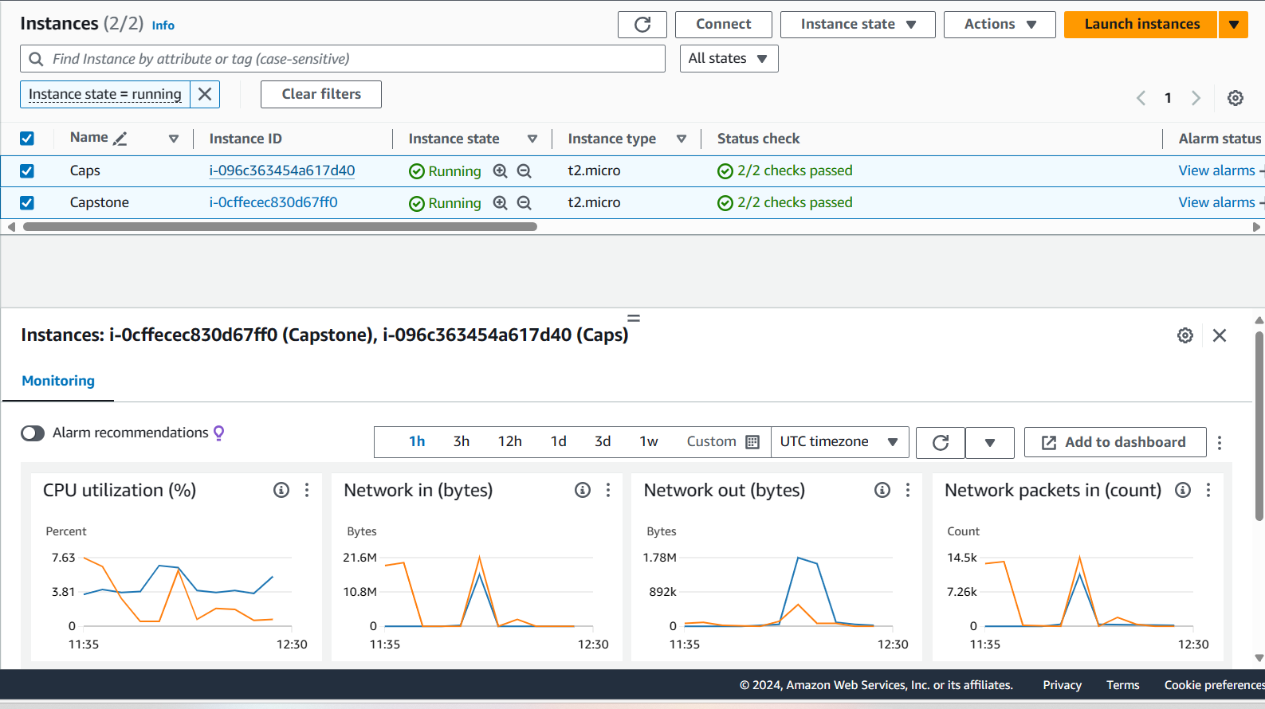

**SG (Secondary Server):**

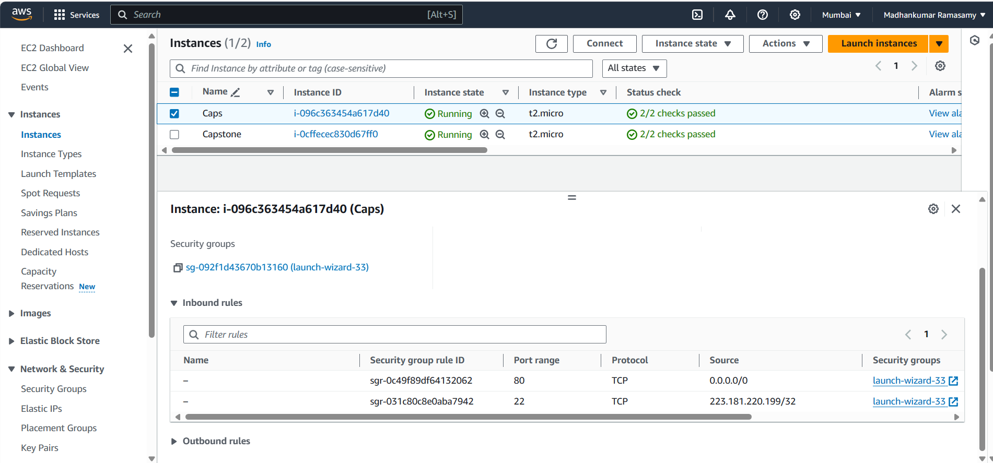

**Secondary Server:**

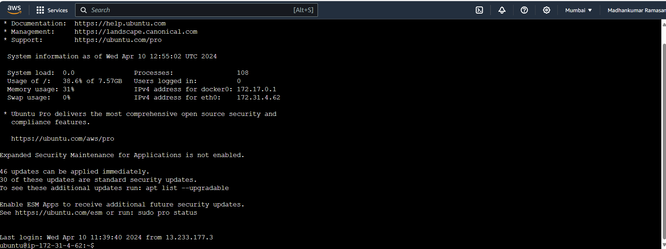

**Primary Server:**

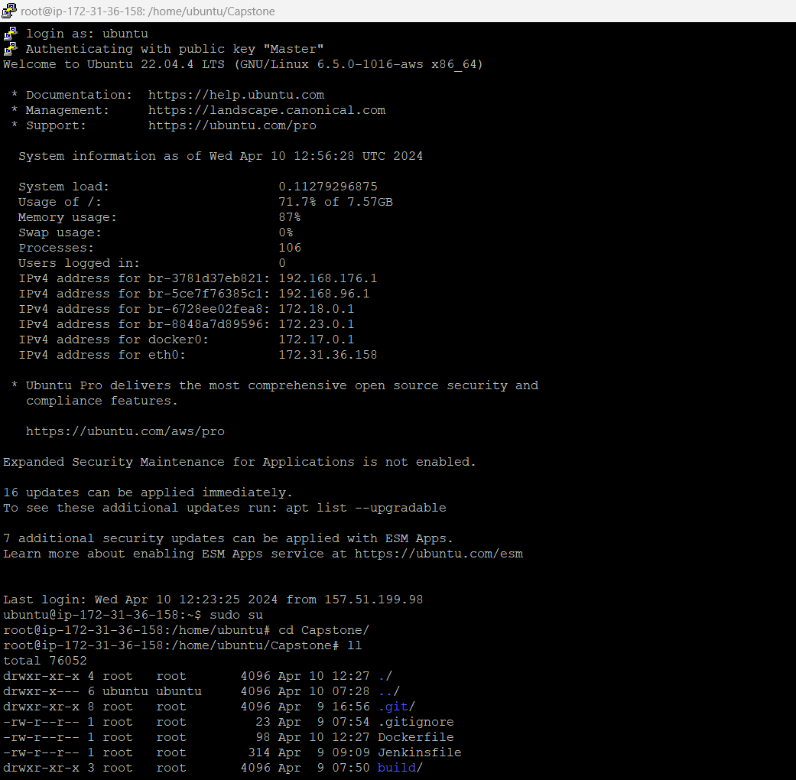

**DockerHub:**

**Repositories:**

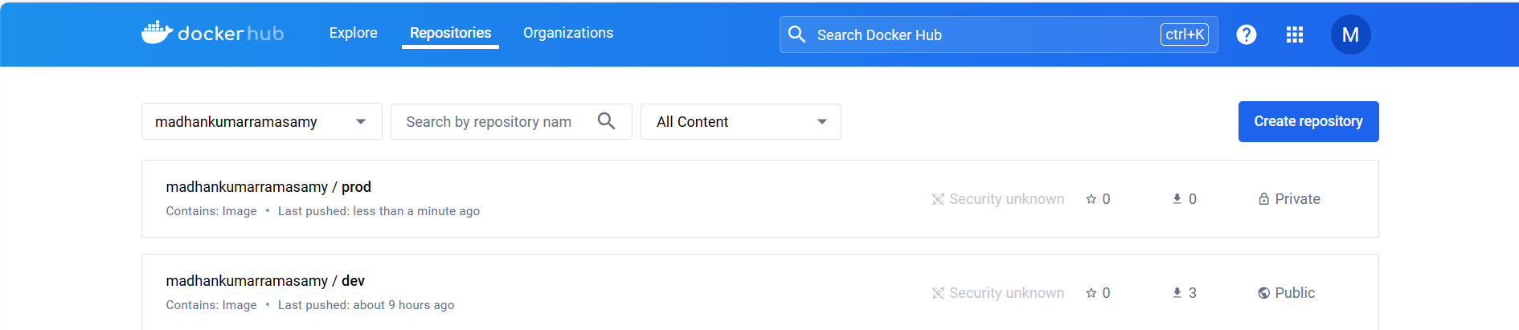

**Repo – Prod:Tags**

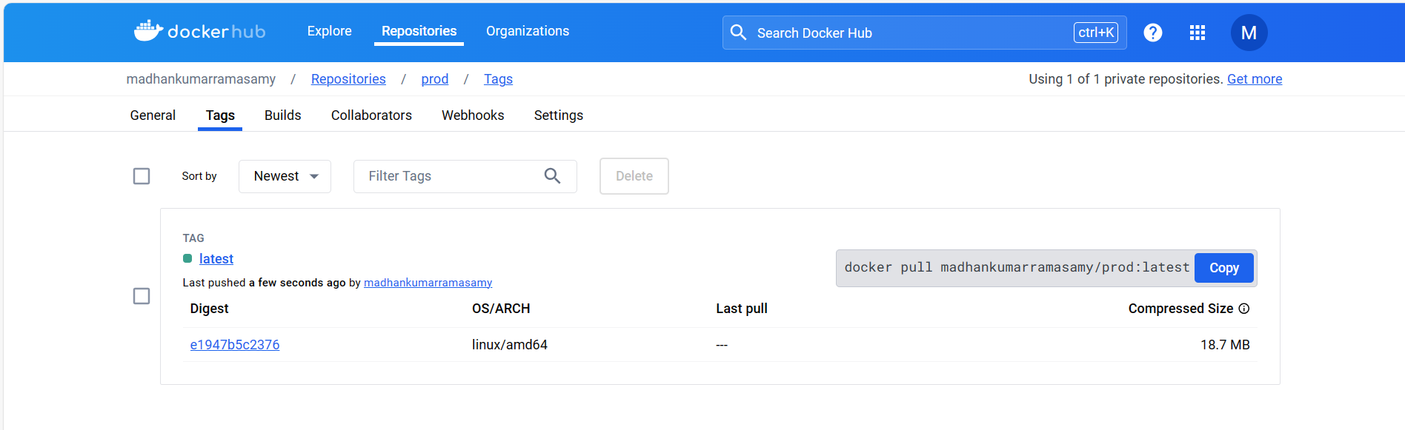

**Repo – dev:Tags**

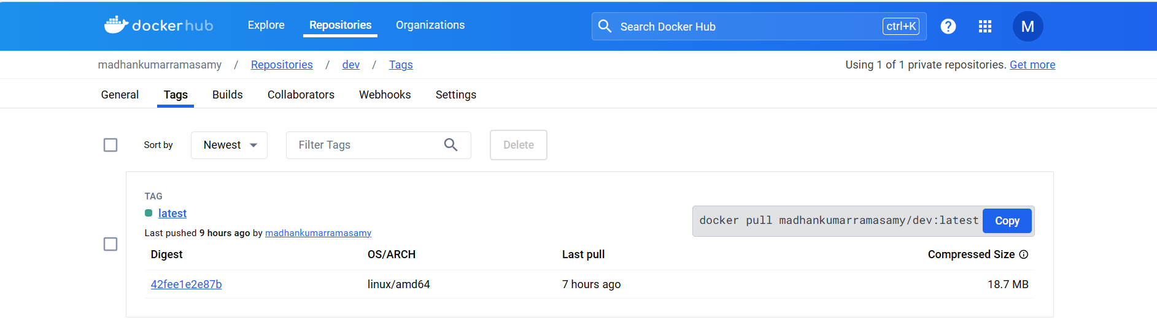

**Docker Image Name:**

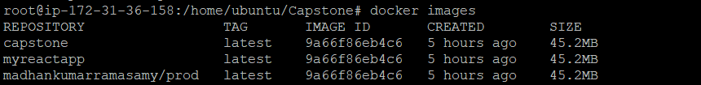

**Deployed Site Page:**

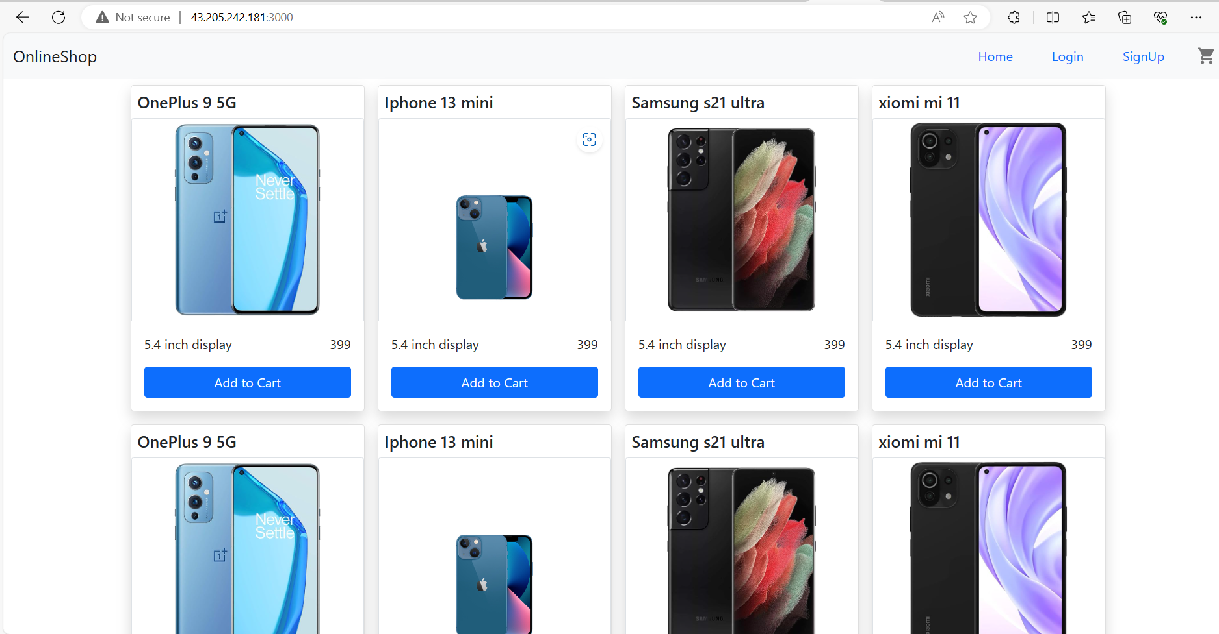

**Health check Status: (Grafana)**

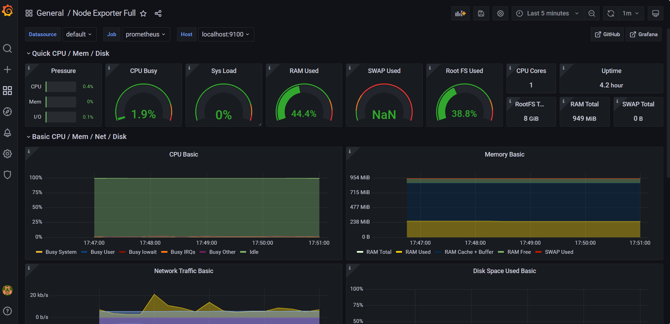

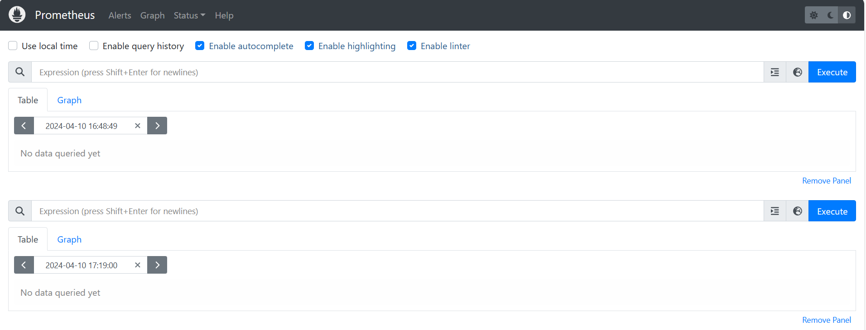

Important URLs:

1. GitHub URL => [MadhankumarRamasamy/MyCapstone (github.com)](https://github.com/MadhankumarRamasamy/MyCapstone)
2. DockerHub URL => [Repositories | Docker Hub](https://hub.docker.com/repositories/madhankumarramasamy)
3. Deployed Site URL => [React App](http://43.205.242.181:3000/)

**Docker Details:**

**Docker Image Name: myreactapp**

**Container Name: mycapstoneproj2_webapp_1**

**Container Id: 02470082d620**