 | 
EV-GUARDIAN 2.0:
INTELLIGENT EV BATTERY SAFETY, PREDICTIVE DIAGNOSTICS AND SAFE-DRIVE INTERLOCK
A MINI PROJECT REPORT
Submitted by
MALINI K | (25EC121)
HARESH S | (25EC066)
MADHAN RAJA S | (25EC116)
LOKITH G | (25EC115)
II YEAR
BACHELOR OF ENGINEERING
in
ELECTRONICS AND COMMUNICATION ENGINEERING
KPR INSTITUTE OF ENGINEERING AND TECHNOLOGY (AUTONOMOUS)
ARASUR, COIMBATORE 641 407
ANNA UNIVERSITY :: CHENNAI 600 025
NOVEMBER 2026
ANNA UNIVERSITY : CHENNAI 600025
BONAFIDE CERTIFICATE
Certified that this project report titled “EV-GUARDIAN 2.0: INTELLIGENT EV BATTERY SAFETY, PREDICTIVE DIAGNOSTICS AND SAFE-DRIVE INTERLOCK” is the bonafide work of “MALINI K, HARESH S, MADHAN RAJA S and LOKITH G” who carried out the project work under my supervision.
SIGNATURE  Dr. M. KATHIRVELU  HEAD OF THE DEPARTMENT,  Department of Electronics and Communication Engineering, KPR Institute of Engineering and Technology, Arasur, Coimbatore – 641 407. | SIGNATURE  SUPRIYA M  SUPERVISOR / PROJECT GUIDE,  Department of Electronics and Communication Engineering, KPR Institute of Engineering and Technology, Arasur, Coimbatore – 641 407.
Submitted for Mini project evaluation conducted on ……………….
Recommended for STRIDE Score ……..……………..
Name & Signature
SKILL OFFICER
ACKNOWLEDGMENT
We express our sincere thanks and profound gratitude to Dr. K. P. Ramasamy, Chairman, and Ms. Gayathri Anandakrishnan, Secretary, KPR Group of Institutions, for providing an excellent academic environment and for their visionary leadership and unwavering support for research and innovation.
We are deeply grateful to Dr. M. Akila, Principal, KPR Institute of Engineering and Technology, for her esteemed guidance and for fostering a culture of academic excellence.
We are especially thankful to Dr. M. Kathirvelu, Professor and Head, Department of Electronics and Communication Engineering, for the support extended to us. We owe our deepest gratitude to our project supervisor, Supriya M, Supervisor and Project Guide, Department of Electronics and Communication Engineering, whose expert guidance, immense patience and constant encouragement have been the cornerstones of this endeavour.
We also extend our heartfelt thanks to our beloved family, faculty members, supporting staff and friends for their unwavering support and motivation.

MALINI K | (25EC121)
HARESH S | (25EC066)
MADHAN RAJA S | (25EC116)
LOKITH G | (25EC115)
ABSTRACT
Battery safety is one of the most critical requirements for the wider adoption of electric vehicles (EVs). A conventional battery management system (BMS) protects the pack with threshold-based limits, but a threshold alarm alone does not tell an operator what is abnormal, where it is occurring, how serious it is, or what should be done next. This project presents EV-GUARDIAN 2.0, a low-cost embedded diagnostic layer that works alongside the BMS of a low-voltage 4S battery demonstrator. An ESP32 edge controller acquires cell voltage, pack current, four-point temperature and cooling / emergency-stop status, validates every signal for range, freshness and plausibility, and extracts features such as cell-voltage imbalance, temperature difference, temperature rise rate and current trend. A hybrid diagnostic engine combines deterministic safety rules with an edge anomaly score to localize the suspected cell or condition and to compute an explainable EV Safety Score between 0 and 100.
The diagnosis drives a closed-loop response consisting of warning, cooling, controlled isolation and event logging to a microSD Safety Black Box, together with a fail-safe Safe-Drive Interlock that blocks the drive / contactor permit whenever a required safety input is missing, invalid or critical. The design is demonstrated through a software-in-the-loop simulator that injects six controlled fault scenarios: cell thermal rise, cell undervoltage, overcurrent, sensor failure, cooling failure and multiple faults. In every injected scenario the simulator lowered the Safety Score, identified the affected location and blocked the drive permit, and the permit was restored only after the fault was cleared and the inputs were revalidated. The estimated budget for the hardware demonstrator is about ₹4,400, and the complete project files are available in a public GitHub repository (github.com/lokith0709/ev-guard). All testing is limited to simulated faults on low-voltage, current-limited hardware; destructive lithium-battery testing is explicitly excluded, and the hardware prototype is under development.
TABLE OF CONTENTS
CHAPTER NO. | TITLE | PAGE NO.
 | ACKNOWLEDGMENT | iii
 | ABSTRACT | iv
 | LIST OF FIGURES | vii
 | LIST OF TABLES | viii
 | LIST OF ABBREVIATIONS | ix
1. | INTRODUCTION | 1
 | 1.1 OBJECTIVE | 1
 | 1.2 OVERVIEW OF EV BATTERY SAFETY AND INTELLIGENT DIAGNOSTICS | 1
 | 1.3 PROBLEM STATEMENT | 2
 | 1.4 SCOPE AND CONSTRAINTS | 3
 | 1.5 DIRECT BENEFITS | 3
 | 1.6 INDIRECT BENEFITS | 3
 | 1.7 ORGANIZATION OF THE REPORT | 3
2. | REVIEW OF LITERATURE | 4
 | 2.1 RELATED BACKGROUNDS | 4
 | 2.2 BATTERY FAILURE MODES AND MEASURABLE INDICATORS | 6
 | 2.3 SUMMARY AND IDENTIFIED GAP | 6
3. | SYSTEM IMPLEMENTATION | 8
 | 3.1 DESIGN PHILOSOPHY AND SAFETY BOUNDARIES | 8
 | 3.2 SYSTEM REQUIREMENTS | 8
 | 3.3 SYSTEM ARCHITECTURE | 9
 | 3.4 HARDWARE COMPONENTS | 10
 | 3.5 ELECTRICAL INTERFACING AND PIN ASSIGNMENT | 11
 | 3.6 MECHANICAL AND ENCLOSURE DESIGN | 13
 | 3.7 SOFTWARE STACK | 14
 | 3.8 FIRMWARE ARCHITECTURE AND TASK SCHEDULE | 14
 | 3.9 WORKING LOGIC | 15
 | 3.10 SIGNAL VALIDATION | 16
 | 3.11 FILTERING AND FEATURE EXTRACTION | 16
 | 3.12 RULE ENGINE AND SEVERITY CLASSIFICATION | 16
 | 3.13 EDGE ANOMALY SCORE | 17
 | 3.14 EV SAFETY SCORE | 17
 | 3.15 FAULT LOCALIZATION | 18
 | 3.16 SAFE-DRIVE INTERLOCK | 19
 | 3.17 CLOSED-LOOP PROTECTION AND SAFETY BLACK BOX | 19
 | 3.18 DASHBOARD AND USER INTERFACE | 20
 | 3.19 SOFTWARE-IN-THE-LOOP SIMULATOR | 20
 | 3.20 TEST PLAN AND SAFETY PRECAUTIONS | 21
 | 3.21 DEVELOPMENT PLAN | 21
4. | RESULT | 22
 | 4.1 TEST METHOD AND SCOPE | 22
 | 4.2 SIMULATOR OUTPUT FOR REPRESENTATIVE SCENARIOS | 22
 | 4.3 FAULT SCENARIO DEFINITIONS | 23
 | 4.4 SCENARIO-WISE RESULTS | 24
 | 4.5 SAFETY SCORE AND SIGNAL TRENDS | 25
 | 4.6 INTERLOCK BEHAVIOUR AND SAFETY BLACK BOX | 26
 | 4.7 COMPARISON WITH A THRESHOLD-ONLY ALARM | 27
 | 4.8 SIMULATED RESPONSE TIME | 27
 | 4.9 VALIDATION MATRIX FOR THE HARDWARE PROTOTYPE | 28
 | 4.10 DISCUSSION AND LIMITATIONS | 28
5. | CONCLUSION AND FUTURE TRENDS | 29
 | 5.1 CONCLUSION | 29
 | 5.2 KEY CONTRIBUTIONS | 29
 | 5.3 FUTURE TRENDS | 29
 | 5.4 ALIGNMENT WITH SUSTAINABLE DEVELOPMENT GOALS | 29
 | APPENDIX I – CORE LOGIC PSEUDOCODE | 30
 | APPENDIX II – PROJECT REPOSITORY | 31
 | APPENDIX III – SIMULATOR IMPLEMENTATION NOTES | 32
 | REFERENCES | 33
LIST OF FIGURES
FIGURE NO. | FIGURE NAME | PAGE NO.
3.1 | Concept render of the EV-GUARDIAN 2.0 demonstrator (prototype under development) | 9
3.2 | Exploded view of the EV-GUARDIAN 2.0 low-voltage demonstrator | 9
3.3 | Functional architecture of EV-GUARDIAN 2.0 | 10
3.4 | Distribution of the estimated hardware cost | 11
3.5 | Hardware interconnection of EV-GUARDIAN 2.0 | 12
3.6 | Layered firmware architecture | 14
3.7 | Decision flow (working logic) of EV-GUARDIAN 2.0 | 15
3.8 | Safe-Drive Interlock finite-state machine | 19
4.1 | Simulator dashboard in the normal (healthy) condition | 22
4.2 | Simulator dashboard after the C3 thermal fault injection | 23
4.3 | Simulator dashboard after the multiple-fault injection | 23
4.4 | EV Safety Score versus simulation step for the injected faults | 26
4.5 | Virtual temperature, current and voltage trends during fault injection | 26
4.6 | Final EV Safety Score of each simulated scenario | 26
A.1 | Public GitHub repository of the project (lokith0709/ev-guard) | 31
LIST OF TABLES
TABLE NO. | TABLE NAME | PAGE NO.
1.1 | Existing approaches and the gap addressed by EV-GUARDIAN 2.0 | 2
2.1 | Comparison of diagnostic method families | 5
2.2 | Abnormal conditions and their measurable indicators | 6
2.3 | Summary of the reviewed background and its relation to this project | 6
3.1 | Functional and non-functional requirements | 8
3.2 | Hardware components and estimated cost | 11
3.3 | Proposed ESP32 pin assignment (to be confirmed during wiring) | 13
3.4 | Software stack and diagnostic logic | 14
3.5 | Proposed firmware task schedule | 15
3.6 | Indicative rule settings (to be calibrated on hardware) | 17
3.7 | Initial risk weights (maximum points removed from the score; to be tuned) | 18
3.8 | Fault matrix: evidence, localization and response | 18
3.9 | Safe-Drive Interlock checks | 19
3.10 | Safety Black Box record fields | 20
3.11 | Development plan | 21
4.1 | Signal ramps used for the fault scenarios | 24
4.2 | Results of the simulated fault scenarios (value after step 5) | 24
4.3 | Interlock behaviour for different input conditions | 27
4.4 | Information provided by a threshold-only alarm and by EV-GUARDIAN 2.0 | 27
4.5 | Validation matrix and status | 28
A.1 | Files in the project repository | 31
A.2 | Main functions of the simulator | 32
LIST OF ABBREVIATIONS
ADC | Analog-to-Digital Converter
AI | Artificial Intelligence
BMS | Battery Management System
CAN | Controller Area Network
E-stop | Emergency Stop
EV | Electric Vehicle
FSM | Finite-State Machine
GPIO | General-Purpose Input / Output
I²C | Inter-Integrated Circuit
IoT | Internet of Things
Li-ion | Lithium-ion
ML | Machine Learning
MUX | Multiplexer
OLED | Organic Light-Emitting Diode
RUL | Remaining Useful Life
SDG | Sustainable Development Goals
SIL | Software-in-the-Loop
SoC | State of Charge
SoH | State of Health
UI | User Interface

CHAPTER 1
INTRODUCTION

1.1 OBJECTIVE
The main objective of this project is to design and demonstrate EV-GUARDIAN 2.0, a low-cost embedded diagnostic layer that continuously watches the electrical and thermal condition of an electric vehicle (EV) battery pack, explains what is abnormal and where it is occurring, and takes a defined protective action, while preventing unsafe activation of the drive or contactor request.
The specific objectives are:
- To acquire cell voltage, pack current, multi-point temperature and cooling / emergency-stop status from a safe, low-voltage 4S battery demonstrator using an ESP32 edge controller.
- To validate every signal for range, freshness and plausibility before it is used in any decision.
- To extract diagnostic features such as cell-voltage imbalance, temperature difference across sensors, temperature rise rate and current trend.
- To combine deterministic safety rules with an edge anomaly score and localize the suspected cell or condition when the evidence supports it.
- To calculate an explainable EV Safety Score between 0 and 100 and to display the reasons behind every reduction in the score.
- To implement closed-loop protection (warning, cooling, controlled isolation) and a fail-safe Safe-Drive Interlock that defaults to “no permit”.
- To record every event in a Safety Black Box so that the sequence of readings, diagnosis and action can be reviewed after the event.
- To validate the complete workflow safely using controlled, simulated faults, without any destructive lithium-battery testing.

1.2 OVERVIEW OF EV BATTERY SAFETY AND INTELLIGENT DIAGNOSTICS

1.2.1 Importance of battery safety in electric vehicles
The lithium-ion battery pack is the most valuable and the most safety-critical component of an electric vehicle. Cells in a pack can drift apart in voltage, heat unevenly, be over-stressed by excessive current, or be monitored by a sensor that has silently failed or lost its connection. If such conditions are not noticed early, they can lead to reduced battery life, sudden loss of power or, in the worst case, thermal events. Reliable early detection and clear communication of battery risk are therefore essential for user safety, maintenance planning and public confidence in electric mobility.

1.2.2 Limitations of existing approaches
A battery management system (BMS) is essential and is not replaced by this project. However, a simple threshold alarm only reports that a limit has been crossed. It gives limited context about the suspected location, the severity, the likely explanation and the recommended action. Table 1.1 summarizes the common approaches and the gap that EV-GUARDIAN 2.0 addresses.
Table 1.1: Existing approaches and the gap addressed by EV-GUARDIAN 2.0
Approach | Strength | Gap addressed by EV-GUARDIAN 2.0
Basic threshold alarm | Simple and fast | Limited context, localization and explanation
BMS protection | Essential battery monitoring and protection | Project adds a diagnostic / interpretation layer instead of replacing the BMS
Cloud monitoring | Remote visibility | May add latency and network dependency; this project keeps the core diagnostic logic at the edge
AI anomaly detection alone | Can detect complex patterns | Safety-critical actions must not depend only on machine learning; deterministic interlocks remain

1.2.3 The EV-GUARDIAN 2.0 concept
EV-GUARDIAN 2.0 is a low-cost intelligent diagnostic layer that sits beside the BMS. It follows a seven-step philosophy: SENSE → DIAGNOSE → LOCALIZE → PREDICT → PROTECT → INTERLOCK → RECORD. Instead of reporting only “limit crossed”, the system answers four practical questions: what is abnormal, where it is likely occurring, how serious it is, and what should happen next. A dynamic EV Safety Score, an explanation panel, protective outputs and a Safety Black Box make the result easy to understand and review.

1.3 PROBLEM STATEMENT
Electric two-wheelers, cars, buses and stationary storage systems depend on battery packs that are built from many cells connected in series and parallel. A pack can be dangerous long before it fails visibly: a single cell may run hotter than its neighbours, a cell may drift to a lower voltage, a current sensor may saturate, or a temperature probe may detach and keep reporting an old value. A conventional limit alarm can miss the early pattern and does not decide whether the vehicle may drive.
The problem addressed in this project is therefore stated as follows: to design a low-cost, explainable, edge-based diagnostic and protection layer that detects abnormal battery behaviour from multiple signals, localizes it, quantifies the risk with a Safety Score, takes a protective action and prevents unsafe drive activation, while keeping a record of the event, and to validate this safely using a low-voltage demonstrator and controlled simulated faults.

1.4 SCOPE AND CONSTRAINTS
The scope of the work is deliberately limited so that every claim can be demonstrated safely.
- In scope: a 4S low-voltage battery demonstrator; ESP32-based sensing of cell voltage, current, four-point temperature, cooling and emergency-stop status; rule-based diagnosis with an edge anomaly score; the EV Safety Score; protective outputs; the Safe-Drive Interlock; the Safety Black Box; and a software-in-the-loop (SIL) simulator.
- Out of scope: destructive testing, thermal-runaway or short-circuit experiments, high-voltage traction batteries, real vehicle propulsion control, and any claim of automotive certification.

1.5 DIRECT BENEFITS
- Multi-parameter diagnosis: voltage, current, temperature and sensor health are correlated instead of relying on a single alarm.
- Fault localization: a suspected cell or condition is identified when the available measurements support it.
- Explainable safety score: a single 0–100 indicator is shown together with the reasons that reduce it.
- Closed-loop response: diagnosis is connected to warning, cooling, controlled isolation and event logging.
- Accidental-activation prevention: the Safe-Drive Interlock blocks the drive / contactor request whenever a required input is missing, invalid or critical.
- Post-event review: the Safety Black Box stores sensor history and event context.
- Low cost: the demonstrator uses widely available modules with an estimated budget of about ₹4,400.

1.6 INDIRECT BENEFITS
- Supports safer maintenance and faster fault review for battery operators and maintenance teams.
- Provides a low-cost educational platform for teaching embedded EV battery safety.
- Creates a modular path towards CAN integration, fleet analytics and digital-twin models.

1.7 ORGANIZATION OF THE REPORT
The report is organized into five chapters. Chapter 1 states the objective and the problem, defines the scope and lists the benefits. Chapter 2 reviews the related literature and identifies the research gap. Chapter 3 describes the system implementation, including the requirements, architecture, hardware, firmware, diagnostic algorithms, safety score, interlock, user interface and the software-in-the-loop simulator. Chapter 4 presents the simulated results, and Chapter 5 concludes the work and outlines future trends. The appendices give the core pseudocode, the public project repository and the simulator notes, followed by the references.

CHAPTER 2
REVIEW OF LITERATURE

2.1 RELATED BACKGROUNDS
This chapter summarizes the background topics on which EV-GUARDIAN 2.0 is built: battery hazards, battery management systems, thermal management, fault diagnosis and anomaly detection, edge computing, and functional safety. The broad technologies behind battery monitoring, BMS protection, AI anomaly detection and fault diagnosis already exist in research and industry; the contribution of this project is therefore the integrated, low-cost embedded implementation and the way the modules are demonstrated together.

2.1.1 Lithium-ion battery hazards and thermal runaway
Feng et al. [4] reviewed the thermal runaway mechanism of lithium-ion batteries for electric vehicles, describing how abuse conditions such as overheating, overcharge or mechanical and electrical stress can trigger a chain of self-heating reactions inside a cell and how the failure can spread to neighbouring cells. The review highlights why early detection of abnormal temperature behaviour, rather than only a high absolute temperature, is valuable. This motivates the use of temperature rise rate and temperature difference across sensors as diagnostic features in EV-GUARDIAN 2.0.

2.1.2 Battery management systems
Lu et al. [3] reviewed the key issues in lithium-ion battery management for electric vehicles, including state estimation, cell balancing, thermal management and safety protection. Rahimi-Eichi et al. [5] presented an overview of battery management systems for electric vehicles and smart-grid applications, and Hannan et al. [6] discussed the state of the art and the issues and recommendations for energy management of lithium-ion batteries in EV applications. Plett’s textbooks [1], [2] provide the modelling and estimation foundation used in modern BMS design. These works establish the BMS as the essential protection layer; EV-GUARDIAN 2.0 does not replace it but adds an interpretation layer that explains risk and records the event.

2.1.3 State estimation and cell balancing
State of charge (SoC) and state of health (SoH) are the most widely studied BMS functions. Model-based estimators use an equivalent-circuit model of the cell together with a filter, as described by Plett [1], [2], while cell balancing keeps the voltages of series-connected cells close to each other by bleeding charge from the higher cells (passive balancing) or by transferring charge between cells (active balancing). Cell-voltage imbalance is also a useful diagnostic signal in itself: a growing imbalance may indicate a weak cell, a poor connection or a sensing fault. Here, balancing is left to the pack’s BMS board and the imbalance value is used for diagnosis.

2.1.4 Thermal management of battery packs
Temperature strongly affects the safety, performance and ageing of lithium-ion cells. Thermal management strategies range from passive heat spreading to forced-air and liquid cooling [3], [6]. Because a cooling system can itself fail, a diagnostic layer should not only switch cooling on but also check that cooling is actually available; EV-GUARDIAN 2.0 therefore treats “temperature rising while cooling feedback is unavailable” as a separate, more serious condition than a temperature rise with working cooling.

2.1.5 Fault diagnosis and anomaly detection
Battery fault diagnosis is commonly approached through threshold and rule-based methods, model-based methods and data-driven or machine-learning methods. Rule-based methods are simple, fast and predictable, but they may give limited insight when several signals drift together. Data-driven anomaly detection can capture complex patterns, but it depends on the quality and coverage of training data and may behave unpredictably in situations that were not represented during training. For this reason, EV-GUARDIAN 2.0 uses a hybrid design: deterministic rules form the baseline, a lightweight anomaly score enhances detection, and machine learning is never the sole safety mechanism. Table 2.1 compares the three families of methods.
Table 2.1: Comparison of diagnostic method families
Method family | Principle | Advantages | Limitations | Role in EV-GUARDIAN 2.0
Threshold / rule-based | Compare signals with fixed or hysteresis limits | Simple, fast, predictable, explainable | Limited context; may miss slow or multi-signal drift | Baseline safety logic and interlock
Model-based | Compare measurements with a battery model | Physical meaning; can estimate hidden states | Needs accurate model and parameters | Future extension (SoC / SoH)
Data-driven / ML | Learn normal behaviour from data | Can detect complex patterns | Needs data; may behave unpredictably outside training | Lightweight anomaly score; never the sole safety mechanism

2.1.6 Embedded IoT and edge analytics
Low-cost microcontrollers with integrated Wi-Fi, such as the ESP32 [8], make it possible to acquire sensor data, run filtering and decision logic, and host a local web dashboard on a single board. Sensors suitable for a student demonstrator include the INA219 current and power monitor with an I²C interface [9] and the DS18B20 digital thermometer with a 1-Wire interface [10]. Keeping the core logic at the edge avoids dependence on the network.

2.1.7 Functional safety and fail-safe interlocks
ISO 26262 [7] defines the functional-safety lifecycle for road-vehicle electrical and electronic systems and is built on the idea that a system should be able to reach a defined safe state when a fault is detected. The Safe-Drive Interlock of EV-GUARDIAN 2.0 follows this principle at demonstrator level: when a required safety input is missing, invalid or critical, the default state is “no drive / contactor permit”. The project does not claim compliance with ISO 26262; production deployment would require formal automotive functional-safety engineering.

2.2 BATTERY FAILURE MODES AND MEASURABLE INDICATORS
Table 2.2 relates the abnormal conditions that EV-GUARDIAN 2.0 targets to the signals through which each condition can be observed. This mapping is the basis of the feature set and of the fault matrix presented in Chapter 3.
Table 2.2: Abnormal conditions and their measurable indicators
Abnormal condition | Typical cause | Measurable indicator
Cell thermal abnormality | Local heating, poor contact, internal fault | High cell temperature, high dT/dt, rising ΔT across sensors
Cell undervoltage / imbalance | Weak cell, balancing fault, loose tap | Cell-voltage deviation from the pack mean
Pack overcurrent | Excess load or short in the load path | Pack current above limit or rising current trend
Sensor failure | Broken wire, detached probe, bus error | Out-of-range, stale or implausible reading
Cooling failure | Fan or driver failure | Temperature rising with no cooling feedback
Unsafe drive request | Request while a condition above exists | Invalid input, E-stop or critical state

2.3 SUMMARY AND IDENTIFIED GAP
Table 2.3: Summary of the reviewed background and its relation to this project
Reference | Topic | Relevance to EV-GUARDIAN 2.0
Feng et al. [4] | Thermal runaway mechanism in EV lithium-ion batteries | Motivates temperature rise rate and ΔT features for early warning
Lu et al. [3] | Key issues in EV battery management | Defines the BMS functions that the project complements
Rahimi-Eichi et al. [5] | BMS overview for EVs and smart grid | Confirms BMS as the essential protection layer
Hannan et al. [6] | Energy management of Li-ion batteries in EVs | Context for monitoring, issues and recommendations
Plett [1], [2] | BMS modelling and estimation | Foundation for future SoC / SoH / RUL extensions
ISO 26262 [7] | Automotive functional safety | Basis for the fail-safe, deterministic interlock concept
Datasheets [8]–[10] | ESP32, INA219, DS18B20 | Hardware interfaces used in the prototype

From the review, the gap can be stated as follows: existing practice provides essential protection and powerful analytics, but there is room for a low-cost, edge-first layer that links multi-parameter diagnosis, fault localization, an explainable score, a protective response, a fail-safe drive interlock and an event record in a single demonstrable system. EV-GUARDIAN 2.0 is designed to fill this gap. No “first-ever” or patent claim is made, and the integrated workflow must be validated as one system.

CHAPTER 3
SYSTEM IMPLEMENTATION

3.1 DESIGN PHILOSOPHY AND SAFETY BOUNDARIES
The system is designed around three principles. First, safety comes before intelligence: deterministic rules and the interlock finite-state machine remain independent of the optional anomaly layer. Second, explainability: every score reduction and every blocked permit must be accompanied by a human-readable reason. Third, fail-safe default: whenever a required input is missing, invalid or critical, the output defaults to “no permit”.
To keep the demonstration safe, a visible 4S low-voltage battery demonstrator with current-limited hardware is used. All abnormal conditions are created with controlled test signals or software-injected faults. Thermal runaway, intentional short circuits, punctures, uncontrolled overcurrent and other destructive lithium-battery tests are explicitly excluded.

3.2 SYSTEM REQUIREMENTS
The requirements in Table 3.1 were derived from the objectives and the safety boundaries. Each requirement is verified either in the SIL simulator (Chapter 4) or on the hardware demonstrator (Section 3.20).
Table 3.1: Functional and non-functional requirements
ID | Requirement | Verified by
FR1 | Acquire four cell voltages, pack current, four temperatures, cooling status and emergency-stop status | Hardware test
FR2 | Validate every required signal for range, freshness and plausibility | SIL (sensor failure) / hardware
FR3 | Compute ΔV_{cell}, ΔT, dT/dt and current trend | SIL / hardware
FR4 | Classify the state as NORMAL, MONITOR, WARNING or CRITICAL | SIL scenarios
FR5 | Name the suspected cell or condition when evidence supports it | SIL scenarios
FR6 | Compute and display an explainable Safety Score from 0 to 100 | SIL scenarios
FR7 | Issue warning, cooling and isolation actions according to severity | SIL / hardware
FR8 | Block the drive permit when any required input is invalid or critical (fail-safe) | SIL / hardware
FR9 | Record every event with time, values, score, diagnosis and action | Hardware test
NFR1 | Operate only at low voltage with current-limited hardware | Design review
NFR2 | Meet an estimated budget of about ₹4,400 | Bill of materials
NFR3 | Run core diagnosis locally on the ESP32 without a cloud connection | Hardware test
NFR4 | Keep the safety path deterministic and independent of the anomaly layer | Design review

3.3 SYSTEM ARCHITECTURE
The prototype is a transparent enclosure that exposes the battery, sensors, controller, display and protection hardware. Figure 3.1 shows the concept render of the demonstrator and Figure 3.2 shows its exploded view with the main modules labelled. These are design representations of the prototype under development and are not evidence of physical testing.
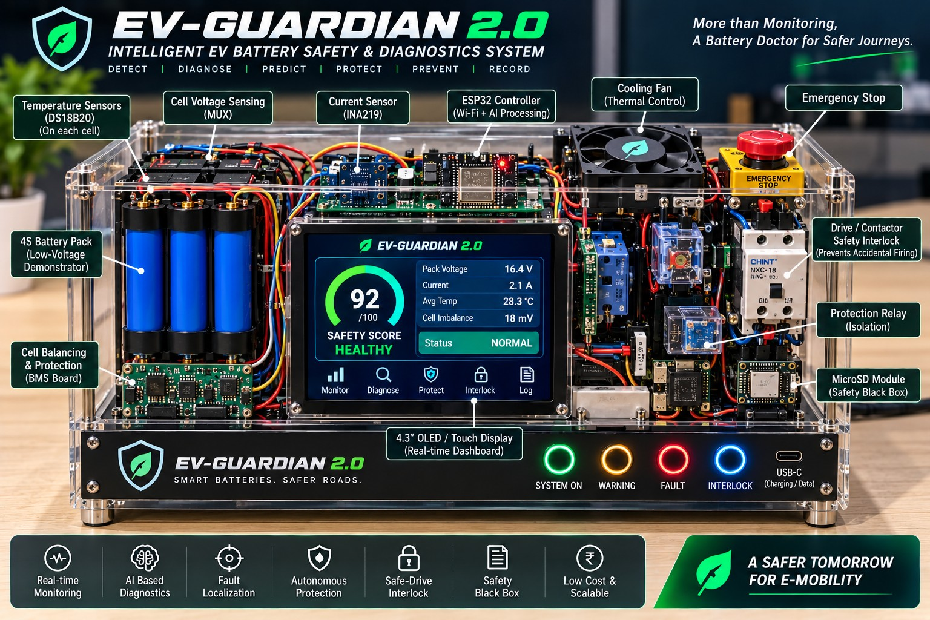
Figure 3.1: Concept render of the EV-GUARDIAN 2.0 demonstrator (prototype under development)
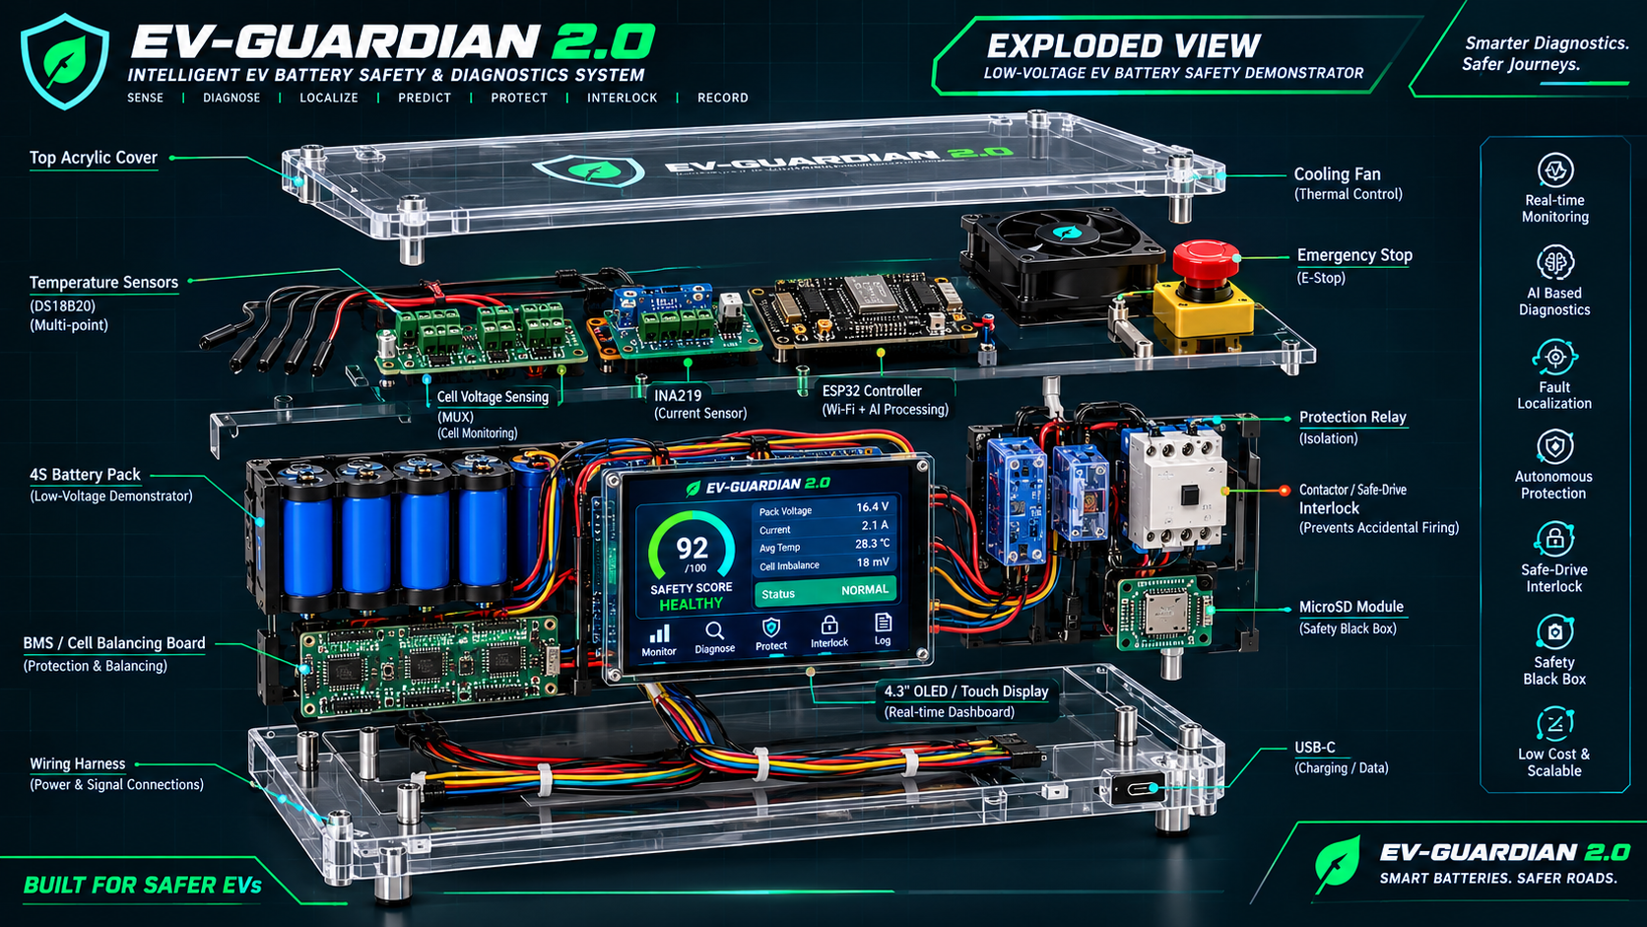
Figure 3.2: Exploded view of the EV-GUARDIAN 2.0 low-voltage demonstrator
The functional architecture is shown in Figure 3.3. Sensors feed the ESP32 edge controller, which performs signal validation and feature extraction. The rule engine and the anomaly score produce the fault localization, the Safety Score and the explanation. The decision then drives four outputs: warning (buzzer and LEDs), cooling (fan), protection (relay) and the Safe-Drive Interlock. All results are also shown on the OLED display and the web dashboard and are stored in the microSD Safety Black Box.
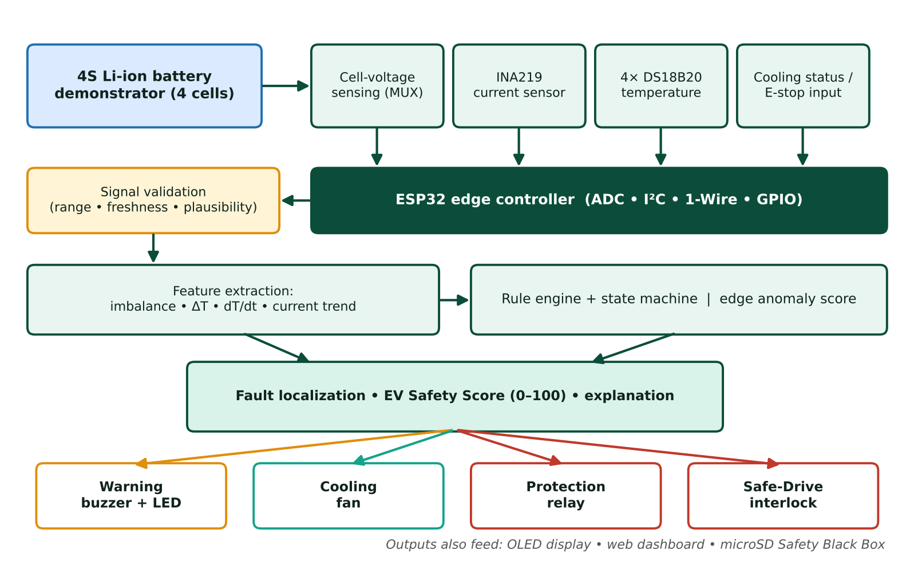
Figure 3.3: Functional architecture of EV-GUARDIAN 2.0

3.4 HARDWARE COMPONENTS
The hardware is built from widely available, low-cost modules. Table 3.2 lists the components, their purpose and the estimated cost, and Figure 3.4 shows the distribution of the cost. The final bill of materials must be replaced with actual purchase prices when the components are procured; the project repository also contains the bill of materials (BOM.md and bill_of_materials.csv).
Table 3.2: Hardware components and estimated cost
Component | Purpose | Est. cost (₹)
ESP32 DevKit | Main controller, Wi-Fi and sensor acquisition | 500
4S cells + BMS board | Safe low-voltage demonstrator pack with cell balancing and protection | 750
4× DS18B20 sensors | Multi-point temperature monitoring | 400
INA219 module | Pack current measurement over I²C | 120
Cell-voltage sensing (MUX) | Individual cell voltage measurement | 150
OLED / touch display | Local safety dashboard and Safety Score | 150
Relay, 5 V fan, buzzer and LEDs | Protection / isolation output, thermal demonstration, alerts | 380
microSD module + emergency stop | Safety Black Box logging and manual safe shutdown | 350
Enclosure, wiring, connectors | Mechanical and electrical integration | 1,000
Itemised total |  | 3,800
Miscellaneous allowance (spares, connectors, shipping) | Allowance to cover the difference to the budget figure | 600
Estimated budget build | Showcase version: approximately ₹6,000–₹7,000 | ≈ 4,400

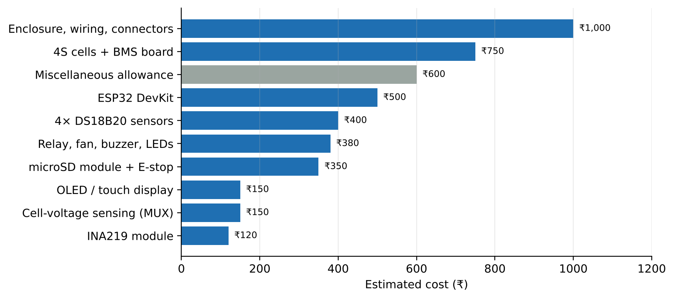
Figure 3.4: Distribution of the estimated hardware cost
An optional MPU6050 motion sensor may be added for vibration trend sensing. The emergency-stop push button is wired as a hard-wired input so that it can force a safe state independently of the software.

3.5 ELECTRICAL INTERFACING AND PIN ASSIGNMENT
Figure 3.5 shows how the modules are connected to the ESP32. Sensors are placed on the left of the controller and the outputs on the right. A common ground and a fuse are used for the whole demonstrator, and the emergency-stop contact is placed in series with the drive-permit path.
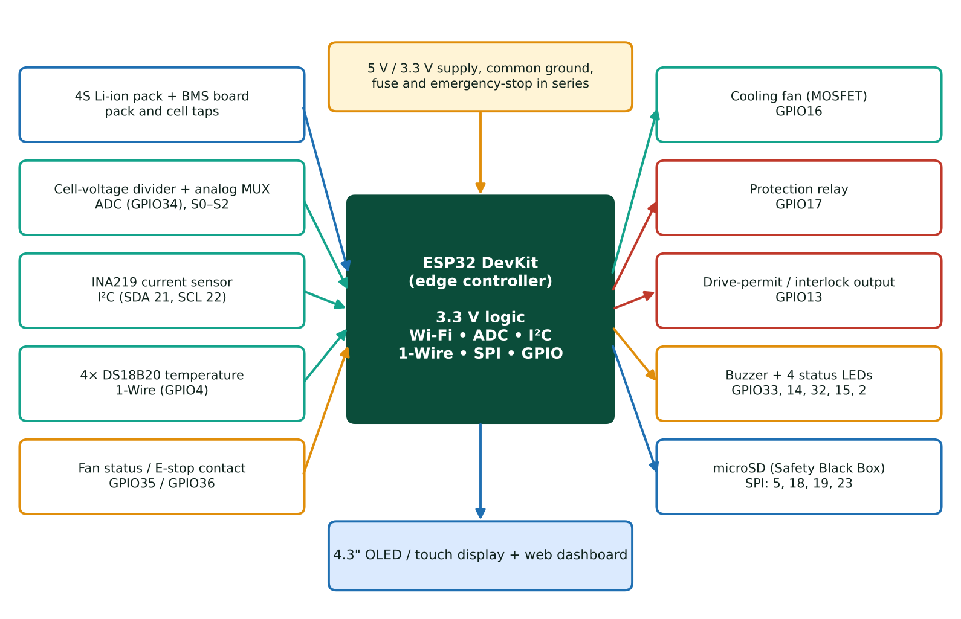
Figure 3.5: Hardware interconnection of EV-GUARDIAN 2.0
- Cell voltage: the cell taps are scaled by resistor dividers so that the highest tap (about 16.8 V for a fully charged 4S pack) stays below the ADC input limit of the ESP32; an analog multiplexer selects one tap at a time, and the voltage of each cell is obtained from the difference between adjacent taps after calibration against a multimeter.
- Pack current: the INA219 measures pack current through a shunt and reports it over the I²C bus.
- Temperature: four DS18B20 sensors share one 1-Wire bus, one sensor on each cell, giving four-point thermal monitoring.
- Cooling and emergency stop: the fan feedback / status and the emergency-stop contact are read as digital or analog inputs.
- Outputs: the buzzer, LEDs, cooling fan, protection relay and drive-permit output are driven from GPIO pins through a relay / MOSFET stage; the display and microSD module are connected over their serial interfaces.
Table 3.3 gives a proposed pin assignment. The final assignment will be fixed during wiring and may differ from this table.
Table 3.3: Proposed ESP32 pin assignment (to be confirmed during wiring)
Signal | Interface | ESP32 pin | Notes
Cell-voltage ADC | Analog (ADC1) | GPIO34 | Through divider and analog MUX
MUX select S0, S1, S2 | Digital output | GPIO25, 26, 27 | Selects the cell tap
INA219 current sensor | I²C | SDA 21, SCL 22 | Address 0x40
DS18B20 ×4 | 1-Wire | GPIO4 | Shared bus with pull-up resistor
Fan status | Input | GPIO35 | Cooling feedback
Emergency stop | Input | GPIO36 | External pull-up; also hard-wired in the permit path
Cooling fan driver | Output (MOSFET) | GPIO16 | Low-voltage fan
Protection relay | Output (relay driver) | GPIO17 | Isolation output
Drive-permit output | Output (relay / LED) | GPIO13 | Fail-safe: de-energized means no permit
Buzzer and status LEDs | Output | GPIO33, 14, 32, 15, 2 | Buzzer; SYSTEM ON, WARNING, FAULT, INTERLOCK
microSD module | SPI | GPIO5, 18, 19, 23 | Safety Black Box
Display / touch | Module-specific (serial) | As per module | To be fixed with the selected display

3.6 MECHANICAL AND ENCLOSURE DESIGN
The enclosure is a transparent acrylic case so that the internal modules are visible during a demonstration. As seen in the exploded view of Figure 3.2, the construction is arranged in layers held by standoffs:
- Top acrylic cover: carries the project name and protects the upper layer.
- Sensing and control layer: temperature sensor leads, the cell-voltage sensing (MUX) board, the INA219 current sensor, the ESP32 controller, the cooling fan and the emergency-stop button.
- Power and display layer: the 4S battery pack with the BMS / cell-balancing board, the 4.3-inch display, the protection relays, the contactor representing the Safe-Drive Interlock and the microSD module.
- Base layer: the wiring harness for power and signal connections and the USB-C port for charging and data.
The front panel carries four indicator LEDs (SYSTEM ON, WARNING, FAULT and INTERLOCK) and the USB-C port. Separate power and signal harnesses and a fuse close to the battery reduce noise pick-up and accidental shorts.

3.7 SOFTWARE STACK
Table 3.4: Software stack and diagnostic logic
Layer | Implementation
Firmware | ESP32 C/C++ with the Arduino framework
Acquisition | ADC, I²C, 1-Wire and GPIO interfaces
Filtering | Moving average / exponential smoothing with range checks
Safety rules | Thresholds, hysteresis, multi-sensor correlation and a state machine
Anomaly layer | Lightweight edge anomaly score; optional enhancement added after the rule-based baseline
Dashboard | ESP32 local web UI; optional cloud extension
Logging | microSD event log with timestamp, sensor values, score, diagnosis and action
Interlock | Deterministic finite-state machine with a fail-safe no-permit default
Simulator | Browser-based SIL simulator (HTML, CSS and JavaScript)

3.8 FIRMWARE ARCHITECTURE AND TASK SCHEDULE
The firmware is organized in the layers shown in Figure 3.6. Lower layers acquire and validate data, the middle layers compute features and decisions, and the upper layers act and present the result. The deterministic rules and the interlock state machine form the safety-critical path and do not depend on the anomaly layer.
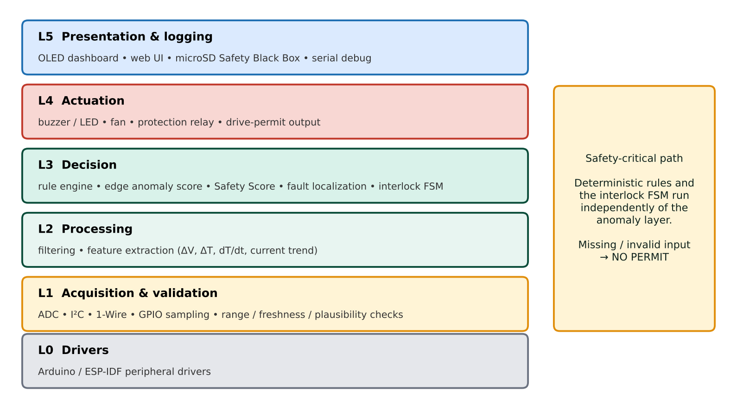
Figure 3.6: Layered firmware architecture
The tasks run at different rates because the signals change at different speeds, as listed in Table 3.5. The safety task has the highest priority so that a slow display refresh or web request can never delay a protective decision. The DS18B20 sensors need up to 750 ms for a 12-bit conversion, so temperatures are updated at a slower rate than the electrical signals.
Table 3.5: Proposed firmware task schedule
Task | Period | Priority | Function
Safety task | 100 ms | Highest | Sample electrical inputs, validate, evaluate rules, update interlock
Temperature task | 1 s | High | Start and read the DS18B20 conversion, update thermal features
Diagnosis task | 500 ms | Medium | Anomaly score, Safety Score, fault localization
Display task | 250 ms | Low | Refresh the OLED dashboard and indicator LEDs
Logging task | 1 s and on event | Low | Write Safety Black Box records to the microSD card
Web server | Background | Lowest | Serve the local dashboard

3.9 WORKING LOGIC
The firmware runs a repeating cycle, shown as a flowchart in Figure 3.7. In each cycle, the controller reads all inputs, validates them, extracts features, evaluates the safety rules and anomaly score, localizes the suspected cell or condition and calculates the Safety Score. If a critical fault exists or any interlock input is invalid, the drive permit is blocked and an alarm, protective output and event log are generated. Otherwise the permit is allowed only when all required conditions are healthy. The diagnosis, reason and recommendation are then displayed and the cycle continues.
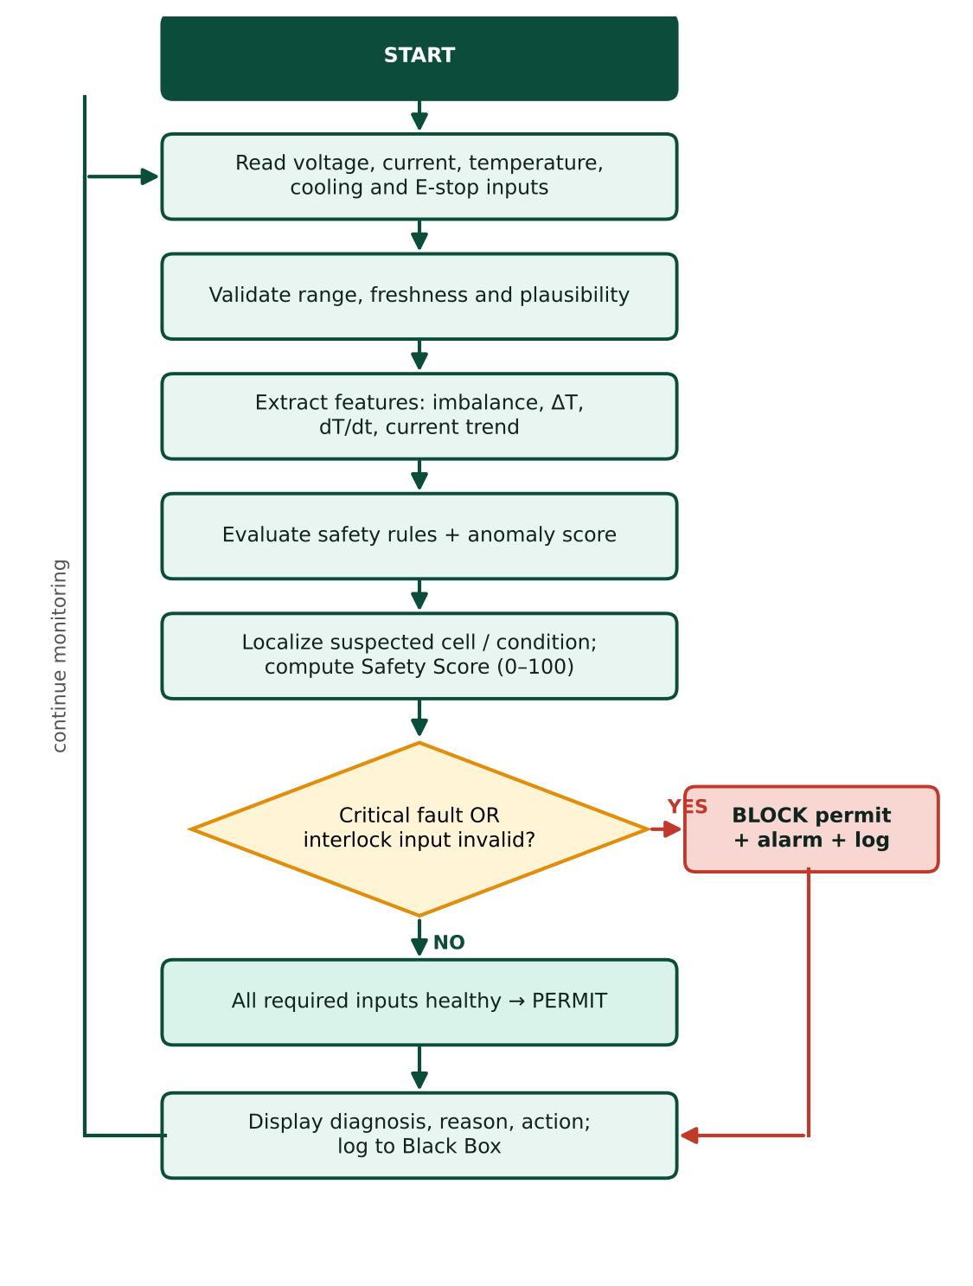
Figure 3.7: Decision flow (working logic) of EV-GUARDIAN 2.0

3.10 SIGNAL VALIDATION
Before any value is used, the following checks are applied. A reading that fails any check is flagged invalid, and if the signal is a required safety input the interlock moves to its fail-safe state.
- Range check: the value must lie inside the physically possible range of the sensor.
- Freshness check: the sample must have been updated within the allowed time window; missing or stale data is invalid.
- Plausibility check: the value must be consistent with related signals and with its own recent history (for example, a temperature that jumps by an impossible amount between two samples).

3.11 FILTERING AND FEATURE EXTRACTION
Raw samples are smoothed with an exponential filter to suppress noise while keeping a fast response to genuine changes:
x̂_{k} = α · x_{k} + (1 − α) · x̂_{k−1} (0 < α ≤ 1)
From the validated and filtered signals, the following features are then computed in every cycle:
ΔV_{cell} = V_{cell,max} − V_{cell,min} (cell-voltage imbalance)
ΔT = T_{max} − T_{min} (temperature difference across sensors)
dT/dt = (T_{k} − T_{k−n}) / (n · Δt) (temperature rise rate)
In addition, the current trend and the consistency between redundant signals are evaluated. The cell with the largest voltage deviation from the pack mean, or with the highest temperature and rise rate, becomes the suspected location. Computing dT/dt over several samples instead of two consecutive samples reduces the effect of sensor resolution and noise.

3.12 RULE ENGINE AND SEVERITY CLASSIFICATION
The rule engine compares the features with configurable limits, using hysteresis so that the state does not chatter when a value hovers around a limit, and uses multi-sensor correlation so that a single noisy sensor does not by itself cause a critical decision. Table 3.6 gives indicative settings. These values are illustrative and must be calibrated for the actual cells during hardware testing.
Table 3.6: Indicative rule settings (to be calibrated on hardware)
Parameter | Monitor | Warning | Critical
Cell-voltage imbalance ΔV_{cell} | > 30 mV | > 60 mV | > 100 mV
Maximum cell temperature | > 37 °C | > 42 °C | > 50 °C
Temperature rise rate | Above normal trend | High | Very high with rising ΔT
Pack current | > 12 A | > 15 A | > 25 A
Sensor validity | — | Optional sensor invalid | Required sensor invalid → fail-safe
Cooling status | — | Cooling requested | Cooling failed while temperature rising

The final severity class is one of NORMAL, MONITOR, WARNING or CRITICAL, taken as the more severe of the rule result and the score band described in Section 3.14.

3.13 EDGE ANOMALY SCORE
The anomaly layer is intentionally lightweight so that it can run on the ESP32 without a cloud connection. For each monitored feature x (for example dT/dt, ΔV_{cell} and the current trend), an exponentially weighted mean and variance of the residual are maintained, and a normalized residual is computed:
r_{k} = x_{k} − μ_{k−1}, μ_{k} = β · x_{k} + (1 − β) · μ_{k−1}, z_{k} = r_{k} / σ_{k}
A feature is flagged as anomalous when |z| exceeds a limit (for example 3) for several consecutive samples, and the anomaly score is the largest normalized deviation among the features, limited to the range 0 to 1. The anomaly score can raise the severity from NORMAL to MONITOR or from MONITOR to WARNING and can add a “trend abnormal” reason to the explanation, but it can never lower a severity decided by the deterministic rules and can never grant a drive permit. This keeps the safety decision independent of any learned behaviour.

3.14 EV SAFETY SCORE
The EV Safety Score is a prototype engineering indicator, not a certified automotive safety metric. It combines normalized risk contributions from voltage imbalance, thermal deviation, temperature rise rate, current abnormality, sensor validity and other enabled signals:
Risk = w_{V}·R_{V} + w_{T}·R_{T} + w_{ΔT}·R_{ΔT} + w_{I}·R_{I} + w_{S}·R_{S} + …
Safety Score = clamp(100 − Risk, 0, 100)
Each R term is normalized between 0 and 1 and multiplied by its weight, so the weight is the maximum number of points that the term can remove from the score. Table 3.7 gives initial weights that add up to 100. These are starting values for the firmware and must be tuned and validated during testing. The dashboard shows not only the score but also the top reasons for the reduction, for example “Cell 3 temperature rising” or “temperature rise rate abnormal”. In the dashboard the score is coloured green above 70, amber between 40 and 70, and red below 40; these bands are used as the NORMAL / MONITOR, WARNING and CRITICAL ranges in this prototype.
Table 3.7: Initial risk weights (maximum points removed from the score; to be tuned)
Risk term | Symbol | Weight (points) | Driven by
Cell-voltage deviation | w_{V} | 20 | ΔV_{cell}, undervoltage
Absolute cell temperature | w_{T} | 25 | Maximum cell temperature
Temperature rise and spread | w_{ΔT} | 20 | dT/dt and ΔT
Current abnormality | w_{I} | 15 | Pack current and trend
Sensor validity | w_{S} | 15 | Range, freshness, plausibility
Cooling availability | w_{C} | 5 | Fan feedback while temperature rises
Total |  | 100

3.15 FAULT LOCALIZATION
When the available measurements support it, the system names the suspected cell or condition. A single-cell thermal rise with stable neighbours points to that cell; a voltage deviation on one cell points to that cell; a current anomaly with normal cell values points to the pack or load; an implausible or missing reading points to the sensor network; and a rising temperature with unavailable cooling feedback points to the cooling subsystem. Fault localization depends on sensor placement and measurement quality, and its accuracy must be verified for the abnormal conditions represented during validation. Table 3.8 summarizes the fault matrix used by the diagnostic engine and the simulator.
Table 3.8: Fault matrix: evidence, localization and response
Condition | Evidence | Suspected location | Recommended action
Cell thermal abnormality | High cell temperature and rise rate | Cell 3 (example) | Cooling on + drive interlock
Cell undervoltage | Voltage deviation detected | Cell 2 (example) | Controlled isolation + drive interlock
Pack overcurrent | Current trend abnormal | Pack | Warning + isolation + drive interlock
Required sensor invalid | Freshness / plausibility check failed | Sensor network | Fail-safe no drive
Cooling feedback failure | Temperature rising + cooling unavailable | Cooling subsystem | Drive interlock
Multiple abnormal conditions | Voltage + temperature + current abnormal | C2 / C3 / pack | Maximum protection state

3.16 SAFE-DRIVE INTERLOCK
The Safe-Drive Interlock prevents unintended activation of the demonstrator’s drive / contactor request when critical safety conditions are not satisfied. It is demonstrated only with a low-voltage relay, LED or small DC-load interface, and never by controlling a real vehicle propulsion system. The interlock principle is: fail-safe default = no drive / contactor permit whenever a required safety input is missing, invalid or critical. Table 3.9 lists the checks and Figure 3.8 shows the state machine.
Table 3.9: Safe-Drive Interlock checks
Safety check | Required state | If invalid
Battery voltage | Within the configured safe range | Block permit
Temperature | Within the configured range and no abnormal rise trend | Block + warning / cooling
Current | Within the configured test range | Block + warning
Sensor validity | All required sensors plausible and available | Fail-safe block
Emergency stop | Released | Block
Critical diagnostic state | No critical fault | Block + alarm + log
Charger / drive request logic | Valid state for the demonstration | Block

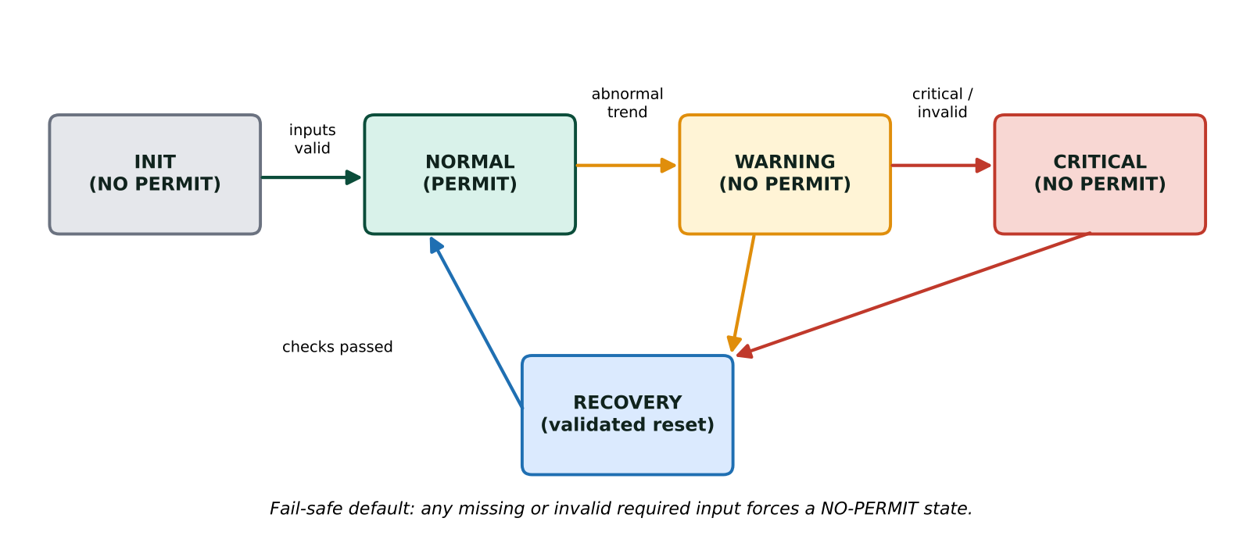
Figure 3.8: Safe-Drive Interlock finite-state machine
The permit is granted only in the NORMAL state. From WARNING or CRITICAL the system enters a RECOVERY state, and the permit is restored only after the faults have cleared and the inputs have been revalidated through a defined reset sequence. The drive-permit output is wired so that a de-energized output means “no permit”; a power loss or a controller reset therefore also removes the permit.

3.17 CLOSED-LOOP PROTECTION AND SAFETY BLACK BOX
Depending on the severity and the diagnosis, the controller issues one or more protective actions: a buzzer / LED warning, a cooling request that switches the fan on, a controlled isolation through the protection relay, and the interlock block. Every event is written to the microSD card as a Safety Black Box record so that the sensor sequence, diagnosis, score, action and interlock state can be reviewed after the event. The recorded fields are given in Table 3.10.
Table 3.10: Safety Black Box record fields
Field | Description
Timestamp | Time of the sample or event
Sensor values | Cell voltages, pack current and four temperatures
Features | ΔV, ΔT, temperature rise rate, current trend
Safety Score | Score value and the top reasons for reduction
Diagnosis | Detected condition, suspected location and confidence
Action | Warning, cooling, isolation and interlock state
State | NORMAL / MONITOR / WARNING / CRITICAL and permit status

3.18 DASHBOARD AND USER INTERFACE
The local dashboard on the 4.3-inch display has five screens, selected from the icons at the bottom of the display: Monitor (pack voltage, current, average temperature and cell imbalance), Diagnose (detected condition, suspected location, evidence and recommended action), Protect (status of cooling, relay and warnings), Interlock (drive-permit state and the checks behind it) and Log (recent Safety Black Box events). The main screen shows the Safety Score as a gauge with a status line such as HEALTHY and NORMAL. The same information is available on a local web page served by the ESP32.
The four front-panel LEDs show SYSTEM ON (green), WARNING (amber), FAULT (red) and INTERLOCK (blue); every state is also written as text so that colour is never the only indicator.

3.19 SOFTWARE-IN-THE-LOOP SIMULATOR
To validate the diagnostic workflow before and alongside hardware construction, a browser-based software-in-the-loop (SIL) simulator was developed. It reproduces the user interface and the decision flow using virtual sensor data, and no physical battery is connected. The simulator contains the following panels:
- 3D virtual battery and sensor network: four cells (C1–C4), temperature sensors, the edge diagnostic board and an animated cooling fan.
- Fault injection controls: Normal, C3 Thermal, C2 Undervoltage, Overcurrent, Sensor Failure, Cooling Failure, Multiple Fault and Recover.
- Telemetry and score: pack voltage, current, maximum temperature, state of charge and a trend chart, with a 0–100 Safety Score gauge and its reason.
- Diagnostics: per-cell temperature and voltage, detected condition, suspected location, evidence and recommended action.
- Protection and Black Box: the drive permit, the status of sensors, cooling and interlock, and a time-stamped event history.
In the simulator, each injected fault ramps the relevant virtual signals over five steps, reduces the Safety Score along a scripted profile, and then applies the final diagnosis, protective action and interlock block. The scripted score profile is a demonstration of the intended behaviour; the formula-based score of Section 3.14 is to be implemented and tuned in the ESP32 firmware. The simulator is a single HTML file included in the project repository (Appendix II).

3.20 TEST PLAN AND SAFETY PRECAUTIONS
All hardware tests will use safe, controlled conditions. The planned way of creating each abnormal condition is listed below.
- Cell-voltage deviation: a test signal is injected at one tap input through a divider or potentiometer; the battery cells are not over-discharged.
- Temperature rise: a DS18B20 probe is warmed in a controlled warm-water bath or with a small, limited heat source well below any hazardous level.
- Overcurrent: a resistive or electronic load is used within the current limit of the supply and the fuse.
- Sensor failure: a sensor is disconnected to confirm that the freshness / plausibility checks block the permit.
- Cooling failure: the fan-feedback input is disconnected while the temperature test signal rises.
Every test uses a current-limited supply with an inline fuse, a hard-wired emergency stop, a ventilated area under faculty supervision and a fire-safe surface; no cell is punctured, crushed, short-circuited or overcharged, and any unexpected heating or swelling stops the test immediately.

3.21 DEVELOPMENT PLAN
Table 3.11: Development plan
Stage | Target work
Week 1 | Finalize architecture, enclosure, sensor interfaces and safety boundaries
Week 2 | ESP32 acquisition and local / dashboard visualization
Week 3 | Diagnostic rules, Safety Score and fault localization
Week 4 | Protection outputs, Safety Black Box and Safe-Drive Interlock
Week 5 onward | Edge anomaly model, repeatable validation scenarios, UI refinement and demonstration preparation

CHAPTER 4
RESULT

4.1 TEST METHOD AND SCOPE
The results in this chapter were obtained from the software-in-the-loop simulator described in Section 3.19, using controlled, simulated faults on virtual sensor data. The nominal condition of the virtual 4S pack is 16.08 V, 8.2 A, a maximum temperature of 32 °C, and a Safety Score of 94. Each fault is injected from the dashboard and the simulator is observed for five steps, after which the diagnosis, protective action and interlock state are recorded. The hardware prototype is under development; therefore, no result in this chapter should be read as a measurement on a physical battery.

4.2 SIMULATOR OUTPUT FOR REPRESENTATIVE SCENARIOS
Figure 4.1 shows the dashboard in the healthy condition. All inputs are valid, the Safety Score is 94, the state is SAFE and the drive permit is allowed.
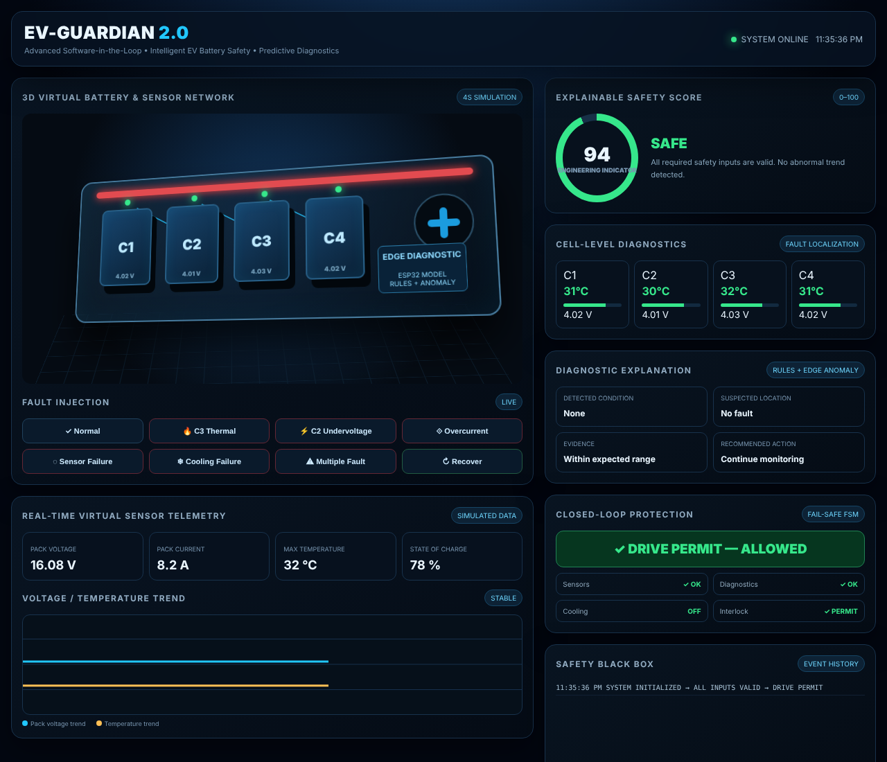
Figure 4.1: Simulator dashboard in the normal (healthy) condition
Figure 4.2 shows the result of the C3 thermal fault. The temperature of cell C3 rises to 48 °C, the score falls to 50, the suspected location is identified as Cell 3 and the recommended action is “cooling on + drive interlock”. The drive permit is blocked, the interlock shows BLOCKED and the Black Box records the event.
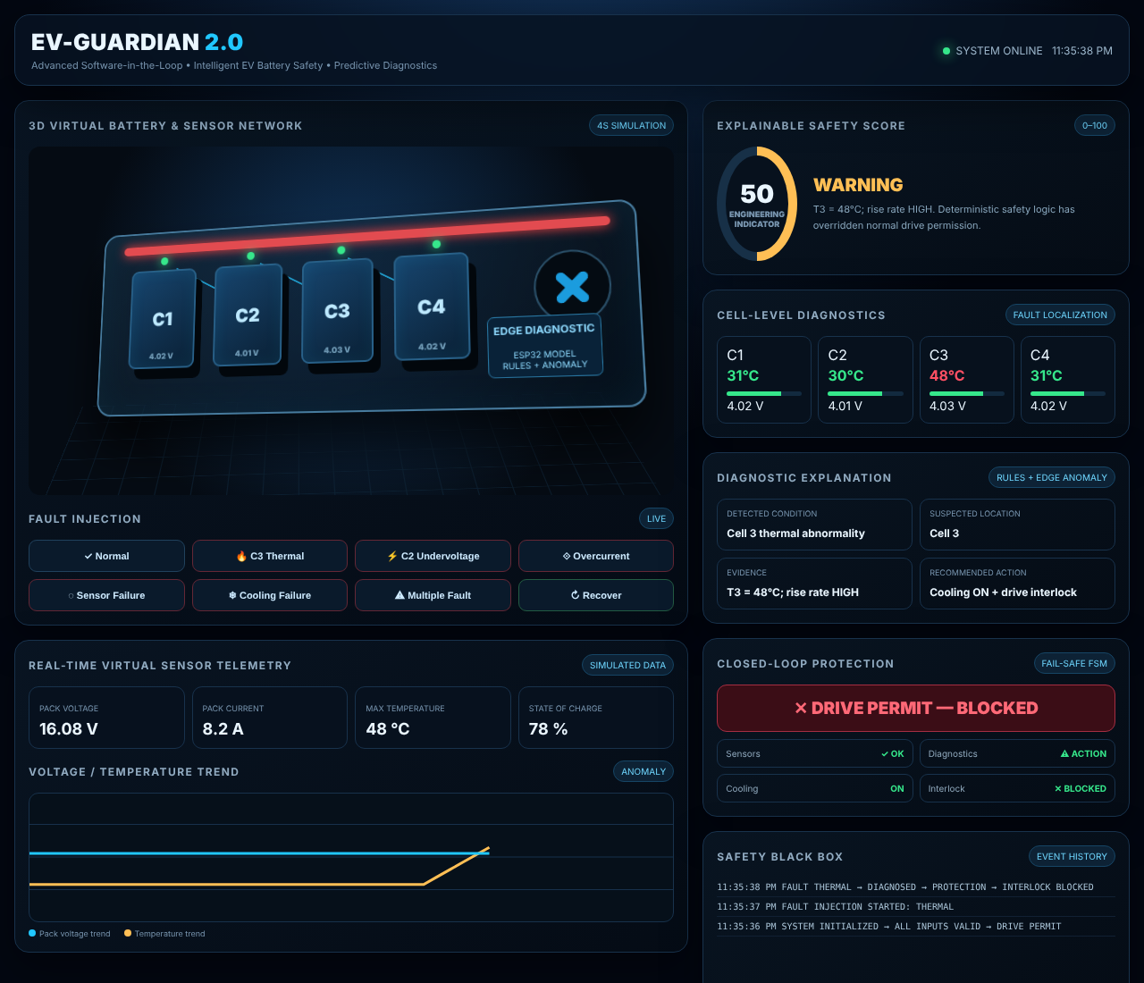
Figure 4.2: Simulator dashboard after the C3 thermal fault injection
Figure 4.3 shows the multiple-fault scenario, in which temperature, current and voltage become abnormal together. The state becomes CRITICAL, the score falls to 30 and the maximum protection state is applied.
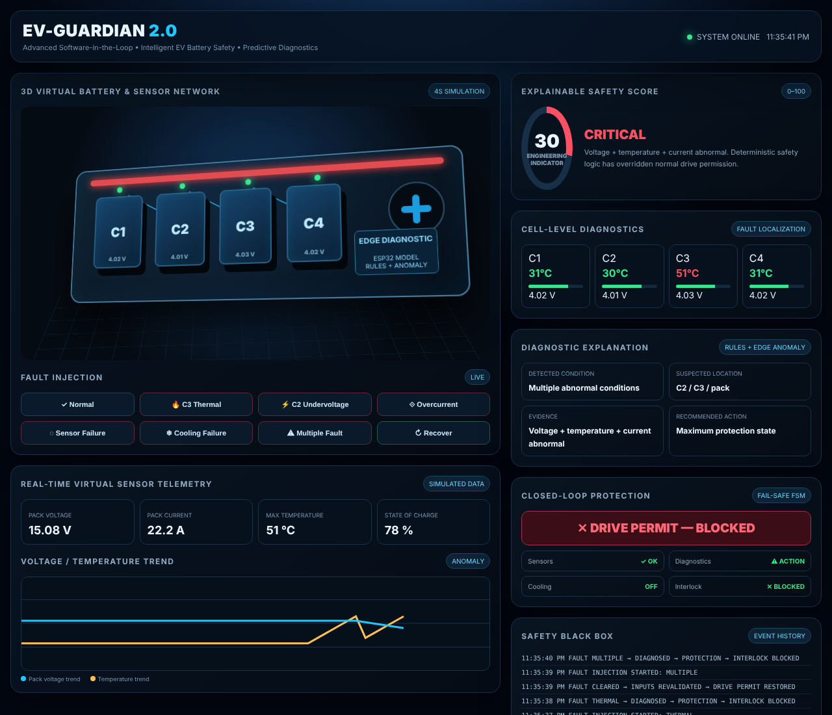
Figure 4.3: Simulator dashboard after the multiple-fault injection

4.3 FAULT SCENARIO DEFINITIONS
Each fault is generated by ramping the affected virtual signals over five steps (n = 1 to 5). The simulator advances one step every 220 ms. Table 4.1 gives the ramp of every scenario and the value reached at the last step.
Table 4.1: Signal ramps used for the fault scenarios
Scenario | Signal(s) changed | Ramp (n = 1 … 5) | Value at n = 5
C3 thermal | Cell 3 temperature | 32 + 3.2 n °C | 48 °C
C2 undervoltage | Pack voltage | 16.08 − 0.28 n V | 14.68 V
Overcurrent | Pack current | 8.2 + 2.5 n A | 20.7 A
Sensor failure | Required sensor validity | Telemetry unchanged; validity check fails at the end | INVALID
Cooling failure | Cell 3 temperature; fan status | 32 + 2.7 n °C; fan feedback FAIL at the end | 45.5 °C
Multiple fault | Temperature, current, voltage | 32 + 3.8 n °C; 8.2 + 2.8 n A; 16.08 − 0.2 n V | 51 °C, 22.2 A, 15.08 V

4.4 SCENARIO-WISE RESULTS
Table 4.2 summarizes the final values of all scenarios. In every injected scenario the Safety Score decreased, the affected location was identified, the drive permit was blocked and the event was logged.
Table 4.2: Results of the simulated fault scenarios (value after step 5)
Scenario | Max temp (°C) | Current (A) | Pack voltage (V) | Score | State | Suspected location | Permit
Normal | 32 | 8.2 | 16.08 | 94 | SAFE | No fault | Allowed
C3 thermal | 48 | 8.2 | 16.08 | 50 | WARNING | Cell 3 | Blocked
C2 undervoltage | 32 | 8.2 | 14.68 | 56 | WARNING | Cell 2 | Blocked
Overcurrent | 32 | 20.7 | 16.08 | 48 | WARNING | Pack | Blocked
Sensor failure | 32 | 8.2 | 16.08 | 30 | CRITICAL | Sensor network | Blocked
Cooling failure | 45.5 | 8.2 | 16.08 | 48 | WARNING | Cooling subsystem | Blocked
Multiple fault | 51 | 22.2 | 15.08 | 30 | CRITICAL | C2 / C3 / pack | Blocked

4.4.1 C3 thermal fault
The temperature of cell C3 rises by 3.2 °C per step to 48 °C while the other cells stay at 30–32 °C. The score falls from 94 to 50 and the state becomes WARNING. The diagnosis is “Cell 3 thermal abnormality” with the evidence “T3 = 48 °C; rise rate HIGH”. The recommended action is cooling on plus the drive interlock, the cooling status changes to ON, the fan animation starts and the drive permit is blocked.

4.4.2 C2 undervoltage fault
The pack voltage falls from 16.08 V to 14.68 V and the score falls to 56. The diagnosis is “Cell 2 undervoltage” with the evidence “voltage deviation detected”, and the action is controlled isolation plus the drive interlock. This scenario shows how a deviation of one cell is attributed to a specific cell rather than reported as a general low-voltage alarm.

4.4.3 Overcurrent fault
The pack current rises from 8.2 A to 20.7 A, above the 15 A warning limit of Table 3.6, and the score falls to 48. The diagnosis is “pack overcurrent” with the evidence “current trend abnormal”, localized to the pack because all cell temperatures and voltages remain normal. The action is a warning, isolation and the drive interlock.

4.4.4 Sensor failure
In this scenario the telemetry values do not change, because the fault is an invalid or stale sensor signal. The freshness / plausibility check fails, the diagnosis is “required sensor invalid” localized to the sensor network, the state becomes CRITICAL, the score falls to 30 and the sensor status changes to INVALID. The fail-safe rule blocks the drive permit, demonstrating that the absence of trustworthy data is treated as unsafe rather than as “no problem”.

4.4.5 Cooling failure
The temperature rises by 2.7 °C per step to 45.5 °C while the cooling status changes to FAIL, so no cooling action is available. The diagnosis is “cooling feedback failure” localized to the cooling subsystem, the score falls to 48, and the interlock blocks the permit. The fan does not spin, unlike in the thermal scenario, which shows that the system distinguishes a hot cell with working cooling from a hot cell without cooling.

4.4.6 Multiple fault
Temperature, current and voltage become abnormal together (51 °C, 22.2 A and 15.08 V). The state becomes CRITICAL, the score falls to 30, the suspected location is “C2 / C3 / pack” and the maximum protection state is applied. This confirms that several simultaneous abnormal conditions reduce the score more strongly than any single fault.

4.5 SAFETY SCORE AND SIGNAL TRENDS
Figure 4.4 shows the fall of the Safety Score with each simulation step for the injected faults, together with the green / amber / red bands. The multiple-fault and sensor-failure profile falls fastest and enters the critical band, while single faults settle in the warning band. Figure 4.5 shows the corresponding ramps of temperature, current and voltage, and Figure 4.6 compares the final score of every scenario.
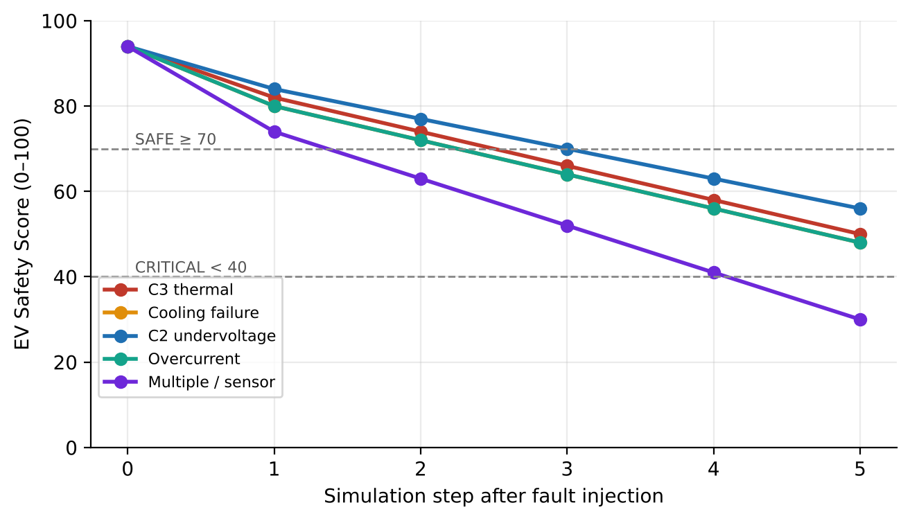
Figure 4.4: EV Safety Score versus simulation step for the injected faults
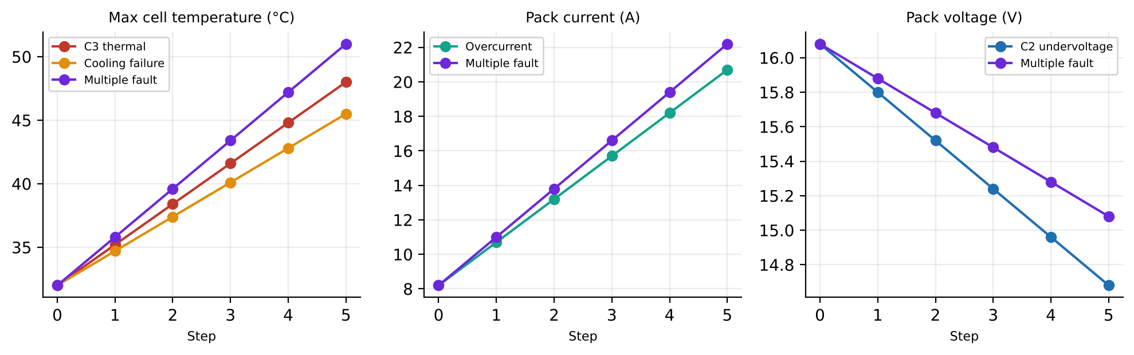
Figure 4.5: Virtual temperature, current and voltage trends during fault injection
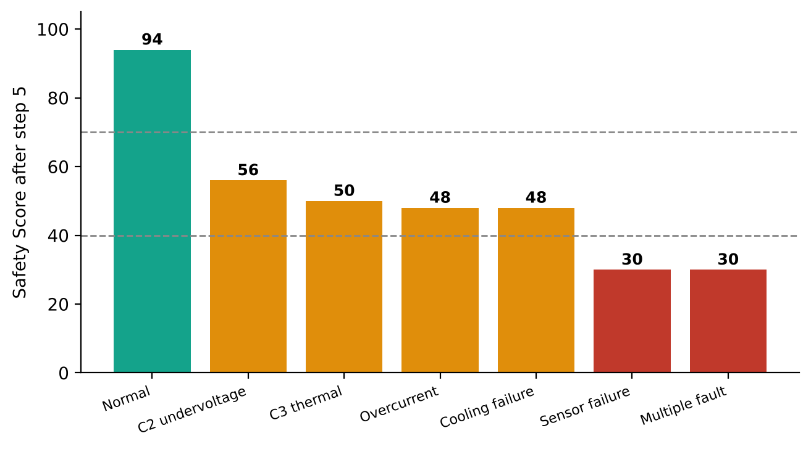
Figure 4.6: Final EV Safety Score of each simulated scenario

4.6 INTERLOCK BEHAVIOUR AND SAFETY BLACK BOX
For every scenario the interlock changed from PERMIT to BLOCKED when the fault was applied. After the Recover command the simulator returned to the healthy state only after the inputs were revalidated and the permit was restored. Table 4.3 summarizes the interlock behaviour, and the Safety Black Box recorded the sequence of events. A typical record sequence for the thermal fault is shown below.
Table 4.3: Interlock behaviour for different input conditions
Input condition | System state | Drive permit
All inputs valid, no fault, E-stop released | NORMAL | Allowed
One abnormal condition (warning level) | WARNING | Blocked
Critical fault or several faults together | CRITICAL | Blocked
Required sensor invalid or stale | CRITICAL (fail-safe) | Blocked
Emergency stop pressed | CRITICAL | Blocked
Fault cleared but inputs not yet revalidated | RECOVERY | Blocked
Fault cleared and inputs revalidated | NORMAL | Restored

SYSTEM INITIALIZED -> ALL INPUTS VALID -> DRIVE PERMIT
FAULT INJECTION STARTED: THERMAL
FAULT THERMAL -> DIAGNOSED -> PROTECTION -> INTERLOCK BLOCKED
FAULT CLEARED -> INPUTS REVALIDATED -> DRIVE PERMIT RESTORED

4.7 COMPARISON WITH A THRESHOLD-ONLY ALARM
Table 4.4 compares the information that a simple threshold alarm typically provides with the information produced by EV-GUARDIAN 2.0 for the same scenario. The right-hand column is taken directly from the simulator output; the middle column is a general description of a limit-only alarm and not a measurement of any specific product.
Table 4.4: Information provided by a threshold-only alarm and by EV-GUARDIAN 2.0
Scenario | Typical threshold-only alarm | EV-GUARDIAN 2.0 output
C3 thermal | High-temperature alarm | Cell 3 thermal abnormality; T3 = 48 °C; rise rate HIGH; cooling ON + drive interlock
C2 undervoltage | Low-voltage alarm, often at pack level | Cell 2 undervoltage; voltage deviation detected; controlled isolation + interlock
Overcurrent | Over-current alarm | Pack overcurrent; current trend abnormal; warning + isolation + interlock
Sensor failure | May go unnoticed or show the last value | Required sensor invalid; freshness / plausibility failed; fail-safe no drive
Cooling failure | Temperature alarm only after the limit | Cooling feedback failure; temperature rising + cooling unavailable; drive interlock
Multiple fault | Several separate alarms | Multiple abnormal conditions at C2 / C3 / pack; maximum protection state

4.8 SIMULATED RESPONSE TIME
In the simulator each fault reaches its final diagnosis after five steps of 220 ms, that is, after about 1.1 s of simulated time, after which the interlock is blocked and the event is logged. This number describes the pacing of the demonstration and is not a measured hardware latency. The real detection latency depends on the sampling periods of Table 3.5 (100 ms for the electrical safety task and 1 s for temperature) and on the confirmation counts of the rules, and will be measured on the hardware prototype during validation.

4.9 VALIDATION MATRIX FOR THE HARDWARE PROTOTYPE
The simulator demonstrates the intended behaviour of the logic. The same scenarios are to be repeated on the low-voltage hardware using safe test signals. Table 4.5 gives the validation matrix and its current status.
Table 4.5: Validation matrix and status
Test | Input | Expected state | Pass condition | Status
Normal operation | Stable voltage, current, temperature | Normal | Score high; monitoring continues | Simulated
Cell imbalance | One cell-voltage input shifted by test signal | Monitor / Warning | Imbalance flagged with suspected cell | Simulated (C2 undervoltage)
Temperature rise | Controlled increasing temperature trend | Warning | Risk increases; cooling recommended | Simulated
Critical fault | Combination of abnormal test signals | Critical | Alarm, protection output and log | Simulated
Unsafe drive request | Request with an invalid safety condition | Interlock | Activation blocked, warning, log | Simulated
Recovery | Signals returned to a valid state | Normal / Monitor | Cleared only after recovery checks | Simulated
All of the above on hardware | Safe test signals on the demonstrator | — | As above | Pending hardware build

4.10 DISCUSSION AND LIMITATIONS
- The simulated results show that combining several signals gives a more informative output than a single alarm: each scenario produced a condition, a location, evidence and an action.
- The Safety Score profile in the simulator is scripted; the weights of the formula in Section 3.14 must be tuned and validated against real measurements.
- Fault localization depends on sensor placement, measurement quality and the abnormal conditions represented during validation.
- The ESP32 analog-to-digital converter has limited accuracy and linearity; detecting imbalances of a few tens of millivolts reliably may require calibration or an external precision ADC.
- A low-voltage demonstrator does not prove production EV performance or regulatory compliance, and the machine-learning layer must never be the sole safety mechanism.

CHAPTER 5
CONCLUSION AND FUTURE TRENDS

5.1 CONCLUSION
This project presented EV-GUARDIAN 2.0, a low-cost embedded diagnostic layer for an EV battery demonstrator that follows the sequence sense, diagnose, localize, predict, protect, interlock and record. The system integrates multi-parameter edge sensing, signal validation, fault localization, explainable diagnosis, a dynamic 0–100 Safety Score, automated protective response, a fail-safe Safe-Drive Interlock and a Safety Black Box in a single design.
The software-in-the-loop simulation of six controlled fault scenarios showed that the intended behaviour is achieved: the Safety Score fell, the affected cell or condition was identified, the drive permit was blocked and the event was recorded, and the permit returned only after the fault cleared and the inputs were revalidated. The estimated budget of about ₹4,400 makes the concept suitable as an educational demonstration platform. The hardware prototype is under development, and all further testing will use controlled simulated faults on low-voltage, current-limited hardware. The Safety Score is an engineering indicator, not a certified metric, and production use would need formal automotive validation.

5.2 KEY CONTRIBUTIONS
- An integrated, edge-first diagnostic and protection workflow for a low-voltage EV battery demonstrator, from sensing to logging.
- A hybrid diagnostic design with an explainable Safety Score, in which deterministic rules and the interlock are independent of the optional anomaly layer.
- A fail-safe Safe-Drive Interlock with a defined recovery sequence, and a browser-based SIL simulator with a public repository for reproducibility.

5.3 FUTURE TRENDS
- Cell-level state-of-charge (SoC), state-of-health (SoH) and remaining-useful-life (RUL) estimation.
- Time-series anomaly detection trained on real or validated datasets, and digital-twin or physics-informed models.
- CAN integration with a real BMS / vehicle controller, automotive-grade isolation and contactors, and secure event logs.
- Cloud-based fleet diagnostics and predictive maintenance; extension to e-scooters, cars, buses and charging infrastructure.

5.4 ALIGNMENT WITH SUSTAINABLE DEVELOPMENT GOALS
By making battery risk understandable and supporting safer EV operation and maintenance, the project contributes to SDG 7 (affordable and clean energy), SDG 9 (industry, innovation and infrastructure), SDG 11 (sustainable cities and communities) and SDG 13 (climate action).

APPENDIX I
CORE LOGIC PSEUDOCODE
The following pseudocode summarizes the main control cycle and the Safe-Drive Interlock. It is a design outline and not the final firmware. The repository file pseudocode.md holds the same outline.

A. Main control cycle
loop every sample period:
raw = readSensors() // V1-V4, I, T1-T4, fan, estop
ok = validate(raw) // range, freshness, plausibility
x = filter(raw) // moving average / smoothing
f = extractFeatures(x) // dVcell, dT, dTdt, current
rule = evaluateRules(f) // deterministic, with hysteresis
anom = anomalyScore(f) // optional edge model
loc = localize(f, ok) // suspected cell / condition
risk = sum(w[i] * R[i](f)) // normalized risk terms
score = clamp(100 - risk, 0, 100)
state = max(rule.severity, band(score))
permit = interlock(state, ok, estop) // see below
act(state, loc, permit) // buzzer, fan, relay, drive
show(score, loc, reason); logBlackBox(...)

B. Safe-Drive Interlock
function interlock(state, ok, estop):
if not allRequiredValid(ok): return NO_PERMIT // fail-safe
if estop == PRESSED: return NO_PERMIT
if state in (WARNING, CRITICAL): return NO_PERMIT
if voltageBad or currentBad or tempTrendBad:
return NO_PERMIT
if inRecovery and not recoveryOK: return NO_PERMIT
return PERMIT // only when all checks pass

C. Simulator controls
The SIL simulator provides eight controls: Normal, C3 Thermal, C2 Undervoltage, Overcurrent, Sensor Failure, Cooling Failure, Multiple Fault and Recover. Each fault control starts the injection, updates the virtual telemetry for five steps, and applies the final diagnosis, protective action and interlock state.

APPENDIX II
PROJECT REPOSITORY
All project files are published in a public GitHub repository, ev-guard, owned by the user account lokith0709:
https://github.com/lokith0709/ev-guard
The repository is released under the MIT license and holds the report, the figures, the bill of materials, the pseudocode and the simulator. Its README presents the project as the II-year B.E. ECE mini project of KPR Institute of Engineering and Technology (Autonomous), Coimbatore, by Team Electronova, November 2026, and states clearly that the SIL simulator is complete while the hardware prototype is under development and that all results come from simulated faults on virtual sensor data. Figure A.1 shows the repository page, and Table A.1 lists its files. To run the simulator, open index.html in any modern web browser.
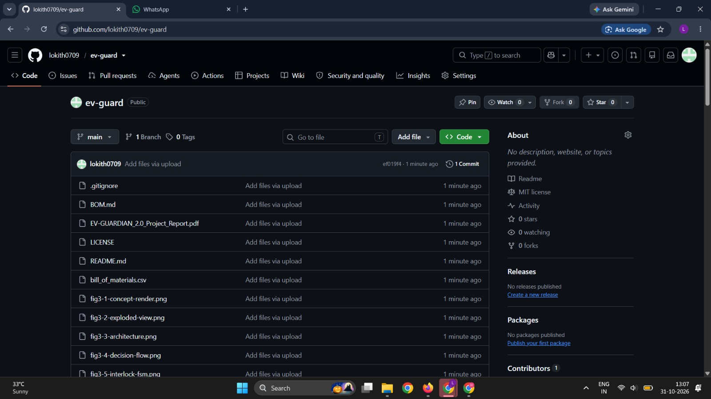
Figure A.1: Public GitHub repository of the project (lokith0709/ev-guard)
Table A.1: Files in the project repository
File | Description
README.md | Project overview: concept, status note and summary of the workflow
EV-GUARDIAN_2.0_Project_Report.pdf | Project report
index.html | Browser-based software-in-the-loop simulator (single HTML file)
pseudocode.md | Core control-cycle and interlock pseudocode
BOM.md and bill_of_materials.csv | Bill of materials in readable and spreadsheet form
fig3-1 … fig3-5 (PNG) | Concept render, exploded view, architecture, decision flow and interlock state machine
fig4-1 … fig4-5 (PNG) | Simulator screenshots (normal, C3 thermal, multiple fault), safety-score chart and signal trends
LICENSE and .gitignore | MIT license and repository settings

APPENDIX III
SIMULATOR IMPLEMENTATION NOTES
The simulator is written in plain HTML, CSS and JavaScript. The 3D battery view is built with CSS transforms, the charts with an inline SVG, and the logic with a small set of functions, listed in Table A.2. The fault ramps of Table 4.1 are implemented inside the function animateFault, and the diagnosis texts of Table 3.8 inside applyFinal.
Table A.2: Main functions of the simulator
Function | Purpose
run(type) | Entry point of the fault buttons; starts a fault injection, or resets to normal or recovers
normal(recover) | Restores the nominal values, clears the diagnosis and restores the drive permit
animateFault(type) | Ramps the virtual signals over five steps of 220 ms and updates the score and the trend chart
applyFinal(type) | Sets the final condition, location, evidence, recommended action, state, interlock block and log entry
gauge(n) | Draws the Safety Score gauge and colours it green, amber or red by band
plot(v, t) | Adds the latest voltage and temperature samples to the trend chart
log(x) | Writes a time-stamped line to the Safety Black Box panel

The score gauge uses the same bands as Section 3.14: green above 70, amber from 41 to 70 and red at 40 or below. After a fault the final score is the lower bound of the scripted profile, for example the profile for the thermal fault is the larger of 48 and (90 − 8n), which gives 50 at step 5.

REFERENCES
[1] G. L. Plett, Battery Management Systems, Volume I: Battery Modeling. Norwood, MA, USA: Artech House, 2015.
[2] G. L. Plett, Battery Management Systems, Volume II: Equivalent-Circuit Methods. Norwood, MA, USA: Artech House, 2016.
[3] L. Lu, X. Han, J. Li, J. Hua and M. Ouyang, “A review on the key issues for lithium-ion battery management in electric vehicles,” Journal of Power Sources, vol. 226, pp. 272–288, 2013.
[4] X. Feng, M. Ouyang, X. Liu, L. Lu, Y. Xia and X. He, “Thermal runaway mechanism of lithium ion battery for electric vehicles: A review,” Energy Storage Materials, vol. 10, pp. 246–267, 2018.
[5] H. Rahimi-Eichi, U. Ojha, F. Baronti and M.-Y. Chow, “Battery management system: An overview of its application in the smart grid and electric vehicles,” IEEE Industrial Electronics Magazine, vol. 7, no. 2, pp. 4–16, Jun. 2013.
[6] M. A. Hannan, M. M. Hoque, A. Hussain, Y. Yusof and P. J. Ker, “State-of-the-art and energy management system of lithium-ion batteries in electric vehicle applications: Issues and recommendations,” IEEE Access, vol. 6, pp. 19362–19378, 2018.
[7] ISO 26262:2018, Road vehicles — Functional safety, International Organization for Standardization, Geneva, 2018.
[8] Espressif Systems, ESP32 Series Datasheet.
[9] Texas Instruments, INA219 Zero-Drift, Bidirectional Current/Power Monitor With I²C Interface, Datasheet.
[10] Maxim Integrated (Analog Devices), DS18B20 Programmable Resolution 1-Wire Digital Thermometer, Datasheet.
[11] EV-GUARDIAN 2.0 project repository (ev-guard), GitHub, https://github.com/lokith0709/ev-guard (accessed Nov. 2026).

