Date: July 28, 2026
Madhav Karthickk
www.madhavk.com | https://github.com/Madhav-tech1212

Florida Retail Store Sales Analysis
End-to-End Data Analysis using Google BigQuery, SQL & Power BI

Contents
1. Executive Summary 2
2. Business Problem 2
3. Analysis Objectives 2
4. Dataset Description 3
5. Tools & Technologies 3
6. Project Workflow 4
6.1. End-to-End Data Pipeline 4
7. Data Preparation 5
7.1. Data Import 5
7.2. Data Integration 5
7.3. Feature Engineering 5
8. SQL Analysis 6
8.1. Business Metrics 6
8.2. SQL Scripts Used 6
9. Dashboard Design 6
9.1. Dashboard Objectives 7
9.2. Dashboard Components 7
9.3. Dashboard Design Principles 7
10. Key Business Insights 8
10.1. Store Performance 8
10. 2. Sales Trend Over Time 8
10. 3. Customer Demographics 8
10.4. Average Sales per Customer 8
10.5. Weather Influence on Sales 8
10.6. Weekday vs. Weekend Performance 9
10.7. Interactive Business Monitoring 9
Summary of Insights 9
11. Future Improvements 9
11.1. Optimize Staffing and Inventory 9
11.2. Implement Weather-Based Promotions 10
11.3. Expand High-Performing Store Operations 10
11.4. Develop Customer Loyalty Programs 10
11.5. Personalize Marketing Campaigns 10
11.6. Enhance the Analytics Platform 10
11.7. Future Roadmap 11
12. Conclusion 11

1. Executive Summary
This project analyzes two years of retail sales data to identify trends in customer behavior, outlet performance, and the influence of weather conditions on sales. Multiple datasets were integrated using SQL in Google BigQuery, and an interactive Power BI dashboard was developed to support business decision-making.

2. Business Problem
Retail organizations generate large volumes of sales, customer, and operational data every day. When this information is stored across separate datasets, it becomes difficult to understand the factors driving business performance and customer demand.
This project addresses that challenge by integrating retail sales, customer survey, and weather data into a unified analytical dataset using Google BigQuery and SQL. An interactive Power BI dashboard was then developed to enable stakeholders to monitor sales performance, compare store performance, analyze customer demographics, and evaluate the impact of weather conditions on sales.
The objective is to provide actionable insights that support data-driven decision-making in inventory management, workforce planning, promotional campaigns, and overall business strategy.

3. Analysis Objectives
- Integrate retail sales, customer survey, and weather datasets into a single analytics-ready dataset using Google BigQuery and SQL.
- Analyze sales trends across different retail stores, time periods, and customer segments.
- Evaluate the impact of weather conditions, including temperature and rainfall, on daily sales performance.
- Compare store performance using key metrics such as total sales, customer count, and average sales per customer.
- Identify customer demographic patterns by analyzing gender and family versus single customer distributions.
- Develop an interactive Power BI dashboard to visualize key performance indicators (KPIs) and enable data-driven business decisions.

4. Dataset Description
This project combines three datasets representing different aspects of retail operations. These datasets were integrated using Google BigQuery and SQL to create a single analytics-ready dataset for visualization in Power BI.
Dataset | Description | Key Fields
Sales | Contains daily sales transactions for four retail stores in Florida. | Date, Shop ID, Shop Name, Customers, Sales (USD)
Customer Survey | Contains customer demographic information collected through surveys. | Date, % Male, % Female, % Single, % Family
Weather | Contains daily weather observations for the retail locations. | Date, Average Temperature (°F), Humidity, Rain Indicator, Precipitation

5. Tools & Technologies
This project leverages a combination of cloud-based data warehousing, SQL, business intelligence, and version control tools to perform end-to-end data analysis and visualization.
Tool / Technology | Purpose
Microsoft Excel | Source of the raw sales, customer survey, and weather datasets.
Google BigQuery | Imported datasets, stored data, and performed SQL-based data transformation and integration.
SQL (GoogleSQL) | Joined multiple datasets, created derived columns, and prepared the final analytics dataset.
Microsoft Power BI | Designed interactive dashboards and visualized key business metrics and insights.
Visual Studio Code | Managed SQL scripts, project documentation, and repository structure.
Git | Tracked project changes through version control.
GitHub | Hosted the project repository and documentation for portfolio presentation.

6. Project Workflow
This project follows an end-to-end analytics workflow, starting from raw data collection and ending with an interactive business intelligence dashboard. The process involved data ingestion, transformation, integration, visualization, and reporting.
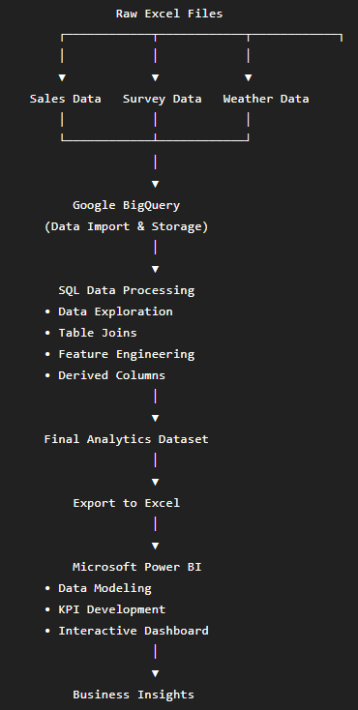

6.1. End-to-End Data Pipeline
Stage | Output
Data Collection | Raw Excel datasets
Data Storage | Google BigQuery tables
Data Transformation | SQL-based integrated dataset
Data Export | Analytics-ready Excel file
Data Visualization | Interactive Power BI dashboard
Business Outcome | Actionable insights for decision-making

7. Data Preparation
Before performing the analysis, the raw datasets were imported into Google BigQuery and prepared using SQL. The goal was to transform the data into a clean, integrated, and analytics-ready dataset that could be used for visualization in Microsoft Power BI.

7.1. Data Import
Three Excel datasets were imported into Google BigQuery as separate tables:
- Sales – Daily sales transactions for each retail store.
- Survey – Customer demographic information.
- Weather – Daily weather observations.
Each dataset was validated to ensure the data types and column names were correctly imported.

7.2. Data Integration
The datasets were combined using LEFT JOIN operations with the Date column as the common key. This created a unified dataset containing sales, customer demographics, and weather information.
FROM `Florida_Retail_Store.sales` s
LEFT JOIN `Florida_Retail_Store.survey` su
ON s.date = su.date
LEFT JOIN `Florida_Retail_Store.weather` w
ON s.date = w.date

7.3. Feature Engineering
Additional columns were created to simplify business analysis and improve dashboard usability.
Derived Column | Purpose
Day of Sale | Displays the weekday name (e.g., Monday, Tuesday).
Week of Year | Groups sales by ISO week number.
Year of Sales | Enables year-wise comparisons.
Week Type | Classifies records as Weekday or Weekend.
Average Sales per Customer | Calculates the average revenue generated per customer.

8. SQL Analysis
SQL played a central role in transforming and integrating the raw datasets into a single analytics-ready table. The analysis involved exploring the data, joining multiple datasets, creating derived fields, and generating business metrics that were later visualized in Power BI.

8.1. Business Metrics
The transformed dataset enabled the calculation of several business metrics used in the dashboard.
Metric | Purpose
Total Sales | Measure revenue generated by each store
Customer Count | Analyze store footfall
Average Sales per Customer | Evaluate customer spending
Temperature | Measure weather impact
Rain Indicator | Compare rainy vs. non-rainy days
Customer Demographics | Analyze gender and family distribution
Weekday vs. Weekend | Compare shopping behavior

8.2. SQL Scripts Used
File | Description
01_explore_data.sql | Explored the raw datasets
02_data_join.sql | Joined sales, survey, and weather tables
03_create_final_table.sql | Built the final analytics-ready dataset
04_analysis_queries.sql | Generated business metrics and KPI calculations

9. Dashboard Design
The dashboard was designed to provide a clear and interactive view of retail sales performance across four Florida store locations. It enables users to monitor key performance indicators, identify sales trends, compare store performance, and analyze customer demographics and weather conditions through interactive visualizations.
The layout follows a business-oriented design, allowing decision-makers to quickly access important metrics while providing filtering options for deeper analysis.

9.1. Dashboard Objectives
The dashboard was developed to help stakeholders:
- Monitor overall retail sales performance.
- Compare sales across different store locations.
- Analyze customer demographics and purchasing behavior.
- Evaluate the impact of weather conditions on daily sales.
- Explore sales trends across different time periods.
- Support data-driven business decision-making through interactive visualizations.

9.2. Dashboard Components
KPI Metrics
The dashboard includes key performance indicators that provide a quick overview of business performance.
- Total Sales
- Total Customers
- Average Sales per Customer
- Average Temperature
These KPIs help users understand the overall business performance at a glance.

9.3. Dashboard Design Principles
The dashboard was designed to provide business users with a clear and interactive view of retail sales performance across four Florida store locations.
- Simple and consistent layout
- Clear chart titles and labels
- Interactive filtering for easy exploration
- Appropriate chart selection for different data types
- Minimal visual clutter to improve readability

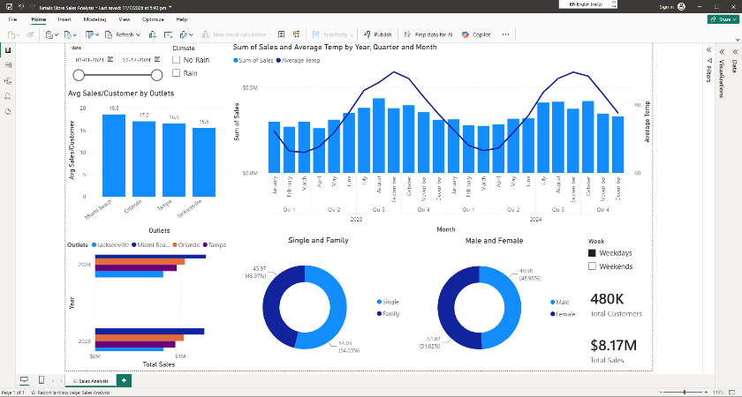

10. Key Business Insights
The dashboard provides several insights into sales performance, customer behavior, and the influence of external factors on retail operations. The following observations summarize the key findings from the analysis.

10.1. Store Performance
Among the four retail stores, sales performance varied significantly. Miami Beach generated the highest average sales per customer, averaging $18.5, while acksonville recorded the lowest at $15.6.
Business Impact
High-performing stores can serve as benchmarks for operational practices, while lower-performing stores may require targeted marketing campaigns or operational improvements.

10.2. Sales Trend Over Time
The sales trend shows noticeable fluctuations throughout the two-year period, suggesting the presence of seasonal demand patterns rather than consistent daily performance.
Business Impact
Understanding these trends helps management improve inventory planning, staffing schedules, and promotional timing during high-demand periods.

10.3. Customer Demographics
The customer demographic analysis indicates a balanced distribution between male and female customers. The dashboard also highlights the proportion of family and single shoppers, providing valuable insights into the primary customer segments.
Business Impact
These insights can support targeted marketing strategies and promotional campaigns based on customer preferences.

10.4. Average Sales per Customer
The calculated average sales per customer provides a useful measure of customer spending across stores. Comparing this metric helps identify locations where customers tend to spend more per visit.
Business Impact
Stores with higher average spending may offer opportunities to replicate successful product placement or pricing strategies across other locations.

10.5. Weather Influence on Sales
By combining weather and sales data, the dashboard enables analysis of how environmental conditions may influence customer traffic and purchasing behavior.
While weather alone does not determine sales performance, it provides additional context that can support operational planning.

Business Impact
Weather forecasts can be incorporated into staffing, inventory allocation, and promotional planning to improve operational efficiency.

10.6. Weekday vs. Weekend Performance
The analysis allows comparison of sales between weekdays and weekends, helping identify periods of increased customer activity.
Business Impact
Understanding shopping patterns enables better workforce scheduling and resource allocation during peak business hours.

10.7. Interactive Business Monitoring
The dashboard provides dynamic filtering by date, weather conditions, and day type, allowing users to explore sales performance from multiple perspectives without modifying the underlying data.
Business Impact
Interactive reporting enables business users to quickly answer operational questions and make informed decisions based on current business needs.

Summary of Insights
Insight | Business Value
Store Performance Comparison | Identifies high- and low-performing stores
Sales Trend Analysis | Supports seasonal planning and forecasting
Customer Demographics | Enables targeted marketing strategies
Average Sales per Customer | Measures customer spending behavior
Weather Analysis | Provides context for operational planning
Weekday vs. Weekend Analysis | Improves staffing and inventory planning
Interactive Dashboard | Supports data-driven decision-making

11. Future Improvements
Based on the insights generated from this analysis, several opportunities exist to enhance both the analytics solution and business operations.

11.1. Optimize Staffing and Inventory
Leverage seasonal sales trends and weather forecasts to improve workforce scheduling and inventory planning during high-demand periods.
Expected Benefit
- Better product availability
- Reduced operational costs
- Improved customer experience

11.2. Implement Weather-Based Promotions
Introduce targeted promotional campaigns during rainy days or periods of lower customer traffic to maintain consistent sales.
Expected Benefit
- Increased customer footfall
- Higher sales during low-demand periods

11.3. Expand High-Performing Store Operations
Analyze successful stores to identify best practices and replicate them across other retail locations.
Expected Benefit
- Improved overall store performance
- More consistent customer experience

11.4. Develop Customer Loyalty Programs
Use customer demographic insights to design loyalty and retention programs tailored to different customer segments.
Expected Benefit
- Increased repeat customers
- Higher customer lifetime value

11.5. Personalize Marketing Campaigns
Develop targeted marketing strategies based on customer demographics and shopping behavior.
Examples include:
- Weekend promotions for families
- Weekday offers for individual shoppers
- Location-specific campaigns based on customer demand
Expected Benefit
- Higher campaign effectiveness
- Improved customer engagement

11.6. Enhance the Analytics Platform
Future iterations of this solution could include the following enhancements:
- Connecting Power BI directly to Google BigQuery
- Automating dashboard refreshes
- Adding executive KPI dashboards
- Incorporating additional business data such as inventory, product categories, and promotions
- Expanding the solution to support real-time business monitoring

11.7. Future Roadmap
Area | Future Enhancement
Business Operations | Optimize staffing and inventory planning
Marketing | Weather-based and demographic-based promotions
Customer Experience | Loyalty and personalized marketing programs
Analytics | Direct BigQuery–Power BI integration
Reporting | Automated refresh and executive dashboards
Scalability | Integration of additional business datasets

12. Conclusion
This project provided valuable hands-on experience in building an end-to-end analytics solution using Google BigQuery, SQL, and Power BI. Starting with separate sales, customer survey, and weather datasets, I integrated and transformed the data into a single analysis-ready dataset that could be used for meaningful business reporting.
Using this dataset, I developed an interactive Power BI dashboard that helps visualize sales trends, compare store performance, understand customer demographics, and analyze how weather conditions may influence retail sales. The dashboard is designed to help stakeholders quickly explore key metrics and make informed business decisions.
Throughout this project, I strengthened my practical skills in SQL, data transformation, cloud-based data storage, and dashboard design. More importantly, I learned that effective data analysis is not just about creating visualizations; it's about understanding the business problem, preparing reliable data, and presenting insights that support better decision-making.
Overall, this project reflects my ability to work through the complete data analytics process, from collecting and preparing raw data to building an interactive dashboard that delivers actionable business insights. It has provided a strong foundation for tackling more complex analytics projects and further developing my skills as a Data Analyst.

