**Admin Module**

In the dashboard - what is the no of companies in this? Pl explain

If we have developed this as a product then we have to have a separate admin module for each company and super admin module for us to manage each company

Currently role management and company management is not working at all

In franchisee management - unable to view/edit/delete any of the franchisee

Unable to add - when we click, add button it gives following error

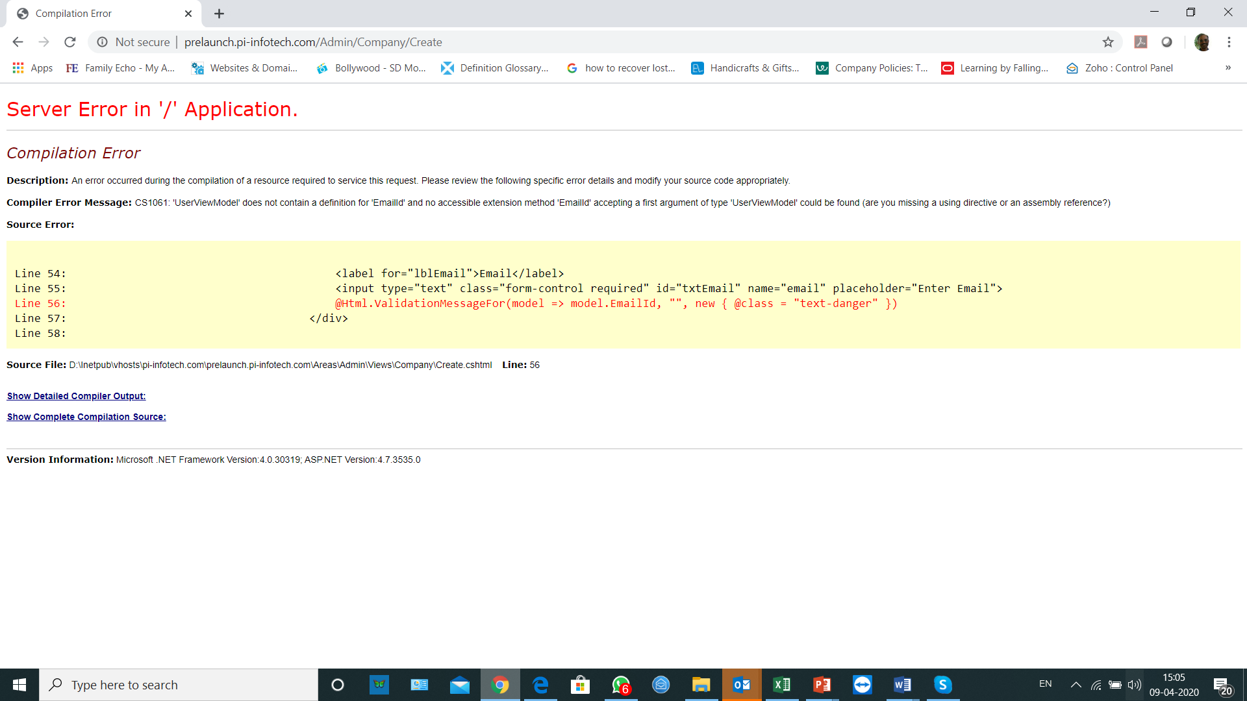

In the company admin module we need to have following options -

1. Dashboard to only show list of franchisee
2. Franchisee Management Module - where we can view / edit / disabled / enable / delete / add the franchisee
3. Master update module for following masters with the option for add/delete/edit/view option
4. Item Category Master - in this one need to define the item category. As of now following are the categories -
   1. Equipment & Utensil
   2. Disposable Items
   3. Consumable Items
   4. Frozen Food Items
   5. Other Food Item / Vegetable item
5. Master update module to update the master list of various items having following fields
   1. Item category
   2. Item Code - System to create automatically
   3. HSN Code
   4. Item Description
   5. Rate
   6. GST Rate
   7. Special Remarks
6. Responsibility Matrix Master - this will have Company & Franchisee
7. Scope of Work Category Master - This will have the list of the main Scope Category such as -
   1. Shop/Location Related
   2. Agreement with Company
   3. Item Procurement
   4. Shop Setup
   5. Manpower Hiring & Training
   6. Payment
   7. Launch Preparation
   8. On-Line Support
8. Detail Scope of work Master - In this we will have the detail of the scope of the work. In this one will select the category and then define the scope of work and default responsibility
9. Document type master Update - In this we will have the list of document type basis which document upload will be done
10. Payment Mode Master - where we will have
11. Email Templet Master - Here we will have various email templets for various Notifications