**Requirements Specification Document**

# 1. Project Summary

## 1.1 Project Overview

This Travelling Agency website is a solution for all customers who wants to visit or travel to wide range of places with affordable prices. It allows customers to choose their favorite tourist package offered by our travel agency. We also provide Hotel booking options with variety of discount offers on Every Packages at their respective nearest places. So that they don’t need to go for searching of good hotels. This website will reduce time consumption and save time and money.

## 1.2 Project Scope

The web application provides a secured platform for customer where they can log in with a username and password to choose their destination for their vacation. Upon login, customers can select the place from the given choices in web application to book the package related to that specific place they want to visit.

Package price will be can be taken on the basis of:

* Departure -> Destination
* Mode of transportation
* Season
* Hotels that you prefer.

Customer can view price and further details of the package for the complete tour once they login in web application and fill the required details. The respective customer should upload their original details like Name, Contact, Address, for their better experience.

## 2.0 General Description

Welcome to MAHV Travel Agency, your one-stop destination for all your travel needs! Whether you're seeking a relaxing beach getaway, an adventurous trek through the mountains, or a cultural exploration in a vibrant city, we've got you covered.

Discover a world of possibilities as you navigate through our user-friendly website. Here's what you can expect:

1. Explore Destinations: Browse through our extensive collection of destinations around the India. From exotic tropical islands to bustling urban metropolises, we offer a diverse range of destinations to suit every traveler preference.

2. Plan Your Trip: Utilize our comprehensive trip planning tools to create your itinerary. With customizable options for Buses, Travel vehicles, accommodations, activities, and transportation, you can tailor your trip to perfectly match your interests and budget.

3. Exclusive Deal’s: Take advantage of our exclusive deals and discounts on Bike rentals, hotels, tours, and more. Our partnerships with leading travel providers ensure that you get the best value for your money.

5. 24/7 Customer Support: Enjoy peace of mind knowing that our dedicated customer support team is available round-the-clock to assist you with any inquiries or issues that may arise during your trip.

7. Community Forum: Connect with like-minded travelers and share your experiences in our vibrant community forum. Exchange travel advice, tips, and recommendations with fellow members to enhance your journey.

Start your journey with MAHV Travel Agency today and embark on unforgettable adventures of India . Wherever your wanderlust takes you, we'll be there every step of the way.

## 2.1 Product Functions Overview

**Types of users/actors**

1. **Owner/Admin**
2. **Passenger/Customer**

**Owner/Admin features**

1. Updating new Tourist Packages.
2. Updating the website features.
3. Creating new Offers on Ticket Prices.

**Customer features**

1. Choosing of Tourist Packages.
2. Choosing of Hotels, Restaurants, Guides.
3. Rating and feedback of their experience with us

2.**2 User interface Design**

Design using paper and pencil and upload here. Label the screens properly

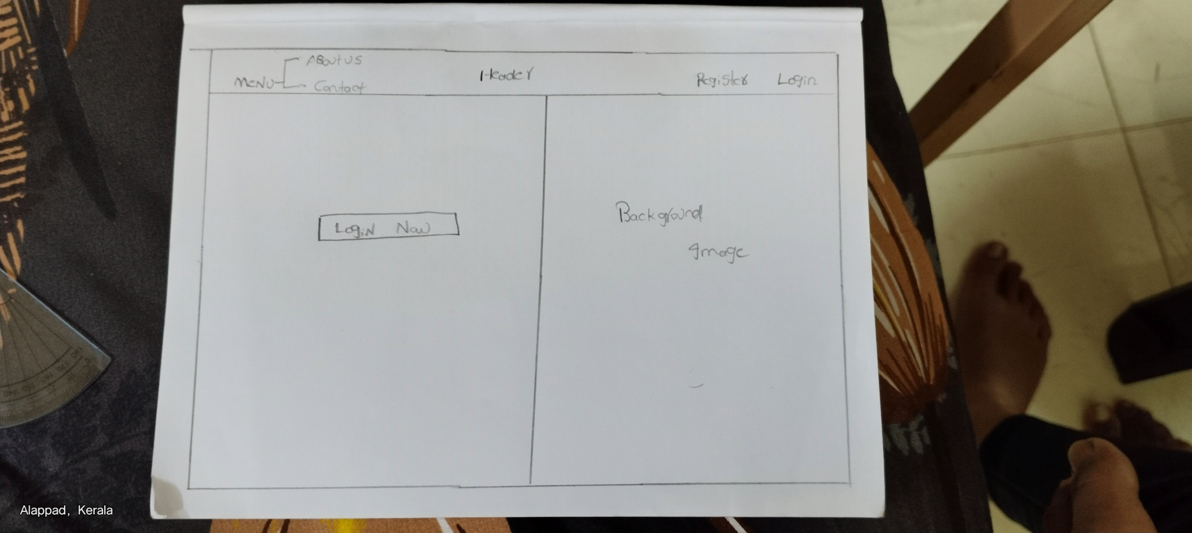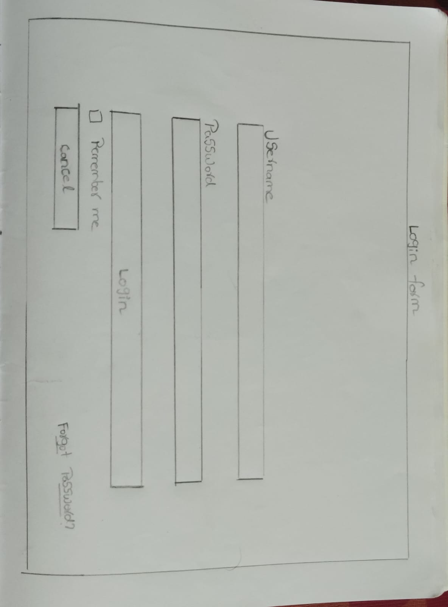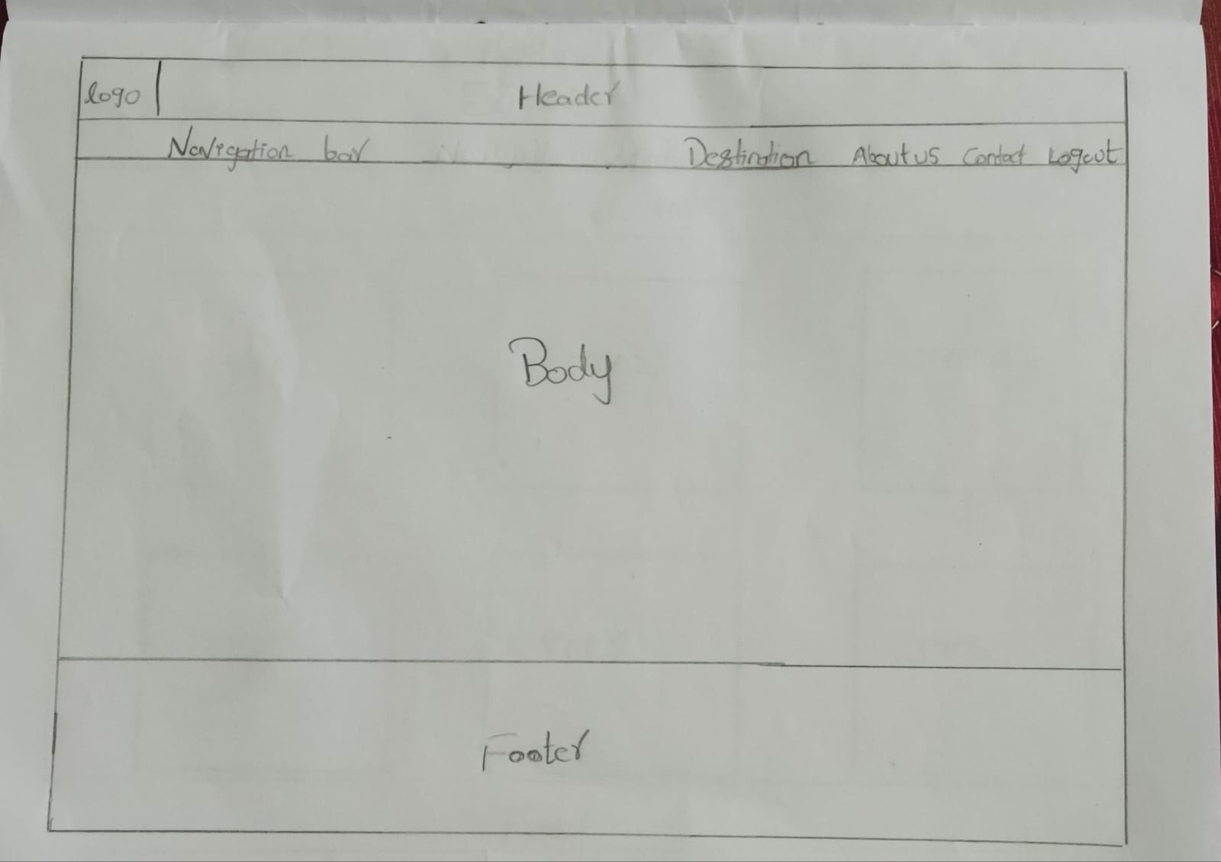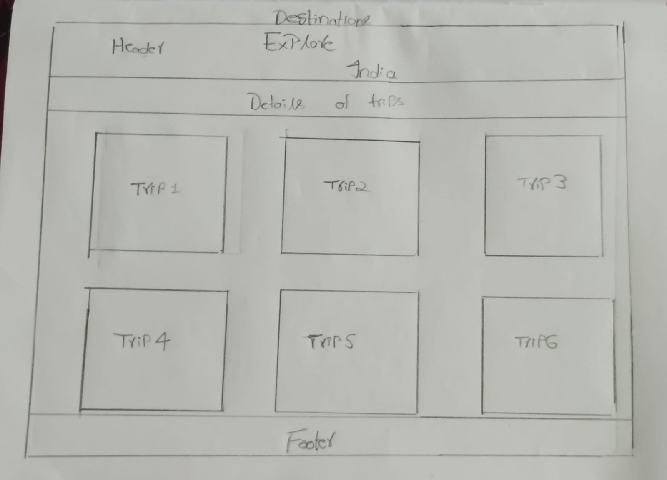

If we click on trips more pages will be redirected along with hotel bookings, bike rentals, feedback forms,etc…