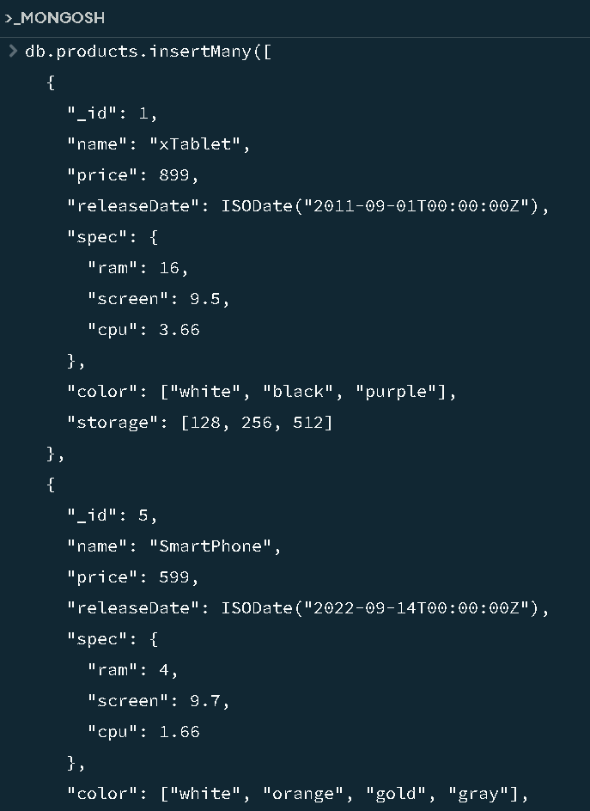

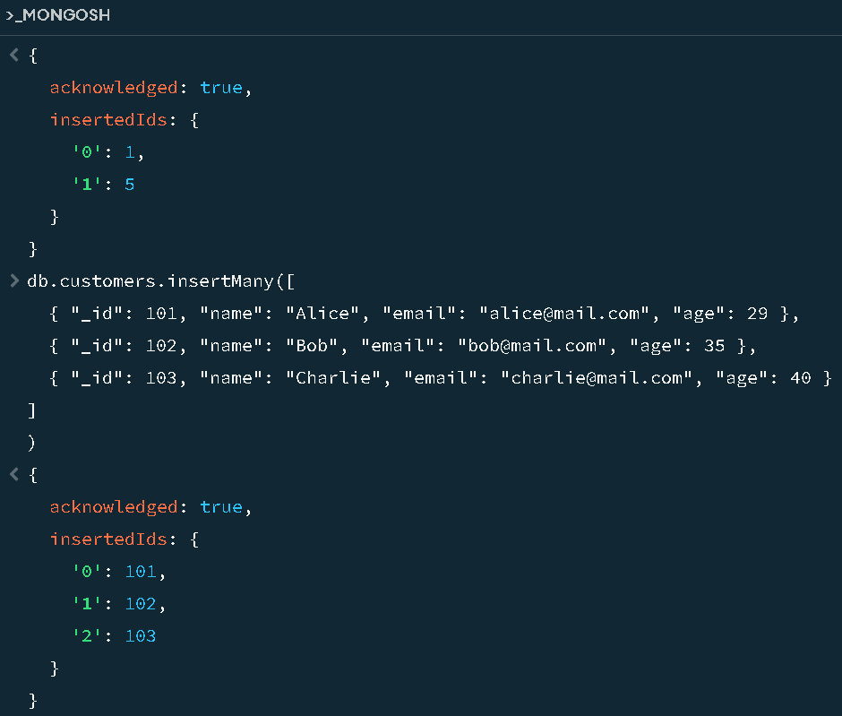

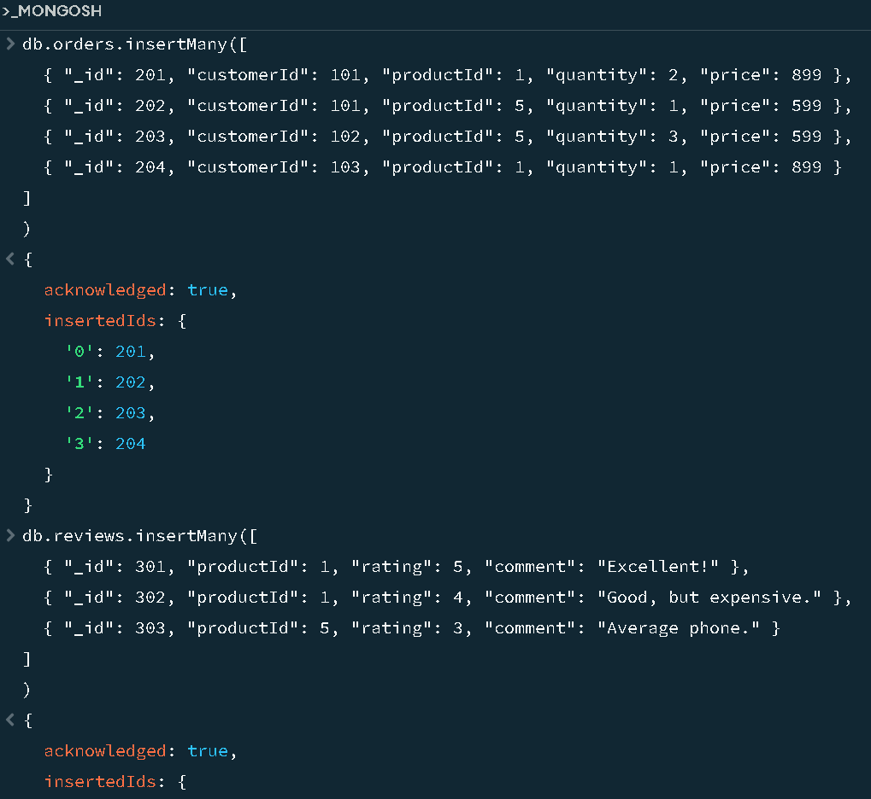

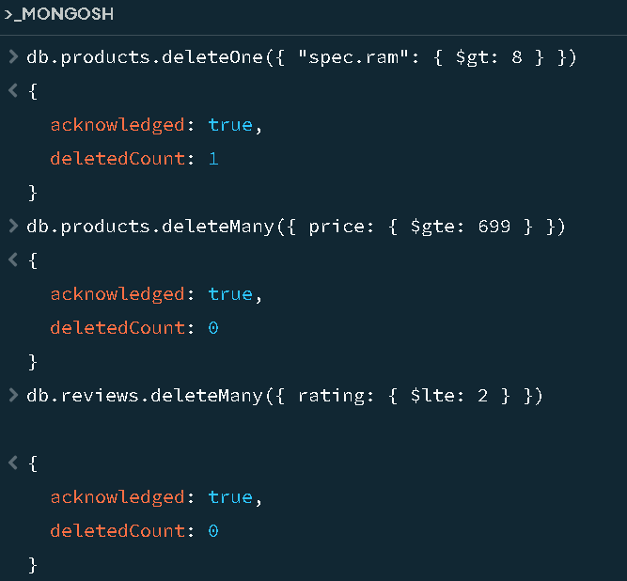

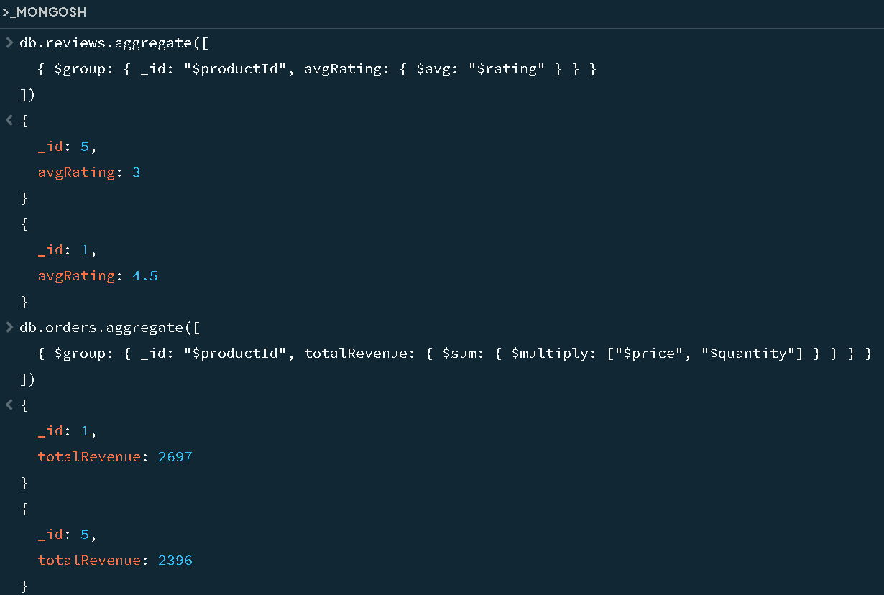

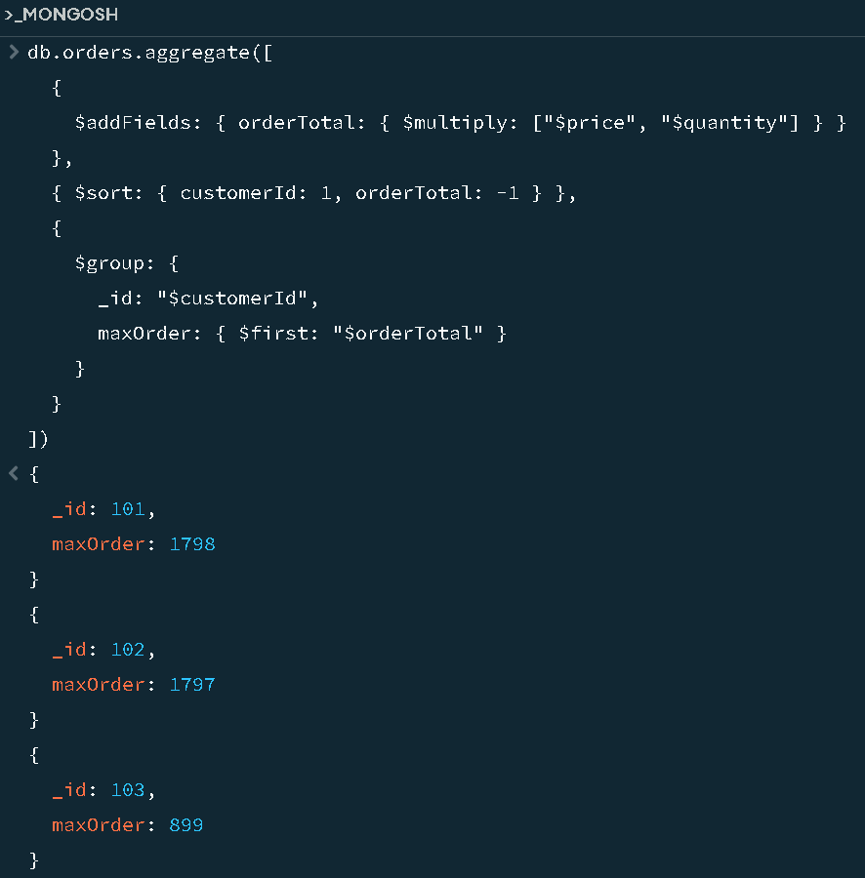

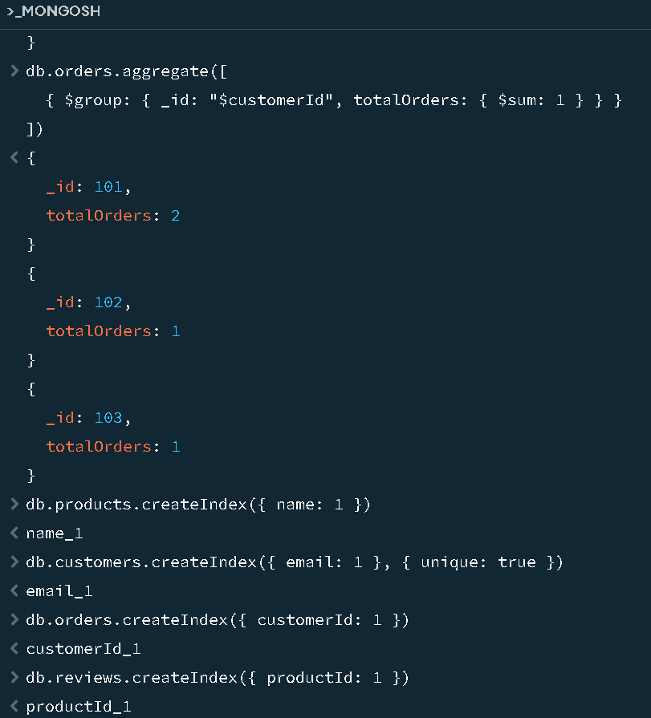

package connection;

import com.mongodb.MongoClient;

import com.mongodb.MongoCredential;

import com.mongodb.client.MongoDatabase;

public class mongoDB {

public static void main(String[] args) {

try {

MongoClient db = new MongoClient("localhost", 27017);

MongoCredential credential = MongoCredential.createCredential(

"GFGUser", "mongoDb", "password".toCharArray());

System.out.println("Successfully Connected to the database");

MongoDatabase database = db.getDatabase("mongoDb");

System.out.println("Credentials are: " + credential);

} catch (Exception e) {

System.out.println("Connection establishment failed");

System.out.println(e);

}

}

}