**Name: Chinnari Krishna Madhav**

**Reg no: 22BCE2121**

Using Online Compiler-https://www.programiz.com/sql/online-compiler

Tables:

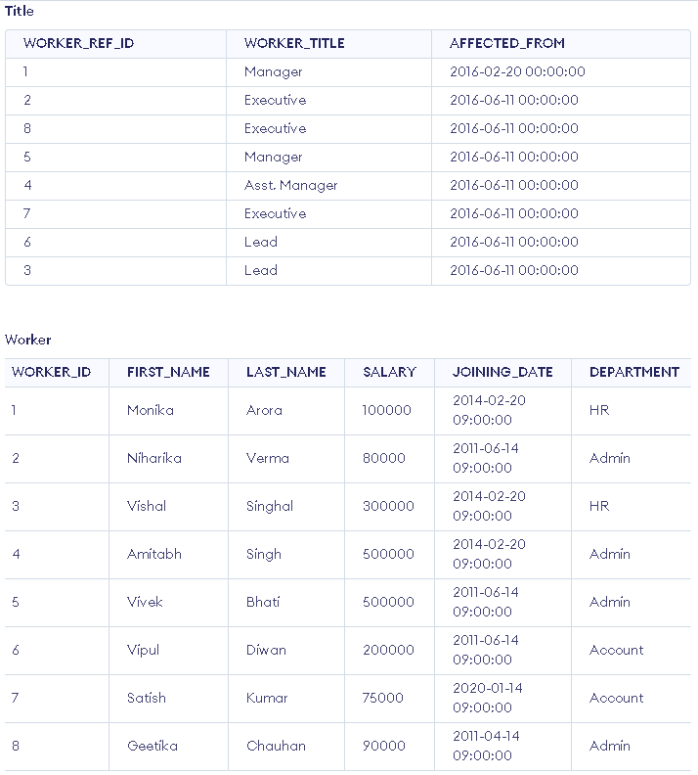

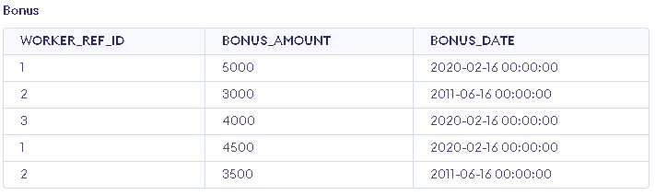

1. Write an SQL query to fetch unique values of DEPARTMENT from Worker table.

Sol:

//SELECT DISTINCT DEPARTMENT FROM Worker;

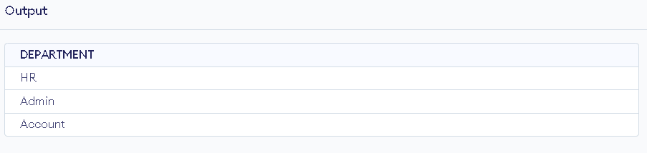

2. Write an SQL query to print all Worker details from the Worker table order by FIRST_NAME Ascending and DEPARTMENT Descending

Sol:

//SELECT * FROM Worker ORDER BY FIRST_NAME ASC, DEPARTMENT DESC;

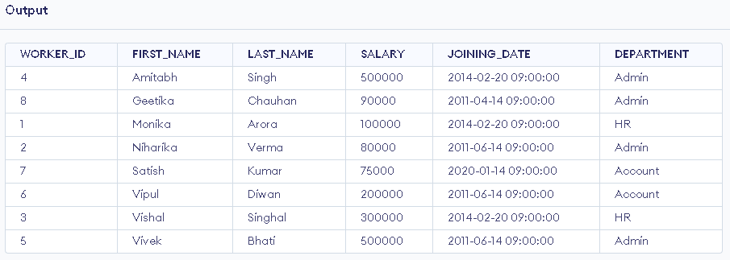

3. Write an SQL query to print details of the Workers whose FIRST_NAME contains ‘a’

Sol:

//SELECT * FROM Worker WHERE FIRST_NAME LIKE '%a%';

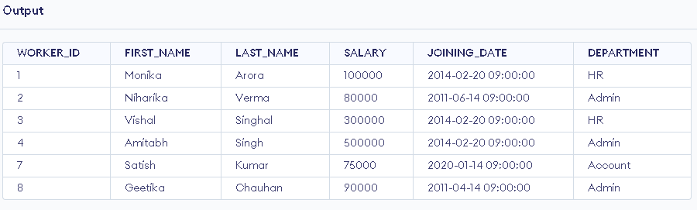

4. Write an SQL query to print details of the Workers whose FIRST_NAME ends with ‘h’ and contains six alphabets

Sol:

//SELECT * FROM Worker WHERE FIRST_NAME LIKE '_____h';

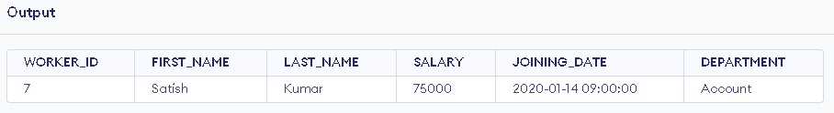

5. Write an SQL query to print details of the Workers whose SALARY lies between 100000 and 500000

Sol:

//SELECT * FROM Worker WHERE SALARY >= 100000 AND SALARY <= 500000;

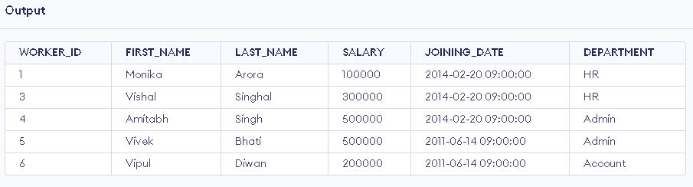

6. Write an SQL query to print details of the Workers who have joined in Feb’2014.

Sol:

//SELECT * FROM Worker WHERE JOINING_DATE >= '2014-02-01' AND JOINING_DATE < '2014-03-01';

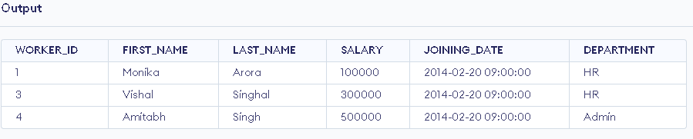

7. Write an SQL query to fetch the count of employees working in the department ‘Admin’

Sol:

//SELECT COUNT(*) AS Admin_Count FROM Worker WHERE DEPARTMENT = 'Admin';

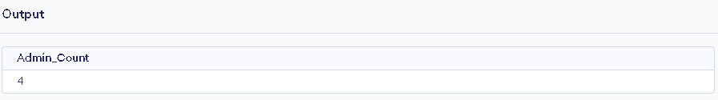

8. Write an SQL query to fetch worker names with salaries >= 50000 and <= 100000.

Sol:

//SELECT FIRST_NAME, LAST_NAME FROM Worker WHERE SALARY >= 50000 AND SALARY <= 100000;

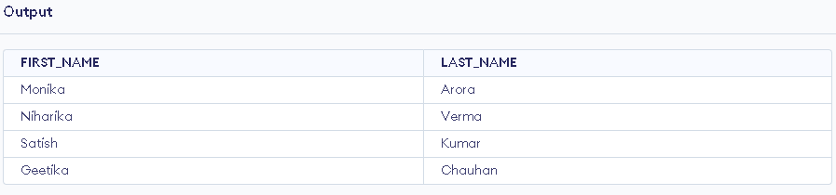

9. Write an SQL query to fetch the no. of workers for each department in the descending order

Sol:

//SELECT DEPARTMENT, COUNT(*) AS Worker_Count FROM Worker GROUP BY DEPARTMENT ORDER BY Worker_Count DESC;

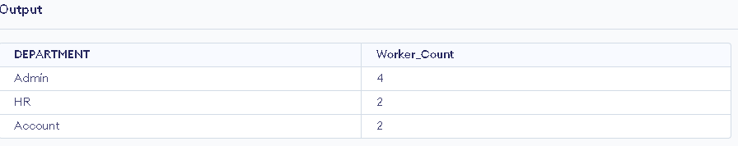

10. Write an SQL query to print details of the Workers who are also Managers

Sol:

//SELECT Worker.* FROM Worker, Title WHERE Worker.WORKER_ID = Title.WORKER_REF_ID AND Title.WORKER_TITLE = 'Manager';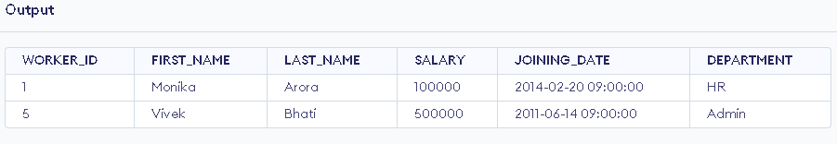

11. Write an SQL query to determine the 2nd lowest salary without using TOP or limit method.

Sol:

//SELECT MIN(SALARY) AS SecondLowestSalary FROM Worker WHERE SALARY > (SELECT MIN(SALARY) FROM Worker);

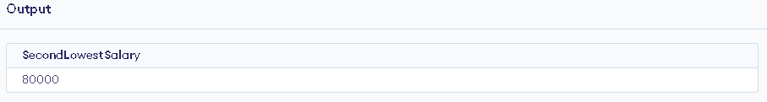

12. Write an SQL query to fetch the list of employees with the same salary

Sol:

//SELECT * FROM Worker

WHERE SALARY IN (

SELECT SALARY

FROM Worker

GROUP BY SALARY

HAVING COUNT(*) > 1

);

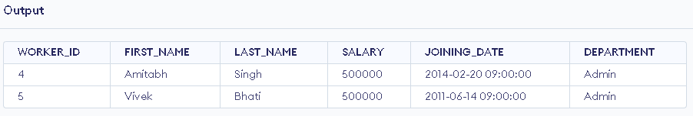

13. Write an SQL query to show the second highest salary from a table

Sol:

//SELECT MAX(SALARY) AS SecondHighestSalary FROM Worker WHERE SALARY < (SELECT MAX(SALARY) FROM Worker);

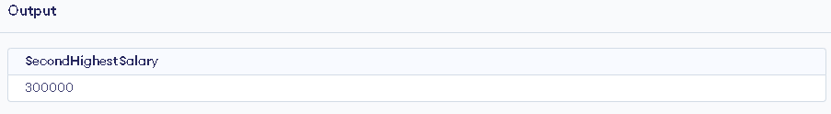

14. Write an SQL query to show one row twice in results from a table.

Sol:

//SELECT * FROM Worker WHERE WORKER_ID = 1 UNION ALL SELECT * FROM Worker WHERE WORKER_ID = 1;

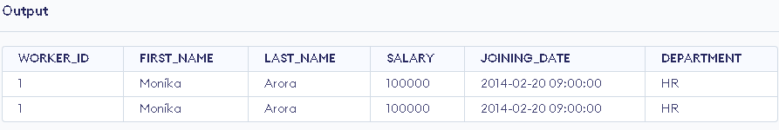

15. Write an SQL query to fetch the first 50% records from a table.

Sol:

//SELECT * FROM Worker WHERE WORKER_ID <= 4;

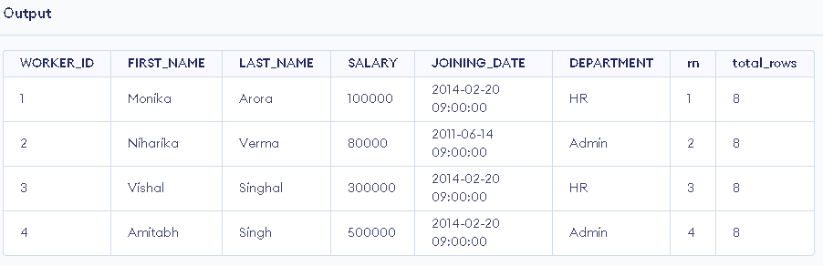

16. Write an SQL query to fetch the departments that have less than three people in it. FACE Webinar19 7:33 PM

Sol:

//SELECT DEPARTMENT FROM Worker GROUP BY DEPARTMENT HAVING COUNT(*) < 3;

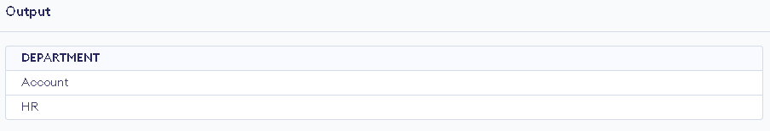

17. Write an SQL query to show all departments along with the number of people in there.

Sol:

//SELECT DEPARTMENT, COUNT(*) AS Total_Employees FROM Worker GROUP BY DEPARTMENT;

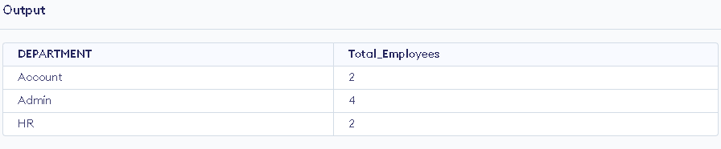

18. Write an SQL query to fetch the last five records from a table.

Sol:

//SELECT * FROM Worker ORDER BY WORKER_ID DESC;

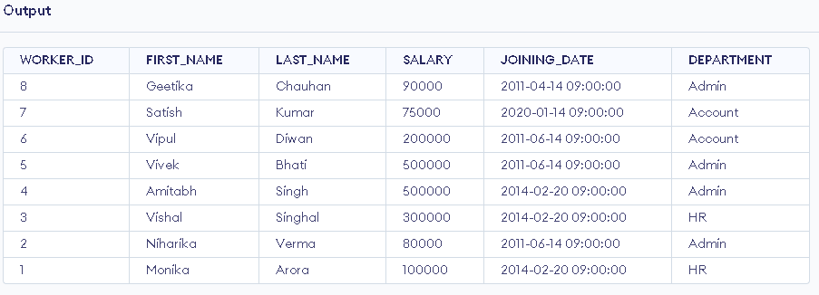

19. Write an SQL query to print the name of employees having the highest salary in each department

Sol:

//SELECT FIRST_NAME, LAST_NAME, DEPARTMENT, SALARY FROM Worker w

WHERE SALARY = (

SELECT MAX(SALARY)

FROM Worker

WHERE DEPARTMENT = w.DEPARTMENT

);

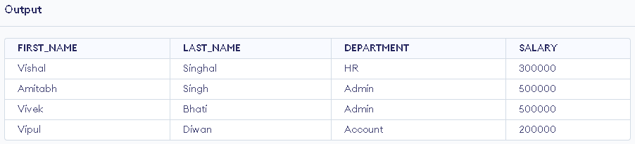

20. Write an SQL query to fetch three max salaries from a table

Sol:

//SELECT DISTINCT SALARY FROM Worker w1

WHERE 2 >= (

SELECT COUNT(DISTINCT SALARY)

FROM Worker w2

WHERE w2.SALARY > w1.SALARY

);

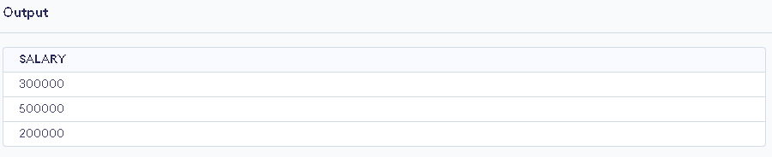

21. Write an SQL query to print the name of employees having the lowest salary in accunt and admin department

Sol:

//SELECT FIRST_NAME, LAST_NAME, DEPARTMENT, SALARY FROM Worker w

WHERE (DEPARTMENT = 'Account' AND SALARY = (

SELECT MIN(SALARY)

FROM Worker

WHERE DEPARTMENT = 'Account'

))

OR (DEPARTMENT = 'Admin' AND SALARY = (

SELECT MIN(SALARY)

FROM Worker

WHERE DEPARTMENT = 'Admin'

));

