INPUT WAVEFORM:

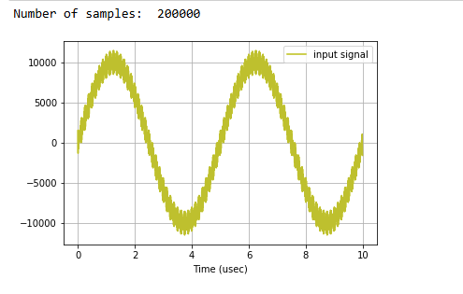

SOFTWARE IMPLEMENTATION OUTPUT:

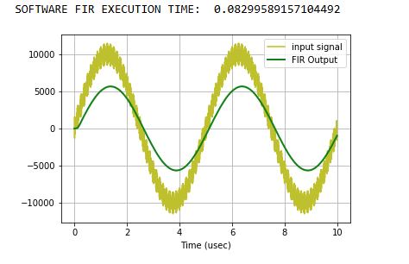

HARDWARE IMPLEMENTATION OUTPUT:

