Ask the Sensors: Grounded, Explainable Activity Question Answering over Wearable Motion Signals
  - Challenge 1 technical report
Group [NAME] — [Member 1], [Member 2], [Member 3], [Member 4]
[Submission date]

Abstract
We present a system that answers natural-language questions about a person’s physical activity from raw accelerometer and gyroscope recordings, and supports every answer with evidence: the timestamps it relied on, the sensor modality and channels, and an explanation built from measured signal properties. The system is layered. Signals are cleaned, resampled to 25 Hz and cut into 6 s windows. A class-balanced gradient-boosted classifier labels each window from 35 named physical features. A sticky hidden Markov model decodes the window probabilities into an activity timeline. Questions are parsed into a structured intent and executed as operations on that timeline. The central design rule is that the language layer never produces a number: every duration, count, timestamp and feature value in an answer is read off the timeline. On 767 questions over 40 recordings of 12 held-out ExtraSensory users the system answers 63.6% correctly (macro-average over eight question types) and 47.5% correctly with correct evidence. Temporal decoding raised these from 55.3% and 38.1%. A rule-based parser hardened on a development set reaches 96% intent accuracy on unseen hand-written questions, well above small language models used as parsers (58–62% intent accuracy for Qwen2.5-0.5B). For the efficiency extra credit, a distilled, 8-bit quantised MLP is 380× smaller than the full model (19 KB vs 7.3 MB) and 40× faster in classification, with no measurable loss of QA accuracy (paired 95% CI of the difference −0.020 to +0.017).

1. Problem framing
The task is question answering over a sensor stream rather than over text. A question such as “When did the user start running?” has an answer that is a number, an interval, a label or a verdict, and the brief requires that it be grounded: the answer must name the time range and the sensor channels it rests on, and explain how the signal supports it. Grading is on hidden recordings and hidden questions, so the system must generalise across users, devices and phrasings.
We frame the problem as four sub-problems, matching the four tiers of the brief:
- Recognition (tier 1): which of seven activities — lying down, sitting, standing in place, standing and moving, walking, running, bicycling — happens in each short stretch of signal.
- Temporal and quantitative reasoning (tier 2): durations, counts, comparisons, longest bouts and prolonged periods over a whole recording. These depend less on per-window accuracy than on whether the recognised timeline has the right structure.
- Evidence grounding (tier 3): onsets and cited intervals, scored by temporal overlap.
- Open-world reasoning (tier 4): judgements beyond the seven labels — exercise, sleep, commuting, chores, falls — argued from activity patterns and signal properties.
Two consequences shaped the design. First, numbers produced by a language model cannot be trusted to match the signal, so all quantitative content must come from a deterministic structure. Second, a question about a whole recording aggregates hundreds of window decisions, so errors that are harmless per window (an isolated misclassification) become severe after aggregation (a spurious extra bout). Section 3.4 shows this effect is the main lever for tier-2 accuracy.

2. Data and evaluation protocol

2.1 ExtraSensory subset
We use the ExtraSensory dataset (Vaizman et al., 2017): 60 users who carried their own phones in daily life. For each minute the app recorded about 20 s of raw accelerometer and processed gyroscope samples, and users self-reported context labels. We keep the accelerometer and gyroscope only, map the seven original_label columns to our classes, and keep minutes with exactly one of the seven labels. Working with the raw files exposed several data problems that the loader now handles:
- Units differ by phone: iPhones report g, Android phones m/s². Units are decided once per recording from the median magnitude (a per-minute decision mis-scaled some bursts).
- Sampling rates differ: most phones sample at ~40 Hz, some Android phones at 100–200 Hz. A box anti-aliasing filter is applied before interpolation when the source rate exceeds 50 Hz.
- Glitched timestamps: some bursts contain a sample whose clock jumps by ~1.8 million seconds and back. Left in, one 130-minute session stretched to 498 h and exhausted memory. Samples more than 60 s from the burst’s median time are dropped.
- A faulty sensor: one phone’s per-burst median |acc| swings between 0.03 and 1.4 g. Users whose 10–90th percentile spread exceeds 0.5 g are excluded (1 of 60).
- Missing gyroscope: 3 of 60 users have no gyroscope; 94% of training windows have one.
Labels are self-reported and cover the whole minute, while the phone may be on a table during the recorded burst. Of the training windows labelled walking, running or bicycling, 22% show essentially no motion (accelerometer-magnitude variability below 0.01 g).

2.2 Split and windows
Users are split once, with a fixed seed, into 47 training and 12 test users (stored in configs/split.json; no user appears in both). Recordings are runs of minutes with gaps of at most 5 minutes, cut into pieces of at most 12 hours. After windowing (6 s windows, 3 s hop, at least 60% of samples present) there are 1.40 M labelled training windows and 325 k test windows.
Labelled windows per class. The imbalance spans two orders of magnitude.
Class | Training windows | Share | Test windows
Lying down | 501,636 | 35.9% | 90,605
Sitting | 598,984 | 42.8% | 164,166
Standing in place | 35,318 | 2.5% | 9,402
Standing and moving | 140,796 | 10.1% | 24,620
Walking | 92,312 | 6.6% | 30,659
Running | 6,356 | 0.5% | 1,087
Bicycling | 23,475 | 1.7% | 4,279

2.3 Question sets and scoring
The evaluation questions are hidden, so we built two complementary question sets.
Generated QA set (end-to-end). For each held-out recording, eval/questions.py generates questions of eight types from the ground-truth labels: identification, verification, duration, count, comparison, onset (“grounding”), prolonged and open-world. The reference answer is obtained by running the same operation on a timeline built from the ground-truth labels, with the intent constructed directly rather than parsed. This makes definitions (what a “bout” is, what “prolonged” means) identical between system and reference, and tests recognition, aggregation and parsing together. The fixed set has 767 questions over 40 recordings of the 12 test users; question sampling is seeded per recording, so every configuration answers exactly the same questions.
Hand-written parser sets. Generated questions use a handful of templates, which says little about unseen phrasing. We wrote 105 questions annotated with the intent they should produce (operation, activity groups, time range), covering paraphrases, synonyms, number words, clock and day-period times, typos, unsupported quantities and open-world cues. They were split before any parser work into a development set (55 questions, used to improve the parser) and a test set (50, only scored, before and after).
Correctness rules. Following the brief, each answer type has its own rule, and overall QA accuracy is the fraction correct per type, macro-averaged over types:
Scoring rules. The last row is the stricter “with evidence” score.
Type | Rule
Identification, verification, comparison, prolonged, open-world | exact match
Duration | absolute error ≤ max(30 s, 10% of the reference)
Count | absolute error ≤ 1
Onset (grounding) | yes/no matches, and when yes, IoU of cited and reference interval ≥ 0.5
Grounded and correct | answer correct and cited-interval IoU ≥ 0.5 and modality matches

3. System design
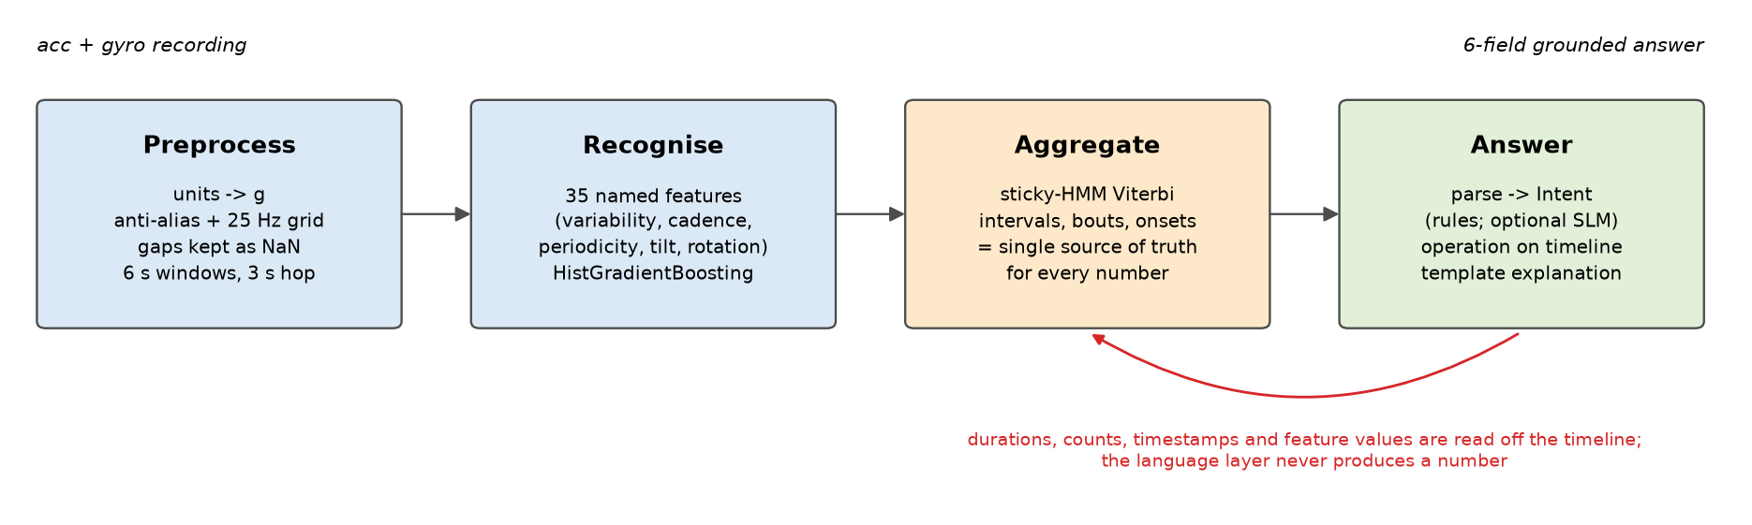
System architecture. Every quantitative statement in an answer is read off the timeline.

3.1 Preprocessing
Each recording is placed on a single 25 Hz grid (the common time base the brief requires). Samples are interpolated linearly; grid points farther than 0.2 s from a real sample stay missing (NaN) instead of being invented, so ExtraSensory’s 40 s gaps between bursts remain gaps. Windows are 6 s (150 samples, at least six gait cycles at 1 Hz) with a 3 s hop; a window is kept if at least 60% of its accelerometer samples are real, and small holes inside a kept window are interpolated. Gyroscope channels stay NaN when the phone has no gyroscope.

3.2 Features
We extract 35 features per window, each with a physical meaning: per-axis mean and standard deviation; device tilt relative to gravity on each axis; accelerometer-magnitude mean, variability, percentiles, range, peak and jerk; dominant frequency and periodicity in the 0.5–6 Hz gait band; autocorrelation peak; low- and high-band energy ratios; inter-axis correlations; and gyroscope magnitude mean, variability, peak, dominant frequency and periodicity. Engineered features were chosen over a learned representation because the same numbers are quoted back in the explanations (“a regular rhythm at 2.1 Hz, about 128 steps per minute”), which ties every explanation to the signal by construction.

3.3 Recognition backbone
A HistGradientBoostingClassifier (300 rounds, 31 leaves, learning rate 0.08) labels each window. It is small, fast on a CPU, handles missing gyroscope values natively, and supports class weighting. The training recipe addresses the data problems of Section 2:
- Class-balanced weights and a cap of 3,000 windows per user and class, so two heavy-sitting users cannot dominate.
- Gyroscope dropout: gyroscope features are blanked on 20% of training windows, so the model also learns an accelerometer-only path. Without it a no-gyroscope user was never recognised as running in our synthetic checks.
- Label cleaning (training only): walking/running/bicycling windows with no motion are dropped from training; test labels are never touched.

3.4 Timeline: sticky-HMM temporal decoding
The timeline turns per-window probabilities into intervals and is the single source of truth for every temporal answer. Our first version took the arg-max of a 5-window moving average of the probabilities. It recognised windows reasonably but fragmented the timeline: across a 12-hour recording, isolated misclassifications split long bouts, so a user with 3 sitting bouts was reported with 37. Count, duration and onset accuracy suffered (0.37, 0.29 and 0.15).
We therefore decode the activity sequence with a sticky hidden Markov model and the Viterbi algorithm. The emission score of class c in window t is log p(c | x_{t}) + λ log π_{c}, where p is the (5-window smoothed) classifier output, π is the class prior and λ = 0.5. Because the classifier is trained with balanced class weights its outputs behave like scaled likelihoods, so the prior is added back explicitly. Between windows Δt seconds apart the activity persists with probability exp(−Δt/τ) and otherwise switches to one of the other six classes with equal probability. τ is the expected bout length, and a longer data gap makes a change more plausible. Decoding runs independently on each stretch of data separated by gaps too long to bridge (> 48 s).
The three parameters were tuned on 10 users held out from the training users with a validation model trained on the other 37; test users were never used. The objective averaged window macro-F1 and two QA proxies (per-activity count within ±1 and total duration within tolerance). Settings from τ = 600 s to 4,800 s form a flat optimum (objective 0.290–0.291); we chose τ = 600 s, an interior and physically plausible value. On the validation users the predicted number of bouts per true bout fell from 1.80 to 0.98, and count accuracy rose from 0.14 to 0.39.
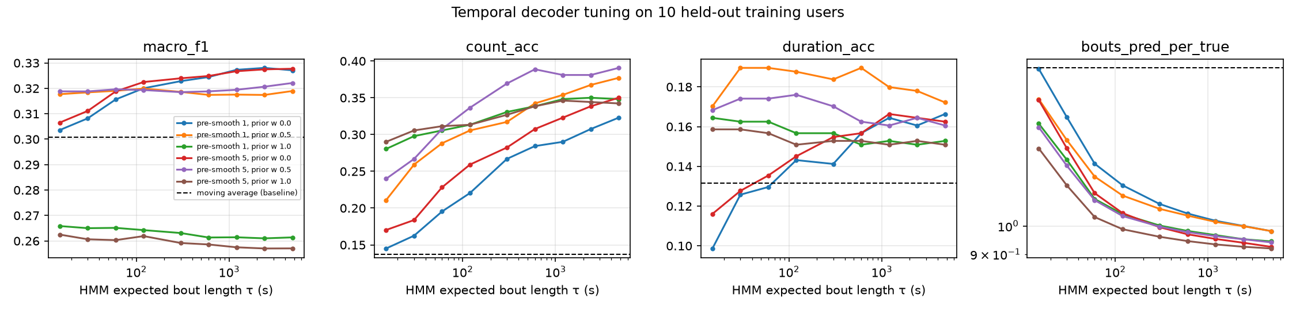
Decoder tuning on held-out training users. Dashed: moving-average baseline.
After decoding, consecutive same-label windows are merged into intervals, gaps up to 45 s are bridged (ExtraSensory’s normal gap between bursts is ~40 s), intervals shorter than 9 s between two touching intervals of the same activity are absorbed, a bout must last at least 10 s, and prolonged means a bout of at least 600 s.

3.5 Question understanding
A question is parsed into an Intent: an operation (identify, verify, duration, count, onset, compare, longest, prolonged, open), a list of activity groups and an optional time range. Activity groups let one word stand for several classes (“standing” covers both standing classes, “resting” covers lying, sitting and standing in place, “on foot” covers walking and running).
The default parser is rule-based: deterministic, about 0.3 ms per question, and fully reproducible. It normalises spoken forms (number words, “half an hour”, “final”, “minute 3”), corrects misspelt activity words (same first letter, ≥ 88% string similarity, with a list of real words such as “waking” that are never corrected), resolves relative ranges (“first 10 minutes”, “after 20 minutes”, “45 minutes in”), clock times (± 30 min) and day periods (clipped to the recording), and selects the operation by ordered patterns. Questions that ask for unmeasurable quantities (heart rate, location, mood) are routed to an explicit refusal rather than answered from motion.
An optional small language model (Qwen2.5-0.5B-Instruct by default, few-shot prompted) produces the same intent as JSON. By design it only decides the operation and the activities; time ranges stay with the deterministic extractor, because small models are unreliable at converting “around 10:15” into seconds from the recording start. Its output is validated against the schema; anything invalid falls back to the rules. In hybrid mode the rules answer first and the model is consulted only when the rule parse looks uncertain. Section 5.5 compares the options.

3.6 Operations and the grounding rule
Each operation reads the timeline and fills the six required output fields:
Operations. All numbers are read off the timeline.
Operation | Answer | Evidence cited
identify | activity with the most time in the range | its longest intervals in the range
verify | Yes / Likely yes / No | the matching bouts; for “No”, the dominant activity instead
duration | total seconds | every contributing interval
count | number of bouts ≥ 10 s | the bouts
onset | “Yes, X began at t s” | the first bout, contrasted with the preceding interval
compare | the activity with more (or less) time | both totals
longest | length and span of the longest bout | that bout
prolonged | Yes/No against the 600 s threshold | the longest bout
open | verdict (Consistent / Partially / Not consistent) | intervals of supporting activities
The modality field is “Accelerometer, Gyroscope” when the recording has a gyroscope and “Accelerometer” otherwise. Explanations are templates filled with the mean feature values of the cited windows, contrasted with the rest of the recording, for example: “The cited windows show accelerometer magnitude variability of 0.193 g, a regular rhythm at 2.14 Hz (about 128 cycles/min, periodicity 0.39), gyroscope rotation averaging 0.97 rad/s … For contrast, the rest of the recording averages 0.062 g variability.” A “Yes” whose supporting intervals have a mean probability below 0.6 is hedged as “Likely yes”, and a “No” is still grounded by citing what the user was doing instead.

3.7 Open-world reasoning
Each behaviour outside the seven labels is described by the recognised activities that would support it and a signal property it requires: exercise needs running, cycling or walking at moderate-to-vigorous intensity; commuting needs sustained walking or cycling bouts (≥ 5 min); sleeping needs lying down with almost no motion; desk work needs still sitting; chores and shopping need light standing-and-moving and walking. The verdict follows from the share of analysed time that meets both conditions (≥ 50% consistent, ≥ 15% partially), and the explanation states that share, the intensity and the longest bout. Falls are handled separately: a fall needs an impact (peak > 2 g with jerk far above the recording’s typical level) followed by a fall signature — stillness (< 0.03 g variability) or a device-orientation change above 45° within the next minute. Impacts during continuing movement with unchanged orientation are reported as likely footstrikes or bumps, with their timestamps, rather than as falls.

4. Implementation and reproducibility
The code is a Python package (src/ats/) with one module per layer, plus scripts:
Step | Command | Output
Download raw data (~16 GB zipped) | scripts/download_data.py | data/raw/ (never committed)
Window features per user | scripts/build_dataset.py | data/processed/
Train, Figure 2 | scripts/train.py | models/hgb_full.joblib
Tune the decoder (optional) | scripts/tune_smoothing.py | tuning table and figure
QA evaluation, Figures 1, 3, 5 | scripts/evaluate.py --robustness | metrics, records, figures
Efficiency, Figure 4 | scripts/benchmark.py | efficiency.json, figure
Parser evaluation | scripts/eval_parser.py | intent accuracy per set
Answer questions | scripts/answer.py --recording r.csv --questions q.txt | 6-field answers
All randomness is seeded: the user split is stored in configs/split.json, question sampling is seeded by a CRC32 hash of the recording id (Python’s hash() is salted per process), and models use fixed random states. A test suite of 24 checks (pytest) exercises every layer on synthetic signals, which are used only for testing and never reported as results. The runnable system reads any CSV with a time column and accelerometer (optionally gyroscope) columns, with loose column-name matching; a 4.4-hour recording is loaded and 11 questions answered in about 2 s on a laptop.

5. Results

5.1 Recognition backbone
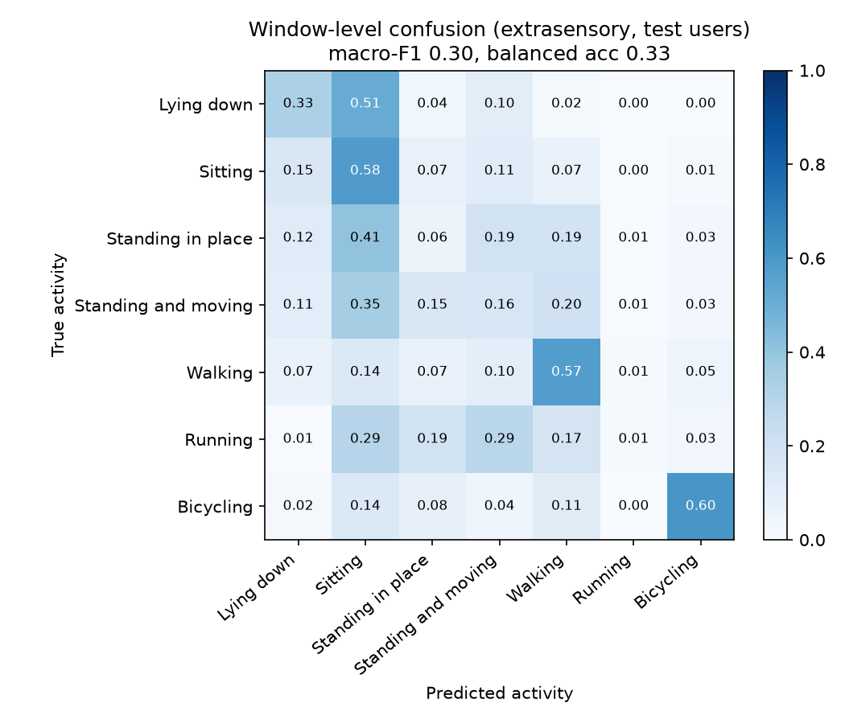
Figure 2. Window-level confusion matrix on the 12 test users (raw classifier output, before temporal decoding).
Per-class window metrics on test users. Macro-F1 0.30 raw, 0.38 after HMM decoding; balanced accuracy 0.33 raw, 0.36 decoded.
Class | Precision | Recall | F1
Lying down | 0.49 | 0.33 | 0.40
Sitting | 0.60 | 0.58 | 0.59
Standing in place | 0.03 | 0.06 | 0.04
Standing and moving | 0.10 | 0.16 | 0.13
Walking | 0.47 | 0.57 | 0.52
Running | 0.01 | 0.01 | 0.01
Bicycling | 0.34 | 0.60 | 0.43
Window-level accuracy is modest, and the confusion matrix shows why. (i) Lying versus sitting: both are still, so they are told apart only by phone orientation, which depends on where the phone is (pocket, bag, table); 43% of lying windows are predicted as sitting. (ii) Label noise: 816 of the 1,087 test windows labelled running come from one user whose phone was essentially motionless (median variability 0.002 g) during those minutes, so no motion-based model can recognise them. Restricted to windows where the phone actually moves (variability ≥ 0.05 g), walking recall is 0.81 and bicycling 0.83. (iii) Running versus walking: even on moving windows only 6% of running is recognised; 76% is called walking, as a phone in a bag does not show the larger impacts a body-worn sensor would. Vaizman et al. score each label one-vs-rest and fuse more sensors (watch, audio, location), so their figures are not directly comparable with a 7-way choice from phone motion alone. For reference, our one-vs-rest balanced accuracies are 0.79 (bicycling), 0.75 (walking), 0.59–0.60 (sitting, lying) and 0.50–0.52 (standing in place, standing and moving, running).

5.2 Question answering
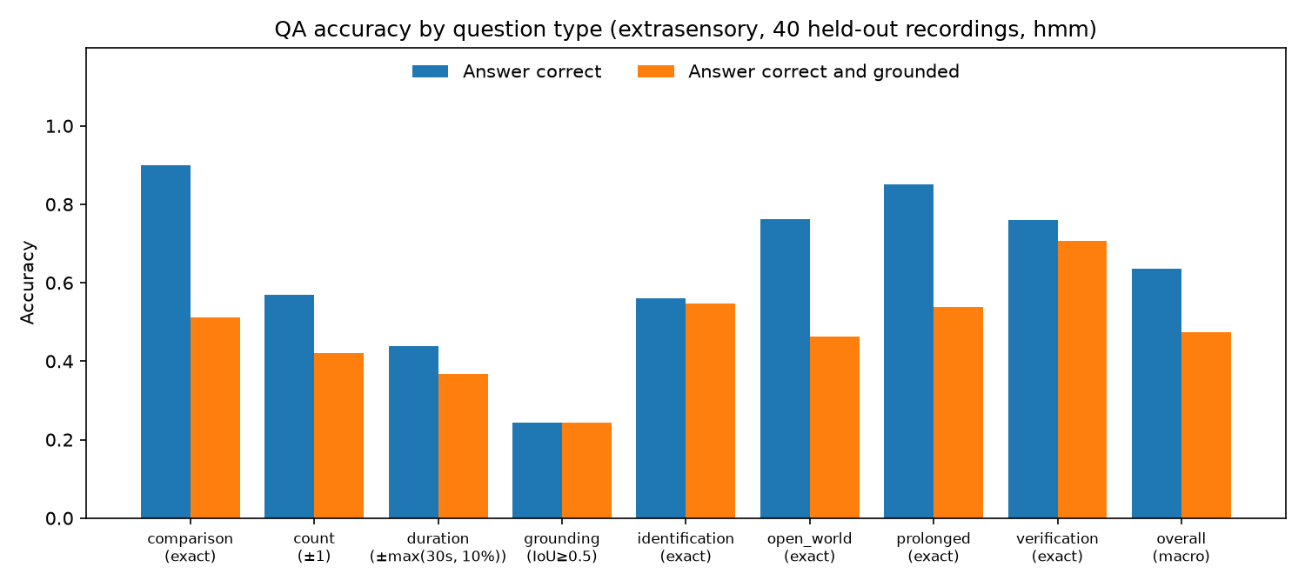
Figure 1. QA accuracy by question type on 767 questions over 40 held-out recordings, with the correctness rule under each type. Blue: answer correct; orange: answer correct and evidence grounded.
QA accuracy before and after temporal decoding (same model, same questions).
Question type | Moving average | HMM | Grounded, MA | Grounded, HMM
Identification | 0.51 | 0.56 | 0.44 | 0.55
Verification | 0.73 | 0.76 | 0.60 | 0.71
Duration | 0.29 | 0.44 | 0.26 | 0.37
Count | 0.37 | 0.57 | 0.30 | 0.42
Comparison | 0.79 | 0.90 | 0.41 | 0.51
Onset (grounding) | 0.15 | 0.24 | 0.15 | 0.24
Prolonged | 0.84 | 0.85 | 0.49 | 0.54
Open-world | 0.75 | 0.76 | 0.40 | 0.46
Overall (macro) | 0.553 | 0.636 | 0.381 | 0.475
The headline is 63.6% overall QA accuracy and 47.5% with grounded evidence. Accuracy is high where the answer depends on the overall picture (comparison 0.90, prolonged 0.85, verification 0.76, open-world 0.76) and lower where exact boundaries matter (onset 0.24, duration 0.44). The gap between the two bars is the “price of evidence”: it is small for verification and onset, whose answers already are intervals, and large for comparison and open-world questions, where the verdict can be right while the cited intervals overlap the reference only partly. Temporal decoding improved every type and cut the mean duration error from 1,600 s to 1,056 s; it did not change the classifier at all.

5.3 Accuracy versus strictness
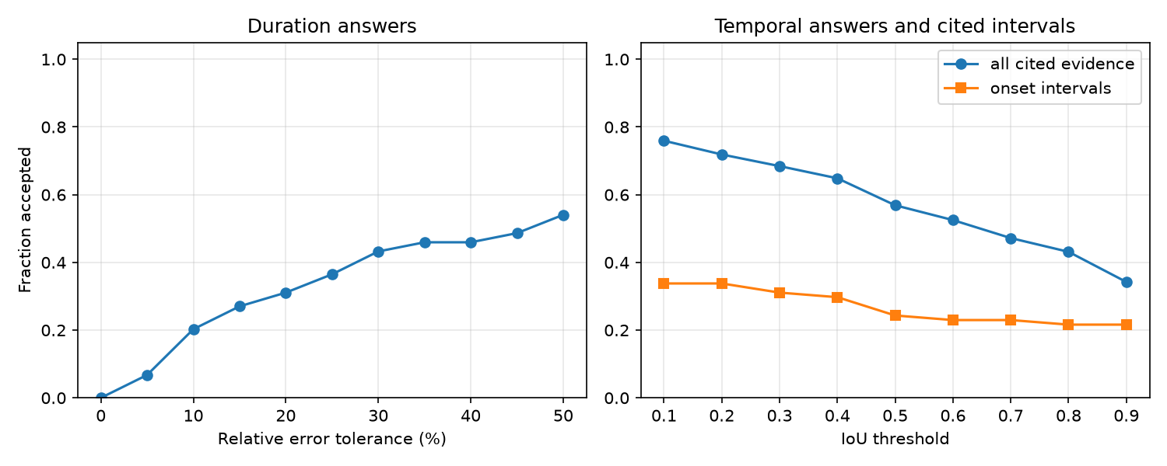
Figure 3. Left: share of duration answers accepted as the relative-error tolerance grows. Right: share of cited intervals accepted as the IoU threshold grows.
Figure 3 shows whether misses are near or wild. Duration acceptance grows steadily with the tolerance, so many misses are moderate rather than catastrophic. For onsets, the yes/no part is right in 82% of cases; when both system and reference say yes, the predicted onset is within 60 s of the true one in 34% of cases, within 5 minutes in 51% (median error 258 s). The fixed IoU ≥ 0.5 rule is therefore strict for onsets: the first bout is often found a few minutes early or late, or starts at the very beginning of a recording that the reference begins later.

5.4 Robustness
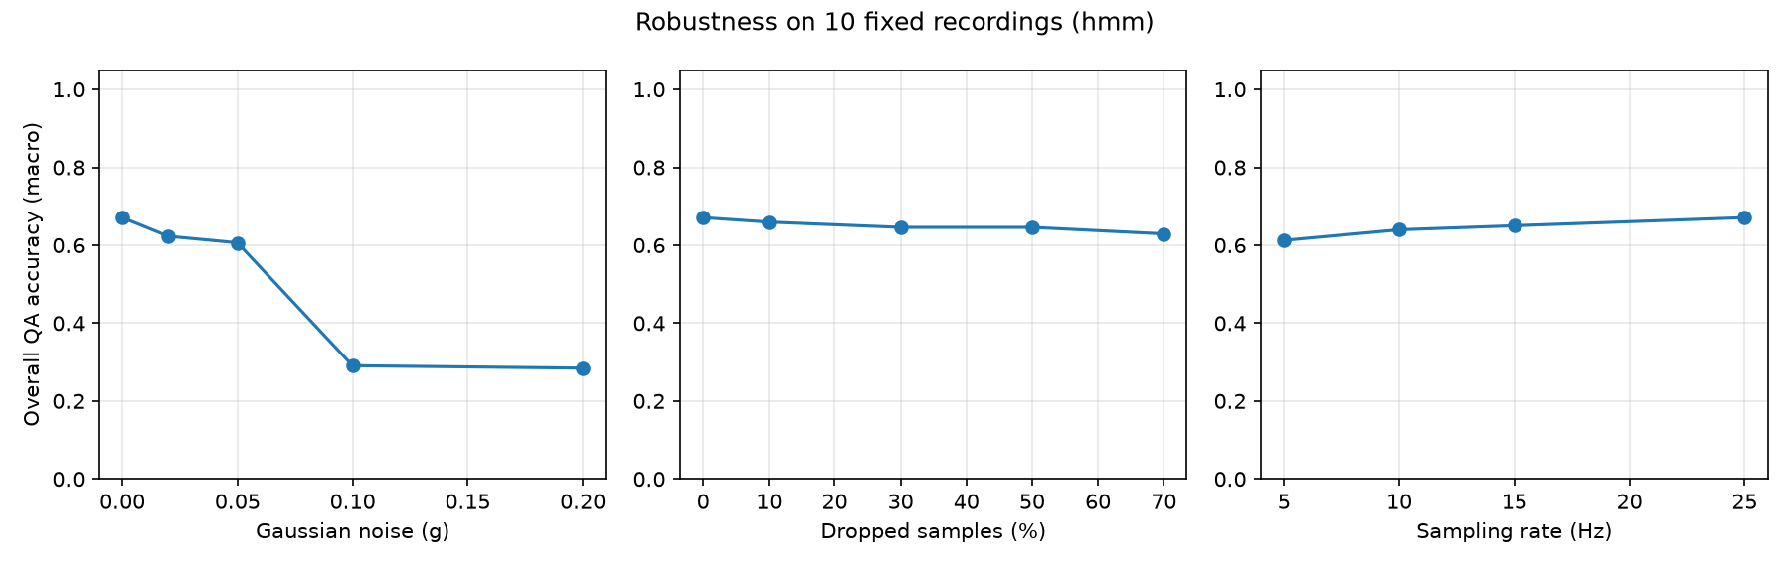
Figure 5. Overall QA accuracy on a fixed set of 10 recordings as the input is degraded.
Robustness (HMM decoder). Recordings are re-resampled from the surviving samples, as the loader would treat a sparser stream.
Degradation | Levels → overall QA accuracy
Dropped samples | 0%: 0.67 · 10%: 0.66 · 30%: 0.65 · 50%: 0.65 · 70%: 0.63
Sampling rate | 25 Hz: 0.67 · 15 Hz: 0.65 · 10 Hz: 0.64 · 5 Hz: 0.61
Gaussian noise | 0 g: 0.67 · 0.02 g: 0.62 · 0.05 g: 0.61 · 0.1 g: 0.29 · 0.2 g: 0.28
The system degrades gracefully with missing data and low sampling rates: 70% dropped samples cost 0.04, and sampling at 5 Hz costs 0.06. Gap-aware resampling and the per-window coverage rule make missing data a non-issue, and the features that matter (variability, tilt, cadence up to ~2.5 Hz) survive at 5 Hz. Additive noise is the weak point: up to 0.05 g accuracy holds (the HMM decoder raised accuracy at 0.05 g from 0.26 to 0.61), but at 0.1 g and above accuracy collapses, because still postures are separated by variability differences of a few milli-g, which the noise swamps. Typical phone accelerometer noise is a few milli-g, so the collapse lies outside realistic operating conditions, but it identifies noise-augmented training as the next robustness step.

5.5 Parser generalisation
Intent accuracy (operation, activities and time range all correct) on the hand-written sets. CPU, single process. Qwen2.5-1.5B (≈6 GB in fp32) was also tried but did not fit in the 8 GB of the target laptop: it swapped and had not finished after 2.5 h, so it is not reported.
Parser | Dev intent acc. | Test intent acc. | Latency / question
Rules, before hardening | 0.74 | 0.66 | 0.1 ms
Rules, after hardening | 1.00 | 0.96 | 0.3 ms
Qwen2.5-0.5B-Instruct (LLM only) | 0.62 | 0.58 | 1.6–1.9 s
Hybrid (rules first, 0.5B fallback) | 1.00 | 0.96 | 0.3 ms
Hardening the rules on the development set raised test accuracy from 0.66 to 0.96 (operation and activity detection are perfect on the test set; the two misses are time ranges on open-world questions). The test set was written before the hardening and scored only twice, but by the same authors, so it is not a substitute for truly unseen questions. Small language models were clearly worse: mainly they confused operations (a two-activity comparison parsed as “prolonged”, a verification as “duration”) and sometimes produced output that failed validation (8 of 55 dev and 11 of 50 test questions fell back to the rules), while being nearly four orders of magnitude slower. We therefore ship the rule parser as the default and offer the hybrid mode, which on these sets never needed the model but keeps it as a safety net for phrasings no rule anticipates.

5.6 Error analysis
Typical remaining errors, from the evaluation records:
- Posture confusions propagate to every type. The most frequent identification errors are lying predicted as sitting (7 of 33 errors) and standing-and-moving versus sitting or walking (15). A comparison such as “more standing in place or lying down?” fails when one of the two is systematically under-recognised.
- Count and duration inherit recognition bias. “How much time did the user spend sitting?” answered 25,377 s against 30,604 s: the timeline is coherent, but part of the sitting was labelled as lying. Count errors are now mostly within a few bouts (6 vs 3, 4 vs 2) rather than the 37 vs 3 seen before decoding.
- Onsets are found near, not at, the reference. “When did the user start walking?” answered 9,414 s against 9,356 s fails the IoU rule although the onset is 58 s off. Others fail because the activity is detected in the first minutes of the recording, where the self-reported label starts later.

6. Efficiency and the accuracy-versus-overhead tradeoff
Target. Apple M2 laptop CPU restricted to a single thread (via threadpoolctl) to emulate a single-core edge device; Python 3.14, NumPy and scikit-learn. Costs. Model size is the bytes of the serialised model file. Single-query latency is the time to answer one question about a fresh 1-hour, 25 Hz recording end to end (windowing, features, classifier, decoding, parsing, answering), median of 7 runs. We also report the classifier’s share. Accuracy is the overall QA accuracy on the same 767 questions, through the full pipeline.
We compare nine configurations: the deployed model; pruning (keeping the first 100, 30 or 10 boosting rounds); distillation of the full model’s class probabilities into one regression tree (depth 10 or 6) or a 2-layer MLP (128–64 units, trained to match the teacher’s log-probabilities); 8-bit quantisation of that MLP (int8 weights per output unit, 8-bit activations calibrated on training data, uint8 after ReLU, exact int32 accumulation); and an accelerometer-only model retrained without gyroscope features, so the gyroscope can stay switched off.
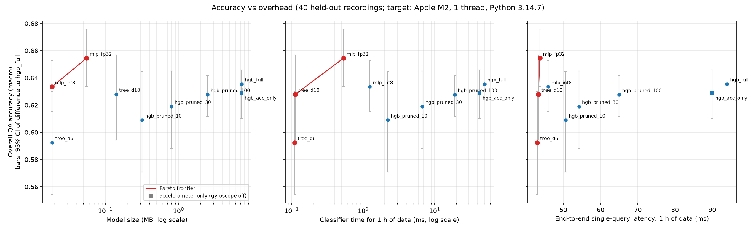
Figure 4. Accuracy versus model size, classifier time and end-to-end latency. Red: Pareto frontier. Error bars: paired 95% bootstrap interval of the difference to the full model, drawn around each point.
Efficiency results. Peak working memory is ~20 MB for every configuration (dominated by the recording, not the model).
Configuration | Size | Classifier, 1 h | Query, 1 h | QA acc. | Δ vs full (95% CI)
HGB full (deployed) | 7.32 MB | 49.6 ms | 94.0 ms | 0.636 | —
HGB pruned to 100 rounds | 2.49 MB | 19.1 ms | 65.0 ms | 0.628 | −0.024 to +0.006
HGB pruned to 30 rounds | 0.80 MB | 6.7 ms | 54.2 ms | 0.619 | −0.047 to +0.009
HGB pruned to 10 rounds | 0.32 MB | 2.2 ms | 50.6 ms | 0.609 | −0.065 to +0.009
HGB accelerometer only | 7.30 MB | 42.3 ms | 90.0 ms | 0.629 | −0.025 to +0.010
Distilled tree, depth 10 | 0.14 MB | 0.11 ms | 43.3 ms | 0.628 | −0.041 to +0.021
Distilled tree, depth 6 | 0.019 MB | 0.11 ms | 43.0 ms | 0.592 | −0.081 to −0.005
Distilled MLP, float32 | 0.056 MB | 0.53 ms | 43.7 ms | 0.654 | −0.002 to +0.040
Distilled MLP, int8 | 0.019 MB | 1.24 ms | 46.0 ms | 0.633 | −0.020 to +0.017
The three compression techniques behave differently. Pruning trades accuracy away smoothly. Distillation keeps nearly all of it: the float MLP even scores slightly above its teacher, but its interval includes zero, so we read it as matching the full model. Quantising the MLP to 8 bits costs about 0.02 for a further 3× size reduction. The int8 student is 380× smaller than the deployed model and its accuracy is statistically indistinguishable from it, which is the “small accuracy for a large cost reduction” the challenge asks for. Only the depth-6 tree loses significantly. The accelerometer-only model loses nothing measurable, so the gyroscope can be switched off, saving sensor power on a real device.
Two caveats. First, after compression the end-to-end latency flattens at ~43 ms, which is windowing and feature extraction; cheaper features would be the next lever. Second, the int8 classifier is slower than the float one here (1.2 vs 0.5 ms) because NumPy has no 8-bit arithmetic kernels; its gain on this machine is size, and a speed gain requires int8-capable hardware.

7. Limitations and future work
- Labels and placement bound recognition. Self-reported minute labels and free phone placement cap window-level accuracy, especially lying versus sitting and running versus walking.
- Noise robustness. Accuracy collapses above 0.05 g of added noise. Training on noise-augmented windows, or estimating each recording’s noise floor and correcting the variability features, would address this; both require re-extracting the features from the raw data.
- Neural backbone. A compact 1D-CNN on raw windows was planned but not built. The engineered features are what the explanations quote, so a CNN would need a separate feature path for explanations, and our analysis suggests label noise rather than model capacity is the bottleneck.
- Onset precision. Onsets are often found minutes from the reference. A dedicated change-point refinement around the decoded transition could tighten them.
- Question coverage. The generated questions use templates, and the hand-written sets were written by the authors. The hidden questions will contain phrasings neither set anticipates; the hybrid parser is the mitigation.

8. Contribution statement
[To be completed by the group. For each member, state what they designed, implemented, ran and wrote, for example: data pipeline and loader fixes; recognition backbone and training recipe; temporal decoding and tuning; question parser and hand-written question sets; operations, explanations and open-world reasoning; evaluation harness and figures; efficiency study; report sections. The repository’s commit history should support this statement.]
Member | Contributions
[Member 1] | […]
[Member 2] | […]
[Member 3] | […]
[Member 4] | […]

9. AI-use disclosure
[Review and complete before submission so that it is accurate for the whole group.] We used Claude Code (Anthropic; an AI coding assistant running the Claude Opus model) during development. It was used to: draft and refactor code across all layers of the system; diagnose data problems (unit mismatches, glitched timestamps, a faulty sensor) and propose fixes; design and run experiments (decoder tuning, efficiency benchmark, parser evaluation); generate the figures; and draft this report. Group members [describe: specified the design and requirements, reviewed and tested the code, checked the results, and edited the text]. All reported numbers come from scripts in the repository run on the real ExtraSensory data and can be reproduced with the commands in Section 4. [List any other AI tools used, and what for.]

References
- Y. Vaizman, K. Ellis, G. Lanckriet. Recognizing detailed human context in the wild from smartphones and smartwatches. IEEE Pervasive Computing 16(4), 2017.
- J. Ba, R. Caruana. Do deep nets really need to be deep? NeurIPS, 2014 (logit-matching distillation).
- G. Ke et al. LightGBM: a highly efficient gradient boosting decision tree. NeurIPS, 2017 (the histogram-based boosting that scikit-learn’s HistGradientBoosting follows).
- L. Rabiner. A tutorial on hidden Markov models and selected applications in speech recognition. Proceedings of the IEEE 77(2), 1989.
- Qwen Team. Qwen2.5 technical report. arXiv:2412.15115, 2024.

