SonarQube setup in Windows

**With this setup we can connect and run the scan with local code until we get cloud URL from the client**

Required: Sonarcube Server and Sonarcube Scanner

**Setup Sonarcube server**

Download SonarQube community server with this link <https://www.sonarqube.org/downloads/>

Download SonarQube 7.8 -> java 8 is required (and for all higher versions required JDK 11)

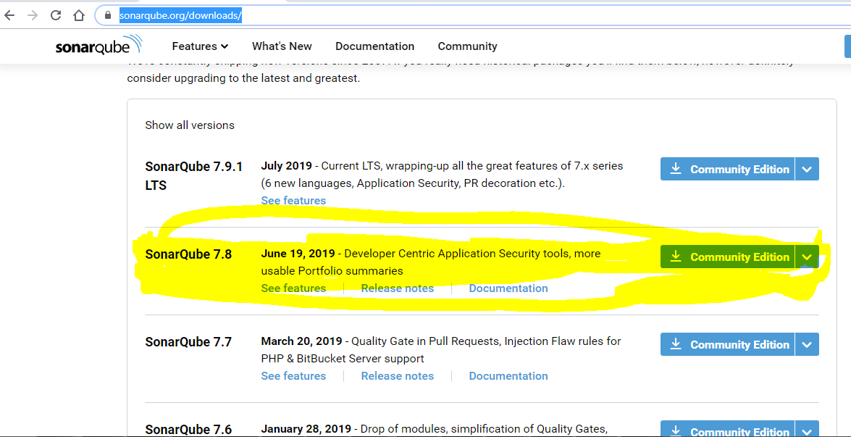

**Place the downloaded zip file in one place and Extract**

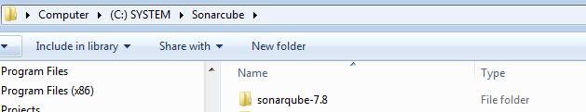

**Add this path in Environment variables C:\Sonarcube\sonarqube-7.8\bin\windows-x86-64**

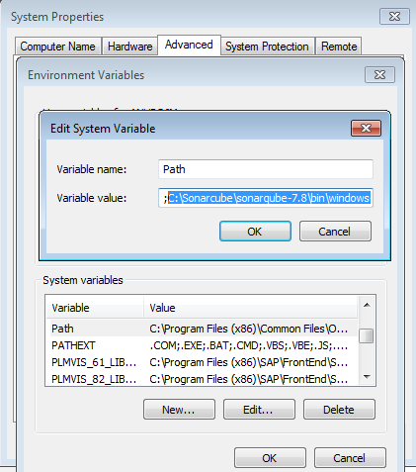

**Now Server is configures**

**To Start the Sonarcube server**

**Go to this path C:\Sonarcube\sonarqube-7.8\bin\windows-x86-64 in CMD**

**Type StartSonar.bat**

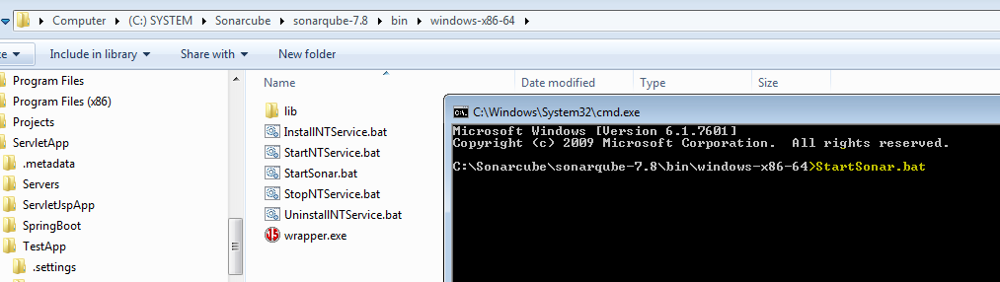

**Now Server will be started**

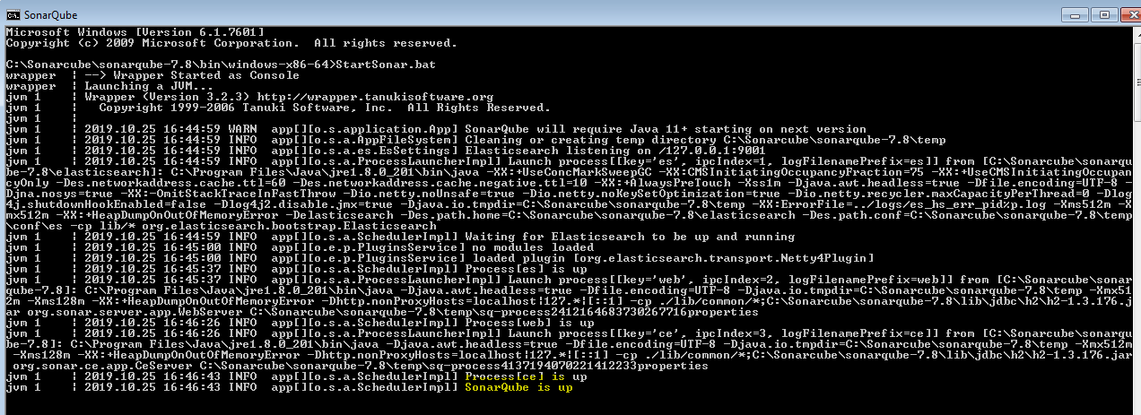

We can access the application http://localhost:9000/

Click on login and enter user name admin and password admin

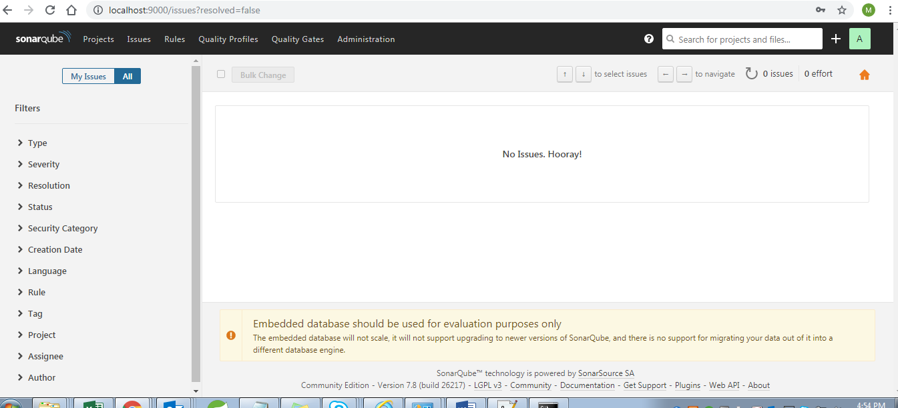

Now Setup the Sonarcube scanner

Go to this link and download <https://docs.sonarqube.org/latest/analysis/scan/sonarscanner/>

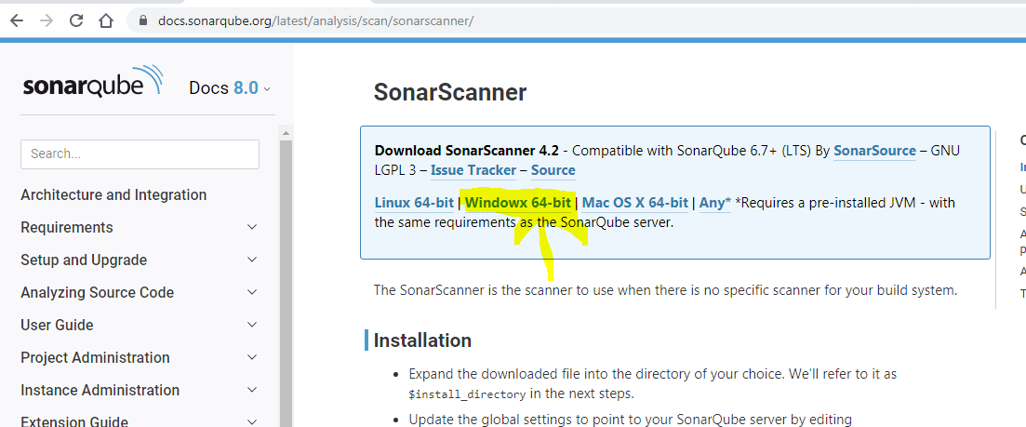

**Place the downloaded zip file in one place and Extract**

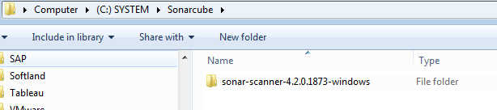

**Add this path in Environment variables C:\Sonarcube\sonar-scanner-4.2.0.1873-windows\bin;**

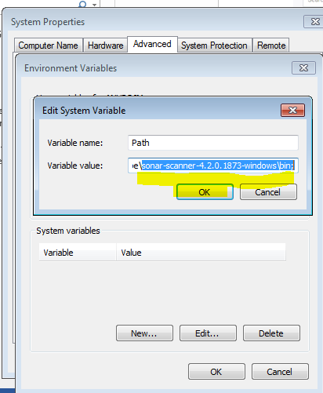

**Now open sonar-scanner.properties file from the location C:\Sonarcube\sonar-scanner-4.2.0.1873-windows\conf\sonar-scanner.properties**

**Edit the above file as below and click on save**

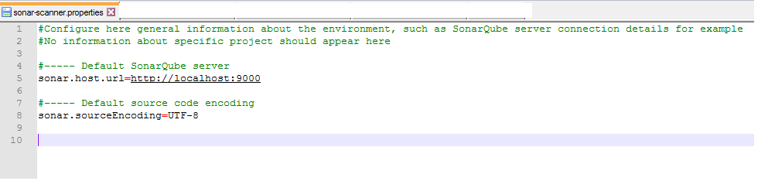

**====Now Sonarcube server and sonarqube scanner setup is done=====================**

**Running the Socanqube scan for a project**

**For fast scan result, scan the particular project for example CLMFramework project**

**To run the scan for the above scan, do the following**

**Add the property files in this path C:\Projects\OWL\CLMFramework**

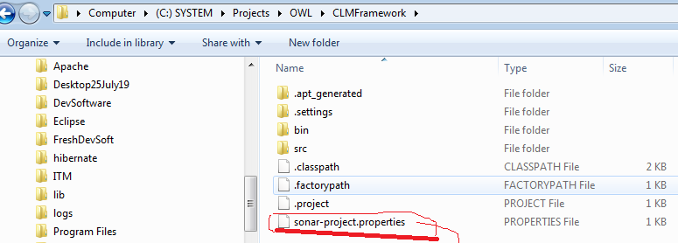

**This sonar-project.properties file contains some configuration**

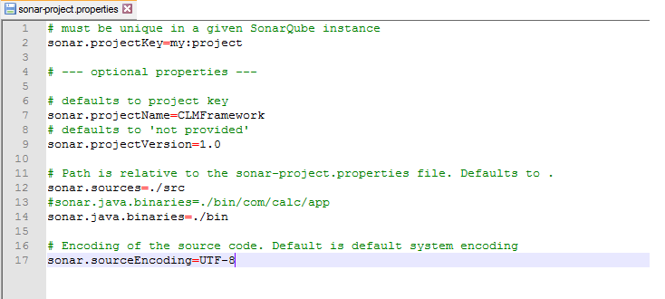



**Now start the scanner as below**

**Go to this path C:\Projects\OWL\CLMFramework in CMD and type this command sonar-scanner**

**Now it will start scanning**

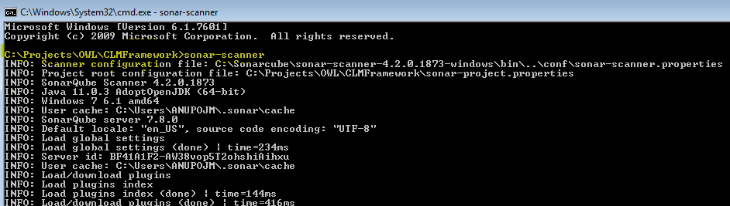

**Once scan is done we get the below message**

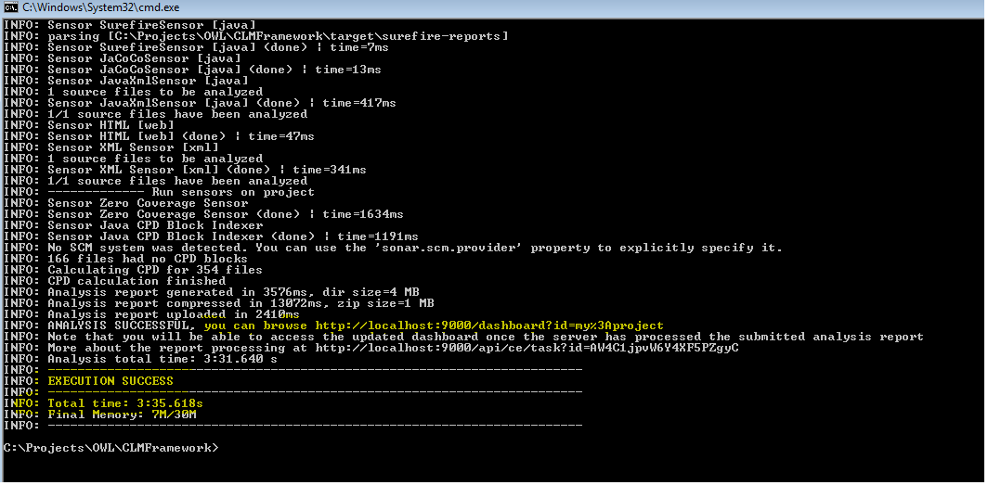

**Now we can see the result at** <http://localhost:9000/projects>

Scanned only one project CLMFramework(Results will be fast if only project is scanned at a time)

