Improving Hinglish Sentiment Analysis using Context-Aware Feature Engineering in Classical Machine Learning
Madhav Kathuria
South Asian University
Delhi, New Delhi, India
madhavkathuria@students.sau.ac.in

Abstract

This project focuses on improving sentiment analysis of Hinglish (code-mixed Hindi-English) text using classical machine learning techniques. Sentiment analysis is a widely used Natural Language Processing task that aims to classify text into categories such as positive or negative. While traditional approaches have shown good performance on standard English datasets, they often fail when applied to code-mixed languages like Hinglish due to inconsistent grammar, informal vocabulary, and variations in spelling.
Hinglish text presents unique challenges, including the use of Hindi words written in Roman script, frequent mixing of languages within a single sentence, and the presence of slang or non-standard expressions. These factors reduce the effectiveness of conventional preprocessing and feature extraction techniques. As a result, standard machine learning models may misinterpret contextual meaning and fail to capture sentiment accurately.
To address these challenges, this project proposes the use of context-aware feature engineering techniques within a classical machine learning framework. The approach includes Hinglish-specific preprocessing such as normalization of commonly used words, handling of spelling variations, and incorporation of domain-specific mappings (e.g., “mast” to “good”, “bakwaas” to “bad”). Additionally, n-gram features (unigrams and bigrams) will be utilized to capture relationships between words, and negation handling techniques will be applied to better interpret phrases such as “not good” or “nahi acha”.
The processed text data will be transformed using TF-IDF vectorization and used to train multiple machine learning models including Logistic Regression, Naive Bayes, and Support Vector Machines. The performance of these models will be evaluated using standard metrics such as accuracy, precision, recall, and F1-score. The study aims to demonstrate that incorporating context-aware feature engineering significantly improves the performance of classical machine learning models on Hinglish sentiment analysis tasks.
This work contributes to the growing area of code-mixed language processing by providing a lightweight and interpretable approach that does not rely on computationally expensive deep learning models, making it suitable for resource-constrained environments.

1. Introduction

Sentiment analysis is a fundamental task in Natural Language Processing that involves determining the emotional tone or opinion expressed in a piece of text. It is widely used in applications such as product review analysis, social media monitoring, and customer feedback systems. Traditional sentiment analysis techniques have been extensively developed for standard English text and have achieved high accuracy using both machine learning and deep learning approaches.

However, in multilingual societies such as India, users often communicate using code-mixed languages, where multiple languages are combined within a single sentence. One of the most common forms of such communication is Hinglish, which blends Hindi and English, typically written in the Roman script. For example, a sentence like “yeh phone mast hai but battery bakwaas hai” contains both Hindi and English words, making it difficult for standard NLP systems to process effectively.

The primary challenge in analyzing Hinglish text lies in its lack of standardization. Words may have multiple spellings (e.g., “acha”, “accha”, “achha”), grammar is often informal, and domain-specific slang is frequently used. Additionally, the presence of negation and contextual dependencies further complicates sentiment interpretation. Traditional machine learning models that rely on simple feature extraction techniques such as bag-of-words often fail to capture these nuances, leading to reduced classification performance.

To address these challenges, this project proposes a context-aware feature engineering approach within a classical machine learning framework. Instead of relying on computationally intensive deep learning models, the focus is on enhancing traditional techniques by incorporating Hinglish-specific preprocessing, normalization of commonly used terms, n-gram features to capture contextual relationships, and explicit handling of negation patterns. These enhancements aim to improve the model’s ability to understand semantic relationships within code-mixed text.

The objective of this work is to evaluate whether such feature engineering techniques can significantly improve sentiment classification performance on Hinglish datasets while maintaining computational efficiency and interpretability. By doing so, the project aims to contribute toward more effective and accessible solutions for sentiment analysis in code-mixed language settings.

2. Literature Review
- Sentiment analysis of code-mixed text has emerged as an important research area due to the increasing use of multilingual communication on social media platforms. In countries like India, users frequently mix Hindi and English within the same sentence, creating Hinglish text that poses significant challenges for traditional Natural Language Processing systems.
- Several studies have explored sentiment analysis for Hinglish and other code-mixed languages. Singh (2021) investigated multiple machine learning approaches for sentiment classification of Hinglish social media text, including Naive Bayes, Support Vector Machines, and ensemble models. The study emphasized the importance of data preprocessing and feature engineering, showing that iterative data cleaning and transformation significantly improve model performance. The best-performing model achieved an F1-score of approximately 69%, demonstrating the effectiveness of classical machine learning techniques when combined with proper preprocessing strategies (ResearchGate).
- More recent work has focused on advanced deep learning approaches for handling code-mixed data. A study by Kumar et al. (2023) proposed a multitask learning framework for sentiment and emotion detection in Hinglish text using cross-lingual embeddings and transfer learning techniques. The authors highlighted that code-mixed language processing remains relatively underexplored and that incorporating contextual information can improve model performance. Their approach achieved improved results compared to baseline models, demonstrating the importance of capturing contextual relationships in Hinglish sentiment analysis (ScienceDirect).
- Despite these advancements, existing approaches present certain limitations. Deep learning models, while effective, require large datasets and significant computational resources, making them less suitable for lightweight applications. On the other hand, classical machine learning models are computationally efficient but often fail to capture contextual dependencies and linguistic variations present in code-mixed text.
- Therefore, there is a need for approaches that combine the efficiency of classical machine learning with improved contextual understanding. This project addresses this gap by incorporating context-aware feature engineering techniques such as n-grams, Hinglish-specific normalization, and negation handling to enhance the performance of traditional machine learning models for sentiment analysis of Hinglish text.

3. Dataset Description
- The dataset used in this project is a publicly available Hinglish (code-mixed Hindi-English) text dataset originally designed for cyberbullying detection. It consists of approximately 25,000 social media text samples written in Roman script, reflecting real-world multilingual communication patterns commonly observed in online platforms.
- Each instance in the dataset is labeled based on whether the text contains cyberbullying content. However, for the purpose of this project, the dataset is adapted for sentiment analysis by mapping the original labels into sentiment categories. Specifically, instances labeled as cyberbullying are treated as negative sentiment, while non-cyberbullying instances are treated as neutral or positive sentiment. This transformation allows the dataset to be effectively repurposed for binary sentiment classification.
- The dataset presents several challenges typical of Hinglish text, including inconsistent spelling, informal grammar, and the presence of slang expressions. Words such as “acha”, “accha”, and “achha” may appear in different forms, while commonly used terms like “mast” (good) and “bakwaas” (bad) carry strong sentiment but are not part of standard English vocabulary. Additionally, sentences often contain a mixture of Hindi and English words, making traditional Natural Language Processing techniques less effective.
- A typical sample from the dataset is shown below:
Text: “tu bahut bakwaas hai” → Negative
Text: “yeh video mast hai” → Positive
- Before applying machine learning models, the dataset requires preprocessing to handle noise and inconsistencies. This includes text normalization, removal of punctuation, tokenization, and handling of spelling variations. Furthermore, special attention is given to negation terms such as “not” and “nahi”, which play a critical role in determining sentiment.
- An initial exploratory data analysis (EDA) will be conducted to examine the distribution of sentiment classes after transformation. This includes visualizing the number of positive and negative samples to identify any class imbalance that may affect model performance.
- Overall, the dataset provides a large-scale and realistic representation of Hinglish text, making it suitable for evaluating the effectiveness of context-aware feature engineering techniques in classical machine learning-based sentiment analysis.
4. Exploratory Data Analysis
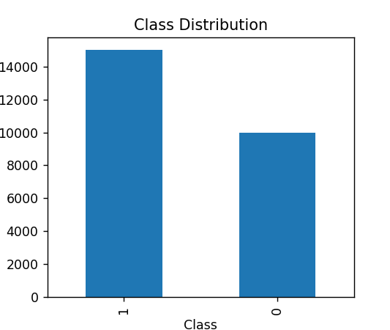
- An exploratory data analysis (EDA) was conducted to understand the structure and characteristics of the dataset. The dataset consists of approximately 25,000 Hinglish text samples labeled into two classes. A visualization of the class distribution was performed, which indicates a relatively balanced representation of both classes, ensuring that the dataset is suitable for training machine learning models without significant bias toward a particular class. Sample text instances reveal the presence of code-mixed language, informal expressions, and slang terms, highlighting the complexity of the dataset. These observations emphasize the need for specialized preprocessing techniques to handle linguistic variations and improve model performance.
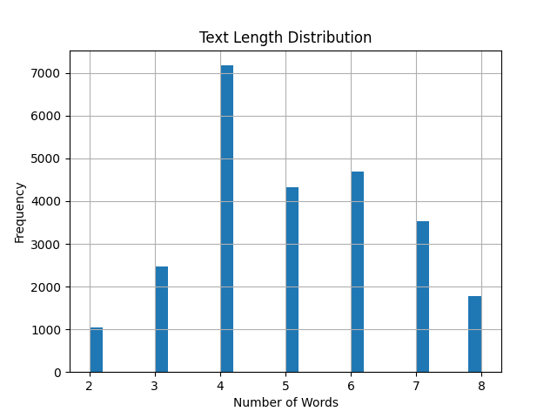
- Further analysis was conducted on the length of the text samples to understand the nature of the data. A histogram of text lengths shows that most sentences are relatively short, typically consisting of a small number of words. This reflects the informal and concise nature of social media communication, where users tend to express opinions briefly. The short length of sentences also implies that capturing contextual relationships using techniques such as n-grams becomes particularly important for accurate sentiment classification.

5. Methodology
- The proposed methodology focuses on improving sentiment classification of Hinglish text using classical machine learning techniques enhanced with context-aware feature engineering. The overall pipeline consists of preprocessing, feature extraction, model training, and evaluation.
- In the preprocessing stage, the raw text data is cleaned and standardized to reduce noise and inconsistencies. This includes converting all text to lowercase, removing punctuation, and tokenizing sentences into individual words. Additionally, Hinglish-specific normalization is applied to map commonly used words to their standardized forms. For example, variations such as “acha”, “accha”, and “achha” are normalized to a single representation, and frequently used sentiment-bearing words such as “mast” and “bakwaas” are mapped to their corresponding English meanings. This step helps reduce vocabulary sparsity and improves feature consistency.
- To incorporate contextual understanding within a classical machine learning framework, feature engineering techniques are employed. The text is transformed into numerical representations using TF-IDF vectorization. Both unigrams and bigrams are utilized to capture not only individual word importance but also relationships between adjacent words. In addition, explicit handling of negation is implemented by combining negation terms with subsequent words (e.g., “not good” → “not_good”), allowing the model to better interpret sentiment in such cases.
- The processed feature vectors are then used to train multiple machine learning models, including Logistic Regression, Naive Bayes, and Support Vector Machines. These models are chosen due to their efficiency, interpretability, and strong performance in text classification tasks. Training multiple models allows for a comparative analysis to determine the most effective approach for Hinglish sentiment classification.
- Finally, model performance is evaluated using standard metrics such as accuracy, precision, recall, and F1-score. Comparative analysis will be conducted across different feature engineering configurations, including baseline TF-IDF, TF-IDF with n-grams, and enhanced preprocessing techniques. This evaluation aims to demonstrate the impact of context-aware feature engineering on improving the performance of classical machine learning models.

6. Results and Analysis (Interim)
- At the current stage of the project, preliminary data exploration and initial preprocessing have been completed. A baseline understanding of the dataset has been established through exploratory data analysis, which revealed a relatively balanced class distribution and the presence of short, informal Hinglish text samples. These observations provide a strong foundation for applying machine learning techniques.
- The baseline model using simple TF-IDF vectorization and classical machine learning algorithms is expected to achieve moderate classification performance. However, due to the inherent challenges of Hinglish text, including spelling variations, code-mixing, and informal grammar, standard approaches may not fully capture contextual meaning.
- To address these limitations, the proposed methodology incorporates context-aware feature engineering techniques such as n-grams, Hinglish-specific normalization, and negation handling. It is anticipated that these enhancements will significantly improve model performance by enabling better representation of contextual relationships within the text.
- Further experiments will involve comparing multiple models and feature configurations to evaluate their effectiveness. The results will be analyzed using metrics such as accuracy, precision, recall, and F1-score, along with visual comparisons. The final outcome is expected to demonstrate that incorporating context-aware features leads to measurable improvements over baseline models in Hinglish sentiment classification.

References
[1] G. Singh, “Sentiment Analysis of Code-Mixed Social Media Text (Hinglish),” 2021. Available: https://www.researchgate.net/publication/349583268_Sentiment_Analysis_of_Code-Mixed_Social_Media_Text_Hinglish
[2] S. Kumar, A. Sharma, and R. Kumar, “Multitasking of sentiment detection and emotion recognition in code-mixed Hinglish data,” Knowledge-Based Systems, vol. 266, 2023. Available: https://www.sciencedirect.com/science/article/pii/S0950705122012783
[3] F. Sebastiani, “Machine Learning in Automated Text Categorization,” ACM Computing Surveys, vol. 34, no. 1, pp. 1–47, 2002.
[4] J. Ramos, “Using TF-IDF to Determine Word Relevance in Document Queries,” Proceedings of the First Instructional Conference on Machine Learning, 2003.

