VERIFACT-Lite: Reproducing a Context-Preserving Fact-Verification Pipeline with Small Open-Weight Models
Madhav Krishna Arumulla Sanskar Jadhav Sri Charan Komati Reddy Gourav Verma Trinath Reddy Vundela
Department of Computer Science, Texas Tech University, Lubbock, TX, USA
Midterm report — Neural Networks

Abstract—Decomposing a long-form answer into atomic facts is now the standard first step in automatic factuality evaluation, but decomposition discards the conditions, comparisons and inter-sentence relations that make a claim true. VeriFact (EMNLP 2025) addresses this by detecting incomplete facts and missing relational facts and repairing them before verification. This report describes VERIFACT-Lite, a reimplementation of that mechanism that runs entirely on open-weight models small enough for a 4 GB consumer GPU, with Wikipedia as the evidence source and no commercial API of any kind. We reproduce the paper's mechanism rather than its numbers, and we evaluate it on a 12-question benchmark with 86 hand-written reference facts. On the laptop configuration, refinement reduces the incomplete-fact rate from 0.105 to 0.091, recovers all 51 missing relational facts, and lowers measured precision from 0.4200 to 0.3426. Repeating the study with 7–8B judges on a free cloud GPU produces the report's central finding: on an identical fact set, the incomplete-fact rate is 0.105 under a 3B detector and 0.438 under a 7B detector, so this family of metrics measures the judge as much as the system under test. Refinement changed the verdict on 34.7–45.6 % of refined facts across three configurations, against 24.9 % reported in the paper. We close with six changes to the method itself, each argued from one of these measurements.
Index Terms—factuality evaluation, atomic facts, claim decomposition, large language models, LLM-as-judge, reproducibility, retrieval-augmented verification.
I. Introduction
Automatic factuality evaluation of long-form text has converged on a three-stage recipe: decompose a response into atomic facts, retrieve evidence for each fact, and label each fact as supported or not. FactScore and SAFE established the pattern, and most later systems inherit it. The recipe has a structural weakness that is easy to state and hard to see in aggregate scores: decomposition is lossy. A sentence carrying a condition, a comparison or a causal link is split into fragments that no longer carry it, and the verifier then adjudicates a claim the model never actually made.
The example the VeriFact authors use is representative. Given the answer “If the demand for gold as jewelry were to disappear, the price of gold could drop by 20–50 % or more, making it more competitive with other materials like copper and silver,” a SAFE-style extractor produces, among others, “The price of gold could drop by 20–50 % or more” and “Copper and silver are competitive with gold in price.” The first has lost its hypothetical; the second is stated unconditionally and the causal link in “making” is never extracted at all. Verifying either fragment against evidence produces a verdict about something the answer did not assert.
VeriFact inserts two steps between decomposition and verification. It detects incomplete facts, labelled by subtype, and missing relational facts, which are inter-sentence temporal or contingency relations that no extracted fact captures; it then repairs the first group and writes new facts for the second. On the authors' benchmark this reduces the incomplete-fact rate on SAFE output from 56.7 % to 22.5 % and the number of missing facts per response from 1.22 to 0.76, and changes the verdict on 24.9 % of refined facts.
That pipeline as published depends on resources a student project does not have: GPT-4o, Llama 3.3-70B and Qwen 2.5-32B as a detection ensemble, Llama 3.3-70B for extraction and refinement, paid Google Search through Serper for evidence, a cross-encoder reranker, and 1,096 benchmark prompts. The question this project asks is narrower and, we argue, more useful: does the mechanism still behave as described when every one of those components is replaced by something that runs locally and costs nothing?
The contributions of this midterm report are the following. First, a complete, configuration-driven reimplementation of the VeriFact mechanism on quantized 3B–8B open-weight models with Wikipedia evidence and BM25 ranking, reproducible from one command without a GPU because every model call and every retrieved page is cached. Second, a measurement of the mechanism against its own baseline on a benchmark deliberately written to contain the failure modes the paper targets. Third, a controlled repetition of the entire study with larger judges, which shows that the headline metric of this literature is a property of the judge as much as of the system being judged. Fourth, a test of the paper's union rule against a majority vote at three model sizes. Fifth, six proposed changes to the method itself, each argued from one of our measurements rather than from intuition.
We state plainly what this report does not claim. We do not reproduce the paper's reported numbers, and we do not attempt to: the models, the evidence source, the benchmark size and the annotation procedure all differ. Every figure reported here is produced by our own repository and is reproducible from the artifacts we ship.
II. Background and Related Work
A. Decomposition-based factuality evaluation
FactScore introduced per-atomic-fact scoring of long-form generation, and SAFE added a search-augmented evaluator that decomposes a response into self-contained claims and checks each one against retrieved evidence. FactCheck-GPT formalised the verification stage into a pipeline of decomposition, evidence retrieval and stance classification. All three share the assumption that an atomic fact can be verified in isolation. VeriFact is a direct attack on that assumption.
B. What VeriFact adds
VeriFact defines two defect types. An incomplete fact is one whose meaning depends on context that decomposition removed; the paper labels four subtypes, which our implementation preserves: an ambiguous concept or pronoun, a missing comparison, an omitted condition or source, and other. A missing fact is an inter-sentence discourse relation, in the PDTB sense and restricted to the temporal and contingency classes, that no extracted fact expresses. Detection is performed by an ensemble of three LLM judges whose positive detections are unioned rather than voted, a choice the authors justify by the low agreement of a single LLM judge with human annotators, reported as κ = 0.33. Repair is a self-reflection step that rewrites each flagged fact and writes one new fact per detected missing relation.
C. Running large pipelines on small hardware
Quantized inference with llama.cpp-derived runtimes has made 3B–8B instruction-tuned models usable on consumer hardware, and Ollama provides a serving layer over them. Our implementation targets this stack directly, with a model-agnostic client so that the same code path runs against a laptop GPU and a cloud T4 with no change beyond two identifiers in a configuration file.
III. System Description
VERIFACT-Lite implements the four stages of the published pipeline. Model identifiers, decoding parameters, ensemble strategy, retrieval behaviour and benchmark paths all live in a single configuration file; no model name appears anywhere in the source.
A. Stage 1: baseline extraction
A SAFE-style extractor splits each sentence of the response into atomic facts and then decontextualizes them, resolving pronouns and vague references against the full response. This stage is deliberately left weak: it is the baseline that the rest of the pipeline is supposed to improve, so strengthening it would hide the effect under study.
B. Stage 2: detection
Incomplete-fact detection presents each fact together with the response it came from and asks the judge for a verdict and a subtype. Missing-relation detection is a two-step procedure. First, span coverage marks every character of the response that is matched by some extracted fact, using longest-common-substring matching per sentence, and collects the contiguous runs that stayed uncovered; our normalization for case, whitespace and line breaks is index-preserving, one character in and one character out, so span offsets remain valid against the original text. Second, each uncovered span is put to the judges twice: does the span express a temporal or contingency relation, and is that relation already captured by a single existing fact? A span becomes a missing relation only when the first answer is yes and the second is no.
C. Stage 3: refinement
Each flagged fact is rewritten with the response in context, and each confirmed missing relation produces one new relational fact. The refined set replaces the original fact set for verification.
D. Stage 4: grounded verification
Evidence comes from the Wikipedia API. Retrieved paragraphs are ranked with BM25 and the top five are passed to the verifier, which must return a label, a confidence and a verbatim quote from the evidence. A SUPPORTED or CONTRADICTED verdict whose quote cannot be found in the evidence is downgraded to UNDECIDED. This guard was not optional: an earlier version of our verifier, without it, reported precision 0.92 and zero contradictions across 258 facts, and labelled “Aluminium is the rarest metal in the Earth's crust” as SUPPORTED with confidence 1.0. Requiring the quote moved precision to 0.42 and made contradictions appear.
E. Reproducibility machinery
Every model call is cached under a hash of model identifier, prompt and decoding parameters, and every retrieved page is cached on disk. The three runs reported here replay from those caches: the laptop run resolves 2518 cached model calls and 4084 cached page fetches with zero network calls, so the tables below are reproducible on a machine with no GPU and no internet connection. The repository carries 59 unit tests covering span coverage, JSON parsing, metric computation and pipeline wiring.
IV. Experimental Setup
A. Benchmark
The benchmark is 12 open-ended questions written so that a correct answer naturally contains conditions, comparisons, event order or cause and effect — the structures decomposition damages. Topics include the gold and jewellery example from the paper, aluminium against silver, Chernobyl, the Panama Canal, Concorde, the ozone layer and Arctic sea ice. For recall we hand-wrote 86 reference facts, three to eight per question, from authoritative sources, with the source recorded for each. The reference facts were written before any system output was inspected and are deliberately not derived from the answers being evaluated.
TABLE I
Benchmark composition
ID | Topic | Structure the question invites | Ref.
Q01 | gold and jewellery demand | counterfactual condition | 7
Q02 | aluminium against silver | historical comparison | 7
Q03 | uranium to electricity | process chain | 7
Q04 | Chernobyl | event order, causation | 8
Q05 | lithium-ion against lead-acid | comparison | 7
Q06 | cabin depressurization | condition, consequence | 7
Q07 | interest rates and inflation | causation | 7
Q08 | Panama Canal | before and after | 8
Q09 | vaccine second dose | temporal relation | 7
Q10 | ozone layer recovery | condition, source | 7
Q11 | Concorde economics | counterfactual | 7
Q12 | Antarctic and Arctic sea ice | comparison, causation | 7
Table I lists the benchmark. The distribution is deliberate rather than natural: every question was written to force at least one of the structures that decomposition damages, so the benchmark is a stress test and not a sample of typical usage. This is the same design decision the paper makes when it reports that 51 % of the missing facts it finds are omitted conditions.
B. Metrics
Precision is supported facts over all extracted facts, with UNDECIDED reported separately and never counted as support; we also report decided precision, computed only over facts the verifier could decide. Recall is the fraction of the 86 reference facts entailed by the answer; because it scores the answer rather than the fact set, refinement cannot move it, which is a useful invariant when reading the tables. The incomplete-fact rate is measured by one designated judge, while refinement is driven by the ensemble, so that facts are never scored by the same rule that selected them for repair.
C. Configurations
The answer for each question is generated once and reused by every run, verified identical by hash, so that any difference between systems is attributable to the pipeline and not to sampling. Three configurations are reported, summarised in Table II. The laptop configuration runs entirely on a 4 GB GTX 1650. Run A upgrades only the two judges and replays extraction from cache, which makes its baseline fact set byte-identical to the laptop's and isolates the judge change. Run B additionally replaces the extractor, the verifier and the entailment model used for recall, so its columns are read only against its own baseline.
TABLE II
The three configurations
Run | Primary model | Judges | Controlled
laptop-3B | Qwen2.5-3B | Qwen2.5-3B + Llama-3.2-3B | reference
run A | Qwen2.5-3B (unchanged) | Qwen2.5-7B + Llama-3.1-8B | yes
run B | Qwen2.5-7B | Qwen2.5-7B + Llama-3.1-8B | no
All models are Q4_K_M quantized and served through Ollama. Runs A and B execute on a free Colab T4. No API key is used at any point in the pipeline.
V. Results
A. The mechanism against its own baseline
Table III reports the laptop configuration. Refinement does what the paper describes to the fact set: the incomplete-fact rate falls from 0.105 to 0.091, and all 51 missing relational facts are recovered, 163 facts being rewritten and 51 added. Measured precision falls with it, from 0.4200 to 0.3426. Fig. 1 shows the same three scores side by side.
TABLE III
Baseline against VERIFACT-Lite, laptop configuration
Measure | Baseline | VERIFACT-Lite
Facts per answer | 21.50 | 24.67
Incomplete rate | 0.105 | 0.091
Missing relations | 51 | 0
Supported | 109 | 108
Contradicted | 3 | 3
Undecided | 146 | 185
Precision | 0.4200 | 0.3426
Decided precision | 0.9732 | 0.9730
Recall | 0.4077 | 0.4077
F1 | 0.4138 | 0.3723
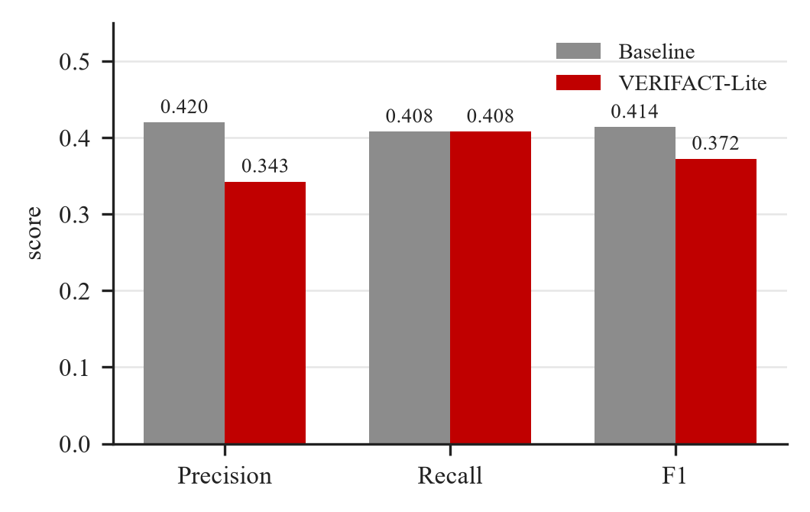
Fig. 1. Precision, recall and F1 before and after refinement, laptop configuration. Recall is fixed by construction because it scores the answer, not the fact set.
The precision drop is not a bug, and the counts explain it. Supported falls only from 109 to 108, while undecided rises from 146 to 185. A refined claim carries its condition or comparison target, so a single Wikipedia sentence must support more, and frequently none does. Decided precision barely moves, from 0.9732 to 0.9730, which locates the cost in retrieval coverage rather than in correctness.
B. Ablation
Table IV separates the two halves of the contribution. Incomplete-fact refinement alone produces the largest single improvement in the incomplete rate, 0.105 to 0.078, and carries most of the precision cost. Relation recovery alone removes all missing relations and raises the incomplete rate slightly, to 0.113, because the newly written relational facts are themselves judged. The full system inherits both effects.
TABLE IV
Ablation, laptop configuration, union ensemble
System | Incompl. | Missing | Precision | F1
Baseline | 0.105 | 51 | 0.4200 | 0.4138
+ incomplete-fact refinement | 0.078 | 51 | 0.3680 | 0.3868
+ missing-relation recovery | 0.113 | 0 | 0.3839 | 0.3954
Full VERIFACT-Lite | 0.091 | 0 | 0.3426 | 0.3723
C. The detector is part of the measurement
Run A changes the two judges and nothing else. Because extraction replays from cache, the fact set it scores is byte-identical to the laptop's: 21.50 facts per answer, precision 0.4200, identical to Table III. On that identical input, the incomplete-fact rate measured by the 3B detector is 0.105 and the rate measured by the 7B detector is 0.438 — a factor of 4.2 on the same text, against 0.567 reported in the paper for SAFE output under GPT-4o. Fig. 2 places the three side by side.
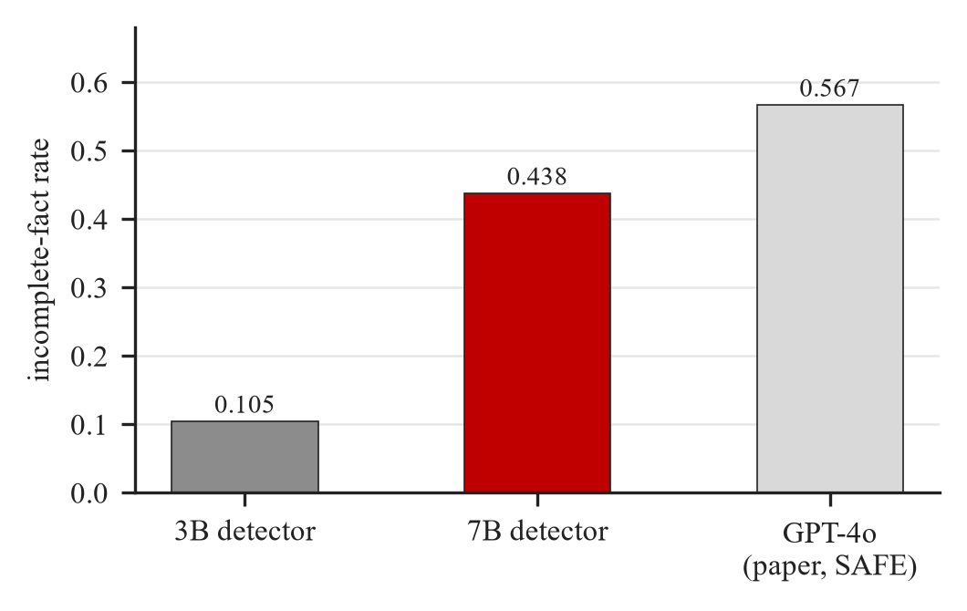
Fig. 2. Incomplete-fact rate on an identical baseline fact set under detectors of different size. Nothing about the system under test changes between the first two bars; the paper's figure is shown for scale.
The same effect appears in recall. Run B scores the same 12 answers against the same 86 reference facts with a larger entailment model and credits the answers with 0.2812 against 0.4077, a coverage of 24 of 86 reference facts rather than 35. We therefore read our absolute precision, recall and F1 as properties of a measurement apparatus rather than as system quality, and we compare only within a fixed detector.
D. Union against majority
The paper unions positive detections across judges. Table V compares that rule with a majority vote in all three configurations, holding everything else fixed. Majority gives higher precision and F1 in every case. The large advantage in incomplete rate that the laptop run shows, 0.042 against 0.091, does not survive scale: with 7–8B judges the two rules are within four percent of each other, and with a 7B extractor they are indistinguishable. We reported that advantage in an earlier version of this work and withdraw it here as an artifact of small judges.
TABLE V
Union against majority, full system, all three runs
Run | Rule | Incompl. | Precision | F1
laptop-3B | union | 0.091 | 0.3426 | 0.372
laptop-3B | majority | 0.042 | 0.4071 | 0.407
run A | union | 0.411 | 0.3018 | 0.347
run A | majority | 0.393 | 0.4106 | 0.409
run B | union | 0.286 | 0.4802 | 0.355
run B | majority | 0.287 | 0.4985 | 0.360
Table VI explains why the rule matters so little for one of the two tasks. For missing relations the union equals the more permissive judge exactly in all three runs — 51 of 51, 54 of 54 and 21 of 21 — so the second judge contributes nothing there at any model size. For incompleteness the picture changes with scale: at 3B the ensemble again equals one judge, but at 7–8B it exceeds both individually, which is the complementarity the union rule assumes.
TABLE VI
Facts flagged by each judge and by the union
Run and task | Qwen | Llama | Union
3B — incompleteness | 20 | 34 | 34
3B — relations | 2 | 51 | 51
7–8B — incompleteness | 32 | 27 | 33
7–8B — relations | 15 | 54 | 54
E. Does repairing a claim change its verdict?
This is the paper's central question, and the one result that transfers cleanly across configurations. Every refined fact is verified twice, once as its original claim and once as its refined claim, through the same evidence pipeline. The verdict changes for 39.3 % of refined facts on the laptop (70 of 178), 45.6 % in run A (68 of 149) and 34.7 % in run B (26 of 75), against 24.9 % in the paper. Whether a claim keeps its context decides between a quarter and nearly half of all verdicts.
The direction of the change is informative. With 3B judges we reproduced only half of the paper's reported signature: supported fell, but the contradicted count never moved off 3. With 7–8B judges it rises from 3 to 8, and run A records 4 facts moving directly from SUPPORTED to CONTRADICTED once repaired. That is the other half of the paper's claim that ignoring incomplete facts overestimates factuality: the error was present in the response all along and the stripped claim hid it.
F. A stronger extractor leaves less to repair
Run B is not a controlled comparison, but one effect is worth recording. A 7B extractor writes 15.92 facts per answer against 21.50, with a lower incomplete rate under the same 7B detector (0.319 against 0.438) and higher precision (0.5050 against 0.4200). Refinement then costs far less precision, −0.025 against −0.118 in run A. Fewer, coarser, more self-contained facts are both easier to verify and less in need of repair.
G. Cost and reproducibility
The pipeline is dominated by detection, which asks every judge about every fact and then about every uncovered span. The laptop run resolves 2518 model calls and 4084 page fetches, run A 2444 and 3905, and run B 1621 and 2531. Two 3B judges at Q4_K_M do not fit together in 4 GB, so the implementation drives one judge over the whole fact list before releasing its weights; without that, every call pays a model load of roughly twenty seconds. Retrieval needed its own care: Wikipedia rate-limits unauthenticated clients and failed requests are not cached, so without retries a 429 silently becomes “no evidence” and two runs of the same pipeline disagree. All three runs now replay from cache with zero network calls.
H. Qualitative behaviour
Reading the output exposes a failure mode that no aggregate metric reports. On the ozone-layer question the refiner behaves exactly as intended, turning “These substances are in the atmosphere” into “The substances are in the atmosphere since the Montreal Protocol was signed,” which moves from UNDECIDED to SUPPORTED. On the gold question it inverts a claim: “There was demand for gold as jewelry” becomes “There was no demand for gold as jewelry,” because the hypothetical in the question was pasted into a fact asserting the opposite. A 3B refiner has no guard against changing the meaning of what it repairs, and the label-change rate counts that corruption and a genuine repair identically.
VI. Comparison with the Published Results
Table VII places our figures beside the paper's. The agreement to look for is directional. Both defect types are detected and repaired; refinement changes a large fraction of verdicts; supported falls and contradicted rises once the judges are large enough to see the errors. The magnitudes are not comparable and we do not present them as such: different models, a different evidence source, 12 prompts instead of 1,096, and no human annotation.
TABLE VII
Paper against VERIFACT-Lite
Measure | Paper | This work | Agreement
Incomplete, baseline | 0.567 | 0.105 / 0.438 | closes with scale
Incomplete, refined | 0.225 | 0.091 / 0.411 | same direction
Missing relations | 1.22 → 0.76 | 51 → 0 | same direction
Verdict changes | 24.9 % | 39.3 % / 45.6 % | same phenomenon
Direction of change | sup. ↓, con. ↑ | both at 7–8B | reproduced
Precision | 82.8 | 34.3–48.0 | not comparable
F1 | 57.5 | 34.7–41.4 | not comparable
VII. Proposed Changes to the Method
The following six changes target VeriFact as published rather than our reimplementation. Each is argued from a measurement reported above.
1) Vote instead of union, and drop the second judge for relations. The union rule is justified by low single-judge agreement, but Table V shows majority voting winning on precision in all three configurations, and Table VI shows the union equalling one judge exactly on relation detection at every model size. The second judge buys nothing on that task and costs a full pass over the fact set.
2) Gate refinement on faithfulness. Self-reflection rewrites a fact with no check that the response still entails it, which is how our refiner produced a claim asserting the opposite of the source sentence. One entailment call per rewrite would reject such repairs. Without that gate, the headline label-change rate cannot distinguish a repair from a corruption.
3) Refine against the evidence rather than blind to it. The published order refines first and retrieves second, and the paper reports precision falling after refinement without accounting for it. Our counts locate the loss precisely: undecided rises from 146 to 185 while decided precision is unchanged. Retrieving first and conditioning the rewrite on the evidence that actually exists would preserve context without destroying checkability.
4) Make span coverage semantic. Coverage is computed by longest-common-substring matching, so a paraphrased relation reads as uncovered and is re-added as a new fact. Character coverage ran between 0.55 and 0.59 across our answers and produced 73 candidate spans. Embedding-based coverage would remove a class of spurious candidates at negligible cost.
5) Calibrate the detector before ranking models. The paper benchmarks twelve generators against one fixed detector and compares the resulting rates directly. Our Fig. 2 shows that swapping the detector alone moves that rate by a factor of 4.2 on identical text. Anchoring every detector on one small annotated probe set, and reporting rates relative to that anchor, would make such comparisons mean what they appear to mean.
6) Escalate only on disagreement. Detection runs three frontier models over every extracted fact and dominates the cost of the pipeline. Cheap judges agree on the large majority of facts; routing only the disputed ones to a large model targets the same detections for a fraction of the calls. This is what made the method runnable on a 4 GB GPU at all.
VIII. Limitations
The benchmark is 12 questions and 86 reference facts, which supports trends and not significance. There is no human annotation, so every incompleteness and relation judgement comes from a model. Only run A is a controlled comparison against the laptop configuration; run B changes four components at once and is read only against its own baseline. Recall depends on the entailment model and is therefore not comparable across runs that change it. Evidence is restricted to Wikipedia, which caps what any verifier can decide and concentrates the UNDECIDED mass that drives our precision figures. Finally, temperature-zero decoding is not bit-reproducible until the cache is warm; all artifacts shipped with this report are self-consistent and replay exactly.
IX. Conclusion and Remaining Work
The VeriFact mechanism survives the move to small open-weight models. Detection and repair behave as described, all missing relational facts are recovered, measured precision falls for a reason we can locate in the verdict counts, and the paper's central phenomenon — that repairing a claim changes its verdict — holds at 34.7 to 45.6 % across three model configurations against 24.9 % reported. The reimplementation needs no API key and replays from cache without a GPU.
The finding we consider most consequential is methodological. On an identical fact set the incomplete-fact rate is 0.105 under a 3B detector and 0.438 under a 7B detector. A metric that moves by a factor of four when only the measuring model changes cannot be compared across papers, or across models within a paper, without calibration. That observation generalises beyond VeriFact to the whole decomposition-based factuality literature.
For the remainder of the term we intend to implement the faithfulness gate and the evidence-conditioned refinement order, since both are cheap and both target measured failures, and to build the small annotated probe set that the calibration proposal requires. We also plan to extend the benchmark and to report per-subtype incompleteness rates, which our pipeline already records but does not yet aggregate.
X. References
[1] X. Liu, Y. Zhang, A. Munir, Y. Gu, and L. Wang, “VeriFact: Verifying facts in LLM-generated long-form text with incomplete and missing facts,” in Proc. EMNLP, 2025, pp. 17908–17925.
[2] J. Wei et al., “Long-form factuality in large language models,” arXiv:2403.18802, 2024.
[3] S. Min et al., “FActScore: Fine-grained atomic evaluation of factual precision in long form text generation,” in Proc. EMNLP, 2023.
[4] Y. Wang et al., “Factcheck-GPT: End-to-end fine-grained document-level fact-checking and correction of LLM output,” arXiv:2311.09000, 2023.
[5] B. Webber, R. Prasad, A. Lee, and A. Joshi, “The Penn Discourse Treebank 3.0 annotation manual,” Univ. of Pennsylvania, 2019.
[6] A. Yang et al., “Qwen2.5 technical report,” arXiv:2412.15115, 2024.
[7] A. Dubey et al., “The Llama 3 herd of models,” arXiv:2407.21783, 2024.
[8] S. Robertson and H. Zaragoza, “The probabilistic relevance framework: BM25 and beyond,” Foundations and Trends in Information Retrieval, vol. 3, no. 4, pp. 333–389, 2009.
[9] G. Gerganov et al., “llama.cpp,” GitHub repository, 2023. [Online]. Available: https://github.com/ggerganov/llama.cpp
[10] Ollama, “Ollama: Get up and running with large language models locally,” 2024. [Online]. Available: https://ollama.com

