**School of Computer Science**

**UNIVERSITY OF PETROLEUM AND ENERGY STUDIES**

**DEHRADUN, UTTARAKHAND**



**Artificial Intelligence & Machine Learning**

**Lab File (2022-2026)**

# **6th Semester**

|  |  |
| --- | --- |
| *Submitted To:*  ***Dr. Tanupriya Choudhury*** | *Submitted By:*  *Madhav Madan*  *(500105699)*  *B Tech CSE*  *DevOps[6th Semester]*  *R2142220265*  *Batch - 1* |

**EXPERIMENT 1**

**Q1. Write a Python program to perform basic arithmetic operations (addition, subtraction, multiplication, division, and modulus) on two numbers.**

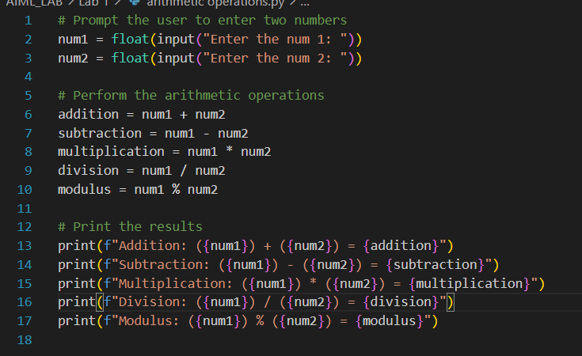

**Output:-**

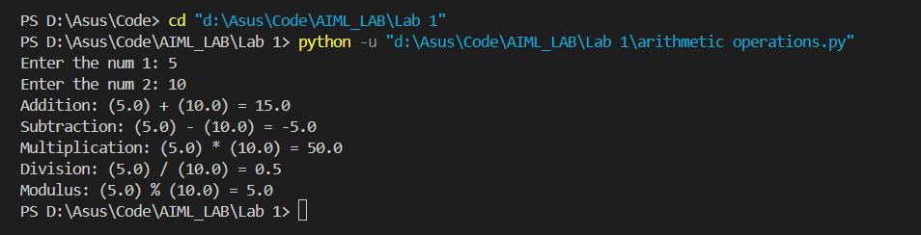

**Q2. Create variables of different data types (integer, float, string, boolean) and perform basic operations on them.**

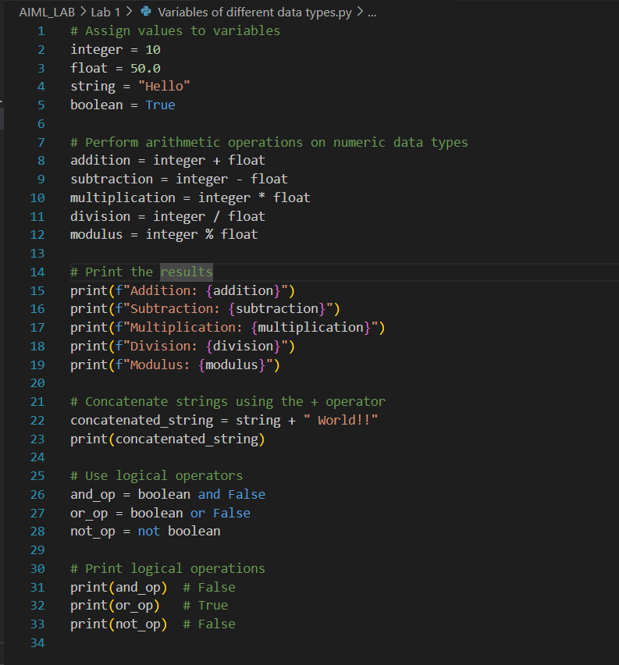

**Output:-**

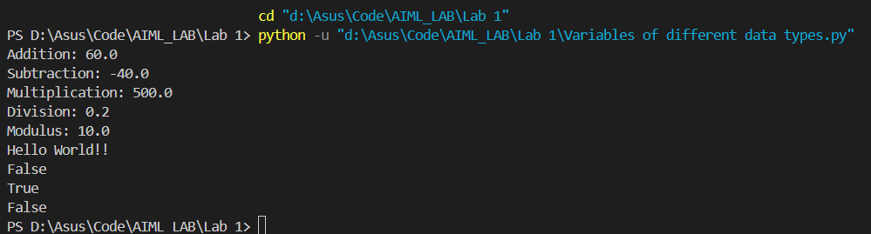

**Q3. Write a program to take user input, process it, and display the result.**

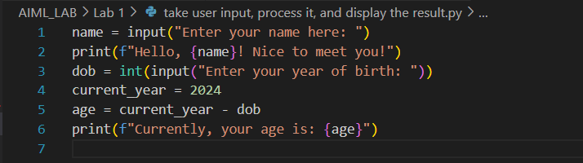

**Output**

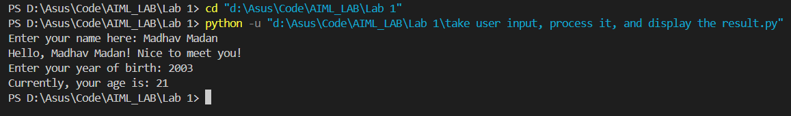

**Q4. Write a program to check if a number is even or odd.**

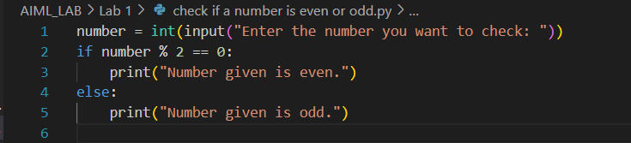

**Output**

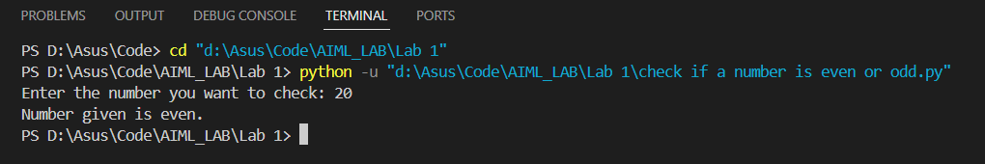

**Q5. Write a program to print the numbers from 1 to 10 using both for and while loops.**

* **Use a for loop to iterate through a range of numbers:**

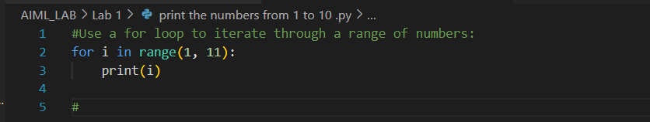**Output:-**

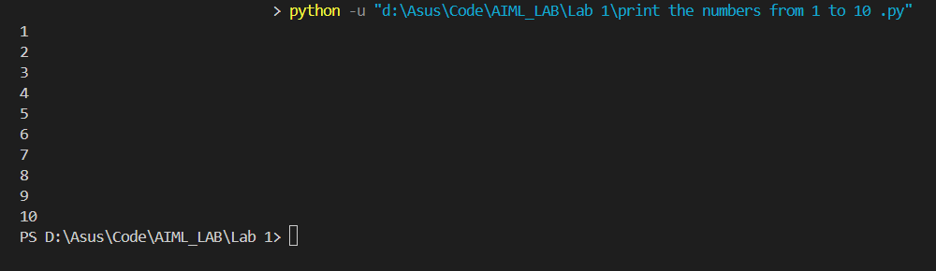

* **Use a while loop with a counter variable:**

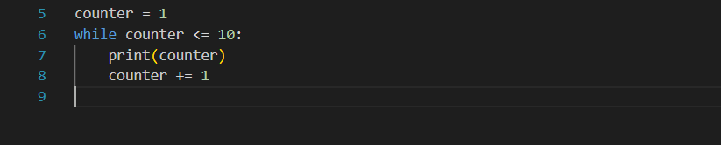

**Output:-**

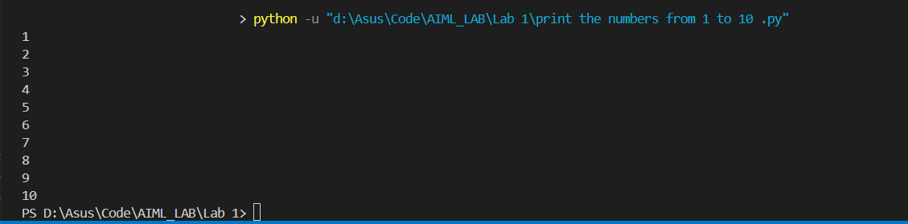

**Q6. Create a list, access elements, modify elements, and perform list operations.**

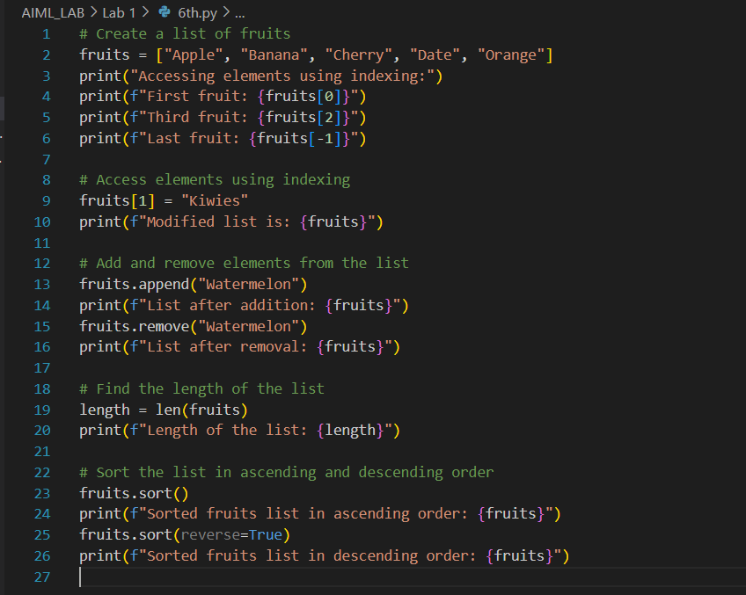

**Output:-**

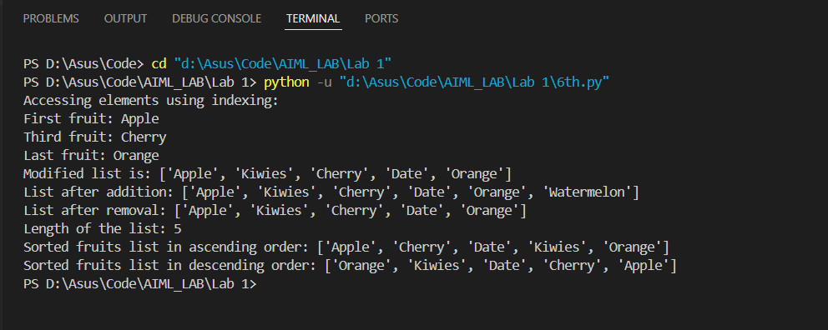

**Q7: Manipulate strings using various built-in functions.**

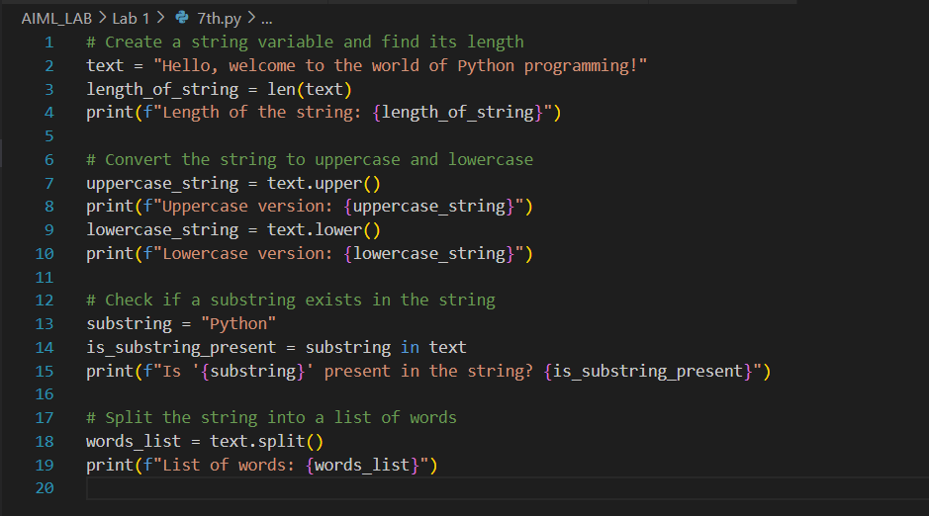

**Output:-**

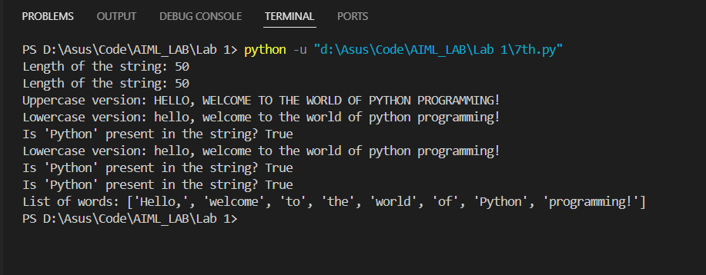

**Q8: Write a program to find the largest and smallest number in a list.**

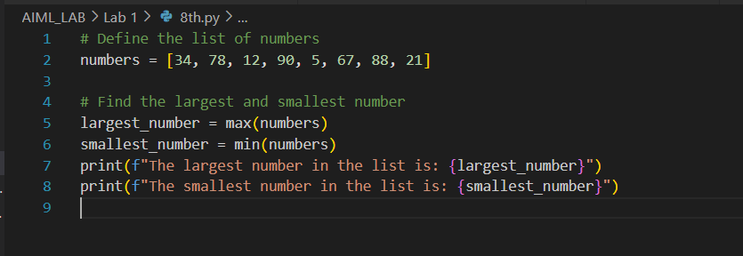

**Output:-**

