Car Rental Management System

Course: CS 1103 – Introduction to Databases
Instructor: Jong-Kyou Kim, PhD
Student: Madhav Manchanda
ID: 3781053
Date: April 5, 2026

ABSTRACT

This project is a Car Rental Management System designed using SQLite and Java. It manages customers, cars, reservations, rentals, and payments. The system demonstrates database design, SQL operations, and Java database connectivity using JDBC.

INTRODUCTION

The purpose of this project is to understand database concepts by building a real-world application. A car rental company needs to manage customer records, vehicle details, reservations, rentals, and payments in an organized way. This system stores all information in a structured relational database.

SYSTEM DESIGN

The system contains the following entities:
- Customer
- Car
- Reservation
- Rental
- Payment

These entities are connected using primary keys and foreign keys.

ER DIAGRAM

+-----------+ +--------------+ +-----------+
| Customer | | Reservation | | Car |
+-----------+ +--------------+ +-----------+
| customer_id (PK) | reservation_id (PK) | car_id (PK) |
| name | customer_id (FK) | model |
| phone | car_id (FK) | brand |
| email | start_date | price |
| license_no | end_date | available |
+-----------+ +--------------+ +-----------+
|
v
+-------------+
| Rental |
+-------------+
| rental_id (PK) |
| reservation_id (FK) |
| rental_date |
| return_date |
| total_cost |
+-------------+
|
v
+-------------+
| Payment |
+-------------+
| payment_id (PK) |
| rental_id (FK) |
| payment_date |
| amount |
| method |
+-------------+

DDL STATEMENTS

DROP TABLE IF EXISTS Payment;
DROP TABLE IF EXISTS Rental;
DROP TABLE IF EXISTS Reservation;
DROP TABLE IF EXISTS Car;
DROP TABLE IF EXISTS Customer;

CREATE TABLE Customer (
customer_id INTEGER PRIMARY KEY,
name TEXT,
phone TEXT,
email TEXT,
driver_license_no TEXT
);

CREATE TABLE Car (
car_id INTEGER PRIMARY KEY,
brand TEXT,
model TEXT,
year INTEGER,
daily_rate REAL,
availability_status TEXT
);

CREATE TABLE Reservation (
reservation_id INTEGER PRIMARY KEY,
customer_id INTEGER,
car_id INTEGER,
start_date TEXT,
end_date TEXT,
FOREIGN KEY (customer_id) REFERENCES Customer(customer_id),
FOREIGN KEY (car_id) REFERENCES Car(car_id)
);

CREATE TABLE Rental (
rental_id INTEGER PRIMARY KEY,
reservation_id INTEGER,
pickup_date TEXT,
return_date TEXT,
total_cost REAL,
FOREIGN KEY (reservation_id) REFERENCES Reservation(reservation_id)
);

CREATE TABLE Payment (
payment_id INTEGER PRIMARY KEY,
rental_id INTEGER,
payment_date TEXT,
amount REAL,
payment_method TEXT,
FOREIGN KEY (rental_id) REFERENCES Rental(rental_id)
);

DDL EXPLANATION

- Customer stores customer information
- Car stores car details
- Reservation connects customer and car
- Rental stores rental information
- Payment stores payment details

Foreign keys are used to maintain relationships between tables.

SAMPLE INSERT STATEMENTS

INSERT INTO Customer VALUES (1, 'John', '1234567890', 'john@mail.com', 'DL123');
INSERT INTO Customer VALUES (2, 'Mike', '9876543210', 'mike@mail.com', 'DL456');

INSERT INTO Car VALUES (1, 'Toyota', 'Camry', 2022, 50, 'Available');
INSERT INTO Car VALUES (2, 'Honda', 'Civic', 2021, 40, 'Available');

INSERT INTO Reservation VALUES (1, 1, 1, '2026-04-01', '2026-04-05');

INSERT INTO Rental VALUES (1, 1, '2026-04-01', '2026-04-05', 200);

INSERT INTO Payment VALUES (1, 1, '2026-04-01', 200, 'Credit Card');

CRUD OPERATIONS

The system supports:

- INSERT → Add Customer
- SELECT → View Customers
- UPDATE → Update Customer
- DELETE → Delete Customer

These operations are implemented using Java and JDBC.

JDBC IMPLEMENTATION

The Java program connects to the SQLite database using JDBC. It allows users to perform operations through a menu-driven interface.

APPLICATION DESIGN

Menu options:

1. Add Customer
2. View Customers
3. Update Customer
4. Delete Customer
5. Exit

SCREENSHOTS
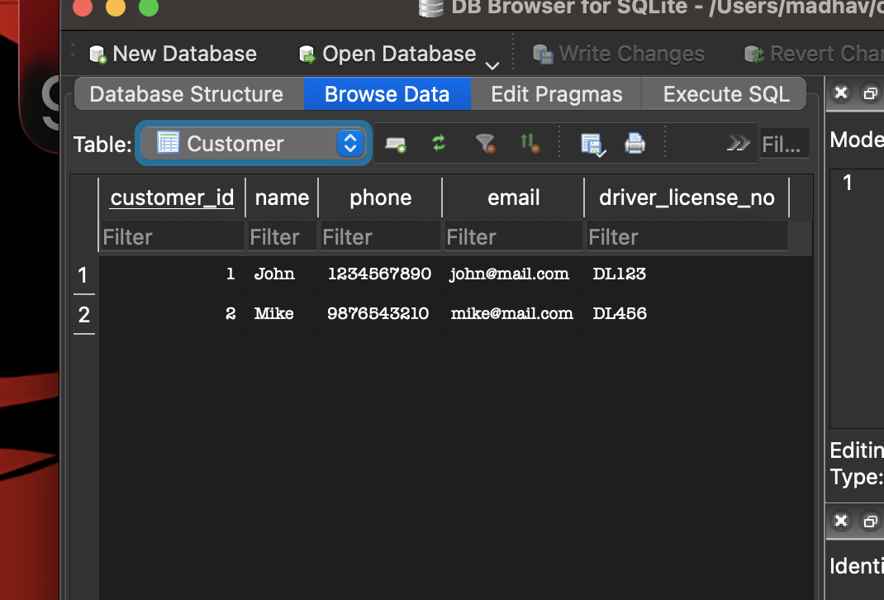

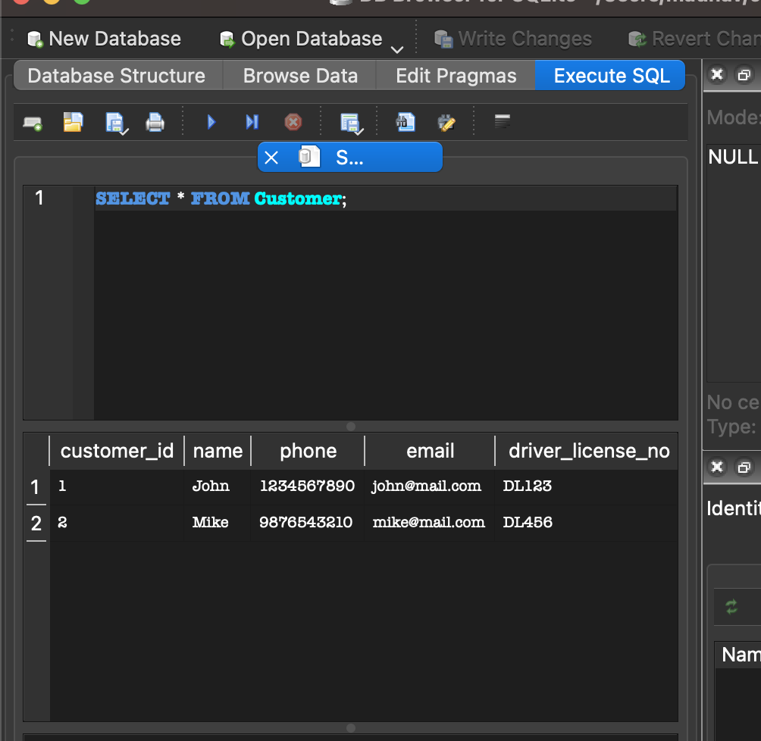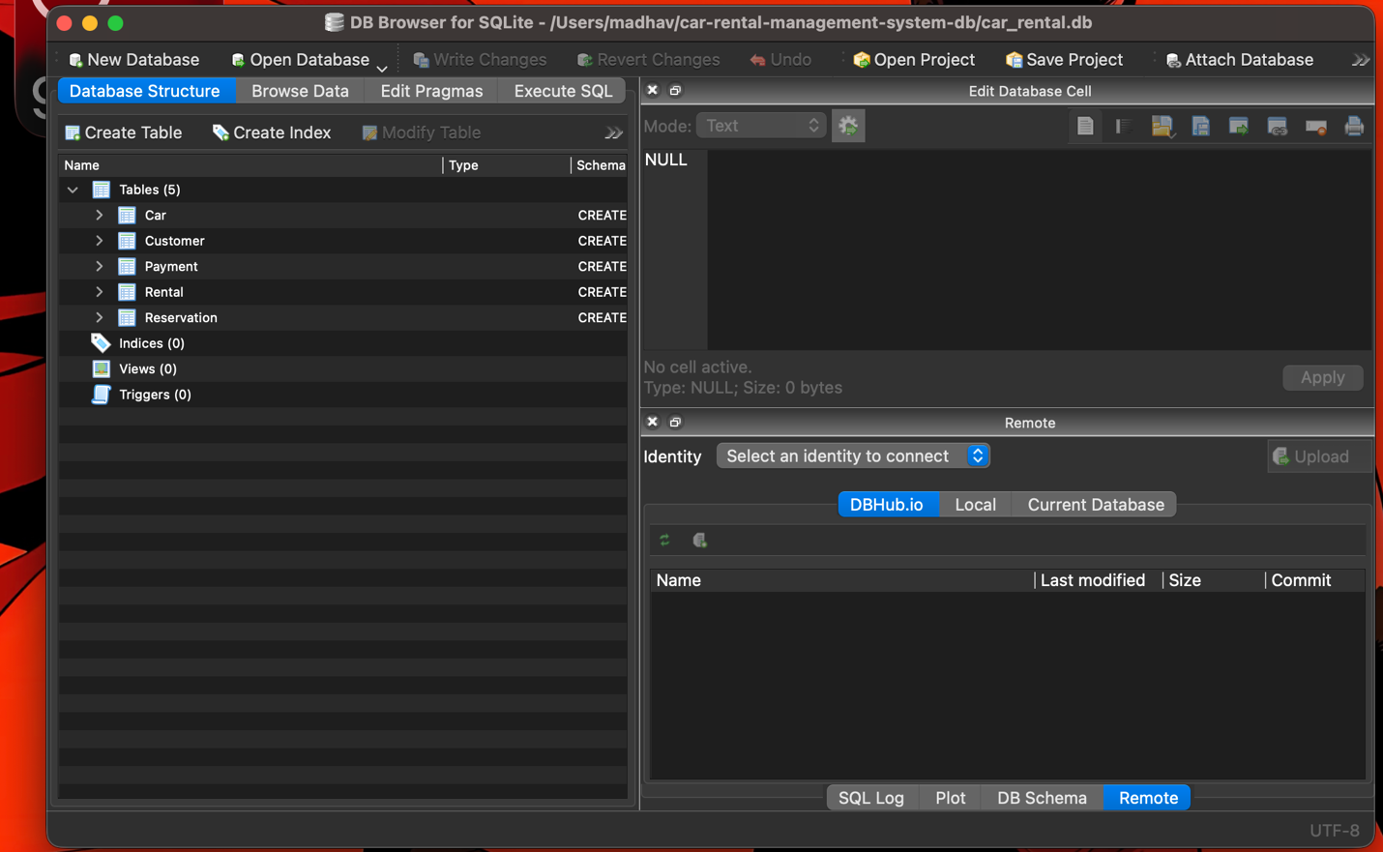

CONCLUSION

This project helped me understand database design, SQL queries, and Java JDBC integration. It demonstrates how real-world systems use databases.

APPENDIX

Includes:
- SQL code
- Java code
- Screenshots

